Leather Garments and Goods Production
Level I
Based on December 2021, curriculum version I
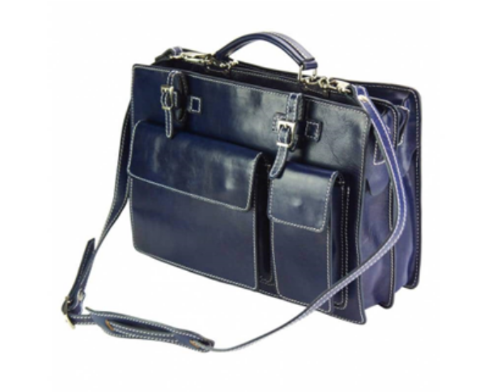
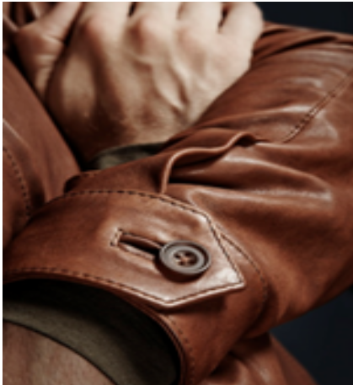

Module Title: - Carrying Out Basic Leather
Garment and Goods Construction
Module Code: IND LGG1 M05 1221
Nominal hour: 92 hrs.
Prepared by: Ministry of Labor and Skill
Aug. 2022
Addis Ababa, Ethiopia

Table of Contents
Introduction to the Module 5
Unit one: Prepare for work 6
1.1 Assessing quality of received work bundles. 7
1.2 Cleaning and checking the functionality of tools 8
1.3 Selecting appropriate construction technique 15
Self-Check -1 21
Unit two: Identify and apply types of seams 22
2.1. Identifying sewing hand tools 23
2.2. Using sewing hand tools 29
2.3. Applying seam techniques 36
Self-Check 2 43
Unit three: Edge construction techniques 44
3.1 Performing basic construction 45
3.2. Joining components using appropriate adhesives 52
3.3. Performing OHS practice for edge constructions 62
Self-Check 3 70
Unit four: construct components of leather goods and garments 71
4.1. Performing table of work activities 72
4.2. Use appropriate adhesive 83
4.3. Performing pocket construction 86
4.4. Constructing garment and goods components 89
Self-Check 4 95
Operation Sheet-4.1 Constructing leather garment component 96
Operation Sheet-4.2 Constructing goods component 108
LAP Test-practical demonstration 125
Unit five: Check the quality of constructed components 126
5.1. Checking quality of constructed component 127
5.2. Reporting faults and rework 131
Self-Check 5 140
Unit six: Dispatch completed work 141
6.1 Bundling and dispatching component 142
6.2. Recording production faults 145
6.3. Completing and Maintaining Records 147
Self-Check 6 149
List of Reference Materials 150

Acknowledgment

Ministry of Labor and Skills wish to extend thanks and appreciation to the many representatives of TVET instructors and respective industry experts who donated their time and expertise to the development of this Teaching, Training and Learning Materials (TTLM).

Introduction to the Module

In Leather garment and goods production basic construction is the process of constructing the components of the leather garment or goods using different methods. The knowledge and skill of basic construction is the start point for having full knowledge of making leather garment and goods
This module is designed to meet the industry requirement in leather garment and goods production occupational standard, particularly for the unit of competency: Carrying Out Basic Leather Garment and Goods Construction.
This module covers the units:
- Prepare for work
- types of seams
- edge construction techniques
- components of leather goods and garments
- quality of constructed components
- completed Work dispatching
Learning Objective of the Module
- Prepare for work
- Identify and apply types of seams
- Identify and apply types edge construction technique
- Construct components of leather goods and garments
- Check the quality of constructed components
- Dispatch completed Work
Module Instruction
For effective use of this module trainees are expected to follow the following module instruction:
- Read the information written in each unit
- Accomplish the Self-checks at the end of each unit
- Perform Operation Sheets which were provided at the end of units
- Do the “LAP test” giver at the end of each unit and
- Read the identified reference book for Examples and exercise

Unit one: Prepare for work
This unit is developed to provide you the necessary information regarding the following content coverage and topics:
  - Assessing quality of received work bundle
  - Cleaning and checking the functionality of tools
  - Selecting appropriate construction technique
This unit will also assist you to attain the learning outcomes stated in the cover page. Specifically, upon completion of this learning guide, you will be able to:
  - Assess quality of received work bundle any follow up action determined in accordance with workplace procedures.
  - Clean and check the functionality of tools in accordance with work place procedures and OHS practices
  - Select appropriate construction technique according to the given work

Assessing quality of received work bundles.
1.1.1 Receiving and checking up work bundle
Definition of work bundle
Work bundle is a bundled component which is received from the cutting department, to be processed by the bench worker. The worker who received a bundle should check the components and the specification. Specification is an instruction which demonstrates how to do the work and what to check before start working. We have to check the following parameters against the specification and the patterns.
- Measurements
- Shapes
- Allowances
- Uniformity of components
- Amount of components
- Left and Right components
- Reference marks
- Pre-fabrications (skiving & splitting)
While checking the above parameters if there is a fault found in the components you have to make corrections or report the fault to your supervisor.
1.1.2 Assessing the received work Quality
After checking the received bundle and specification the next step is to assess the quality. This assessment is used for ensuring that if the work bundle has the quality requirement which allows it to goes through the bench work process.
While assessing the quality of work you have to assure that all the components have
- Accurate Edges
- Same thickness
- Good surface/Grain
- Same color
- Thickness Skived component
- Thickness Splinted component

Cleaning and checking the functionality of tools

Tools
A tool is an extension of human hand. Tools are expensive and manufactured with high quality materials, properly machined, nicely finished, and fitted with comfortable handles.
Hand tools offer high degree of control and precision. Using proper tools for the proper jobs and safety precautions are the key factors for producing quality products. As tools play a vital role in the manufacturing of leather products, it is necessary to keep them in good working condition by storing them ready to use as well as safe from damage.
Good tools and equipment’s help to give more professional finish to sewing.
In leather garment and goods tools is divided into:
- Marking,
- Measuring and drafting,
- Cutting,
- Punching
- Stitching and
- Pressing.
For each of these processes, there are essential tools and equipment’s to make the steps easier and the results superior.
- Marking tools
The symbols on pattern piece are the guides for the accurate construction of the leather garment and goods.
Transferring these symbols from pattern to leather or lining is essential to fitting and sewing. Therefore, it is necessary to have a variety of marking tools.

- Tracing wheels:
Tracing wheels are used to transfer pattern markings to garment leathers. Tracing wheels come in two types. They are serrated and smooth edge. The serrated edge-tracing wheel makes a dotted line marking but may pierce delicate ones. The smooth-edge tracing wheel protects delicate, smooth linings. It makes a solid line marking.
- Tailor’s chalk/Silver marking pencil:
Silver-marking pencil is used to mark on leathers and linings with patterns for cutting components. It marks quickly and easily, directly on leathers and linings.
- Awl:
An awl or stiletto is a small sharp instrument, used to make marks in the patterns for fixing fittings.
An awl is a hard sharp steel needle with a wooden handle. It helps to make marks during pattern cutting process and also during assembling process where leather components are marked and fitted with fittings. The tip of the awl should always be sharp; to check the functionality of the awl we can scratch it on a piece of board. If it makes a scratch on the board it means the tip is damaged and need to be sharpened.
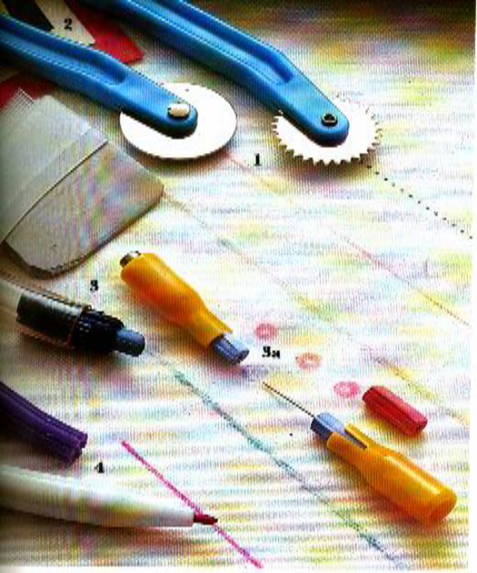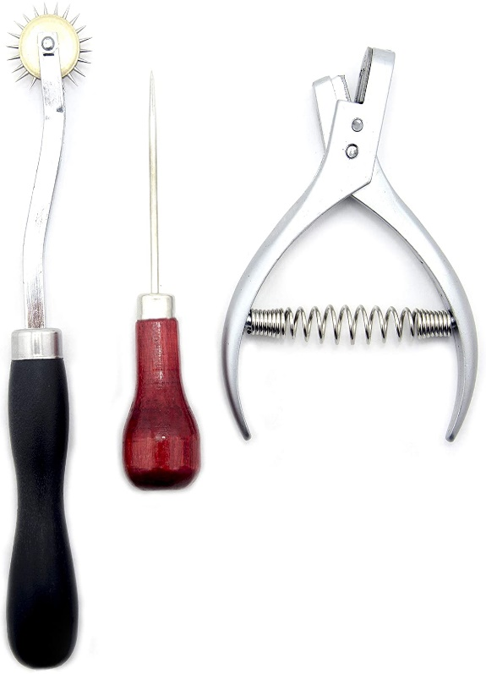
Figure 1: Marking tools
- Measuring and drafting tools:
Body and pattern measurements both require measuring and drafting tools. To ensure a good fit, accurate measurements with the best tools are essential.
- Tape measure:
Tape measure is essential for taking measurements. It is a flexible synthetic or fiber glass, which will not tear or stretch. A 60” (150 cm) long tape with metal tips and measurements on both sides is used to take body measurements for correct fitting.
- Stainless-steel rulers:
Stainless steel scale/ruler is used as a cutting guide for cutting and it is also used as a measuring tool. This tool’s edges should always kept smooth to make a good straight cut. The units written at both sides should be visible to read. If it is dark and hard to read it should be cleaned with oil and a towel.
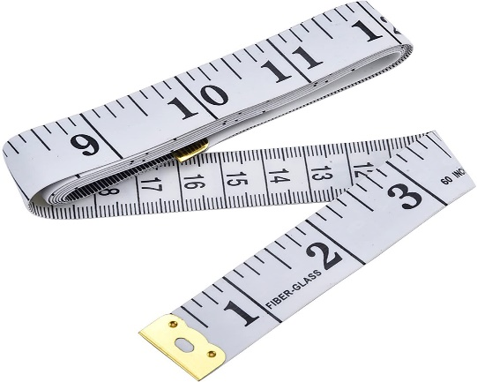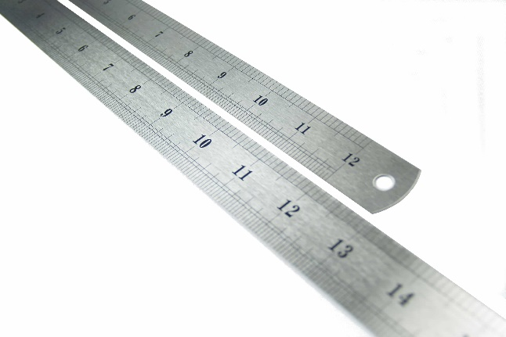
Figure 2: Measuring and drafting tools
- Cutting tools:
Cutting knife:
Cutting knife is made of high-speed steel blade and is used to cut paper and board patterns. It is also used to cut leather and lining components.
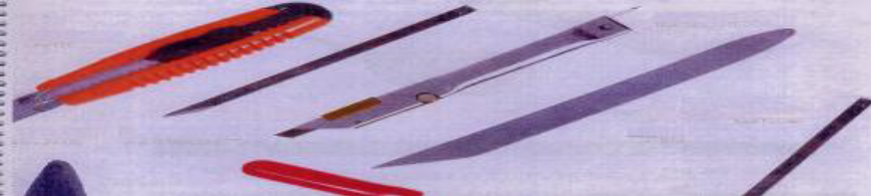
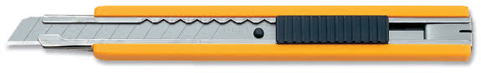
Figure 3: Clicking and utility knives
Scissors and shears
Scissors are used for cutting or trimming leather, lining, or reinforcements. Scissors should have sharp edges and should cut any materials smoothly and easily. We can check the functionality of a scissors by opening and closing it repeatedly and see if it is crossing over properly. Scissors can be sharpened and by a grinding wheel with care. The difference between “scissors” and “shears” is length and design of the handles. Scissors are smaller than 10” with two identical handles while shears are 10” or longer with one rounded bow for the thumb and a longer more elliptical bow for two or more fingers.
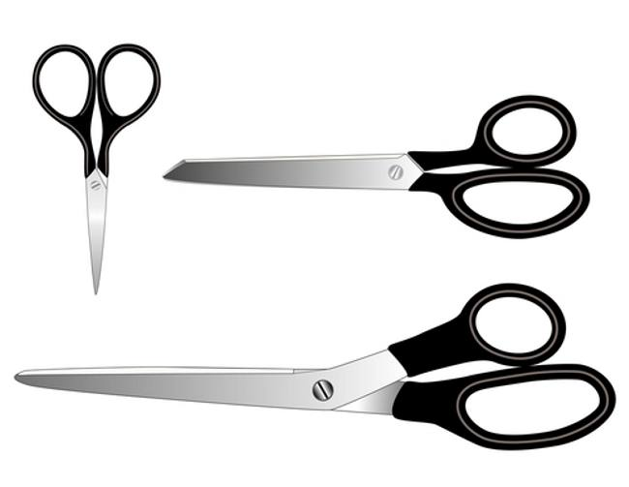
Figure 4: Scissors and shears
- Punching tools
- Revolving punch
The revolving punch with four or six different size tubes is used for punching holes for lacing, riveting, eyeleting, and snap setting in leather components. We have to check that the tubes have sharp rounds so that the holes made by the puncher will be smooth. We can check the functionality of the puncher on a scrap of leather.
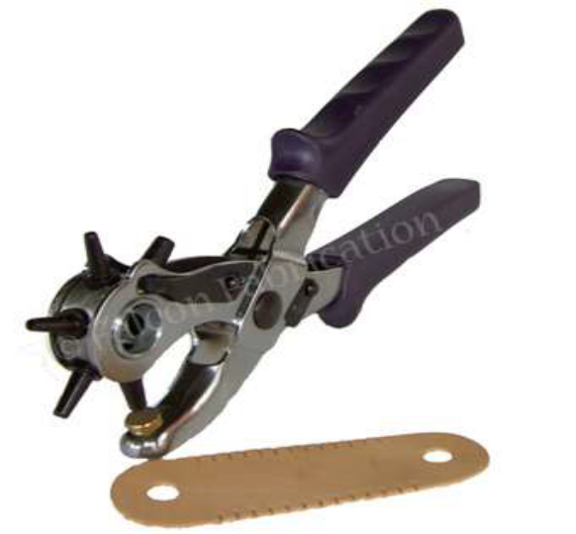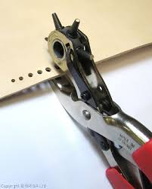
Figure 5: Revolving punch
- Punch or round drive punch
Punch or round drive punch is a cylindrical slotted punch made of tempered steel.
Different sizes of punches 00, 0,1,2,3, and 4 are used for making different sizes of holes in leather components. These punches are used for fixing buttons, rivets, rivet buttons, eyelets, studs, etc. in leather goods. Oblong/crew punches are used for making holes in leather belts and hold all straps. As we check the revolving puncher we have to check also that the punch tubes have perfect and sharp rounds.
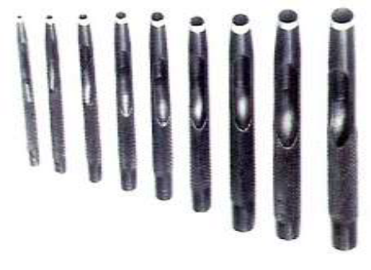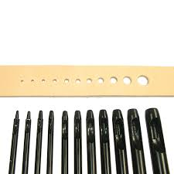
Figure 6: Punch or round drive punch
- Other tools
- Hammer/ mallet
Rubber mallets are ideal for use on leather materials where the head will not leave any damage during bench work activity.
The common hammer has a foot-long handle, secured through the eye of the head with wooden block and a pair of iron ones. The hammer will do all the pounding, pulling, tapping, knocking, etc. Since hammer is no less extension of the arm than any other tool, it is important to have one that is suited size and is comfortable to use. Steel hammer or rubber mallet is used in assembling process. Light weight hammers 100gms and 200gms are used for light works and hammers of weight 300gms and 500gms are used for medium and heavy works.
We have to check the head of hammer that it is flat and it has no bumps on it.
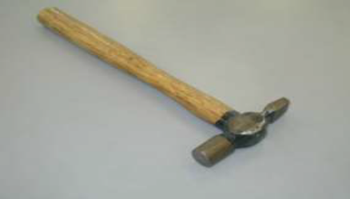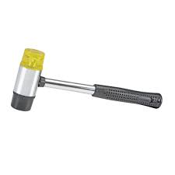
Figure 7: Hammer/ mallet
- Bone folder:
Bone folder is made of horns. One end of the folder is filed off to a pointed edge and the other end is rounded off to a smooth edge. It is also made from plastic. It is used for edge folding. The edges of bone folder should be smooth. A rough or damaged edge of a bone folder can be rubbed and refined with a sand paper.
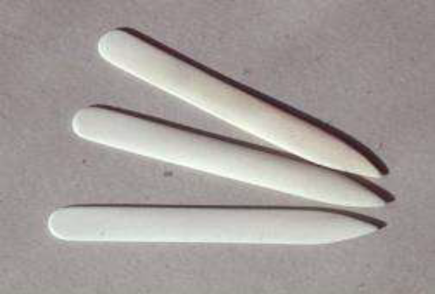
Figure 8: Bone folder
- Brush
It is one of the most basic and useful tools known to leather products manufacturing. It generally consists of a handle or block to which fibers are attached. The fibers should be kept free from drying so that it will not damage material surfaces and minimizes wastage of glue. To prevent it from drying it should be washed with kerosene and kept in container filled with water.
To see the functionality of a brush we can press it on aboard and see if it is flexible, if it is stiffed and dry it should be washed with kerosene.
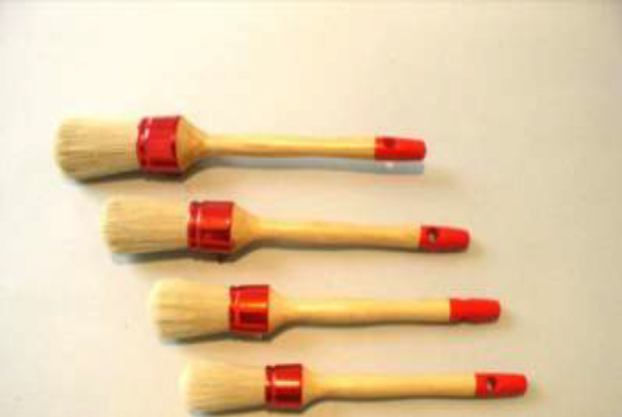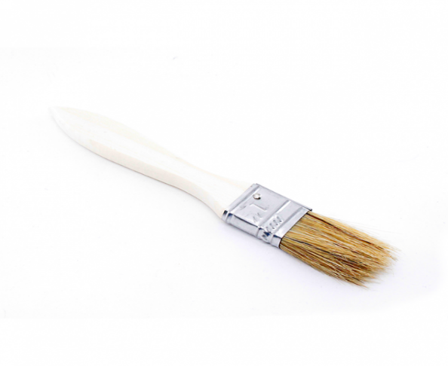
Figure 9: Brush
Checking the functionality of tools
In the process of bench work operation there are a variety of tools used; these tools should be functional and handy. Always and before using any tool we have to check that it is functional.
Some of check points for the tools can be:
- Checking if there is breakage on the tools
- Checking sharpness of Blades, Dies ,etc., …
- Checking the accuracy of measuring, and other related tools.

Selecting appropriate construction technique

Types of construction:
In leather goods manufacturing, different techniques of constructions are used for making leather goods. Most commonly used constructions are:
- Cut edge construction, (raw edge construction)
- Turnover-edge construction (fold-edge construction),
- Turn-edge construction (stitch and turn construction),
- Butt-edge construction,
- Molded construction,
- Built-up construction,
- Box-work construction,
- Cut-edge construction, (raw edge construction)
The components are cut to definite sizes of the product and assembled. In this type of construction, the cutting edges are seen. The edges are flush or level when stitched. The edges are stained with the matching colour of the product to improve its elegance. The edges are creased and wax polished. After wax polishing, the edges are rubbed with a piece of smooth cloth or circular slicker to get glossiness of the edge. Good cut-edge work depends upon the edge being cleanly cut and the crease line being bright and shiny.
E.g. coin purses, wallets, under-arm cases, gents’ belts, shoulder bags pilot chart bags, document cases, etc.
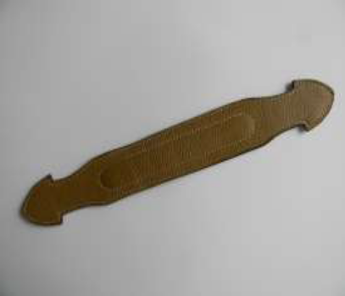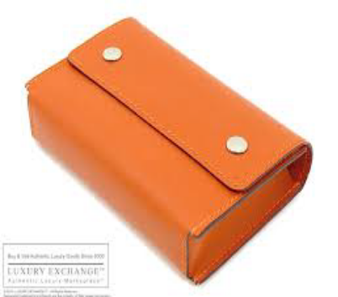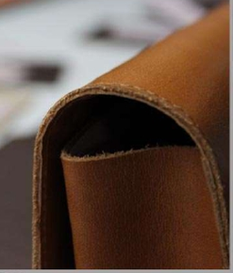
Figure 10: Cut-edge or raw edge construction
- Turn-over edge Construction, (Fold-edge Construction):
In this type of construction, the leather components are cut with allowances for folding.
The edges are skived to a suitable thickness for easy and perfect folding. Turnover or folding is done over the lining or reinforcement and then stitched. This encloses all raw cut-edges. This construction imparts greater durability and elegance to the products. E.g. wallets, passport covers, gent’s belts, ladies handbags, portfolio bags, etc.
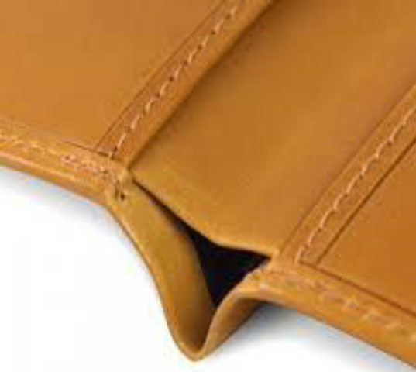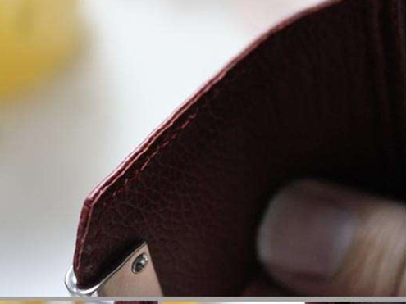
Figure 11: Turn-over edge Construction (Fold-edge Construction)
There are two types of curves in folding,
  - Convex Curve,
  - Concave Curve.
a) Convex Curve: In this type put the reinforcement and fold it .Here the folds will formed as pleats. The excess material for folding cut and reduces it and nicely pressed the components by mallet.
b) Concave Curve: In this concave curve the excess material for fold should be cuts/nicks. But the cut should not touch to the edge of the components. If so the cut should be visible from the front/upper part.
- While folding care has to be taken:
- The folding allowance should not be excess otherwise the impression will find from the upper part.
- The cuts should be even and correct for good stitching.
- Not too much adhesive is used, otherwise the lumps could be formed which could cause problems in stitching.
- If beads of adhesive are visible at the needle holes after heat setting, it means the adhesive is not good and it hampers the machine and cut the threads.
- The reinforcement must be placed properly.
- Butt-edge construction:
In butt-edge construction, two turned over edges are joined together, keeping the grain side out and stitched. It gives a double edge with stitches on all round the edges. E.g. spectacle cases, framed handbags, shoulder bags, document cases, etc.
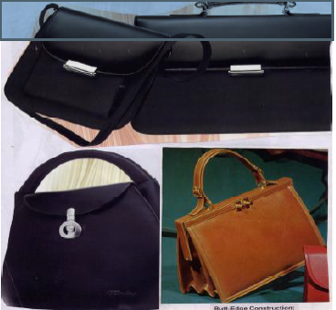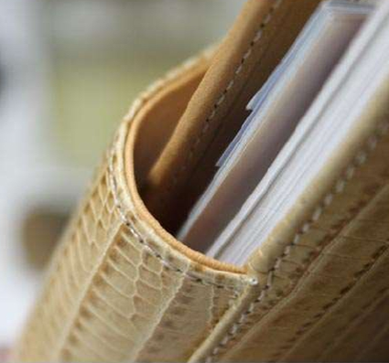
Figure 12: butt-edge construction
- Turn-edge construction: (Stitch and turn construction):
Turn edge or stitch and turn edge construction is very popular and extensively used in leather goods making. The stitches in the article are not seen outside. During assembly, the components and piping are assembled with inside out (flesh side out) and stitched.
When stitching is over, the right side (grain side) of the article is pulled out. So, the stitches are seen only inside and the piping is seen outside. The piping on the seam adds strength and beauty. E.g. wrist bags, ladies handbags, air bags, shopping bags, etc.
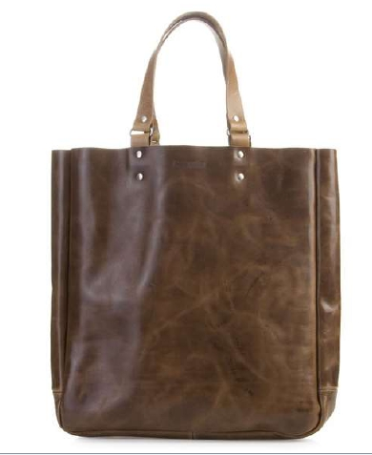
Figure 13: Turn edge or stitch and turn edge construction
- Turn-edge with Piping edge construction
Piping edge construction is similar to stitch and turn edge construction.
The stitches in the article are not seen outside. During assembly the components and piping are assembled with inside out (flesh side out) and stitched. When stitching is over, the right side (grain side) of the article is pulled out. So, thestitches are seen only inside and the piping is seen outside. The piping on the seamadds strength and beauty. E.g. wrist bags, ladies handbags, air bags, shopping bags,etc.
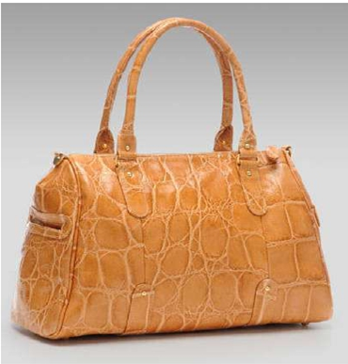
Figure 14: Stitch and turn with piping construction

- Box-work construction:
Box Work construction: In box-work construction, wooden frame or box of required sizes is made first from lightwood like pine wood, ply wood, deal wood etc. Since the wooden surface is coarse, it is covered with millboard to give an uniform and smooth surface. Foam and leather are fixed over the board using adhesive. Foam is given for giving cushioning effect. The metal hinges or leather hinges are used to join the top and bottom lids. The fittings such as handles, locks, rivets etc are fixed. The inside of the product is lined either with suede or fabric or silk or imitation suede or synthetic fabric with foam as a backing material. Load bearing parts are fixed with studs to overcome wear and tear. The fittings should be well riveted to carry or hold the intended weight for which it is meant,
e.g. brief cases, jewel boxes, cosmetic boxes, card cases, etc 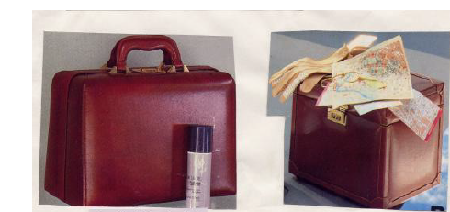
Figure 15: Examples of box work construction
- Molded construction:
Molded Construction: leather is molded to any desired shapes and they only retain the molded shapes. Vegetable tanned leathers of even thickness are wetted and wrapped round the mold of desired shape of an article and allowed to dry completely. In some cases, the leathers are pressed under a mold to get the desired shape and dried. After drying, it would retain the shape of the mold. Then the joints are well secured by using adhesives or stitches,
e.g. water bottles, camera cases, cigar cases etc. 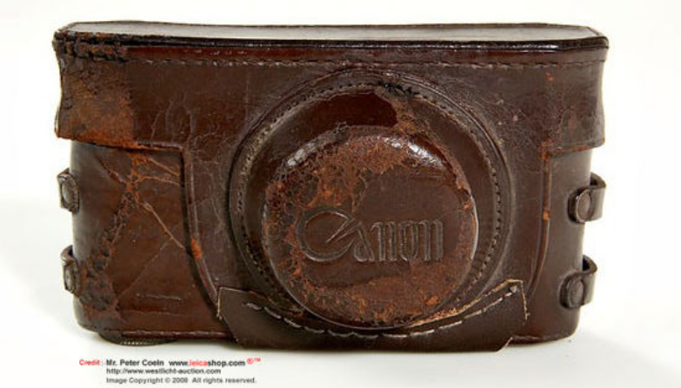
Figure 16: Examples of molded Construction
- Built up construction:
In built-up construction, a strong yellow straw board is used as a foundation for the article to be made. The yellow straw board is moistened using water and sponge evenly. It is then wrapped round the wooden mould. After drying, the foundation of the article is built up with millboard and leather (with or without foam) using adhesive and finished. The inner lining of the article is built up with the paper and lining leather or silk using adhesive. E.g. penholder tumblers, pincushions, pencil trays, letter paper cases, visiting card cases, etc
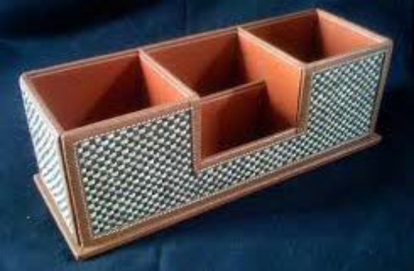
Figure 17: Examples of built-up construction

Self-Check -1 | Written Test

Name…………………………………………… ID………………………… Date…….
Directions: Answer all the questions listed below.
- Short answer
- What is work bundle? (3pts)
- What is the use of assessing the received work quality? (3pts)
- While assessing the quality of work what kind of points assured? (3pts)
- What parameters of bundles are checked against the specification and the patterns? (3pts)
- List out two examples for each of marking tools, measuring and drafting tools, cutting tools, punching tools. (5pts)
- What points should be checked before using tools? (5pts)
- What is cut edge construction? (3pts.)
- What is folded edge construction? (3pts.)
- What is butt edge construction? (3pts.)
- What is stitch and turn construction? (3pts.)
Matching
 |  | A |  | B
 | 1 | Bundle | A | Measuring tool
 | 2 | Steel ruler | B | Cutting tool
 | 3 | Piping | C | Used to apply adhesive
 | 4 | Molded construction | D | A construction technique by using a cord
 | 5 | Brush | E | A construction technique to make a leather good to a desired shape

Unit two: Identify and apply types of seams
This unit is developed to provide you the necessary information regarding the following content coverage and topics:
  - Identifying sewing hand tools
  - Using sewing hand tools
  - Applying seam techniques
This unit will also assist you to attain the learning outcomes stated in the cover page. Specifically, upon completion of this learning guide, you will be able to:
  - Identify sewing hand tools
  - Use sewing hand tools
  - Apply seam techniques

Identifying sewing hand tools

2.1.1 Selection of stitching tools and attachments according to specified work
There are some sewing tools that you can’t even begin without. The correct sewing tool makes any sewing project easier. Knowing which tool to select and where to use it will simplify and improve the outcome of each sewing step.
- Trimmer
Thread nippers/trimmer/
Are simple thread scissors that are designed primarily for cutting threads in a concise and clean manner? Generally, the design for these types of scissors is smaller than a pair of sewing shears and will fit easily into the palm of the hand. Many versions of thread nippers/trimmer/ are no more than four inches in length.
The purpose for thread nippers is to cut through thread, even when the thread is thick or made from a particularly sturdy material. Because of the non-traditional design for the scissors, it is possible to apply more pressure for threads that are more durable, such as some synthetic blends.
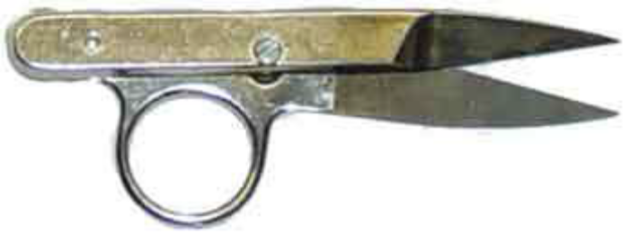
Figure 18: Thread nippers/trimmer/
- Stitch Repair
Stitching repairing needle is a tempered steel needle. One end of it is flattened with a groove to pull the thread. The flattened head is made very sharp so that it can pierce into the fibrous leather components easily. It is generally known as cobbler's needle.
It is used in leather goods making for stitching handles and also for joining components where machine stitching is not possible.
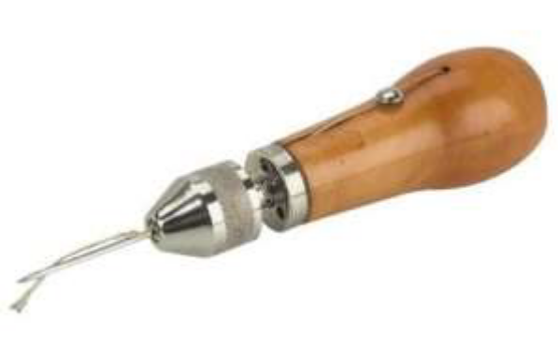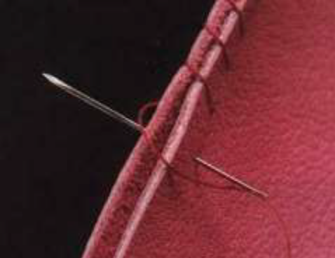
Figure 19: Stitch Repair
- Scissors
Scissors are used for cutting leather components, lining components, foam, reinforcements, etc. in leather products fabrication. Big scissor is used for cutting leathers, linings, etc. while small scissor is used for trimming excess thread after stitching. Pinking scissor is used for ornamental cuttings. It is very much used in garment industries.
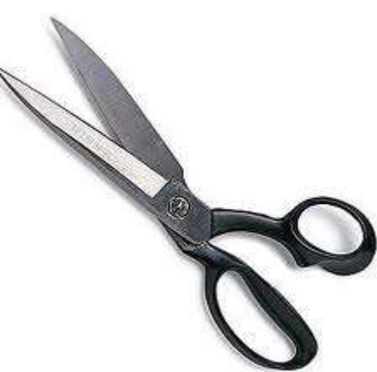
Figure 20: Scissors
- Hand sewing needles
Hand sewing needles- When choosing a needle it's best to consider the type of leather or fabric you'll be using. In general, the lighter your leather, the thinner the needle you'll want to use with it. If you're unsure of the best needle, just try passing a few different sized needles through an inconspicuous place on the leather.
The various and most common types of hand sewing needles are:
i. Sharps- These are the most commonly used ones with a sharp point and medium length. They have a rounded eye for threading and come in a variety of thickness and lengths. 1 being the longest and thickest and 10 being the shortest and thinnest
ii. Ball point needles- These have rounded edges, come in sizes 5-10 and have a rounded edge that makes them ideal for woolen fabrics
iii. Embroidery or Crewel needles- These are a lot like the Sharp needles except that they have a larger eye to allow different kinds of threads to pass through. They also come in sizes 1-10. Milliner’s needles, Tapestry, Quilting and Chenille are some of the other hand sewing needles that are more specialized.
- Loop turner-
This is a clever tool that allows you to easily turn a sewn tube of Leather or fabric inside out.
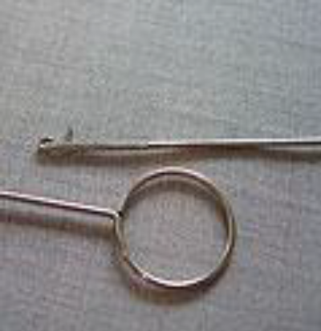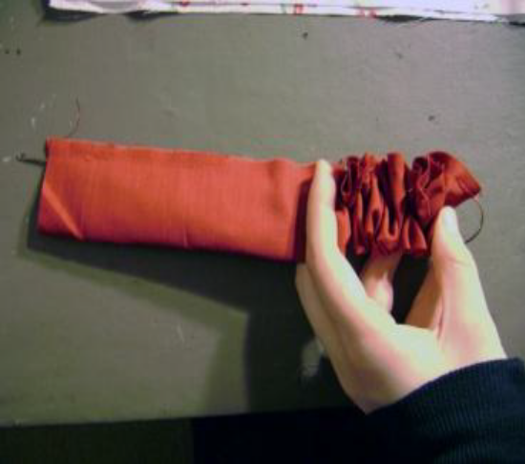
Figure 21: Loop turner
- Presser foots
The presser foot exerts downward pressure on the leather fabric as it is fed under the needle
The all-purpose presser foot comes on the sewing machine. It is the foot that you will use for all regular straight sewing. If your machine has zigzag capability, this foot has an opening wide enough for the needle in any position.
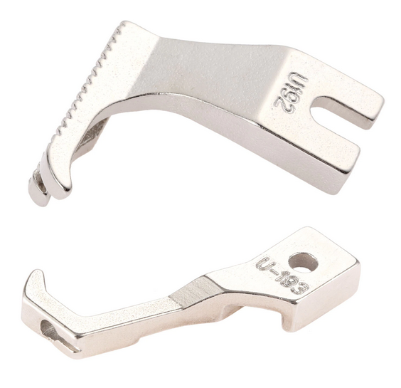
Figure 22: presser foot
- Sewing box-
This is a very important tool because this will keep all the smaller tools in one place and prevent them from getting spoilt or lost. Typically, you will put things like thimbles, bodkins, buttons, small scissors, various feet of the sewing machine, needles, some odd threads, in this box. It is not important that this should be a fancy box or even just one single box. The important thing is to organize your everyday use equipment in an easy to store box where you will be able to find things quickly and also keep them safe.
2.1.2 How to select Leather garment and goods tools
Instructions
1. Make sure that you have a flat, stable surface on which to work. A rubber mat placed under your work will prevent the surface from being scarred and will also protect the blades of your cutting tools.
2. Cut out leather pieces with a razor knife and use paring tools such as edge bevellers and skives to remove thin layers from a piece of leather. Leather shears can be used to cut thinner pieces of leather.
3. Tool a piece of leather with a swivel knife, wood or rawhide mallet, and a variety of leather stamps. Decorative cuts are made with swivel knife and then the mallet and stamps are used to create textures and depressed surfaces around those cuts. Stamps come in a variety of patterns.
4. Make perforations in your leather with an awl, a stitching awl (for holes that will be stitched through) and/or leather whole punches of various sizes. Use a rotary whole punch for easy, even whole placement.
5. Sew leather with leather-craft sewing needles, waxed linen thread and artificial sinew. Use the waxed linen thread on softer, thinner pieces of leather and use the artificial sinew on harder pieces. The artificial sinew does not stretch and may cut into the stitching holes in soft pieces of leather.
2.1.3. Hand Tool Safety
Hammers, wrenches, chisels, pliers, screwdrivers, and other hand tools are often underrated as sources of potential danger. Hand tools may look harmless, but they are the cause of many injuries. In fact, an estimated 8 percent of all workplace compensable injuries are caused by incidents associated with hand tools. These injuries can be serious, including loss of fingers or eyesight.
Hand tools can cause many types of injuries:
- Cuts, abrasions, amputations, and punctures; If hand tools are designed to cut or move metal and wood, remember what a single slip can do to fragile human flesh.
- Repetitive motion injuries; using the same tool in the same way all day long, day after day, can stress human muscles and ligaments. Carpal tunnel syndrome (inflammation of the nerve sheath in the wrist) and injuries to muscles, joints and ligaments are increasingly common if the wrong tool is used, or the right tool is used improperly. Injury from continuous vibration can also cause numbness or poor circulation in hands and arms.
- Eye injuries; flying chips of wood or metal is a common hazard, often causing needless and permanent blindness
- Broken bones and bruises; Tools can slip, fall from heights, or even be thrown by careless employees, causing severe injuries. A hammer that falls from a ladder is a lethal weapon.

To avoid such injuries, remember the following safety procedures:
- Use the right tool for the job. Don't use your wrench as a hammer. Don't use a screwdriver as a chisel, etc. Go back to the tool house and get the right tool in the right size for the job.
- Don't use broken or damaged tools, dull cutting tools, or screwdrivers with worn tips.
- Carry tools securely in a tool belt or box. Don't carry tools up ladders. Use a hoist or rope.
- Pass a tool to another person by the handle; never toss it to them.
- Use the right personal protective equipment (PPE) for the job. Follow company instructions for selecting and using safety eyewear, steel toed shoes, gloves, hard hats, etc.
- Never carry sharp or pointed tools such as a screwdriver in your pocket.
- Select ergonomic tools for your work task when movements are repetitive and forceful.
- Always keep your tools in top condition. A dull blade or blunt point can lead to injury.
- Store tools properly when you stop work.
Basic Safety Rules for Hand Tools
- Use tools that are the right size & right type for your job.
- Follow the correct procedure for using every tool.
- Keep your cutting tools sharp and in good condition.
- Don’t work with oily or greasy hands.
- Handle sharp edged and pointed tools with care.
- Always carry pointed tools by your side with the points and heavy ends down.
- Never carry tools in your pockets.
- Don’t use tools which are loose or cracked.
- Keep your punches & chisels in good condition. Mushroomed heads can chip & cause juries.
- Don’t use a file without a handle.
- After using a tool clean it and return it to its proper storage place.
- If anything breaks or malfunctions - report it to your instructor at once.
- Never place tools & materials where they hang on the edge of a bench.
- Store tools and materials vertically, with the points and heavy end down.
- Cut away from yourself when you use chisels and other edged tools.
- Don’t force screws; make sure that the correct screw for the job is being used.

Using sewing hand tools
Tools are expensive and manufactured with high quality materials, properly machined, nicely finished and fitted with comfortable handles. Hand tools offer high degree of control and precision. Using proper tools for the proper jobs, a clean well-lighted working area, adequate instructions for performing jobs and safety precautions are the key factors for producing quality products. As tools play a vital role in the manufacturing of leather products, it is necessary to keep them in good working condition by storing them ready to hand as well as safe from damage. Tools are classified into: tools for pattern cutting, tools for leather goods fabricating, tools for leather crafting and tools for dual performance i.e. tools for leather goods fabricating and repairs and maintenance of equipment and machinery. Good tools and equipment help to give more professional finish to sewing. For leather garment making the basic sewing is divided into: marking, measuring and drafting, cutting, stitching and pressing. For each of these processes, there are essential tools and equipment to make the steps easier and the results superior.
Tools used in leather garment and goods construction
- Marking Pen
Silver marking pen is used to mark defects on leathers during assorting process. Silver marking pen is also used to mark on leathers with patterns for cutting components to achieve the maximum cutting value. It is also used to mark on the components for fixing fittings with the help of patterns.
In the pattern making the color markings are needed for process of manufacturing leather garment and goods. Such as leather patterns are mark by Red Pen, Lining patterns are mark by Black Pen and Reinforcement patterns are mark by Green Pen.
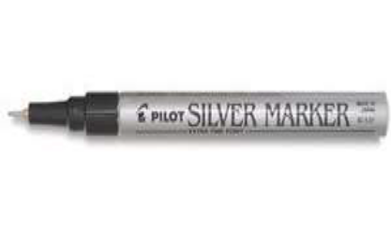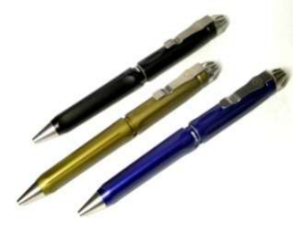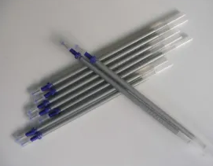
Figure 23: Silver/ marking pen
- Awl
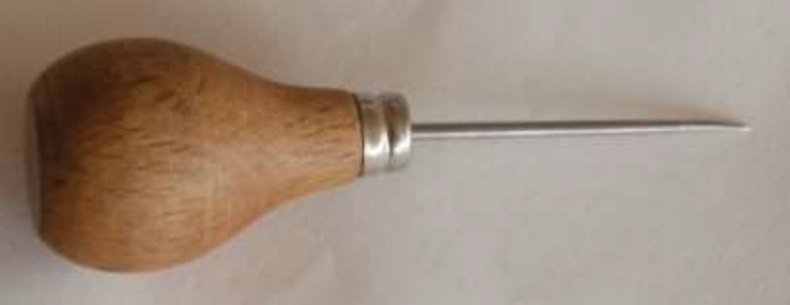
Awl is a tempered sharp steel needle with a wooden handle. It helps to make marks during pattern cutting process and also during assembling process where leather components are marked and fitted with fittings.

Figure 24: Awl
- Bone Folder
Bone folder is made of buffalo horns. One end of the folder is filed off to a pointed edge and the other end is rounded off to a smooth edge. It is also made from plastic. It is an inexpensive folder and edge crasser. It is used for folding, lining, piping and creasing during assembling process. American folding tool is also used for folding the glued components.
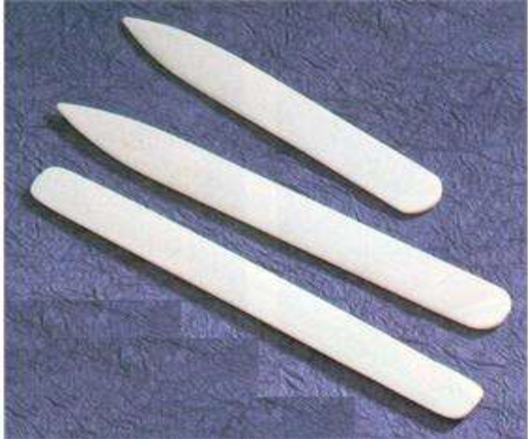
Figure 25: Bone folder

- Hammer
The common hammer has a foot-long hickory handle, secured through the eye of the head with wooden wedge and a pair of iron ones. The hammer will do all the pounding, pulling, tapping, knocking, etc. Since hammer is no less extension of the arm than any other tool, it is important to have one that is suited to size and is comfortable to use.
Steel hammer is used in assembling process for making leather goods. Light weight hammers 100gms and 200gms are used for light works and hammers of weight
300gms and 500gms are used for medium and heavy works. Hammers are used for punching holes, setting rivets and snaps. In the soft edge folding Teflon hammer are used.
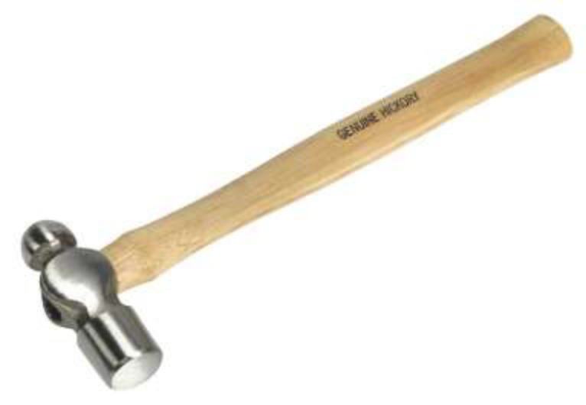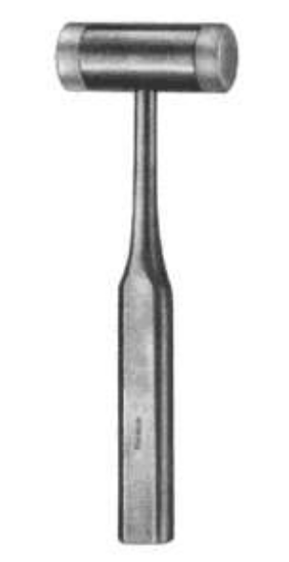
Figure 26: hammer
- Scissors
Scissors are used for cutting leather components, lining components, foam, reinforcements, etc. in leather products fabrication. Big scissor is used for cutting leathers, linings, etc. while small scissor is used for trimming excess thread after stitching. Pinking scissor is used for ornamental cuttings. It is very much used in garment and leather goods industries.
Figure 27: Scissors
- Threads
To provide good sewing performance a thread must have consistent size, strength, stretch and needle heat resistance. The thread selected for sewing has to provide satisfactory appearance in the seam in both stitch formation and color match. Sewing threads are made from two types of fibers –
(1) Natural fibers (cotton, silk and linen) and
(2) Synthetic fibers: (nylon, polyester, rayon etc.)
Natural fibers provide best sewing performance while synthetic fibers provide best seaming performance. Cotton thread is vulnerable to abrasion while synthetic thread provides excellent seam strength, resistance to abrasion and wears.
Special features of Polyester cotton Threads:
- Improved sewing performance because it is less harsh.
- Cotton rap acts as insulation against needle heat.
- Gives extra seam grip.
- Fills the needle hole completely and
- Prevents leathers being cut by the hard synthetic core.
Special features of Nylon cotton Threads:
- High strength and durability.
- Excellent fineness/strength ratio.
- Higher abrasion resistance.
- Improved sew ability.
- Better seam performance.
- Rot-proof and immune to attack by mildew, fungus etc. and
- Minimum wear of machine parts because of superior lubrication.
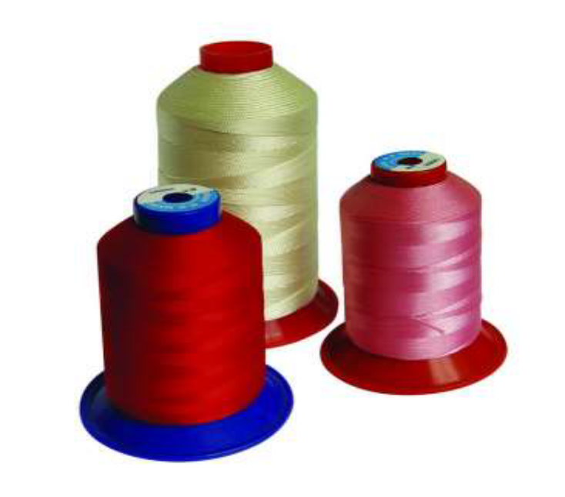
Figure 28: Threads
- Trimmer
Thread trimmer is used to trim excess thread after stitching of the components or products in the sewing machine. It is also used in final finishing of the products to trim excess thread, left un-noticed. Thread trimming tool is a very important tool used to fuse excess thread after stitching. Since leather goods are stitched with synthetic threads, it is necessary to use thread burning tool to fuse the excess thread after stitching. This enhances stitch appearance on the products.
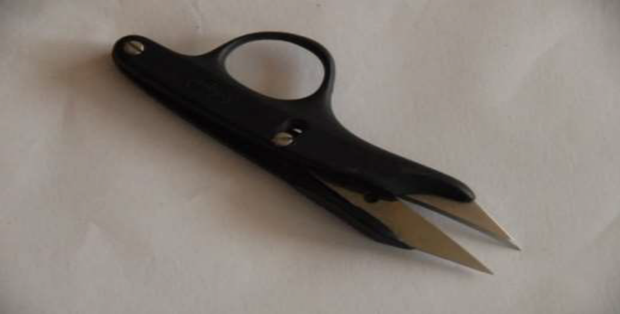

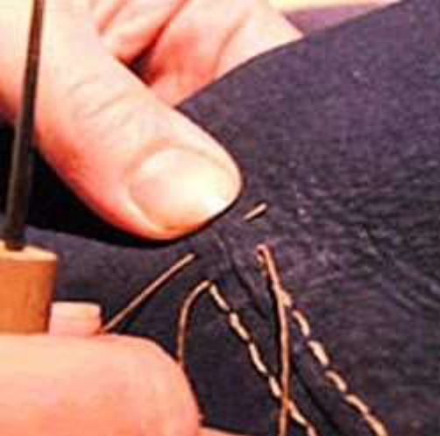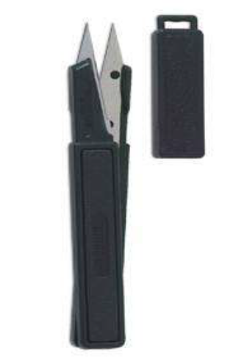
Figure 29: Thread trimmer
In the finishing process of leather goods and garment excess threads has to be removed carefully in manufacturing units. For the quality of the product this maintain by quality checkers, who are responsible for the work. Thread trimmer is used to trim excess thread after stitching of the components or products in the sewing machine. It is also used in final finishing of the products to trim excess thread, left un-noticed. Thread trimming tool is a very important tool used to fuse excess thread after stitching. Since leather garment and goods are stitched with synthetic threads, it is necessary to use thread burning tool to fuse the excess thread after stitching. This enhances stitch appearance on the products
- Creaser
Creasing tool is used to crease edges of the leather components by heating. It is used for making distinct lines in cut-edged articles and crafted articles. Viz. coin purses, wallets, key cases, belts, etc.
It not only gives strength to the components by compressing the fibers but also gives decorative and aesthetic look. Different types of creasing tools are used for different types of works. Generally, single line creaser, double line creaser and adjustable creaser are used for making creases at the edges of the components of the products.
1. Single creases can be used to mark out work for cutting or creasing area where creases have insufficient adjustment to reach.
2. Double creases may also be called checkers, these tools are used for making ornamental lines where one edge of the crease follows, initially the edge of the leather and then the first line done.
3. Bevel creases are much thicker blades and rounded than single creases. they are used for heavy ornamental lines, usually on loops.
4. Screw purse creases mark the edge of work for ornamentation and to provide a guide for pricking iron. They are fully adjustable.
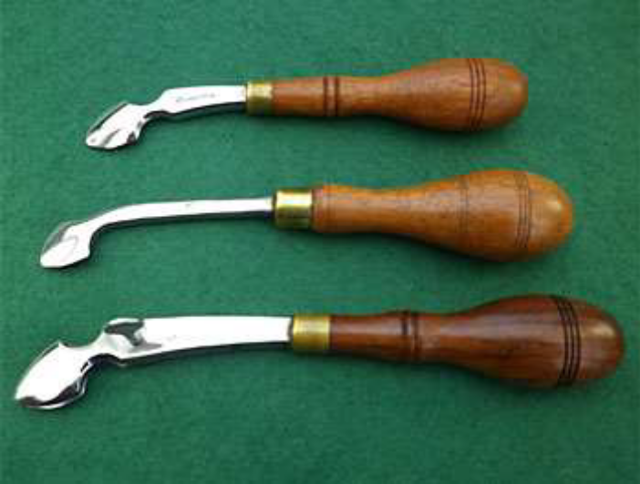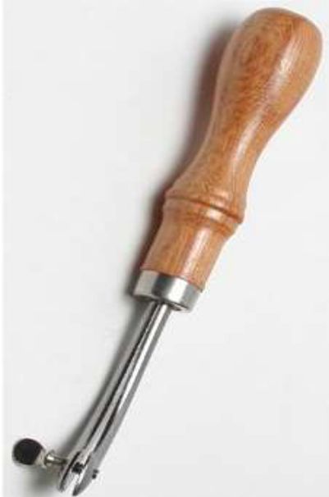
Figure 30: creaser
5. Single purse creases are a lighter version of a double crease.
6. Edge irons are a non-adjustable version of a screw crease.

Applying seam techniques
Define seams:
In leather garment and goods assembling process, two or more plies of fabric or other materials are detained by rows of stitches known as a seam. Seams are generally categorized based on the seam type as superimposed seam, lapped seam, bound seam, flat seam and based on their location in the completed garment such as center back seam, inseam and side seam. Seams finishing can be carried out with a range of methods to prevent unraveling of fabric raw edges as well as to neaten seam edges on the inside of garments. The type of seam and sewing thread used will vary with each application.
Seams are the result of a sewing operation which forms a number of stitches, in a material using a continuous thread. The purpose of Seam is to Joining, Reinforcing and Decorating of the material.
- Seam joining:
Seam joining of leather piece is a common feature in leather garment and goods making. Since leather is having an irregular shape, it is very difficult to get a long strap. It is therefore necessary to cut leathers into pieces and join for making gussets, piping straps, shoulder straps etc.
Joining components are an art or design part of the leather goods. There are various types of leather joining by pasting and stitching. Seams are the result of a sewing operation which forms a number of stitches, in a material using a continuous thread.
Moreover, the cost of leather is very expensive. In order to bring down the cost of leather products and maximize the cutting value, it is necessary to cut leather into pieces and join. Joining of pieces is done using various techniques.
The purpose of Seam is to Joining, Reinforcing and Decorating of the material.

Different Types of Seams and Joining
- Joining With Closed Seams:
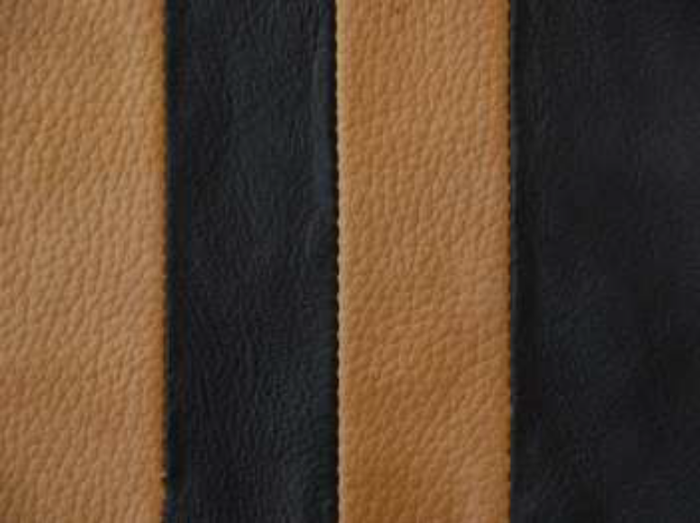
Figure 31: closed seam
The leather components are placed face to face (grain side) and stitched usually 1cm from the edge. The seam is then opened and rubbed down. This is usually done on a flatbed stitching machine; use of a work guide is effective in both an even edge stitching and productivity. Closed seams have to undergo tension both during wear and strength. Hence it is very important to use the right thread and stitch density. The tension must also be correct to avoid “grinning or puckering”.
TIPS:
- The texture and the thickness of both the components must be matched otherwise seam will be incorrect.
- Skiving must be done uniform.
- Edge distance must be uniform.
- Always use P point needle.
- Do not use a thread heavier than 40 numbers.

- Joining With Brooklyn Seam:
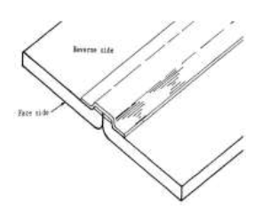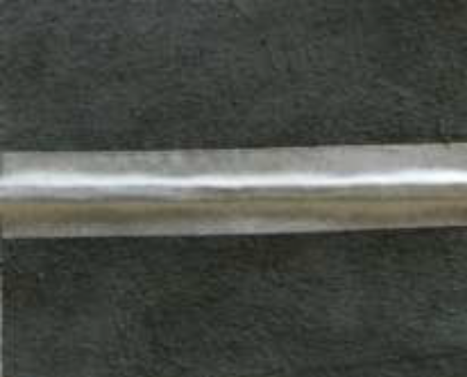
Figure 32: Brooklyn seam
When the seam is rubbed down and tapped it is called a Brooklyn Seam.
- Joining With Closed Seam:

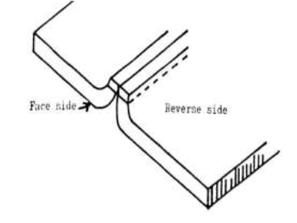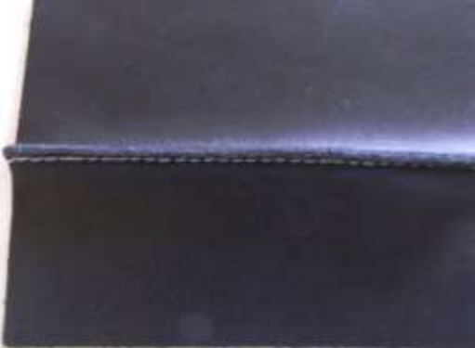
Figure 33: Closed seam
Closed seam is rubbed and a woven tape is attached to the reverse side with two rows of stitching one on each side of the seam. Such a seam is called a French seam. There is a special machine for this – a twin needle, two thread chain stitch machine.
- Joining With An Open Seam:
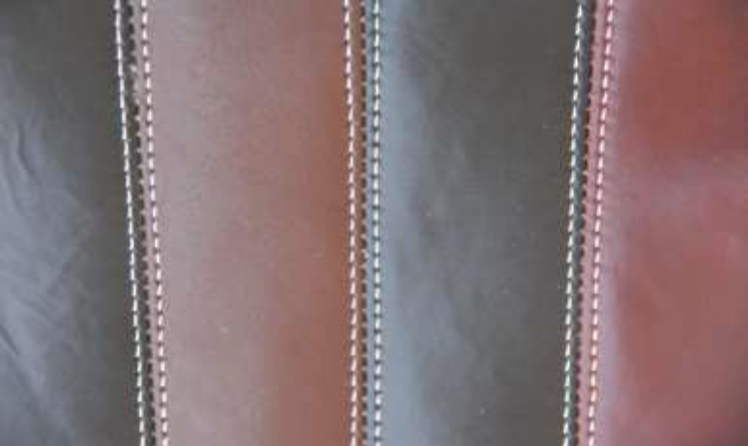
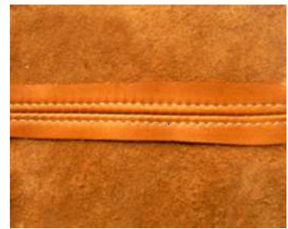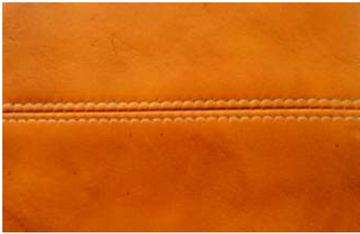
Figure 34: Open seam
In the leather garment and bags maximum open stitch has been used in the back part and the decorative part also. Stitch is similar to be closed seam except that the pieces are placed grain to grain and stitched. The edges should be skived uniformly. A tape or cotton cloth should be used in the back portion and stitch from the top (it can be a decorative /design stitch).
- Joining With Welted Stitch:
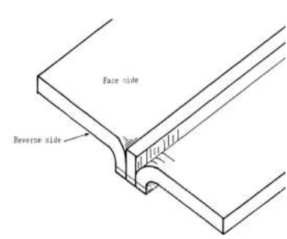
Figure 35: Welted stitch
Welted stitch is a variation of a closed seam, used on heavy material to overcome tension. A strip of seam material is placed in between the component and stitched flush with the edges.
- Joining With Blind Seam:
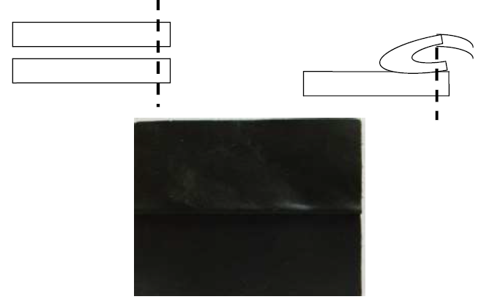
Figure 36: Blind seam
The seam is made invisible by tapping the top piece on the bottom piece. For this, an underlay must be done on the bottom piece.
Blind seams used when the stitching holding the two pieces is not to be seen. The edge of the bottom component is underlay skived on the grain side. The top component is stitched face to face on the stitch mark. Adhesive is then applied to the part of the bottom component. Then the top piece is pulled back and stuck.
- Joining With Lapped Seam:
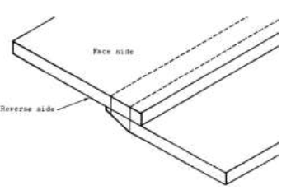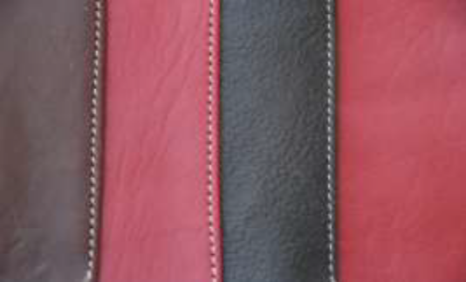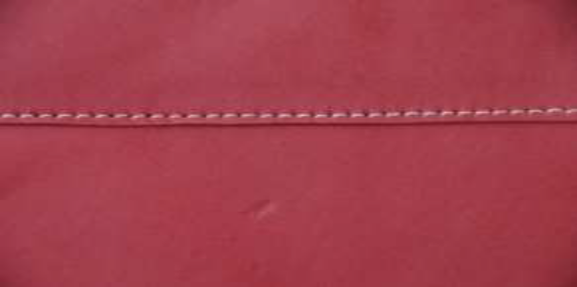
Figure 37: Lapped seam
The edges of two components are placed on top of one another, both are facing upwards. The underlay pieces have an allowance of 8- 10 mm, and are skived. The pieces are stitched together usually with a double row. The underlay part of the leather should be light skive otherwise it will be tear with strain.
- Joining With Piped Seam:
A piping is done on the first piece on the grain side .A second piece is then fixed against the piping. The finished seam is identical to a simple seam with the piping in the middle.
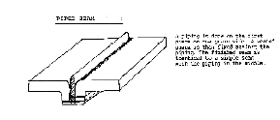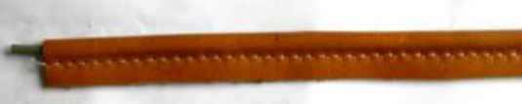
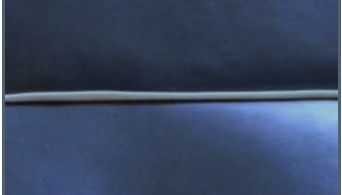
Figure 38: Piped seam
- Joining With Butted Seam:
When two pieces are joining with butted seam stitch together without any allowance, both components facing the same way. This is done on the Zigzag machine. Normally the stitch throw is 6mm. for leather, 8mm. for synthetics and 10mm. for fabrics. This seam is not strong enough but it should be reinforced in the back.
N.B The distance of the stitching from the edge should be 2.5mm – 3mm. Too narrow an edge distance may lead to upper material failures. Normally in the bag the distance maintained 3mm from the edge and 2.5mm in the wallet or small leather goods. Too wide an allowance adds to unnecessary bulk and problems in leather goods.
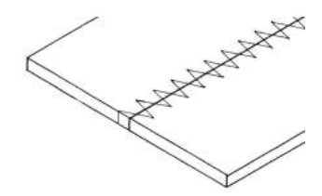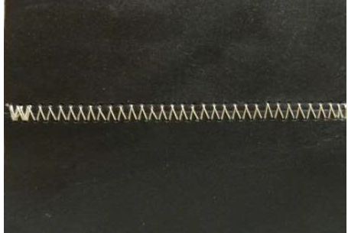
Figure 39: Lapped seam
Different seams need different types of needles
Table 1: Different types of needles
SEAM | NEEDLE POINTS
Close Seam | P
Blind Seam | P
French Binding | P / SD1
Decorative Stitching | LR /P /S
Top line | LR / P
U- Binding | R /SD1
Elastic | R
Lapped Seam | P /LR

Self-Check 2 | Written Test

Directions: Answer all the questions listed below.
- Write five basic safety rules for leather garment and goods making hand tools (5pts.)
- For what types of injures can hand tools cause? (5pts.)
- List out stitching tools and attachments (5pts.)
- What kind of tools used in leather garments and goods construction? (3pts.)
- Write the functions of silver marking pen: (3pts.)
- Write the functions of awl and trimmer: (3pts.)
- List creasers used to crease the edge of the components? (3pts.)
- What is the purpose of seam? (3pts)
- What is closed seam? (3pts)
- What is butted seam? (3pts)

 |  | A |  | B
 | 1 | pieces are placed grain to grain and stitched | A | Bone folder
 | 2 | mark the edge of work for ornamentation | B | lapped seam
 | 3 | used for folding leather | C | Trimmer
 | 4 | edges of two components are placed on top of one another, both are facing upwards | D | Open seam
 | 5 | Used to trim excess thread | E | creaser

Unit three: Edge construction techniques
This unit is developed to provide you the necessary information regarding the following content coverage and topics:
  - Performing construction operation.
  - Joining components Using appropriate adhesives’
  - Performing edge construction according to OHS practice
This unit will also assist you to attain the learning outcomes stated in the cover page. Specifically, upon completion of this learning guide, you will be able to:
  - Perform construction operation.
  - Join components Using appropriate adhesives’
  - Perform edge construction according to OHS practice

Performing basic construction
Leather garment and goods production is an organized activity consisting of sequential processes such as laying, marking, cutting, stitching, checking, finishing, pressing and packaging. This is a process of converting raw materials into finished products. It will be difficult to maintain the industry if production is not, up to the mark if the preproduction phase of preparation of material is not properly carried out.
    - Type of Edge construction:
Leather garment and goods are fabricated with different types of edges according to the designs.
They are:
- Raw edges,
- Folded edges,
- Bound edges
- Bound edges with binding,
- Bound edges without binding
- Straddled edges
- Mixed edges.
- Raw edges:
The leather components are stitched with its raw edges seen e.g. spectacle cases, gents belts, wallets, key cases, document cases, shoulder bags, etc.

Raw Edge Treatments:
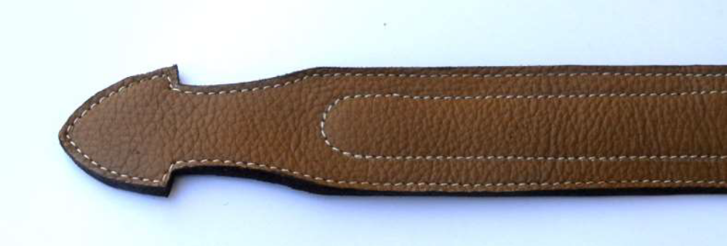
Figure 40: Raw edge treatments
The leather has to choose minimum substance and not looseness. According to the thickness of the leather should be split into measurements, suppose the handle or strap the thickness should be 2 or 2.2mm. So the upper part should be 1.4 or 1.2mm and the lower part be .8mm both has to be joined to make a strap. After that the Strap cutting machine is required to cut the leather according right measurements for the straps. In the lower part of the strap put the reinforcement – Eva (rubber), cotton cloth, canvas cloth with the glue and pasted the top part also. After joining the both side then the final trimming needed. For smoothening the edge of the strap use the Emery paper (00 numbers).With the help of brush or Edge coloring machine put the color with binder on the edge of strap. After drying the edge again smoothen the surface with emery paper and again color it. For finishing the edge should be needed waxing and polishing it. Before stitching every function should be finish.
For good finishing belt needed little bit skiving and proper reinforcement and good decorative stitching?
- Folded Edges:
The leather components are turned over or folded over another leather or lining and then stitched. This covers raw edges e.g., wallets, passport covers, handbags, portfolio bags, ladies’ handbags, etc.
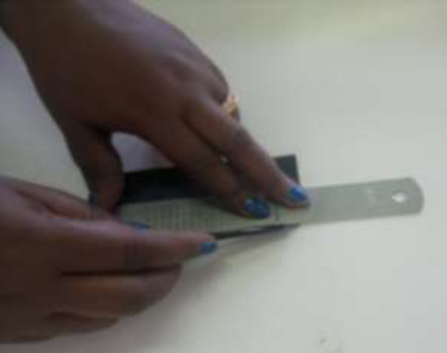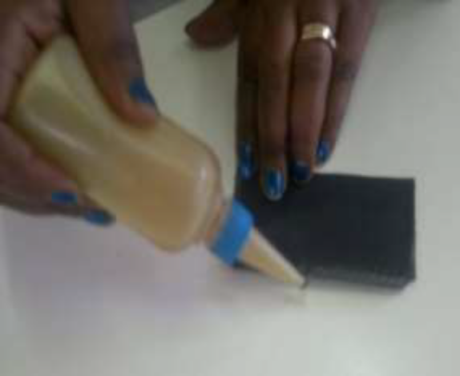
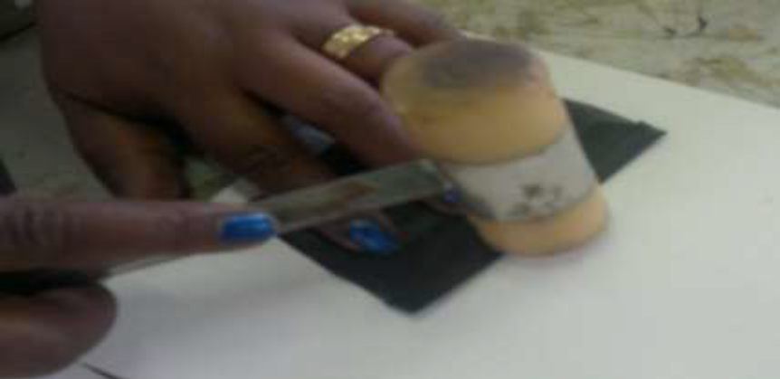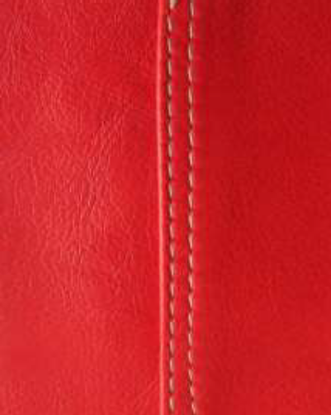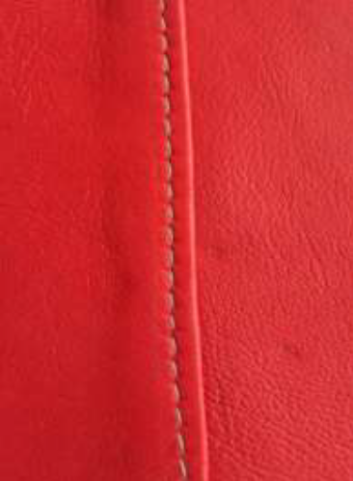
Figure 41: Folded edge
In this type of construction, the leather components are cut with allowances for folding.
The edges are skived to a suitable thickness for easy and perfect folding. Turnover or folding is done over the lining or reinforcement and then stitched. This encloses all raw cut-edges. This construction imparts greater durability and elegance to the products.
E.g. wallets, passport covers, gent’s belts, ladies handbags, portfolio bags, etc
Folded Edge Treatments:
The edge of the components or the straps has to be skive according the measurements of the folding. If the fold measurement is 1cm, then the skive portion should be 1.1cm. Put the reinforcement with glue and fold it. Folding could be done by hand or by Thermo Folding Machine.
There are two types of curves in folding,
a) Convex Curve,
b) Concave Curve.
- Convex curve:
In this type put the reinforcement and fold it. Here the folds will form as pleats. The excess material for folding cut and reduces it and nicely pressed the components by Mallet.

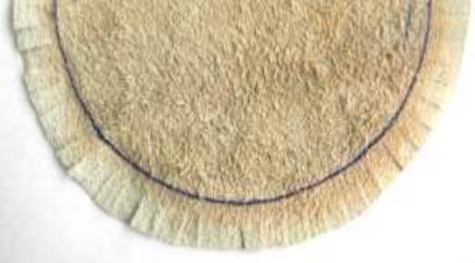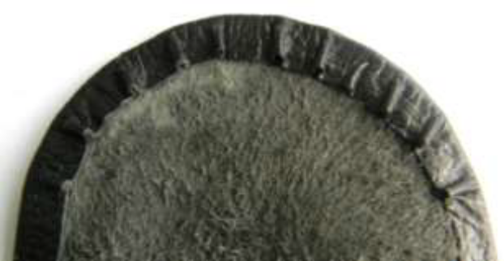
Figure 42: Convex curve
- Concave Curve:
In this concave curve the excess material for fold should be cuts/nicks. But the cut should not touch to the edge of the components. If so, the cut should be visible from the front/upper part.

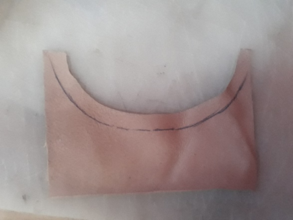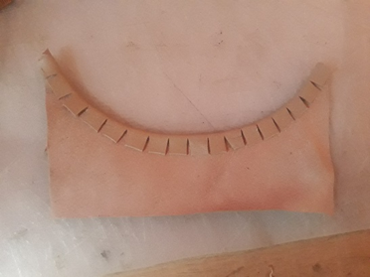
Figure 43: Concave curve
While folding care has to be taken:
- The folding allowance should not be excess otherwise the impression will find from the upper part.
- The cuts should be even and correct for good stitching.
- Not too much adhesive is used, otherwise the lumps could be formed which could cause problems in stitching.
- If beads of adhesive are visible at the needle holes after heat setting, it means the adhesive is not good and it hampers the machine and cut the threads.
- The reinforcement must be placed properly.
- Bound edges with piping:
Two leather components and piping are attached with its flesh sides out. After stitching, the components are turned to grain sides. Only piping is seen and stitching is not seen e.g., ladies’ handbags, shoulder bags and softy types of articles.
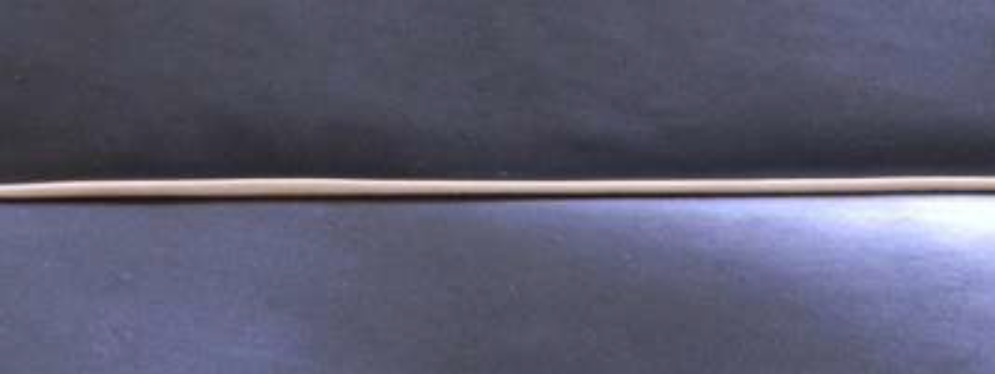
Figure 44: Bound edges with piping
In this, a piping of same or contrasting color is inserted in between the two components for design or decoration. Piping can be made by covering cord with strips of bias cut fabric. The cord comes in a range of thicknesses and is readily available from fabric and upholstery stores.
Cut and join enough bias strips for the required length and wide enough to cover the cord plus the seam allowance. Lay the cord in the center, on the wrong side of the bias strip. Fold the bias strip over the cord matching the raw edges. Stitch the open edges of the bias strip together along the length. Use a zipper foot or cording foot on the sewing machine to ensure that the stitches are close to the cord.
Binding: Binding is attaching a strip of leather on the mouth of the component.
There are two types of binding –
(A) English Binding
(B) French Binding.
- English binding:
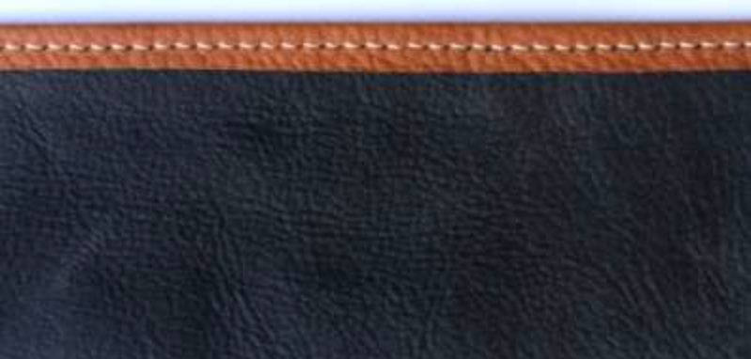
Figure 45: English binding
- This binding is stitched over the edge of the upper part or any component.
- This construction is done on a Cylinder Bed Machine with Binding apparatus.
- The selection of the tube depends upon the binding width, total thickness of the material (including twice of the binding thickness).
- Binding are usually reinforced.
- This binding is strong and stretch resistant.

- French Binding:
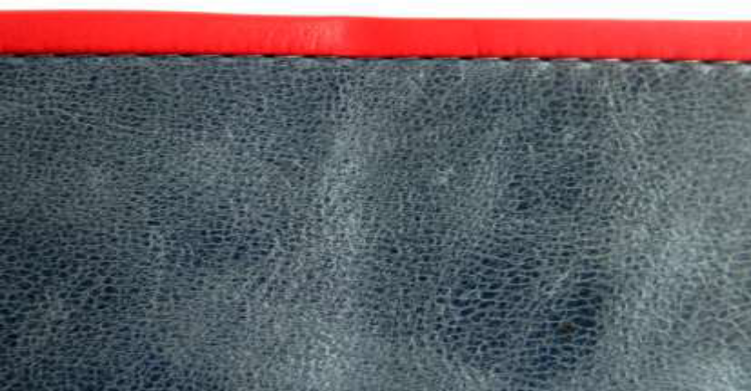
Figure 46: French binding
- This French Binding is stitched (approximately 15mm in width) face to face with the upper component. The reinforcement is given on the flesh side of the upper at the edge. Then the binding is folded over the edge, stuck and hammered down. Stitched down by a row of top stitching.
- Use of work guide could facilitate edge stitching operation.
- This binding is strong and does not stretch.
Sometimes the front/top stitch can be invisible or can be in the middle of the binding.
- Bound Edges Without Binding:
Two leather components are stitched with its flesh sides out and then turned to its grain sides so that the stitches are not seen e.g. coin pouches, softy ladies purses, etc.
- Straddled Edges:
Two leather components are covered with a piece of leather strap as piping and then stitched. This covers raw edges of the components e.g. shopping bags, school bags, folio cases, shoulder bags, etc.
- Mixed Edges:
One leather component is folded and attached with an unfolded component (raw edged component) and then stitched. This sees mixed edges e.g. gent’s belts, shoulder straps, etc.
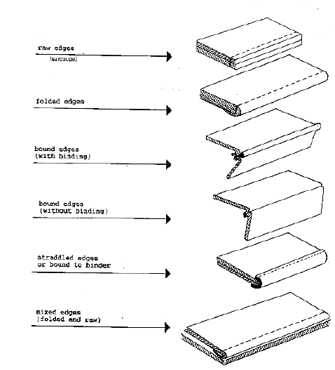
Figure 47: Mixed Edges
Bagged top line: This seam is to give a reverse stitch with no top stitching. The lining is stitched face to face with the outside section of the upper. The seam is stuck down towards the inside of the upper section and then lining is folded over the top line with the seam below the edge of the upper. Outer and lining must be securely bonded otherwise the edges will be loose and bulky. Glue must be evenly spread to avoid bumps. The lining should be tightly pulled down while turning over and securely bonded; otherwise it will lead to lining appearing loose and wrinkled.

Joining components using appropriate adhesives

Adhesion plays a vital role in assembling components viz. leather, lining and reinforcements during fabrication of the products. Further strength of the parts can be achieved by stitching. There are two types of adhesives, which are extensively used in the fabrication of leather goods.
They are (I) temporary adhesive and (ii) permanent adhesive.
(i) Temporary adhesive:
Rubber adhesive is a temporary adhesive as it gives temporary bonding effect and so stitching is necessary after joining the components. It is buff coloured natural rubber adhesive. It is easy spreading characteristics coupled with cleanliness, flexible bondage and economy of application make it particularly suitable for general works. It gives a firm grip while stitching and helps in making articles with stitches.
- Application:
Rubber adhesive is applied uniformly to the surface to be bonded. After achieving maximum tack development, the surfaces are joined. The joined surfaces are rolled down with a smooth roller to remove air bubbles. The components are then taken for stitching.
- Demerits of temporary adhesive:
Rubber adhesive is composed of crepe white natural rubber and petrol (Gasoline). The components assembled with rubber adhesive separate after sometime when left unstitched. This is because the solvent petrol in the rubber adhesive evaporates and only the rubber is left. Rubber starts melting slowly due to atmospheric conditions. It is therefore necessary to stitch articles glued with rubber adhesive. It is inflammable and produces toxic vapours.
(ii) Permanent Adhesive:
Synthetic rubber adhesive in solvent medium is a permanent adhesive as it gives permanent bonding effect. It is extensively used in leather articles which are made without stitches and also in attaching components where stitching is not possible. It is more advantageous than other adhesives because curing takes place immediately. It is buff coloured adhesive, freely flowing and very smooth to apply. It is good water, alkali and oil resistance coupled with high bonding strength make it an excellent adhesive for all types of high bonding works in leather goods manufacturing.
- Application:
Surfaces to be bonded must be clean, dry and even. The adhesive is applied thinly and rapidly to both the surfaces and the coverage of adhesive is ensured completely and effectively. The solvent of the adhesive is allowed to evaporate till tack formation is felt.
The glued surfaces are joined carefully and accurately avoiding air bubbles. The components are then pressed uniformly throughout for perfect and accurate joining.
Figure 48: Gluing
Demerits of permanent adhesive:
As the bonding strength of the synthetic adhesive is very high, it is very difficult to separate the components in case of wrong assembly. Excess application of adhesive not only causes damage to the products but also stain to the linings.
It is inflammable
produces toxic vapours and strong pungent smell.
It is moisture sensitive.

1.1.2 Gussets:
Gussets are determined by its holding capacity of leather goods. Gussets are inserted where spaciousness is required. Articles, with proportionate gussets assembled in right way and stitched properly, give well outlook and serve for a long time. Gussets are made in a variety of types and commonly used gussets in leather goods making are side gussets, continuous gussets and folded gussets. Gussets are also made with different types of gusset joints.
Side gussets are joined at the sides of the article e.g. ladies handbags, shopping bags, duffel bags, medical representative bags, etc.
Continuous gussets are joined at the sides, top and bottom of the article e.g. air bags, shoulder bags, wrist pouches, shaving kit bags, ladies hand bags, etc.
1.1.3 Handle making:
A wide range of handles is fabricated in leather goods making. Lighter handles are used in box work constructions like jewel boxes, cosmetic boxes etc. Heavier handles are used in heavy and luggage goods like briefcases, document cases, travel cases, instrument cases etc.
The straps and Handles are very much depended according Designs, Purposes and Feelings. There are various types of Straps and Handles. Different constructions are used for making a variety of handles such as round handles; flat handles and shaped handles to suit to the designs of the articles.
- Raw Edge Strap:
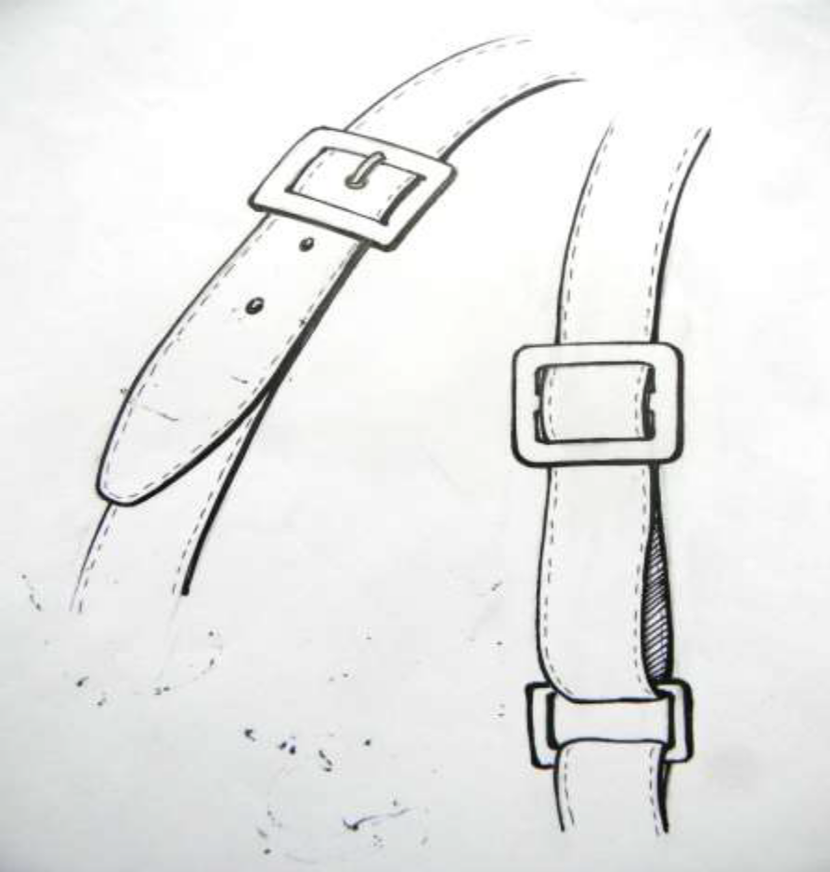
Figure 49: Raw edge strap
The leather should be chosen tight no looseness will be there. The straps thickness should be 2mm or 2.2mm. The top part of the strap will be 1.2mm and lower strap.8mm. It should be spitted if required. This strap can cut by Strap Cutting Machine. Between top and bottom part paste by cloth or self-fusing or tape. Paste the both leather by gluing. Then cut the leather by use of strap cutting machine. The size or width of the strap will depend upon the measurement of the accessories and according this the spacer and blade will be adjusted. Suppose D-ring (accessories) size is 3cm. then the actual strap width will be 2.8 cm and 2 mm for clearance. The strap cutting machine will be adjusting 2.6cm. Because the spacer is 2.6cm and blade will be 1mm thickness (1mm+ 2.6cm+ 1mm =2.8cm). After cutting straps smooth the edge by Buffing Machine and color by Edge Coloring Machine. Waxing and Polishing will be done by Buffing Machine.
- Folded Edge Strap:
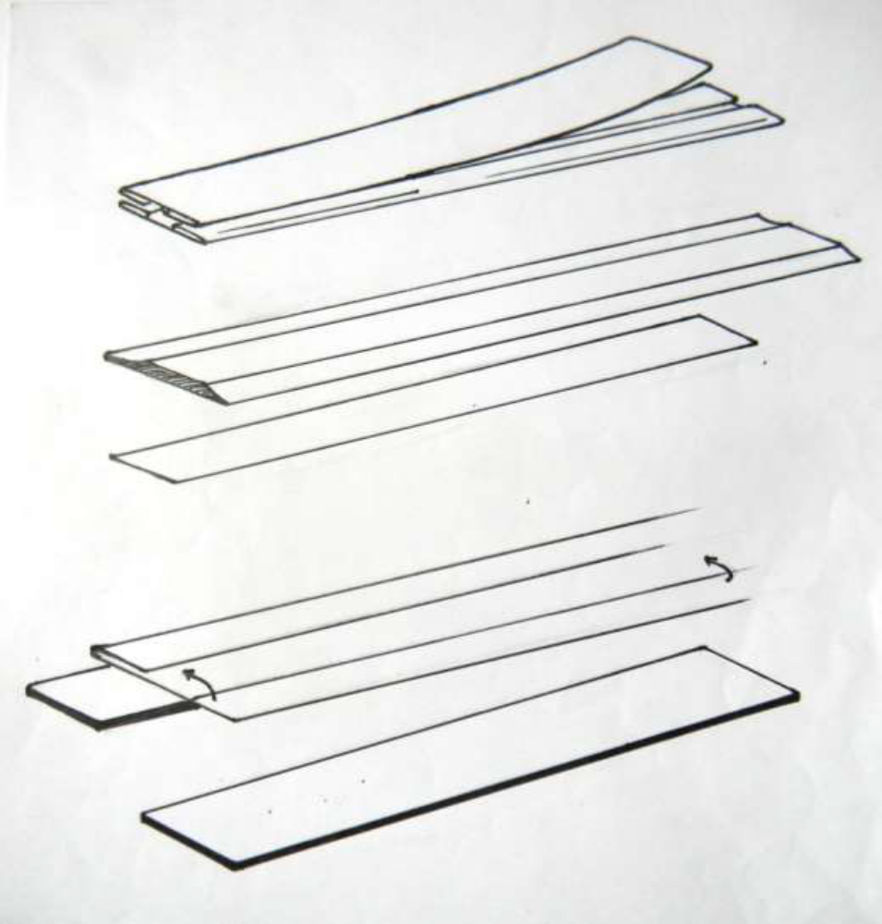
Figure 50: Folded edge strap
The leather should be chosen tight no looseness will be there. The straps thickness should be 2mm or 2.2mm. the top part of the strap will be 1.2mm and lower strap.8mm.
It should be splitted if required. Suppose accessories size is 2.5 cm.The width of the leather to cut 4.3 cm (1cm + 2.3cm + 1cm) 1cm for folding allowance. The leather parts should be bevel skived (1.1cm). Actual size after folding will be 2.3cm. Both the top and lower part has to be reinforced and pasted.
- Rope / Pipe Handle:
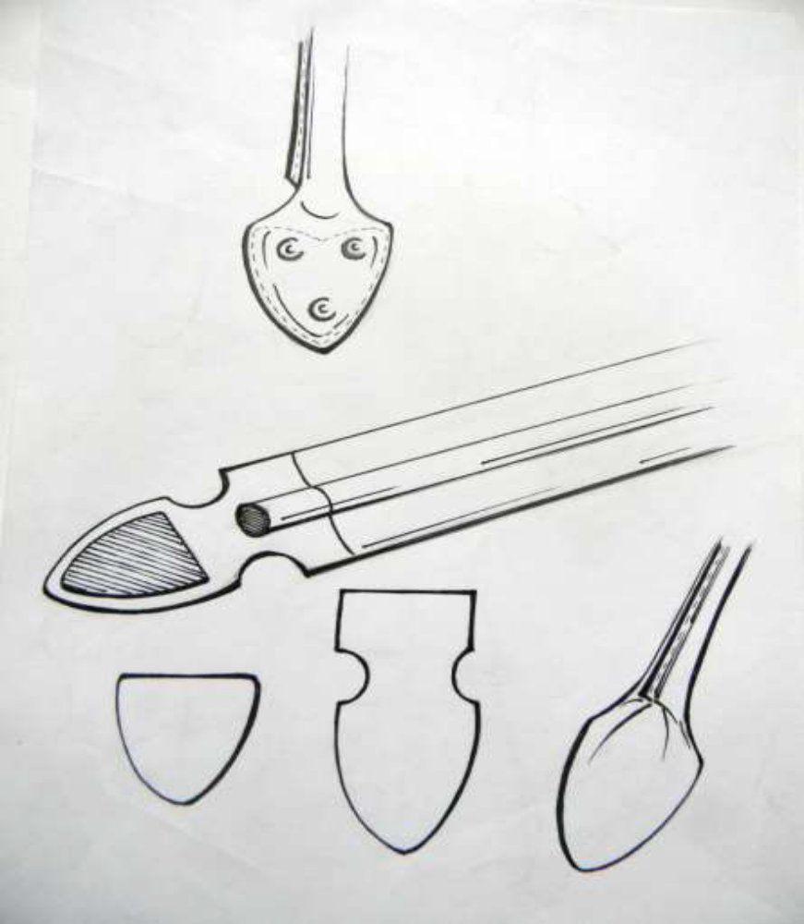
Figure 51: Rope / Pipe Handle
These types of handles are seen in the Classic Bags – Bugatti Bag, Boston Trunk, and others. The leather has to cut as per size – such as length is 65cm to 70cm. and the width is 4.5cm. Leather has to cut according to the pattern. Rope or Plastic Pipe has to place in the middle of the leather part by glue. Put Eva or Rubber in the tip of handle as bump effect. Cover the back part by small piece of leather (spitted). Fold the handle as round and the edge will be match. Stitch and Color the edge.
Portfolio Handles:
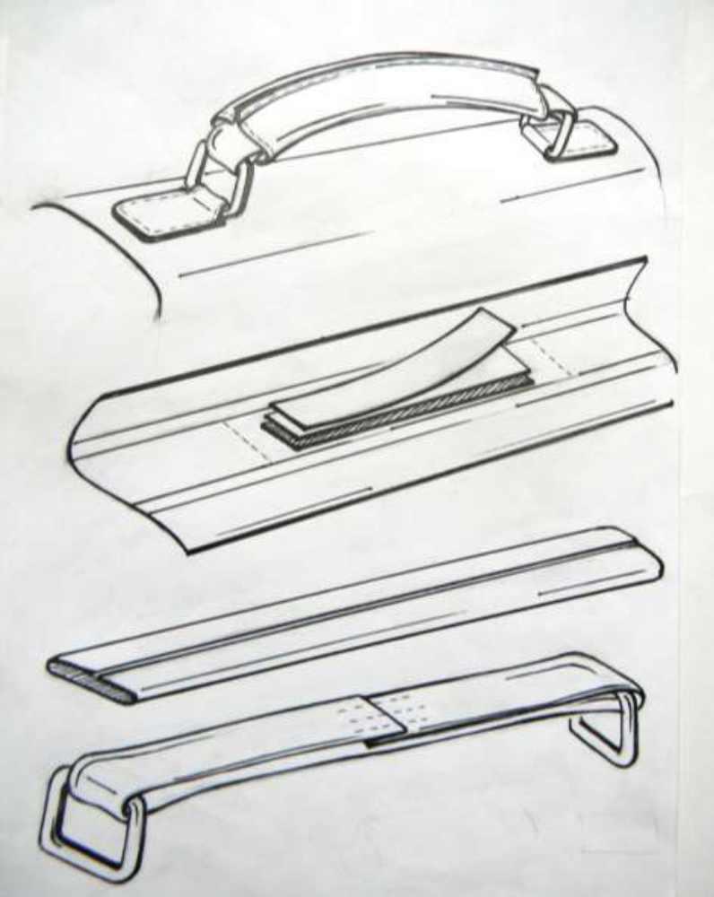
Figure 52: Portfolio handles
This handles are mainly used in portfolio or briefcase. Most of the classical portfolio uses such type of handles. The Italian vegetable Tan leather is appropriate for this type of handles in bags. The size of this handle is 16cm average and the width will be 3cm or 3.5cm. For preparing this handle, cut the leather according to the pattern, length will be 8cm+16cm+9cm= 33cm and width minimum 3cm (according D-Ring Size). i.e. width will be 2cm+0.5mm+2.8cm+0.5mm+2cm=7.8cm total is (L 33cmx 7.8cm).In the middle of this 33cm leather, reinforcement will be pasted – Rubber, Texan Board and Rubber (13cm x2.4cm) according to feel. Both side of 13cm, clearance should be 1.5cm each for D-Ring and fold it. Stitch the thick part. Make a cover of this handle of 13cm length and as per the diameter of thickness. Stitch the edge and color it. Pour the D-Ring handle into the cover.
Pleated /Fancy Handle:
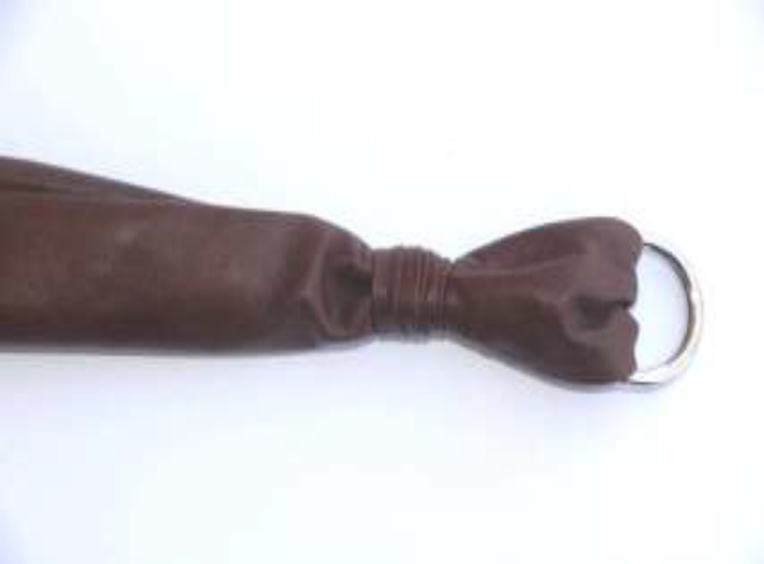
Figure 53: Portfolio handles
Choose the soft leather for pleats. Cut the leather according to the length the size of the bag and the width will be 6cm+1cm =7cm, (0.5mm stitch allowance on both side).This two leather pieces will be stitch in reverse (flesh side) and turned into the grain side (tube). Put the accessory and fold the tube. Join the mouth by stitching.
Make a leather lace and cover the joint by it.
In the process of assembling, the prepared components are assembled part by part.
The assembled components are then joined to give a shape to the article. In assembling process, different techniques of constructions are used depending upon the types of articles to be stitched according to the construction. After assembling, the assembling of the components are checked for quality and then sent for stitching operations.
1.1.4 ZIPS:
Zip fasteners are extensively used in leather goods making because they enable quick opening and closing of the products. They are generally used in softy types of leather goods. Different types of zips in different colors are fixed according to the needs of the products and also to match the color of the products. Zips may be metallic or nylon and are manufactured in attractive colors to match the color of the products. Zips are manufactured as rolls and sold in meters. No.3, No.5, and No. 8 zips are used in making leather goods. No. 3 zips, which have small teeth, are used in small leather goods, No 5 zips, which have medium teeth, are used in medium leather goods and No 8 zips, which have big teeth, are used in heavy leather goods. Zip is a closing device and is used in a variety of leather goods. It is extensively used in leather goods because it is ready made, it can cover a long opening in a minimum time and it is a quick device of closing. Zips are used in pouches, wallets, ladies handbags, zip folio cases, travel bags, travel suitcases, etc. It is also used as a closing device in pockets.
YKK is the renowned brand in Zip Company.
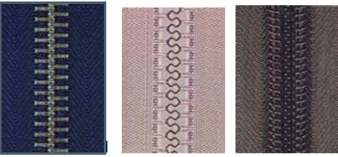
Figure 55: Metal Molded Nylon
In many bags and similar garments, the opening is closed entirely when the slider is at one of the ends of the tape. The mechanism allows for partial fastening where only some of the tape is fastened together, but various movements and pressures may move the slider around the tape. In many kinds of luggage, there are two sliders on the tape, mounted in opposite directions; the part of the zipper between them is unfastened. When the sliders are located at opposite ends of the tape, the zipper is fully unfastened; when the two sliders are located next to each other, which can be at any point along the tape, the zipper is fully closed. There are different types of the zippers such as Aluminum, Brass, Zinc Oxidized, Plastic Molded etc.
In the process of sewing, sewing is the most important operation, which decides the quality of the end products. The highly skilled stitchery s who are well versed in operating various types of sewing machines do sewing. Sewing the finished products are carried out in flat bed sewing machine or cylinder bed sewing machine as the case may be. Stitching thread should have good tensile strength, abrasive resistance to moisture, heat and ability to withstand oils, solvents and adhesives. A correct thread for specific use is essential to achieve efficient production. Commonly used threads are cotton, nylon, nylon cotton, and polyester cotton. Before stitching of the products, the stitches are tested on a piece of leather. If necessary, suitable adjustments are made for perfect stitching. In stitching leather products, two types of stitches are commonly used. They are lock stitches and chain stitches. In lock stitches, the thread from the needle and bobbin lock together and fix firmly in the material. In chain stitching, the stitch is formed by single thread. It is not as strong as lock stitches. When the thread breaks, the seams become weak. The products are stitched carefully. After stitching of the products, they are checked for quality of stitching and then sent for finishing.

Performing OHS practice for edge constructions
Define Work place safety
Workplace safety is about preventing injury and illness to employees and volunteers in the workplace. Therefore, it's about protecting the nonprofit's most valuable asset: its workers. By protecting the employees' and volunteers' well-being, the nonprofit reduces the amount of money paid out in health insurance benefits, workers' compensation benefits and the cost of wages for temporary help. Also factor in saving the cost of lost work hours (days away from work or restricted hours or job transfer), time spent in orienting temporary help, and the programs and services that may suffer due to fewer service providers, stress on those providers who are picking up the absent workers' share or, worse case, having to suspend or shut down a program due to lack or providers. Every manufacturing organization will establish safe work practices at all its workplaces to minimize the risk of injury, illness and property damage. Specific safe work procedures will be developed for particularly hazardous and critical tasks.
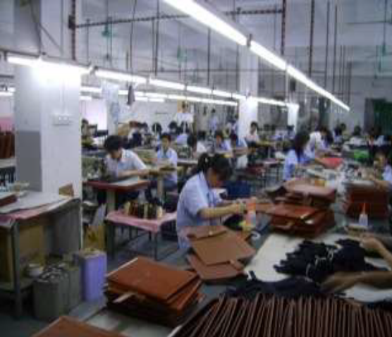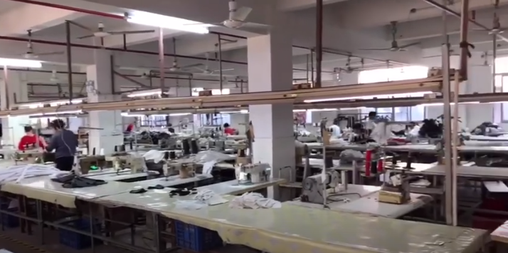
Figure 56: Production Hall
Work place hazard analysis and control:
A workplace hazard is something that can hurt you, or has the potential to hurt you. There are hazards in every type of job and every type of workplace. Everyone at the workplace: workers, managers and the employer, share in the responsibility to identify and control hazards
Controlling hazards requires employers to do a job or task hazard analysis. Many workplaces involve the employees who are in contact with the hazards of a particular task or job, in the analysis. Hazard analysis can look at a thing, a work process, or even a whole job description. Task or job hazard analysis ends with a safe work procedure designed to meet health and safety needs, and to control or eliminate the potential for injury.
Hazard control
Hazard can be controlled in three ways. Each describes how and where the controls are placed on the ‘path’ between the worker, and the hazard.
1. Control at the Source: The best way to control a hazard is to eliminate it. If this is not possible, the next step is the substitution of a non-hazardous or less hazardous material or process. If there is no acceptable substitution, then the hazard is enclosed or isolated from workers. Example, when lubricating oil used for leather garment and goods machine produce hazard replacing the existing lubricating oil with new brand lubricating oil not produce hazard. This would be controlling the hazard ‘at the source.
2. Control Along the Path: Some hazards, and the work processes that they are part of, cannot be enclosed or isolated. Placing a control ‘along the path’ means different protective measures are put in place between the hazard and workers.
3. Control at the Worker: If controls ‘at the source’ and ‘along the path’ may not be enough to prevent injury, then placing controls ‘at the worker’ will be necessary. Control at the worker often consists of personal protective clothing and equipment that must be worn while performing certain tasks. Common types of this control are wearing gloves to protect the hands, hearing protection, or masks or respirators to protect airways. At the worker’ is often the first type of hazard control that businesses put into place.

Measure performance
In safety and health, continuous improvement involves seeking better ways to work, measuring performance and reporting against set targets. It is also about systematically evaluating compliance with procedures, standards and regulations; understanding the causes of incidents and injuries; and openly acknowledging and promptly correcting any deficiencies. Performance measurement can be:
- reduction in lost-time injury frequency
- reduction in medical treatment injury frequency (beyond first aid care)
- reduction in sick days used
- lower workers' compensation costs
- lower medical benefits payments (doctor's visits, prescription
Manual Handling Techniques
Material master data is used to represent and identify each item, product or service that a company is producing, selling or processing over that material.
While creating Material Master Data material type is a mandatory field that should be defined for each master data record in SAP systems.
Material Type is a major data which identifies what data is relevant to the related material and identifies basic behaviors of the material.
Standard Operating Procedures
Standard Operating Procedures (SOPs) help maximum safety and operational efficiency for leather garment and goods manufacturing unit: SOPs are detailed written instructions to achieve uniformity of the performance of a specific function. A well-written SOP can be used to satisfy compliance requirements. SOPs are recommended for all procedures that pose a potential risk to the health and safety of personnel.
Personal Protective Equipment
Every worker obliged to secure its qualified attendance through the respective training from the point of view of the safety or work attendance. The operative must be properly trained and acquainted with the danger existing on tools and equipment.
- Safety glass must be worn when using the grind stone.
- Always use a safe method to break a cutter blade;
- Avoid wearing loose cloth.
- For female workers tide their hairs.
- Never carry around the knife with blade exposed, it could cause injury may be you and others.
Safe Material Handling
Organization safety is extremely important both to staffs/ workers and managers and owners. Generally leather product processing is not as dangerous as many other manufacturing plants. Occasionally accidents can happen .It is easier and cheaper to prevent accidents before rather than later. In leather products some of the high inflammable materials are used, such as Rubber Solution, Dendrite, Rubber Sheet, Eva Sheet, Spirit, Synthetic material and others. But It is needed proper storage and maintenance. For Safety precautions we have to keep in our mind such as –
Electricity:
- Cables used should be good quality and high resistance,
- Loose connection should always checked,
- Fuses are too strong to protect current flow.
- FIRE :
- Handling of inflammable materials such as adhesive, chemicals, spirits, rubber sheet etc. are dangerous,
- Due to loose connection can cause an accident,
- Sourcing of metal causes small sparks which can glow for hours before igniting, usually occurs when nobody is around.
- OTHERS :
- Poor knowledge of machines and equipments
- Poor conditions of tools and equipments,
- Bad condition of storage can cause of accidents,
- Poor knowledge of infrastructure planning etc.

Ergonomic Arrangement of Workplaces
The word ergonomics is derived from two words: ergo meaning work & nomo’s meaning the law. Ergonomics is the scientific study of the relationship between the man, the machine (with which he works) & the environment (in which he works).
Ergonomics is also termed as human engineering & bio-techniques.
The modern approach of ergonomics is “fit man & machine together”.
Therefore it is very useful tool to make man & machine compatible for maximum efficiency.
There are main constituent areas of study of ergonomics, which guide us towards best ergonomically practices:-
1) Stand or sit with the work in front of you – avoid twisted postures.
2) Employ smooth, rhythmical movement – avoid sudden changes of direction
3) Keep things on the level to avoid vertical movements
4) Avoid sudden changes of direction
5) Avoid continuous repetition of movement
6) Avoid stretching where possible – keep items used frequently within arm’s reach
7) Chairs should provide support for the lower part of the back, and the worker should sit so that his/her back at the lower most curved part, is in contact with this support whether standing or sitting the individual worker should be able to adjust his/her position to enable the requirements.
Safe Storage of Equipment
This leather goods unit deals with the skills and knowledge required to use hand tools for the manufacturing leather goods. It also applies to the use of hand and power tools in the maintenance. This unit is based and equivalent to the leather goods unit Use hand tools, which has been contextualized to meet the requirements of the leather exports.
This article has covered the importance of using hand tools safely and treating them with respect. Always remember, safety is essential to good job performance. Pay attention to what’s going on around you, be flexible, and adapt to changing conditions.
Think before you react, and keep your head in the game. Think about tool safety each and every time you begin a job, and you’ll perform your job safely and effectively. Those are your hands that are being extended by the knife or the hammer. Treat your tools as carefully as you treat your hands.
General safety rules:
All accidents, incidents, and injuries as well as unsafe acts and conditions observed by an employee are to be reported promptly to their immediate supervisor, and not later than the end of the working day. Employees are also required to report any concerns about poor workstation / task design and any early signs or symptoms of soft tissue injuries they may experience.
- First aid treatment is to be obtained promptly for any injury, and must be recorded in the First Aid Logbook.
- Employees shall comply with the Occupational Health and Safety Act and regulations.
- All work must be carried out according to appropriate safe work practices and safe work procedures where applicable.
- Employees must wear proper Personal Protective Equipment (PPE) in accordance with safe work practices, and shall maintain and clean personal protective equipment which is issued to them.
- Tools are to be used only for the purpose for which they were intended.
- Only tools which are in good repair shall be used.
- Tools which are designed for use with guards and safety devices shall not be used if those guards or safety devices have been removed or tampered with.
- All tools or equipment which have been damaged or become worn are to be promptly tagged and taken out of service for repair or replacement.
- Good housekeeping practices must be maintained daily in all work areas. This includes personal work areas/offices.
- Employees are prohibited from arriving at work or remaining at work when their ability to perform the job safely is impaired for any reason.
- Employees shall actively participate in the department's safety program, including attendance at training sessions.
- Horseplay, fighting, harassment of any kind, and otherwise interfering with another worker is strictly prohibited.
- Where there is a danger of entanglement, employees may not wear rings, watches, or other jewelry or loose fitting clothing, and shall confine long hair.
Reporting Accidents and Incidents
Members often fail to complete Accident Book entries, or report incidents, including near misses, to either their managers or to local union health and safety representatives.
By doing this, they are storing up problems for other workers, making the job of keeping staff safe harder for union reps and managers and may even be breaking the law.
- Employers and risk assessments
Employers have a legal duty to safeguard the safety and health at work of all their employees.
Part of this requires them to assess the hazards and risks that their workers are exposed to and to ensure that they have placed adequate precautions in place.
These risk assessments have to be revised at any time when evidence suggests that they are no longer valid.
Reports of incidents, where there was a potential injury, even if no actual or serious injury occurred, could highlight deficiencies in the risk assessments that the employer has to remedy.
- Safety representatives
Safety reps do a valuable job in reducing accidents and injuries at work – independent surveys have found that the accident rate in workplaces where there are safety reps who are consulted properly by management can be as much as 50% less than workplaces with no safety reps.
But, to be effective, they need to know what is going on. They have a legal right to inspect the workplace, on a quarterly basis, but they also need to be told when incidents happen.
If members put details into Accident Books, the rep can see what has been going on in the workplace over the preceding three months when they start their inspections.
Legal duty on employees
If you know that something is a risk to safety, you must tell your employer (via your line manager) or bring it to the attention of your local PCS safety rep, who can follow the matter up with management.

Self-Check 3 | Written Test

Directions: Answer all the questions listed below. Use the Answer sheet provided in the next page:
    - Short answer
  - List out type of edge construction and folding in curves? (3pts.)
  - Define raw edges and folded edges? (3pts.)
  - What is binding? (3pts.)
  - List out type of handles and straps? (3pts.)
  - What is meant by work place safety? (3pts.)
  - What is SOP? (3pts.)
  - List the 3 ways of controlling hazard? (3pts.)
  - Define ergonomics? (3pts.)
    - Matching

 | A |  | B
1 | Fancy handle type | A | Binding type
2 | French and English | B | pleated handle
3 | components and piping are attached with its flesh sides out | C | Molded zipper
4 | Zipper type | D | Raw edge construction
5 | components are stitched with its cut edges seen | E | Bound edges with piping

Unit four: construct components of leather goods and garments
This unit is developed to provide you the necessary information regarding the following content coverage and topics:
  - Performing table of work activities
  - Using appropriate adhesive
  - Performing pocket construction operation.
  - constructing garment and goods component
This unit will also assist you to attain the learning outcomes stated in the cover page. Specifically, upon completion of this learning guide, you will be able to:
  - Perform table of work activities
  - Use appropriate adhesive
  - Perform pocket construction operation.
  - construct garment and goods component

Performing table of work activities

Table work Processes:
Bench work processes are carried out by team of skilled technicians headed by highly skilled supervisors. In bench work processes, the components are prepared with linings, zips, folding, gussets, piping, handle, etc. for subsequent process of assembling.
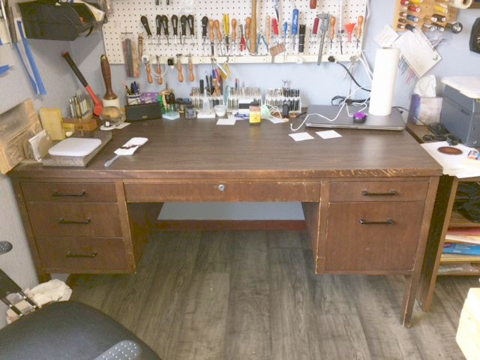
Figure 57: Table of work
Some components may need immediate stitching and some may not. The prepared components, which need immediate stitching, are sent for stitching.

Bench operations comprise of:
- Gusset making
- Edge folding and
- Handle making.
- Staining
- Creasing
- Punching
- riveting,
- Eyeleting
- Buttoning
- zip fastening
- lining

(a) Staining:
Staining is done on articles made by cut edge construction. The edges of the components are smoothened with emery paper first and then stained with water-soluble pigments using a wire brush with an absorbing cotton ball. The staining is done carefully without damaging the surface of the leather components. After drying the edges are wax polished and rubbed with a piece of smooth cloth vigorously for glossiness. In case of bulk production, edge staining machine is used to stain the edges.
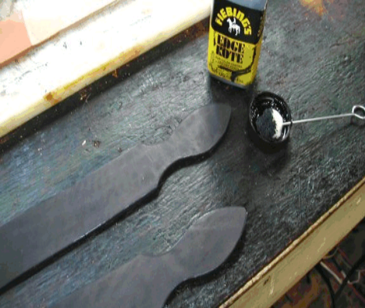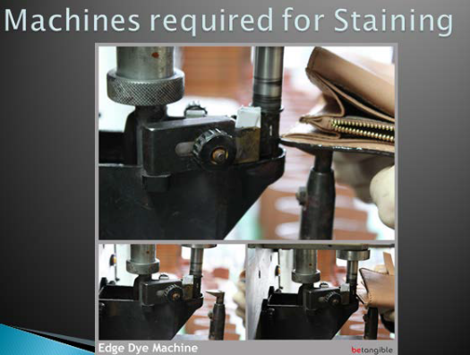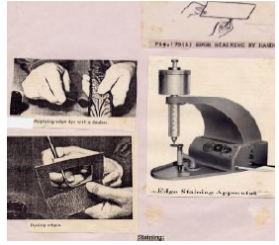
Figure 58: Staining
(b) Creasing:
Creasing is done on the leather components with a suitable temperature. Creasing is done on cut edges as well as folded edges. Creasing helps in compressing the cut fibers at the edges and thus strengthens the edges. Creasing gives a permanent, slightly darker and glossy line. It improves the elegancy of the products. It also gives a decorative and aesthetic appearance. Using a variety of creasers viz. single head creaser, double head creaser and adjustable creaser, creasing is done. Care is taken to see that the working edge of the creaser is kept smooth to avoid scratching during creasing operation. The tip of the creaser is slightly rounded off for smooth sliding while creasing.
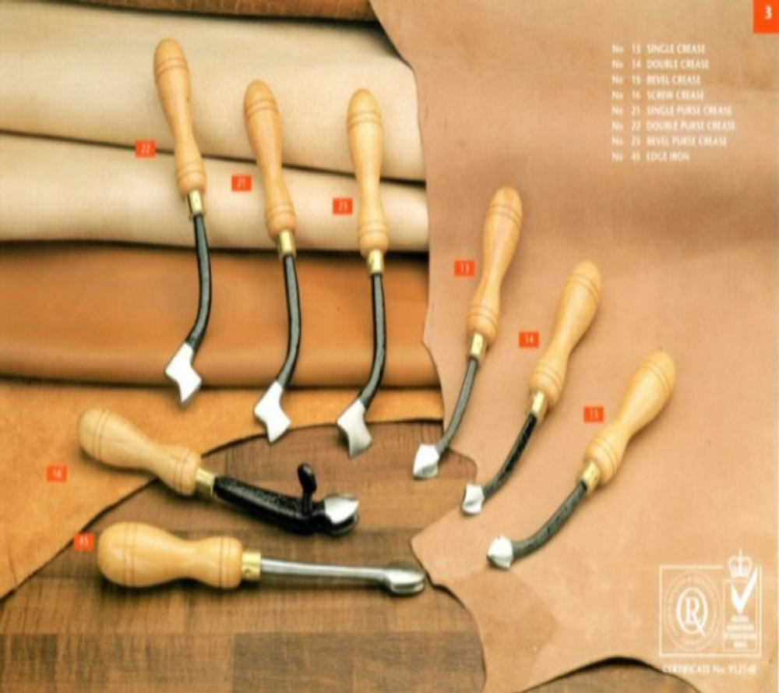
Figure 59: Creasing
The following points must be remembered while creasing:
- The creasing line must be close to the edge.
- The line marked should be distinct and glossy appearance.
- Suitable temperature must be needed for perfect creasing.
- The straight lines must be creased first and then the corners.
- In case of bulk production, creasing machine is used for creasing.
(c) Punching:
Punching is the process of making holes in leather components using a set of hole punching tools for varied sizes of holes needed for fixing fittings. Holes are made to fix buckles, buttons, eyelets, rivets, rivet buttons, studs etc. Punching holes are done in the articles like belts, watch straps, shoulder straps etc. to insert the buckle prong. In case of bulk production, punching is done by hand or treadle operated punching machine.
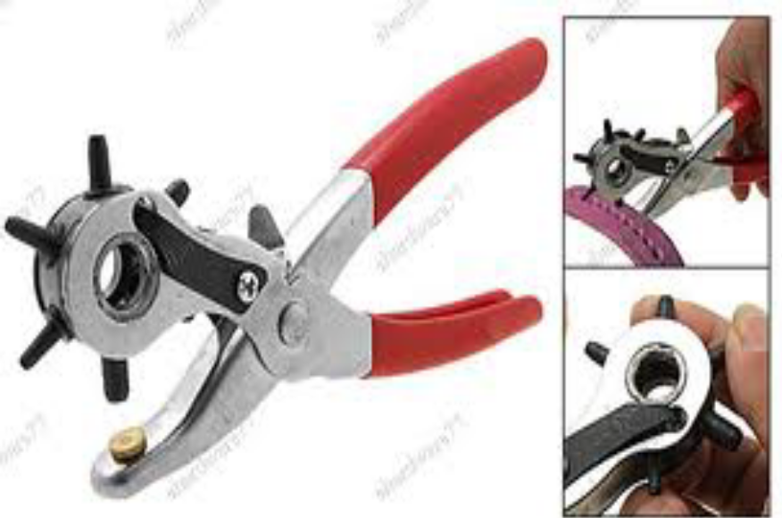
Figure 60: Punching
(d) Riveting:
Riveting is done with rivets and rivet buttons using riveting tool for fixing handles, hinges, locks, etc. and also for joining assembled components. Riveting is also done in the riveting machine in case of bulk production. Automatic and Pneumatic riveting machines are used in big industries.
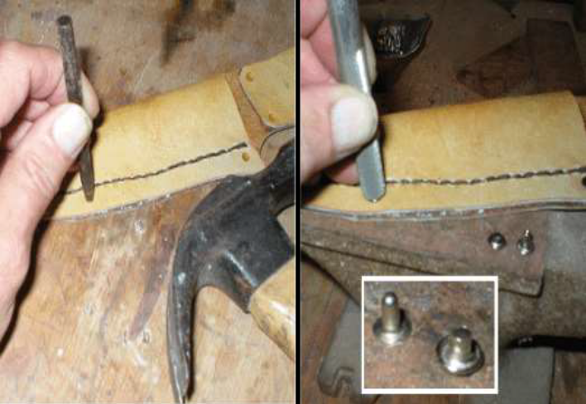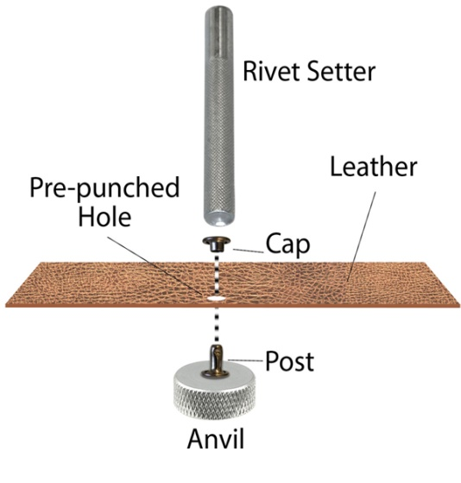
Figure 61: Riveting
(e) Eyeleting:
Eyeleting in articles is done by eyeleting tool. Colored small eyelets are used to fasten key hooks fittings in key cases while fancy eyelets are used in stretch bags. In case of bulk production, an automatic eyeleting machine is used for eyeleting.
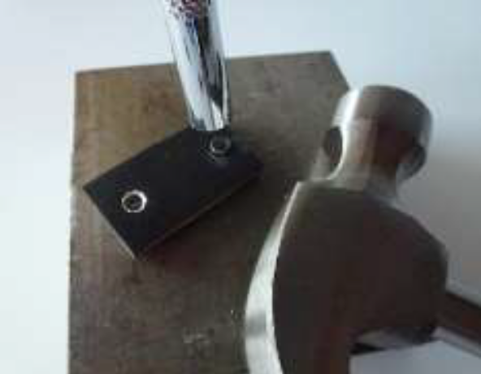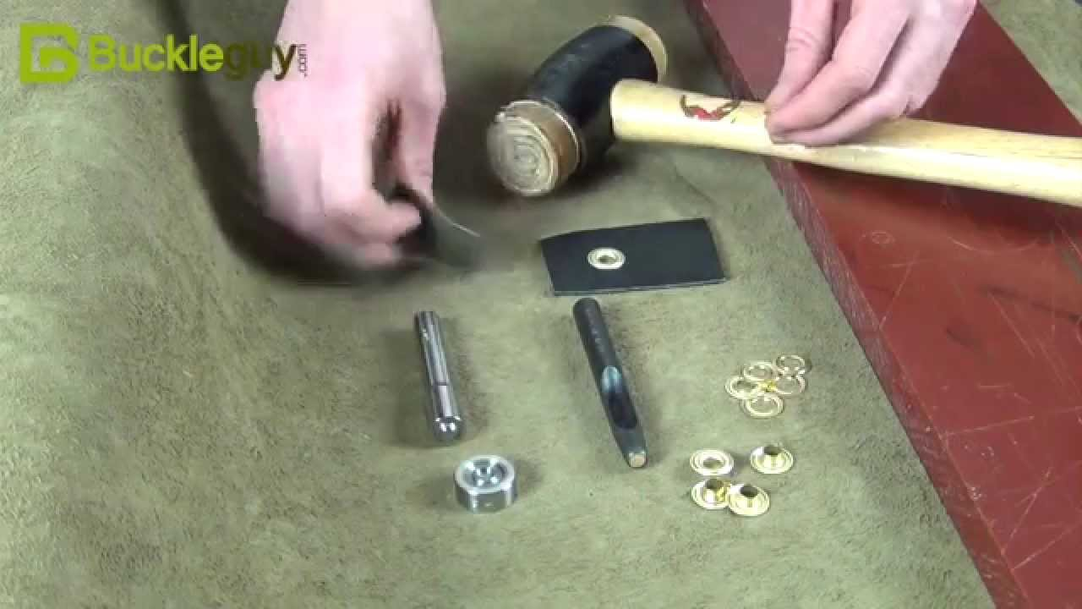
Figure 62: Eyeleting
(f) Buttoning:
Purse buttons of different sizes (3/2, 3/3, 4/3 and 7/7) are extensively used in leather goods. The button-fitting tool is used for buttoning. When fixing the buttons, care is taken to hammer the buttons gently as heavy hammering may damage the buttons. Since hand operation is a slow process, treadle operated or hand operated buttoning machine is used which ensures speedy operation and perfect setting of buttons. Automatic buttoning machine is used in big industries.
Button marking
Button position is the most important things for accurate position of the components and for better appearance. If the button position is not on the right position the part may be somewhat inclined and not good appearance.
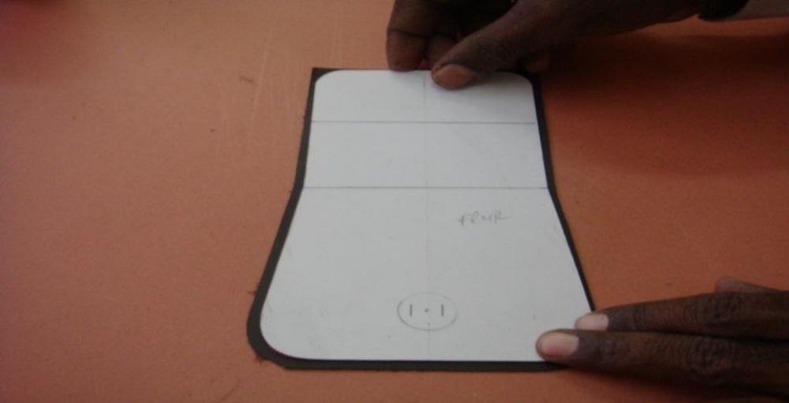
Figure 63: Magnetic button mark
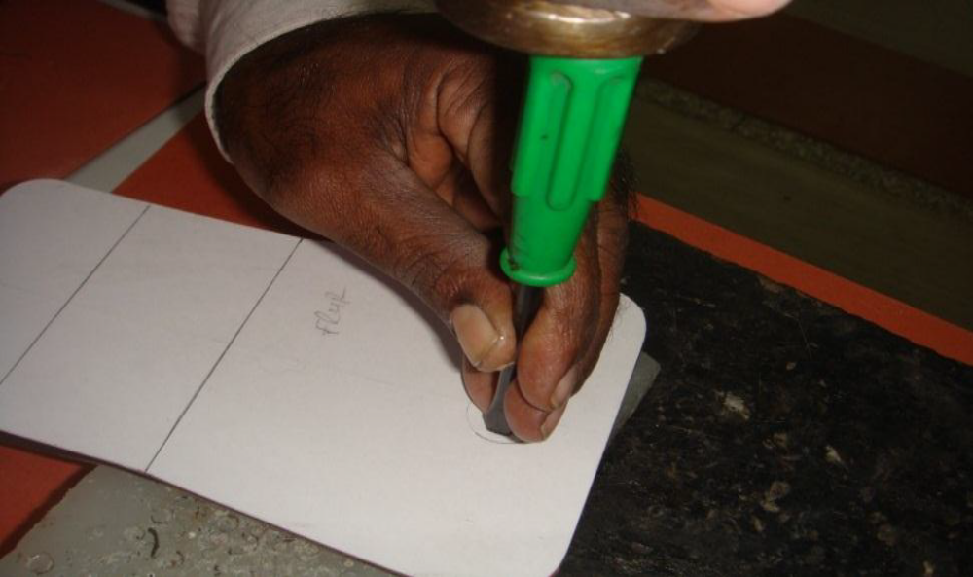
Figure 64: Punch the mark position
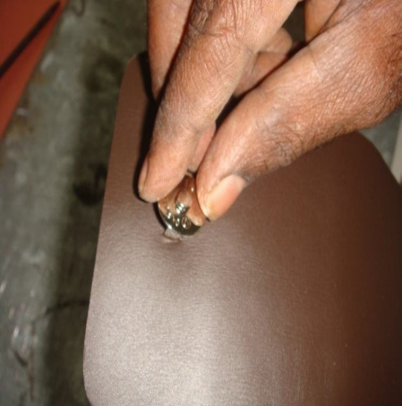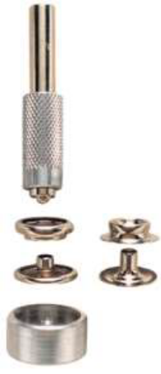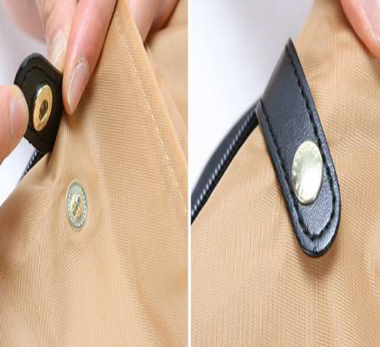
Figure 65: Fix the button on leather
(g) Zip fastening:
Zip fasteners are extensively used in leather goods making because they enable quick opening and closing of the products. They are generally used in softy types of leather goods. Different types of zips in different colours are fixed according to the needs of the products and also to match the colour of the products. There are 3 types of zip fastening, which are commonly used in leather goods making.
They are – (i) slot seam fastening (ii) lapped seam fastening and (iii) invisible seam fastening.
(i) Slot seam fastening:
The slot of the zip pocket is cut in the component using pattern. The zip tape with the runner is cut according to the size of the slot and then attached in the slot using double face adhesive tape. The runner is moved and checked for smooth and perfect closing. The stitch is then made. The slot seam fastening is used as a closing device for pockets in leather goods. Slot seam fastening can also be done by folding the edges of the slot.
(ii) Lapped seam fastening:
The top gusset pieces are cut with the patterns. The zip tape with the runner is cut according to the size of the top gusset. The zip tape is opened by the runner and separated. Each part of the zip tape is attached to the gusset pieces with the double adhesive tape. The runner is inserted to join the top gusset pieces and checked for smooth closing. The stitching is then made. Lapped seam fastening is used as a closing device in most of the leather goods, in particular softy types of leather goods.
iii) Invisible seam fastening:
In this type of fastening, when the zipper is closed, all that shows on the article are a plain seam and zip tab only. The slot of the zip packet is cut using pattern. The zip tape with the runner is cut according to the size of the slot. Two folded pieces are attached in the slot using adhesive in such a way that its edges exactly meet at the center of the zip teeth.
The zip tape is then attached in the slot using double face adhesive tape. The runner is moved and checked for easy and smooth closing. The stitching is then made. The other way of invisible zip fastening is – the slot of the zip pocket is cut using pattern, which has center and v cuts. The zip is then attached using double face adhesive tape and the runner is moved and checked for smooth running and closing. The stitching is then made. By this technique, the teeth of the zip are fully covered leaving the runner out. Invisible zip fastening is used as pocket closing device. This type of fastening enhances the elegance of the products.
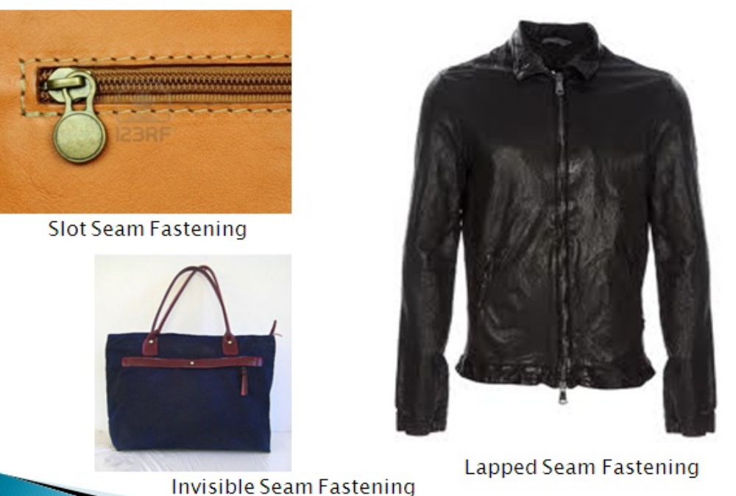
Figure 66: Zip fastening
(k) Gussets making:
Gussets are determined by its holding capacity of leather goods. Gussets are inserted where spaciousness is required. Articles, with proportionate gussets assembled in right way and stitched properly, give well outlook and serve for a long time. Gussets are made in a variety of types and commonly used gussets in leather goods making are side gussets, continuous gussets and folded gussets. Gussets are also made with different types of gusset joints.
- Side Gussets:
Side gussets are joined at the sides of the article e.g., ladies’ handbags, shopping bags, duffel bags, medical representative bags, etc.
- Continuous Gussets:
Continuous gussets are joined at the sides, top and bottom of the article e.g., air bags, shoulder bags, wrist pouches, shaving kit bags, ladies hand bags, etc.
- Folded gussets:
Folded gussets are joined at the sides and bottom of the article e.g., document cases, file cases, portfolio bags, clutch bags, ladies’ handbags, etc.
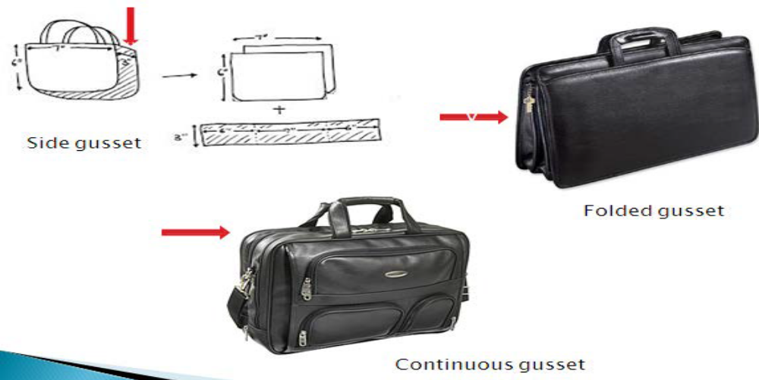
Figure 67: Gussets making
(l) Handle making:
A wide range of handles is fabricated in leather goods making. Lighter handles are used in box work constructions like jewel boxes, cosmetic boxes etc. Heavier handles are used in heavy and luggage goods like briefcases, document cases, travel cases, instrument cases etc. Different constructions are used for making a variety of handles such as round handles; flat handles and shaped handles to suit to the designs of the articles.
(m) Frame fixing:
Frame fixing is done in ladies framed purses and handbags. Frames are available in different sizes and shapes with high glossy finish of chromium plating or brass plating.
Suitable frames are selected for the products and fixed either manually or mechanically.
In the manual process, framing tools are used for fixing frames. As frame fixing is considered to be a very high skill job, it is always done only by highly skilled technicians.
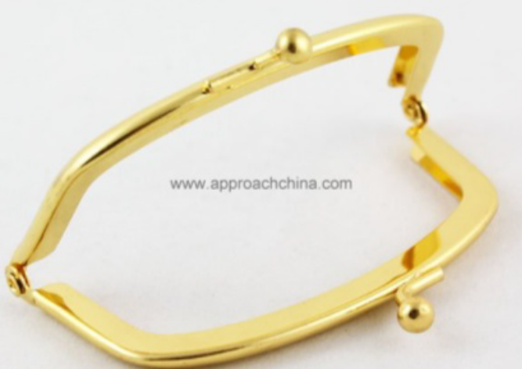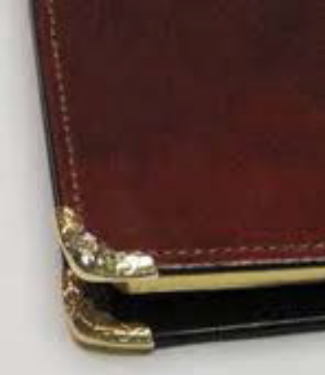
Figure 68: Frame fixing
Ladies handbag frames are manufactured in different shapes, sizes and styles. Smaller frames of sizes 8cms to 15cms are used for making framed purses and pouches while bigger frames of sizes 18cms to 30cms are used for making framed handbags. Handbag frame closing can be a valve type or snuff box type or friction type
(n) Edge Coloring
Single edge inking machine used in various leather - goods sectors for coloring the edges of handbags, briefcases, wallets, saddler, small leather-goods, footwear uppers etc.
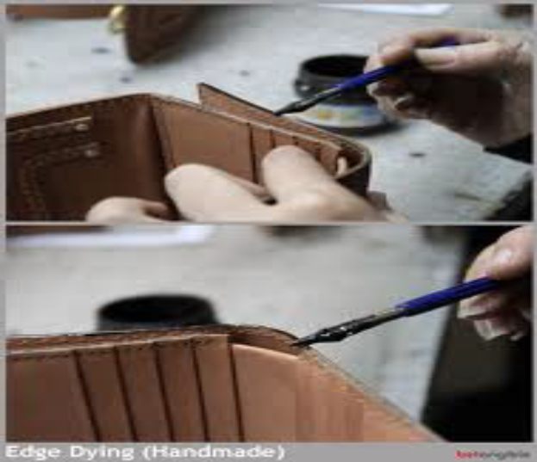
Figure 69: Edge Coloring

Use appropriate adhesive

Adhesion plays a vital role in assembling components viz. leather, lining and reinforcements during fabrication of the products. Further strength of the parts can be achieved by stitching. There are two types of adhesives, which are extensively used in the fabrication of leather goods.
They are (I) temporary adhesive and (ii) permanent adhesive.
(i) Temporary adhesive:
Rubber adhesive is a temporary adhesive as it gives temporary bonding effect and so stitching is necessary after joining the components. It is buff coloured natural rubber adhesive. It is easy spreading characteristics coupled with cleanliness, flexible bondage and economy of application make it particularly suitable for general works. It gives a firm grip while stitching and helps in making articles with stitches.
- Application:
Rubber adhesive is applied uniformly to the surface to be bonded. After achieving maximum tack development, the surfaces are joined. The joined surfaces are rolled down with a smooth roller to remove air bubbles. The components are then taken for stitching.
- Demerits of temporary adhesive:
Rubber adhesive is composed of crepe white natural rubber and petrol (Gasoline). The components assembled with rubber adhesive separate after sometime when left unstitched. This is because the solvent petrol in the rubber adhesive evaporates and only the rubber is left. Rubber starts melting slowly due to atmospheric conditions. It is therefore necessary to stitch articles glued with rubber adhesive. It is inflammable and produces toxic vapours.
(ii) Permanent Adhesive:
Synthetic rubber adhesive in solvent medium is a permanent adhesive as it gives permanent bonding effect. It is extensively used in leather articles which are made without stitches and also in attaching components where stitching is not possible. It is more advantageous than other adhesives because curing takes place immediately. It is buff coloured adhesive, freely flowing and very smooth to apply. It is good water, alkali and oil resistance coupled with high bonding strength make it an excellent adhesive for all types of high bonding works in leather goods manufacturing.
- Application:
Surfaces to be bonded must be clean, dry and even. The adhesive is applied thinly and rapidly to both the surfaces and the coverage of adhesive is ensured completely and effectively. The solvent of the adhesive is allowed to evaporate till tack formation is felt.
The glued surfaces are joined carefully and accurately avoiding air bubbles. The components are then pressed uniformly throughout for perfect and accurate joining.
Figure 70: Gluing
Demerits of permanent adhesive:
As the bonding strength of the synthetic adhesive is very high, it is very difficult to separate the components in case of wrong assembly. Excess application of adhesive not only causes damage to the products but also stain to the linings.
It is inflammable
produces toxic vapours and strong pungent smell.
It is moisture sensitive.
(j) Edge folding:
Edge folding is done during the fabrication of leather goods. Most of the leather goods are made with folded edges or turn over edges. It is a process of folding the leather uniformly along the edges to a predetermined width either in straight lines or in curves.
The folding is done to improve the edges and to enhance the beauty of appearance. The skived edges are coated with adhesive and then with the help of a bone folder or a scale, the edge is folded along the entire length of the leather component. Folding is done over the lining or foam or reinforcement material. The folding must be done accurately,
Skillfully and perfectly so that in the subsequent operation of stitching, there will not be any problem. In folding, the straight edge folding is done first and then curved corners.
The curved corners require hairline cuts for perfect curved folding.
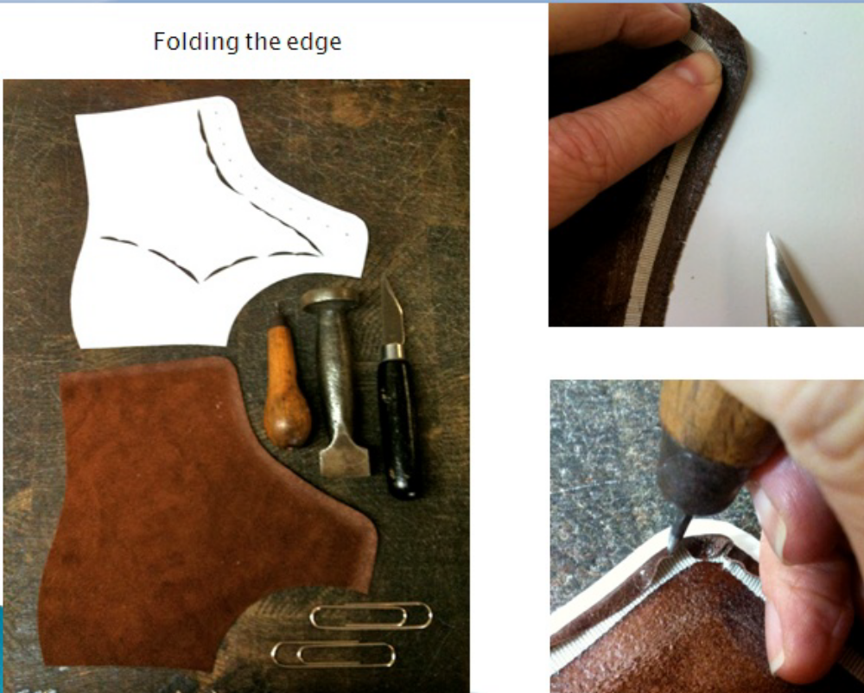
Figure 71: Edge folding
In case of bulk production, folding of the components is done in the straight edge-folding machine. Folding to any desired width can be obtained by adjusting the guide plates .In certain articles, folding and creasing can also be done in the edge folding and creasing machine

Performing pocket construction

Pocket is a pouch that has a closed end is usually stitched on leather goods or even inside the goods. Pocket can be both functional and decorative purpose. Pocket helps in holding and small article temporarily. It is important that pocket size, shape, and placement should complement the design of the leather goods.
Pocket can be classified based on shape/style and placements
Classification based on shape/style
  - Patch pocket
  - Patch pocket with top stitch
  - Flap pocket
  - Buttoned flap patch pocket
Classification based on appearance
- Outside pocket
- Patch pocket_ Patch pockets appear on the outside of the leather goods. They can be lined or underlined and attached by machine. They can be square, rectangular, pointed or curved and may be decorated with topstitching, lace or braid trims or construction details such as pleats.
- Pouch pocket_ it appears on the outside of the leather goods. They can be lined or underlined and attached by machine. They are attached by round gusset type.
- Accordion pocket_ it appears on the outside of the leather goods. They can be lined or underlined and attached by machine. They have some gathered and pleated part.
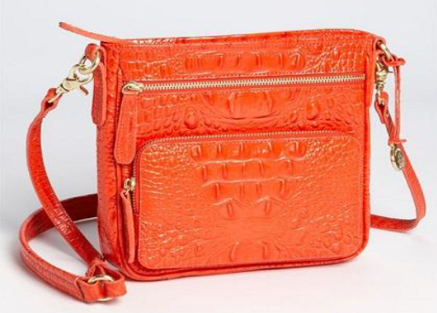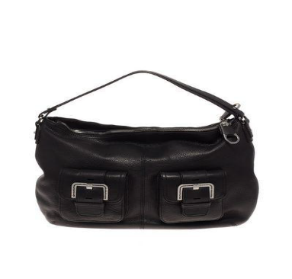
Figure 72: A) Patch pocket B) pouch pocket
- Inserted pocket
This kind of pouch is stitched inside of the leather goods into a straight and stylized seam. Inside pockets are usually made from a lining fabric. They are kept on the inside of the leather goods and the opening to the pocket can either invisible or decorative.
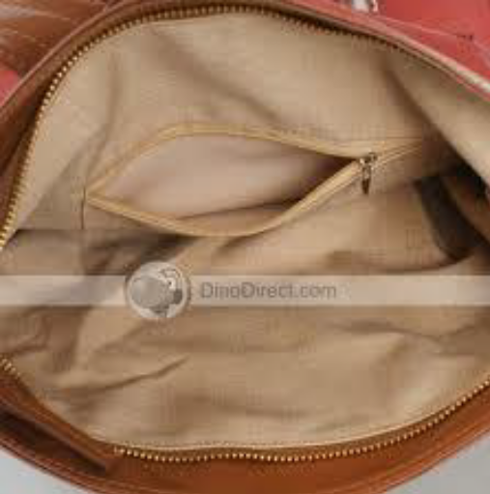
Figure 73: Inner pocket
- Welt pocket
A welt pocket is a small, flat pocket that is commonly used on the exterior and interior part of leather goods. Depending on the design of the pocket, it has either one or two lips.
A lip is simply a finishing on the opening edge of the welt pocket. When there is just one lip, it is usually the lower lip. When there are two lips, there are finished edges on the top and bottom of the pocket opening.
The width of a welt pocket lip can vary according to design and style. It is common for the width of a welt pocket lip to range from three-eighths of an inch (about one centimeter) to one inch (about two and a half centimeters).
Wider welt pocket lips are usually used in luggage bags that only have a lower lip. Thinner welt pocket lips, on the other hand, are usually used in medium and soft ladies bags.

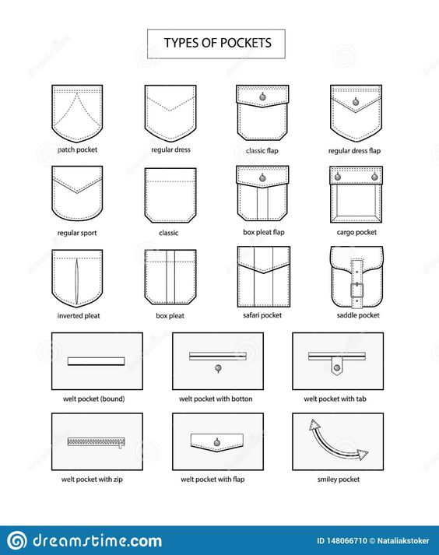
Figure 74: Types of pocket

Constructing garment and goods components
Leather Garment and goods production is an organized activity consisting of sequential processes such as Design/pattern making, marking, cutting, stitching, checking, finishing, pressing and packaging. This is a process of converting raw materials into finished products. It will be difficult to maintain the industry if production is not, up to the mark if the preproduction phase of preparation of material is not properly carried out.
    - Leather Garment component
The leather garment components are garment parts that require one or more separate pieces to be assembled as a unit. Leather garment components are the basic sections of garments including top fronts, top backs, bottom fronts, bottom backs, sleeves, collars /neckline treatments, cuffs / sleeve treatments, plackets, pockets, and waistline treatments. Hems may be completed as a part of a component or as part of final assembly. Stitches, seams, and / or bonding are used to assemble components and final garment structure.
Components such as collars, cuffs, and pockets are small parts that are usually constructed independently for final assembly.
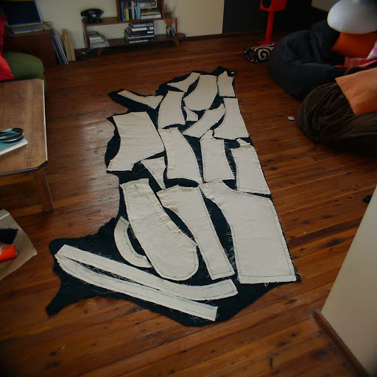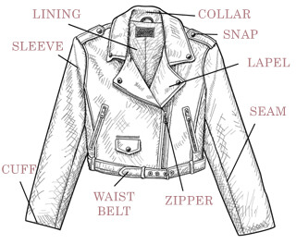

Figure 75: jacket components

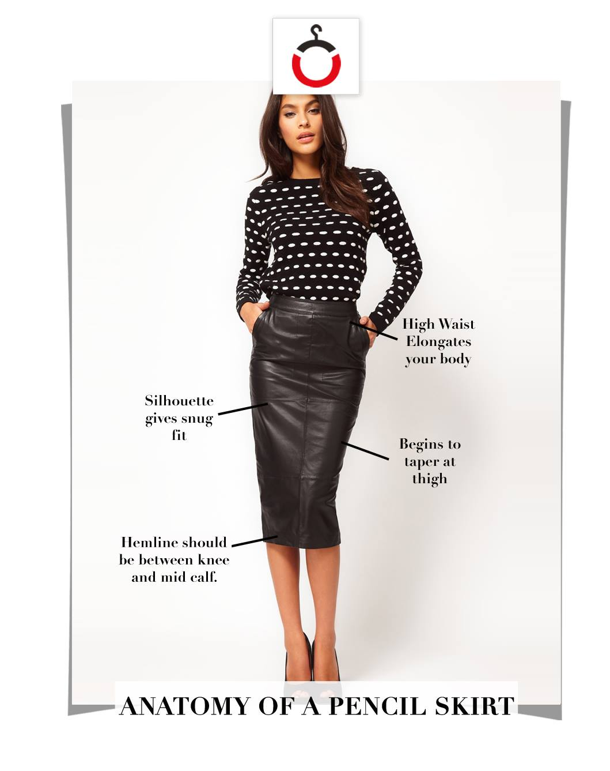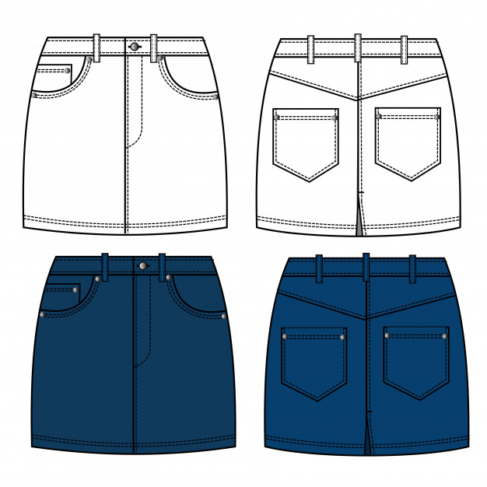
Figure 75: skirt
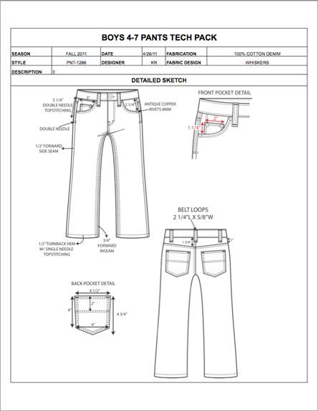
Figure 76: Leather Garment component

    - Leather Goods component
The leather goods components are goods parts that require one or more separate pieces to be assembled as a unit. Leather goods components are the basic sections of goods including top fronts, bottom fronts, top backs, bottom backs, gusset, base, pockets, strap/handle and flap. Stitches, seams, and / or bonding are used to assemble components and final goods structure.
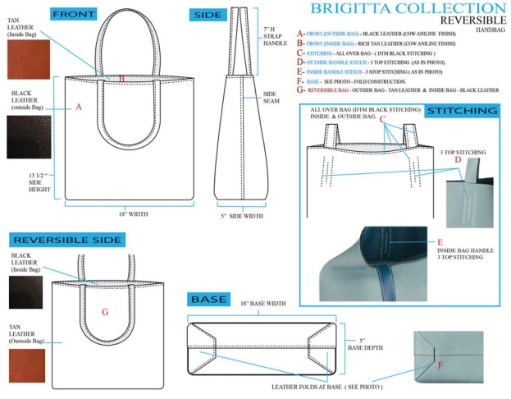
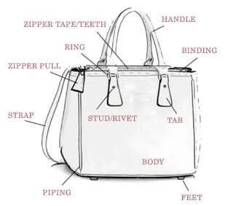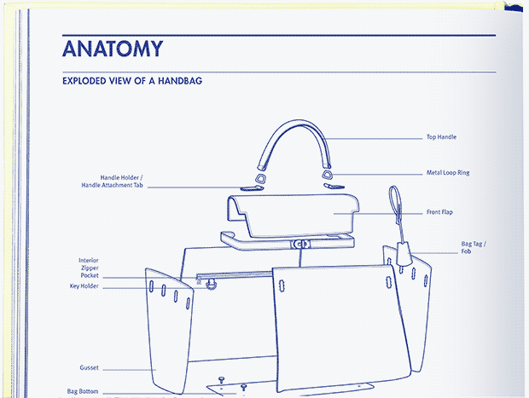
Figure 77: Leather Goods component
Steps of Leather Garments and Goods Manufacturing Sequence
Design / Sketch
↓
Pattern Making
↓
Sample Making
↓
Production Pattern
↓
Grading
↓
Marker Making
↓
Cutting
↓
Sorting/Bundling
↓
Sewing/Assembling
↓
Inspection
↓
Pressing/ Finishing
↓
Final Inspection
↓
Packing
↓
Dispatch

Self-Check 4 | Written Test

Directions: Answer all the questions listed below. Use the Answer sheet provided in the next page:
    - Short answer
- What is bench work operation?
- Explain about eyeleting and riveting.
- What is creasing?
    - Matching

 | A |  | B
1 | A flat pocket stitched on the body of a bag | A | Staining
2 | Temporary adhesive | B | Gusset
3 | Dying of a leather edge | C | Rubber adhesive
4 | Determines the volume or holding capacity of a bag | D | Patch pocket
 |  | E | Synthetic adhesive

Operation Sheet-4.1 Constructing leather garment component
Operation title: Constructing leather garment pocket
Purpose: to practice and demonstrate the knowledge and skill of making leather garment pocket Instruction; follow the steps below to practice making leather garment pocket.
Tools and requirement
- Work bench
- Trade trimmer
- Scissors
- Scale
- Glue container
- Glue/ latex and neoprene/
- Hammer
- Marking pen
- Sharping stone
- Cutter
- Medium/heavy duty flatbed lock stitch machine
- 40/3 nylon or polyester or blended sewing thread
- 18/110/_19/120/ needle
A) Patch with flap pocket construction
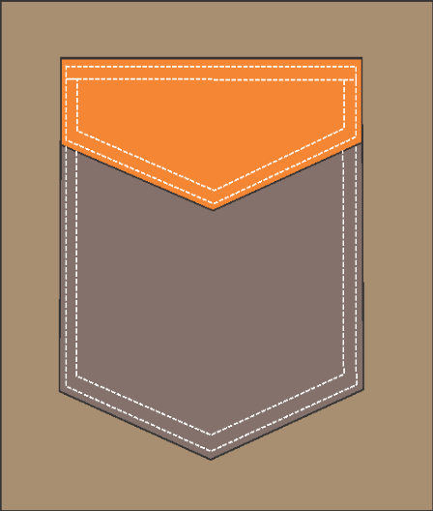
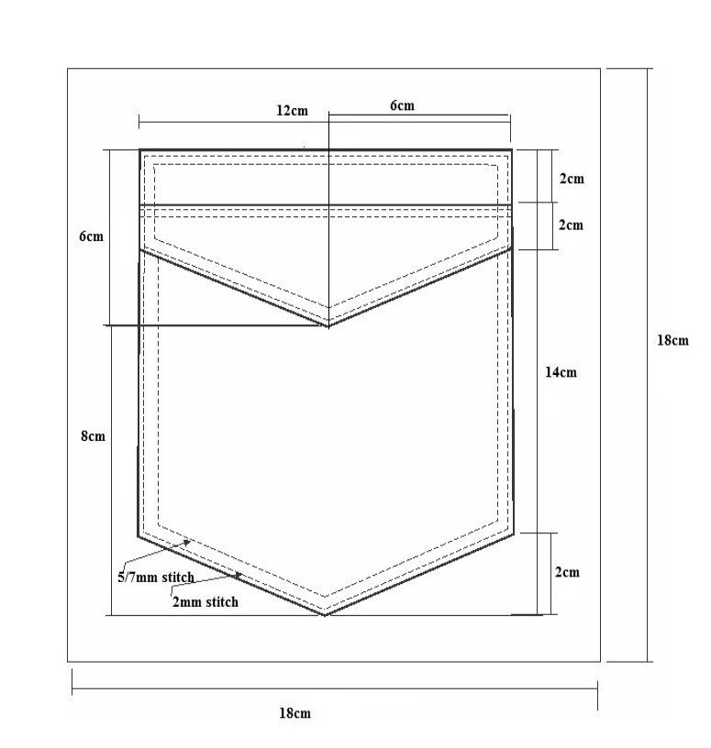
Figure 78: Patch with flap pocket dimension
Procedures of Patch pocket construction
- Cutting
- Cut all components- outer leather or all leather components and lining using cutting patterns and skives as per instruction.
Cut component of the pocket
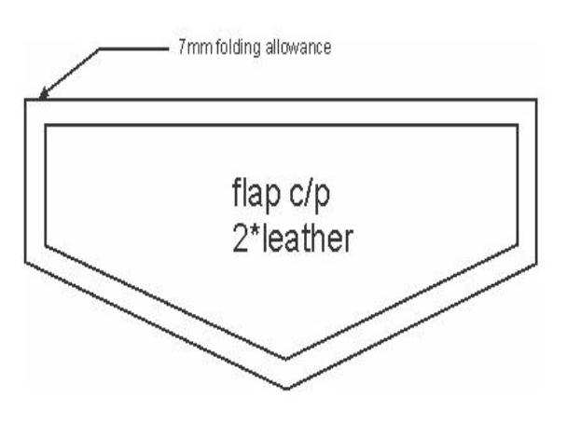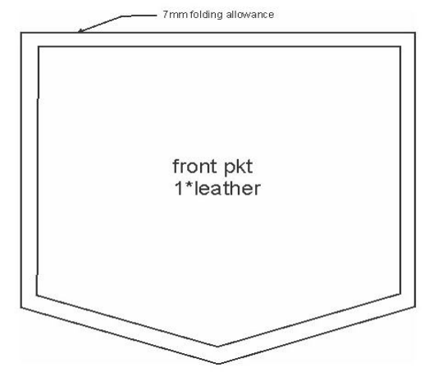
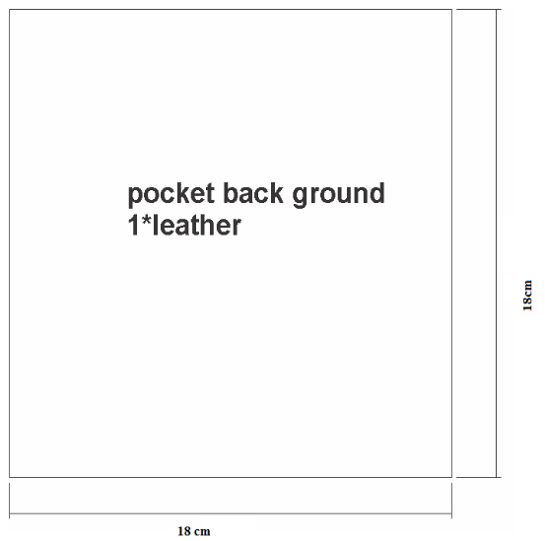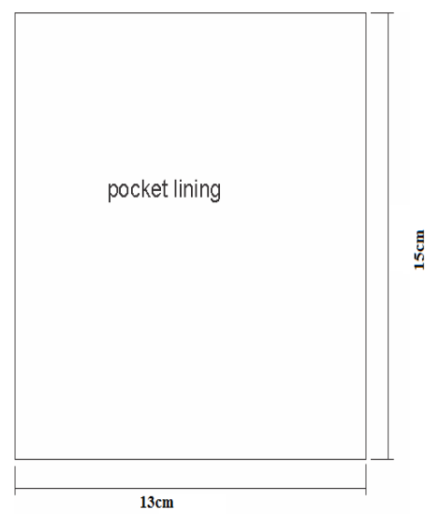

- Assembling and stitching
Sequence of assembling and stitching of patch pocket with flap
a). Flap preparation
i) Top flap
- On the flesh side of the cut flap leather, apply glue on the skived edge for proper folding to have the required dimension of flap.
- On the grain side of the cut flap leather, apply latex glue and put the making pattern of the flap, then follow the edge of the pattern paper and fold the excess size of the leather inside to the flesh side.
- For proper fixation and good edge shape slightly hammer to the folded part.
- The straight/long edge of the flap is not fold because it will be folded with the inner one.
- Reduce/cut 5mm from the cut allowance of the flap panel to reduce the excess folding leather.
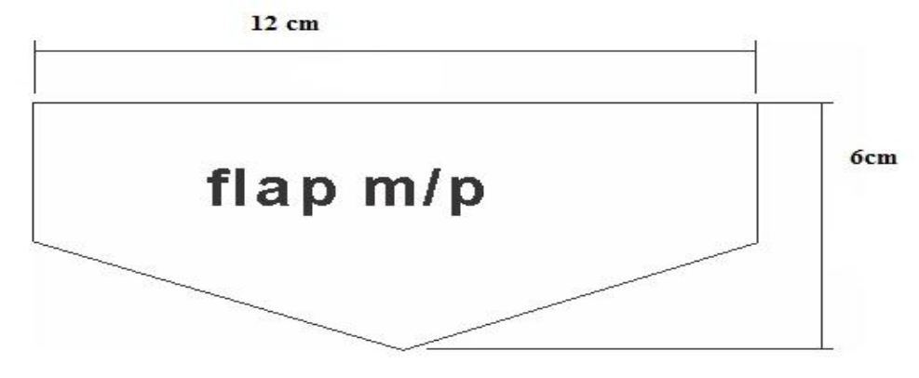
- Top flap panel before folding
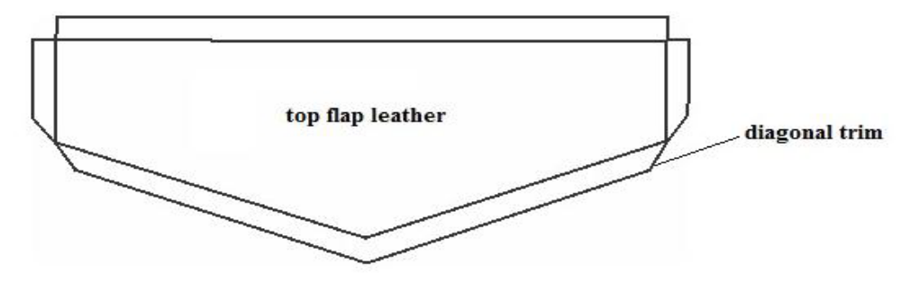
- Top flap after 3 side folding
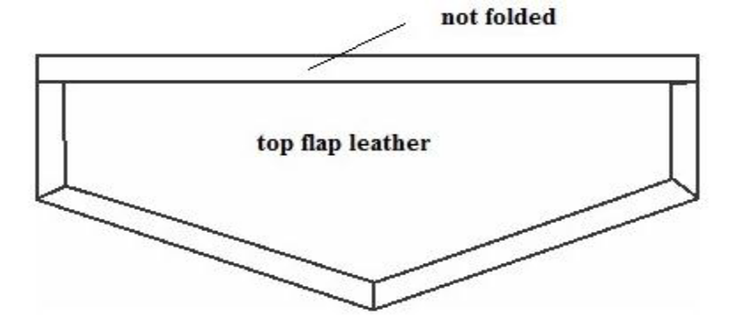
ii). Bottom flap
- On the flesh side of the cut flap leather, apply glue on the skived edge for proper folding to have the required dimension of lap.
- On the grain side of the cut flap leather, apply glue and put the making pattern of the flap, then follow the edge of the pattern paper and fold the excess size of the leather inside to the flesh side.
- For proper fixation and good edge shape slightly hammer to the folded part.
- The straight/long edge of the flap is not fold because it will be folded with the inner one.
- Reduce/cut 12mm from the cut allowance of the flap panel to reduce the excess folding leather and easy stitching because of the layer or the thickness of leather is reduced.
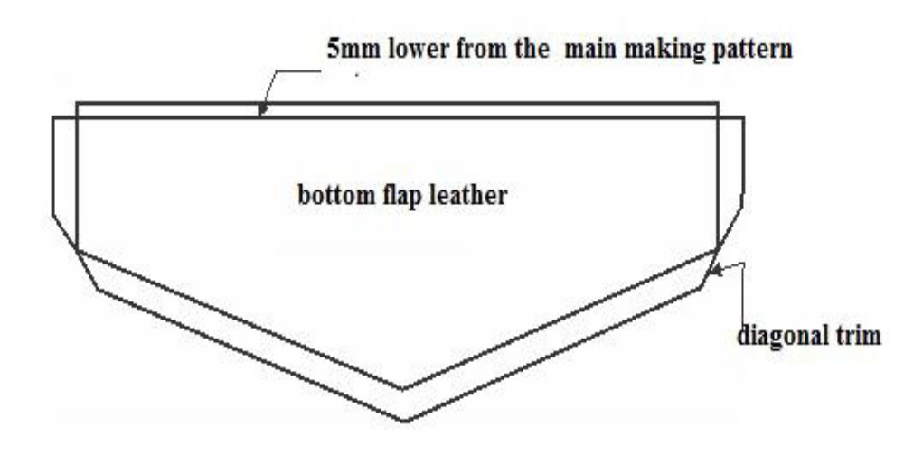
Bottom flap before folding
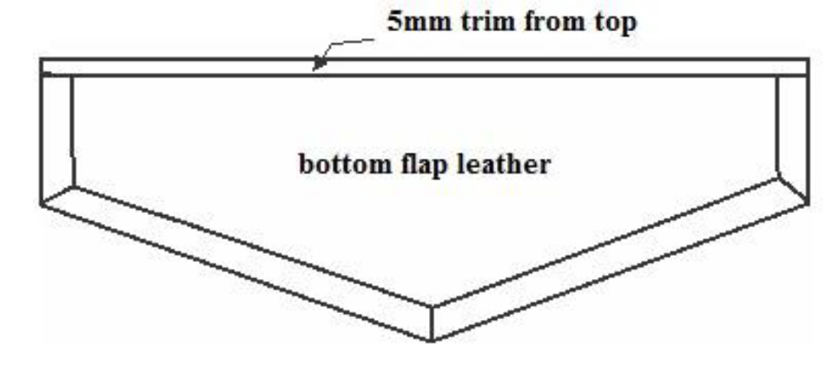
Bottom flap after 3 side folding
Assembling and stitching top and bottom flap
- Apply glue on the folded side of the bottom and top flap panel. After 1-2 minute latter fix the top and bottom flap on the proper dimension.
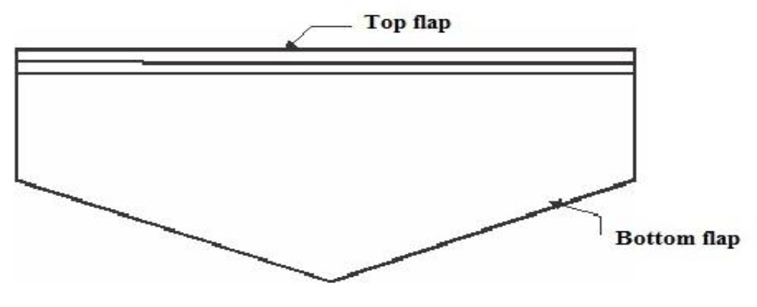
- Stitch all round except the top side, double stitch 2mm for the first single stitch and 7mm (from the edge) for the second stitch.
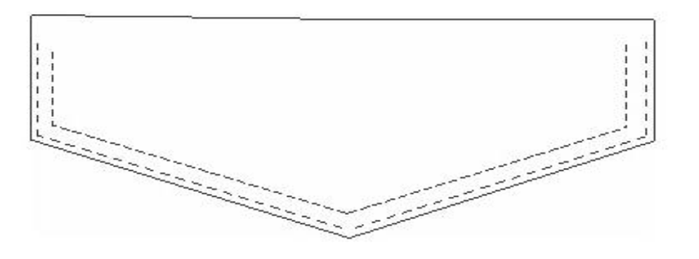
b). Front pocket preparation
- On the flesh side of the cut flap leather, apply glue on the skived edge for proper folding to have the required dimension of lap.
- On the grain side of the cut front pocket leather, apply latex glue and put the making pattern of the front pocket, then follow the edge of the pattern paper and fold the excess size of the leather inside to the flesh side.
- For proper fixation and good edge shape slightly hammer to the folded part.
- Trim the corner edge in diagonal way in order to have nice corner shape.
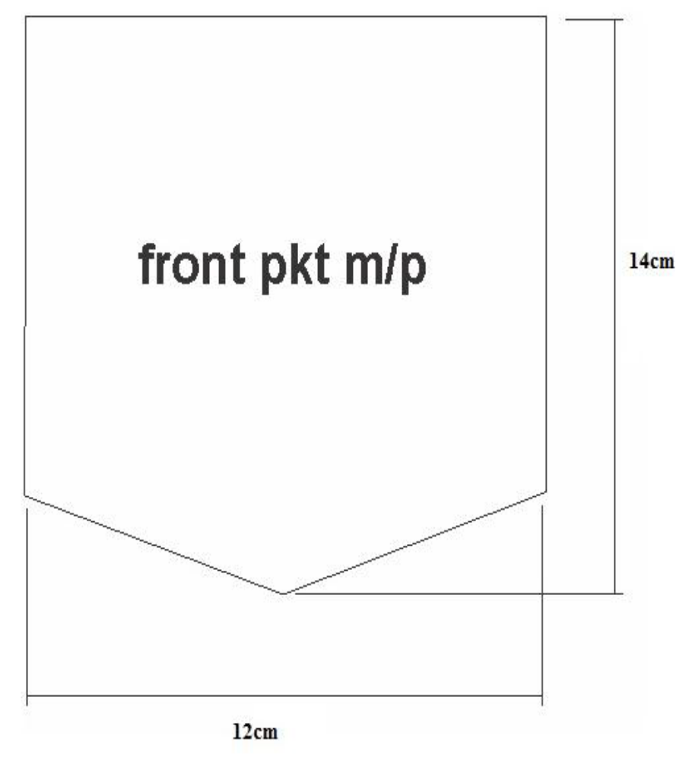
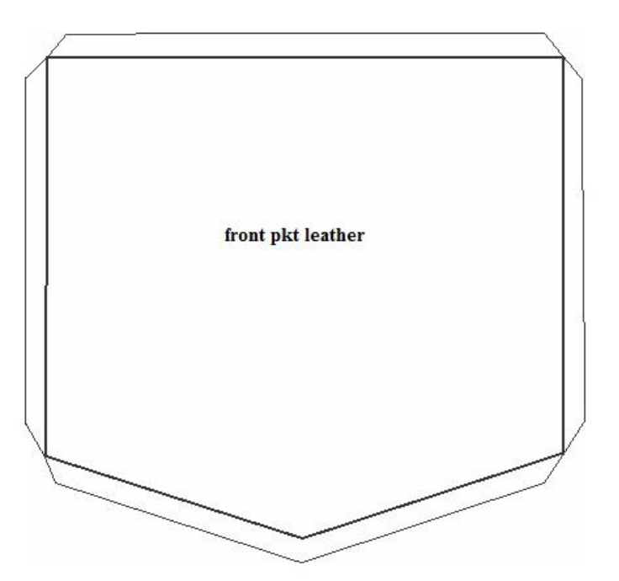
Front pocket after folding
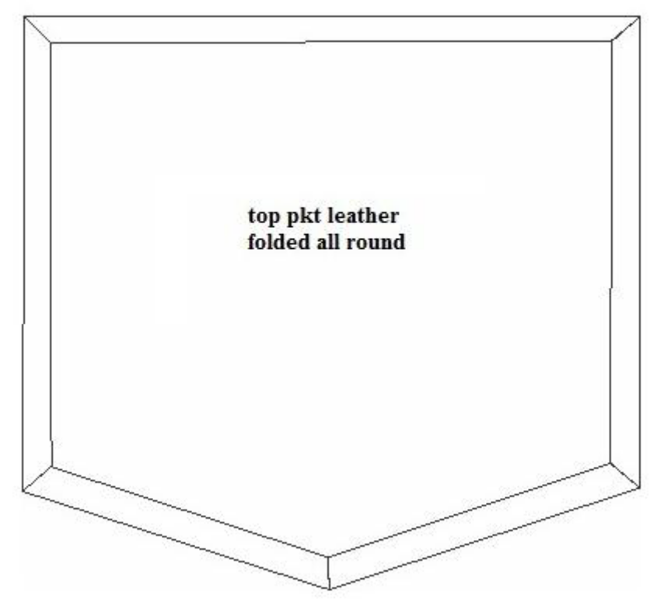
- To attach lining under the pocket, apply neoprene glue on the top edge of the lining and fold properly on straight way.
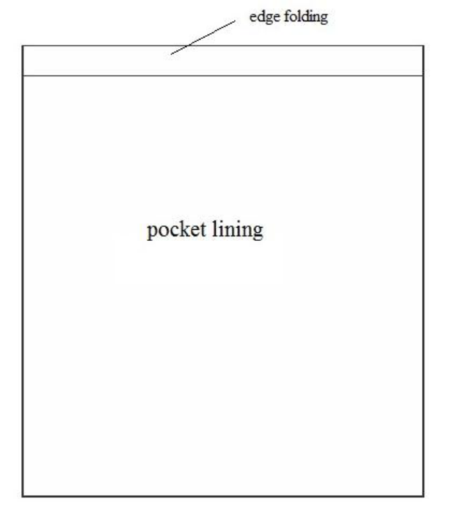
- Apply glue in all round of the flesh side the front pocket edge. After 1-2 minute fix the lining properly. The folded edge must be fix on the top folded edge of the front pocket.
- Trim the lining 3mm inside of the edge of the edge of the front pocket
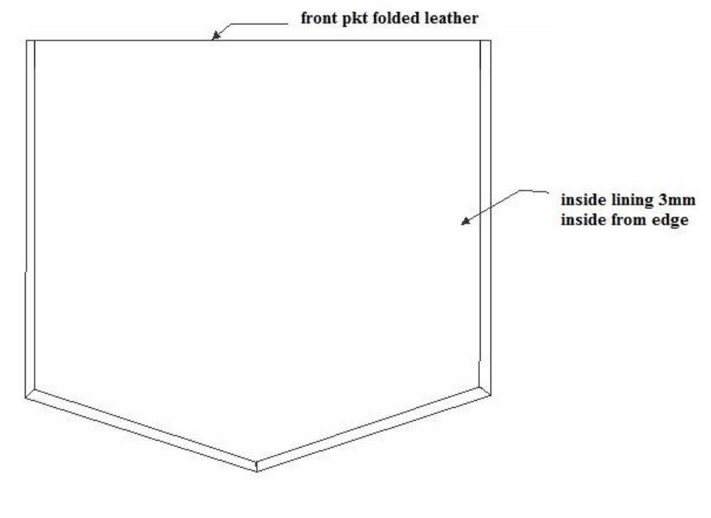
- Stitch the mouth part of the pocket by double stitch. The first single stitch with in 2mm and the next double stitch 7mm from the edge of the pocket.
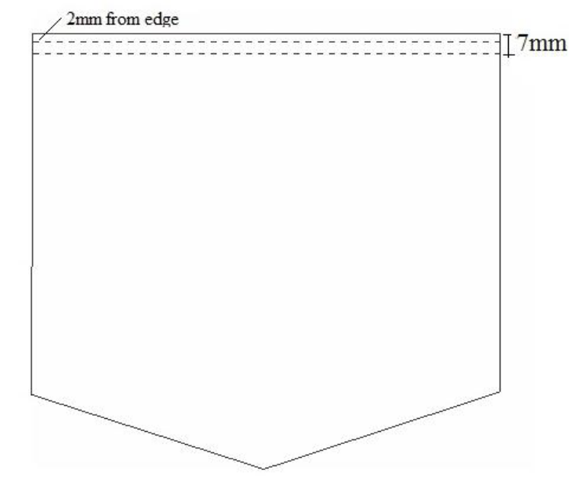
c). Assembling and stitching front and flap with back ground/body
Mark the right position of the front panel and flap on the back ground leather by using the master patterns.
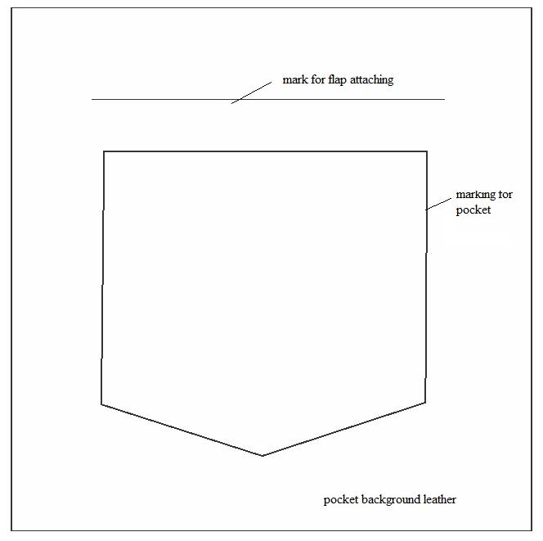
- Apply the glue on back ground leather which the front pocket is marked. After 1-2 minute latter properly attach the front pocket panel on the marked line and slightly hammer it. Stitch the 3 side with double stitch in which the first stich is 2mm from the edge and the second stitch is 7mm from the folded edge.
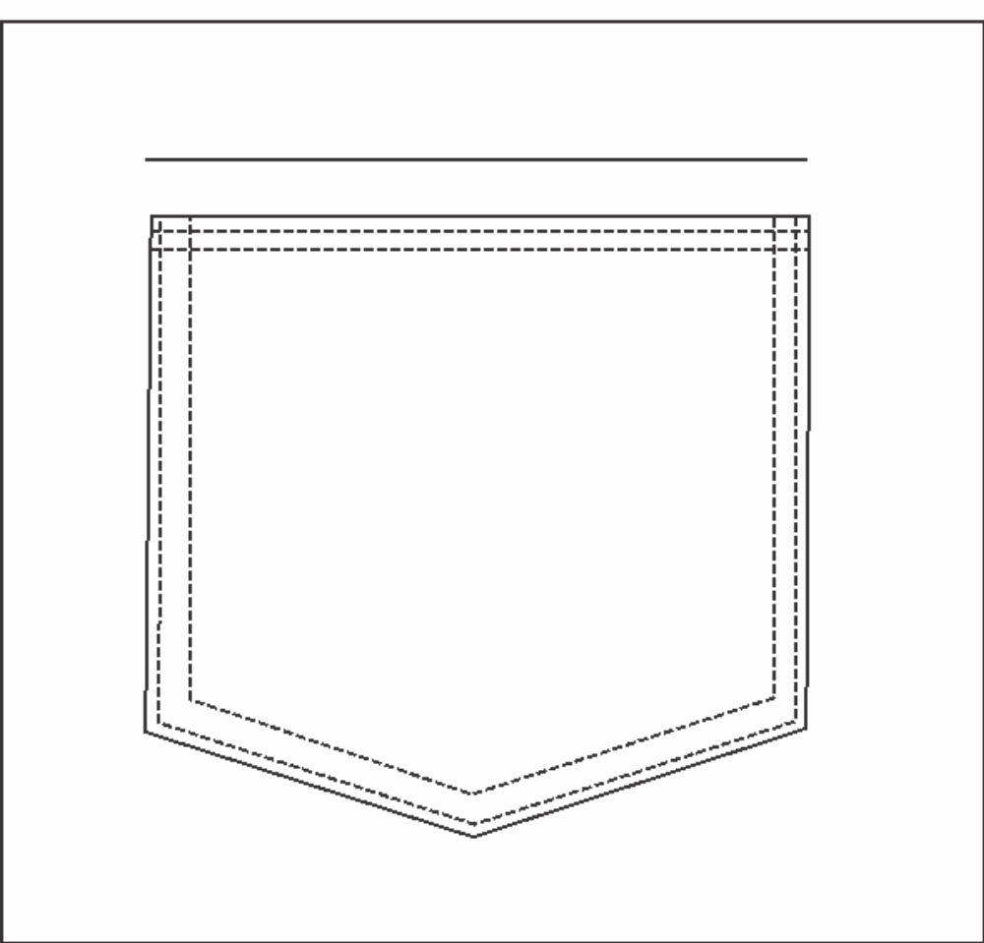
- Apply the neoprene glue on back ground leather which the flap is marked. After 1-2 minute latter properly attach the flap panel on the marked line and slightly hammer it. Stitch the flap with double stitch in which the first stich is 2mm from the edge and the second stitch is 7mm from the edge.
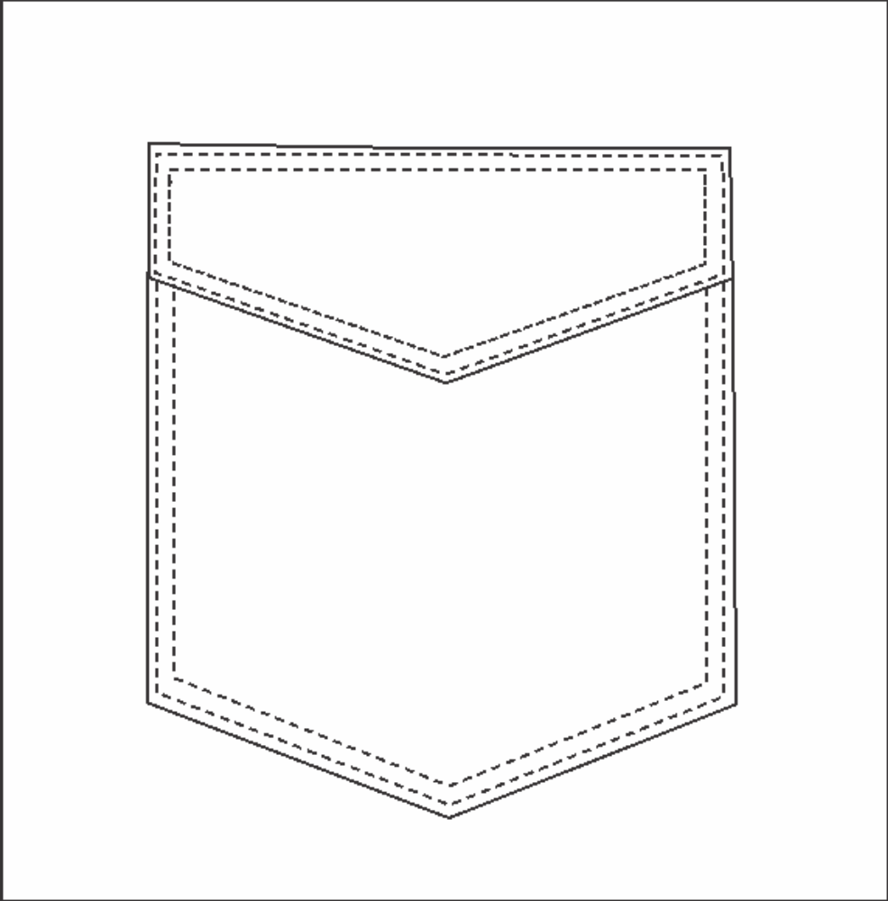
- Finishing operation
- Cut the thread ends and burn by thread burner
- Remove any marking line on the leather

Operation Sheet-4.2 Constructing goods component
    - Constructing goods component
      - Pouch pocket construction
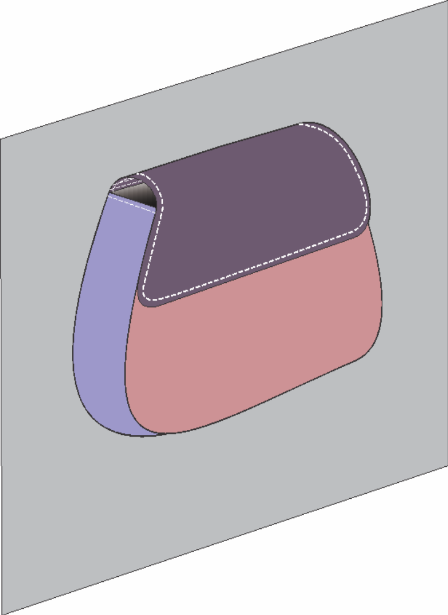
Figure 79: Pouch pocket

The required tools, equipment’s and machines
- Bench work table
- Trade trimmer
- Scissors
- Scale
- Magnetic button
- Foam
- Shuttle/awl/
- Glue container
- Glue/ latex and neoprene/
- Hammer
- Marking pen
- Sharping stone
- Cutter
- Medium/heavy duty flatbed lock stitch machine
- 40/3 nylon or polyester or blended sewing thread
- 18/110/_19/120/ needle
Procedures of the Pouch Pocket Construction
Task 1. Cutting operation
Cut all components- outer leather or all leather components and lining using cutting patterns.

Pouch pocket components pattern
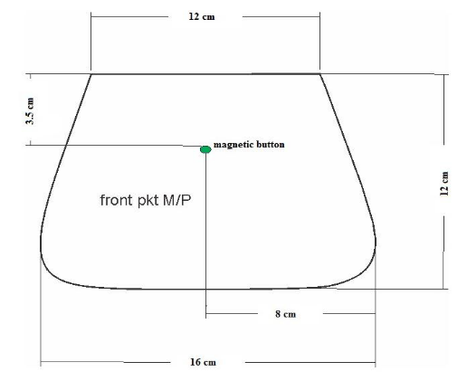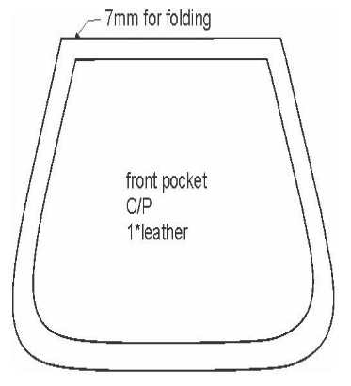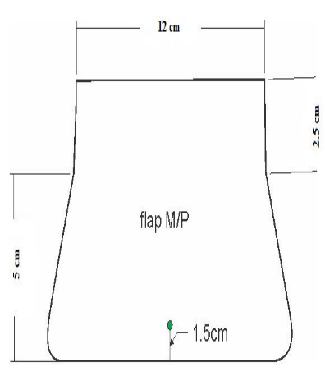
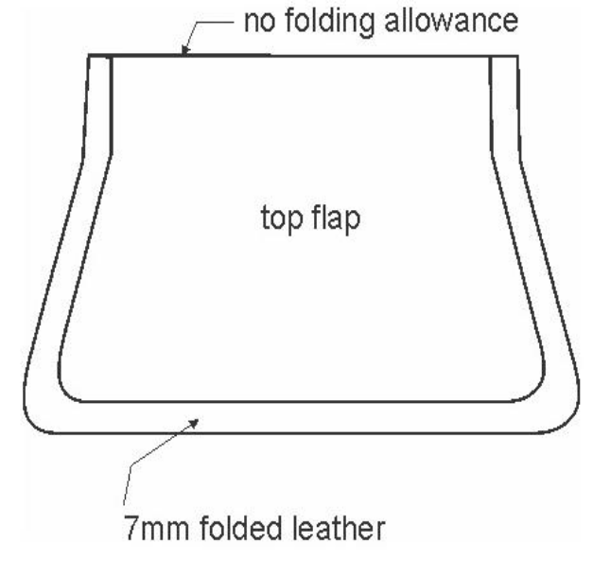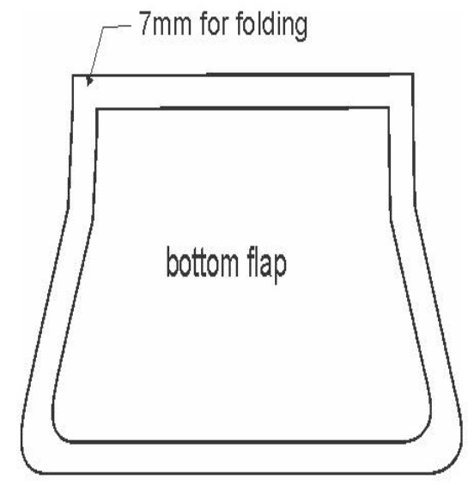
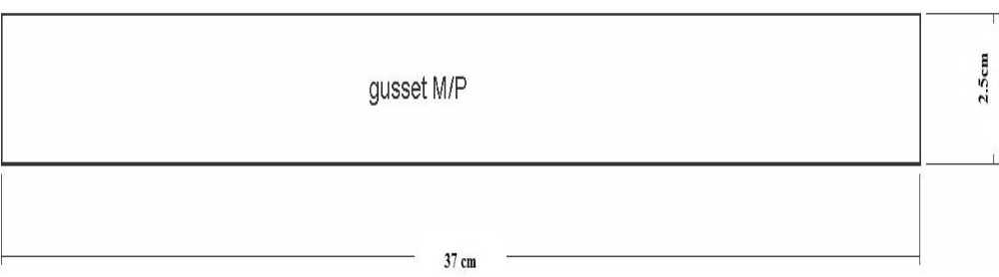
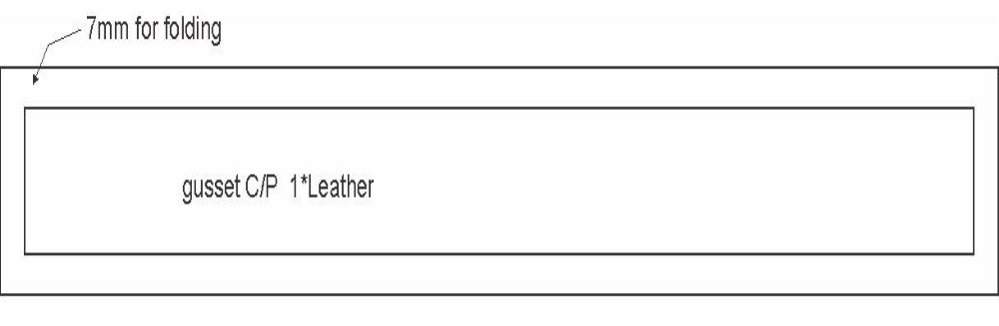
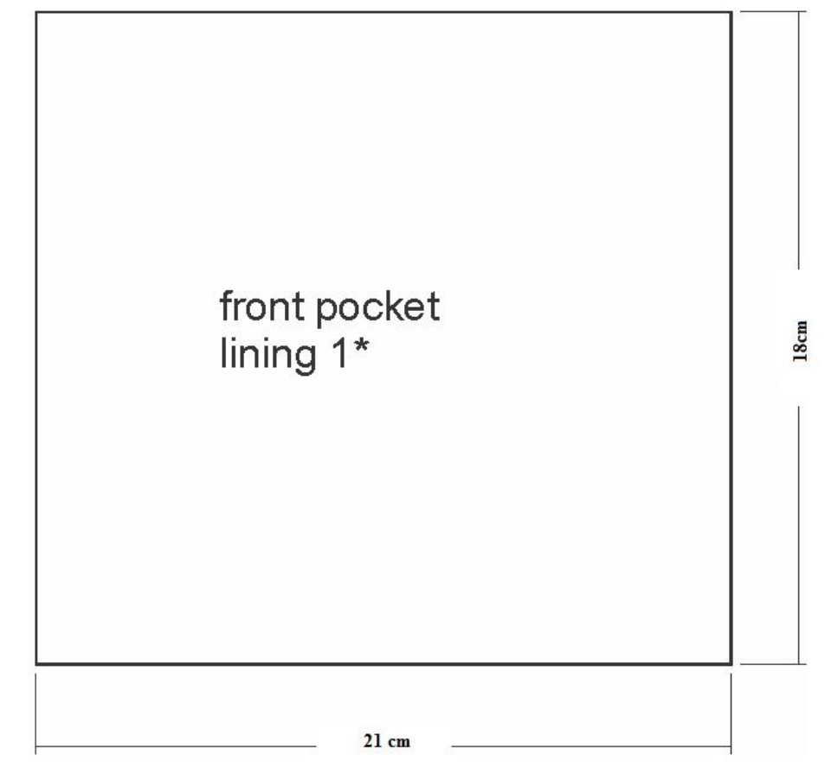
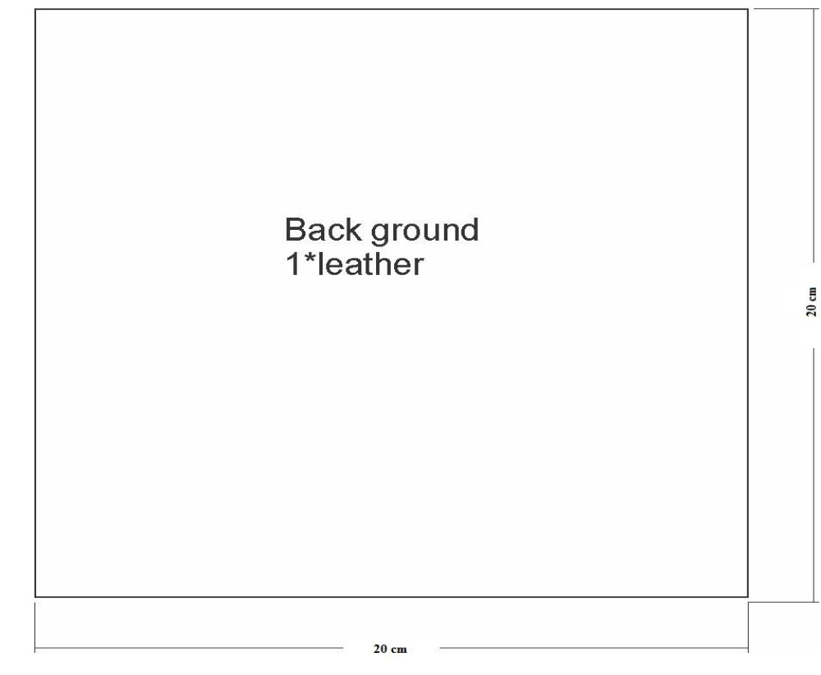
Task 2. Skiving cut components pieces instruction
Table: 2 Skiving cut components pieces instruction
S.No | Components | Side to be skived | No of component to skive | Width to skive
1 | Front pocket panel | All side | 1 | 7mm
2 | Flap panel top | All side | 1 | 7mm
3 | Flap panel bottom | 3 side | 1 | 7mm
4 | Side gusset | 4 side | 1 | 7mm
Sequence of Assembling and stitching process
Task3. Front pocket construction
- Apply rubber/latex glue on the skived part and after 1-2minute latter put the making or fixing patter on the grain side of the cut component and fold the 7mm towards the flesh side. Slightly hammer for proper fixation and nice edge shape. Mark the button position and attach the magnetic button on the proper position with the right dimension.
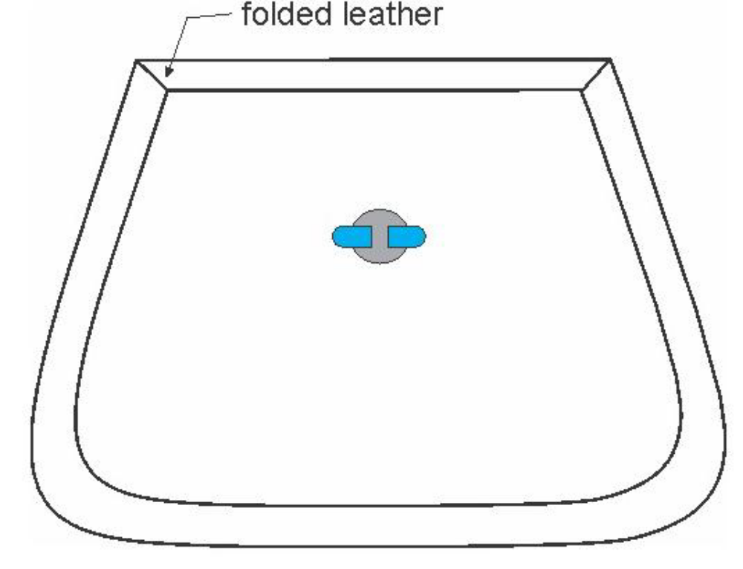
- Apply neoprene glue on top edge of the pocket, and after 1-2 minute attach the lining.
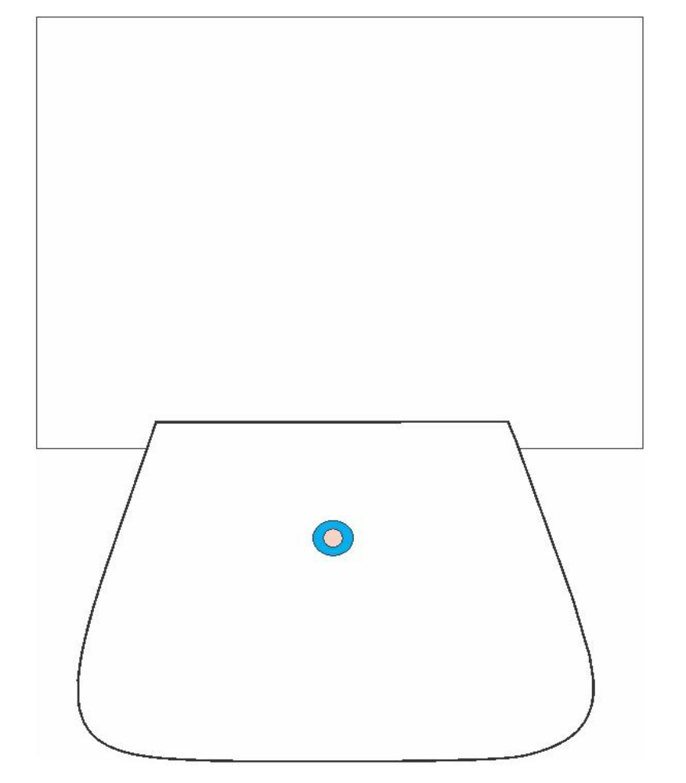
- Stitch 2 mm on the top and turn down the lining.
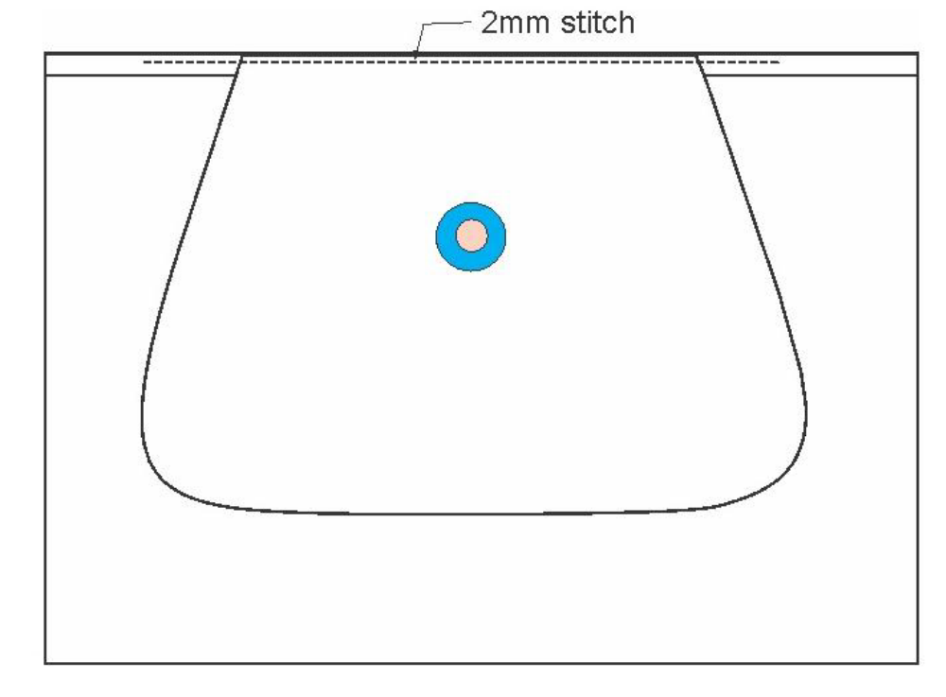
- Trim the excess lining with 2.5 cm from its 3 side
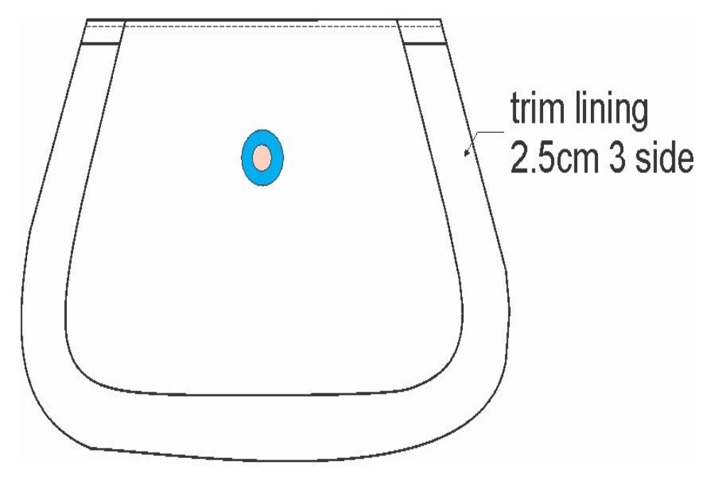
Task4. Gusset construction
- The 2 side cut or trim diagonally for nice corner creation
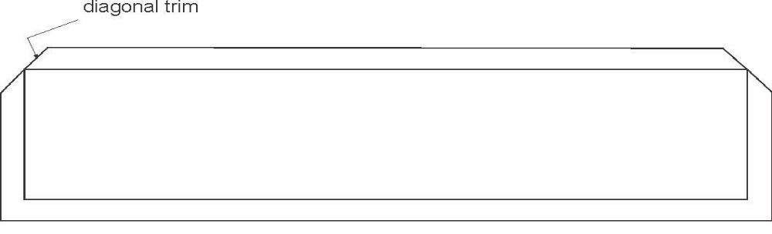
- Apply neoprene glue on the 3 side of the gusset. 1 side of gusset no need to fold because it is directly attach with the front pocket and after stitch it will turn. So need of folding. After 1-2minute put the fixing pattern and fold the 7mm towards flesh side and hammer it to have nice shape as well as good fixation.
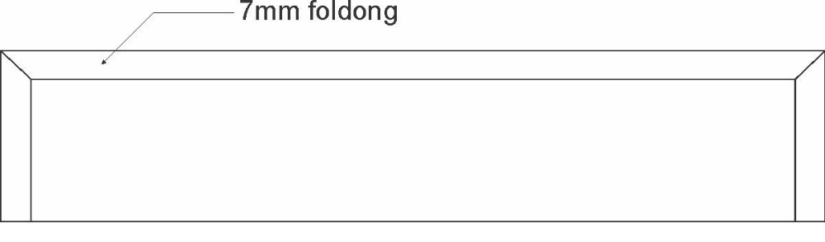
- Apply neoprene glue on both edge of the gusset lining and after 1-2 minute fold 7mm.
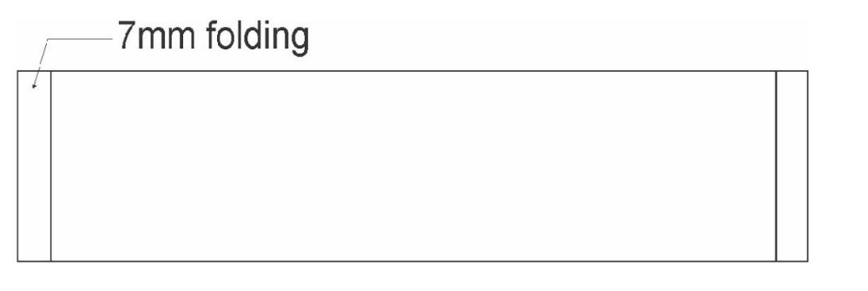
- Apply neoprene glue on both folded edge of gusset and after 1-2 minute attach the lining with gusset. Stitch 2mm the two edges. Trim the lining which should less 3-4mm than that of gusset this may help during attaching the front pocket with back ground leather for applying glue and properly fix or bind.
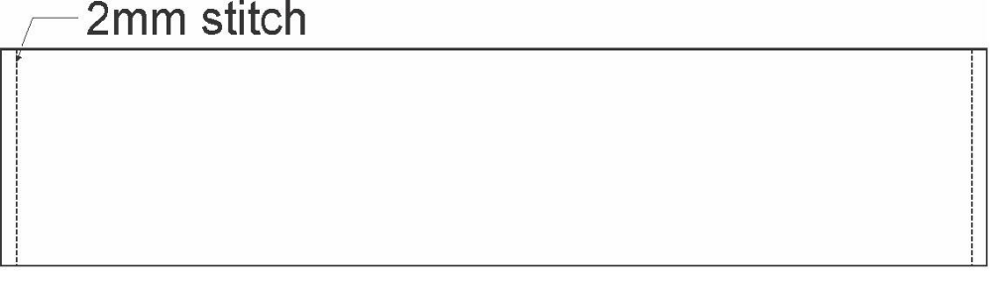
Flap construction
Task 5. Bottom flap construction
- Apply neoprene glue on the skived part. After 1-2minute Fold the 7mm skived towards flesh side by putting the fixing pattern. And slightly hammer it for nice shape.
- Put the fixing pattern and mark the button position and attach the magnetic button on the proper position with the right dimension.
- On the top side of the flap 5mm should go down from the exact size on the making pattern and remove the folded part. This will help during attaching with the top flap and having the curve shape.
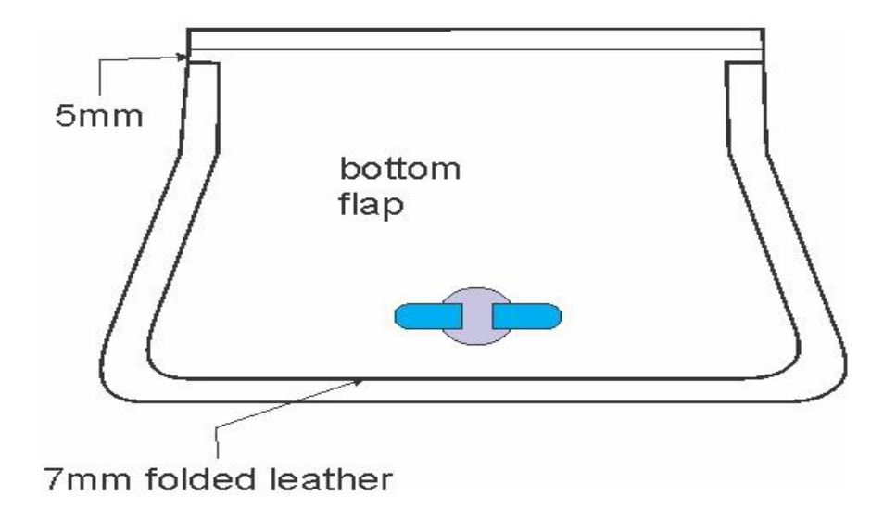
Task 6.Top flap construction
- Apply neoprene glue on the skived part. After 1-2minute Fold the 7mm skived towards flesh side by putting the fixing pattern. And slightly hammer it for nice shape.
- On the top side of the flap 5mm should go down from the exact size on the making pattern and remove it. This will help during attaching with the bottom flap and having the curve shape.
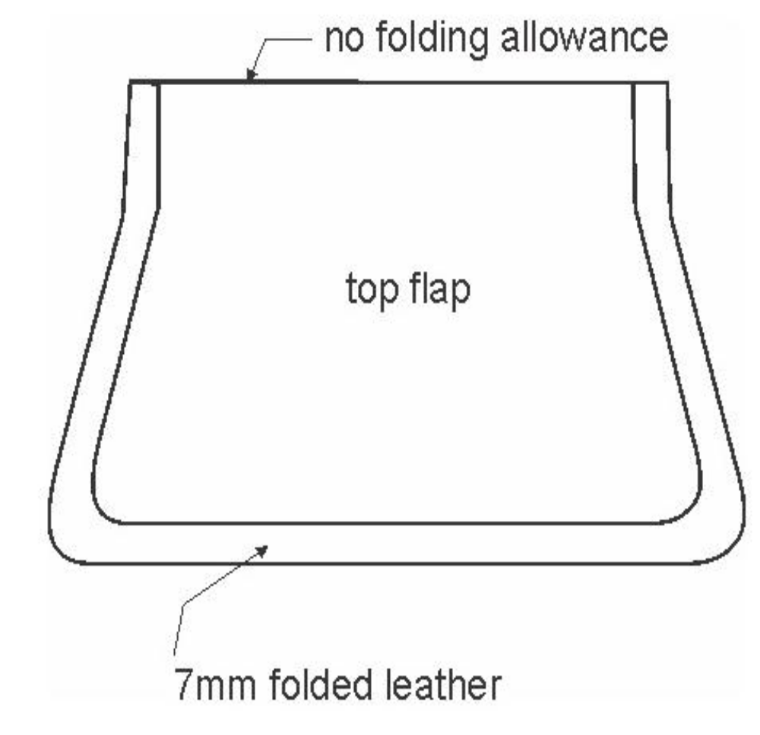
- Apply neoprene glue on the folded side of the top flap. After 1-2 minutes, attach the top flap with bottom one. During fixing of the top with bottom, the edge of the top flap should be point where 5mm reduced from fixing pattern on the bottom flap. Hammer the edge to have the bend shape and proper fixing.
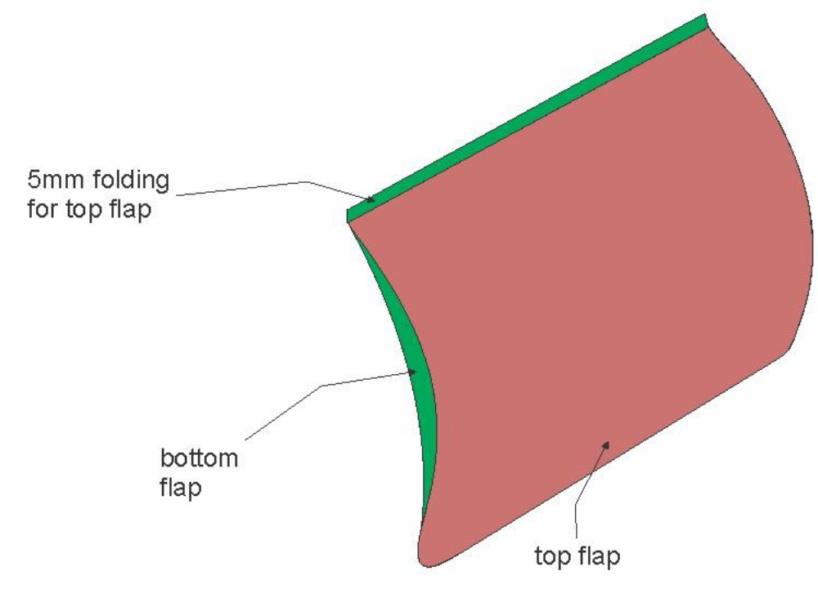
- Stitch the 3 side of the flap with 2mm
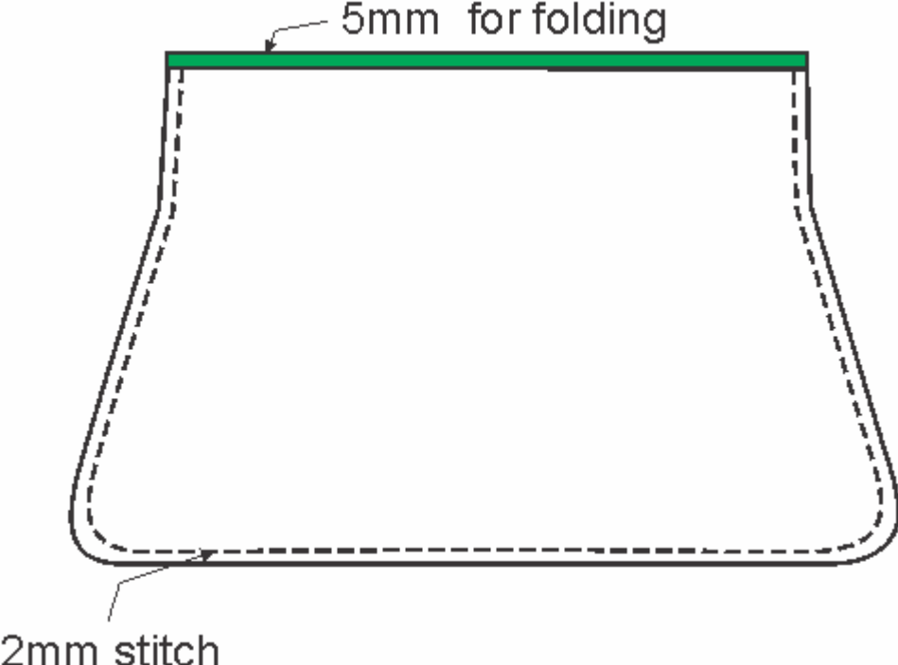
- Apply neoprene glue on the edge of top flap. 1-2minute latter fold the bottom flap5mm length towards top flap and hammer it for sticking/fixing/
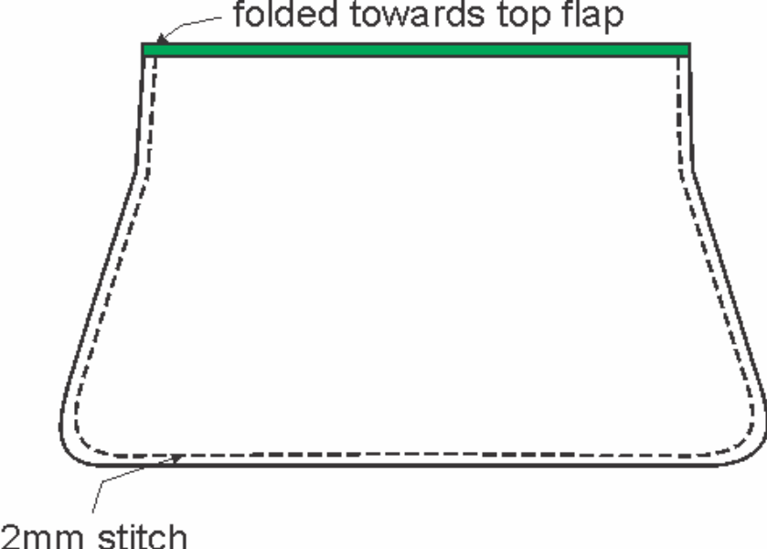
Task 7. Attaching gusset with front pocket
- Apply rubber /latex glue on the lining of front pocket to attach with foam and well spread the lining to remove any unwanted crease formation. Apply neoprene glue on the 3 side’s edge of the front pocket and also on the unfolded part of the gusset. The glue is added on the grain side of the front pocket as well as gusset. Slightly hammer the attached round part for better fixation.
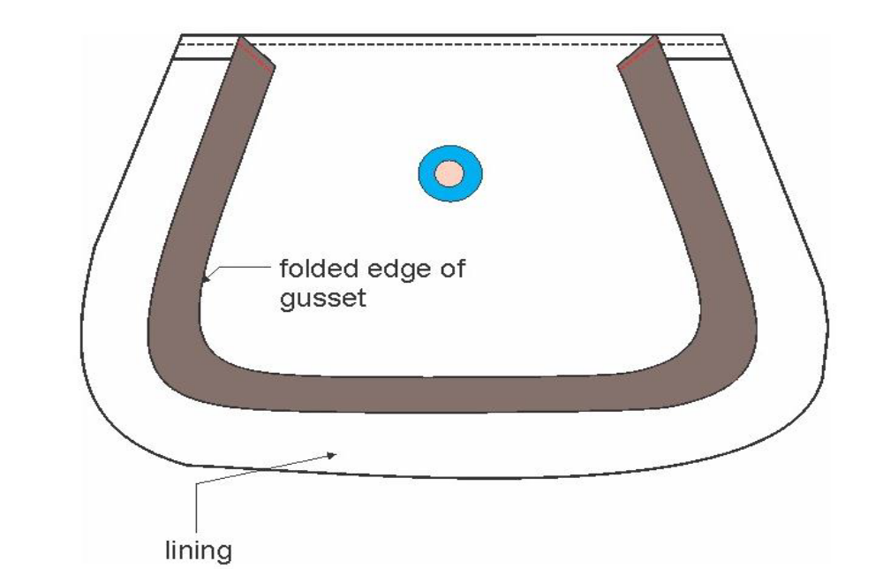
- Apply neoprene glue on the edge of the attached gusset and front pocket then the front pocket lining should turn towards the gusset to cover the edge of the gusset and pocket.
- Stitch 7mm mm the 3 side round. Remove the excess lining with 2mm far from the stitch.
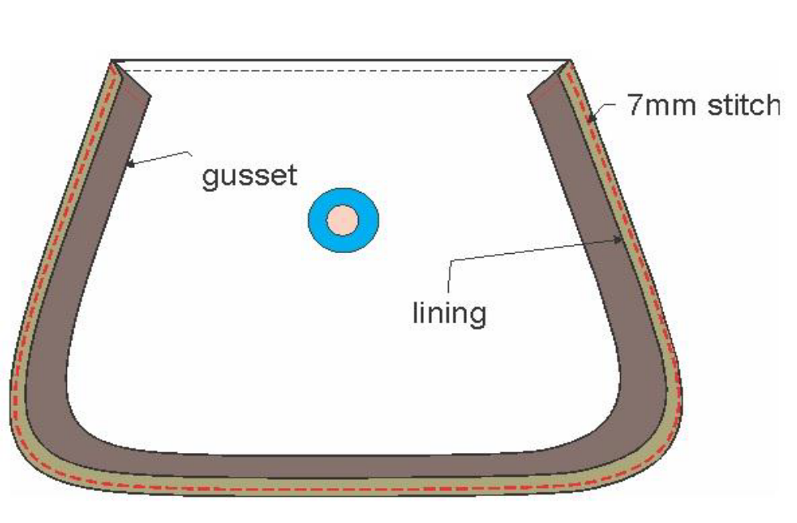
- Turn the gusset and maintain the curve shape by hammering the edge slightly
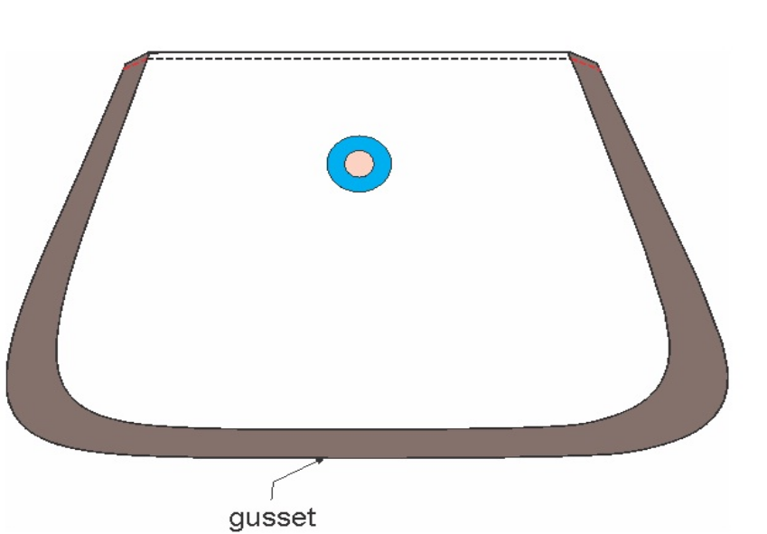
Task 8. Attaching stitched front pocket and flap with back ground leather
- Mark the line where the front pocket and flap can be place by putting the master pattern and transfer the point by awl. And draw the line or use the point as it is also.
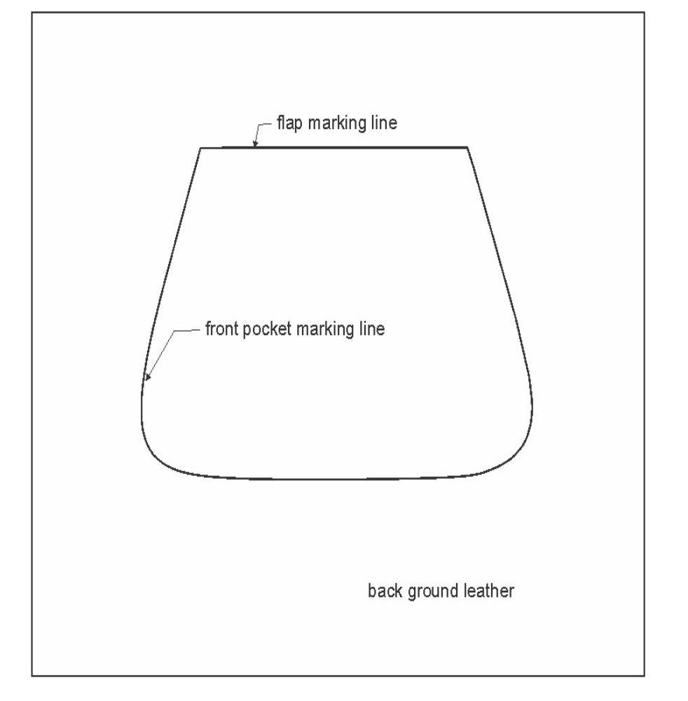
- Apply neoprene glue on the flap marking line. After 3-4 minute attach the flap and slightly hammer for better binding.
- Stitch 2 mm the first line and 5/7mm for the second stitching line
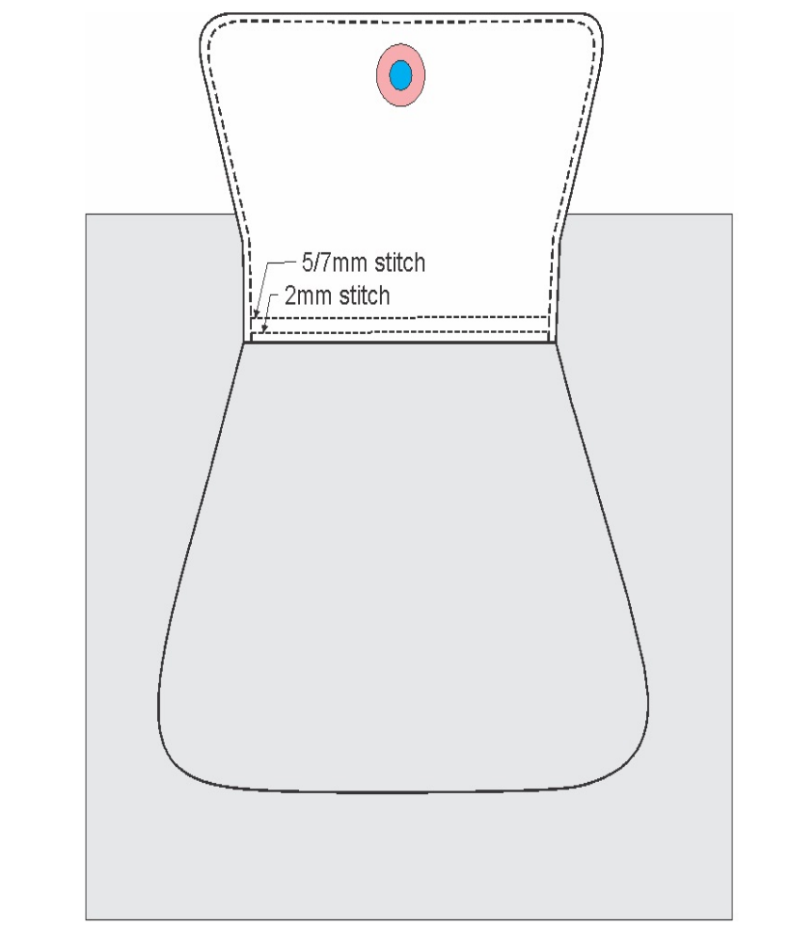
- Apply neoprene glue on the marked line of the front pocket. After 3-4 minute attach the front pocket by maintaining the curve and slightly hammer the edge to fix properly.
- Stitch the 3 side with 2 mm.
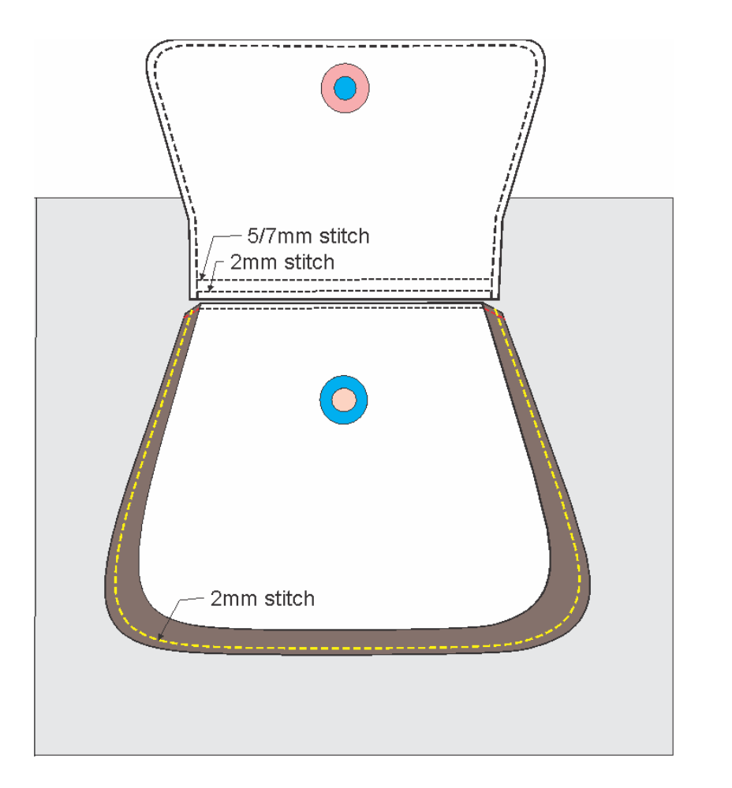
Task 9. Finishing operation
- Cut the thread ends and burn by thread burner.
- Remove any marking line on the leather
- Clean the latex/rubber glue by using textile cloth

LAP Test-practical demonstration

Directions: perform all the activities
- Make Patch with flap pocket construction
- Make a Pouch pocket construction
- Make a collar construction
- Make a sleeve with cuff construction

Unit five: Check the quality of constructed components
This unit is developed to provide you the necessary information regarding the following content coverage and topics:
  - Checking quality of component
  - Checking quality of stitched/constructed components
  - Reporting faults and rework
This unit will also assist you to attain the learning outcomes stated in the cover page. Specifically, upon completion of this learning guide, you will be able to:
  - Check quality of component
  - Check quality of stitched/constructed components
  - Report faults and rework

Checking quality of constructed component
Introduction to Quality
- Quality - Meet specification, fitness for use, anything that can be improved, absence of variation, conformance to requirements and bad quality is a social loss
- Control - preventing defects from happening
- Quality control is a system of integrating quality development, quality management and quality improvement
Quality control aspects of leather garment and goods manufacturing
Quality management:
In quality management, the management must have a considered policy for quality and then make sure that all employees understand it. Supervisors play an important role in workers motivation and in quality control.
Specifications:
• Written specifications are essential to ensure that the buyer and seller both understand exactly what is to be manufactured.
• The term “commercially acceptable” is frequently encountered but unfortunately, it does not tell the leather goods maker what standards his product should conform to or the leather goods producer what the leather characteristics should be.
• Formal specification results in the company being control of the whole operation
- Parameters of quality
- Performance: Must satisfy a customer under normal working conditions by virtue of its ability to achieve the desired results or service.
- Features: Product must be able to offer or give the expected performance easily and comfortably under normal operating conditions.
- Reliability: Reliability ensures optimum performance of product without frequent failures and without any constant attention, adjustment or maintenance.
- Conformance: Ensures the dimension of quality adherence of a product to the stipulated specification or performance.
- Durability: Durability ensures the life span of the product over which it is enabled to offer the optimum performance.
- Serviceability: Offers an uninterrupted performance of the product by way of prompt and competent service.
- Aesthetics: Contributes to the customers’ satisfaction.
- Perceived quality: Involves the image, advertisements, brand names etc, which influence expectations and confidence of the customer to go for a particular product.
- Quality Checking Aspects of constructed component
- Checking components against specification
Conformance checking of components is a testing method to see if the application and its specification are equivalent.
Such checking is necessary to assure if the requirements given in the specification are achieved or not.
- Check the edge of the cut components.
- Components should be check if any fault on the edges of the components.
- Check the Sewing defects of the leather garment and goods components
- Check Sewing defects - Like open seams, wrong stitching techniques used, same color leather garment and goods, but usage of different color threads on the garment, miss out of stitches in between, erroneous thread tension and raw edges are some sewing defects and checking stitched quality
- Checking the size of the component
- Check Sizing defects - Wrong gradation of sizes, difference in measurement of a garment and goods part from other, for example- top sleeves and under sleeves miss much the size, width and length of the straps , the size of the front, the size of the back ,the size of the gusset and base , the size of pockets. Such defects do not occur has to be seen too.
- Checking the construction component
- Check leather garment and goods construction component defects - During manufacturing process defects could occur like faulty zippers, loose buttons, raw edges, improper button holes, uneven parts, inappropriate trimming, and difference in fabric colors
- Checking the Color of component
- Check Color effects - Color defects that could occur are difference of the color of final produced leather garment and goods to the sample shown, accessories used are of wrong color combination and mismatching of dye amongst the pieces.
The purpose of checking of a component is:
- To have defective work corrected
- To prevent the dispatching of defective work
- Types of quality checks
1. Line quality control:
Regular hourly inspections are carried out in the processing line starting from the first operation of selection and inspection of leathers to finished products The faults occurring in between the process are recorded and remedial measures are taken to rectify the defects immediately.
2. Stage quality control:
Stages are created viz. first stage, second stage, third stage etc. for regular inspection at predetermined points of problem areas depending upon the need and importance. If defects are noticed in anyone of the stages, the process is stopped for corrective action.
3. Final quality Control:
The finished products are thoroughly checked for 100% perfection. If the product does not conform to the standards and specifications, the product is rejected.
- Some other terms
- In Process Quality Control
The In-Process Quality Control system lays emphasis on the responsibility of manufacturers’ processors in ensuring consistency in quality during all stages of production by adopting quality control drills and exercising control on raw materials and bought-out components, manufacturing process, packing and final testing.
- Can also be referred as in line qc
- Identify problems as early as possible
- Only way to fix a problem is find a problem
- Post production Quality Control
In the post-production quality control process inspectors examine all products and remove the ones with substandard features.
- Acceptable quality level:
Random checks or check as per sampling plan is carried out for acceptable quality level. If the samples do not satisfy the acceptable quality level, they are sent for necessary corrective action. If the samples are found to be good, they are sent for consignment inspection.

Reporting faults and rework
Definition of faults
The defect in a garment is not intended. But somehow defects are generated during the processing of the garment. To make a quality garment, all the defects must be rectified through the checking process. Further action is taken for eliminating garment defects from the process and from the raw materials or avoids using the defective raw materials. By knowing the defects that may arise at each stage of garment manufacturing, it can help in taking appropriate control measures to ensure the production of the right quality of the garment.
Common fault and remedies during leather garment and goods
Sewing Defects: These defects are usually caused by errors arising from wrong functioning of sewing machines.
A. fault of stitch formation
i) Slipped stitch: Missing of interloping or interlacing between top and bottom threads.
Causes:
- Looper or hook and needle are not properly placed.
- Irregular thread tension.
- Needle deflection.
- Needle threads loop size too small.
Remedies:
- Proper placement of needle and looper or hook.
- Accurate tension maintaining.
- Needle can be changed.
ii) Staggered stitch: Stitch is not parallel produced by needle.
Causes:
- Needle deflection.
- Due to wrong needle point.
- Defected motion of feed dog.
- Wrong adjustment of needle and thread size.
Remedies:
- Increase needle size.
- Needle size and thread size to be altered.
- Motion of feed dog to be adjusted.
iii) Unbalance Stitch: Improper interlacement of threads especially in lock stitch machine.
Causes:
- Wrong tension of sewing thread.
- Used wrong thread path.
- Snagging of needle with bobbing case.
Remedies:
- Setting of proper tension to the sewing threads.
- Use of right thread path.
- Bobbin case to be smooth.
- Variable stitch density: Number of stitch per unit length is not equal.
Causes:
- Improper unwinding of thread from package during sewing.
- Twisting of needle thread in the bottom of thread package.
- Snarling of thread before tension disk.
- Use of broken check spring.
- Fraying of thread in the needle.
Remedies:
- The position of thread guide must be 2.5 times higher than the position of thread package.
- Foam pad must be used to the bottom of thread package.
- Winding of more threads in the thread guide.
Check spring need to be changed.
- Finer threads must be used or to be used heavy needle.
v) Frequent thread breakage: Thread breaking frequently during sewing.
Causes:
- More tension to the bobbin threads or more rotating of bobbin.
- Wrong fitting of bobbin case.
Remedies:
- Proper winding of threads on to the bobbin.
- The tension must be adjusted to the bobbin threads.
- Checking out the damaging case.
B. Problem of puckers:
Causes:
- Variable or uneven stretch on fabric plies.
- Fabric dimensional instability.
- Extension of sewing thread.
- Sewing threads shrinkage.
- Fabric construction
- Mismatched patterns.
Remedies:
- Proper feed mechanism should be used with equal ply stretch.
- Fabric shrinkage property must be almost equal.
- Using less tension to the thread.
- Fabric and sewing thread shrinkage% should be equal.
- By reducing stitch density for heavy fabric.
- Pattern should be matched properly.
C. Damage of fabrics on seam line:
Fabrics or threads are damaged along the seam line during sewing.
Causes:
- Mechanical damage.
- Needle heating damage.
Remedies:
- By using perfect size and shape of needle and needle point.
- By testing sew ability before sewing fabrics.
- By flowing cool air on the needle during sewing.
- By using lubricant to the needle and fabrics to the sewing line.
Seaming defects: These defects are usually caused by errors arising from the interaction of the operator and machine in the handling of garment.
Placement Defects: These defects are usually caused by errors arising in marking and cutting as well as sewing operations in the sewing room or a combination of these defects category
Major defects: Uncut Thread, Skipped Stitches, Scissor or knife cut Puckering, Broken stitches, Oil Mark / splash, Uneven Stitches, Misaligned Buttons & Button Holes, Uneven Margin, Open Seam
2 Reporting faults for rework
While checking components some faults may be identified, these faults should be reported to the superiors or return to the assembling section where they could get repaired or reworked.
Leather Garment and Goods Preparation manner for Repair
The Production Manager / Supervisor carry out repairs on leather garment and goods in manufacturing environment –
1. Examine the article to see what repairs are required
2. Where appropriate, tell the customer what the options are, the likely length of time the repair will take, and expected costs
3. Prepare the machines and tools
4. Prepare the article for repair including removing worn or damaged parts and preparing any adhesive solutions
5. Make sure that the materials used in the repair are free of faults and compatible with the article’s materials
6. Minimize wastage of repair materials
7. Attach new components
8. Complete any final repairs
9. Trim any excess material
10. Polish and buff the article as required
Tools, material or equipment for the repair work
Selection of appropriate tools and equipment required to perform repair work or finishing operations.
1 Crepe Rubber
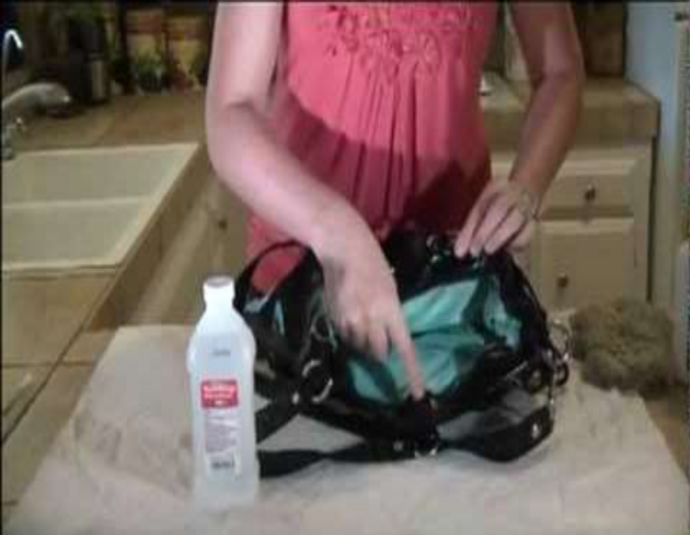
Figure 81: Crepe Rubber
Crepe Rubber is used to clean the surface of the bags wherever glue or adhesive has been be stuck. For cleaning purposes it is a good option to clean. It is a natural product produced by coagulation the latex from the rubber tree. Latex is formed into thin sheets, and then laminating and pressing a good number of sheets together to give a specific thickness. Chemically it is a polymer made from “Isoprene” monomer units which has sufficient strength not to need vulcanizing.
The crepe which is harder and lighter in color provides better wear comfort.
2. Foam
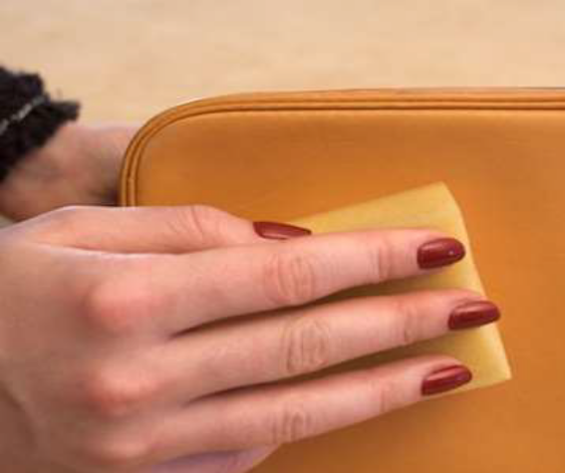
Figure 82: Foam
The whole product is cleaned both inside and outside with a clean piece of foam.
Before the articles are sent for packing, strict quality control is observed for perfection in assembling, Stitching accuracy and smooth functioning of fittings. Start by removing any dirt or debris by wiping the bags with a foam/ cloth. Apply a small amount of shoe cream and spread evenly in a circular motion over bags. You can use either Foam, cotton cloth or a polish application brush to apply. Polyurethane foam rubber sheets are used in a variety of leather goods where cushioning of the products is necessary. 2m x 1m x 3mm and 2m x 1m x 6mm foam rubber sheets.
3. Polishing Cream
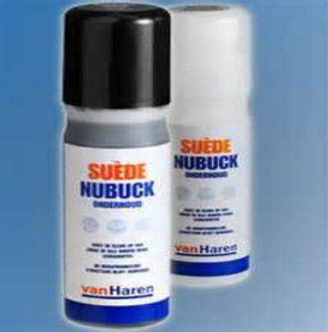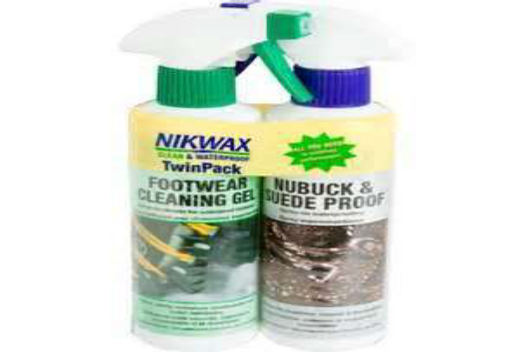
Figure 83: Polishing Cream
Polish usually contains several kinds of synthetic waxes, paraffin waxes, resin, solvents, auxiliary agent and water. As well as the requirements of the consumer, cost of the components is an important factor in the formulations.
While shoe finishing are non-commonly and loosely referred to as inks and stains many more chemical products are in general use in bag factories as essential raw materials for finishing purpose. In big cities polishes are used for both shining the shoes and protecting them against dust etc. In all types of color and design the polishes are needed with every type of leather goods.
Liquid polish used as a protectors, which is normally applied by aerosol spray, confer on the footwear material a measure of water / oil repellency and hence reduce the severity of subsequent staining. The depth of absorption and hence the degree of protection depends upon the absorbency of the material. They are therefore most popular for unfinished leathers like suede and nu- bucks.
Get into the habit of polishing leather shoes regularly. A polish conditions and helps retain leathers natural oils. It masks scuffs and marks, enhances the color and provides a protective layer from light rains and spills.
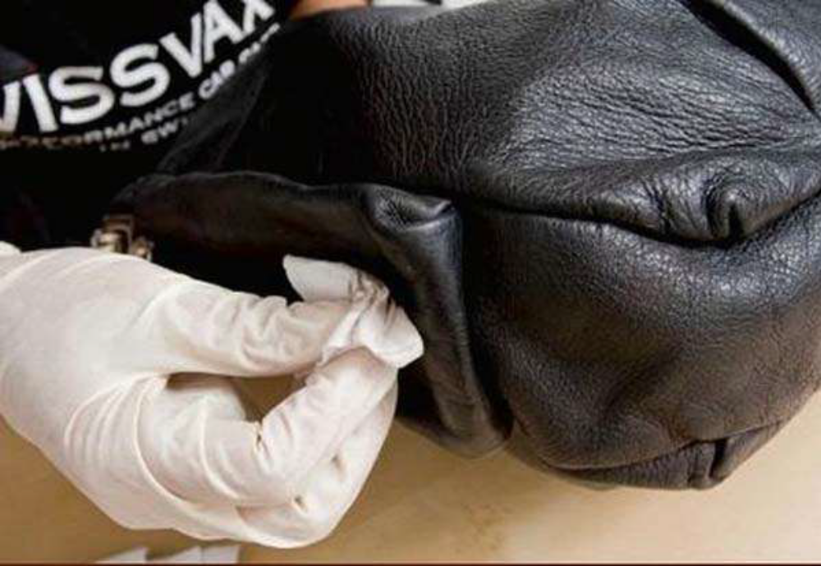
Figure 84: Polishing
Leather Bag Maintenance
- The leather bags should not be stored in plastic bags or other nonporous covers as they encourage the growth of mildew and bacteria that ruin the leather.
- In a dry environment, regularly condition the leather in order to prevent it from drying out and cracking.
- Alcohol, Turpentine and mineral spirits must be avoided as they can pull color.
- No waxes or silicone should be used on soft leather as they gum up the pores, making it impossible to oil and condition.
- Fresh stains of blood or food items can be cleaned up with a damp cloth. While those from oil or grease can be cleaned by grinding ordinary blackboard chalk, sprinkling the area and leaving the powder on for a twenty-four hour period.
- A dampened cheesecloth and a leather conditioning cream should be used thrice or four times a year. This facilitates the durability, shines with and increases the beauty of the leather bags.
Storage of Leather Bags
- Opt for not hanging your purses on a hook or a hanger. Depending on the strap of the handbag, a hook or hanger can distort the shape of it. Instead, store your purses in an open basket in a clean, dry spot in your home. Make sure that the basket has a piece of fabric or cloth on the bottom of it.
- Keep tissue paper stuffed into it. It will help to keep the bag in a nice shape when you’re not using it. If the purse has no flap or zipper on it, the tissue paper will also prevent dust from flying into it. Since most purses already come with big wads of it, use that instead of having to buy some.
- Make sure to store the basket that contains the purses off of the floor.
- Keep them stored out of direct sunlight. The light can distort the color of the bags and ruin them.
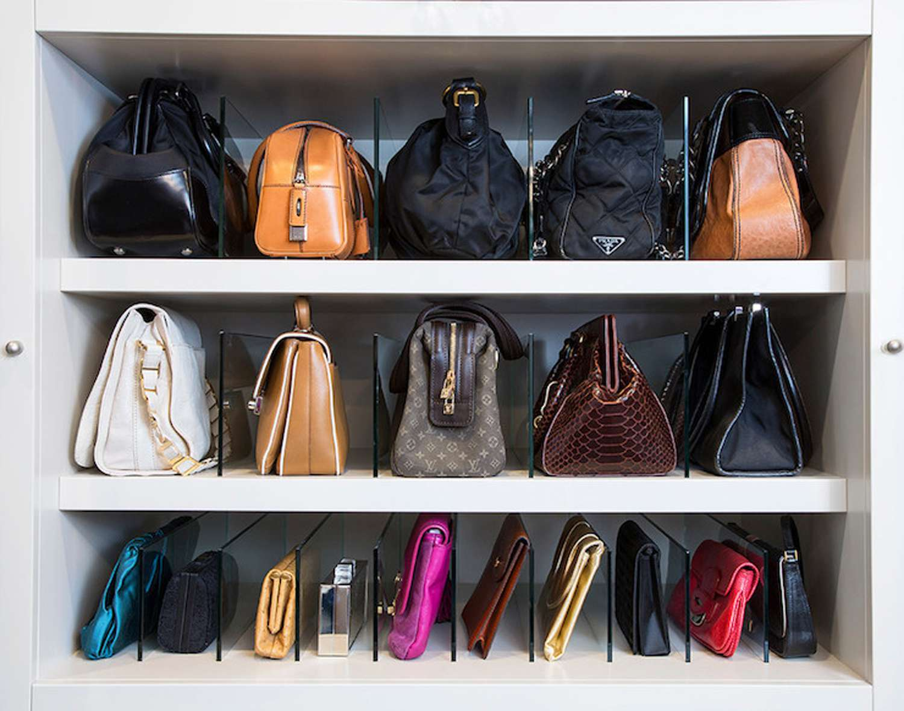
Figure 84: storing leather goods

Self-Check 5 | Written Test
Directions: Answer all the questions listed below.
        - 1. What is quality? (5pts.)
        - What are the parameters of Quality? (5pts.)
        - List Types of quality checks? (5pts.)
        - List Tools, material or equipment for the repair work? (5pts)
        - 2. What is the use of Crepe rubber? (5pts)
        - 3. List Common fault and remedies during leather garment and goods? (5pts)

Unit six: Dispatch completed work
This unit is developed to provide you the necessary information regarding the following content coverage and topics:
  - Bundling, stacking, storing or dispatching component
  - Recording production faults
  - Completing and maintain recorded faults.
This unit will also assist you to attain the learning outcomes stated in the cover page. Specifically, upon completion of this learning guide, you will be able to:
  - Bundle, stack, store or dispatching component
  - Record production faults
  - Complete and maintain recorded faults.

Bundling and dispatching component
Bundling
Bundling is the process of assembling the same type of components or products together.
This process is carried out to prevent merging different types of components.
Bundling is the process of disassembling the stacked and cut pieces and reassembling them in production lots grouped accordingly. Manufacturers use a variety of bundling methods depending upon their needs, with four basic systems being the most common among local manufacturers.
A. Item Bundling
All pieces that comprise the product are bundled together.
B. Group Bundling
Several (10-20) components are put together in a bundle and given to a single operator or team to sew.
C. Progressive Bundling
Pieces corresponding to specific sections of the product are bundled together and given to one operator. Other operators sew other parts of the garment, which are then assembled into the finished product in the final phase.
Stacking
Stacking is the process of giving batches or identification for the bundled products or component.
Dispatching
Dispatching is forwarding a work to the next section for further process.
Dispatching is the routine of setting productive activities in motion through the release of orders and necessary instructions according to pre-planned times and sequence of operations embodied in route sheets and loading schedules.
In other words, once a job is in an area where an operation is to be performed, it has to be determined when and by whom the job will be processed and also the sequence of waiting orders to be processed. The decision of assigning the various jobs to different machines and equipment is called Dispatching. The final decisions of dispatching are to be taken within the constraints set up by scheduling function.

Functions of Dispatching:
- To check the availability of input materials and ensure the movement of material from store to first process and then from process to process.
- To ensure the availability of all production and inspection aids.
- To obtain the requisite drawings, specifications and material lists.
- To assign the work appropriate machine, workplace and men.
- The issue of job orders authorizing operations in accordance with dates and times previously planned and entered on load charts and route sheets.
- The issue of time tickets, instruction cards and other required items to the workers who are to perform the various activities.
- The issue of inspection orders after each operation in order to determine result regarding the quality of products if excessive spoilage occurs, to find out its causes.
- Clean up on jobs, collection of time tickets, blueprints and instruction cards and their return to appropriate section of production control depth.
- To ensure that the work is forwarded to next department or store room etc.
- To record the beginning and completion times of jobs on time tickets for calculation of time interval. To forward time ticket to accounts depth for preparing wages.
- To record and report idle time of men and machines and request for corrective action required.

Forms used in Dispatching Department:
1. Tool Order:
It is normal practice to specify the tools, jigs and fixture for each job. The function of the tool order is to ensure the availability of these tools at right time when the job is scheduled to start.
2. The Job Order:
The main function of this order is to provide authority for starting operation. In general this order is combined with some other forms like; the job card, production ticket, time ticket, inspection order and move ticket.

Recording production faults
Fault records are one of the most important pieces of evidence that event analysts can have during system event investigations. They can provide the reasons for premature equipment failure, supply waveforms and status of equipment behavior during an event, and give necessary information to perform post-fault event analysis.
Proper use and interpretation of event records can lead to corrective action for a given system problem resulting in improved performance and reliability of any generation, transmission, and distribution system. Fault records are now captured by microprocessor relays but records are limited to sampling rate and record length. Some use digital filters that do not reflect the real captured waveform.
Fault recording has been used for decades now, and it is generally used for two main purposes:
- Recording of system events
- Monitoring of system protection performance
Recording Production faults
This unit is to monitor your own production activities;
- Identify and find out the cause of faults;
- Correct faults;
- Make a variety of decisions;
- Use appropriate methods not only to rectify any faults but to prevent any repetition of the fault.
- The competent person must:
  - Carry out quality checks at specified intervals according to instructions
  - Identify faults and take appropriate action
  - Report faults outside personal responsibility to the appropriate person
  - Record information accurately, completely and legibly
  - Identify faults in materials and products
  - Identify causes of faults to maintain product quality
  - Follow reporting procedures where the cause of faults cannot be identified
  - Identify and report potential solutions to rectify faults
  - Priorities the fault rectification process to maintain production requirements
  - Make adjustments promptly to return product to specification
  - Monitor rectified faults to ensure the problems have been solved
  - Record adjustments not covered by established procedures for future reference.
- The job role will involve:
- Finding the cause of faults in materials and products
- Correcting faults and recording details
- Carry out quality checks at specified intervals according to instructions
Identify faults and take appropriate action
- Record information accurately, completely and legibly
- Identify faults in materials and products
- Identify causes of faults to maintain product quality
- Make adjustments promptly to return product to specification
- Monitor rectified faults to ensure the problems have been solved
- Record adjustments not covered by established
- Recording Production faults
The faults that happened in the process of the production, the cause, and the solution taken must be recorded and kept safe. This helps to prevent the fault.
- Following points must be recorded
  - Reason behind the fault.
  - How to correct it.
  - What correction technique is used

Completing and Maintaining Records
Maintaining Records is the practice of maintaining the records of an organization from the time they are created up to their eventual disposal. This may include classifying, storing, securing, and destruction (or in some cases, archival preservation) of records.
A record can be either a tangible object or digital information: for office documents, databases, application data, and e-mail. Records management is primarily concerned with the evidence of an organization's activities, and is usually applied according to the value of the records rather than their physical format.
Records must be identified and authenticated. This is usually a matter of filing and retrieval; in some circumstances, more careful handling is required.
Identifying records:
If an item is presented as a legal record, it needs to be authenticated and that any damage, alteration, or missing content is documented. This level of authentication is rare, but requires that special care be taken in the creation and retention of the records of an organization.
Storing records:
Records must be stored in such a way that they are accessible and safeguarded against environmental damage. A typical paper document may be stored in a filing cabinet in an office. However, some organizations employ file rooms with specialized environmental controls including temperature and humidity. Vital records may need to be stored in a disaster-resistant safe or vault to protect against fire, flood, earthquakes and conflict.
Circulating records:
Tracking the record while it is away from the normal storage area is referred to as circulation. Often this is handled by simple written recording procedures. However, many modern records environments use a computerized system.
These can also be used for periodic auditing to identify unauthorized movement of the record.
Disposal of records:
Disposal of records does not always mean destruction. Destruction of records ought to be authorized by law, statute, regulation, or operating procedure, and the records should be disposed of with care to avoid inadvertent disclosure of information. The process needs to be well-documented, starting with a records retention schedule and policies and procedures that have been approved at the highest level. An inventory of the records disposed of should be maintained, including certification that they have been destroyed. Records should never simply be discarded as refuse.
Managing electronic records:
The general principles of records management apply to records in any format. Digital records (almost always referred to as electronic records), however, raise specific issues. It is more difficult to ensure that the content, context and structure of records is preserved and protected when the records do not have a physical existence. This has important implications for the authenticity, reliability, and trustworthiness of records
At the end of your work, all workplace records should be updated. It is the responsibility of the operator to:
- Do a quick visual check to make sure everything is OK
- Ensure the work area housekeeping is up to standard
- Ensure that productions are dispatched accordingly.

Self-Check 6 | Written Test

Directions: Answer all the questions listed below.
  - What is dispatching? (3pts)
  - What is bundling? 3pts)
  - List out function of dispatching? (3pts)
  - What is stacking? (3pts)
  - What is recording production faults? (3pts.)
  - During recording production faults the competent person must fulfill what kind of point? (3pts.)
  - What are the points which must be recorded while recording production faults? (3pts.)
  - List the two general purpose Fault recording? (3pts.)

List of Reference Materials

- A Manual of leather accessories and leather wear, Subramanian Natesan, CLRI,ADYAR, CHENNAI, INDIA
- http://latestnews.bsi-inc.com/2009/05/safe-use-of-adhesives.html

Experts Who Developed this Learning Guide
No | Name | Educational Background | Region | E-mail
1 | Getaneh kifle | Msc creative design CAD-CAM | Addis Abeba, | Getaye438@gmail.com
2 | Endalew tagele | BSC in Leather and leather product technology | Bahirdar

