Leather Garments and Goods Production
Level I
Based on December 2021, curriculum version I
+
Module Title: performing preparation works
Module Code: IND LGG1 M05 1221
Nominal hour: 84 hrs.
Prepared by: Ministry of Labor and Skill
Aug. 2022
Addis Ababa, Ethiopia

Table of Contents
Introduction to the Module 5
Unit one: Preparation machine set up 6
1.1 Cleaning work area and machine 7
1.2 Establishing safe working environment 10
Self-check 1 18
Unit Two: Preparation hand tools 19
2.1 Identifying and Use preparation hand tools 20
2.2 Cleaning and keeping hand tools 27
Self-check 2 30
Unit Three: Preparation Machine Operation 31
3.1 Identify and use Preparation Machine 32
3.2 aligning work piece correctly to machine by connecting machine to power safely 44
3.3 Preparation machine operation with OHS practice 48
3.4 Monitoring performance oa machine. 54
Self-check 3 56
Operation sheet 3.1 57
Operation sheet 3.2 57
Operation sheet 3.3 58
LAP test 59
Unit Four: Checking works received 60
4.1 Receiving and checking completed works 61
4.2 Labeling or tagging completed work 63
Self-check 4 64
Unit Five: bench work operation 65
5.1 Identifying necessary table work tools 66
5.2 performing bench work operations 67
Self-check 78
Operation sheet 5 - performing bench work operations 79
Unit six: checking component quality 81
6.1 Checking components against specification 82
6.2 Reporting and/or returning faults for rework or repair 83
Self-check 84
Unit seven: dispatching completed works 85
7.1 Bundling, stacking, dispatching and storing of components Dispatching 86
7.2 Recording Production faults 87
7.3 Completing and maintaining records 88
Self-check 89
Reference 90

Acknowledgment

Ministry of Labor and Skills wish to extend thanks and appreciation to the many representatives of TVET instructors and respective industry experts who donated their time and expertise to the development of this Teaching, Training and Learning Materials (TTLM).

Introduction to the Module

Leather garment and goods production is done by operation from simple to complex. Every operation done in leather garment and goods production are very important and mandatory. Preparation is one of the most important operations and done by high number of workers.
This module is designed to meet the industry requirement in leather garment and goods production occupational standard, particularly for the unit of competency: perform preparation work
This module covers the units:
- Preparation machine set up
- Preparation hand tools
- Preparation Machine Operation
- Checking works received
- bench work operation
- Checking component quality
- Dispatching completed Work
Learning Objective of the Module
- Prepare work and set up a machine
- Identify and use Preparation hand tools
- Identify and Operate Preparation Machine
- Check works received from a machine
- Perform bench work operation
- Check the quality of components
- Dispatch completed Work
Module Instruction
For effective use of this module trainees are expected to follow the following module instruction:
- Read the information written in each unit
- Accomplish the Self-checks at the end of each unit
- Perform Operation Sheets which were provided at the end of units
- Do the “LAP test” giver at the end of each unit and
- Read the identified reference book for Examples and exercise

Unit one: Preparation machine set up
This unit is developed to provide you the necessary information regarding the following content coverage and topics:
  - Cleaning work area and machine
  - Establishing safe working environment
  - Checking up Machine condition.
  - Cleaning a machine and make ready for work
This unit will also assist you to attain the learning outcomes stated in the cover page. Specifically, upon completion of this learning guide, you will be able to:
  - Clean work area and machine to prepare for work.
  - Establish safe working environment.
  - Check machine condition as per the requirement.
  - Cleaning a machine and make ready for work

Cleaning work area and machine
Preparation is one of the most important sections of leather garment and goods production operation. It is necessary for a worker to make ready his work station and machinery for work. every phase of the leather garment and goods production should apply the cleaning and maintenance procedures throughout the entire premises. It is more than mere cleanliness. It requires orderly conditions, the avoidance of congestion, and attention to such details as an orderly layout of the whole workplace, the marking of aisles, adequate storage arrangements, and suitable provision for cleaning and maintenance.
lubrication
Lubrication is the action of applying solution like grease or oil to a part of an equipment or a machine to minimize friction and allow smooth movement.
cleaning
Cleaning is the process of making something clean or it is the action of removing unwanted wastes, dusts and other impurities for best functioning of the machine.

Importance of cleaning machines regularly
- Reduce machine failure
- Keep machine in proper work condition
- Improve production efficiency.
- Helps to increase working life time of the machine
- Plays a great role to maximize productivity
- Prevent accident.
Cleaning preparation machines
- Cleaning Splitting
- blow dusts all over the machine.
- remove scrap dust and Clean inner filter.
- Clean scrap dust filter.
- Clean knife wheel scrapers.
- Clean felt plate.
- Clean the grinding unit
- empty and clean emery dust bag
- Clean emery dust front chamber and emery dust side chamber

Lubricating:
Lubricate upper felts with Vaseline oil, light mineral paraffinic oil, and other lubricating oils.

- Cleaning Skiving machine
- Switch off the machine and open the door of the scrap box
- Take out and empty the waste basket
- Remove the material which has accidentally come out of the basket before removing the filter.
- Once the internal case is thoroughly clean, take out the filter.
- Clean the filter by carefully following the instructions printed on its side
- Clean that no machining waste material has accidentally fallen into the underlying fan. If it has, clean it carefully.
- Correctly install the filter again (see assembly drawing) as well as the basket and properly close the door.

Lubrication& Greasing:
- Dismantle the feed roller and grease the pin.
- Loosen the screw that locks the lever and extract the piece. After having cleaned by naphtha, grease the pieces with lubricating grease and assemble all again.
- Before assembling again, the feeding transport roller set grease the tops of the screws.
- Check the oil into the box it must cover until the half of its diameter the helical wheel.

- Belt Edge Roughing Machine
General cleaning of surfaces every day at the end of the working cycle
- Clean sliding guides every day, at the end of the working cycle
- Clean exhauster bag and filter every week
- Clean transport rollers every week
- Clan machine internal bottom every year.
Lubrication & Greasing:

- Apply grease and lubricate chains and transmission gears every month.

Visual check:

- Check functioning of the transport and tools every day before starting the working cycle
- Check tooling wear every day before starting the working cycle
- Check belt wear every month

Punching, riveting and Buttoning machine
Cleaning:
- brush and clean every part of the equipment every week.
- Clean hopper at the end of the working cycle for automatic riveting machine
- Clean feed track at the end of the working cycle for automatic riveting machine
- add grease and oil on the spring every month

Establishing safe working environment

safe working environment is a working place where employees feel secured and enjoy a safe physical work environment; feel recognized for the work they do. enjoy a positive social environment that encourage respect, fosters a sense of belonging and purpose.
The purpose of a workplace’s occupational health and safety activities is to improve
working conditions – to prevent and fix deficiencies and help solve work-related
problems.
In the preparation stage of leather garment and goods production there are some solutions and chemicals used which are volatile and harmful health. therefore, the production area must have good safety rules. There are also tools which are used for preparation that have to be used minding the chance of hurting our body.
Workplace environment and conditions influence workers performance to a great extent. Temperature & humidity, noise and quality of light are some key conditions. These can have an effect on the safety and health of workers and can easily be improved.
Temperature & humidity

. Good ventilation and air circulation in the work area and insulation of buildings against outside health and cold will contribute to pleasant temperature and reduction of humidity. At eh same time, overall ventilation also reduces the concentration of airborne contaminant.
Ideally factors such as direction of wind and facing northern direction for sunshine should be always considered when planning the construction of a production area.
  - Use natural ventilation and air circulation to achieve low-cost overall ventilation first, taking advantage of horizontal air movement around and though buildings or the tendency of hot air to rise. Simple modifications such as removal of separating walls or increase of wall opening will improve the natural airflow.
  - Install fans, where natural air ventilation and circulation are not sufficient.

Insulation against heat and cold
Before resorting to expensive equipment to control temperature, be aware that heat and cold are also caused by outside climatic conditions. Heat and cold may get inside the factory directly through opening such as windows, doors, gaps, skylights, or indirectly though conduction through walls and roots. While ventilation is one way to remove heat from the work place, also consider to:
  - Improving the heat reflection of walls and roofs by plastering or whitewashing;
  - Improving the insulation of the roof by using insulating material or double layer roof;
  - Using radiant heat from machines and process to warm the work place in cold climate;
  - Using shades for the walls opening to deflect heat from direct sun shine;

Quality of light
Poor lighting leads to low productivity and poor quality, as workers will start suffering from eye strain, fatigue and headache. Better lighting does not mean that more light bulbs have to be fixed in many cases, rearrangement of existing lighting and proper maintenance and cleanliness of reflectors/fittings will result in improvements.

  - Make full use of natural daylight by installing skylights or modifying size and location of window. Keeps window clean all the time. You save the electricity cost of artificial lighting.
  - Paint ceilings and inner walls in lighter colors. This provides better reflection and distribution of existing light sources besides resulting in better visual condition and a pleasant work environment.
  - Avoid direct and indirect glare, glare can distract the workers concentration, possibly resulting in poorer quality or even accidents.

Noise

Not all sound is noise – noise is sound that people do not like. Noise can be annoying and it can interfere with your ability to work by causing stress and disturbing your concentration. Noise can cause accident by interfering with communication and warning signals. Noise can cause chronic health problems. Noise can also cause you to lose your hearing. Hearing loss from exposure to noise in the workplace is one of the most common of all industrial diseases. Workers can be exposed to high noise level in workplaces as varied as construction industries, foundries and textile industries. Short-term exposure to excessive nose can cause temporary hearing loss, lasting from a few seconds to a few days. Exposure to noise over a long period of time can cause permanent hearing loss. Hearing loss that occurs over time is not always easy to recognize and unfortunately, most workers do not realize they are going deaf until their hearing is permanently damaged. Industrial noise exposure can be controlled – often for minimal cost and without technical difficulty. The goal in controlling industrial noise is to eliminate or reduce the noise at the source producing it.
The health effect of noise exposure depends on the level of the noise and the length of the exposure.
Temporary hearing loss
After spending a short time in a noisy workplace, you may have noticed that you cannot hear very well and you have a ringing in your ears. This condition is called temporary threshold shift. The ringing and the feeling of deafness normally war off after you have been away from the noise for the short time. However, the longer you are exposed to the noise, the longer it takes several hours for a workers may find it difficult to hear what other people are saying or may want the radio or television on louder that the rest of the family. Suspect hearing loss if a person complains that he or she cannot hear something when you can.

Permanent hearing loss
Eventually, after you have been exposed to excessive noises for too long, our ears do not recover and the hearing loss becomes permanent. Permanent hearing loss can never be repaired. This type of damage to the ear can be caused by long term exposure to loud noise or, in some case, by short exposures to very loud noises. When a work begins to lose his or her hearing, he or she may first notice that normal talking unclear. Worker often adapt himself or herself to hearing loss produced by harmful noise at work. It is important to be aware of science of hearing loss.

Other effects

In addition to hearing loss, exposure to noise in the workplace can cause a variety of other problems, including chronic health problem for example:
  - Decrease of coordination and concentration.

  - Noise increases stress, which can lead to a number of health problems, including heart, stomach and nervous disorders. Noise is suspected of being one of the causes of heart disease and stomach ulcers.

Risk assessment

Risk assessment is the basis for occupational health and safety. It is the employer’s
duty to carry out assessments.
The working environment must be designed so that it is as safe as possible, even in
case of human error. Hazards must be removed or minimized so that the employee’s
health is not endangered. Hazards are assessed at the workplace through risk
assessment.
It is the employer’s duty to carry out assessments. The assessment looks into hazards
and flaws detected in working conditions and their severity and probability. Working
conditions, accidents that have occurred, near-misses and occupational illnesses
must be taken into account in the risk assessment. Also, the employee’s age, gender,
expertise and other personal characteristics must be considered.
Risk assessment is the basis for occupational health and safety. It helps to pinpoint
how occupational safety should be improved at the workplace and which order the
improvements should be made in. A range of existing assessment models is available.

How can risks in the working environment be remedied?

The first issues that should be remedied are ones that can be fixed immediately.
Deficiencies are reported to the supervisor and occupational safety ombudsman.
Remedying deficiencies is the responsibility of the supervisor. They must ensure that
the deficiency is fixed. There are also issues that cannot be remedied immediately.
Of these, the first to be fixed should be problems that are assessed to be the most
harmful.
Remediation measures must be scheduled so that the most urgent ones come first.
Visible or invisible risk?
A work environment’s risks can be classified as either visible or invisible. A visible
risk is, for example, poor ergonomics. An invisible risk, on the other hand, could be a
disturbance that occurs suddenly, such as a defect in a device.
Similarly, an invisible risk is a problem situation that comes up for the first time: for
example, when an employee is presented with a sudden responsibility that they do not
have the required expertise for.

Working safely during preparation
In the above section you try to discuss about safe working environment in an organization generally. So, we have to relate all the concepts and ideas of keeping working environment to preparation section of leather garment and goods manufacturing.
- Make sure that the distance between you and preparation machine is safe enough.
- Check if there is moisture or water near electric power supplies.
- Use safety gloves when using preparation machine
- Mind the size of the leather to processed under preparation machines.
- Use safety eye glasses and mask when using adhesive in preparation
- Take care of your hand we you are using hammer or mallet during preparation.

1.3 Checking up Machine condition
Preparation machines should be checked their condition regularly for proper functioning.it helps the machine to minimize the risk of failure and damage. It also has a vital role for increasing the working life time of the machine
Checking up condition of machines used during preparation stage.
Checking condition of Leather splitting machine

The machine is equipped with a control panel (a microprocessor) which controls the overall operation of the machine. Emergency signals flash on the control panel which means that the machine is in emergency state and
therefore, intervention is immediately required to ensure efficient function. Press the key and a page will appear with a list of maintenance operations; flashing signal indicates the emergency situations to be corrected.
Worn blades, loos blade, emergency active, open guard, scrap box full, dirty conveyor roller, blade motor alarm, transport motor alarm, sharpening motor alarm, fan 1 alarm, open line contactor, machine maintenance in progress, all of these have their respective signal that flashes on the control panel for the corrective actions to be carried out.

Irregular material advance

- The blade edge is worn sharpen.
- If the lower conveyor roller is worn then replace.
- If there is difficulty in transporting with fixed foot when using heavy materials or “varnish”, replace with upper roller.
- If there is insufficient pressure of lower roller, increase the pressure.

Insufficient scrap suction

- If the scrap container is incorrectly closed, check the closure.
- If the grill is dirty, clean using compressed air.
- If the dust bag is clogged, clean.
Insufficient sharpening: dust removal
- Suction mouths with scale deposits, clean the wheel work area.
- Clogged clay filter clean
- If there is Intermediate full container, empty.

Checking condition of skiving machine
- Check the sharpness of the blade
- Check the functionality of skiving width and depth adjustment.
- Check for clogged scraps
- Make sure that the presser foot of the machine on the right pressure.
- The oil leakage must be checked.
- Recommended oil alone must be used.
- The blockage of dust particles in the hosepipes must be periodically checked.

Checking condition of Leather Edge dyeing machine

Edge dyeing machine is suitable for painting any type of edge of handbags, wallets and leather goods in general. With a simple application it is also capable of making an ornamental edge giving to the piece to be painted a pleasant decorated appearance
Machine Condition Checkup
Check that the inking roller is turning in the anticlockwise direction; if it should turn in the opposite direction, remove the plug from the main line, and invert one of the wires inside the plug taking care not to touch the earth wire.

Self-check 1

Directions: Answer all the questions listed below. Use the Answer sheet provided in
the next page:
- Multiple choice
- What is the importance of cleaning a machine?
  - Reduce machine failure
  - Keep machine in proper work condition
  - Improve production efficiency
  - All of the above
- Why we need to lubricate a machine?
  - To prevent the machine from corrosion
  - For smooth function of the machine
  - To increase the life time
  - All of the above
- What conditions have to be checked for splitting machine
  - Irregular material advance
  - Insufficient scrap suction
  - Insufficient sharpening: dust removal
  - All of the above
- Short answer
- Describe the importance of cleaning machines and tools regularly
- Write how to clean splitting machine.
- Explain briefly how to lubricate skiving machine.
- Discuss about the importance of cleaning machines regularly.
- Define safe working environment.
- Define and explain cleaning and lubrication?
- How can risks in the working environment be remedied?
- Explain the importance of checking up of machine condition.
- What do we check to assess the condition of splitting machine?
- What do we check to assess the condition of skiving machine?

Unit Two: Preparation hand tools
This unit to provide you the necessary information regarding the following content coverage and topics:
- Identifying and Use preparation hand tools
- Cleaning and keeping hand tools
This guide will also assist you to attain the learning outcomes stated in the cover page. Specifically, upon completion of this learning guide, you will be able to:
- Identify Preparation hand tools
- Clean and keep hand tools based on the type of the tools.

2.1 Identifying and Use preparation hand tools

A hand tool is a device or implement, especially one held in the hand, used to carry out a particular function.it is an extension of human hand. Leather preparation hand tools are devises can be held on hand used to accomplish tasks during preparation.
Hand tools offer high degree of control and precision. Using proper tools for the proper
jobs and safety precautions are the key factors for producing quality products. As tools
play a vital role in the manufacturing of leather products, it is necessary to keep them in
good working condition by storing them ready to use as well as safe from damage.
In the process of bench work operation there are a variety of tools used; these tools
should be functional and handy. Always and before using any tool we have to check
that it is functional.
Some of check points for the tools can be:
• Checking if there is breakage on the tools
• Checking sharpness of Blades, Dies, etc., …
• Checking the accuracy of measuring, and other related tools.

The most common preparation tools are described below.
Brush
It is one of the most basic and useful preparation tools known to leather products manufacturing. It generally consists of a handle or block to which fibers or filaments are attached. The fibers should be kept free from drying so that it will not damage material surfaces and minimizes wastage of glue.
To prevent it from drying it should be washed with kerosene and kept in container filled with water. To see the functionality of a brush we can press it on aboard and see if it is flexible, if itis stiffed and dry it should be washed with kerosene.


Fig 2.1 preparation brush
Hammer
The common hammer has a foot-long handle, secured through the eye of the head
with wooden block and a pair of iron ones. The hammer will do all the pounding,
pulling, tapping, knocking, etc. Since hammer is no less extension of the arm than any
other tool, it is important to have one that is suited size and is comfortable to use. Steel
hammer is used in assembling process. Light weight hammers 100gms and 200gms
are used for light works and hammers of weight 300gms and 500gms are used for
medium and heavy works.
We have to check the head of hammer that it is flat and it has no bumps on it.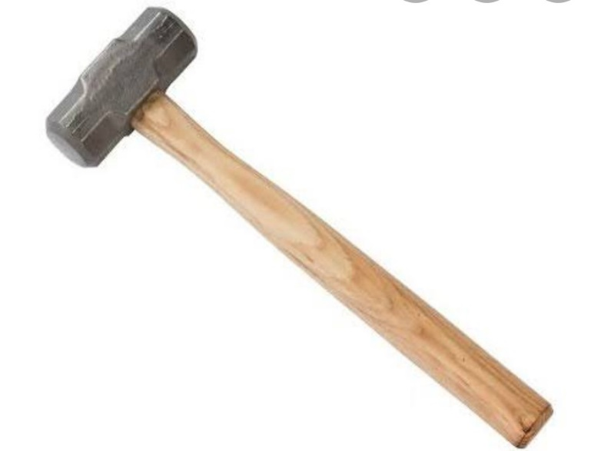
Fig 2.2 hammer
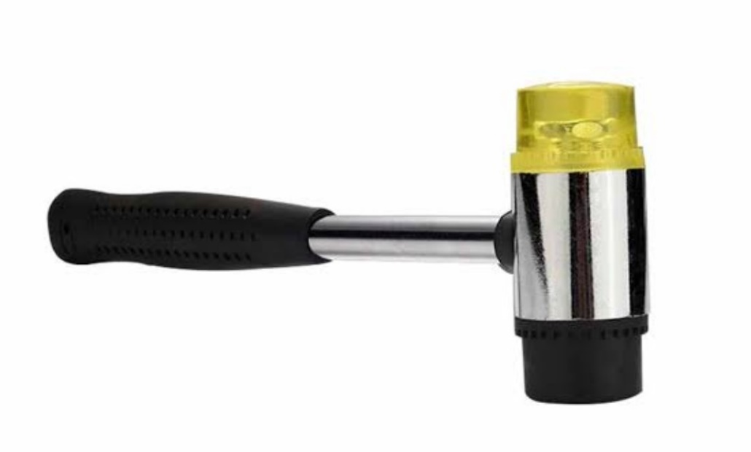
Fig 2.3 double face hammer
Hand stamper
Hand stamper is used in bench work operations. It is very convenient to use when
compared to hammers. Hand stamper is used for punching holes, setting rivets, snaps
and edge folding of glued components during assembling process as the hammer a
hand stamper head should also be flat and should not have bumps.
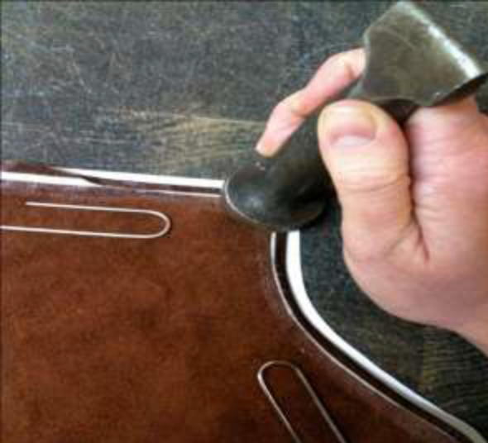

Fig 2.4 hand stamper

Revolving punch
The revolving punch with four or six different size tubes is used for punching holes for
lacing, riveting, eyeleting, and snap setting in leather components.
We have to check that the tubes have sharp rounds so that the holes made by the
puncher will be smooth. We can check the functionality of the puncher on a scrap of
leather.
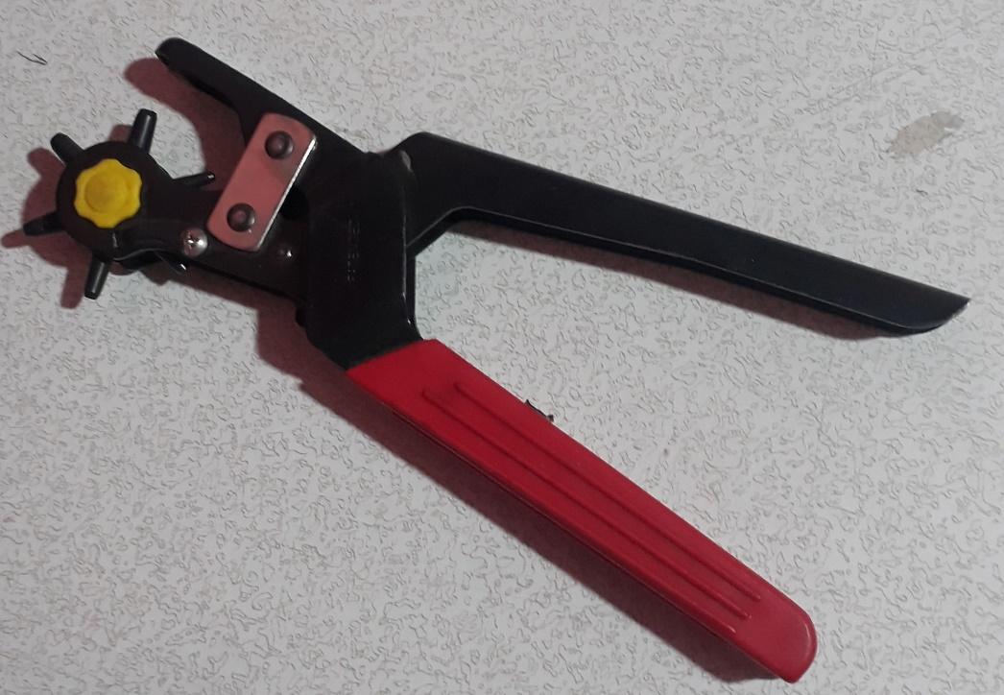
Fig 2.5 revolving punch
Punch
Punch or round drive punch is a cylindrical slotted punch made of tempered steel.
Different sizes of punches 00, 0,1,2,3, and 4 are used for making different sizes of
holes in leather components. These punches are used for fixing buttons, rivets, rivet
buttons, eyelets, studs, etc. in leather goods. Oblong/crew punches are used for
making holes in leather belts and hold all straps. As we check the revolving puncher
we have to check also that the punch tubes have perfect and sharp rounds.
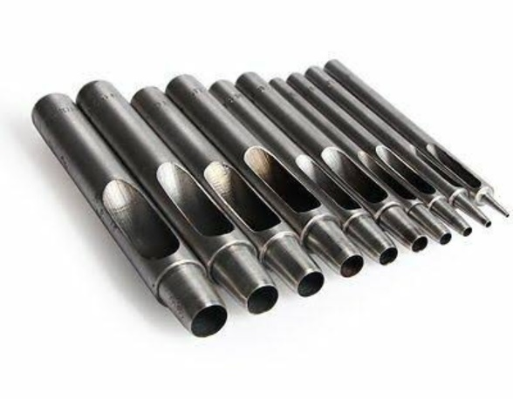
Fig 2.6 punch set
Scissors
Scissors are used for cutting or trimming leather, lining, or reinforcements. Scissors
should have sharp edges and should cut any materials smoothly and easily. We can
check the functionality of a scissors by opening and closing it repeatedly and see if it is
crossing over properly. Scissors can be sharpened and by a grinding wheel with care.

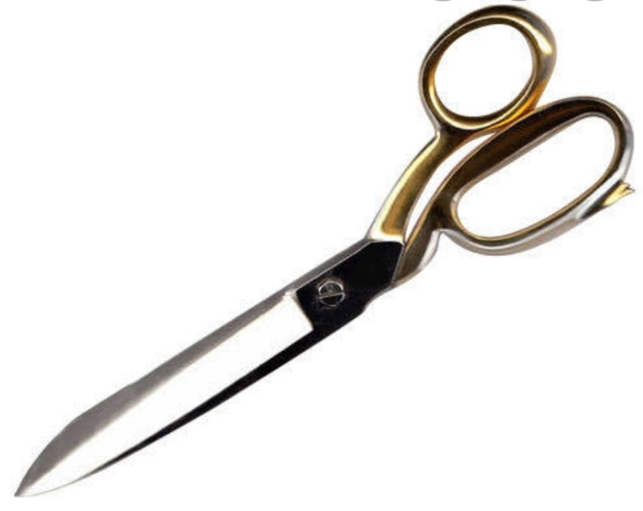

Fig 2.7 scissor

Bone folder:
Bone folder is made of horns. One end of the folder is filed off to a pointed edge and
the other end is rounded off to a smooth edge. It is also made from plastic. It is used
for edge folding. The edges of bone folder should be smooth. A rough or damaged
edge of a bone folder can be rubbed and refined with a sand paper.
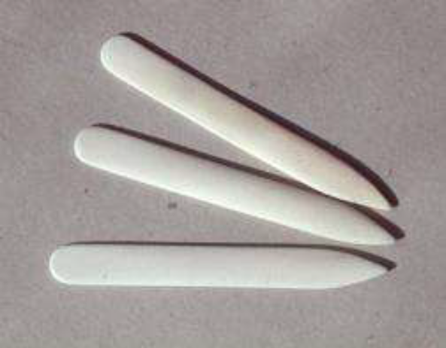
Fig 2.8 bone folder
Awl:
An awl is a hard-sharp steel needle with a wooden handle. It helps to make marks
during pattern cutting process and also during assembling process where leather
components are marked and fitted with fittings. The tip of the awl should always be
sharp; to check the functionality of the awl we can scratch it on a piece of board. If it
makes a scratch on the board it means the tip is damaged and need to be sharpened.

Fig 2.9 Awl

Cleaning and keeping hand tools

Cleaning hand tools
The hand tools used in preparation processes have to be cleaned and keep nice. The functionality of the tools will be decreased time by time, unless they are cleaned regularly.
In leather manufacturing industries different types of cleaning materials are used for cleaning the tools. Such as:
- Oils and grease
  - They are used for a tool which are made of steel that can be corroded
- Kerosene
  - Used as a solvent for cleaning adhesives and dyes
- Water
  - Used to clean and keep tools like brush
- Thinner
  - Used to remove adhesives and dyes.
Cleaning brush used for gluing
- Put small amount of kerosene or thinner on a can
- Put the brush on it and leave for a couple of minutes.
- Use your hand to remove the glue
- Dry the brush with a piece of fabric
- Put it on dry place provided
Cleaning scissors
- If there is moisture or water on the scissor dry it with fabric
- Add lubricating oil on the joint of the scissor
- Put it at dry place provided

Cleaning punches
- Remove punched pieces in the punch holes
- Clean it with oil
- Put it in the place provided
Cleaning hammer and mallet
- Remove glue attached on the mallet or hammer using glue remover
- Put on small amount of water on a piece of fabric and Clean the head of the hammer or the mallet.
- Put it on dry place provided.

    - Storing and keeping hand tools

The efficient handling and storing of tools are vital to manufacturing industry. In
addition to raw materials, these operations provide a continuous flow of work through
the workplace and ensure that tools is available when needed. Unfortunately, the
improper handling and storing of equipment often result in costly injuries.
Keep tools protected
One of the most important factors when storing your tools is to keep them protected
from moisture, dust and any other potential damage. A self-storage unit can provide
the perfect setting to accomplish this goal.
An absolute no-no in hand stool storage is to leave tools on the ground. If any
moisture is on the ground; your tools could rust. Plus, it creates clutter and just isn’t
an effective way to store tools. Instead, invest in shelving and storage units. Leaving
tools on shelves is better than the floor, but your tools will still be exposed to dust
unless you throw a plastic cover over them. Dust can damage motors and stick to
lubricants causing your tools to stop working. Cabinets with drawers will help protect
against dust, as well as hard cases. The plastic in hard cases will keep tools from being
damaged and allow you to store cords, batteries and other accessories along with
your tool. Plastic bins can also be used to store tools but stay away from cardboard
boxes – the cardboard can be destroyed by moisture and will be ineffective in
protecting your tools.
Make the best use of space
To maximize your storage space, line the walls with shelving. Fill drawers with tools and
accessories, storing bigger items in plastic bins underneath (you can use pallets to
keep the bins off the floor for extra protection). You can pile any hard cases on top
of the shelves. You can organize smaller items in drawers or small containers.

Self-check 2
Directions: Answer all the questions listed below. Use the Answer sheet provided in
the next page:
                - Short answer
- List and explain tools of preparation.
- For what purpose do we use hammer during preparation?
- What kind of tools can we use to make holes and eyelet openings?
- What is safe material handling?
- List and explain cleaning materials and solutions?
- What should do one worker to maximize tool storage space?
                - Matching
 | A |  | B
1 | Different size in one punching tool | A | Hand tool
2 | Used for applying adhesive | B | Brush
3 | hard-sharp steel needle with a wooden handle | C | Hand stamper
4 | used for punching holes, setting rivets, snaps  and edge folding | D | Revolving punch
5 | device or implement, especially one held in the hand, used to carry out a particular function. | E | Awl

Unit Three: Preparation Machine Operation
This unit to provide you the necessary information regarding the following content coverage and topics:
  - Identifying and selecting preparation machine
  - aligning work piece correctly to machine by connecting machine to power safely
  - Feeding work pieces and machine operation with OHS practice
  - Monitoring performance of machine
This guide will also assist you to attain the learning outcomes stated in the cover page. Specifically, upon completion of this learning guide, you will be able to:
  - Identify and select preparation machine
  - aligning work piece correctly to machine
  - operate Machine with OHS practice
  - Check performance of machine.

Identify and use Preparation Machine
Preparation machines are machines used during preparation stage of leather goods and garment production. These machines can be used in other stage of leather garment and goods production in addition to preparation. Some of common preparation machines are listed below.
- Splitting machine
- Skiving
- Embossing
- Edge dyeing
- Edge roughing
- Riveting and eyeleting
- Butting machine
- Spray gluing machine
    - Set up and operate preparation machines

- Splitting machine:
Splitting machine is one of the most important machines in leather goods manufacturing. Finished leathers available from tanneries will have more thickness than the requirement for making leather goods. Since leather goods are made with different thickness, it is necessary to split the leather components according to the required thickness. This can be achieved only with the help of a splitting machine.
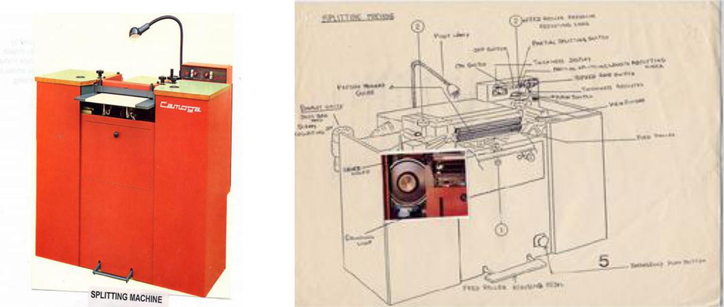

Fig 3.1 splitting machine
Parts and functions:
Parts |  |  | Functions
Main switch |  |  | To supply electrical power to the machine
Control Switches (on/off switches) |  |  | To start or stop the machine
Speed rate switches |  |  | To increase the speed rates for splitting
Partial splitting switch |  |  | To do partial splitting
Partial splitting length |  |  | To split the components partially to required length
adjusting knob
Thickness indicating meter |  |  | To indicate splitting thickness
Thickness adjusting wheel |  |  | To adjust to required splitting thickness
Band knife |  |  | To split leather components
Grinding unit |  |  | To sharpen the blade for accuracy of splitting
Optical viewing system |  |  | To check the knife bevel whether it touches the
 |  |  | splitting line
Upper driven guide roller |  |  | To split thickness from 0.5mm to 12 mm
Lower feed roller |  |  | Feed the components for splitting
Guide bar |  |  | To split thickness up to 0.2mm
Feed roller pressure |  |  | To adjust the pressure of the feed roller for uniform
adjusting knobs |  |  | Splitting
Exhaust units |  |  | To collect scraps and dust during splitting
Pilot lamp |  |  | To provide sufficient light during splitting
Treadle |  |  | To pull out the stuck components between the rollers
Safety switch |  |  | To stop the machine if troubles develop suddenly

Table 3.1 parts of splitting machine
Caution
  - Grinding stone must be dressed periodically for smooth sharpening of the knife.
  - After sharpening of knife, the burr must be removed by the dressing tool for perfect skiving.
  - Presser foot should not touch the feed roller while skiving, otherwise both presser foot and feed roller will get damaged.
  - Feed roller must be at a suitable distance from the knife while skiving. If feed roller is touching the knife, the feed roller will get damaged.
  - For taper skiving both presser foot and the feed roller must be at the same angle. Otherwise both presser foot and feed roller will get damaged.
  - If the bell knife gets reduced and not fit for skiving, a new bell knife /must be replaced.

- Hydraulic embossing machine
Hydraulic embossing machine works on hydraulic pressure. It is used to iron leather and lining components before assembling process. Leather and lining components need ironing to remove wrinkles due to handling at various unit operations. It is also used for design embossing on leather components by removing the plain plate and fixing the required design plate. Then embossing is done with suitable temperature and pressure to transfer the design

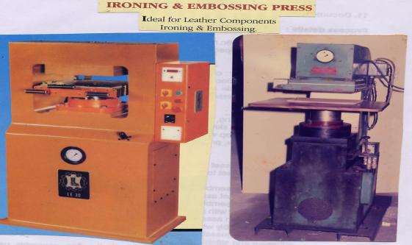
Fig 3.2 hydraulic embossing machine
Parts and functions:

Parts | Functions
Main switch | To supply electrical power to the machine
Felt bad | To place the components for ironing
Top metal bed | To fix plain or design plate
Temperature device | To provide suitable temperature for ironing or embossing
Pressure gauge | To provide suitable pressure for ironing or embossing
Handle | To move the bottom plate for pressing the components
Oil sump | To push the oil at a high pressure through the oil line
 | into the cylinder
Moveable piston | To move the bottom plate up when pressure is on and down
 | when pressure is released

Table 3.2 : Hydraulic embossing machine – Parts and its functions

Operations:
The required pressure and heat are first adjusted. The components are placed on the bed one by one and ironed. After ironing, the quality of ironing is checked and sent for next unit operation.
Caution:
  - Before commencement of the splitting operation, the knife should be sharpened well for perfect and accuracy of splitting.
  - When grinding for sharpening of the blade is on, the machine should not be stopped because it will cause damage to the knife. After sharpening, the grinding stones must be pushed away from the blade by adjusting screws of the grinders.
  - Due to constant splitting, the thickness of the blade gets progressively reduced and unfit for splitting. This will affect the accuracy of splitting. In such case, the reduced blade must be replaced with a new one.
  - The Presser roller and feed roller must be cleaned well otherwise components may get stuck between the rollers.
  - The machine should be cleaned well and lubricated after completion of the splitting operation. This will help the smooth running of the machine.
- leather skiving machine:
This machine is very important machine and is extensively used in leather goods manufacturing. It helps to reduce thickness of the leather components at the edges for easy folding. Only skilled persons can operate this machine as the quality of skiving depends on various adjustments and operation techniques. Different types of skiving viz. parallel skiving, channel skiving, taper skiving and fine edge skiving can be achieved using appropriate presser foot. The skiving can be done to a width of 3mm to 50 mm

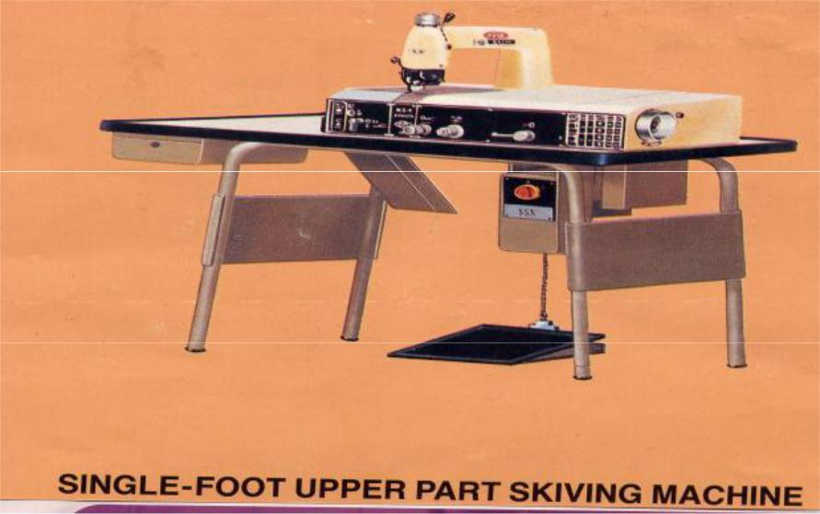

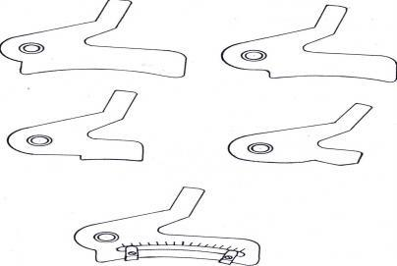

Fig 3.3. leather Skiving machine and its parts
Caution:
  - The oil leakage must be checked.
  - Recommended oil alone must be used.
  - The blockage of dust particles in the hosepipes must be periodically checked.

- Edge staining machine:
Edge staining machine is used for staining the raw edges of the cut-edged construction.

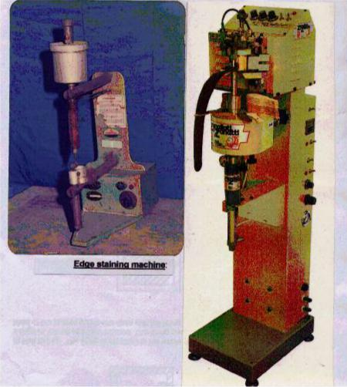

Fig 3.4. Edge staining machine

Parts and functions:
Parts | Functions
Switch | To supply electrical power to the machine
Reservoir | To store dye for staining
Electrical transformer | To regulate the voltage
Vibrator switches | To control the flow of dye
Beak | To enable to run the leather easily in the cavity
Turning stopper | To regulate the height of the cavity
Pedal | To regulate the uniform flow of dye

Table3.3: Edge staining machine – Parts and its functions
Operations:
The color dye is filled into the reservoir. The electric transformer is regulated on the required voltage. The switch is turned on to the position 1 indicated in the vibrator. The raw edge is passed between the valve and the beak. The leather must run easily in the cavity. Turning the stopper placed under the small shaft with spring attached can regulate the height of the cavity. The pedal is pressed and at the same time the stopper is unscrewed in order to get the regulation of the dye. If the dye does not flow continuously, the switch is turned to the next position and so on until there is a uniform flow. After staining is done, the nozzle and the supporting foot are cleaned carefully with the solvent. The stained edges are checked for quality. Different types of edge staining machines are used in industries.

8. Straight edge folding and creasing machine:
Edge folding and creasing machine is used to fold and crease simultaneously for making turnover edge articles with crease. This machine is used mainly for making small exportable leather goods viz. wallets, bill folds, credit card cases, key cases, passport covers, etc.

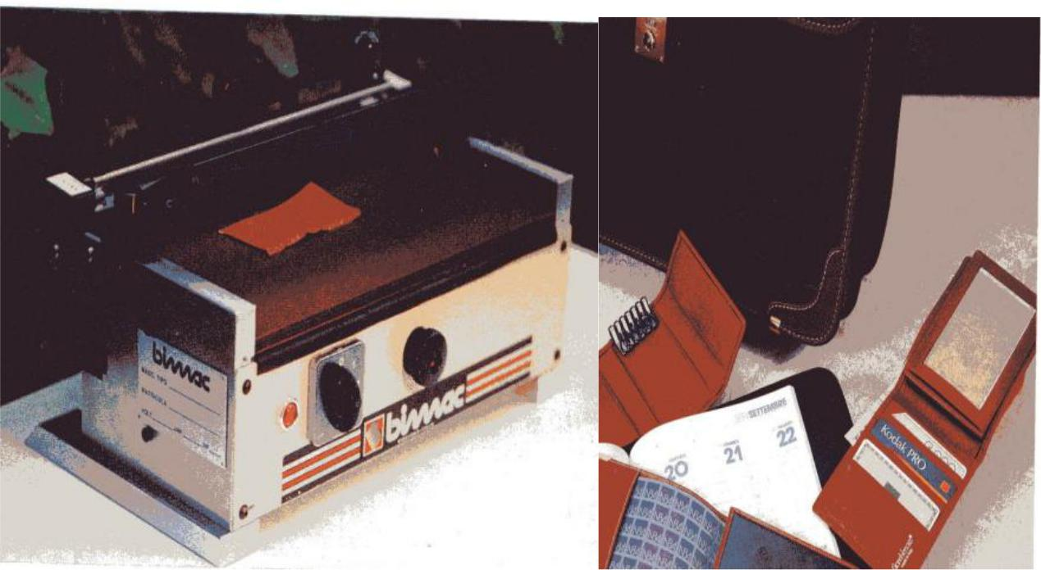

Fig.3.5 Straightedge folding and creasing machine
Parts and functions:
Parts | Functions:
Switch | To supply electrical power to the machine
Creaser | To crease the leather components
Folding device | To fold straight the glued components
Fold width adjusting knobs | To adjust for the width of the folding
Thickness adjusting knobs | To adjust for the thickness of the leather components
Clutch type handle | To press the component for creasing
Thermostat control | To control the temperature for perfect creasing

Table 3.4: Straightedge folding and creasing machine – Parts and its functions
Operations:
The components, which require straightedge folding and creasing are first skived at the edges. They are then glued and fed into the machine. The required heat for perfect folding and creasing is adjusted using thermostat control. The handle is pressed till uniform folding and creasing is achieved. The width of the folding can be adjusted by
folding width-adjusting knobs. The maximum folding width is 2 cm and the maximum folding length is 30 cm. Different types of edge folding cum creasing machines and thermosetting and folding machines are used in big leather goods industries.
9. Frame opening and closing machine:
Framing machine is used for the manufacture of framed ladies purses and bags .
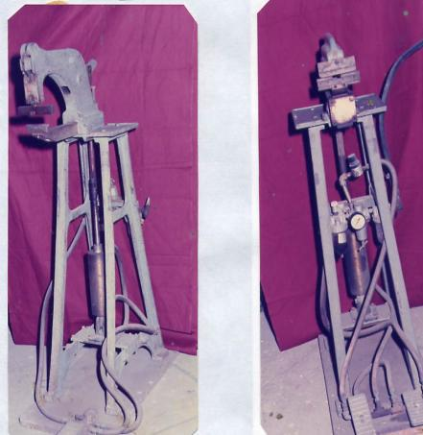

Fig 3.6: Frame opening and closing machine

Parts and functions:
Parts | Functions:
Pneumatic system (air cylinder and | To provide pneumatic pressure
turbo control)
Frame opening plate | To open the frame
Single stage foot control treadle | To provide pneumatic pressure for opening
Frame closing guide | To close the frame
Double stage foot control treadles | To provide pneumatic pressure for opening and closing

Table3.5: Frame opening and closing machine
Before the frame is fixed to the bag, the slot of the frame is to be opened sufficiently so that the framing of the bag can be done without difficulty. The slot of the frame is gently pressed into the plate of the frame opening machine and the treadle is pressed. By means of air pressure, the top device comes down and opens the slot of the frame to a required gap. The frame is then removed for fitting to the handbag. The top of the assembled handbag is pushed into the slot of the opened frame perfectly and then placed under the closing device of the frame closing machine. The first treadle in the double stage foot

control is pressed. The frame is held firmly by the frame closing plate. Any adjustments to be made in straight alignment can be done at this stage. When everything is correct, the second treadle in the double stage foot control is pressed. Now the closing guide firmly presses the frame thereby perfect framing is obtained.

Advantages over manual framing of the articles:
- Fixing frames by hand may not be uniform.
- Most of the times, the frames get dented by fixing manually with hand tools thereby the elegancy of the product is lost.
- Fixing the frames by hand takes enormous time.

aligning work piece correctly to machine by connecting machine to power safely
Prepare templates using splitting machine
Splitting machine is used to adjust the thickness of a leather to the required thickness size. Finished leathers could have a thickness that have to be adjusted to make suitable for the required purpose. Since leather goods are made with different thickness, it is necessary to split the leather components according to the required thickness for the specific product. This can be achieved only with the help of a splitting machine.
To operate splitting machine the operator should have the required level of skill. To split leather using the splitting leather one should follow the operational manual of the machine by considering safety.
Patterns of templates for splitting


template 1
size:15cm*15cm

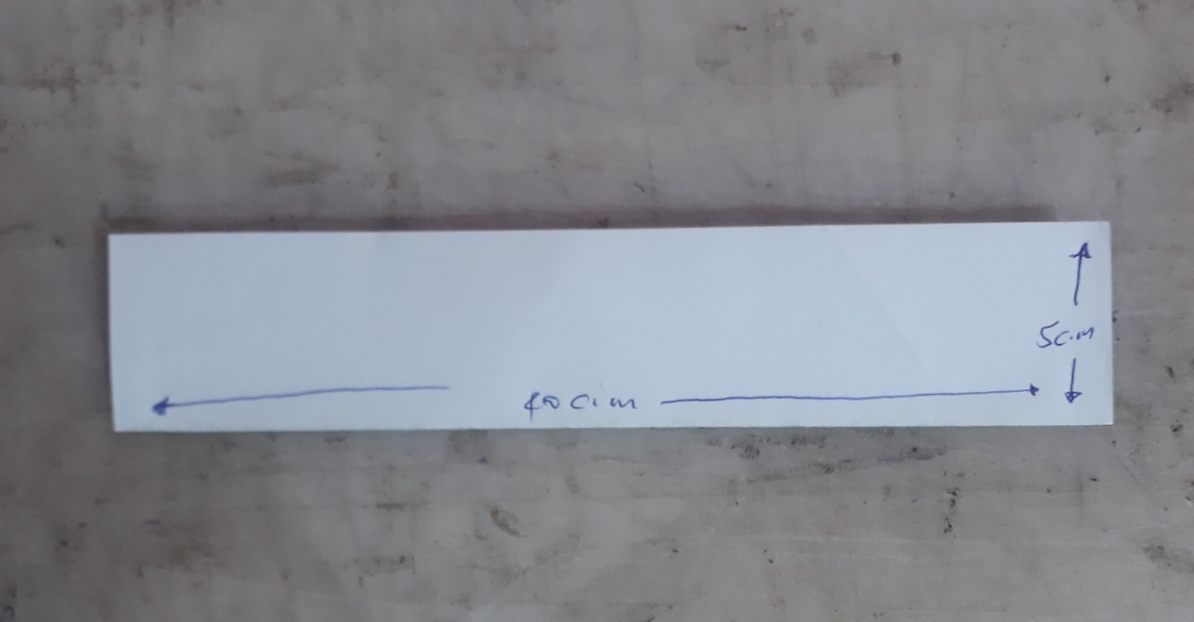
Template 2
Size:40cm*5cm
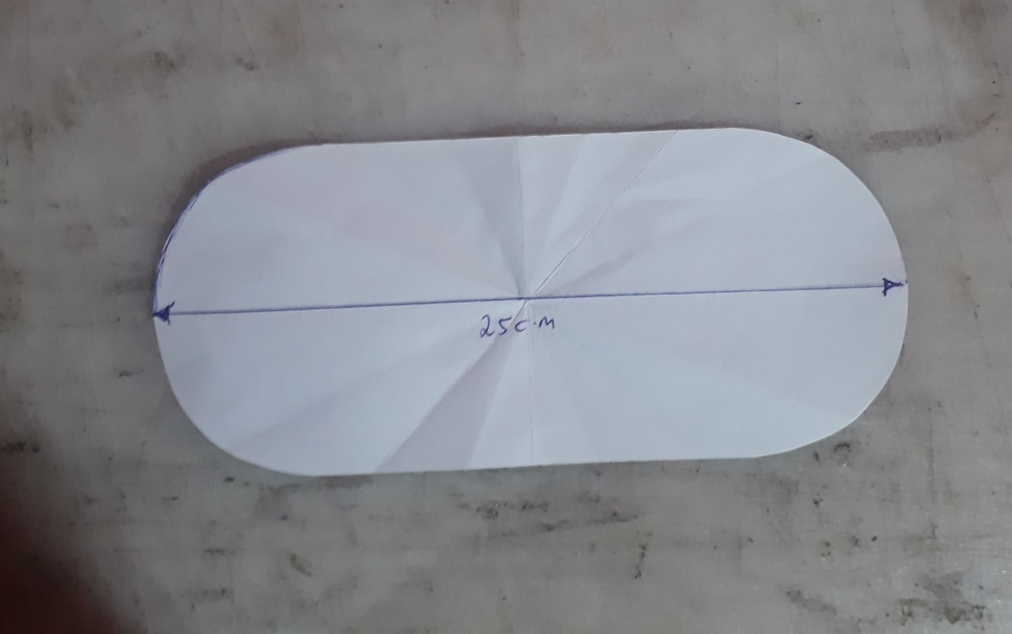

Template 3
Size 25cm*12cm
Templates for skiving


Template 1
Size:20cm*20cm


Template 2
Size:20cm*12cm
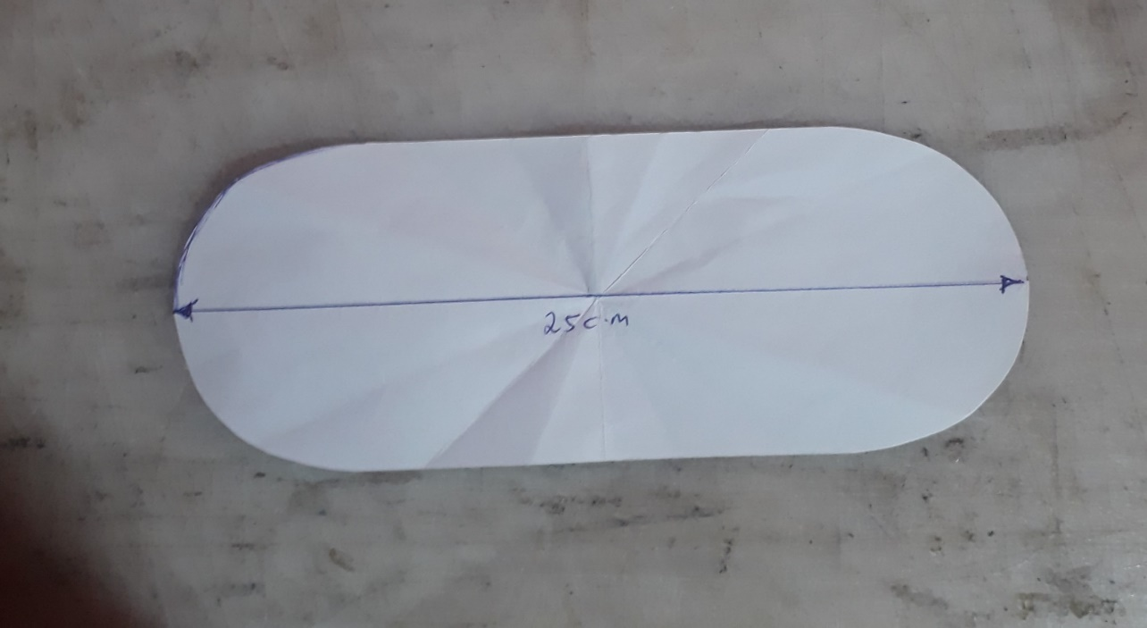
Template 3
Size: 25cm*12cm

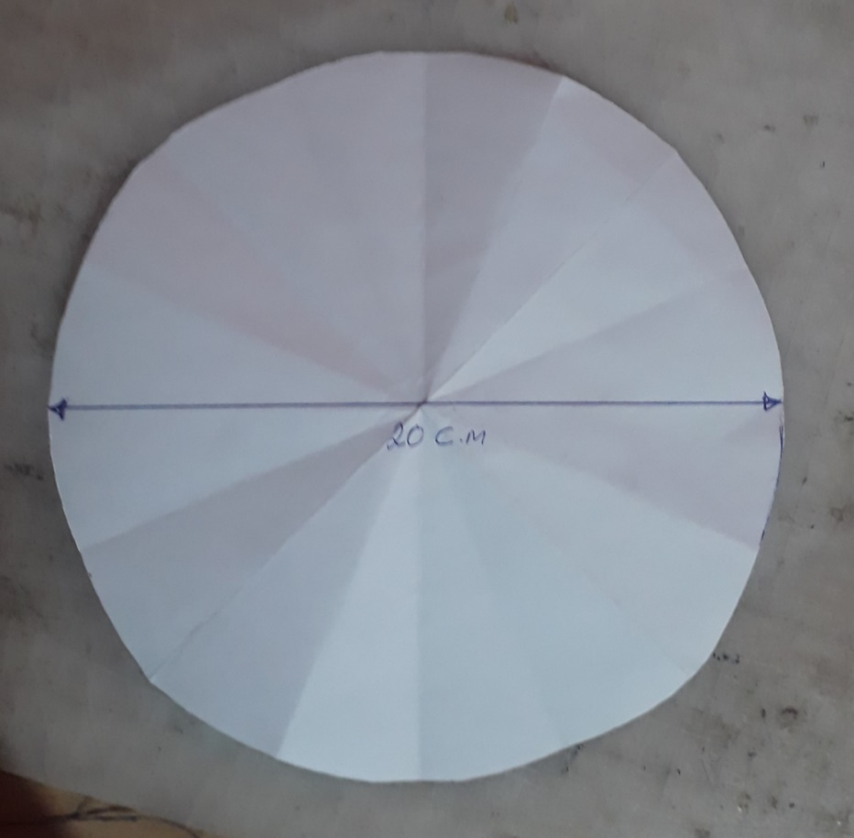
Template 4
Size 20cm diameter

Preparation machine operation with OHS practice
What is occupational health and safety? (OHS)
Occupational health and safety is a discipline with a broad scope involving many specialized fields. In its broadest sense, it should aim at:
- the promotion and maintenance of the highest degree of physical, mental and social well-being of workers in all occupations;
- the prevention among workers of adverse effects on health caused by their working conditions;
- the protection of workers in their employment from risks resulting from factors averse to health;
- the placing and maintenance of workers in an occupational environment adapted to physical and mental needs;
- The adaptation of work to humans.
In other words, occupational health and safety encompasses the social, mental and physical well-being of workers that is the “whole person”.
Successful occupational health and safety practice requires the collaboration and participation of both employer and workers in health and safety programs, and involves the consideration of issues relating to occupational medicine, industrial hygiene, toxicology, education, engineering safety, ergonomics, psychology, etc.
Hazard identification and control
A workplace hazard is something that can hurt you, or has the potential to hurt you. There are hazards in every type of job and every type of workplace. Everyone at the workplace: workers, managers and the employer, share in the responsibility to identify and control hazards. For workers, this first step means recognizing what a workplace hazard is (or could be) and how to report it to the employer. For employers, the first step is to inform workers of potential hazards, to have control
systems in place to decrease the risk of injury. But what if you’re not quite sure what to look for? What is a workplace hazard, anyway?
WORKPLACE HAZARDS: CLASSES
Even though hazards look different in every workplace and in every type of industry, there are five defined classes. Here’s a list and introductory definitions for each.
  - Physical
Physical hazards are things or agents that may come into contact with the body with potential for harm.
Examples of physical hazard while performing preparation by machine
- Loose blade guard.
- Electric cables
- Vibration from the preparation machines
- Sparks while griding blade
- Heat from the machines
- Slippery floor
- Materials in preparation
- Chemical
Chemicals can be natural or manufactured, and come in the form of liquids, gases, vapors, solids or particulates (very small pieces). Naturally occurring and manufactured chemicals both carry potential for harm for people working around them. This potential is based on the level and type of exposure that someone is subjected to.
Examples of chemical hazard while performing preparation by machine.
- Adhesive
- cleaning solutions
- grease
- dyes
- Biological
Biological hazards are typically in the form of bacteria and viruses transmitted by contact with insects, birds, animals, plants, fungi, and humans. Unprotected exposure to biological hazards can result in a range of infections and illnesses. Some may appear fairly commonplace, like catching a cold or a skin rash, but has serious side effects such as poor recovery. Other types of biological hazards, like body fluid borne diseases or bacteria carried by some fungi, can be extremely dangerous.

- Ergonomic
Ergonomic hazards are caused by the way work tasks are designed and carried out. The injuries that result from ergonomic hazards always affect the muscles and the skeleton, and are the most common type of workplace injury in Nova Scotia. These injuries may happen suddenly, but are more likely to form over very long periods of time.
Examples of chemical hazard while performing preparation by machine.
- Poor Posture while operating preparation machine like splitting
- Forceful Motions
- Stationary Positions.
- Direct Pressure.
- Using improper chair

Hazard controls
Hazard controls can be thought of in three ways. Each describes how and where the controls are placed on the ‘path’ between the worker, and the hazard.

Control at the Source:
The best way to control a hazard is to eliminate it. If this is not possible, the next step is the substitution of a non-hazardous or less-hazardous material or process. If there is no acceptable substitution, then the hazard has to be isolated from workers. An example of this may be closing a high-voltage electrical panel and sealing it off from workers in an office. This would be controlling the hazard ‘at the source.’
Control along the Path:
Some hazards are part of work processes that cannot be enclosed or isolated. Placing a control ‘along the path’ means different protective measures are put in place between the hazard and workers. In the electrical panel example, office workers have been sealed off from the hazard but electricians will still have to Work safely on the panel. To protect the electricians, controls ‘along the path’ would probably include using energy lockout procedures and devices and non-conductive tools.

Control at the Worker:
If controls ‘at the source ’and ‘along the path’ may not be enough to prevent injury, then placing controls ‘at the worker’ will be necessary. Control at the worker often consists of personal protective clothing and equipment that must be worn while performing certain tasks. Common types of this control are wearing gloves to protect the hands, hearing protection, or masks or respirators to protect airways. ‘At the worker’ is often the first type of hazard control that businesses put into place. Employers always need to consider controlling hazards ‘at the source’ and ‘along the path’ as well.

2.3.2 Personal protective equipment
All equipment (including clothing affording protection against the weather) which is intended to be worn or held by a person at work which protects them against one or more risks to their health and safety. PPE includes equipment such as safety foot wear, hardhats, high visibility waistcoats, life jackets, respirators and safety harnesses. Water proof, weather proof or insulated clothing is subject to the regulation only if its use is necessary to protect employees against adverse climatic conditions that could otherwise affect their health and safety.
When to use PPE
PPE must always be regarded as a ‘last resort’ to protect against risks to safety and health. Engineering controls and safe systems of work must always be considered first. For example, it may be possible to do the job using methods that will not require the use of PPE if this is not possible, more effective safeguards should be put in place. For example, fixing needle could be provided rather than individual eye protection. There are a number of reasons why PPE must be considered as a ‘last resort’
- PPE only protects the person wearing it, whereas controlling the risk at source protect everyone in the work place
- Theoretical maximum levels of protection are difficult to achieve and the actual level of protection is difficult to assess. Effective protection is only achieved by selecting suitable PPE and it is correctly fitted, maintained and used
- PPE may restrict the wearer to some extent by limiting mobility or visibility or by requiring additional weight to be carried.

Suitability of PPE

To be able to choose the right type of PPE the hazards involved in the task or work environment must be considered carefully. PPE must also meet the needs of the individual.
The following factors should be considered when assessing the suitability of PPE
- Does the PPE prevent or adequately control the risk involved without increasing the overall risk? E.g. gloves should not be worn when using a pillar drill, due to the increased risk of entanglement
- Can the PPE be adjusted to fit the wearer correctly? e.g. if a person wears glasses, ear defenders may not provide a proper seal to protect against noise hazards
- What are the needs and demands of the job it places on the wearer? How long will the PPE need to be worn? What are the requirements for visibility and communication?

Storage of PPE
Where PPE is provided, adequate storage facilities for PPE must be provided (e.g. foot wear or clothing)
Accommodation may be simple (e.g. pegs for water proof clothing or safety helmets) and it need not be fixed (e.g. a case for safety glasses or a container in a vehicle) Storage should be adequate to protect the PPE from contamination, loss damage, damp or sunlight
Where ever PPE become contaminated during use, storage should be separate from any storage provided for ordinary clothing

Duties of employees regarding PPE
The regulations also have the following duties on employees:
- PPE must be worn and used in accordance with the instructions provided to them
- Employees must take all reasonable steps to ensure that PPE is returned to the storage provided for it after it has been used.
- PPE must be examined before use
- Any loss or obvious defect must be immediately reported to their supervisor
Ergonomic arrangement of work places
The word ergonomics is derived from two words: ergos meaning work & nomos meaning the law. Ergonomics is the scientific study of the relationship between the man, the machine (with which he works) & the environment (in which he works). Ergonomics is also termed as human engineering. The modern approach of ergonomics is “fit man & machine together”.
Therefore, it is very useful tool to make man & machine compatible for maximum efficiency.

Monitoring performance oa machine.

Performance is the degree to which the machine is doing what it is supposed to do. The performance of a machine shows how effective the machine is opperating as per the intended use of the machine. During preparation the performance of the machine could be affected by various reasons. The quality of material used to biuld the machine, the length of working time, handling of the machine and so on can affect the performance of the machine. Checking the performance of a machine helps to identify if ther is a breakdown or failur. So, by following up the performance of the machine its needed to reduce failur and breakdown. The consequence of reducing breakdowns and
defects are improvement on production rate, reduction in costs, reduction in
inventory and eventually, increase in productivity.
If the performance of a machine is decreased the following losses could happen.
Downtime losses
- Breakdown losses categorized as time losses and quantity losses caused
by equipment failure or breakdown. For example, a breakdown of
preparation machine motor in a leather goods and garment industry leads to downtime and thus production loss.
- Set-up and adjustment losses occur when production is changing over
from requirement of one item to another. For example, during skiving when we skive different size (width and depth) the adjustment should be checked.
Speed losses
- Idling and minor stoppage losses occur when production is interrupted by
temporary malfunction or when machine is idling. For example, if preparation machine stop working for a long period of time their performance can decrease.
- Reduced speed losses refer to the difference between equipment design
speed and actual operating speed.

Quality Losses
- Quality defects and rework are losses in quality caused by malfunctioning
production machines. For example, if the preparation machines have quality problems caused by several reasons.
- Reduced yield during start-up are yield losses that occur from machine
start-up to stabilization.
.

Self-check 3
Directions: Answer all the questions listed below. Use the Answer sheet provided in
the next page:
- List machines used during preparation?
- Explain how to operate splitting machine?
- List parts of leather skiving machine?
- Explain the use of PPE?
- Define and explain ergonomics?
- Discus about some kinds of physical hazards that could occur in preparation section?
- What does performance mean?
- Discuss about break dawn losses?
- Discuss about break dawn losses?

Operation sheet 3.1 Prepare template using splitting machine
Operation title: split a leather by splitting machine
Purpose: to practice and demonstrate the knowledge and skill of using splitting machine.
Instruction; follow the steps below to split the leather.
Tools and requirement
- Splitting machine
- cutter
- leather
- safety tools
procedure to do this task
use splitting machine and split the templates provided by following the steps below
- Duplicate the templates
- Cut leather using the templates
- Turn on the main power
- Start the machine
- adjust the thickness on the machine
- Feed the prepared leather to the machine
- Put your foot on the pedal and start splitting
- Pull the split leather gently

Operation sheet 3.2 - Prepare template using skiving machine
Operation title: skiving a leather by skiving machine
Purpose: to practice and demonstrate the knowledge and skill of using skiving machine.
Instruction; follow the steps below to skive the leather.
Tools and requirement
- Skiving machine
- cutter
- leather
- safety tools

use skiving machine and skive the templates provided by following the steps below
- Duplicate the templates
- Cut leather using the templates
- Turn on the machine
- adjust the width and depth to be skived on the machine
- Feed the prepared leather to the machine
- Put your foot on the pedal and start skiving

Operation sheet 3.3 - Prepare template using embossing machine
Operation title: emboss a leather by embossing machine
Purpose: to practice and demonstrate the knowledge and skill of using embossing machine.
Instruction; follow the steps below to emboss the leather.
Tools and requirement
- embossing machine
- cutter
- leather
- safety tools
Prepare templates using embossing machines
use embossing machine and print different designs on the templates provided by using following the steps below.
- Cut leather of provided patterns
- Turn on the embossing machine
- Adjust the required pressure and temperature.
- Put the template on the bed
- Iron the component
- Print different types of design on the leather.

LAP test
Directions: perform all the activities given.

- Perform skiving using the prepared template.
- Perform splitting using the prepared template.

Unit Four: Checking works received
This unit to provide you the necessary information regarding the following content coverage and topics:
  - Receiving and checking completed work
  - Labelling or tagging completed work
  - Completing necessary documentation
This guide will also assist you to attain the learning outcomes stated in the cover page. Specifically, upon completion of this learning guide, you will be able to:
  - Receive and Check completed work
  - Label or tag completed work
  - Complete necessary documentation

Receiving and checking completed works
Work bundle is a bundled component which is received from the cutting department, to
be processed by the bench worker. The worker who received a bundle should check
the components and the specification. Specification is an instruction which
demonstrates how to do the work and what to check before start working. We have to
check the following parameters against the specification and the patterns.
- Measurements
- Shapes
- Allowances
- Uniformity of components
- Amount of components
- Left and Right components
- Reference marks
- Pre-fabrications (skiving & splitting)
While checking the above parameters if there is a fault found in the components you
have to make corrections or report the fault to your supervisor.
Assessing the received work Quality
After checking the received bundle and specification the next step is to assess the
quality. This assessment is used for ensuring that if the work bundle has the quality
requirement which allows it to goes through the bench work process.
While assessing the quality of work you have to assure that all the components have
- Accurate Edges
- Same thickness
- Good surface/Grain
- Same color
Determine any follow up action in accordance with
workplace procedures
Once you have checked the above you have to determine what to do first and where to
finish the given work. The work place procedure helps you to determine this, which is
provided with the specific work. Workplace procedures are a fixed, step-by-step
sequence of activities or course of action (with definite start and end points) that must
be followed in the same order to correctly perform a task.

Labeling or tagging completed work

Labeling or tagging is defined as the process of attaching a descriptive words or phrases to some product.
General Labeling Requirements
All product labels must have the following four required statements:
- an identity statements
- a size statements
- a type of material
- company name and address

What is an identity statement?
The common name of the component or product, or an appropriate descriptive term.
Brand names, trademarks, or product identities can be identity statement.

What is size?
The size to be mentioned can be area length, depth or depth of the component. The size can be mentioned by centimeter(cm) or millimeter(mm).

What is type of material?
Material type is the material that component is made of. For example, if the material is leather it can be mentioned with the specific leather type.

How do I list my company name and address?
For fully finished product the name and complete address (including street address, city, state, and zip code) of the manufacturer, packer, or distributor of the product must be listed on the label. For a component which are on process only the stage of production can be mentioned.

Self-check 4
Directions: Answer all the questions listed below. Use the Answer sheet provided in
the next page:
- What is work bundle?
- List assessing parameters of work bundles.
- What should we have check While assessing the quality of work?
- What is labeling or tagging?
- List assessing parameters of work bundles.
- What should we have check While assessing the quality of work?

Unit Five: bench work operation
This unit to provide you the necessary information regarding the following content coverage and topics:
- Identifying necessary table work tools
- performing bench work operations
This guide will also assist you to attain the learning outcomes stated in the cover page. Specifically, upon completion of this learning guide, you will be able to:
- Identify necessary table work tools
- perform bench work operations.

Identifying necessary table work tools
Table work operations are the main preparation activity that is done before assembling and stitching. Table work tools are briefly described in the previous learning outcome. Table work operation and their tool are explained in the following table.
No | Table works | Tools
1 | Staining | Paint brush  Roller dyeing pen
2 | Creasing | Creaser
3 | Punching | Punches  Hammer
4 | Riveting | Punches  Hammer  Riveting dyes
5 | Eyeleting | Punches  Hammer  Eyeleting dyes
6 | Buttoning | Punches  Hammer  Buttoning dyes
7 | Zip fastening | Hammer
8 | Gluing
9 | Folding | Hammer  Mallet  Glue can  Brush

Table 5.1 table works and working tools

performing bench work operations
Bench work operation
Bench work operation are operation that are done on a work bench to prepare work templets for the next section of production. They are carried out by team of skilled technicians supervised
by highly skilled supervisors. In bench work processes, the components are prepared with linings, zips, folding, gussets, piping, handle, etc. for subsequent process of assembling. Some components may need immediate stitching and some may not. The
prepared components, which need immediate stitching, are sent for stitching.
Bench operations involves
1. Staining
2. Creasing
3. Punching
4. Riveting
5. Eyeleting
6. Buttoning
7. Zip fastening
8. Gluing
9. Folding
Staining (edge dying)
Staining is done on products made by cut edge construction. The edges of the components are smoothened with sand paper first and then stained with water-soluble pigments using a brush. The staining is done carefully without damaging the surface of the leather components. After drying the edges are wax polished and rubbed with a piece of smooth cloth vigorously for glossiness. In case of bulk production, edge staining machine is used to stain the edges.
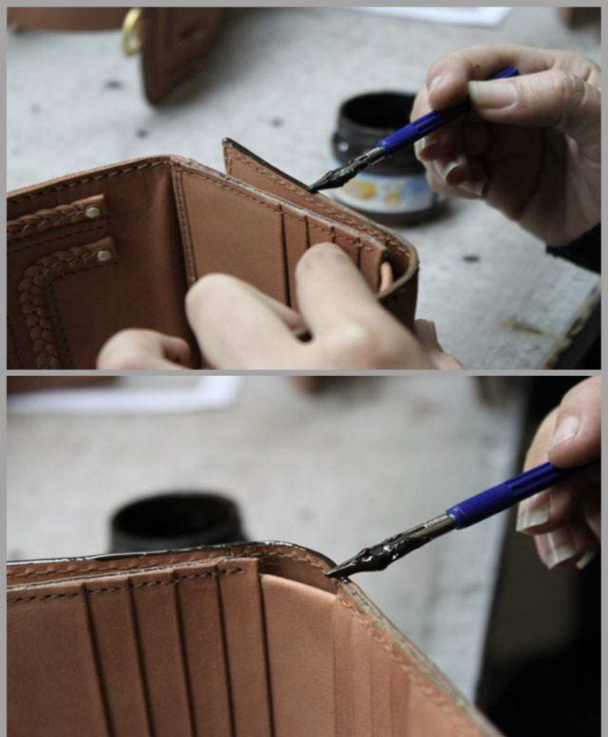
Fig 5.1 edge dying

Creasing
Creasing is done on the leather components with a suitable temperature. Creasing is done on cut edges as well as folded edges. Creasing helps in compressing the cut fibers at the edges and thus strengthens the edges. Creasing gives a permanent, slightly darker and glossy line. It improves the elegancy of the products. It also gives a decorative and aesthetic appearance. Using a variety of creasers which are single head creaser, double head creaser and adjustable creaser, creasing can be done. Care is taken to see that the working edge of the creaser is kept smooth to avoid scratching during creasing operation. The tip of the creaser is slightly rounded off for smooth sliding while creasing.
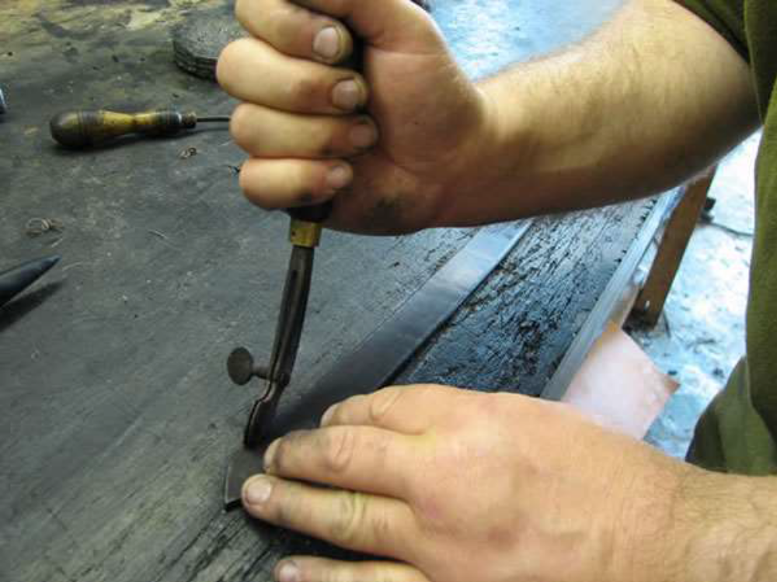
Fig 5.2 creasing

The following points must be remembered while creasing:
1. The creasing line must be close to the edge.
2. The line marked should be distinct and glossy appearance.
3. Suitable temperature must be needed for perfect creasing.
4. The straight lines must be creased first and then the corners.
5. In case of bulk production, creasing machine is used for creasing.
Punching
Punching is the process of making holes in leather components using a set of hole punching tools for varied sizes of holes needed for fixing fittings. Holes are made to fix buckles, buttons, eyelets, rivets, rivet buttons, studs etc. Punching holes are done in the articles like belts, watch straps, shoulder straps etc. to insert the buckle prong. In case of bulk production, punching is done by hand or treadle operated punching machine.
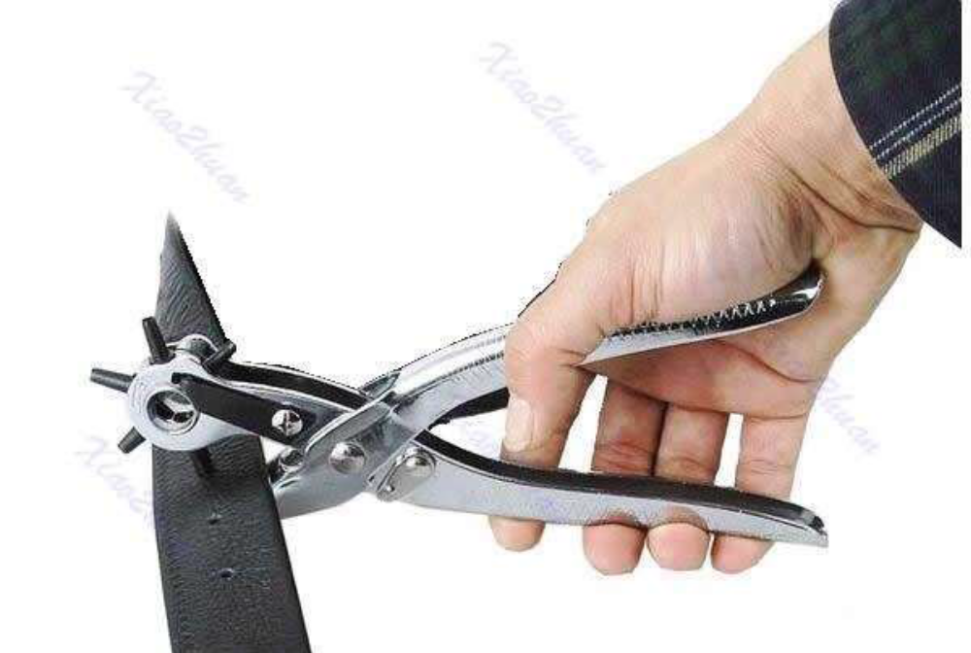
Fig 5.3 punching

Riveting:
Riveting is done with rivets and rivet buttons using riveting tool for fixing handles, hinges, locks, etc. and also for joining assembled components. Riveting is also done in the riveting machine in case of bulk production. Automatic and Pneumatic riveting machines are used in big industries.

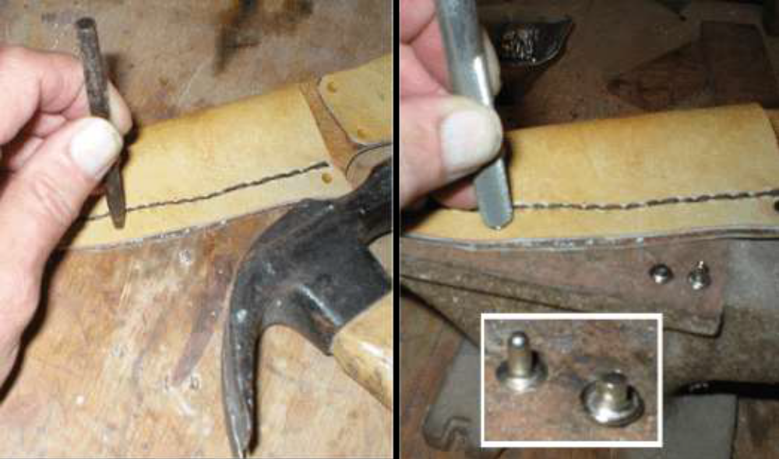
Fig 5.4 riveting
Eyeleting
Eyeleting is done by eyeleting tool. Colored small eyelets are used to Fasten key hooks fittings in key cases while fancy eyelets are used in stretch bags. In case of bulk production, an automatic eyeleting machine is used.
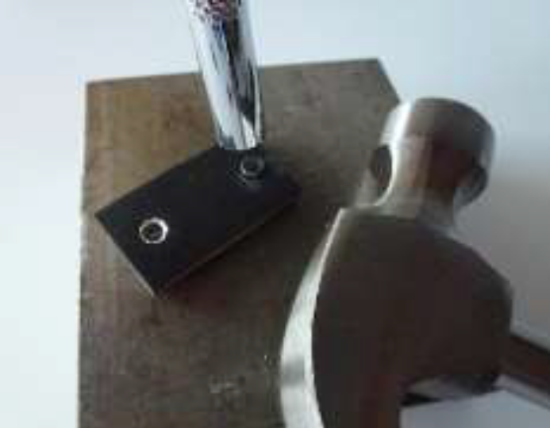
Fig 5.5 eyeleting
Buttoning
Buttons of different sizes (3/2, 3/3, 4/3 and 7/7) are extensively used in leather goods. The button-fitting tool is used for buttoning. When fixing the buttons, care is taken to hammer the buttons gently as heavy hammering may damage the buttons. Since hand operation is a slow process, treadle operated or hand operated buttoning machine is used which ensures speedy operation and perfect setting of buttons. Automatic buttoning machine is used in big industries.
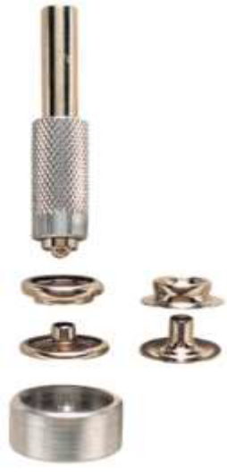
Fig 5.6 buttoning tool

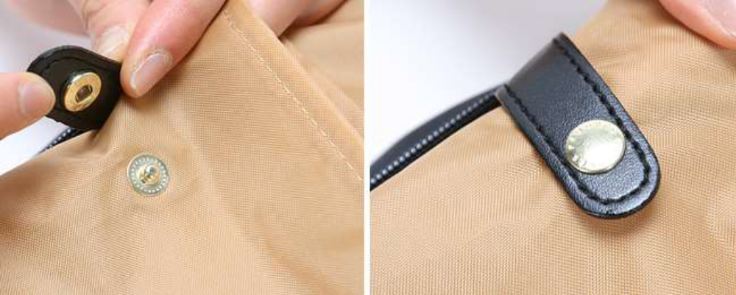
Fig 5.7 buttoning

Zip fastening
Zip fasteners are extensively used in leather goods making because they enable quick opening and closing of the products. Different types of zips in different colors are fixed according to the needs of the products and also to match the color of the products. There are 3 types of zip sizes, which are commonly used in leather goods making.
7.1No-3 zipper
7.2 No-5 zipper
7.3 No-7 zipper
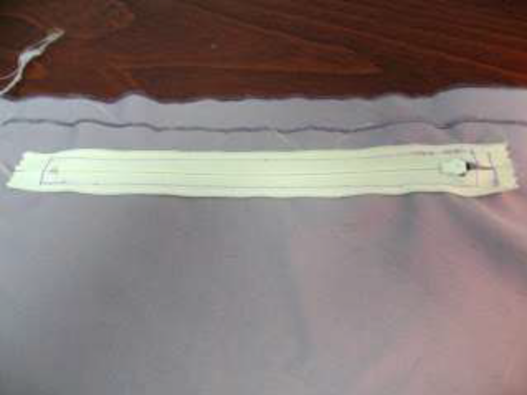
Fig 5.8 zip fastening

Gluing
Adhesion plays a vital role in assembling components of leather, lining and reinforcements during fabrication of the products. Further strength of the parts can be achieved by stitching. There are two types of adhesives, which are extensively used in the fabrication of leather goods.
There are two types of adhesives, which are extensively used in the
fabrication of leather goods.
- Temporary adhesive and
- Permanent adhesive
Temporary adhesive
Rubber adhesive is a temporary adhesive as it gives temporary bonding effect and so stitching is necessary after joining the components. It is beige colored natural rubber adhesive. It has easy spreading characteristics coupled with cleanliness; flexible bondage and economy of application make it particularly suitable for general works. It gives a firm hold while stitching and helps in making products with stitches.
Application
Rubber adhesive is applied uniformly to the surface to be bonded. After
achieving maximum tack development, the surfaces are joined. The joined surfaces are rubbed to remove air bubbles. The components are then
taken for stitching.
Permanent Adhesive
Synthetic rubber adhesive in solvent medium is a permanent adhesive as it gives permanent bonding effect. It is extensively used in leather products which are made without stitches and also in attaching components where stitching is not possible. It is more advantageous than other adhesives because drying takes place immediately. It is buff colored adhesive, freely flowing and very smooth to apply. It has good water, alkali and oil resistance coupled with high bonding strength which makes it an excellent adhesive for all types of high bonding works in leather goods manufacturing.

Application
Surfaces to be bonded must be clean, dry and even. The adhesive is applied thinly and rapidly to both the surfaces and the coverage of adhesive is ensured completely and effectively. The solvent of the adhesive is allowed to evaporate till tack formation is felt.
The glued surfaces are joined carefully and accurately avoiding air bubbles. The components are then pressed uniformly throughout for perfect and accurate joining.

Safe and appropriate uses of adhesives to achieve required quality

Solvent-bused adhesives (including solvent-containing types)

Adhesives of this class represent the most obvious hazard to users.

Storage
Store in a cool dry moderate condition at temperatures from 5' to 30’
Usage
Avoid inhaling the vapors - use in well ventilated areas - avoid contact with the skin. The use of suitable barrier creams for protection of the skin and/or gloves is recommended. Removal of adhesives from the skin should be done with suitable antiseptic cleaning agents rather than straight solvents. When handling low- viscosity adhesives, suitably approved goggles or face shields should be worn to protect the eyes from splashes. Wherever possible, buildup of solvent vapors in the work atmosphere should be controlled by adequate ventilation using flameproof exhaust fans where necessary. If this is not practicable, then suitable breathing apparatus, such as respirators, should be worn.
Spillage
Clean up immediately using sand or powdered limestone to absorb the adhesive before scraping up the residues and disposing of them according to the local regulations.
Fire Risk
If the adhesive contains flammable solvents, DO NOT store or use near naked flames and avoid sparks and non-flameproof equipment.
Toxicity
Although toxicity of solvent vapors from adhesives varies considerably the breathing of appreciable quantities of solvent-laden air should be avoided. More effective ventilation is required to maintain the solvent vapor concentration in the working area below the permissible limit. Where necessary, this concentration should be regularly monitored to ensure safe working conditions.
Water-based adhesives (including emulsions, lattices and
solutions)
Being water based this class of product is not normally flammable. The dry adhesive film formed when water is removed may be capable of burning but does not usually sustain combustion. Some synthetic polymers depolymerize under heat, liberating volatile, toxic and/or flammable vapors. Solvents are incorporated in many emulsion adhesives for special applications and this may affect toxicity and flammability. Synthetic lattices or emulsions contain free monomer which, although normally present at low levels, can be a potential hazard to health. Other volatile ingredients such as ammonia, formaldehyde etc. can also be troublesome. All such products should therefore be used with adequate ventilation. Contact with the skin should be avoided but if this does occur aqueous adhesives should be washed off with cold water before they can dry. This is to avoid discomfort rather than injury from adherent polymer. However,
repeated contact may cause dermatitis in sensitive individuals and the use of barrier cream and/or protective gloves are advisable.
Water-based Adhesives
If adhesives dry on unprotected skin some will be found to pull off without inconvenience. Others, particularly pressure sensitive films, are less easy to remove and may require especial skin cleanser. Do not use solvents. Splashes into eyes, mouth or nose should be washed without delay with plentiful quantities of water and medical advice should be obtained immediately if considered necessary.

Self-check
Directions: Answer all the questions listed below. Use the Answer sheet provided in
the next page:
- List tools we should use during preparation.
- Which tools should we have to use for gluing and folding?
- What are the tools used for eyeleting?
- List bench work activities.
- What is staining?
- Explain how riveting is done.

Operation sheet 5 - performing bench work operations
Operation title: performing bench work operations
Purpose: to practice and demonstrate the knowledge and skill of performing bench work operation
Instruction; follow the steps below to to perform the bench work activity.
Tools and requirement
- Hammer
- Punchers
- Cutter
- Adhesive
- Dyes
- Roller pen
- Bone folder
- Glue can
- cutter
- leather
- safety tools

procedure to do these tasks
- Performing staining
  - Prepare the dye solution
  - Cut sample leather for the activity
  - Rough the edge of the leather
  - Use filler
  - Apply the staining.
- Performing gluing and folding
  - Cut sample leather for the activity
  - Mark the space to apply glue
  - Apply glue and let a few minutes for drying
  - Fold the leather keeping the allowance.
- Perform punching and riveting
  - Cut sample leather for the activity
  - Select different size of punchers and rivet.
  - Punch leather with different size punchers
  - Perform the riveting based on the size

LAP test
Directions: perform all the activities given.

- Perform staining using the prepared template.
- Perform folding using the prepared template.
- Perform riveting using the prepared template.

Unit six: checking component quality
This unit to provide you the necessary information regarding the following content coverage and topics:
- Checking components against specification
- Reporting faults and perform repairing.
This guide will also assist you to attain the learning outcomes stated in the cover page. Specifically, upon completion of this learning guide, you will be able to:
- Check components against specification
- Report faults and perform repairing.

Checking components against specification
Conformance checking of components is a testing method to see if the application and
its specification is equivalent.
Such checking is necessary to assure if the requirements given in the specification are
achieved or not.
The purpose of checking of a component is:
- To have defective work corrected
- T prevent the dispatching of defective work
Examples of checking components against specification
- Checking the size of the front
- Checking the size of the back
- Checking the size of the gusset and base
- Checking the width and length of the straps
- Checking the size of pockets
- Checking the distance of the drop length
- Checking the edges
- Checking the construction

Reporting and/or returning faults for rework or repair
While checking components some faults may be identified, these faults should be
reported to the superiors or return to the assembling section where they could get
repaired or reworked.
Fault
Fault is a defect or imperfection found on some produced item. Faults can be occurred because of different reasons. They can be occurred by human error, mechanical error or raw material.
Repairing
Repairing is the processes of maintaining a fault by using different mechanism. Items passed through a number of manufacturing steps can have any faults. So, the have to be rework again if possible. Any product can be repaired if only they are no completely damaged.
faults to be reported
No | Possible Faults in preparation | Remedial Operation
1 | Un even splitting | Split the leather to the require d thickness by adjusting the machine
2 | Un even skiving | Skive the leather to the required width and depth by adjusting the machine
3 | Less edge dying | Add enough edge dye
4 | Damaged rivet | Change the rivet
5 | Damaged eyelets | Change the eyelet
6 | Deformed folding | Perform the folding again by maintaining the shape of the template
7 | Un even embossing | Adjust the required amount of temperature and pressure of the machine and rework
Table 6.1 preparation faults and their remedies

Self-check
Directions: Answer all the questions listed below. Use the Answer sheet provided in
the next page:
- What are the common checking points to check the quality of the components?
- What is the purpose of checking the component?
- Define fault.
- What is repairing?
- List and explain possible faults during preparation.

Unit seven: dispatching completed works
This unit to provide you the necessary information regarding the following content coverage and topics:
  - Bundling, stacking, dispatching and storing of components
  - Recording production faults
  - Completing and maintaining records
This guide will also assist you to attain the learning outcomes stated in the cover page. Specifically, upon completion of this learning guide, you will be able to:
  - Bundle, stack, dispatch and store of components
  - Record production faults
  - Complete and maintain records

Bundling, stacking, dispatching and storing of components Dispatching
Dispatching
Dispatching is forwarding a work to the next section for further process. In preparation stage works are received from the cutting section and send to assembling and stitching. Work in preparation section have to checked based on their number and specification and make ready for the next stage.
Bundling
Bundling is the process of assembling the same type of components or products together.
This process is carried out to prevent merging different types of components. The prepared components have to be sorted and categorized. After bundling all prepared components, we have to give the bundle some identification.
Stacking
Stacking is the process of giving batches or identification for the bundled products or component. This process allows you for identifying easily any products by only seeing

Recording Production faults
This unit is to monitor your own production activities;
- identify and find out the cause of faults;
- correct faults;
- make a variety of decisions;
- use appropriate methods not only to rectify any faults but to prevent any repetition of the fault.
The job role will involve:
- Finding the cause of faults in materials and products
- Correcting faults and recording details
- Carry out quality checks at specified intervals according to instructions
- Identify faults and take appropriate action
- Record information accurately, completely and legibly
- Identify faults in materials and products
- Identify causes of faults to maintain product quality
- Make adjustments promptly to return product to specification
- Monitor rectified faults to ensure the problems have been solved
- Record adjustments not covered by established
Recording Production faults
The faults that happened in the process of the production, the cause, and the
solution taken must be recorded and kept safe.
This helps to prevent the fault.
Following points must be recorded
• Reason behind the fault.
• How to correct it.
• What correction techniques is used.

Completing and maintaining records
At the end of your work, all workplace records should be updated. It is the responsibility
of the operator to:
- do a quick visual check to make sure everything is OK
- ensure the work area housekeeping is up to standard
- ensure that productions are dispatched accordingly
We can use the following format to maintain records on preparation stage.
Section of production-preparation
Type of product
Product quantity
Finished prepared component
Date | Component | Leather good part |  |  | Total | Cumulative | Remark
Date | Component | Front | back | gusset | Total | Cumulative | Remark
Table 7.1

Self-check
Directions: Answer all the questions listed below. Use the Answer sheet provided in
the next page:
- What is dispatching?
- What is bundling?
- What is staking?
- What is fault?
- What is the importance of recording faults?
- Describe how to record faults?

Reference
- Manual for Leather Accessories and Leather Goods (SUBRAMANIAN NATESAN Retired Scientist, CLADCENTRAL LEATHER RESEARCHINSTITUTE, ADYAR, CHENNAIINDIA)

