Leather Garments and Goods Production Level II
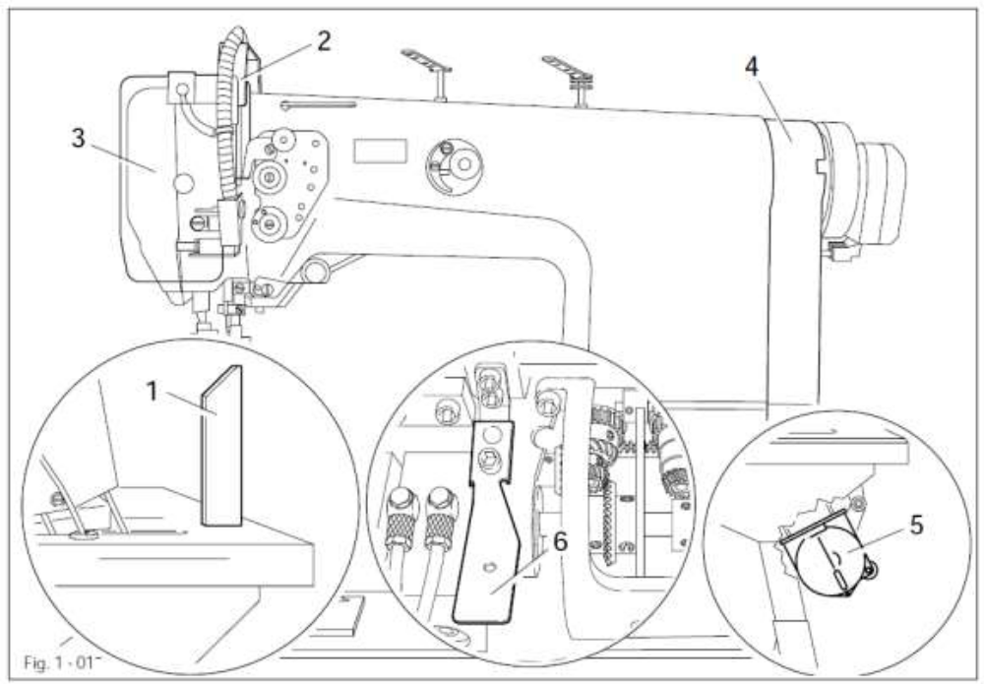
Based on June 2021, Curriculum Version 1

Module Title: -Performing maintenance of sewing machines
Module code: IND LGG2 M01 1221
Nominal duration: 50 Hours

Prepared by: Ministry of Labor and Skill
Aug, 2022
Addis Ababa, Ethiopia

Table of Contents

Acknowledgmen………………………………………………………………………………4
Acronym…………………………………………………………………………………………..5
Introduction to the Module……………………………………………………………………...6
Unit one: Prepare maintenance………………………………………………………………...7
- Maintenance to prevention and correction……………………………………………..8
  - Faulty of machinery and equipment ………………………………………………...14
  - OHS hazards………………………………………………………………………….15

Self-check-1……………………………………………………………………………………..26
Unit Two: preventive maintenance…………………………………………………………...27
- Select, use and maintain personal protective equipment………………………………28
  - Regular operational checksof machinery and equipment …………………………..31
  - Clean, lubricate, grease and other service of equipment and machinery……………..42
  - Adjust machinery and equipment regularly………………………………………......50
  - Conduct preventive maintenance according to OHS requirements…………………..65

Self check-2……………………………………………………………………………………...71

Operation sheet-2……………………………………………………………………………….72

Lap Test-2……………………………………………………………………………………….75

Unit Three: corrective maintenances of sewing machine……………………………………76
- Failures of sewing machine …………………………………………………… 77
- Maintain and restore Sewing machines………………………………………….81
- Conduct corrective maintenances ……………………………………………….84
Self check-3……………………………………………………………………………………..93
Operation sheet-3………………………………………………………………………………95
Lap Test-3……………………………………………………………………………………...105

Unit Four: Scheduled Maintenance…………………………………………………………106
- Annual schedule maintenance …………………………………………………107
- Scheduled maintenances using procedures…………………………………….107
- Record and documentation of maintenance …………………………………...114
Self check-4……………………………………………………………………………………116
Operation sheet-4……………………………………………………………………………..117
Lap Test-4……………………………………………………………………………………..118

Unit five: Complete the maintenance………………………………………………………...119
  - Clean and store tools……………………………………………………………………120
  - Environmental procedures and managing waste……………………………………….123
  - Clean and maintain working area………………………………………………………126
  - Malfunctions, faults and wear or damage of tools……………………………………..129
Self check-5…………………………………………………………………………………....131

Reference ……………………………………………………………………………………..132
Acknowledgment

Ministry of Labor and Skills wish to extend thanks and appreciation to the many representatives of TVET instructors and respective industry experts who donated their time and expertise to the development of this Teaching, Training and Learning Materials (TTLM).

Acronym

LGGLeather Garments And Goods
OHSOccupational Health and Safety
PPE Personal Protective Equipment
SNLSSingle Needle Look Stitches
SMSewing Machines
PDFProbability Density Function
TTLMTeaching, Training and Learning Materials

Introduction to the Module
In Leather Garments and Goods Production,This module covers the knowledge, skills and attitudes required to prepare for maintenance, perform preventive and corrective maintenances, understand scheduled maintenance of sewing machine, and keep maintenance record in production process.
This module is designed to meet the industry requirement under the Garments and Goods Production occupational standard, particularly for the unit of competency: Performing Maintenance of Sewing Machines.
This module covers the units:
- Prepare Maintenance
- Preventive Maintenance
- Corrective Maintenances Of Sewing Machine
- Scheduled Maintenance
- Complete Maintenance
Learning Objective of the Module
- Prepare Work For Maintenance
- Perform Preventive Maintenance
- Perform Corrective Maintenances Of Sewing Machine
- Understand Scheduled Maintenance
- Complete The Maintenance

Module Instruction
For effective use this modules trainees are expected to follow the following module instruction:
- Read the information written in each unit
- Accomplish the Self-checks at the end of each unit
- Perform Operation Sheets which were provided at the end of units
- Do the “LAP test” giver at the end of each unit and
- Read the identified reference book for Examples and exercise

Unit one: Prepare maintenance
This unit is developed to provide you the necessary information regarding the following content coverage and topics:
- Maintenance to prevent and correct
- Faulty of machinery and equipment
- OHS hazards
This unit will also assist you to attain the learning outcomes stated in the cover page. Specifically, upon completion of this learning guide, you will be able to:
- Identify select and provide tools, supplies and materials to carry out preventive and correctivemaintenance.
- Identify and segregate faulty machinery and equipment for repair according to enterprise requirements
- Identify and report OHS hazards to the supervisor

  - Maintenance to prevention and correction
    - Tools and Supplies Required to Perform Sewing Machine Maintenance

You need the following equipment and supplies for the job:
- Pan (pot) for soaking parts in cleaning fluid
- Large and Small screw driver
- Small adjustable wrench

- Hammer (optional)
- Small oil can (clean) for cleaning fluid
- Cleaning brush (narrow, nylon)
- Paring knife (or pocket knife)
- Long needle or small crochet hook
- Tweezers
- Cleaning cloths
- Fabric to test stitching
- Can of sewing machine oil (check your machine instruction booklet for the type recommended)
- Tube of sewing machine lubricant (check your machine instruction booklet for the type recommended)
- Small bottle or can of cleaning solvent that will not flash flame at temperatures below 120O F. It is usually available at gasoline stations or cleaning establishments.
- Paper
- Plastic wraps (household type)
- Rubber gloves
- Magnifying glass (optional)
- Flashlight (optional)

Hand Tools

Allen wrenches Set: You will need one set of METRIC ‘Allen wrenches size from 1.5mm to 10mm.

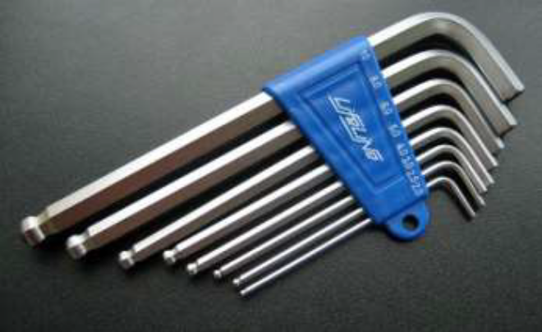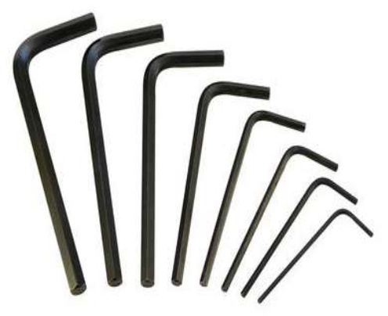

Figure 1.1Allen wrenches Set

The special type of Allen wrench are used to open and adjust special fitting on machine

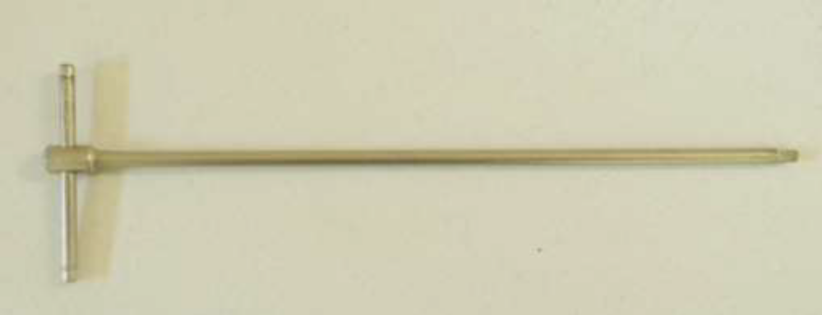

Figure 1.2Allen wrenches Set adjust special fitting

The Allen wrenches are used to open and adjust the Allen screws and bolts.

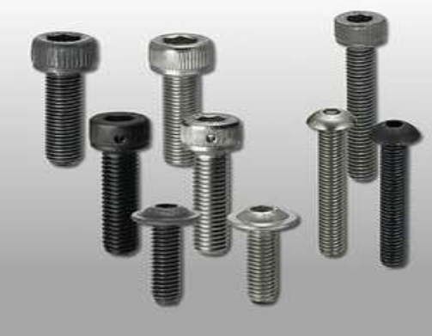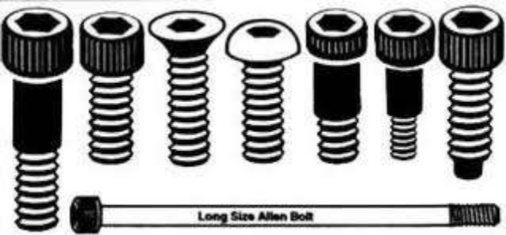

Figure 1.3 open and adjust the Allen screws and bolts
- Spanner Set: You will need one set of METRIC open end and ring spanners from size 6mm to 19mm.

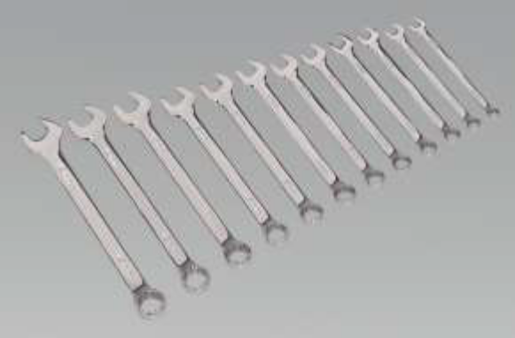

Figure1.4Spanner Set
- Needle Nose Pliers
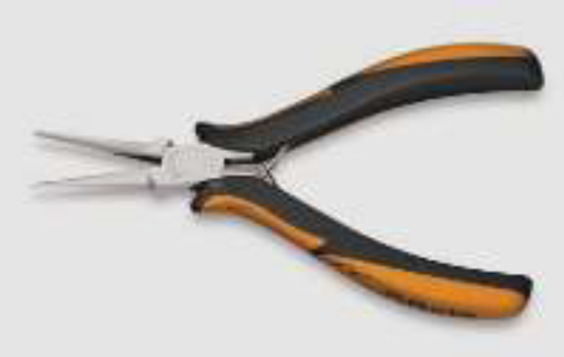
Figure1.5 Pliers
- Screw Drivers
The main tool you will be using is a screwdriver and a well-chosen selection of sizes is essential. The screw has narrow slots so make sure the screwdrivers have thin blades to fit them. Some of the smaller screws are set into recesses, so choose screwdrivers with parallel sides to the blade if possible.
    - Ideal sizes and blade widths
- 9-10 mm with good handles (for stubborn screws).
- 5 mm with shaft length of 3-5 cm (needs to be short for awkward places).
- 4 mm with shaft length of 20 cm (opposite reason to that above).
- 4 mm - not longer than 16 cm overall.
- 3 mm - not longer than 13 cm overall.
- 2 mm Tension screwdriver.
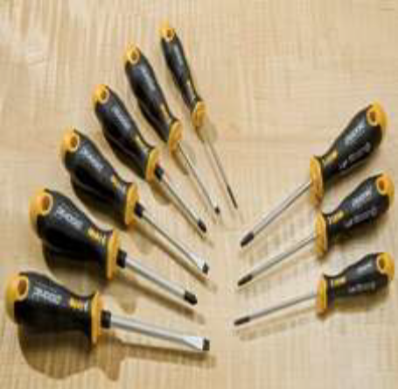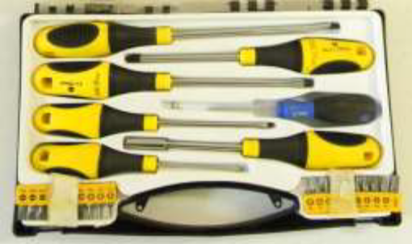
Figure 1.6Screw drivers
Typical Screwdrivers:
1. Stubby screwdriver for working in close quartets
2. Screwdriver with a square shank a wrench can be applied to remove screws.
3. Screwdriver for Phillips screws.
4. Cabinet screwdriver has a thin shank to reach and drive screws in deep, count holes.
- Oilcan
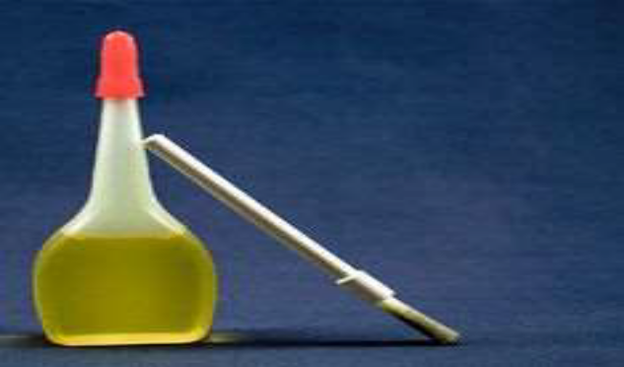
Figure 1.7Oilcans
- Cleaning Cloth/textiles
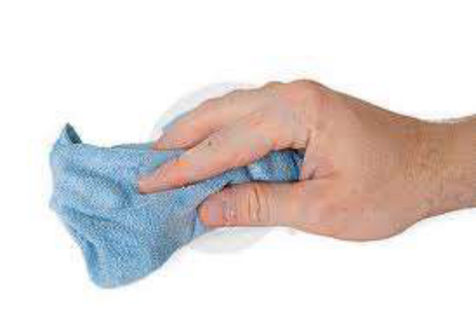
Figure1.8Cleaning Cloth
- Cleaning Brush: Narrow and Nylon
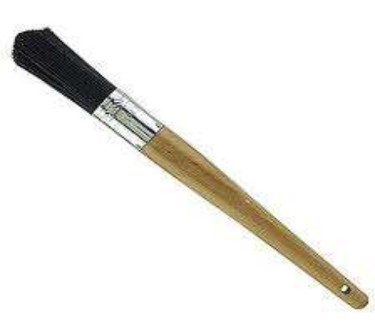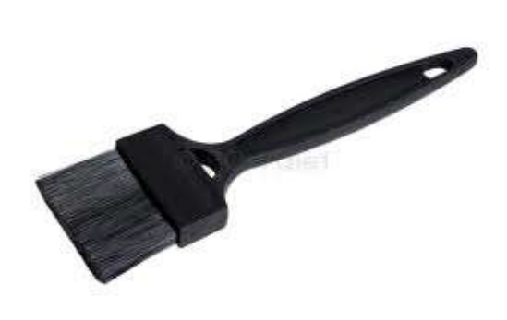
Figure1.9Cleaning Brush
Nylon brushes are suitable for a range of applications from aggressive scrubbing to dusting, in both dry and wet environments.
Narrow brushes are suitable to clean corner edges and narrow places.
Tweezers
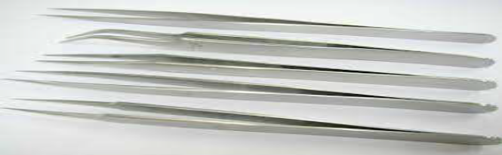
Figure1.10 Tweezers handling screws
The special type Tweezers are used for picking and handling screws and small parts in ‘Sewing Machine’. They are also used to clean out the shuttle area of sewing machines.
- Faulty of machinery and equipment
    - Identify Faults in Sewing Machine
Most sewing machine problems can be traced to poor general maintenance or neglect. Depending upon how much use your sewing machine receives daily, weekly, or monthly, you will want to maintain it accordingly. All machines have owner’s manuals that give recommendations for care and maintenance. If you do not have one for your machine find a dealer or check on line at the manufacturer’s Web site to order a copy. The goal is to keep your machine running and problem free. When problems do arise, check your owner’s manual first and then the list given here for ways to correct them before heading off to the repair shop.
    - Common Faults may occur on Sewing Machine
1) Machine not sewing: If the machine is simply not sewing or has other related errors, the easiest thing to check is whether the thread and needle are set up properly.
2) Breaking Needles: Needles may break due to simple reasons like prolonged use or hitting a straight pin; these breaks can be difficult to predict. However, needles also break from very controllable factors such as forcing the fabric through the feed or by using the wrong needle.
3) Skipping Stitches: Skipped stitches are usually due to a bad needle. The needle may have become damaged or bent by sewing material too thick for the needle, forcing material through the feed dog, or hitting a straight pin.
4) Sewing Machine Thread is Tangling, Bunching or Breaking: Having the thread not cooperate as intended is a problem that can lead to stress among those who sew. The good news is that thread problems usually arise from very fixable issues.
- Thread Looping and Bunching
- Thread Breaking
- Tension Adjustments
5) Mechanical Noises and Maintenance: If the sewing machine is making uncommon noises, such as grinding or banging, the machine parts may be jammed or in need of cleaning or maintenance. Do not use the machine when it is operating this way, and turn off power to the machine before inspecting the issue.
  - OHS hazards
    - Identification and Report of OHS

The following are common hazards that can be found in the workplace, and the problems that they could cause.

You must take reasonable care of your own health and safety at work and avoid harming the health and safety of other people.

Your general duties include:
- Follow health and safety policy and procedures
- Wearing protective clothing, accessories and grooming yourself appropriately.
- Maintaining equipment and operation it correctly.
- Reporting hazards.
- Reporting work related injuries or harm to supervisor.
- Cooperating with employers so that employers are able to carry out their duties under the OHS Act.

Hazards Related to the Sewing Machine:

Stabbing and Puncturing Hazards: Rapidly moving parts of sewing machine.

For example: the needle of a sewing machine.

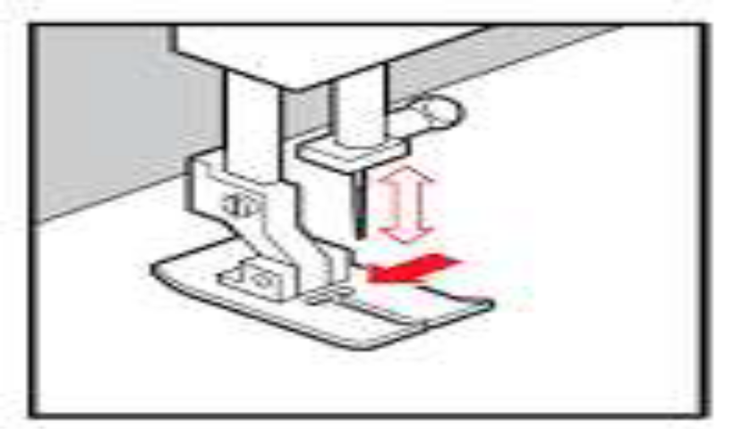

Figure 1.11 holding needle
    - Manual Handling of Sewing Machine

About the machine set-up location:
- Do not set up this sewing machine near other heavy equipment such as grinding, milling machine, and such equipment may be affected the sewing machine.
- The sewing machine should be plugged directly into an AC power wall outlet. Operation problems may result if extension cords are used.

Carrying the machine

The machine should be carried by the arm by two people as shown in the illustration.

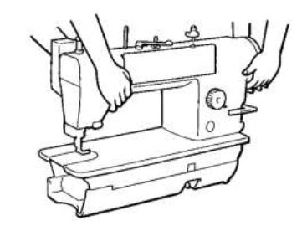

Figure1.12carrying machine

- Do not hold the machine by the machine pulley.

Tilting back the machine head

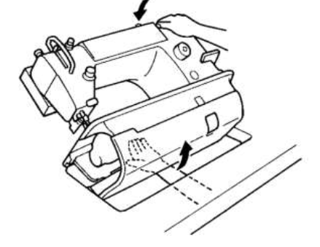

Figure 1.13carrying machine
- While pulling the bottom rear of the bed toward you with your left hand, push the top right of the arm body with your right hand to tilt back the machine head.
- Be careful not to get your left hand caught between the bottom of the bed and the table.

Returning the machine head to the upright position

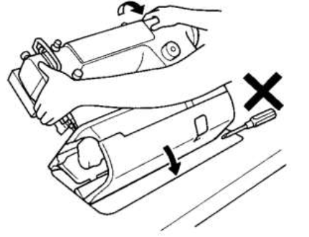

Figure 1.14carrying machine
- Clear away any tools, etc. which may be near the table holes.
- While holding the face plate with your left hand, gently return the machine head to the upright position with your right hand.

The Safe Maintenance of Equipment
- It is important that the machine operator reports all failures and errors to the supervisor or the maintenance department immediately. These persons decide whether it is possible to continue to work with the machine or whether the machine has to be repaired immediately.

Users Safe Work Practices

Users should be required to comply with the following safe work practices with respect to machine guarding and maintenance protection.
- If a guard is on a machine, it should not be removed or bypassed. If misadjusted, it should be reported to your supervisor. Know how guards and other safety devices function and how to inspect them.
- Be sure to follow proper operating procedures for your machine. Take no shortcuts in any step-by-step procedure.
- Keep hands away from moving machine parts and out of points of operation.
- Avoid wearing loose fitting clothing, long hair and jewelry around moving parts of equipment. Gloves also may be inappropriate in such situations.
- Adjust shields properly on points of operation if chips or other eye or face hazards are present.
- Assure that there are no slipping or tripping hazards around machinery.
- Report to your supervisor if your machine makes movements or operates independently of your commands.
- Know where all controls for machines in your work area are located and how to shut down the equipment in an emergency.
- Do not operate a machine you have not been adequately trained to run. If you have any questions or uncertainties, notify your supervisor.
- 10) Notify your supervisor of any problems you discover or any safety hazard on.
    - Appropriate use, maintenance and storage of Personal Protective

Equipment

Personal Protective Equipment is clothing or equipment designed to control risks to health and safety in the Sewing Machine. It includes:
    - Eye Protection: Goggles, Safety Glasses
  - Position goggles over eyes and secure to the head using the ear pieces or headband.
  - Position face shield over face and secure on brow with headband.
  - Adjust to fit comfortably.
    - Hand Protection- Gloves
- Select correct type and size
- Insert hands into gloves
- Extend gloves over isolation gown cuffs.
    - Foot Protection- Safety Boots
    - Body Protection- Aprons, overalls, thermal wear, high-visibility garments, etc...Maintenance of Personal Protective Equipment Inspect PPE before each use. With most PPE, it only takes a few minutes to inspect the equipment for any breaks, tears and visible signs of stress or damage. Maintenance may include: cleaning, examination, replacement, repair and testing. You may be able to carry out simple maintenance (e.g. cleaning), but more intricate repairs must only be carried out by competent personnel. Immediately remove any damaged equipment from service until a competent person or a manufacturer’s representative can certify the equipment for use. If not authorized by a manufacturer to repair PPE, do not attempt to fix it. The costs associated with the maintenance of PPE are the responsibility of the company/concern.

All PPE must be:
- Checked for defects on a regular basis, e.g. perished tubing, holes in gloves etc;
- Cleaned and/or decontaminated after use and maintained in a hygienic fashion – laundry facilities may be required for certain items such as lab coats;
- Stored in appropriate accommodation, e.g. safety goggles kept in a case, lab coats hung up in the lab;
- Replaced if lost or damaged, e.g. if Lenses scratched

Storage of Personal Protective Equipment
- Where PPE is provided, adequate storage facilities for PPE must be made available for when it is not in use, unless the employee may take PPE away from the workplace, e.g., footwear or clothing.
- All PPE must be stored in a clean and sanitary condition ready for use. Accommodation may be simple, e.g.: hangers for waterproof clothing or, E.g.: a case for safety glasses on a designated shelf.
- Storage should be adequate to protect the PPE from contamination, loss, damage, water or sunlight.
- Proper storage often requires a dry and clean place that is not subject to temperature extremes. Where PPE may become contaminated during use, storage should be separate from any storage provided for ordinary clothing.

Protection of People in the Workplace:

By Using Personal Protective Equipment (PPE)

Sewing machine operators should wear two major personal protective mechanisms:-
- Eye and Face Protection: Wear safety glass, any time work operations can cause foreign objects to get in the eye.
- Hearing Protection: Use ear muffs, ear plugs to protect noise from sewing machine.
- Foot Protection: Operator should wear work shoes or boots with slipresistant and puncture-resistant soles. Safety-toed footwear is worn to prevent crushed toes when working around machine or falling objects.
- Hand Protection: Gloves should fit snugly. Operators should wear the right gloves for the job. Example: cotton gloves for handling fabrics to protect from damages, cutting edges.
- Body Protection: Operators should wear Apron and cloths to protect from environmental issues like dust, etc.

By Using Safety Guards and Safety Devices:

Types of guards

Guards are such as permanently fixed physical barriers, interlocked physical barriers, physical barriers securely fixed in position, and presence-sensing systems. Depending on the situation, a combination of two or more of the following guards may be required to ensure workers’ safety.

On Sewing Machine:

Physical barriers securely fixed in position-Safety guards:

Safety Devices: Devices such as eye guard, finger guard, thread take-up cover, motor cover, tension release solenoid cover, inner cover, outer cover, fixed cover and gas spring support cover.

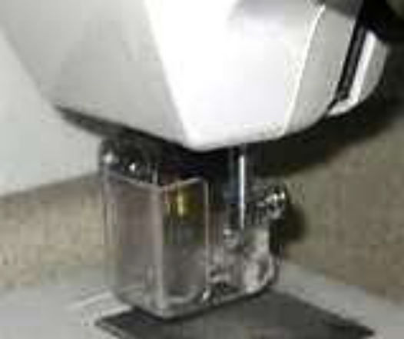
Eye Guard:

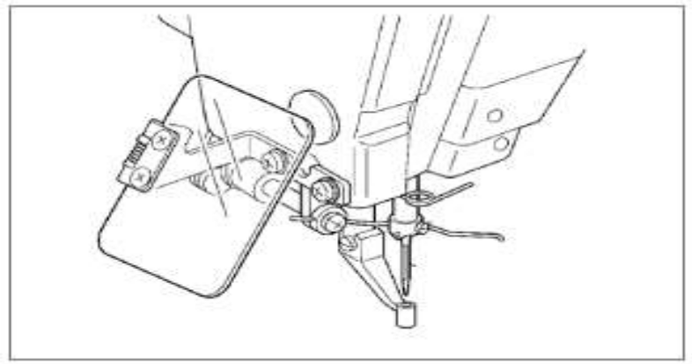

Figure1.15Eye Guard SM

Finger Guard and Eye guard:

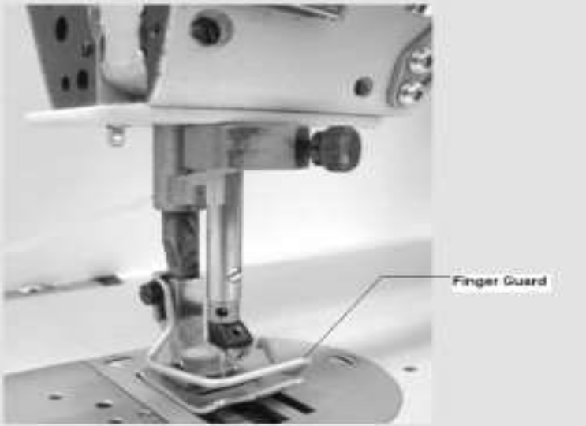

Figure 1.16 Finger Guard

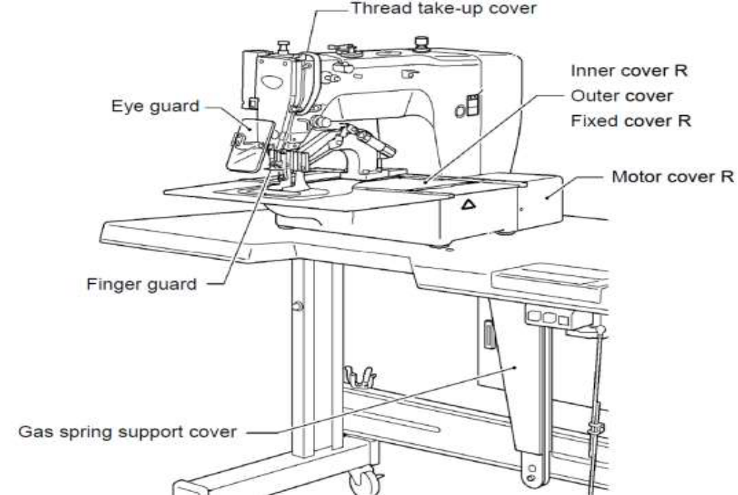

Figure 1.17On sewing machine part and component

By Providing Housekeeping

Maintain all areas in a safe and tidy condition:
- Keep access and egress paths safe and clear;
- Erect general safety signs and keep in good condition;
- Make a safe system for collecting, storing and disposing of waste materials at the workplace;
- Store materials and plant safely; and
- Ensure protruding objects do not pose a hazard (for example exposed nails).

Fire exits, evacuation routes to exits and firefighting appliances must be kept clear and Unobstructed at all times. Evacuation routes include any doorways, corridors, stairways, landings or passage ways forming the path of travel to an exit from any place within the building through a final exit door, to a place of safety outside the building.

Safety Signs:

Exit/Fire Exit:

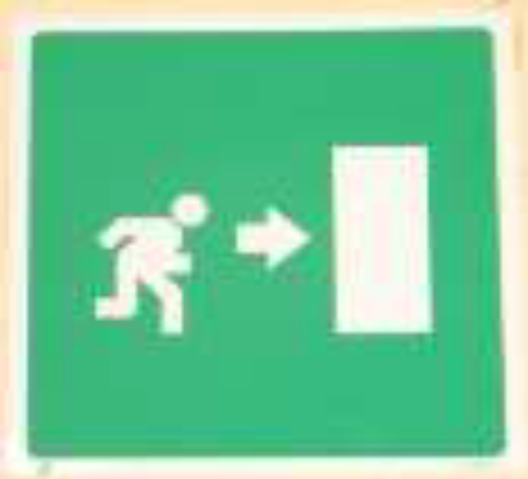

Figure 1.18existing door

Other common signs

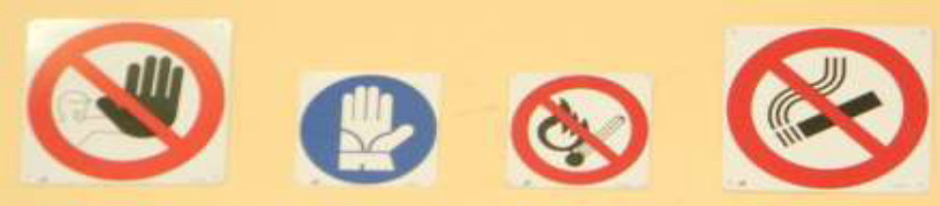

Figure 1.19

Fire Alarm, Fire Extinguisher and Fire Hydrant:

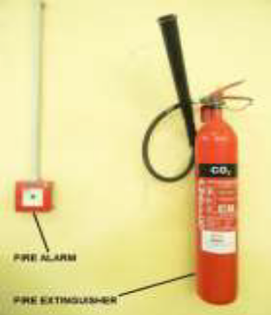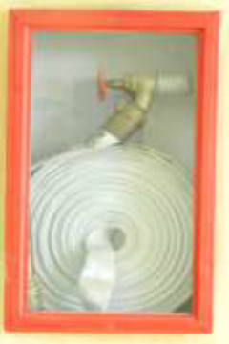

Figure 1.20Fire Extinguishers and Fire Hydrant

Use of Tools and Equipment’s of Machinery

Using tools properly helps prevent accidents and damage to equipment and people. The following actions will minimize the risk of injury:
- Wear the appropriate personal protection when using tools.
- Maintain all tools in proper working order.
- Never modify a tool for a task that it was not designed for.
- Select the correct tool size and type for the task.
- Inspect all tools before use, i.e. discard any worn or damaged tools.
- Use the correct grips/handles.

Work Place Environment and Handling of Material Safely

Maintenance of the working environment and equipment is essential for safe performance of manual tasks. An adequate hazard reporting system and preventative maintenance program will help to ensure equipment and the working environment is kept safe.

Work area on sewing machine:

Workplace design and layout needs to enable sewing machines to be accommodated in the safest configuration.

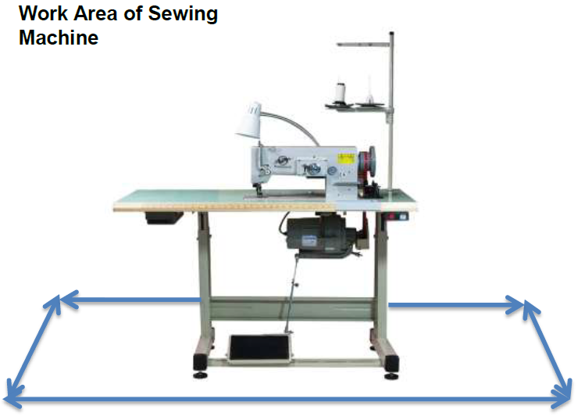

Figure1.21Work area on sewing machine
- Movement in and around sewing machine needs to be free of obstructions such as furniture, materials or other machines.
- Supervisor need to ensure that the space for workers to move and work between sewing machine and other machines (or) materials is at least 800mm
- This is to enable workers to work safely between machines, benches or counters. It will also allow them to evacuate quickly in an emergency Aisles, passageways and access to cupboards, storage or doors need to be in addition to the calculated clear workstation space.

Safe Work Practices-Handling of Material:
- Wear appropriate personal protective equipment such as work gloves when handling materials with sharp edges and safety footwear when handling heavy objects and materials.
- Ensure there is adequate clearance for safe lifting/material handling.
- Ensure storage areas are kept tidy, well organized and free of clutter.
- Use a hand truck, cart, trolley, wheelbarrow, etc to move heavy, awkward or bulky objects. Ask for assistance.
- Do not lift or carry items by the packing straps or cords.
- Do not use a box, desk or chair to reach high objects.
- Do not lift a load if you are not sure that you can handle it safely.

Follow OHS Procedures designated for the task

OHS Safe Work Procedures:
- Wear appropriate personal protective equipment
- Use Emergency Release Button
- Turn OFF machine when not in use.
- Keeps hand away from moving parts
- Use both hands for operation when required.
- Do not use your fingers to remove leather that has become caught between the blades and guide fingers. Use pliers only.
- Do not attempt any electrical repairs. If anything is wrong, tell your instructor.
- Safety Guard: This must always be in place when operating the machine.
- If your hair is longer than shoulder length, use a hair net of tie it back
- Know your fire drill.
- One operator at a time on the machine
- Do not fool around
- If you injure yourself, no matter how minor, tell your supervisor. If necessary seek medical attention

Self check-1
Directions: Answer all the questions listed below. Examples may be necessary to aid some explanations/answers.
- What are the tools and supplies required to perform sewing machine maintenance?
- What is the purpose of ‘Tweezers’?
- What are the common faults may occur on sewing machine?
- Write the personal proactive equipment risk to health and safety in sewing machine?

Multiple Choice Types
Choose the correct answer for each question.
- Which of the following might cause skipped stitches?
- Needle inserted incorrectly
- Upper tension too tight
- Pulling the fabric when stitching
- None
- The machine needle should always be threaded from
- The front to the back
- The side with the short groove
- The side with the long groove
- None
- If your thread keeps breaking or your machine needle keeps coming unthreaded, it probably means that
- The needle is duel or blunt
- The needle is not in right
- The machine is not threaded right
- You are sewing crooked
- When replacing a sewing machine needle it is important that the
- Groove side of the needle face the thread
- Groove side of the needle face away for the thread
- Needle be inserted to the top of the socket
- Bothe A and C answers are correct
- When cleaning the machine the motor should be
- On
- On but feet should be off the foot control
- Off
- All
- When the machine is not use
- raise the presser foot &needle &turn off the motor
- lower the presser foot &needle &turn off the motor
- lower the presser foot ,raise the needle, and turn off the motor
- A & B
- Your machine is making an unusual noise when you are stitching, you should
- check to see that the bobbin is in correctly
- check to see that the needle is all the way in straight
- check the threading
- all of the above
- When making machine adjustments, the machine operator should
- always call the clothing textile teacher
- make only the adjustments of which training has been given
- try to make any adjustments that are needed
- All
- Whose responsibility is it to see that the sewing machine is kept in good condition?
- The shop teacher
- The clothing &textiles teacher
- The student operators
- Both B&C answers are correct

Note: Satisfactory rating – above 60% Unsatisfactory - below 60%
You can ask you teacher for the copy of the correct answers

Unit Two: preventive maintenance
This unit to provide you the necessary information regarding the following content coverage and topics:
- Personal Protective Equipment
- Operational ChecksOf Machinery And Equipment
- Service Of Equipment And Machinery
- Adjust Machinery And Equipment
- Preventive Maintenance
This guide will also assist you to attain the learning outcomes stated in the cover page. Specifically, upon completion of this learning guide, you will be able to:
- Select, use and maintain personal protective equipment
- Regular operational checks of machinery and equipment
- Cleaning, lubricating, greasing and other servicing of equipment and machinery
- Adjusting machinery and equipment regularly
  - Conducting preventive maintenance according to OHS requirements

- Personal protective equipment
    - Suitable Personal Protective Equipment
Assessing suitable PPE
To make sure the right type of PPE is chosen, consider the different hazards in the workplace and identify the PPE that will provide adequate protection against them; this may be different for each job.
Consider the following when assessing suitability:
- Does the PPE protect the wearer from the risks and take account of the environmental conditions where the task is taking place? For example eye protection designed to protect against when using an angle grinder to cut steel or stone.
- Does using PPE increase the overall level of risk or add new risks, e.g. by making communication more difficult?
- Can it be adjusted to fit the wearer correctly?
- What are the needs of the job and the demands it places on the wearer?
For example, the length of time the PPE needs to be worn, the physical effort required to do the job or the requirements for visibility and communication.
- If someone wears more than one item of PPE, are they compatible? For example does using a respirator make it difficult to fit eye protection properly?
Use:-
- Can use to protect from intense heat, splashes of hot metals and other hot parts, impacts from tools, machinery, and materials, cuts, hazardous chemicals.
- When cleaning equipment.
Maintenance:
- Aprons are expensive protective items that should be kept in good condition for as long as possible. Apart from deterioration due to aging, very often aprons are damaged due to incorrect handling.
- Apron (even with the latest improved material) tends to crack when being folded (cross folding would even be worse!), or lay over a pointed object.
- When not in use, aprons should be hung carefully on designated hangers or wrapped over a reinforced towel bar
Gloves
- Gloves made of cotton or other fabrics protect against dirt, slivers, chafing, and abrasion but do not provide sufficient protection to be used with rough, sharp or heavy materials.
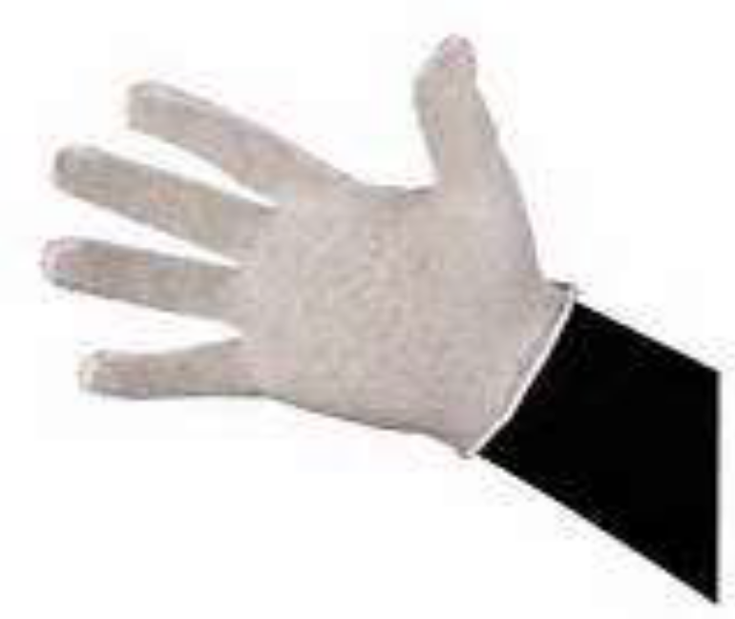
Figure 2.1 Glove cotton
Gloves made of rubber (latex or butyl), plastic, or synthetic rubber-like material such as neoprene protect workers from burns, irritation, and dermatitis caused by contact with oils, greases, solvents, and other chemicals
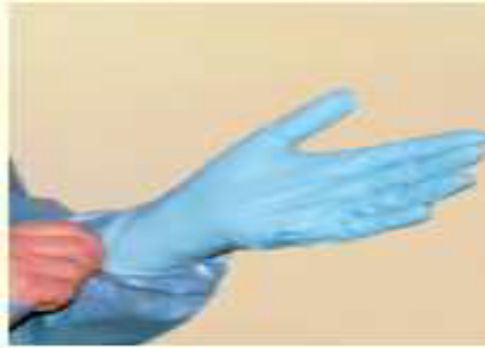
Figure 2.2 Glove rubber latex
Select and use the right kind of glove for the job you are going to be performing:
  - Check fit, always use correct size
  - Make sure chemical resistant to chemical being used
  - Inspect your gloves before you use them
  - Remove any rings, watches, or bracelets that might cut or tear your gloves
  - Look for holes and cracks that might leak
  - Replace gloves that are worn or torn
- Protect hands from contamination with organic matter, and chemicals
- Contact with non intact skin
- Contact with contaminated equipment
- Contact with chemicals
- Cleaning contaminated equipment
- Never wear gloves around powered rotating equipment - drills, lathes, etc

Protective Eye Wear
These may be;
- Safety Spectacles (re-usable)
- Combined single use visor and facemask
Use:
- Protects the eyes from chemicals
- Protects the eyes from flying objects and dusts.
Maintenance:
  - Clean your eye protection equipment. You can usually use mild soap and water and dry it by soft cloth .Never use abrasive soaps, rough paper, or cloth towels.
  - Store your eye protection equipment in a sanitary, cool, dry area away from moisture
  - Read the manufacturer's directions and warnings before using any eye protection equipment.
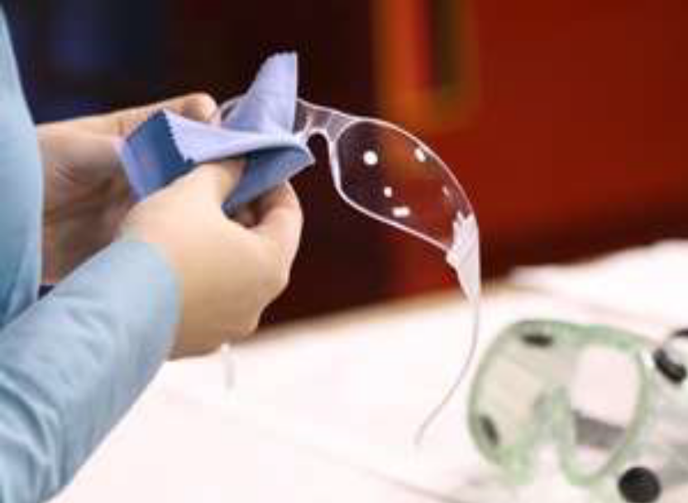
Figure 2.3 Protective Eye Wear
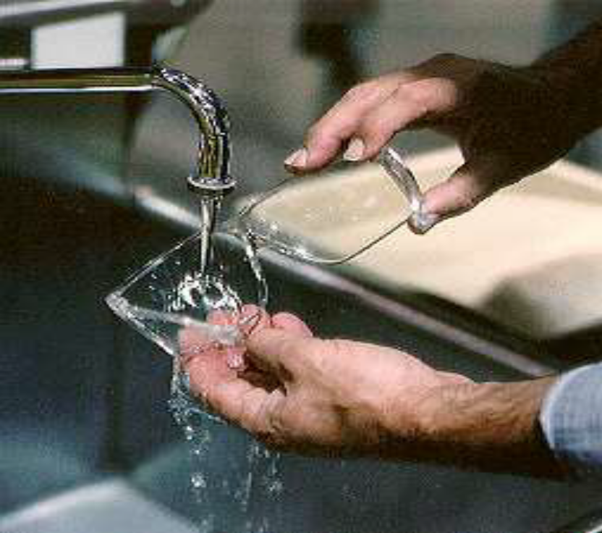
Figure 2.4 Protective Eye wear maintenance

- Operational checksof machinery and equipment
    - Checking machine for correct operation
      - Type of Machine
Flat Bed Sewing Machine
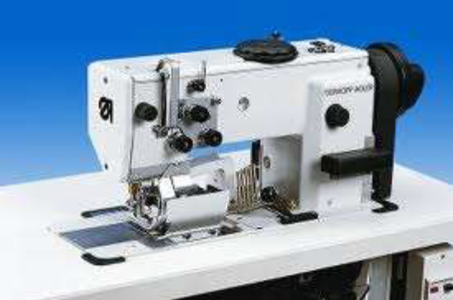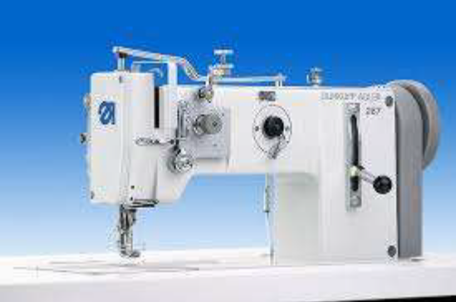
Figure 2.5Flatbed sewing machines
Post Bed Sewing Machine
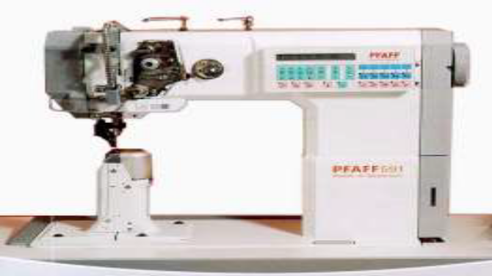
Figure 2.6 Post Bed Sewing Machines
Cylinder Bed Sewing Machine
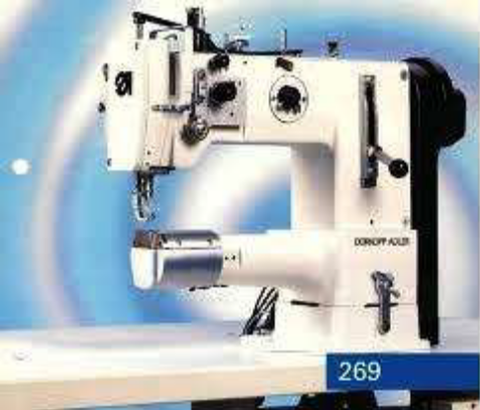
Figure 2.7 Cylinder Bed Sewing Machines
      - Safety Check Components of sewing machine
The following safety checks and precautions should be carried out when preparing to set up and use the sewing machine
Figure 2.8 Components of sewing machine
Components of sewing machine
- Supporter;
- take-up lever guard;
- Eye guard
- Balance wheel
- Belt guards
- Working area of 1 meter is to be kept free both in front of and behind the machine while it is in operation so that it is always easily accessible.
- Check all adjustments and settings carefully before commencing any sewing operation.
- Check a support (1); do not operate the machine without support (1).
- Danger due to top – heavy sewing head. Machine can tip over backwards when tilted.
- Check a take-up lever guard (2). Do not operate the machine without its take-up lever guard (2).
- Check a finger guard. Do not operate two needle machines without the finger guard. Danger of injury by the moving needle.
- Check machines with thread lubricator, only operate the machine with the eye guard (3) lowered. The eye guard (3) protects the eyes from oil particles from the thread lubrication.
- Check belt guard (4) & (5). Do not operate the machine without belt guard (4) &Danger of injury by rotating drive belt.
- Check tilt lock (6). Do not operate the machine without tilt lock (6).
- Danger of crushing between sewing head and table top.
- Check electrical socket. The machine may only be connected to an earthed socket.

      - Operating Safety Precautions
- Make sure all other students keep away from the immediate work area at all times.
- Not wear loose clothing, especially long sleeves and neck ties.
- Remove the cover from the sewing machine and place it on the back of the chair before use.
- One person only is to operate a sewing machine at any time.
- Do not touch a sewing machine whilst another person is operating it.
- Turn the power off when making adjustments to the sewing machine.
- Examples include changing the presser foot and the needle.
- Never race the sewing machine at high speed.
- Take care not to machine over pins.
- Make sure the take-up lever is in the upper most position before pulling out the fabric and cutting threads.

    - Maintenance Check
Post Bed Sewing Machine:
Check and clean the hook compartment and the hook. Lubricate if required.
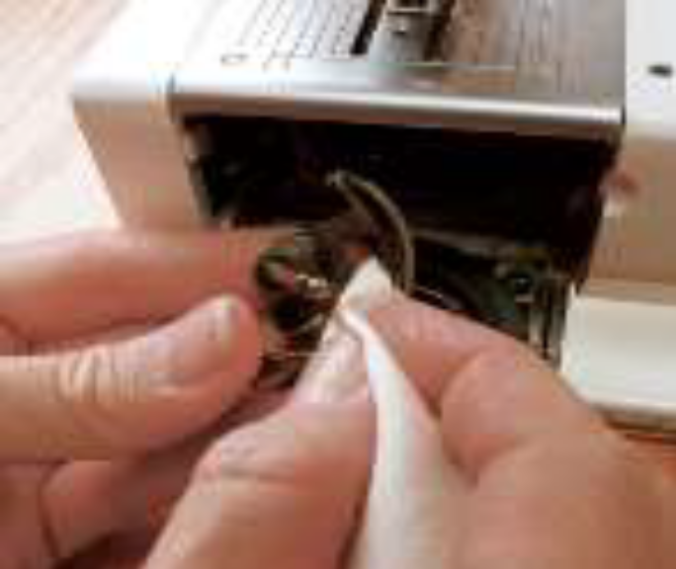
Figure 2.9 Post Bed Sewing Machines
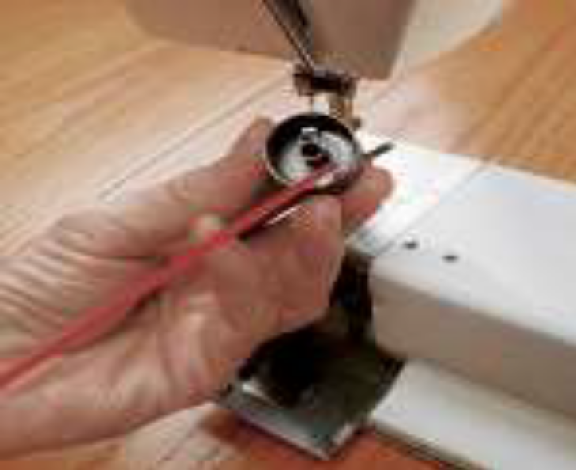
Figure 2.10 Post Bed Sewing Machines
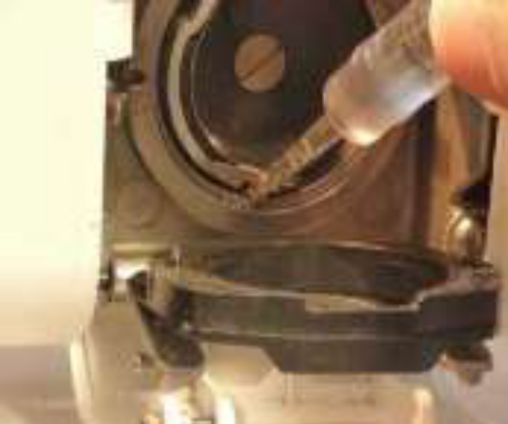
Figure 2.11 Post Bed Sewing Machines
Flat Bed Sewing Machine and Cylinder bed Sewing Machine:
    - Maintenance Check to be carried out on;
    - Check Oil level (Thread lubrication) daily, before operation.
- Upper part of machine:
  - Remove lint, pieces of thread another decries
  - Clean oil collector. Remove lint and oil spills with a cloth
- Sewing Drive:
- Check the condition and tension of the V-belt in every month.
- It must be possible to depress the V-belt by about 10mm by pressing it with a finger at its midpoint.
- Check lubrication level on the upper part of the machine:
- Fill tube (1) to the brim with oil.
- The oil slowly reaches the upper part of the machine through the felt beneath the tube.
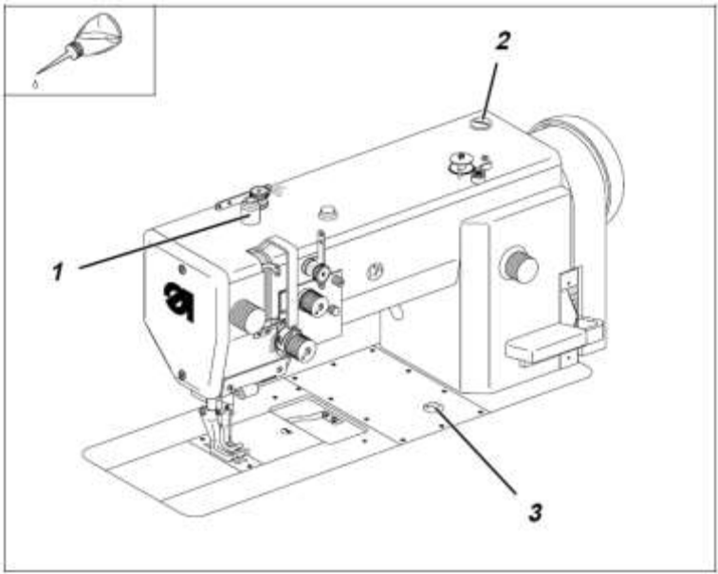
Figure 2.12 Post Bed Sewing Machines

- Check lubrication level of the shuttle:
  - Remove knee lever.
  - Turn the upper part of the machine over.
  - Fill tube (4) with oil up to “MAX’ mark.
- Check lubrication level of the lower part of the machine on weekly:
  - Unscrew oil-filter cap (2).
  - Top up with oil.
  - Check oil level at sight glass (3). The oil level must be between the upper red line and the “LEER” line.
  - Replace oil-filler cap.
  - Remove any oil which has overflowed into the oil collector.

Cylinder Bed Sewing Machine:
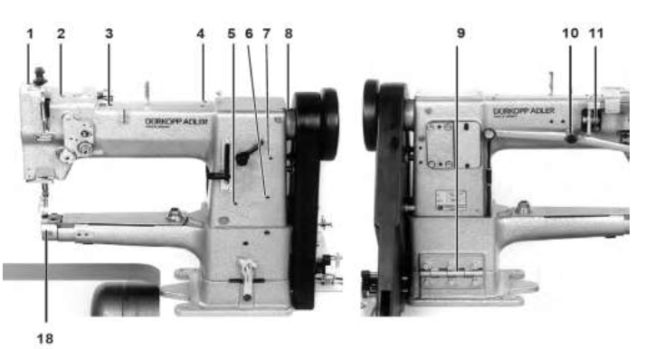
Figure 2.13 Post Bed Sewing Machines

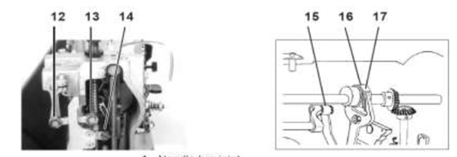
Figure 2.14 Inner Post Bed Sewing Machines
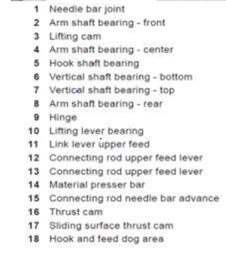
Check oil lubrication points 1-to- 17 weekly.
  - Remove the top.
  - Oil all the lubrication points shown in the illustration with a few drops of oil.
Check the direction of turn.
- Check the direction of turn of the motor ventilator wheel by briefly turning on the main switch.
- The arrow in the illustration shows the correct direction of turn (counterclockwise run)

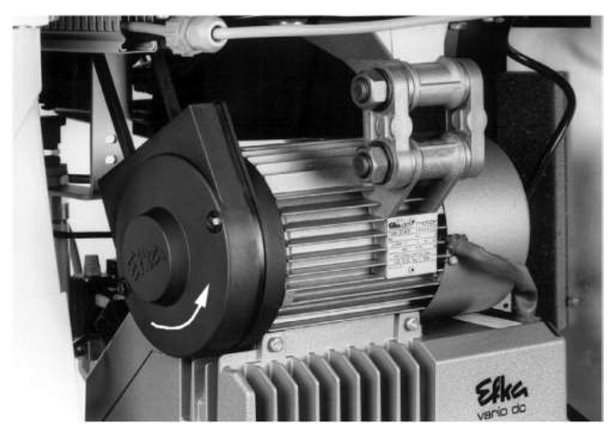
Figure 2.15 Inner motor sewing machine lubricate
Check the positioning:
Reference position: -The reference position the lowering needle point lies at the height of the top of the needle plate.
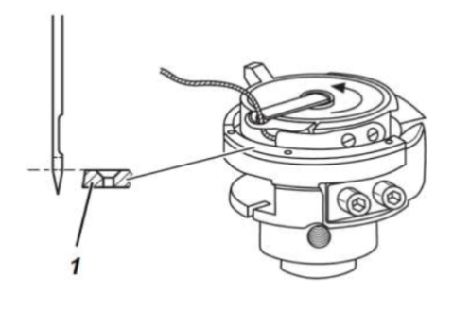 Figure 2.16
Position-1:
  - By sewing machines with thread trimmer the trimming sequence is initiated in the 1st position. The trimming must occur before the needle low position because the thread-pull knife would otherwise collide with the bobbin case opener finger.
  - In the 1st position the lower edge of the needle eye of the lowering needle must lie at one level with the hook covering ring (1).
Position-2: In the 2nd position the thread lever lies in the high position.
Procedure:
  - Turn the main switch ON.
  - Briefly step forward on the pedal. The sewing machine positions in
  - Step the pedal completely back and hold. The thread is trimmed. The sewing machine positions in position-2 (thread lever high position).
  - Check if the thread lever lies at its upper dead center. For this, turn the hand wheel back and forth slightly.
  - This normally completes the check.
    - Sewing Machine Operating Procedure
- Turn ON the main switch
- Lower the presser foot by the lever.
- For pulling up the bobbin thread, hold the needle thread behind the presser foot and rotate the machine,
- Lift the presser foot,
- Place both threads backwards and position the material.
- Lower the presser foot,
- Lower the pedal forwards. The machine will operate faster if the pedal is lowered more (do not push or pull the material).
- Operate machine without material only with lifted presser foot. After sewing, turn off the main switch, and in case of machines with pneumatic connection, stop the compressed air supply.
- Service of equipment and machinery
    - Cleaning, lubricating equipment and machinery
A sewing machine needs care for its smooth running. It should be cleaned and oiled regularly to ensure satisfactory sewing and long life. When not in use, cover machine to prevent dust accumulation on it.
The following points are to be checked:
- Cleaning
- Lubrication
- Periodical service
CLEANING
Use a small dry brush or old toothbrush and soft cloth to remove dust and lint. You should always remove lint deposits, dust and thread bits before oiling any part of the machine. Use a pointed instrument like a needle to pick out the bits of thread and lint that cannot be brushed out.
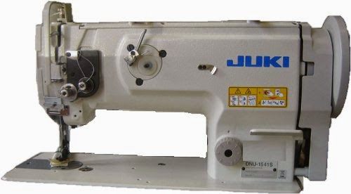
Figure 2.17 Industrial Sewing Machine
Cleaning
The following area to be cleaned; Spool stand, Machine head top complete Hook set area completely.
Table: 2.1 cleaning tool schedule

SN | Description | Schedule | Recommended mode of cleaning | Remarks
1 | Spool stand | Everyday | Cotton | Ensure that there is no  Pins,labels,buttons other than the thread cone on the spool.
2 | Machine head | Everyday | Cotton | Remove the complete dust from the en  Tire areas including  Bobbin winding area,  Knee lifter connecting areas, backside of the machine arm etc..,
3 | Hook shuttle | Twice a week | Soft Brush | Unscrew the needle plate and remove the dust and threads and clean the feed dog, trimming mechanism, hook set areas, feed bar  Areas, feed bar areas etc.,
4 | Oil tank | Everyday | Brush Tweser / Magnet | Where the flap and thread etc., Will accumulate.
5 | Bottom oil tank | Once in a week | Blower | C heck there is no pins, bits of cloth and bits of thread , labels etc., in the oil tank and edge of the oil tank.

Simple steps to follow for a basic machine cleaning
Before you begin, protect the floor and table top with some newspapers. A good floor or table lamp to light the work area from over your left shoulder will be helpful. A flashlight is also helpful in adding light in hard to see areas.
As you clean the machine, it is best to clean one area at a time. Remove only the parts that are involved and be sure to note where each part is from, its position, and which side is top. When remove parterre member that "left is loose and right is tight" on practically all screws and bolts.
Here are simple steps to follow next:
- First, remove the needle, presser foot, slide plate, throat plate, bobbin case, and the face plate (if it comes off). Put them in the pan and cover with cleaning fluid. Set aside to soak while cleaning other areas.
- Now, it is time to begin work to clean the machine head. With a sharp pointed tool, clean out all oil holes.
- Then, with your hand, turn the hand-wheel to run the machine. At the same time, squirt cleaning fluid into all the oil holes, on all bearings and on all other places where one part rubs against or turns within another.
- If possible remove the Bobbin case to clean all lint and lose thread bits. If the machine begins to run hard, it is a sign that dirt or lint has jammed inside a bearing.
Continue running the machine and flushing with cleaning fluid until the dirt and gummed oil are washed from the bearing. When the machine runs easily again, tip the head and flush the parts underneath the machine-all oil holes, bearing and places that rub against or within another. Continue running the machine by hand until it functions smoothly.
- To remove any remaining dirt and oil, dip a cloth or brush in cleaning fluid and scrub all parts of machine that can be reached.
- Use a needle, knife or other pointed instrument to dig or scrap away any remaining gummed dirt or lint in the feed dog, around the bobbin case, and in other areas.
- Pull a thread under the tension of the bobbin to remove dirt.
- Pull a piece of cloth soaked in cleaning fluid back and forth between the discs of the upper tension to clean it. Repeat with a dry cloth to be sure no lint or thread is caught between them.
In addition to general cleaning, remember that there are three areas that always need special attention. They include the hand-wheel bearing and the clutch assembly, the needle-bar and presser foot, and the hook and bobbin areas assembly.
    - Oiling and lubricating a machine
When doing a complete service and lubrication allow the machine to stand overnight so excess cleaning fluid can evaporate before oiling and lubricating it. Do not oil the tension discs, the hand-wheel release or the belts and rubber rings on any machine.
Squirt a little oil in all the designated holes and on all parts that rub against or within another. To distribute the oil run the machine a little so that it gets into all the bearings.
For regular lubrication, one drop of oil on each bearing and in each oil hole is enough. It is a good practice to oil the machine after each day's work or after 8 to 10 hours of use.
Even if you do not use your machine often, oil it occasionally to keep the oil from drying and becoming thick and dirty inside.
Use a lubricant only if the machine requires it and that too only in the areas suggested.
After oiling and lubricating the machine, wipe away excess oil and reassemble the machine carefully making sure you out each part back in its correct place.
It is necessary to oil and lubricate the machine periodically. If the machine is used every day, oil it once a week. After oiling, wipe off the surplus oil and place a piece of folded fabric under the presser foot to absorb any excess oil.
To oil thoroughly, remove the upper thread, needle plate, slide plate, faceplate, bobbin case, and needle and presser foot. Oil the holes on the underside first, after cleaning and then proceed to the upper side. Use only few drops of oil in each hole. Never use coconut oil. Machine oil of different brands may be used for different models of sewing machine, but should be used as recommended in the instruction book.
If the machine becomes gummed with oil, put a drop of kerosene or petrol in each oil hole and joints and run it rapidly for several minutes. Wipe off and re oil it with machine oil. The motor of electric sewing machine should be greased periodically
LUBRICATION:
- Use the exact specified oil as per sample. (How to identify? Check with laboratory. Oil to be purchased along with the laboratory test report.
- Apply oil in the manually applied areas (red house) Please check in the respective manual.

OILTANK
Every 420 hours of machine running, oil to be completely drained gauge. Check twice a week.
OILING SYSTEMS
A. Manual oiling system it requires the operator to oil each point individually, and on a regular (preferred 4-hour) basis.
B. Automatic oiling system it can supply all points of lubrication or can be com binned with manual oiling.

The oil in automatic systems can be distributed:
- Through gravity,
- Through splash,
- Through wicking (such as cotton cord), or
- Through pressure supplied by a pump.
All automatic oiling systems require the reservoir to be filled to a certain level with oil. Wick fed systems range from small reservoirs (the wicking itself may serve as reservoir) to more substantial cavities. The smaller the reservoir, the more often oil will need to be added. Larger oil reservoirs of any system type may have marked indicator levels, so that the operator can verify that enough oil is available in the reservoir.
Pressure lubrication systems may have sight windows or bubbles. A flow or splash of oil seen through these windows or bubbles will indicate that there is likely a good pressure of oil in the system. Pressure systems may also have adjustment needles or valves to control the flow of oil to critical points such as the hook race.
Any system can have an oil return mechanism to re-circulate oil and to prevent build-up of oil in pockets from which it may leak or overflow. The oil return mechanisms can be gravity flow, wicking, or both. Pressure systems may also incorporate a suction return, operated by the same pump that supplies oil pressure.
Lubrication is necessary for the sewing machine maintenance but at the same time lubrication may be the cause of oil stains in a garment.
To prevent the oil stains in a garment, an advance technology is used .On the basis of that technology, we can divide the sewing machines into the following categories:-
- Sewing Machine with Lubrication
- Semi Dry head Sewing Machine
- Dry Head Sewing Machine

SEWING MACHINE (SNLS) WITH LUBRICATION:
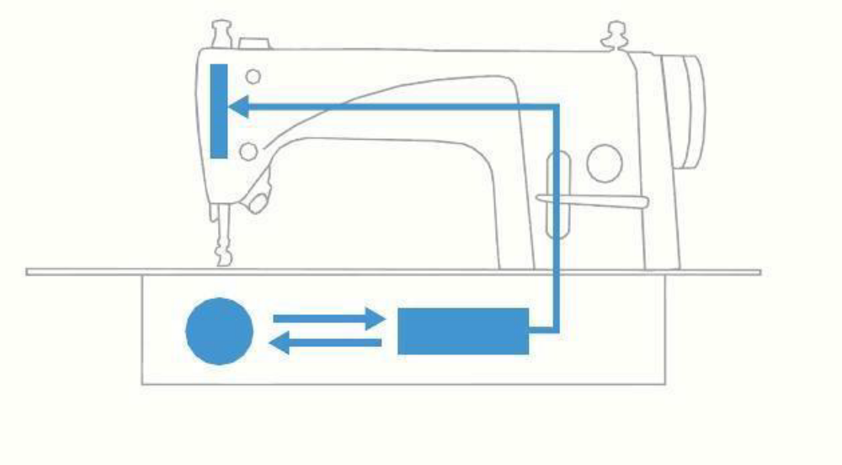
Figure 2.18 Oils system SM /LUBRICATION/
The needle bar and thread take-up components are lubricated with the minimum required quantity of oil. For the hook section, the standard method of lubrication is employed.
Semi dry head sewing machine
With the advanced dry technology of enabling operation without being lubricated, a frame which does not need lubrication has been developed. It is provided with not only a high-speed sewing capability, but also a safety feature for preventing oil stains.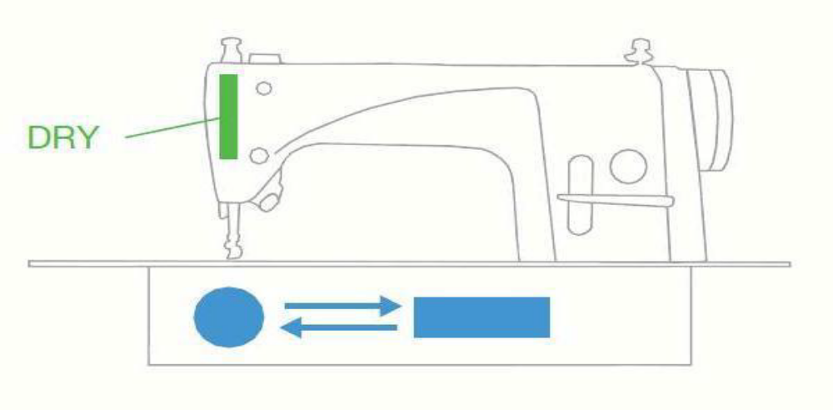
Figure 2.19 semi dry head sewing machine/oils system sm /lubrication/

- The needle bar and thread take-up components are not lubricated.
- For the hook section, the standard method of lubrication is employed.
Dry head sewing machine
As its designation indicates, the dry-head type machine ensures convenience of use by totally preventing the oil from staining the material being sewn. The machine wholly Contributes to the improved quality of finished products.
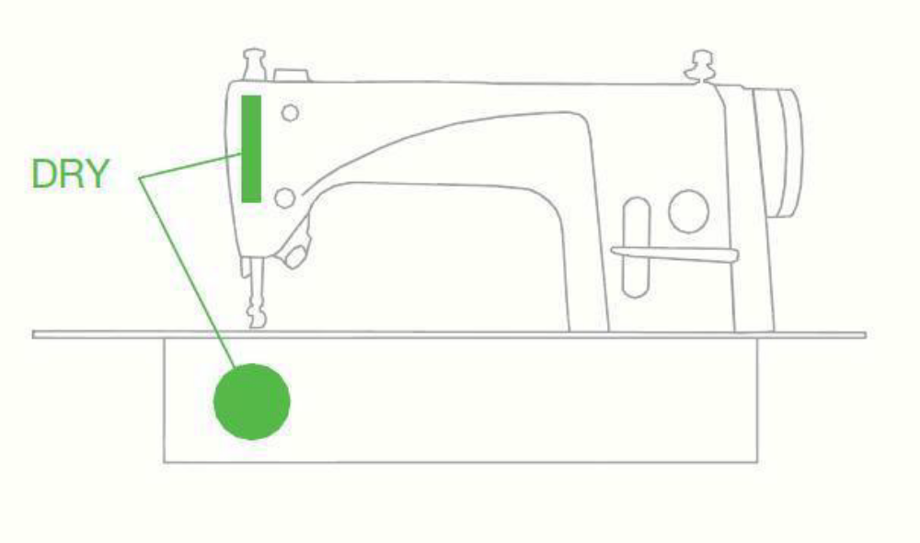
Figure 2.20 Dry head sewing machine
The section around the needle bar, the thread take-up lever and the hook are not lubricated.
Important checking points
- Make sure the oil flow- check the oil gauge window every day. If oil doesn’t flow through the window, please stop the machine and check the entire lubrication device.
- Make sure the hook set lubrication – (refer the technician). In case the oil flow is more or less adjust the oil regulating screw located bottom of the machine.
- Check all the wick lubrication areas; whether the oil flow is proper (refer to manual).
- Adjust machinery and equipment
    - Preparation of a single needle sewing machine
Before starting the operation process in a single needle sewing machine, an Operator should be aware of every aspect relating to the sewing machine. This includes the problems one may be faced with while working too, so that they may be rectified by the Operator or can be reported to one’s supervisor.
Daily Activities:
- Remove throat plate and clean daily.
- Clean circular feed dog, hook, and space around feeding wheel of material and thread residues. To clean it, use brush. It is prohibited to use compressed air for cleaning without protective guards preventing injury of persons with flying impurities.
- Lubrication of the hook path a few oil drops.
Monthly Activities:
- Checking the oil level in the hook lubrication oil tank.
- Checking the oil level in the oil tank of the central distribution.
For the lubrication of this machine ESSO SP-NK 10, DA 10 or an equivalent quality lubricating oil is recommended (Viscosity at 40º C: 10 mm²/S; flash point: 150º C).
Adjustments:
- Adjust Needle position:
- Set the minimum stitch length
- Adjust needle bar according to the requirement
- Adjust Height of the bobbin- case opener: Adjust the bobbin-case opener screws according to the requirement
- Adjust Bobbin-case opener stroke:
- Turn the balance wheel until the bobbin-case opener has pushed the bobbin case down as far as possible
- Adjust the bobbin case base screw according to the requirement.
Adjust of the feed wheel:
- Swing out the roller presser.
- Loosen screws
- Adjust drive wheel according to requirement, taking care to see that the teeth of drive wheel and feed wheel lock into each other properly.
- Tighten screws
- Adjust guide according to requirement and tighten screws.
Adjustment of stitch length control eccentric:
- Set the maximum stitch length.
- Turn stitch length control device screws according to the requirement.
Adjust Stitch length scale disk:
- Set the maximum stitch length.
- Turn the scale disk screws according to the requirement.
Adjust Shaft crank to feed wheel drive:
- Set the maximum stitch length
- Twist or shift the shaft crank screws according to the requirement.
Adjust Shaft crank to presser drive:
- Set the maximum stitch length.
- Twist clamp crank according to the requirement
Adjust Clearance between presser foot and feed wheel:
- Raise the presser bar lifter
- Adjust the presser bar screws according to the requirements. Make sure that the roller presser is parallel to the feed wheel
Adjust presser foot:
- Raise the foot presser.
- Always observe requirement for subsequent adjustments
- Adjust foot presser screw according to requirement.
- Lower foot presser to rest on feed wheel.
- Adjust foot presser bracket screw according to requirement.
Adjust Stitch length on stitch length scale:
- Set stitch length “3”
- By turning the balance wheel, let the needle enter 11 times and measure
- The total length.
- Adjust clamp screw according to the requirement
    - Common Sewing Machine Problems and Remedies
With the manual on hand along with the following tips, many of the most common sewing problems can be resolved.
Machine Not Sewing
If the machine is simply not sewing (nor) has other related errors, the easiest thing to check is whether the thread and needle are set up properly.
Threading the Machine
Check that the machine is threaded properly according the manual. When threading the machine, remember to always do so with the presser foot up, which releases the tension. Once threaded, putting the presser foot down will apply tension to the thread.
Sewing Machine Needle
Be sure that the needle is locked and facing the correct direction for the machine. If it's not, the thread will not be picked up by the hook when sewing. The flat side of the needle shank faces away from the bobbin insertion point in most machines. Blunt or damaged needles can contribute to a number of sewing problems, so don't wait until the needle is broken to change it.
Fabric Not Feeding or Is Jamming
Both the presser foot and feed dog may have raise and lower settings.
Without enough pressure on the fabric from the presser foot, the feed dog cannot do its job. On the other hand, having the presser foot too low may cause too much pressure or prevent the fabric from feeding through, causing jams. Check that the feed dog is in its raised position when sewing. If the feed dog seems to be jammed, it may be due to lint and debris.
Breaking Needles
The needle is often the easiest part of a sewing machine to change; that's fortunate because it is also the part most prone to wear. Needles may break due to simple reasons like prolonged use or hitting a straight pin; these breaks can be difficult to predict. However, needles also break from very controllable factors such as forcing the fabric through the feed or by using the wrong needle. Forcing the fabric rather than allowing the feed dog to do its job can bend or break the needle; a bent needle may hit the hook when sewing, which can lead to broken needles and damage to the hook.
Using the wrong size needle is often the cause of a broken needle. Needle size should be relative to the thickness of the material being sewn. There are also specialty needles for fabrics such as leather and denim.
Problem: Broken Needle

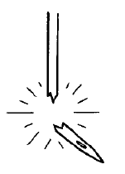
Figure 2.21Breaking Needles
Possible Cause:
- Is the material being pushed or pulled with excessive force during sewing?
- Is the needle properly installed? If it is incorrect, install the needle correctly.
- Is the needle bent, is the needle tip broken, or is the needle hole blocked? Replace the needle.
- Is the needle and rotary hook timing incorrect? Adjust the height of the needle bar. Adjust the clearance between the needle and the rotary hook.
- Is the needle timing advanced too far with respect to the feed dog? Retard the needle timing.

Skipping Stitches
Skipped stitches are usually due to a bad needle. The needle may have become damaged or bent by sewing material too thick for the needle, forcing material through the feed dog, or hitting a straight pin. If the problem seems to be consistently reoccurring, it may be due to forcing the fabric. Sewers should allow the feed dog to pull the fabric and only use their hands to guide the fabric through the feed. When sewing knitted fabrics, using a stretch needle can help prevent skipped stitches.
Problem:
Skipped Stitches occur while sewing:

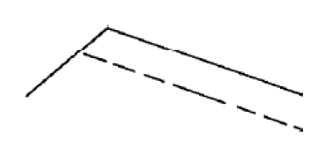
Figure 2.22Skipped Stitches
Possible Cause:
- Is the needle tip bent? Is the needle tip blunt? If the needle tip is bent or broken, replace the needle.
- Is the needle properly installed? If it is incorrect, install the needle correctly.
- Is the machine properly threaded? If it is incorrect, thread the thread correctly.
- Is the presser foot pressure too weak? Adjust the presser foot pressure.
- Is the needle and rotary hook timing incorrect? Adjust the height of the needle bar. Adjust the clearance between the needle and the rotary hook.
- Is the thread tension spring too weak? Adjust the tension of the thread tension spring.
- Is the rotary hook tip broken? If it is broken, replace the rotary hook.

Skipped stitches at sewing start -Thread unraveling at sewing start:
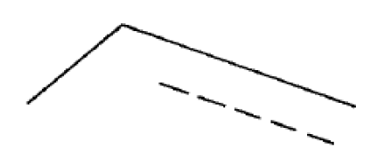
Figure 2.23Skipped stitches at sewing start
Possible Cause:
- Are the thread tension spring tensions too strong? Reduce the tension of the thread tension springs.
- Is the thread tension spring operating range too large? Lower the position of the thread tension spring.
- Are the trailing lengths of the upper threads too short after thread trimming? Adjust the pretension.
- Are the threads not being trimmed cleanly? Sharpen the fixed knives, or replace the fixed and movable knives if necessary.
- Is the needle too wide? Try using a needle with a count that is one lower than the current needle.
- Is the length of thread trailing out from the bobbin case after thread trimming too short? If the bobbin is spinning loosely, replace the stopper spring in the bobbin case.
- Is the sewing speed too fast at the sewing start? Use the slow start feature.
- Is the needle up stop position too high? Adjust the synchronizer.

Sewing Machine Thread Is Tangling, Bunching, or Breaking
Having the thread not cooperate as intended is a problem that can lead to stress among those who sew. The good news is that thread problems usually arise from very fixable issues.
Thread Looping and Bunching
Thread looping problems that occur on the bottom side of the fabric are typically issues with the upper threading, not the bobbin threading.
Looping or bunching that occurs on top of the fabric tends to a problem with the bobbin threading. For any thread issue, it's best to begin by checking that the machine is threaded properly according to the machine's specifications. If the machine was not threaded with the presser foot up, it will not have the needed tension for sewing. Also check that there is no lint or debris in the area and that moving parts are oiled. Finally, check the needle for any damage.
Problem:
Loops appear in seam:
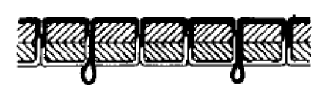
Figure 2.24 Thread Looping
Possible cause:
- Is the thread path not smooth enough? Use a file with a fine grain or sandpaper to polish smooth the thread path.
- Is the bobbin not turning smoothly? Pull out the lower thread to check that there is no slackness in the thread tension, or replace the bobbin or bobbin case.
Lower thread is tangled at the sewing start. Spinning of bobbin during thread trimming:

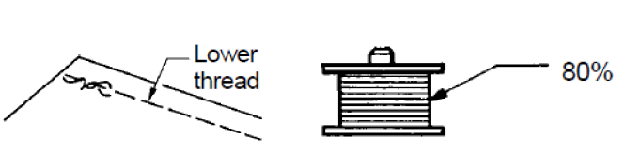
Figure 2.25 Lower thread looping
Possible Cause:
- Is the bobbin spinning direction correct when the lower thread is being pulled? Set the bobbin so that it turns in the opposite direction to the rotary hood.
- Is there too much thread wound onto the bobbin?
The bobbin winding amount should not be more than 80%.
- Is the free spinning prevention spring attached?
Attach the free spinning prevention spring.
- Is the bobbin turning smoothly?
If the bobbin is not turning smoothly, replace the bobbin.
- Is a bobbin other than the light-alloy bobbins?
Use only bobbins which are specified by manufacturer.

Thread Breaking
Thread that continually breaks may be an issue with the quality of the thread or obstructions within the machine. Inexpensive, bargain threads typically shed more lint, contain knots, and break more often than good, quality threads. Lint and knots can obstruct the thread from feeding through the machine. Also check the path the thread travels through, including the bobbin and needle, is free from burrs, nicks, or any sharp points that may cause a break or problem. Polish these areas with sand paper or steel wool. If the spool itself seems to be jamming, try changing the direction from which the spool is unwinding. Some fine threads used for sewing may be more prone to breakage; it is best to use a specified sewing needle for these projects.
Problem: Upper and lower threads are breaking:

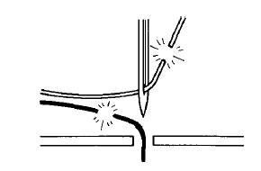
Figure 2.26 Thread Breaking
Problem Cause:
- Is the needle bent or is the needle tip broken?
Replace the needle if it is bent or broken.
- Is the needle properly installed? If it is incorrect, install the needle correctly.
- Is the needle properly threaded? If it is incorrect, thread the needle correctly.
- Is the rotary hook sufficiently lubricated? If the oil gauge is down to the lower reference line in the oil sight glass, add more oil.
- Is the upper or lower thread tension too weak or too strong? Adjust the upper thread or lower thread tension.
- Is the upper thread may be loose because the thread tension spring operating range is too small? Adjust the position of the thread tension spring.
- Is the rotary hook, feed dog or other part damaged? If they are damaged, smooth them with an oiled grindstone or replace the damaged parts.
- Is the thread path damaged? If the thread path is damaged, smooth it with sandpaper, or replace the damaged part.
Tension Adjustments
Most sewing machines require very little altering of the tension settings or disks. However, if all other thread issues have been resolved but the problem is still reoccurring, not having proper tension may be the problem.
Changing the tension can affect the timing of the machine as the pressure exerted on the upper thread and bobbin thread needs to be even; therefore, its best to review the machine's manual for tension specifications. Upper tension is user adjustable, but the setting should be in a medium range for most sewing projects. Tension problems with the bobbin threading are particularly intricate and should be repaired professionally. Using different color threads in the upper threading and bobbin is a good way to determine which area is having tension problems.
For good quality stitching, a balanced tension or balanced stitches are desirable. When the tension of the upper and lower thread is balanced, the threads interlock in the middle of the fabric to make perfect or balanced stitches. Adjust the tensions only as needed until the stitch is balanced. The tension of the stitch is regulated by two controls.

Upper thread tension
After lowering the presser foot, turn the nut to adjust the upper thread tension. For this, turn the nut to the left to loosen it. Turn it to the right to tighten
Problems:
Upper thread is not tight:

Figure 2.27 Upper thread is not tight
Possible Cause:
- Is the upper thread tension too weak, or is the lower thread tension too strong? Adjust the upper thread tension or lower thread tension.
- Is the needle and feed mechanism timing correct? Advance the needle timing.
Lower thread tension /Lower Thread is not tight:
It is adjusted by tightening/loosening the screw of the bobbin case, The bobbin case screw is very short and will fall out if turned too far. The bobbin case tension screw, which is located on the bobbin case, controls the tightness of the bobbin case spring. These controls increase or decrease the amount of pressure on the threads as they feed through the machine.
Appropriate thread tension is needed for perfect stitching. The tension on the needle and the bobbin threads must be heavy enough to pull the threads to the centre of the thickness of the fabric and make a firm stitch.
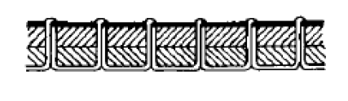
Figure 2.28 lower thread tensions

Possible Cause:
- Is the lower tread tension too week, or is the upper thread tension too strong? Adjust the lower thread tension or upper thread tension.
Mechanical Noises and Maintenance
If the sewing machine is making uncommon noises, such as grinding or banging, the machine parts may be jammed or in need of cleaning or maintenance. Do not use the machine when it is operating this way, and turn off power to the machine before inspecting the issue. Lint buildup will occur due to the constant use of fabric and thread. Clean lint and other debris out of the machine using a brush.
The machine should be oiled according the owner's manual. Only sewing machine oil should be used to lubricate moving parts. The oil prevents wear as well as rust. Run a test thread and fabric through the machine to remove excess oil.
Examine the machine for loose screws and tighten them. However, do not tighten hex screws as these screws often affect the timing and settings of the machine. If any of hex screws seem to be missing or out of order, the machine should be taken to a professional for repairs.
Regular cleaning and maintenance can help protect the machine for future use, but if mechanical noises still continue, the machine should be examined by a professional repairman.
Problems:
Oil gauge is not visible in oil sight glass:

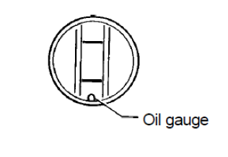
Figure 2.29 Oil gauge
Possible Cause:
- Is the oil tank empty? Fill the oil tank with oil
- Is the rotary hook lubrication adjusting screw too loose? Check the rotary hook lubrication amount, and adjust the rotary hook lubrication adjusting screw.
- Is the oil gauge damaged? Replace the oil gauge.
Motor does not operate smoothly, or motor makes an abnormal noise:
Possible Cause:
- Problem with speed sensor. Replace the sensor or motor.
- Problem with pulley alignment.
- Problem with motor ventilation cover.
The steps for preparing a sewing machine for stitching are listed below.

- Connect the machine to the power supply
- Placement of foot control
- Adjust the presser foot
- Wind the bobbin
- Select the correct needle and thread for sewing
- Fix the needle into needle bar
- Set the bobbin and bobbin case in the machine
- Thread the machine
- Adjust the thread tension
- Adjust the stitch length
- Check the stitch formation
- Check the reverse stitching lever

  - Connect the machine to the power supply
Before connecting the power cord, ensure that the voltage and the frequency shown on the sewing machine conform to the electrical power.
- Connect the plug to connect the foot control.
- Now, connect the foot control to the machine socket.
- Connect the power plug to the power socket.
- Switch ON the power and sewing light.
Note: This step is applicable for a motorized sewing machine.
  - Placement of foot control
1. The speed of the sewing machine can be controlled by the foot control. The stronger it is pressed on the control, the faster the machine runs.
2. The foot control should be placed at the correct position for the Operator to operate it comfortably.
Note: This step is applicable for a motorized sewing machine.
  - Adjust the pressure of the presser foot
It is important for a Sewing Machine Operator to have complete knowledge of the required pressure on the material, and method of adjusting the pressure when needed. The pressure of the presser foot is required to be adjusted as per the thickness or heaviness of the fabric/material to be sewn. Heavy fabrics require more pressure than the lightweight fabrics. The pressure should be heavy enough to prevent the fabric from rising with the needle, and to enable the feed to move the fabric along evenly without side creeping.
The pressure of the presser foot can be adjusted by using the thumbscrew. To increase the pressure, turn the thumbscrew clockwise or downward. To lighten the pressure, turn the thumbscrew anticlockwise.
When the pressure is appropriately applied correct stitches will be formed
  - Wind the bobbin
A sewing machine has two thread sources for stitching— a top thread and a lower thread stored on a bobbin. The following steps are to be followed to fill the bobbin.
- To win the bobbin with the thread, place the bobbin spool on the bobbin winder fitted on the top.
- Wrap the thread from the reel placed in the thread spool around the bobbin.
- Press the treadle/foot control or turn the hand wheel to start winding.
- The winding in the bobbin should be uniform.
- Once the bobbin is sufficiently filled with thread, stop winding and remove the bobbin.
  - Selection of needle and thread for sewing
For the selection of the appropriate needle and thread, kindly refer to session 3 of this Unit.
  - Fix needle into the needle bar
Sewing machine needles have one side flat, so they can only be placed from one side—usually the flat side towards the back. The following steps should be followed to fix the needle into the needle bar.
- Pull the needle bar to the highest level to insert the needle
- Keep in mind that there is a groove. Insert the needle in a straight line in the groove and tighten the needle clamp securely and tightly to fix the needle properly.
- If you are still having trouble, refer to your machine’s manual. 2. Loosen the screw or needle clamp to fix the needle.
  - Set the bobbin and bobbin case in the machine
- Hold the wound bobbin and bobbin case with both hands.
- Place the bobbin in the bobbin case correctly.
- Pass the thread through a small notch at the front of the bobbin case and then pull the thread out,
- It should be checked that the bobbin should move clockwise when the thread is pulled out.
- Leave the end of the thread outside the bobbin case. It should be brought up through the hole in the needle plate after the top thread is threaded.
- Hold the latch of the bobbin case and fix it into the rotary hook.
- Lock the bobbin case in the machine.

  - Thread the machine
- The take-up lever should be raised to keep the needle at its highest point which will help in threading the upper thread.
- This will make threading easier and it will prevent the thread from coming out while sewing.
- Take the thread end with the hand and pull it through the thread guide at the top, and then down.
- Then thread it around the take up lever.
. Follow the instruction to thread as per the guidelines printed in your machine’s manual.
- Usually, the thread follows this general pattern: left, down, into a hook, through the needle.
  - Adjust the stitch length
A stitch length regulator/dial is used to adjust the stitch length and get the desired length.
The stitch length regulator/dial controls the distance that the feed dogs move the fabric to the back of the machine to make a single stitch. The bigger number on the stitch length dial produces a long stitch, and the smaller number produces a smaller stitch. To change the stitch length, dial from a larger setting to a smaller setting, it is simpler to turn the dial.
  - Checking the stitch formation
Before starting sewing on the final material, it is a good practice to check the formation of stitch on a rough fabric. Change the pressure and thread tension as required for correct stitch on the final material.
The method of stitch formation in a sewing machine is as follows.
- The needle descend (that is, the downward action of the needle) passes through the fabric.
- Then it reaches its lowest point and begins to rise slowly.
- It creates a loop. The shuttle enters the slack-loop, enlarging it and taking with it the under thread, and when the needle reaches back to its highest level, a complete interlock stitch is formed.
- Checking of reverse stitching lever
. When the reverse stitching lever is pushed, the cloth feed direction for sewing will be reversed.
- When it is returned to its original position, the feed direction for sewing will change back to normal.

- Preventive maintenance

    - Preventive Maintenance
Preventive maintenance is conducted to keep equipment working and/or extend the life of the equipments. The primary goal of maintenance is to avoid or mitigate the consequences of failure of equipment. Preventive Based Maintenance help to prevent the failure before it actually occurs. It is designed to preserve and restore equipment reliability by replacing worn components before they actually fail.
Preventive maintenance activities include partial or complete overhauls at specified periods, oil changes, lubrication and so on. In addition, workers can record equipment deterioration so they know when to replace or repair worn parts before they cause system failure.
The ideal preventive maintenance program would prevent all equipment failure before it occurs. Following are the two examples of Preventive maintenance Schedule which are commonly used in leather garment and goods industry –1st Plan talks about the, activities which have to be carried out on monthly basis and 2nd Plan talks about the quarterly (3 Months) basis.
Preventive maintenance/Routine maintenance
Preventive maintenance is periodical inspection (daily, weekly, monthly basis cleaning, inspection, oiling and re-tightening) and service activities what are aimed to detected potential failures and perform minor adjustments and repairs which will present major operating problems in future.
Sewing maintenance team does preventive maintenance as per their maintenance schedule or calendar. It’s the preventive maintenance to retain the healthy condition of equipment and prevent major breakdowns of failure by deterioration of facilities. It ranges from such simple tasks as cleaning, inspection, equipment condition diagnosis checking, changing oil, water, air, alignment, re-tightening etc. Routine maintenance consists of periodically inspecting, servicing, lubricating and cleaning equipment and replacing parts to prevent sudden failure and process problems to ensure continuing working condition.
Benefits of Preventive Maintenance
- Equipment downtime is decreased and the number of major repairs is reduced
- Better conservation of assets and increased life expectancy of assets, thereby eliminating premature replacement of machinery and equipment
- Reduced overtime costs and more economical use of maintenance workers due to working on a scheduled basis instead of a crash basis to repair breakdowns
- Timely, routine repairs circumvent fewer large-scale repairs
- Improved safety and quality conditions for everyone
Sewing machine maintenance check list
Preventive Maintenance Checklist for Single Needle Lockstitch machine
- Check to see if the machines are being kept clean
- Machines should be blown off every day to remove lint and trash *
- On lockstitch machines, the hook should be blown off regularly during the day to prevent lint or dirt from building up in the oil ports in the race of the hook
- Check to see that the machines are being lubricated regularly
- Oil levels should be checked daily and additional oil added if necessary
- Randomly check the oil levels in the machines
- A high quality white machine oil should be used that will not stain
- Check availability of proper machine oil in the factory
- Check to make sure the oil is not contaminated
- Check to see that oil reservoir pump filters are cleaned regularly
- If compressed air is used, make sure the air system is regulated properly and has humidity dryers, filters and lubricator in the air lines.
- Check for rusted areas due to excessive moisture in production area
- Check Machines for wear on critical moving parts
- Check for shake in needle bar due to worn needle bar bushings
- Check for excessive movement in stitch forming devices, etc.
- Check condition of critical screws
- Check for missing screws
- Check for defective screws that are difficult to tighten properly
- Check condition of mechanics tools to see that they are being maintained properly.

Best & regular maintenance of plants machinery increase not only machine life but also with quality garments stitching, less consumption of spare parts & reduce tendency of machine problem results increase total productivity. In the view of the above the machinery maintenance policy & procedure are being given below.
Sewing machine maintenance & safety policy practice
Daily maintenance:
While sewing floor is running if any machine create problem, initially floor mechanics try to fix that machine within the line. If it is not possible in a short time, machine will be shifted to the maintenance room replacing by another machine & necessary measure will be taken to fix that Machine. The daily records of maintenance works has been kept in a format.
Monthly maintenance
It is a preventive maintenance to reduce machinery problem & increase machine life, execute by predetermine schedule fixed on the starting of the year by regular basis. This maintenance program covers total servicing of the all machine, oil change, oil filter change, or any defective parts change. Records of monthly maintenance works have been kept in a format.
    - Sewing machine preventive maintenance
Responsibilities of Sewing machine Operator
- Check threading of the machine→ daily
- Complete cleaning of the machine→ daily
- Keep the Clean paper under the foot→ daily
- Check for oil leaks → Every Four hour
- Clean needle/foot/t. feed bars → Every Four hour
- Clean machine head with → Every Four hour
- Clean machine table top→ Every Four hour
- Un-usual noise of the machine→ all day
Responsibilities of Sewing machine Mechanic
Daily Basis work of Sewing machine Mechanic
- Check Machine Setting Correct or Not→ all day
- Check Oil Level and Oil Leaks of the Machine→ Day starting
- Check un-usual noise of the machine →All day
- Check Oil paper → Day starting
- Check safety Equipment→ Day starting
- Check Machine allocation (According to M/C Layout) → Day starting
- Check Production Plan → Day starting
Monthly basis work Sewing machine Mechanic
- Whole machine clean opening parts
- Back/ Front cover
- Hook/ Lopper timing and Needle
- Needle plate
- Feed dog
- Oil lubrication change
- Checking machine fitness to run continuously.
Daily Sewing Machine Check Points

- Tension spring
- Bobbin case spring
- Take up spring
- Thread wiper
- Oil level/ oil leak
- Threading
- Needle plate/ fee dog
- Machine washer
- Laser light
- Needle plate/ fee dog

Monthly Sewing machine maintenance/servicing checklist
- Air device
- Trimmer device
- Super tension post take up spring
- Needle bar, bush and clam condition
- Needle plate condition
- Feed dog condition
- Winder condition
- Rotary hook or loppers
- Oil level/oil filter condition
- Machine table in good condition
- Cleaning and blowing
- The lubricant in equipment (oil and grease cut)
- Main shaft, connecting rod, bearing condition
- Machine head has to be balanced with base plate
- Knife slide
- Power on/off switch
- Motor and control box condition
- Abnormal sound connecting rod and cross head

Self check-2

Direction: - Answer all the questions listed below. Examples may be necessary to aid some explanations/answers

- What is the assessing suitability of PPE?
- Describe type of gloves and their use?
- Describe use and type of protective eyewear?
- What are the uses of cleaning sewing machine?
- List the Simple steps to follow for a basic machine cleaning?
- Write a short note about Thread Breaking?
- What are the steps of the preparing a sewing machine for stitching?
- Write the methods of daily and monthly activity of single needle sewing machine /SNSM/?
- What is Preventive maintenance? Explain it?
- What is the benefit of Preventive maintenance?

Match the following:
A B
1. Eye guard | a) Breathing protection
2. Cotton gloves | b) Hazards
3. Exhale-respirator | c) Safety sign
4. Nip points | d) Safety Device
5. Yellow lines | e) Protection from cutting edges

Multiple Choice Types
Choose the correct answer for each question.
- When adjusting the upper tension the presser foot
- Should be in the down position
- Should be in the up position
- Can be in either the down or up position
- Which of the following problems could be fixed by the student operator?
- Improper threading
- Blunt needle
- Needle in back wards
- All of the above
- Which of these practices might damage or reduce the efficiency of a sewing machine?
- Applying a drop of oil at each oiling point
- Heaving thread ends In the machine
- Removing the throat plate to clean the underside of the machine
- If stitches are not flat on both sides of fabric or if there is loops either side, you should check which of the following
- Presser foot
- Bobbin
- Stitch length
- Tension and threading
- When turning the hand wheel on your sewing machine, you should always turn it
- To ward you
- Away from you
- It doesn’t matter
- None

Note: Satisfactory rating – above 60% Unsatisfactory - below 60%
You can ask you teacher for the copy of the correct answers

Operation sheet-2

Steps followed to carryout preventive to machine Adjustingand equipment regularly

Step1. Clean it out: -

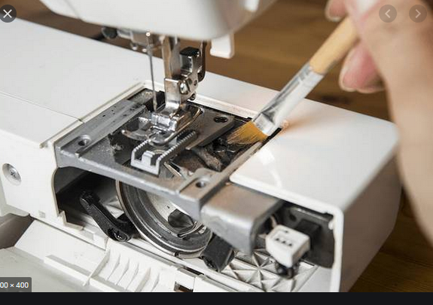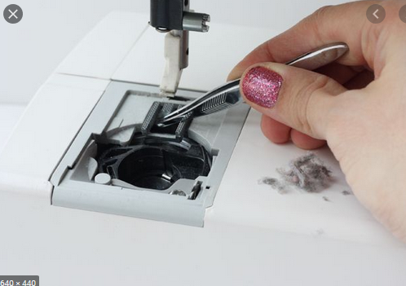

Step 2.Rethread your machine

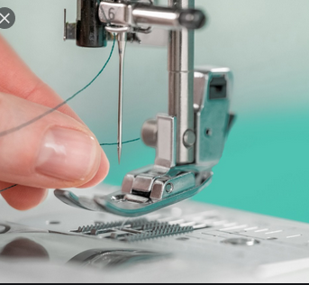

Step 3.Check needleclampandneedle thread
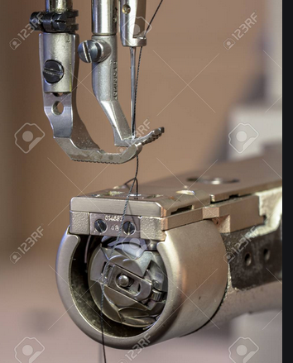

Step4. Check pressure foot and needle plate

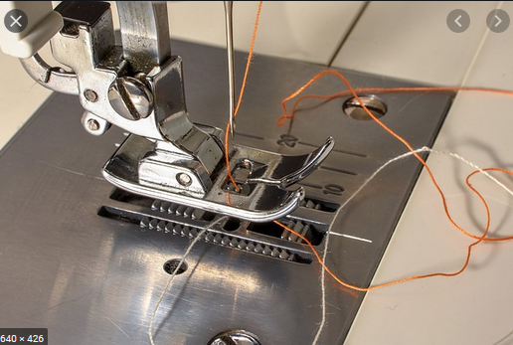

Step5. Check and clean Hook set

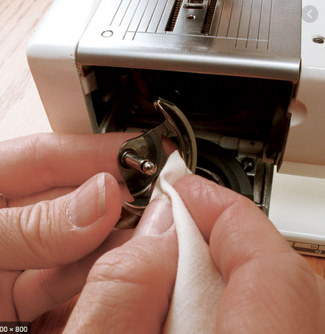

Step 6.Bobbin case Check

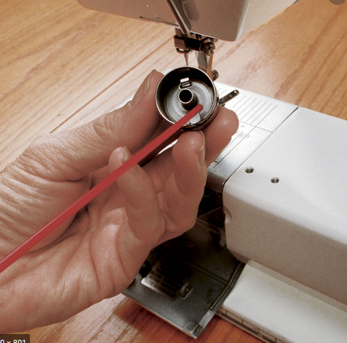

Step7. Oil lubrication system check

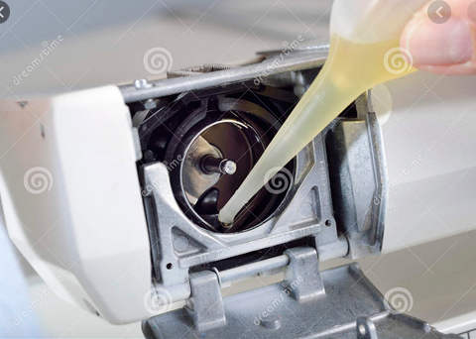

Step8. Adjust and check Lopper thread

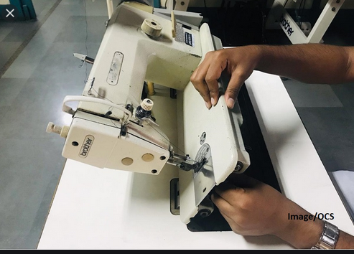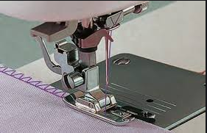

Lap Test-2
Total hour 2
Instructions:-Given necessary machine tools and materials you are required to perform the following task.
Task-1 perform preventive maintenance and adjusting sewing machine

Unit Three: corrective maintenances of sewing machine
This learning guide is developed to provide you the necessary information regarding the following content coverage and topics:
- Failures of sewing machine
- Maintain and restore Sewing machines
- corrective maintenances

This guide will also assist you to attain the learning outcomes stated in the cover page. Specifically, upon completion of this learning guide, you will be able to:
- Identify Failures of sewing machine
- Maintain and restore Sewing machines
- Conduct corrective maintenances according to OHS requirements

- Failures of sewing machine
    - Faults in Sewing Machine
Most sewing machine problems can be traced to poor general maintenance or neglect. Depending upon how much use your sewing machine receives daily, weekly, or monthly, you will want to maintain it accordingly.
All machines have owner’s manuals that give recommendations for care and maintenance. If you do not have one for your machine find a dealer or check on line at the manufacturer’s Web site to order a copy.
The goal is to keep your machine running and problem free. When problems do arise, check your owner’s manual first and then the list given here for ways to correct them before heading off to the repair shop.
Common Faults may occur on Sewing Machine:
- Machine not sewing: If the machine is simply not sewing or has other related errors, the easiest thing to check is whether the thread and needle are set up properly.
- Breaking Needles: Needles may break due to simple reasons like prolonged use or hitting a straight pin; these breaks can be difficult to predict. However, needles also break from very controllable factors such as forcing the fabric through the feed or by using the wrong needle.
To avoid breaking needle
- Use proper size of needles for thread and fabric to be sewn.
- See that the presser foot or attachment is securely fastened to the bar and that the needle goes through the centre of the hole.
- Avoid pulling fabric when sewing. The needle may become bent and strike the back of the needle hole.
- Use a needle of correct length. If it is too long it will come in contact with the bobbin case and break. If it is too short, stitches cannot interlock.
- Be sure needle is tightly fastened in the needle bar. Also be sure presser foot is tightly fastened.
- Sew over pins carefully. Be sure they are perpendicular to the seam and keep the heads of pins away from the stitching line.
Skipping stitches: Skipped stitched are usually due to a needle. The needle may have become damaged or bent by sewing material too thick for the needle, forcing material through the feed dog, or hitting a straight pin.
Cause of skipping stitches

- Needle not correctly inserted in the needle bar
- Needle too small for the thread used
- Needle too short for the machine
- Blunt or bent needle
- If zipper foot is used, the edge of the foot is too far away from the need
- Needle threaded incorrectly
- Needle hole in throat plate too large
- Pressure too light
- Upper tension too tight
- Upper thread and bobbin thread of different size and /or type

Sewing Machine Thread is Tangling, Bunching or Breaking: Having the thread not cooperate as intended is a problem that can lead to stress among those who sew. The good news is that thread problems usually arise from very fixable issues.
Thread Looping and Bunching
Thread Breaking
Causes of upper thread breaking

- Needle is in backwards.
- Machine improperly threaded
- Tension too tight
- Needle bent or having blunt point
- Thread too coarse for needle size
- Burr on needle hole of presser foot (Caused by breaking needle when pulling fabric from machine)
- Needle too long for machine, or not inserted all the way in the needle bar
- Tension discs worn so that thread works in groove
- Needle too fine for size of thread and fabric to be sewn
- Threads not properly pulled back under presser foot when starting to sew Lint or dirt around bobbin case holder
- Irregular sewing speed

Causes of lower thread breaking

- Improper threading of bobbin in bobbin case
- Tension too tight
- Thread wound unevenly on bobbin in bobbin wound too full
- Spring on bobbin case worn to sharp groove
- Burr on underside of throat plate
- Knot in bobbin thread
- Lint, dirt, or thread under tension spring of bobbin case
- Tension Adjustments

    - Tension adjustments

Tension controls increases or decreases the pressure on the threads as they are fed through the machine. When pressure is correct in both thread, the tension is balanced, the threads interlock in the middle of the material to make a perfect or balanced stitch.
The seam is flat and elastic without being loose and there is no seam grin when the seam is stressed. If there is too much pressure on the tension discs, not enough thread is fed into the stitching and the tension is tight.
The material puckers, the seam is strained and the stitches break. If there is too little pressure, too much thread is fed, the tension is too loosed and the seam is loose and weak.
The link position is a good indicator of which thread tension is incorrect. When the tension on the top or needle, thread is too tight or the tension on the bottom or bobbin thread is too loose, the top thread lies along the surface of the material and the thread forms loops on the top. When the tension of the top or needle, thread is too loose or the bottom or bobbin thread is too tight, the bottom thread lies along the underside of the material and the top thread forms loops on the underside.
- To adjust the top thread tension, regulator situated on the front of the machine adjusts the tension discs.
- To decrease tension, turn dial to lower number if present.
- To increase tension, turn dial to high number. The bobbin thread tension is controlled by a screw on the bobbin.
- Clockwise turning increases the tension whereas anti-clockwise turning decreases tension.
Mechanical Noises and Maintenance: If the sewing machine is making uncommon noises, such as grinding or banging, the machine parts may be jammed or in need of cleaning or maintenance. Do not use the machine when it is operating this way, and turn off power to the machine before inspecting the issue.
Cause of machine not feeding properly

- Pressure incorrect for the fabric being sewn
- The feed dog worn smooth. This can be determined by running the finger over the teeth If they are not sharp, the feed dog should be replaced
- Feed dog clogged with lint
- The stitch regulator may have been turned back so far that the feed is entirely out of action.
- Needle may be bent.
- Spool of thread may jerk and catch if machine is operated too rapidly or at uneven speed.
- Stitch regulator incorrectly adjusted
- Throat plate incorrectly positioned

Cause of machine working heavily
- If the machine works hard after standing, it may be gummed with oil and in need of general cleaning.
- The belt may be too tight and hence puts excessive pressure on the bearing.
- When the belt is too loose, it slips on the balance wheel.

- Maintain and restore Sewing machines
    - Identification and Adjustment of sewing machine
The sewing machine Problems are;
- Presser Foot Pressure Problem
- Thread Take-up Spring Tension
- Needle Thread Tension
- Bobbin Thread Tension
Presser Foot Pressure Adjustment
Pressure means the downward force exerted on the fabric by the presser foot, to hold the layers so that they move together evenly during stitching.
The feed exerts upward force that moves the fabric to the back of the machine.
The two forces pressure and feed, work together to produce properly stitched seam.
Pressure has several functions.
It holds the fabric layers in such a way that they move evenly with one another.
It holds the material taut and it helps to assure that the stitches are properly set in the material and that an even stitch tension, and stitch length are maintained. Pressure also prevents the fabric from being pulled down into the bobbin area and can cause skipped stitches.
The primary function of feed is to move the fabric into position for each stitch. Feed also helps in holding the fabric layers taut during stitch formation.
Feed is controlled by the stitch length regulator. The smaller the stitch length setting, the shorter the distance the feed moves the fabric for each successive stitch.
The amount of pressure needed depends on the weight and thickness of the material. Lighter and thinner the fabric weight, the lighter the pressure needed and vice-versa.

    - Thread Take-up (check) Spring Tension Adjustment
Tension adjustments
Tension controls increases or decreases the pressure on the threads as they are fed through the machine. When pressure is correct in both thread, the tension is balanced, the threads interlock in the middle of the material to make a perfect or balanced stitch.
The seam is flat and elastic without being loose and there is no seam grin when the seam is stressed. If there is too much pressure on the tension discs, not enough thread is fed into the stitching and the tension is tight. The material puckers, the seam is strained and the stitches break. If there is too little pressure, too much thread is fed, the tension is too loosed and the seam is loose and weak. The link position is a good indicator of which thread tension is incorrect. When the tension on the top or needle, thread is too tight or the tension on the bottom or bobbin thread is too loose, the top thread lies along the surface of the material and the thread forms loops on the top. When the tension of the top or needle, thread is too loose or the bottom or bobbin thread is too tight, the bottom thread lies along the underside of the material and the top thread forms loops on the underside. To adjust the top thread tension, regulator situated on the front of the machine adjusts the tension discs. To decrease tension, turn dial to lower number if present.
To increase tension, turn dial to high number. The bobbin thread tension is controlled by a screw on the bobbin. Clockwise turning increases the tension whereas anti-clockwise turning decreases tension.
Needle Thread Tension Adjustment
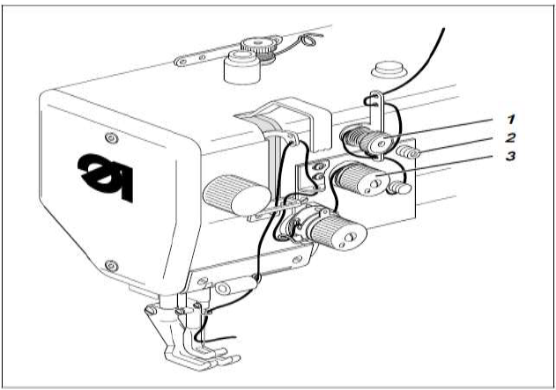
Figure 3.1 Needle Thread Tension Adjustments
Preliminary tension 1
- On the machine the needle thread needs to be under residual tension for the thread cutter to function reliably when the main tensioner 3 is open.
- The preliminary tension 1 should be set lower than the main tension 3.
  - Adjust preliminary tension 1 by rotating the knurled nut.
  - After major changes to preliminary tension 1 the main tension 3 should also be adjusted accordingly.
Main tension 2
The main tension 3 should be set as low as possible. The looping of the threads must be in the Centre of the material with thin material (see Figure-a) excessive thread tension can cause unwanted gathering and thread breakage.
- Adjust the main tension 3 so that the stitches are uniform.

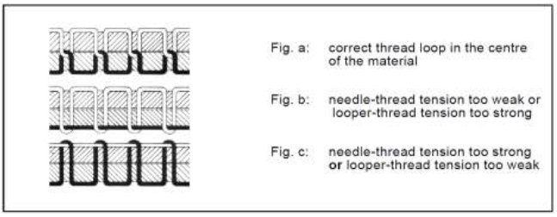
Figure: - 3.2 thread tension

Bobbin Thread Tension Adjustment
General Adjustment:
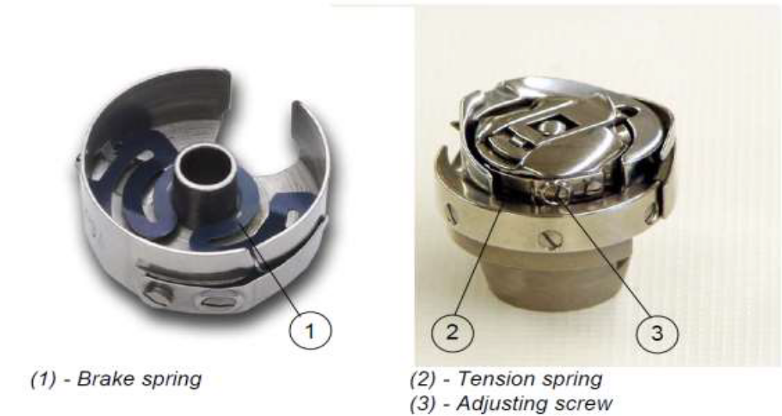
Figure: - 3.3 Bobbin Thread Tension Adjustments

- Corrective maintenances
    - Corrective maintenances

Corrective Maintenance: “The maintenance carried out after a failure has occurred and intended to restore an item to a state in which it can perform its required function.”

While preventing breakdowns is desirable, corrective maintenance can't be avoided completely. There's no way to predict an unexpected breakdown, defect, or fault.

Even perfectly maintained equipment could be vulnerable to defects or external factors such as power surges or even intentional sabotage from a disgruntled employee. Careless operation of the equipment could also require corrective measures.

Run-to-Failure (Corrective Maintenance Only)
To estimate the cost and average availability that can be expected for a run-to-failure (corrective maintenance only) maintenance strategy, the analyst must provide the following information:

- The amount of time that the equipment will operate.
- The probability density function (pdf) that describes the probability that the equipment will fail due to a particular failure cause.
- An indication of whether the failure is detectable during normal operation.
- The amount of time that the equipment is expected to be down each time corrective maintenance. Is required. This can include the time to perform the maintenance as well as any logistical delays (i.e., waiting for labor and/or materials required).
- The cost each time corrective maintenance is required, including the downtime, labor, materials and other costs.
- The degree to which the equipment will be restored by corrective maintenance (e.g., "as good as new," "as bad as old," etc.).

The analyst can then simulate the operation of the equipment for the specified operating time, given the specified reliability/maintainability characteristics, in order to estimate 1) the expected number of corrective maintenance actions that will be performed and 2) the amount of time that the equipment is expected to be operating (uptime) over the specified time. These estimates can then be used to calculate the total operating cost, cost per uptime and average availability, as follows:

Total operating cost=CM quantity x CM cost per incident

Cost per up time = total operating cost/up time

Average availability =up time /operating time

Failures / Causes and Remedies of Sewing Machine

Table 3.1 problems of sewing machine
Needle Thread Breakage
Causes | Remedies
Misaligned off winding from thread package. | Ensure that the overhead guide is directly above cop stand pin, at 2½ times the height of the thread package. Use a foam pad to prevent package tilting.
Thread trapped at thread guide. | Can occur after thread breaks. Rethread correctly.
Excessive tension. | Use a stronger thread or adjust tension
Sharp edges on throat plate, hook point, needle guard, bobbin case, needle groove or eye. | Polish rough edges and replace if necessary. Replace the needle being used with a higher quality needle.
Thread fraying at needle. | Use finer thread or coarser needle, as appropriate.
Use finer thread or coarser needle, as appropriate. | Ensure adequate oil supply. Check the needle to hook clearance
Poor quality thread. | Change to a correctly finished thread of better quality.
Bobbin or Lopper Thread Breakage
Badly wound thread on the bobbin. |  | Adjust bobbin winder alignment. Use pre-wound bobbin
Tension too tight or bobbin over-running |  | Adjust bobbin case tension. Insert a washer or a spring to prevent over-running.
Sharp edges on bobbin case or spring or looper eyelet. |  | Polish edges and correct surfaces.
Bobbin case not fitting correctly. |  | Check the size/type of bobbin for flange distortion.
Skipped Stitches
Hook, looper or needle failing to enter thread loops at the correct time |  | Check machine clearances and timings. Check if the needle is inserted and aligned correctly. Use a needle with a deeper scarf.
Thread loop failure caused by incorrect needle size / style for thread size / type. |  | Change needle size / style.
Flagging of fabric due to poor presser foot control or too large a throat plate hole. |  | Re-adjust the presser foot pressure. Change the throat plate to match the needle.
Needle deflections or bent needle. |  | Use a reinforced needle, reset the needle guard and replace the needle.
Incorrect sewing tension in the needle or under threads |  | Re-adjust the tensions
Poor thread loop formation. |  | Check with a strobe. Change to superior spun polyester or filament based core spun threads.
Imbalanced / Variable Stitching

Incorrect sewing tensions |  | Check for snarling, adjust thread tensions
Incorrect threading |  | Rethread machine.
Needle thread snagging on bobbin case or positioning finger. |  | Polish bobbin case surfaces. Reset positioning finger and opening finger.
Variable tension due to poor thread lubrication |  | Switch to superior quality threads.
Staggered Stitching
Needle vibration or deflection. |  | Increase needle size or change to a reinforced or tapered needle
Incorrect or blunt needle point |  | Change the needle
Incorrect needle-to-thread size relationship. |  | Change needle or thread size as appropriate
Feed dog sway. |  | Tighten the feed dog
Variable Stitch Density
Poor fabric feed control |  | Increase the presser foot pressure. Change to a more positive feed mechanism.
Seam Pucker
Variable differential fabric feed. |  | Improve the fabric feed mechanism. Replace worn out feed dogs. Reduce the maximum sewing speed.
High thread tension. |  | Keep the bobbin tension as low as possible and set the needle thread tension accordingly.
Incorrect thread balance |  | Ensure proper balance between the top and bottom thread
Improper thread type. |  | Use threads with controlled elongation. Properly maintain tension guides

    - Corrective Action of Sewing Defects

Corrective action is to solve or correct the problem which considers as a defect. Action should be specific and work should be divided to related responsible person. This is a very effective way to solve defects. In this corrective action against each and every defect those normally visible. The defects are there and for these defects what are the root causes and how we can minimize these problems are also given below in a chart.

Problems of stitch formation:

Slipped stitch/ Stitches skipped: Stitches in the seam line are present in a regular manner. If the interloping or interlacing between top & bottom thread of stitch does not take place or missed is known as slipped stitch or skipped stitch. This is serious defect in case of chain stitch than lock stitch. The followings are the causes & remedies of slipped stitch formation.

Table 3.2 stitch
No. | Causes | Remedies
01 | If hook or looped & needle are not inserted in loop of thread in time. | Examine the setting & timing between needle & hook or looped. Placing the needle properly. More secure needle should be used.
02 | Irregular thread tension on upper or lower loop. | The tension of the thread should again be adjusted.
03 | Needle deflection. | Needle to be changed.
04 | If needle thread loop size is too small. | Needle size & thread size must be adjusted.
05 | Flagging of fabrics during sewing. | The pressure of pressure foot must be adjusted accurately.  The hole of throat plate & needle size must be adjusted.
06 | If the sewing thread is not capable to form loop. | Thread to be changed

Staggered stitch:

If the stitches produced by needle are not parallel or become curvy to sewing line is known as staggered stitch.

Table 3.3staggered stitch
No. | Causes | Remedies
01 | Needle deflection. | Increase the needle size  Tapered needle should be used.
02 | Due to wrong blunt needle point. | Needle to be changed.
03 | Wrong adjustment of needle & thread size. | Needle size & thread size to be changed.
04 | Deflected motion of feed dog. | Motion of feed dog to be adjusted.
05 | If fabrics are not controlled properly in the feed mechanism. | The pressure of pressure foot must be adjusted accurately.  Feed mechanism to be changed.

Unbalance stitch: This type of defect is found in lock stitch machine. If the interlacement of threads do not take place in the middle (i.e. if the interlacement is taken place in the upper or lower position from the middle) of two layers of fabrics then it is known as unbalance stitch.

Table 3.4Unbalance stitch
No. | Causes | Remedies
01 | Wrong tension of sewing thread. | Setting of proper tension to the sewing thread.  Proper care to the twisting of the thread during sewing.
02 | Used wrong thread path | Use of right thread path.
03 | Wrong adjustment of needle thread path. | Use of right thread path.
04 | Snagging of needle with bobbin case & positioning finger. | Bobbin case to be smooth.  The positioning finger to be set again.
05 | If the thread are not lubricated. | Better qualities of thread must be used.  Thread must be lubricated.

Variable stitch density: Stitches per unit length should be uniform, If it is not then it is called variable stitch density. The main cause of variable stitch density is irregular feed of fabric due to insufficient pressure of pressure foot. The following are the cause & remedies of variable stitch density formation

Table 3.5variable stitch density
No. | Causes | Remedies
01 | Improper unwinding of thread from package during sewing. | The position of thread guide must be 2.5 times higher than the position of thread package. Also proper care should be kept to the thread package not to tiling
02 | Twisting of needle thread in the bottom of the thread package. | Foam pad must be used to the bottom of the thread package.
03 | Snarling of thread before tension disk. | Winding of more threads in the thread guide & to keep less tension to the tensioning disk.
04 | Twisting of thread in the thread guide. | Proper threading of sewing thread during sewing.
05 | More tension to the thread. | The tension of thread should be less or use high strength threads.
06 | Use of broken check spring. | Check spring to be changed.
07 | If the edge of the throat plate, hook point, needle guard, bobbin case, needle groove, needle eye & so on are sharpened. | The edges must be smooth & needle must be changed as needed.
08 | Fraying of thread in the needle. | Fine thread must be used or use heavy needle.
09 | Thread gets heated more | High quality needle must be used.  Needle lubricant must be used.  Needle cooler must be used.
10 | Hook gets heated more | Lubricant must be available.  Examine the distance between the needles & hook.
11 | Use of low quality threads. | Thread to be changed.

Frequent thread breakage: Frequent breakage of thread especially, when there needs to open out the sewing to solve the problem. The following are the causes & remedies of frequent thread breakage.

Table 3.6Frequent thread breakage
No. | Causes | Remedies
01 | Wrong winding of threads on to the bobbin. | Proper winding of threads on to the bobbin.  Pre-wound bobbin may be used.
02 | More tension to the bobbin threads or more rotating of bobbin. | The tension must be adjusted to the bobbin threads. Use of washer to prevent more rotation of bobbin.
03 | If the edges bobbin case, lopper eye & so on are more sharpened. | The edges to be smooth.

Needle heating damage: The damage of leather /fabric due to friction occurring between the needle & leather/fabrics. The resulting temperature due to friction in the needle is very high. The leather/fabric can get damaged in that temperature. There is less damage in case of leather /fabrics made from natural fibers. The following are the steps to be taken to keep the fabrics free from this type of defect:
- By reducing sewing speed, generation of heat to the needle will be less. But it affects production speed and does not suit for large production.
- By changing needle Size & shape so that there is less generation of heat to the needle.
- By sewing smaller length at higher speed.
- By blowing cool air on the needle during sewing so that the temperature can be controlled.
- By using lubricant to the needle.
- By using Teflon coated needle.

Self check-3

Directions: Answer all the questions listed below. Examples may be necessary to aid some explanations/answers.

Directions: Answer all the questions listed below.

1. Write the Common Faults may occur on Sewing Machine.

2. What is the easiest thing to check the machine simply not sewing or has other related errors.

3. What is the cause of skipping stitch?

4. What is the sewing machine Problems?

5. What are the requirements of Flat Bed Single Needle Sewing Machine?

6. How Feed dog is controlled by the stitch length regulator?

7. What is Corrective Maintenance?

8. Write the cause of Needle Thread Breakage.

9. Write the cause of staggered stitch.
Matching Type Questions
Instruction: match the descriptions given under the column “A” to the corresponding terms under column “B” and write the letter of your choice in the space provided.
 | Column “A” | Column “B”
______ | - Is located on the back of the machine;  Lets you raise and lower the presserfoot | - bobbin
______ | - Hold the thread inside the machine | - bobbin case
______ | - Moves leather/fabric along as you sew | - presser foot lever
______ | - Hold the bobbin; allows the bobbin to turn and form the stitch | - reverse control
______ | - Allows the machine to stitch backward | - feed dog  - pedal
 |  | - stitch length

Fill in the blanks:
- Sewing machine is generally requiring the basic maintenance of _________, ___________ and ___________.
- When you have trouble with your sewing machine, a good rule to follow is _______________.
- A __________ (or) _________ can be used to remove pieces of thread (or) lint that cannot be brushed away.
- ____________ are suitable to clean corner edges.
- Never use _______________; it is highly flammable. Never Use __________________; it is very poisonous.
- _________________________that are too high (or) too low can contribute to fatigue, heat illness. And cold related medical conditions.
- The _________________in a work place needs to allow employees and others to move about easily.
- Machines must be ____________-when cleaning, replacing, repairing (or) oiling.
- All ________and _________ facilities need to be serviced regularly maintained in a safe condition.
- .____________ and____________ should only be done in well-ventilated areas. moisture.

Note: Satisfactory rating – above 60% Unsatisfactory - below 60%
You can ask you teacher for the copy of the correct answers

Operation sheet-3

Objective: Maintain and restore Sewing machines

Procedures of Maintain and restore sewing machine
Hand Tools and Measuring Equipment’s to Rectify Problems
- Set of screwdrivers with blade widths from 2 to 10mm
- Set of wrenches with jaw widths from 7 to 14 mm
- Set of Allan keys from 1.5 to 6mm
- Metal rule
- Thread
- Tension tester –Dynamometer

Steps 1 Adjustment Presser Foot Problem of sewing machines

Machine Type-1: Flat Bed Single Needle Sewing Machine

Requirement: The material must be fed reliably. In the process, pressure marks on the material must not be made.

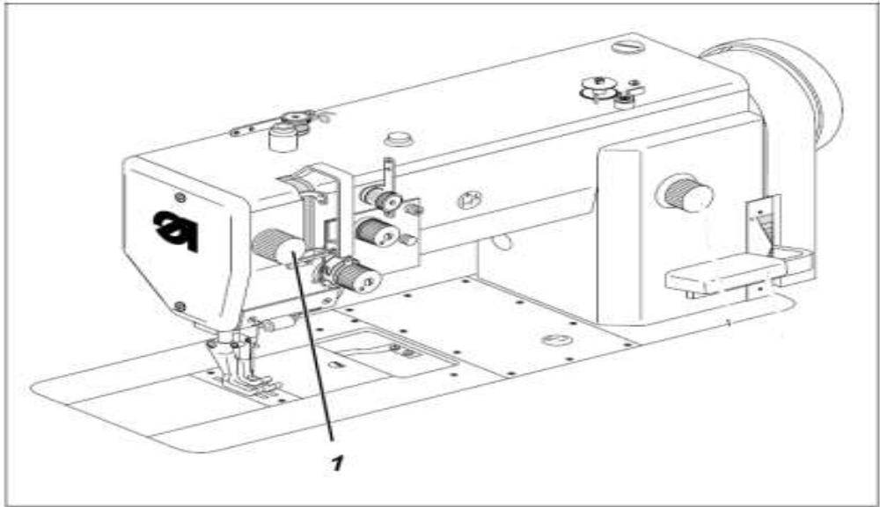

Figure 3.4 Flat Bed Single Needle Sewing Machine pressure arm
- Turn knob (1) in accordance with the requirement.
- The required sewing-foot pressure is set with knob 1.
- To increase sewing-foot pressure = turn knob 1 clockwise
- To decrease sewing-foot pressure = turn knob 1 anti-clockwise

Machine Type-2: Flat Bed Double Needle Lock Stitch Sewing Machine

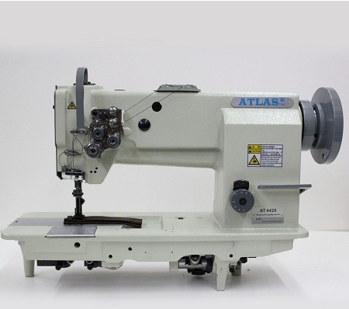

Figure 3.5Flat Bed Double Needle Lock Stitch Sewing Machine

Double Needle Flat-Bed Heavy Duty Lock Stitch Sewing machine Atlas USA AT4420
- Regulate the roller presser pressure with the setting wheel (1).
- To increase the roller presser pressure; turn the setting wheel (1) clock wise.
- To decrease the roller presser pressure; turn the setting wheel (1) anticlockwise.
- The roller pressure is to be as small as possible, but strong enough that the roller presser is not lifted by the needle friction in the material during the upward movement and that the feeding is reliable.
Machine Type-3: Flat Bed- Zigzag Sewing Machine

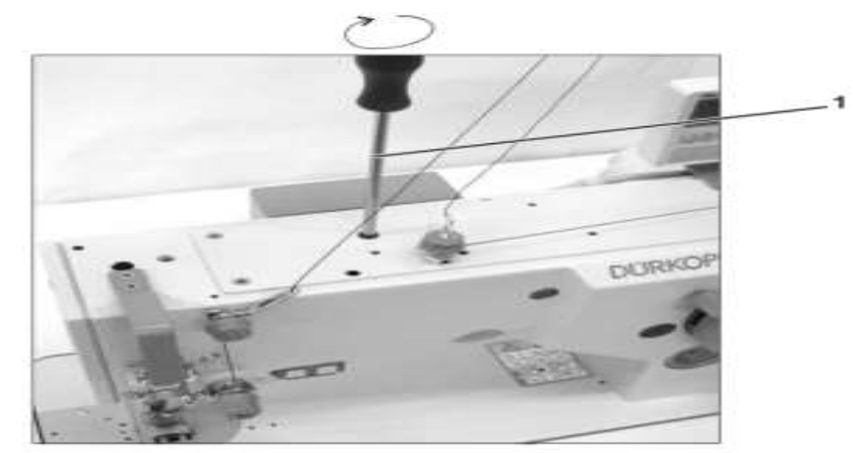

Figure 3.6Flat Bed- Zigzag Sewing Machines
- Regulate the foot pressure by means of a screwdriver (1) which is supplied with the machine accessories.
- The pressure increases by turning in the arrow direction and vice versa.
- The foot pressure should be as small as possible, but strong enough so that the feeding is reliable even at a high sewing speed.
Machine Type-4: Cylinder Bed Sewing Machine

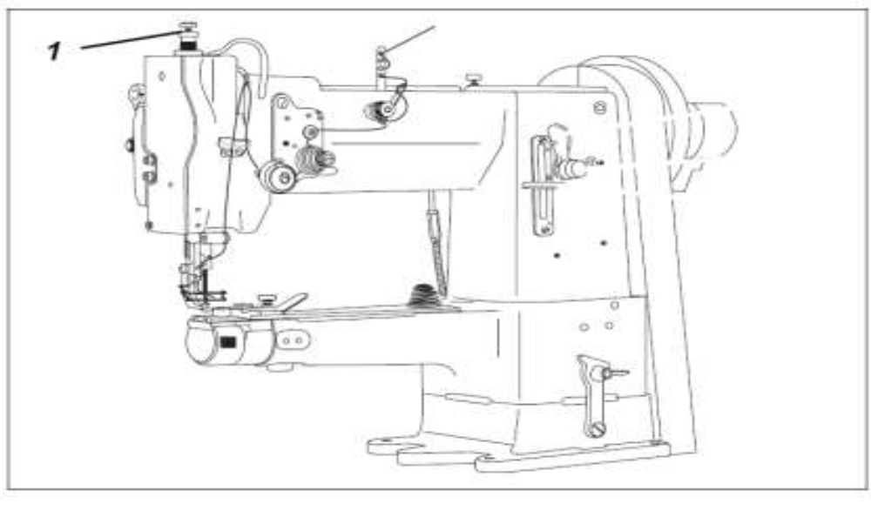

Figure 3.7Cylinder Bed Sewing Machines

Sewing-foot pressure is adjusted with screw 1.

- To increase sewing-foot pressure: turn screw 1 clockwise
- To reduce sewing-foot pressure: turn screw 1 anticlockwise.
Step 2 Thread Take-up (check) Spring Tension Adjustment
Machine Type-1: Post Bed Sewing Machine

Requirement:
The motion of the thread check spring must be completed when the needle point enters the material (spring stroke approx. 7mm)

When the thread loop is largest when going around the hook the thread check spring must have moved by approx. 1mm.

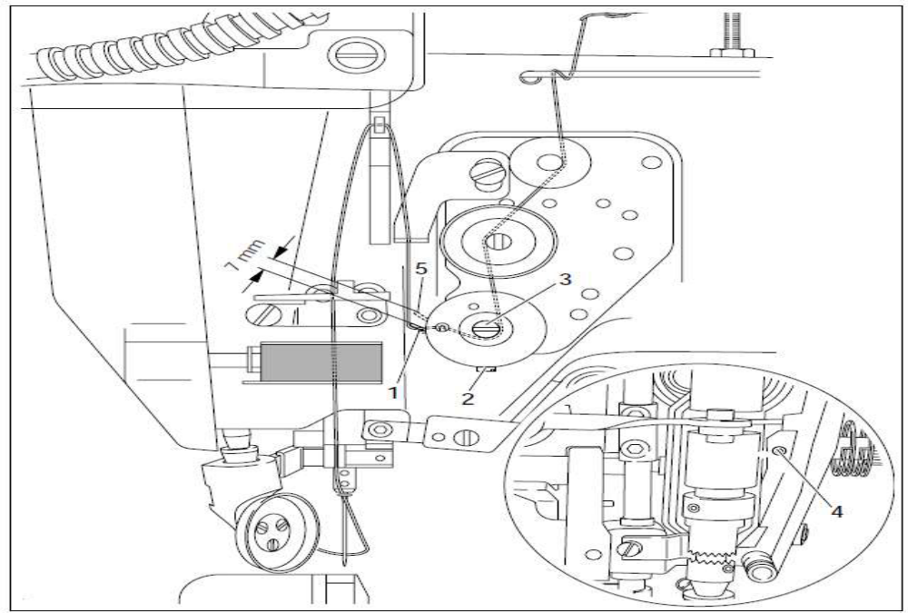

Figure 3.8 Post Bed Sewing Machines

- Turn thread tension (1) (Screw 2) according to requirement (1)
- Turn thread tension (3) (Screw 4) according to requirement (2).
- Due to technical sewing reasons it may be necessary to deviate from the spring stroke indicated above,
- Move the slack thread regulator (3) (Screw 4) toward the “+” (=more thread) or toward the “-“(= less thread).

Machine-2: Flat Bed-Bar Taker Sewing Machine:
- Allen key is used to adjust thread take-up spring height in Bar taker sewing machine.

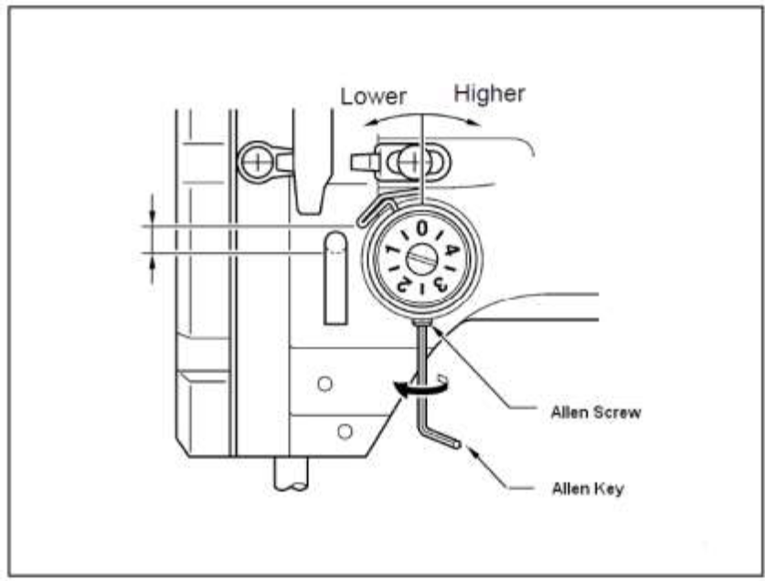

Figure 3.9Flat Bed-Bar Taker Sewing Machine
- With a Screw Driver to adjust the Thread take up spring tension on bar taker sewing machine.

Sewing machine maintenance referto below link address

https://aces.nmsu.edu/pubs/_c/C102/welcome.html

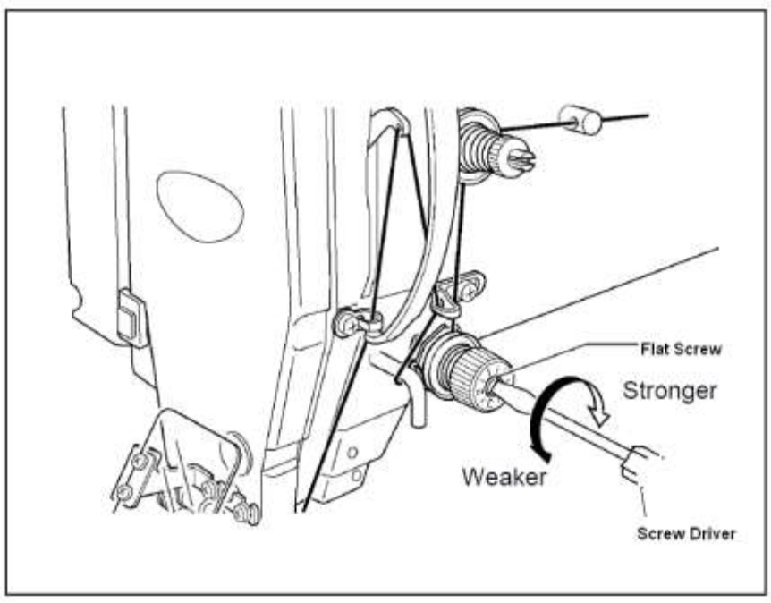

Figure 3.10 Treads tensions spring adjustment

Needle Thread Tension Adjustment

Figure 3.11 Needle Thread Tension Adjustments

Preliminary tension 1

On the machine the needle thread needs to be under residual tension for the thread cutter to function reliably when the main tension 3 is open.

The preliminary tension 1 should be set lower than the main tension 3.

- Adjust preliminary tension 1 by rotating the knurled nut.

- After major changes to preliminary tension 1 the main tension 3 should also be adjusted accordingly.

Main tension 3

The main tension 3 should be set as low as possible. The looping of the threads must be in the Centre of the material with thin material (see Figure-a) excessive thread tension can cause unwanted gathering and thread breakage.

- Adjust the main tension 3 so that the stitches are uniform.

Figure 3.12 tread tension loop

Bobbin Thread Tension Adjustment

General Adjustment:

Figure 3.13 Bobbin Thread Tension Adjustments

Sewing machine care and maintenance refer to below links

https://www.youtube.com/watch?v=wKkzdAD90pc

Steps to adjust Bobbin Thread Tension
- Turn the adjusting screw (3) back so that the tension of the tension spring (2) is completely relieved.
- Bend the brake spring (1) so that half the recommended values of the hook thread tension is applied by the brake spring.
- Insert a bobbin into the upper bobbin casing and thread in the hook thread.
- Insert the bobbin casing with bobbin into the hook.
- Grasp the free end of the thread tightly in one hand.
- Turn the hand wheel until the sewing machine has performed a single stitch.
- Pull the hook thread to the top of the stitch hole using the needle thread.
- Pull the hook thread in the direction of sewing at an angle of 45˚. You should feel about half the tension value.
- Then tighten the adjusting screw (3) until the recommended tension value is produced.

Machine -1: Flat Bed Single Needle Sewing Machine

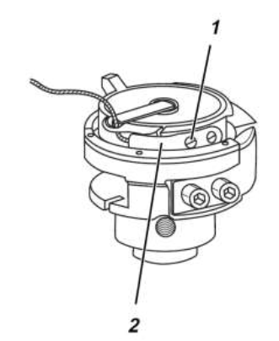

Figure 3.14bobbin tread tension flat bed
- Release right-hand needle-plate slide and push aside.
- Adjust tensioning spring 2 by rotating regulating screw 1.
- To increase bobbin -thread tension:= rotate screw 1 clockwise.
- To decrease bobbin-thread tension= rotate screw 1 anti-clockwise
- Push needle-plate slide back into place.

Machine Type -2: Post Bed Sewing Machine:

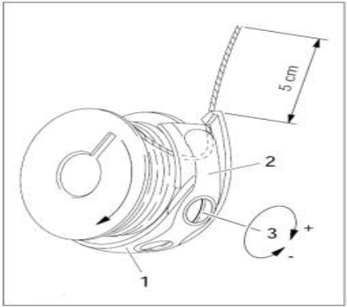

Figure 3.15bobbin tread tension post bed

- Insert the bobbin into the bobbin case [1].
- Pass the thread through the slot under spring[2]
- Pass the thread through the notch.
- Adjust the thread tension by turning screw [3]

Note: When the thread is pulled the bobbin must rotate in direction of the arrow.

Machine Type-3: Cylinder Bed Sewing Machine:

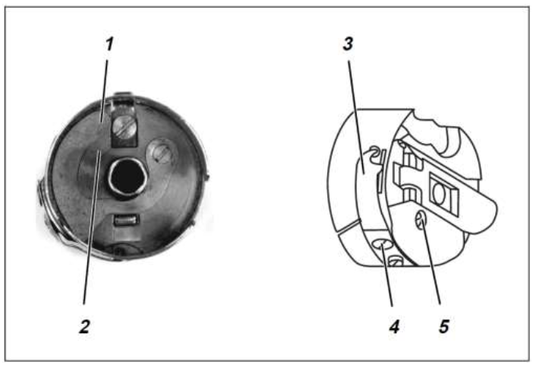

Figure 3.16Adjusting brake spring 1 (class 69-FA-373)

Lap Test-3
Performance Test
Instructions: Given necessary templates, tools and materials you are required to perform the following tasks within 1 hour. The project is expected from each student to do it.

Task 1Using Correct Hand Tools and Measuring Equipment’s to Rectify Problems
Task 2Adjust flatbed single needle sewing machine
- Presser Foot Pressure Problem
- Thread Take-up (check) Spring Tension Adjustment
- Needle Thread Tension Adjustment
- Bobbin Thread Tension Adjustment

Unit Four: Scheduled Maintenance
This learning guide is developed to provide you the necessary information regarding the following content coverage and topics:
- Annual schedule maintenance
- Procedure of Scheduled maintenances
- Maintenance Record and documentation

This guide will also assist you to attain the learning outcomes stated in the cover page. Specifically, upon completion of this learning guide, you will be able to:
- Identify Annual schedule maintenance
- Apply Scheduled maintenances using procedures
- Record and documentation of maintenance

- Annual schedule maintenance

Scheduled maintenance is any task that is given a deadline and assigned to a technician.
It can either be a recurring task done at regular intervals or a one-time task. The primary goals of scheduled maintenance are to reduce reactive maintenance, equipment failure, and maintenance backlog.

The Benefits of Annual Maintenance Contracts
- Predictable, fixed costs: As-needed maintenance planning can quickly spiral into unforeseen costs that significantly affect the entire budget.
- Guaranteed access to maintenance support at any time
- Logistical improvements: A comprehensive maintenance contract takes a holistic approach to all aspects of your maintenance practice.

- Extended equipment life: All too often, maintenance is treated as the practice of addressing breakdowns when they arise – when it should actually be an on-going process with the primary intent of keeping equipment running in top shape for as long as possible.

- Reduced downtime: Building on the benefits of adhering to scheduled maintenance, maintenance partners aim to minimize or eliminate downtime caused by equipment malfunctions.

- Procedure of scheduled maintenances
    - Maintenance planning
Planning and scheduling is a disciplined approach for utilizing your existing maintenance resources to reduce area downtime and minimize the overall production costs. This is accomplished through:
- Prioritizing work
- Developing the physical steps to complete the job
- Procuring necessary tools and materials
- Scheduling the work to be done
- Completing work
- Identifying any additional work to be completed on the equipment
- Filing written documentation for equipment history

Effective planning and scheduling contribute significantly to the following:-
- Reduced maintenance cost.
- Improved utilization of the maintenance workforce by reducing delays and interruptions.
- Improved quality of maintenance work by adopting the best methods and procedures and assigning the most qualified workers for the job.
- Routine maintenance: are maintenance operations of a periodic nature. They are planned and scheduled and in advance. They are covered by blanket orders.
- Emergency or breakdown maintenance: interrupt maintenance schedules in order to be performed. They are planned and scheduled as they happened.

Prerequisites for maintenance planning and scheduling
- Lead-time is essential
- A strong institutionalized Work Order System
- An organizational structures that fosters Pro-action
- Reasonable span of control for supervisors
- Understanding the department’s mission in relation to company objectives
- Assistance for Operations in establishing a practical level of maintenance
- Regards for operations as an internal customer
Purpose of maintenance planning Maintenance Planners need:
- Clear definition of their relationships with maintenance superintendents, supervisors, mechanics and operations.
- Proper computer support to allow development of a comprehensive planning database
- Commitment from maintenance and operating management to hold structured weekly Coordination and scheduling sessions to establish priorities for daily, weekly, down day and major outage work.
- Cooperation from maintenance supervisors, mechanics and operating supervisors in the effective use and application of efforts put into meaningful planned job packages
- Feedback from mechanics and supervisors (maintenance and operations) regarding specific\Short falls in planned job packages so that improvement of future packages is facilitated
- Feedback from maintenance supervisors regarding compliance with and exceptions to the weekly schedule with noted “reasons”.
Convey the many benefits that accrue to each stakeholder Planning, scheduling & coordination provide significant benefits to management by:
- Providing a central source of information
- Improving employee safety
- Improving regulatory compliance
    - Scheduling
Reliable Schedule Must Take Into Consideration
- A job priority ranking reflecting the criticality of the job.
- The availability of all materials needed for the work order in the plant.
- The production master schedule.
- Realistic estimates and what is likely to happen.
- Flexibility in the schedule.
Sewing machine maintenance & safety policy practice
Best & regular maintenance of plants machinery increase not only machine life but also with quality leather garment and goods stitching, less consumption of spare parts & reduce tendency of machine problem results increase total productivity. In the view of the above the machinery maintenance policy & procedure are being given below.

Daily maintenance: while sewing floor is running if any machine create problem, initially floor mechanics try to fix that machine within the line. If it is not possible in a short time, machine will be shifted to the maintenance room replacing by another machine & necessary measure will be taken to fix that Machine. The daily records of maintenance works has been kept in a format.

Monthly maintenance: It is a preventive maintenance to reduce machinery problem & increase machine life, execute by predetermine schedule fixed on the starting of the year by regular basis. This maintenance program covers total servicing of the all machine, oil change, oil filter change, or any defective parts change. Records of monthly maintenance works have been kept in a format.
Sewing machine preventive maintenance
Responsibilities of Sewing machine Operator

- Check threading of the machine→ daily
- Complete cleaning of the machine→ daily
- Keep the Clean paper under the foot→ daily
- Check for oil leaks → Every Four hour
- Clean needle/foot/t. feed bars → Every Four hour
- Clean machine head with → Every Four hour
- Clean machine table top→ Every Four hour
- Un-usual noise of the machine→ all day

    - Responsibilities of Sewing machine Mechanic
Daily Basis work of Sewing machine Mechanic

- Check Machine Setting Correct or Not→ all day
- Check Oil Level and Oil Leaks of the Machine→ Day starting
- Check un-usual noise of the machine →All day
- Check Oil paper → Day starting
- Check safety Equipment→ Day starting
- Check Machine allocation (According to M/C Layout) → Day starting
- Check Production Plan → Day starting

Monthly basis work Sewing machine Mechanic

- Whole machine clean opening parts
- Back/ Front cover
- Hook/ Lopper timing and Needle
- Needle plate
- Feed dog
- Oil lubrication change
- Checking machine fitness to run continuously
Daily Sewing Machine Check Points

- Tension spring
- Take up spring
- Bobbin case spring
- Thread wiper
- Oil level/ oil leak
- Threading
- Needle plate/ fee dog
- Machine washer
- Laser light
- Needle plate/ fee dog

Monthly Sewing machine maintenance/servicing checklist

- Air device
- Trimmer device
- Super tension post take up spring
- Needle bar, bush and clam condition
- Needle plate condition
- Feed dog condition
- Winder condition
- Rotary hook or loppers
- Oil level/ oil filter condition
- Machine table in good condition
- Cleaning and blowing
- The lubricant in equipment (oil and grease cut)
- Main shaft, connecting rod, bearing condition
- Machine head has to be balanced with base plate
- Knife slide
- Power on/ off switch
- Motor and control box condition
- Abnormal sound Connecting rod and crosshead
- Machine table in good condition
- Cleaning and blowing
- The lubricant in equipment (oil and grease cut)
- Main shaft, connecting rod, bearing condition
- Machine head has to be balanced with base plate
- Knife slide
- Power on/ off switch
- Motor and control box condition
- Abnormal sound Connecting rod and crosshead

- Maintenance record and documentation
Record Preparation

The report and record of sewing machine maintenance submitted by the person who is accomplished the work, which verifies that the equipment is either safe to use or should be disposed after accomplished their work. This record of maintenance, with the status, should be kept by the supervisor as part of a permanent file about the piece of equipment.

For each piece of machine used during the day, the supervisor must assure entry of the amount of time that each piece of equipment was used on each activity. Also he must assure the entry of the appropriate materials, location, quantity used, and material code of each material used. This allows the cost of the supplied material to be charged to the work activity.

Do not perform any of maintenance work without written documentation that includes:
- Name and ID number of contact person requesting the work.
- Location of the work
- Accurate, complete description of the work to be done with estimated costs (if available).
- Identification of materials to be used.

As work is performed, the supervisor must properly and accurately record and complete with all details.

Document-1: Maintenance –Inspection Report

This report is an important evaluation involving examination, measurement, testing, gauging, and comparison of materials or items of inspected machine.
Table 4.1 Inspection Report
Maintenance inspection report (sample format)
Department |  |  | Date: 02-09-21
S.NO | Name of machine | Code no | Problem identified | Remarks
1 | Skiving machine | 0210 | Main switch

Document-2: Material Request Form

With help of inspection report the required materials to be listed in below format and submitted to the supervisor. The form may be forwarded to the store (or) purchasing department. The all required materials should be arranged and collected before starting maintenance work.

Document-3: Daily Activities Report

This is summary of all work carried out during maintenance of each machine.

Daily maintenance activities report can be prepared after work carried out and accomplished as prescribed format as shown below.

Table 4.2Daily Activities Report
Maintenance daily activity report (sample format)
Department |  |  | date
S.NO | Name of machine | Code no | Activities done | Spares if any | Remarks

Document-4: Spare Parts Status Tag

During maintenance the damaged (or) reusable spares can be remarked and tag out as prescribed format as shown below.

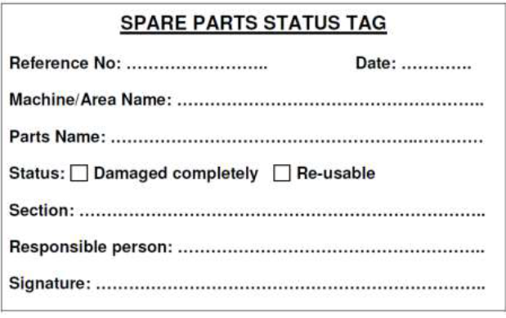

Document-5: Maintenance- Job Card

In case of any malfunctioning in machine, duly filled ‘JOB CARD’ on the prescribed format is shown below. The Maintenance personnel thoroughly will inspect the machine for tracing the fault. The procedure for tools replacement and machine setting is the same as ‘JOB CARD’.

The job card contents a request and completion report can be completed by supervisor after work carried out and accomplished as prescribed format as shown below.

Self check-4

Directions: Answer all the questions listed below
- What is Scheduled maintenance?
- What is an Annual Maintenance Contract?
- What are Planning procedures?
- What is Planning and scheduling?
- Write Daily Sewing Machine Check Points.
- Write the documentations to perform maintenance work.
- Explain about Material request form?
- What is Maintenance –Inspection report?

Note: Satisfactory rating – above 60% Unsatisfactory - below 60%
You can ask you teacher for the copy of the correct answers

Operation sheet-4

Prepare schedule maintenance

Objectives: to prepare schedule maintenance plan

Planning procedures
- Determine the job content.
- Develop work plan. This entails the sequence of the activities in the job and establishing the best methods and procedures to accomplish the job.
- Establish crew size for the job.
- Plan and order parts and material.
- Check if special tools and equipment are needed and obtain them.
- Assign workers with appropriate skills.
- Review safety procedures.
- Set priorities for all maintenance work.
- Assign cost accounts.
- Complete the work order.
- Review the backlog and develop plans for controlling it.
- Predict the maintenance load using effective forecasting technique

Scheduling Procedures (Steps)
- Sort backlog work orders by crafts.
- Arrange orders by priority.
- Compile a list of completed and carry over jobs.
- Consider job duration, location, travel distance, and the possibility of combining jobs in the same area.
- Schedule multi-craft jobs to start at the beginning of every shift.
- Issue a daily schedule (not for shutdown maintenance).
- Authorize a supervisor to make work assignments (dispatching).

Lap Test-4
Directions: Answer the questions listed below.
Given necessary templates, tools and materials refer on Unit Four.
Task 1 Prepare Schedule maintenance plan

Unit five: Complete the maintenance
This learning guide is developed to provide you the necessary information regarding the following content coverage and topics:
- Clean and store tools.
- Environmental procedures and managing waste.
- Clean and maintain working area.
- Malfunctions, faults and wear or damage of tools
This guide will also assist you to attain the learning outcomes stated in the cover page. Specifically, upon completion of this learning guide, you will be able to:
- Clean and store tools as per the requirement.
- Follow environmental procedures and managing waste.
- Clean and maintain working area according to OHS and enterprise requirements.
- Report Malfunctions, faults and wear or damage of tools

  - Clean and store tools
    - Cleaning, Returning and Storing Tools
Points to about cleaning
- Clean tools and equipment helps work more efficiently. At the end of each working day clean the tools and equipment you used and check them for any damage. If you note any damage, tag the tool as ‘faulty’ and organize a repair or replacement.
- Electrical current can travel over oily or greasy surfaces. Keep electrical power tools free from dust and dirt and make sure they are free of oil and grease.
- All workshop equipment should have a maintenance schedule. Always complete the tasks described on the schedule at the required time. This will help to keep the equipment in safe working order.
- Keep your work area tidy. This will help you work more efficiently and safely.
- Always use chemical gloves when using any cleaning material because excessive exposure to cleaning materials can damage skin.
- Some solvents are flammable. Never use cleaning materials near an open flame or cigarette.
- The fumes from cleaning chemicals can be toxic, so wear appropriate respirator and eye protection wherever you are using these products.
- When cleaning products lose their effectiveness they will need to be replaced.
- Refer to the suppliers' recommendations for collection or disposal. Do not pour solvents or other chemicals into the sewage system. This is both environmentally damaging and illegal.
Cleaning Of Equipment
To maintain cleaning equipment and keep it in a good working condition, it must be thoroughly cleaned and stored correctly every time it is used. If regular maintenance does not occur, the equipment may, over time, become dangerous to individuals.
Equipment and Floor that will need cleaning includes:
- Garbage receptacles
- Pans
- Brooms, dusters and brushes
- Mops and buckets
- Electrical equipment, Ex: vacuum cleaners, polishers, scrubbers.
Every time a piece of equipment is used, the general rule is to clean it straight away so it is ready for the next person to use. The manufacturers’ instructions should be strictly followed when maintaining and cleaning equipment.
Clean Hand Tools
Keep your hand tools in good, clean condition with two sets of rags. One rag should be lint-free to clean or handle precision instruments or components.
The other should be oily to prevent rust and corrosion.
- Use kerosene/solvent for cleaning tools
- Clean tool and keep their place
Storing Tools:
- Store commonly used tools in an easy-to-reach location. If a tool, or piece of equipment, is too difficult to return, it could be left on a workbench or on the floor where it will become a safety hazard.
- Tools and equipment shall be kept in proper operating condition and used only for the purpose for which they were designed. If proper and safe tools are unavailable, this should be reported to the supervisor.
- All tools should be inspected at regular intervals, and any tool that develops defects while in use shall be taken from service, tagged and not used again until restored to proper working condition.
- Hammers and similar tools shall be kept in good condition and shall not be used if the handles are loose, cracked, or splintered.
- Wrenches must be kept in good condition. Defective wrenches such as open-end, box-end, socket, and adjustable wrenches with spread jaws, or pipe wrenches with dull teeth, might slip.

    - Storage of Personal Protective Equipment
- Where PPE is provided, adequate storage facilities for PPE must be made available for when it is not in use, unless the employee may take PPE away from the workplace, e.g., footwear or clothing.
- All PPE must be stored in a clean and sanitary condition ready for use.
Accommodation may be simple, e.g.: hangers for waterproof clothing or, E.g.: a case for safety glasses on a designated shelf.
- Storage should be adequate to protect the PPE from contamination, loss, damage, water or sunlight.
- Proper storage often requires a dry and clean place that is not subject to temperature extremes. Where PPE may become contaminated during use, storage should be separate from any storage provided for ordinary clothing.
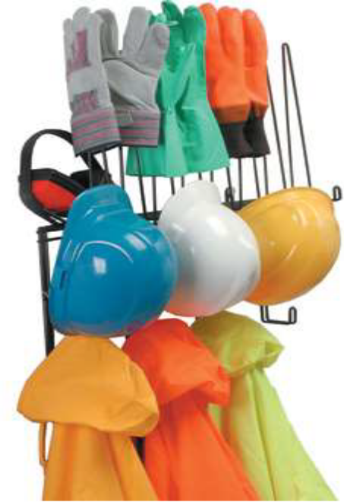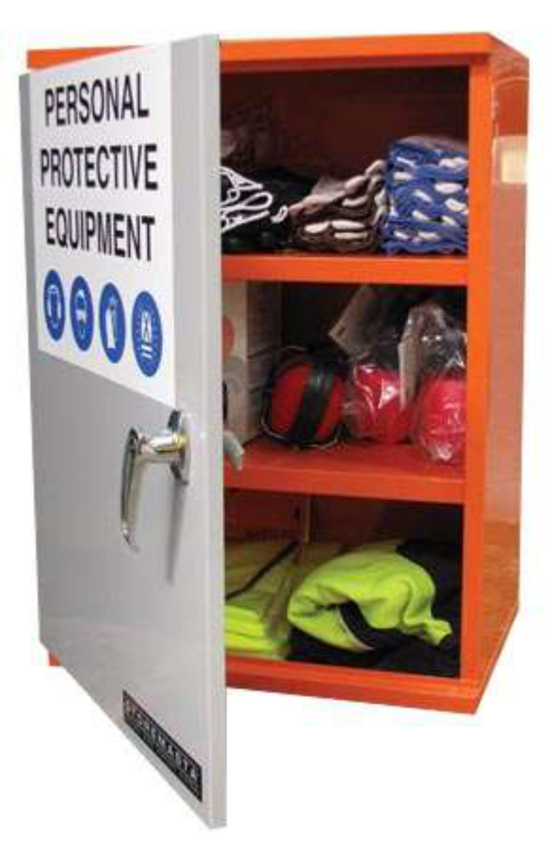
Figure5.1 Storage of Personal Protective Equipment

  - Environmental procedures and managing waste
    - Workplace Environment and Handling of Material Safely
Maintenance of the working environment and equipment is essential for safe performance of manual tasks. An adequate hazard reporting system and preventative maintenance program will help to ensure equipment and the working environment is kept safe.
For example, provide adequate space for handling objects, improve lighting, reduce the effects of adverse climatic conditions, improve floor surfaces, reduce noise and other distractions and provide adequate ventilation.
Work area:
- Workplace design and layout needs to enable workstations to be accommodated in the safest configuration. Workstations need to provide clear space for workers. The clear space needs to be exclusive of desks, benches, machinery and any other fittings.
- Work processes and the ergonomics of materials or manual handling tasks may justify the clear workstation space being increased.
- Environmental factors such as heat or noise may also require increases to the recommended size.
Access ways
- Movement in and around workstation needs to be free of obstructions such as plant, furniture, materials or other workers.
- Supervisor need to ensure that the space for workers to move and work between plant, equipment, structures and materials is at least 800mm.
- This is to enable workers to work safely between machines, benches or counters. It will also allow them to evacuate quickly in an emergency Aisles, passageways and access to cupboards, storage or doors need to be in addition to the calculated clear workstation space.
The following characteristics of the work environment may increase the risk of injury:
- Space available: A lack of space to carry out operation and manual handling may lead to inappropriate body postures and dangerous imbalance in the loads.
- Floor: Handling loads on different working levels or on floors that are slippery, uneven or unstable (such as working platforms or fishing boats) may increase the risk of accidents and back injury.
- Climate: The physical climate (temperature, humidity and ventilation) may affect the risk of injury. Heat makes you feel tired, and sweat makes it hard to hold tools, requiring more force. Cold can make your hands numb, making it hard to grip.
- Lighting: Insufficient lighting may increase the risk of accidents when handling loads and maintenance. It may also make you work in awkward positions to see clearly what you are doing.
Safe Work Practices-Handling of Material:
- Wear appropriate personal protective equipment such as work gloves when handling objects with sharp edges and safety footwear when handling heavy objects.
- Ensure there is adequate clearance for safe lifting/material handling.
- Ensure storage areas are kept tidy, well organized and free of clutter.
- Use a hand truck, cart, dolly, wheelbarrow, etc to move heavy, awkward or bulky objects. Ask for assistance.
- Reduce repetition as much as possible by pacing your work and by varying tasks.
- Use a stepladder or stepstool to reach high places.
- Use a power grasp for loads with handles.
- Use a ledge grasp for loads without handles
- Wherever possible use an elevator to move supplies and equipment between floors. Ask for assistance and/or use a two-wheeled hand truck trolley to move heavy, awkward or bulky items up or down stairs if an elevator is not available.
- Do not lift or carry items by the packing straps or cords.
- Do not use a box, desk or chair to reach high objects.
- Do not lift a load if you are not sure that you can handle it safely.

Emergency and Control Process
The worker and visitors should know a building emergency evacuate.
You are Responsible to report immediately when incidents of:
- Fire
- Accident
- Injury
- Medical
Evacuation Process
- If unsafe circumstances prevail evacuate the building immediately.
- Obey the instructions of your Instructor.
- Proceed to designated exits and evacuate. Walks do not run. Keep calm and orderly.
Emergency Knowledge
- Where the fire extinguisher are kept
- Where emergency equipment relevant to your work is kept
- Who is the first aid officer
- Where the first aid kit is kept
- Where the nearest emergency exits is
- What to do in case of an emergency
Emergency and First Aid
- In an emergency situation, immediate action: SAVES LIFE!
- Assess the situation
- Ensure that you are not placing yourself in danger when approaching the casualty
- Ensure some calls for help and (or) an ambulance if required.
- Do not move the casualty unless there is immediate danger to life, eg: Potential for obstructed airway.

    - OHS Safe Work instruction
- Wear appropriate personal protective equipment
- Use Emergency Release Button
- Turn OFF machine when not in use.
- Keeps hand away from moving and heated parts
- Use both hands for operation when required.
- Do not use your fingers to remove leather that has become caught between the blades and guide fingers. Use pliers only.
- Do not attempt any electrical repairs. If anything is wrong, tell your instructor.
- Safety Guard: This must always be in place when operating the machine.If your hair is longer than shoulder length, use a hair net of tie it back
- Know your fire drill.
- One operator at a time on the machine
- Do not fool around
- If you injure yourself, no matter how minor, tell your supervisor.
- If necessary seek medical attention

  - Clean and maintain working area
    - Cleaning working area
Work Areas:
The layout of work areas should be designed to provide sufficient clear space needs between furniture, fixtures, machinery and fittings so that workers can move about freely without strain or injury and also evacuate quickly in case of an emergency. Space for aisles, passages and access to other areas is needed in addition to the space around workstations.
The space required needs to be based on as assessment that takes into account:
- the physical actions needed to perform the task
- the need to move around while working
- whether the task is to be performed from a sitting or standing position access to workstations
- the equipment to be handled and the personal protective equipment that may be worn to perform the work
Work processes and the ergonomics of materials or manual handling tasks may justify the clear workstation space being increased. Some work activities involve plant such as knives, and the risk of injury will be exacerbated by close working conditions. Environmental factors such as heat or noise may also require increases to the recommended size.
Personal Safety
Whenever you perform a task in the workshop you must use personal protective clothing and equipment. Among other items, this may include:
- Work clothing - such as coveralls and steel-capped footwear
- Eye protection - such as safety glasses and face masks
- Ear protection - such as earmuffs and earplugs
- Hand protection - such as rubber gloves and barrier cream
- Respiratory equipment - such as face masks and valved respirators
If you are not certain what are appropriate or required, ask your Instructor.
Safety Check
- Some cleaning agents are toxic. Refer the instructions on any cleaning agent and follow any recommendations before using it.
- Do not use flammable cleaners or water on electrical equipment.
- Make sure designated walkways are kept clear of any obstructions.
- Always wear protective clothing and the appropriate safety equipment.
- Make sure that you understand and observe all legislative and personal safety procedures when carrying out the maintenance tasks. If you are unsure of what these are, ask your Instructor.

    - Cleaning Up Work Area/Floor
Workplaces and amenities need to be cleaned regularly, usually daily. The cleaning schedule needs to take into account the requirement for hygienic maintenance of work place and amenities such as production areas, toilets, hand basins and showers. These amenities need to be cleaned more frequently, taking into account shift work, the type of work performed and the number of employees.

You have to be:
- Clear and clean the area
- Store any reusable materials
- Check, clean and store away any tools and equipment
- Dispose of hazardous and non-hazardous waste according to legal and workplace requirements.

    - Cleaning and Clearing Techniques
- Select and use an appropriate method for cleaning
- Select tools and specialist equipment
- Check any leakages
- Restore your work area to a safe and tidy condition
- Make sure that any materials, components, tools and equipment that you may need for the next task are set up ready for use.
Material Storage Techniques
- Sort reusable equipment, components and materials from waste
- Reusable materials are correctly stored
- All tools and equipment are properly stored.

Safe Disposal instruction
- Handle and dispose of waste materials appropriately according to organizational and legal requirements
- Recognize what materials are hazardous and require special procedures
- Report any problems associated with cleaning, storing or disposing of materials and equipment to the relevant person.

Hazardous and Non-Hazardous Materials
- Types of waste material generated in the work area
- Know how to handle hazardous waste and reusable materials safely including:
- Fluids
- Adhesives
- Solvents.
- Personal protective equipment is required and to use it.

Clean Floor
- Wipe off any oil or grease on the floor and check for fluid leaks. If you find any, top up the hydraulic fluid. Occasionally, apply a few drops of lubricating oil to the wheels and a few drops to the posts of the safety stands.
- Use detergent to clean floor and moping area properly.

Ensuring Work Area to be Safe for Working
The Workplace Regulations (Health, Safety and Welfare) cover a wide range of basic health, safety and welfare issues and apply to workplaces.
Employers have a general duty of the Health and Safety at Work etc. and to ensure all, so far as is reasonably practicable, the health, safety and welfare of their employees at work.
The Regulations expand on duties and are intended to protect the health and safety of everyone in the workplace, and ensure that adequate welfare facilities are provided for people at work.
These Regulations aim to ensure that workplaces meet the health, safety and welfare needs of all members of a workforce, including people with disabilities.
Several of the regulations require things to be ‘suitable’. Where necessary, parts of the workplace, including in particular doors, passageways, stairs, and workstations, should be made accessible for disabilities.

  - Malfunctions, faults and wear or damage of tools
    - Reporting Malfunctions, faults and wear or damage of tools
The report of minor/routine maintenance submitted by the service person, which verifies that the equipment is either safe to use or should be disposed after accomplished their work. This record of routine maintenance, with the status, should be kept by the work group as part of a permanent file about the piece of equipment.

During maintenance the damaged (or) reusable spares can be remarked and tag out as prescribed format as shown below in
Format-1: spare parts status tag

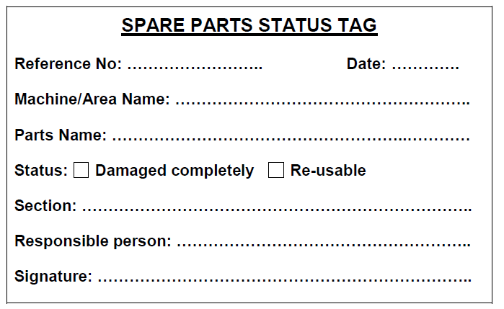

Figure 5.2 spare parts status tag

FORMAT-2

In case of any malfunctioning in machine, duly filled ‘JOB CARD’ on the prescribed format is shown below as FORMAT-2. The Maintenance personnel thoroughly will inspect the machine for tracing the fault. The procedure for tools replacement and machine setting is the same as FORMAT-2 as ‘JOB CARD’.

FORMAT-2job card format

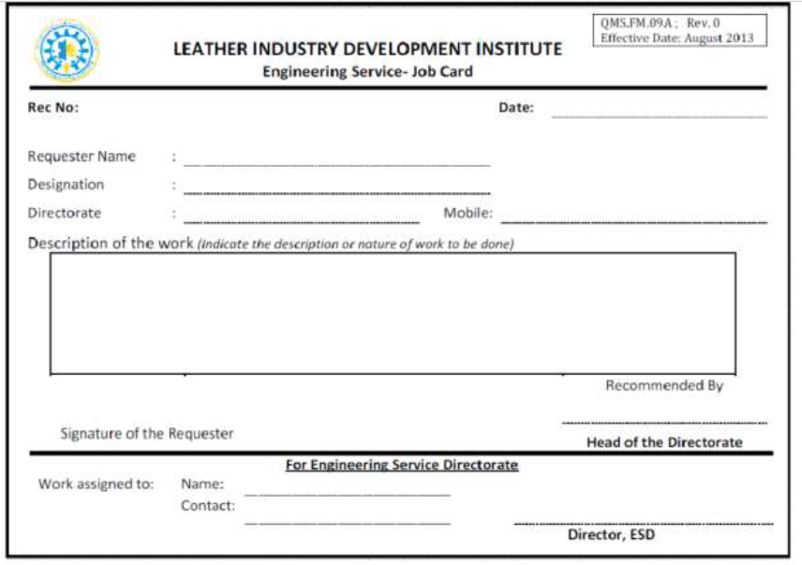

Figure 5.3spare parts status tag

Self check-5

Directions: Answer all the questions listed below. Examples may be necessary to aid some explanations/answers.

Directions: Answer all the questions listed below.
- What it does mean clean tools and equipment helps work more efficiently.
- Describe maintaining and cleaning equipment Step-By-Step Instruction
- Write characteristics of the work environment may increase the risk of injury.
- List Emergency Knowledge’s.
- What is the responsibility of all persons to report immediately when incidents
- How should you design and maintain a ‘Work Area’?
- Write a short on ‘Cleaning and clearing techniques’?
- What are the safety check points Safe Disposal Techniques?
- What is the use of spare part status tag?
- How to necessary job card in maintenance?
Short Answer Questions:

1. Write a short note about ‘working in confined spaces’?
2. Write a don and remove techniques of hand protection?
3. What are the general duties while you are operate a machine and working at place?
4. Briefly explain about Safety measures in Sewing Machine?

5 Write a short note on the work environmental factor?
True (or) False: (5 x 1 = 5 Points)
- Control the oil level before each use.
- Apply grease to all the both flanks and the rack.
- Add grease and lubricant with old lubricant in machine and parts.
- Over a period of time oil and grease leaving a thick sludge in the tank.
- Fill oil through hole into the reservoir.

Note: Satisfactory rating – above 60% Unsatisfactory - below 60%
You can ask you teacher for the copy of the correct answers
Reference

- Performing maintenance of sewing machines draft from leather industry development institute
- Sewing machine maintenance
https://aces.nmsu.edu/pubs/_c/C102/welcome.html
- Sewing machine care and maintenance
https://www.youtube.com/watch?v=wKkzdAD90pc
- Sewing machine maintenance procedure
https://www.onlineclothingstudy.com/2019/04/sewing-machine-maintenance- procedure.html
- Annual servicing and machine repair
https://durabilitymatters.com/sewing-machine-maintenance/

Participants of This Module (Training Material) Preparation
No | Name | Qualification (Level) | Field of Study | Organization/ Institution | Mobile number | E-mail
1 | Siyoum Negash | B(MSC) | Leather Garment | SNNP, Dillapolytechnic college | 0913084257  0902249766 | Siyoum2006@gmail.com  nagashsiyoum@yahoo.com
2 | mohammad juhar | A(MSC) | Garment technology | w/rosiheen polytechnic college | 0913632589 | mdjuher143@gmail.com
3 | KALAB GIETIE | B(MSC) | Leather technology | Deberebrihan | 0996884181 | kalabtenaw@gmail.com

