Leather Garments and Goods Production Level II
Based on June 2021, Curriculum Version 1
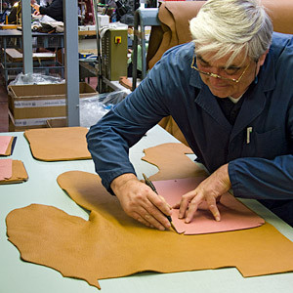

Module Title: -Cutting Leather Garment and Goods Material
Module code: IND LGG2 M02 1221
Nominal duration: 150 Hours

Prepared by: Ministry of Labor and Skill
Aug, 2022
Addis Ababa, Ethiopia
Table of Contents

Acknowledgment…………………………………………………………………………………5
Acronym…………………………………………………………………………………………..6
Introduction to the Module……………………………………………………………………...7
Unit one: Workstation………………………………………………………………………......9
  - Workstation……………………………………………………………………………….12
  - Patterns and Standard Consumption………………...........................................................15
  - Collect, inspect, sort and lay materials …………………………………………………..20
Self check-1……………………………………………………………………………………...27
Unit Two: Read Pattern and Interpretation ……………………………………………….28
- Pattern Templates………………………………………………………………………29
- Types of Patterns……………………………………………………………………….36
- Common Pattern Markings (References) And Specification………………………….40
- Leather Goods And Garment Style ………………………………………………...…43
- Applying correct interpretation of essential element………………………………….56

Self check-2 ……………………………………………………………………………………59
Unit Three: Duplicate cutting patterns …………………………………………………….61
- Tracing Template ……………………………………………………………….62
- Cut traced pattern ……………………………………………………………….63
- Apply reference and specification……………………………………………….64
- Check Pattern Pieces, Information And Specification…………………………..71
- Identify and report garment and goods pattern faults…………………………...74
- Take appropriate corrective action………………………………………………78

Self-check-3………………………………………………………...……………………………83

Operation sheet-3……………………………………………………………………………….84

Lap Test-3……………………………………………………………………………………….87
Unit Four: Sort and assess leather…………………………………………………………...88
  - Bundle Of Leather And Match Shades……………………………………………..89
  - Sort And Assess Of Leather………………………………………………………….93
  - Lay And Assess Of Leather Defects…………………………………………..……104
  - Identify And Mark Defects………………………………………………………...105
  - Report The Records…………………………………………………...……………114

Self-check-4…………………………………………………………………………………...117

Operation sheet-4…………………………………………………………………………….120

Lap Test-4…………………………………………………………………………………….123
Unit five: Cut leather by hand……………………………………………………………….124
  - Identify defects and faults …………………………………………………………..125
  - Positioning patterns………………………………………………………………….131
  - Cut components……………………………………………………………………...134
  - Check the actual consumption of cut components…………………………………..146
  - Identify and repair faults with patterns, knives and cutting boards………………….148
  - Carry out works ……………………………………………………………………..154

Self-check-5…………………………………………………………………………………….162

Operation sheet-5……………………………………………………………………………...164

Lap Test-5………………………………………………………………………………….....169
Unit 6: Cut lining and reinforcement materials by hand………………………………….170
  - Position of patterns for economical cutting…………………………………………….171
  - Match patterns shape, type, size and leather quality using cutting norms……………...172
  - Cut of components Precisely Using cutting techniques………………………………...173
  - Clean cutting boards …………………………………………………………………...174
  - Check the actual consumption of cut components……………………………………..176
  - Identify faults with patterns, scissor cutting knives, cutting boards and referring to repair

Self-check-6……………………………………………………………………………………179
Unit 7: Cut leather and reinforcement by machine ………………………………….…...180
  - Select and prepare cutting dies ………………………………………………………181
  - Set up cutting machine……………………………………………………………...183
  - Position material accurately on cutting machine…………………………………….188
  - Identify defects and positioning dies ………………………………………………..192
  - Cut material…………………………………………………………………………196
  - Consumption of cut components ……………………………………………….......198
  - Operate cutting machine ……………………………………………………………201
  - Monitor performance of machine…………………………………………………...204
  - Perform minor maintenances………………………………………………………..206
  - Report major problems………………………………………………………………215

Self-check-7………………………………………………………………………………….…217

Operation sheet-7……………………………………………………………………………...219
Unit 8: Check cut components………………………………………………………………..221
  - Check components………………………………………………………………….222
  - Address faults…………………………………………………………………….…227
  - Take Corrective Action……………………………………………………………..231

Self-check-8………………………………………………………………………………….....233
Unit 9: Dispatch completed Work……………………………………………………………234
  - Bundle or dispatch component……………………………………………………...235
  - Record faults………………………………………………………………………..243
  - Complete and maintain records…………………………………………………….244

Self-check-9……………………………………………………………………………………253
Reference ………………………………………………………………………………..…...255

Acknowledgment

Ministry of Labor and Skills wish to extend thanks and appreciation to the many representatives of TVET instructors and respective industry experts who donated their time and expertise to the development of this Teaching, Training and Learning Materials (TTLM).

Acronym

TTLM Teaching, Training and Learning Materials
LGG Leather Garments And Goods
OHS Occupational Health and Safety
PPE Personal Protective Equipment
SNLS Single Needle Look Stitches
SM Sewing Machines
PDF Probability Density Function
CB Center Back
CF Center Front

Introduction to the Module
In Leather Garments and Goods Production; the knowledge, skills and attitude to prepare workstation, read and interpret pattern, duplicate cutting patterns from templates, sort and assess leather; cut leather, lining and reinforcement materials by hand and machine; check cut components and to know the dispatch and completed workIn Leather Garments and Goods Production.

This module is designed to meet the industry requirement under the Leather Garments and Goods Production occupational standard, particularly for the unit of competency: Cutting Leather Garment and Goods Material.

This module covers the units:

- workstation
- Read Pattern and Interpretation
- Duplication of cutting patterns
- Sort and assess leather
- Leather cutting by hand
- Cut lining and reinforcement materials
- Cut leather and reinforcement by machine
- Check cut components
- completed Work

Learning Objective of the Module
- Prepare workstation
- Read and Interpret Pattern
- Duplicate cutting patterns from templates
- Sort and assess leather
- Cut leather by hand
- Cut lining and reinforcement materials by hand
- Cut leather and reinforcement by machine
- Check cut components
- Dispatch completed Work

Module Instruction
For effective use this modules trainees are expected to follow the following module instruction:
- Read the information written in each unit
- Accomplish the Self-checks at the end of each unit
- Perform Operation Sheets which were provided at the end of units
- Do the “LAP test” giver at the end of each unit and
- Read the identified reference book for Examples and exercise

Unit one: Workstation
This unit is developed to provide you the necessary information regarding the following content coverage and topics:
- Workstation
- Patterns And Standard Consumption
- Cutting Materials

This unit will also assist you to attain the learning outcomes stated in the cover page. Specifically, upon completion of this learning guide, you will be able to:
- Set Up Workstation
- Receive And Check Cutting Knife, Patterns And Standard Consumption
- Collect, Inspect, Sort And Lay Materials For Cutting

- Workstation

    - Workstation Set Up According to Specifications and Safety

Workstation is defined as an area, in an office, outfitted with equipment and furnishings for one or more workers. Normally leather products are operated in a workshop therefore the workstation for a leather goods/garments worker would be the workshop. It is necessary for a worker to prepare his work station and the pieces to be done Well-arranged working area i.e. properly seated machineries, assembling areas, good and safe placement of tools and equipment facilitates and motivates a worker to do his/her job in a good and respectable way but before doing so a worker should be well aware of the safety rules and regulations.

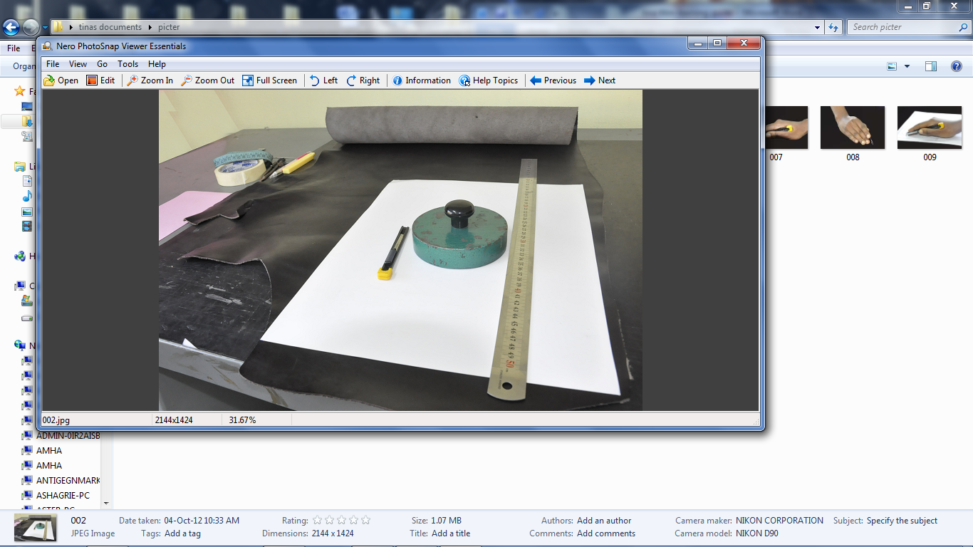

Figure 1.1 working area

Having created a good working area, the subsequent effort would be allocation of work according to the departments/sections. The process of cutting starts after the patterns of the particular product are being completed.

Once the patterns are completed and delivered to the cutting department/section with their specification the next process would be selecting the specified leather and all other necessary materials to be cut (including the color and texture according to the specification given), making ready the necessary tools and equipment, assorting which is a vital process carried out by highly skilled technicians before starting to cut.

It must be done under perfect lighting system so that its quality can be assured. Leathers are assorted according to thickness needed for various parts of the product, size, color, defects, texture, and stretch/elasticity. The person should know the various defects that could exist on the skin/hide and mark them on the leather using silver marking pencil so that it would be visible enough while cutting and he/she must also know where to apply cutting i.e. matching the section of the leather with the part of the product to be cut. Visible areas should be cut from the best section of the leather. But before going through the process the person (cutter) should be aware of the safety procedures and ergonomic principles for a better and organized work.

Safety: means the quality of being safe or freedom from danger or risk of injury. It is a contrivance or device designed to prevent injury. Workshop safety is extremely important both to workers and to managers (owners).

Generally, leather product processing is not as dangerous as many other manufacturing plants, but occasionally accidents can happen. It is easier and cheaper to prevent accidents before it occurs rather than later.

Accidents fall in to one or more of the following categories:-

Electricity: occurs when connections are faulty such as:
- Cables are not fit for the quantity of power
- Cable insulations badly connected, loose cables and its connectors
- Circuit breaker is not installed/ not working or too strong
- Fuses are too strong to protect current flow

Fire: can destroy all the work of years
- Incorrect power connections can heat up cables and produce sparks (fire)
- scouring/rubbing of metal causes small sparks which can glow for hours before igniting (usually occurs when nobody is around)
- Handling of flammable liquids such as alcohol, solvents and glue (the storage of all flammable materials must be away from the working area and stored safely)

Others
- Bad shelf storage of tools and materials, can fall off and hurt people
- Badly placed tools/devices like hot air blower can cut or injure people
- Poor furniture can injure people
- Slippery surfaces can make people fall
- Poor knowledge of machines and equipment
- Poor condition of tools and equipment
- Understanding this accident is not enough for a worker but it is also necessary to take precaution before they happen.
    - Clean and maintenance of cutting board

For cutting Paper Patterns the Rubber sheet also used. The cutting should be flat and convenient. Sometimes people use glass boards also to cut glazed kid. A recent trend has seen thick solid rubber pads used as cutting boards in the leather goods factory they are about as expensive as well-made wood boards, they can take chemical disinfectants, and they are very heavy for their size, so they tend not to slip. Proponents claim remarkable self-healing properties, the same knife protection as good plastic or wood boards. Plastic cutting boards are best for cutting leather cutting, lining and reinforcement materials cutting. They are easy to clean and are scratch resistant. The scratch and dirt’s can remove by tarpon oil or can be crepe rubber. After cutting on a plastic board, scrub the board with a light dish detergent; then allow it to soak for an hour before rinsing. Plastic cutting boards are warp-resistant, and they can be put away damp if necessary.

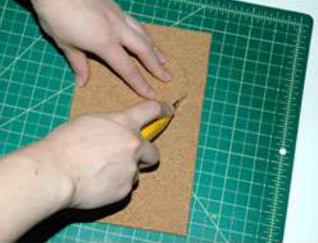

Figure 1.2cutting matt

  - Patterns and Standard Consumption
Different Types of Leather Cutting Tools

Cutting knife consists of a steel blade mounted in a handle to improve grip and control while cutting. The teeth of the blade are removed by grinding it on a grinding machine. The blade then cut in to two equal parts. One end of the blade is tapered at an angle of 45 degree and sharpened well in the grinding machine until a fine cutting edge is obtained.

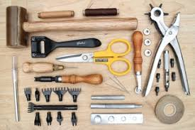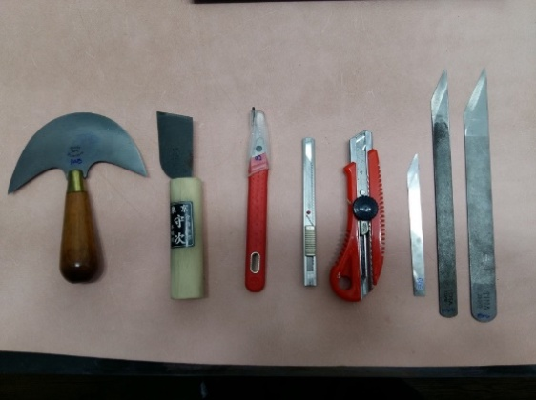

Figure 1.3Leather-cutting tools

Clicking knifeis use to cut out the leather components blade very precisely and repeatedly to the same dimensions and shapes. Clicking knife is made of high-speed steel hacksaw and is use to cut lining, paper and board patterns.

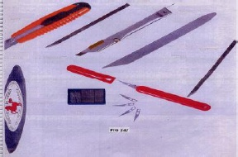

Figure 1.4 Clicking knife

Round knife made of stainless steel with excellent sharpness and edge retention. Especially suitable for thicker leathers (vegetable tanned leather, belt shoulders, buffalo, etc.). Can also be used for skiving (thinning) the leather edges.

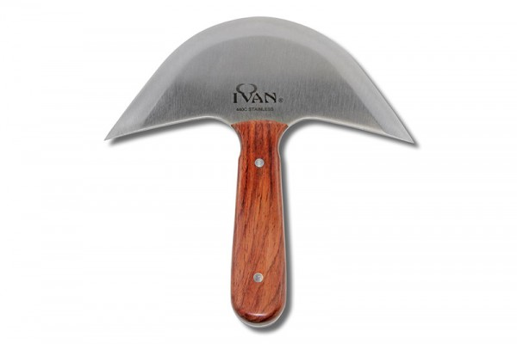

Figure 1.5round knives

A swivel knife is an important part of the leather cutting process, and you will be using it for detail work. It features a very sharp cutting head that makes cutting into a leather piece quite simple. You will be able to perform many tasks with your swivel knife.

This tool can be adjusted from a length of 80mm all the way up to 95mm. It is going to prove to be a very useful part of your leather cutting process. You will often find these swivel knives included in leather cutting kits, making it obvious that it is an essential tool to own.

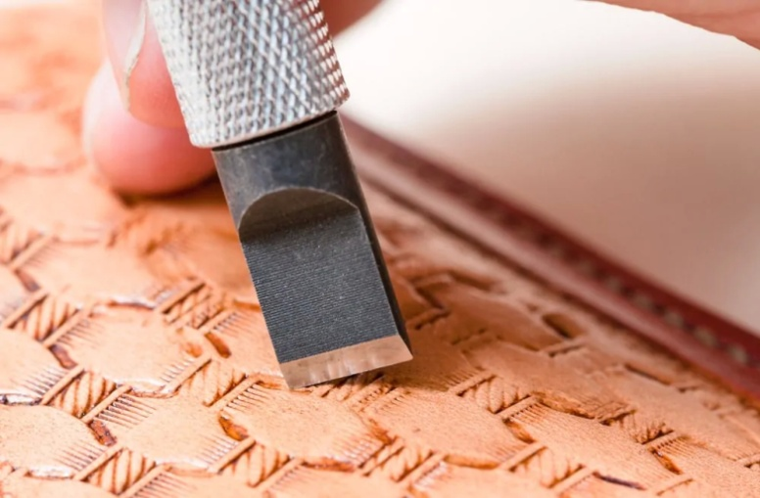

Figure 1.6 Swivel knives

Skiving knife are important tools to consider purchasing, as well. These knives differ from the others that have been covered on this list so far. A skiving knife is good for making general cuts because it is very sharp, but this is not the primary function of the tool. It is excellent for skive your pieces of leather in order to shave off pieces.

When you want to be able to thin out a certain area of the leather piece that you are working on, then you will need a quality skiving blade. Skive a piece of leather is something that you want to take slowly. You need to meticulously shave off the pieces of the leather that you are trying to alter. It may take some time, but you will be able to get great results when using this method.

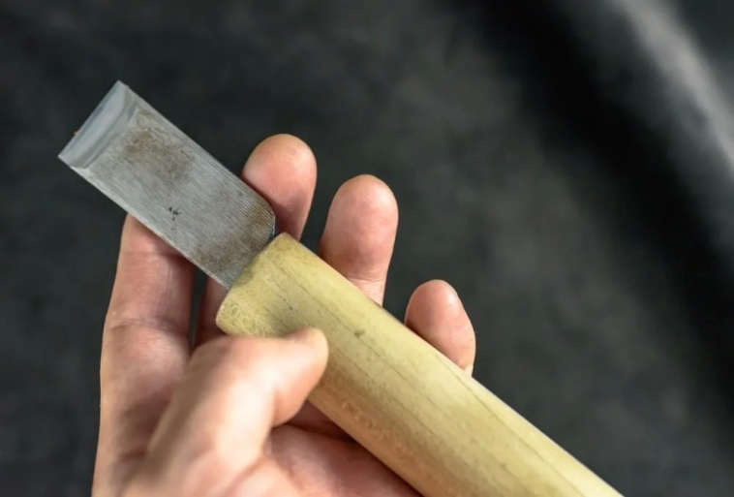

Figure 1.7 Skiving knives

Rotary cutters are common leather cutting tools that will be used for several purposes. These cutting tools are actually used for purposes other than leather cutting pretty often. They can be excellent for cutting through fabrics, felt, and even vinyl. It’s a great tool for leather cutting, as well, and it is going to come in handy when you want to finish off a project properly.

When you want to use a rotary cutter to cut through leather, you’ll just want to ensure that it is sharp enough for the task. The leather is pretty tough and you will need to have a blade that can handle cutting it effectively.

There is a sliding button on this model that is being shown here. You can use it to extend the blade outwards while you are cutting. The handle is very comfortable, and you’ll be able to make good use of this tool in your leather cutting efforts.

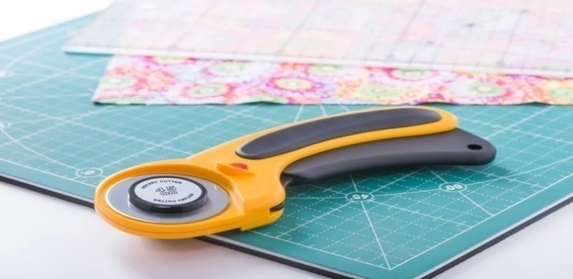

Figure 1.8rotary cutter

Scissors and shears

Scissors have both handles the same size but shears have one handle larger than the other. Scissors and shears are hot-forged, high-grade steel, honed to a fine cutting edge. The blades are joined with an adjustable screw to ensure even pressure along the iolength of the blade. Sharp shears make clean cuts and well-defined notches.

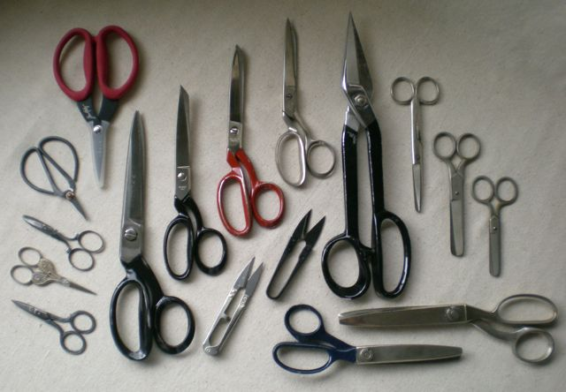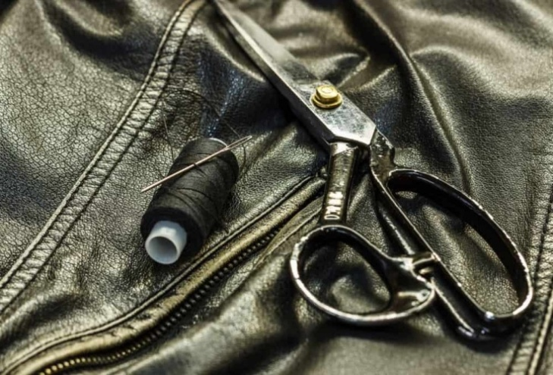

Figure 1.9 scissors and shears

Bent-handled shears

Bent-handled shears are best for pattern cutting because the angle of the lower blade lets Leather/lining lie flat on the cutting surface. Chrome-plated shears are used for heavy-duty cutting. The lighter models with stainless steel blades and plastic handles are used for light weight linings while a serrated-edge shears are used for synthetic linings.

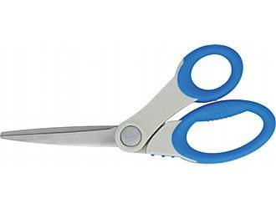

Figure 1.10 Bent-handled shears

Pinking shears or scalloping shears

Pinking scissor or scalloping shear is used for zigzag or scalloped cutting at the edges of the components. Zigzag fold edges give more elegance than plain fold edges. It cuts a ravel-resistant edge.

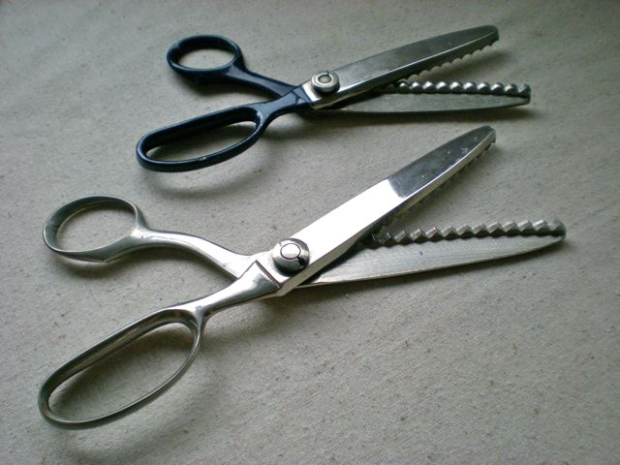

Figure 1.11 Pinking shears or scalloping shears

  - Cutting materials

    - Introduction to leather garments and goods manufacturing

Manufacturing processes

Leather garments manufacturing processes involve assorting, marking, sub-assembling, assembling and finishing. Once the patterns with constructional details and leathers are received, they are sent for assorting and marking.

Assorting of leathers is done by highly skilled technicians who have sound knowledge about garment leathers and its properties. Leathers are assorted on a wooden table under bright lights and carefully examined for imperfections, holes, scratches and thin spots. Any noticeable defects are marked with a silver marking pencil, which can be easily erased by a piece of soft cloth. Leathers are selected which are most alike in feel, thickness, color/shade, texture, stretch, grain pattern, etc.

After selecting leathers, they are sent with patterns having fabricating details to the next process of cutting. Sorting leather before cutting will depend on the producer requirement according to the required product quality and the type of leather needed for the design of the material.

Mostly the sorting of leather can be as follows

- Sorting by Color, the same color shading from a bundle of leather and to use the same color shade in one model at same time of cutting for a product.

- Sorting by size or area of leather -this type of sorting will assist the proper utilization of material to use bigger sizes for bigger patterns.

- Sorting by thickness, the thickness of the material can be split the sorting of leather by thickness will assist to use the thicker material for the required part. This is mostly important for leather garment.

- Sorting by texture / grain – Leather having similar texture will be sorted for the process needed.

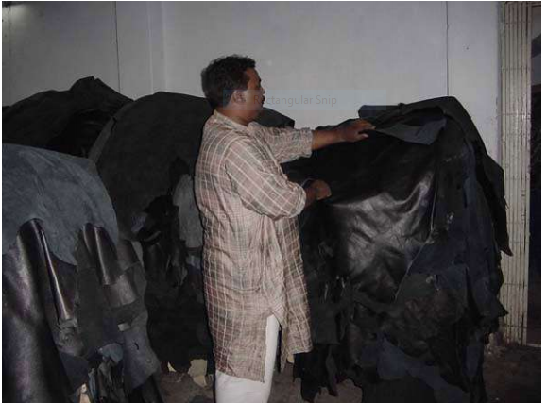

Figure 1.12 sorting

Inter locking is the process of laying the patterns in the appropriate position so that waste can be minimized efficiently. It is the process of making the patterns to fit on the leather. It is also called nesting. Before proceeding for nesting the person who cuts must know all the cutting principles like the lines of tightness and stretch the quality division of the components etc. In order to achieve better pattern interlocking one may consider –
- Curve to curve, and
- Straight edge to straight edge interlocking,silver marking pen is used to mark on leather with patterns for cutting components to achieve the maximum cutting value.

It is used to mark on the components for fixing fittings with the help of patterns and to mark defects on during the sorting process.

Grading the skins for grain matching:

- Before Tracing or cutting any goat or kid skins the cutter must be aware of the grain variation on the skin.
- The grain will usually vary between the Butt and Neck portion.
- The grain will also vary between the backbone and belly region.
- Skins are normally grouped after grading into fine grain, medium grain, and coarse.
- The cutter would normally start using the large grain skin/ coarse grain in the largest size first.
- The size of the skin will also influence the grain, the older the animal the larger the skin, the coarse the grain.
- When grouping the skins it should be folded across the width of the skin and laid out flat.

    - Collect sort and lay of materials in preparation for cutting

While storing leather keep hide flat rather than rolled up. A wooden horse 1 meter wide and 1.25 meters height should be suitable to accommodate even largest hides. Hanging the leather by this method for some time will often help to remove creases that have been formed when the leather was bundled. Grain leathers can be rolled up, grain side outwards with the neck to the center, with final skin rolled with the grain surface on the inside. Wrapping brown paper particularly for vegetable tanned leather is recommended. Split leather is best if kept flat. Synthetics, fabrics, reinforcements and wadding materials are available in roles and are easy for storage.

Sorting done by the Human Eye and hand; it is one of the most difficult areas to train as it relies on individual skills and concepts. There are no exact standards or methods for grading leather, since is done by the grain characteristics, sight and feel developed through experience and training. A skin is divided into five quality regions; the best part is “Butt”. This has the tightest fiber structure.

The fiber structure can vary considerably depending on the age of the animal and the living conditions. The neck and the belly have the loosest fiber structure. In the cutting operation the cutting man has to select the right quality leather, because when one deals in leather he/she will find that no two skins /hides are the same, either in texture, quality or thickness. Therefore , one has to have the necessary skill to determine what parts of the hide/skin is most suitable for each component part and to be able to position cutting patterns in the correct position to minimize waste and still assuring the correct orientation of each component as to its stretch properties.

How to make the correct judgment;-
- Select leather by grade, size, thickness and texture,
- Know the principles of locating markers and knives,
- Accept that each skin has a different quality standard,
- Recognize defects and take advantage of those defects,
- Repair faults,
- Estimate and calculate the most efficient usable area of hide/ skin,
- Reduce materials waste,
- Know the name and model of each patterns to be cut,
- The amount to be cut
- The position (left /right
- The folding lines, notch marks etc.

    - Locate cutting patterns and study of specifications

Once the patterns are ready:-
- Cutting should start from butt to belly (i.e. from left to right side and from bottom to top).
- Make sure that it is the correct pattern of the article you need to cut.
- Examine for defects, size and shape of hide/skin.
- Selective cutting must be able; the best part of the article demands the best part of the hide/skin.
- Visible area should have good grain surface and section covered could contain grain defect.
- Good cutting begins with a sharp knife less sharpens or blunt knife cuts the leather with rugged edge.
- Over cutting and under cutting must be avoided.
- Pattern must be placed in such a way to insure quality, economy and minimum wastage.
- Straight line cutting must be done first with steel scale/ruler curved line cutting or regular shape must be cut with templates.
- Cutting must be done on a smooth surface of soft wood, play wood, galvanized iron plate or zinc plate for accurate cutting.
- Start cutting from left top corner of the pattern and end at the right bottom corner.
- Cut through the leather in one stroke

General rules that a hand cutter should be aware on while cutting the leather
- Closely impact the leather for any defects, these include surface marks, flay cuts, loose offal and mark these areas for ease of identification.
- Check the flesh side of the skin for warble hole and fly cuts.
- Check for the correct line of tightness as this will vary slightly from skin to skin.
- Check the components to be cut make sure that all patterns are there.
- Ensure that your working bench is clean.
- From your cutting sheet select the largest size patterns
- Variations in color
- Grain matching
- The cutter must test his leather for stretch, to ensure that the cut parts are correct.
- After grading and selection the cutter should select for cutting leathers from the horse
- Ensure that your patterns are smooth and your knife is sharp
- After cutting the leather must check the quality of his product, and place it on the bench in front of him.

What You'll Need

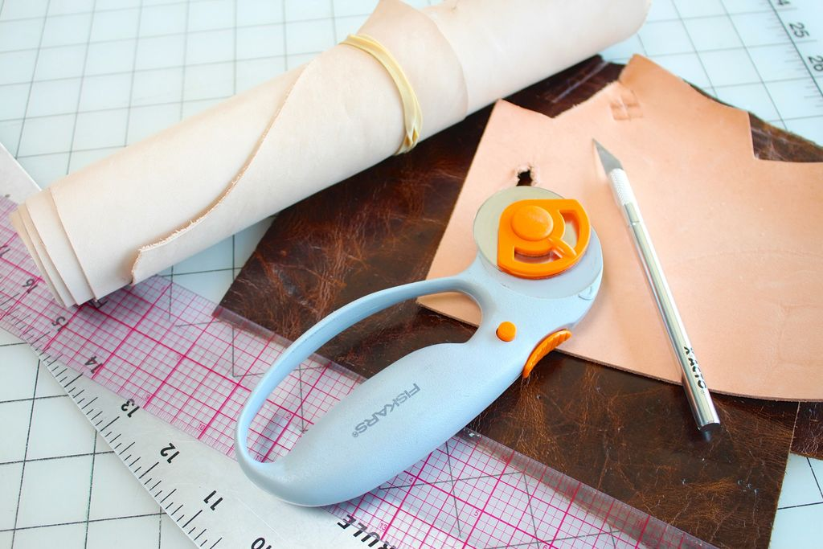

Figure 1.13cutting table with material

- self-healing cutting mat
- hobby knife with a sharp blade
- rotary cutter
- heavy ruler
- leather for cutting

You can definitely use scissors to cut leather, it's not ideal. On thin leather you might not get a nice straight cut because you cut line can move a little every time you move the scissors to take another snip. On thick leather, you might not be able to cut it at all. And even if you do, you'll have to use more force than normal, which can cause jagged and squished edges. (And perhaps break your scissors!)

Before You Cut

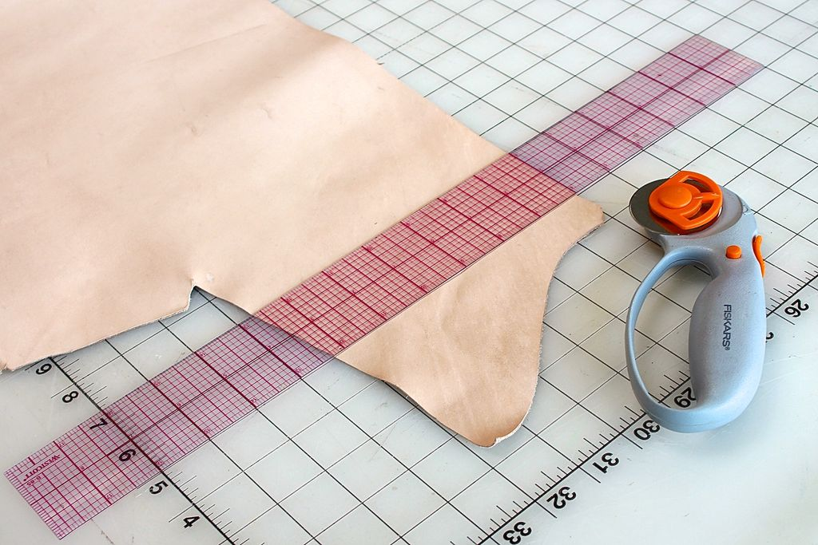

Figure 1.14 Cutting setup

Depending on what you are cutting out, you might want to lay it out and mark it on the leather before and For example, if you are cutting out a wallet that has multiple pieces, it can be a good idea to scope out the grain side of the leather and find a nice area with no major imperfections. Then flip the leather over, copy the pattern using a pen on the flesh side, and cut it out from that. If you don't want to mark up the leather with a pen, the other option is to cut the pattern out of thin plastic or cardboard and use those edges as a guide for cutting.

Making a stiff pattern/template is especially good if your pattern includes curves.

Self check-1
Test I: Multiple Choice Type

- _________________ is defined as an area, in an office, outfitted with equipment and furnishings for one or more workers
- Factory
- School
- Work station
- College
- ______________should start from butt to belly (i.e. from left to right side and from bottom to top).
- Stitching
- Assembling
- Cutting
- Selecting
- ________________is a material made from steel and used to hold the material (leather) against the cutting table so that the leather will not move while the cutting process is held.
- Weight/Load
- Cutter
- Awl
- Knife

- When bundling the leather, start from the_____________ and roll it over until you rich the neck on the grain side so that it would be easy to store .
- Belly
- Butt
- Neck
- Shoulder
- ______________ leather is soft and have larger area with increased cutting value and smoothness of grain. It is used for making softy types of leather goods.
- Cow Napa
- Cow Milled
- Upholstery Leathers
- Split
- _____________ is the poorest in quality, on the sides of the skin/hide lot of elasticity and stretchable.
- Belly
- Shank
- Butt
- Neck
- Once the model (the particular product) to be cut with all its specification has arrived to the ______________ department.
- Design
- Cutting
- Stitching
- Selling
- The cutting person should prepare all the necessary materials i.e. Leather, lining, reinforcements and all other materials accordingly including the ______________ and _______
- Quality & Quantity
- Color& Texture
- Color& Thickness
- All
- The type of sorting will assist the proper utilization of material to use bigger patterns.
- Sorting By Texture
- Sorting By Color
- Sorting By Size/Area of Leather
- None
- The best part of the leather is used for cutting the greater proportion of_____________ parts (patterns).
- Large
- Small
- Medium
- All

Test-II Matching
Instruction: select the correct answer for the give choice. You have given 1 Minute for each question. Each question carries 6 Point.
A | B
---------1. Safety | - steel blade mounted in a handle
---------2. Plastic cutting board | - equipment and furnishings for one or more workers
---------3. Cutting knife | - cutting matt
---------4. Bent-handled shears | - freedom from danger or risk of injury
---------5. Work station | - best for pattern cutting
 | - Pinking scissor or scalloping shear

Test-IIIShort answer

Instructions: Answer all the questions listed below. Examples may be necessary to aid some explanations/answers. Short answer (10 point for each)
  - Define what work station mean?
  - Discuss about safety?
  - Discuss different types of cutting tools used for cutting leather?
  - What is the difference between Scissors and shears?
  - Explain about assorting?
  - Which part of skin is most good for cutting big patterns
  - List rules that hand cuter should be aware before cutting the leathers.

Note: Satisfactory rating –above 60% Unsatisfactory - below 60%
You can ask you teacher for the copy of the correct answers

Unit Two: Read Pattern and Interpretation
This unit to provide you the necessary information regarding the following content coverage and topics:
- Pattern Templates
- Types Of Patterns
- Common Pattern Markings (References) And Specification
- Leather Goods And Garment Style
- Interpretation Of Essential Element

This guide will also assist you to attain the learning outcomes stated in the cover page. Specifically, upon completion of this learning guide, you will be able to:
- Receive And Verify Pattern Templates
- IdentifyTypes Of Patterns For Leather Garment And Goods Making
- IdentifyCommon Pattern Markings (References) And Specification Of Pattern
- IdentifyAnd Verify Leather Goods And Garment Style Feature
- ApplyCorrect Interpretation Of Essential Element

- Pattern Templates
- Template Given On a Card Board
In the process of manufacture of leather goods, pattern making and pattern cutting are the most important and fundamental in fabricating leather goods. It forms the very core and the beginning. Before making any leather goods, the sizes and geometrical shapes of its parts are first cut in paper. Such patterns, which are cut in paper, are called paper patterns.

The paper patterns are stuck on thick millboard or a white board, using adhesive and then cut into cardboard patterns. By using the cardboard patterns, leathers, linings, foam and reinforcements needed for making leather goods are cut. The economy of leather goods depends upon pattern cutting, which determines the cost of production. Since patterns are cutting guide, it must be very accurate. It helps to ensure that the materials are cut accurately without any wastage. The art of pattern cutting requires anticipation, sound judgment, and cultivated style of approach with a sense of quality control. In leather goods making, two kinds of patterns are used. They are making patterns and cutting patterns

- Cutting patterns of bag
- Front Part / Upper Part
The front / upper part are the major or can be the balancing part of the bag. It is depending according to the Proportion, Appropriate Sizing, Consumption and Costing of the articles. On this pattern we have to designed pocket position, the handle position, zipper position, base and different patches or decorative parts.

Every paper pattern has to be crease in the middle part for symmetry or the balance of the article. Some of the front part has to be attached the seam allowances, after these designing on the pattern slash by the knife (TENSILE), to get the different components from the Front / Upper part. Sometimes the Front/ Upper part can be also the Master Pattern according to the construction of the bag

Back Part: The back part is same size according to the front part. The seam allowances / stitching allowances also have to implement into the back part and the designing part also. In the back part the Flap position, Back Zip position, Handle position, the Open Seam stitch for consumption and wastage has to be designed on the back part. Every patterns are included the crease line in the middle part of the pattern for symmetry / balance and the sizing.

- Gusset:
Gussets are determined by its nature of the design of leather goods styling. Gussets are inserted where spaciousness is required. Articles, with proportionate gussets assembled in right way and stitched properly, give well outlook and serve for a long time.
Gussets are made in a variety of types and commonly used gussets in leather goods making are side gussets, continuous gussets and folded gussets.
Gussets are also made with different types of gusset joints. According to the designs of the bag different types of gussets are required. Some of the gussets are joined at the sides of the article e.g. ladies Kelly Bag, Boston Trunk, shopping bags, duffel bags, medical representative bags, etc.

In the U- Shape bag the continuous gussets are joined at the sides, top and bottom of the article e.g. messenger bags, portfolios, travel knighted bag, laptop case, shoulder bags, shopper bags, wrist pouches, shaving kit bags, ladies hand bags, etc. Folded gussets are joined at the sides and bottom of the article e.g. document cases, file cases, portfolio bags, clutch bags, ladies handbags, etc.

- Base:
The Oval Base bag or Bottom Rounded Base bag determined from the bottom part. The front and the back part will depend upon the base part. The Base part pattern has to cut first and then the front/upper part has to cut by pivoting the base. The volume of the bag also depends on the styling of the bag and the purpose of utility. We can see in the European market e.g. Baguette bag, tote bag, Drawstring bag, instrument carrier, wine carrier, shopper bag, shoulder bag etc.

- Pocket: In the leather goods the pockets are assembled on the upper part/ Front part of the bags. In the portfolios the bigger pockets has to use for maximum use. Normally the zip pockets are used in the back part of the bag. There are different types of pocket constructions are used in the leather bags, according to designing.

- Cutting pattern of garment
Pattern making and pattern cutting are the most important and fundamental in fabricating leather garments. Aspects of patterns are derived from the names of components of a garment. The aspects will vary according to the type of garment. For example the Jacket pattern has the aspects such as Front, back, sleeve, yoke etc. But the skirt or pant pattern contains the aspects front, back and waistband. Drawings of different aspects of garments are given below

- Yoke
A yoke is a shaped pattern piece which forms part of a garment, usually fitting around the neck and shoulders, or around the hips to provide support for looser parts of the garment, such as a gathered skirt or the body of a shirt.
Yoke construction was first seen in the 19th century. If a shirt, blouse or dress has a separate pattern piece for the shoulder area that attaches to the front or back of the garment; this piece is Calles a yoke.
A yoke can be in the front or back shoulder area only.
Front & yoke: The pattern used to cut the front portion of the garment is called front pattern.
Back & Yoke: The pattern used to cut the back portion of the garment is called back pattern.

In the jacket the front and back portions can be differentiated by seeing the neck line and armhole line. The front pattern has a deep curve in the neckline as well as armhole line compared to back pattern. Also the bust dart is located in the front pattern.
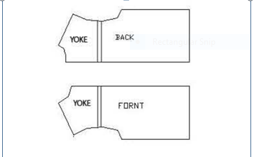
Figure 2.1 front and back yoke

- Sleeve & cuff:
For cutting the components of the sleeve portion of the garment is called sleeve pattern. There are different types of sleeves such as simple shirt sleeve, tailored sleeve, raglan sleeve are used in leather garments. As like front & back sleeve panel may also be divided to number of panels. Cuff is the component attached at the bottom of the sleeve to control the sleeve opening at the bottom.

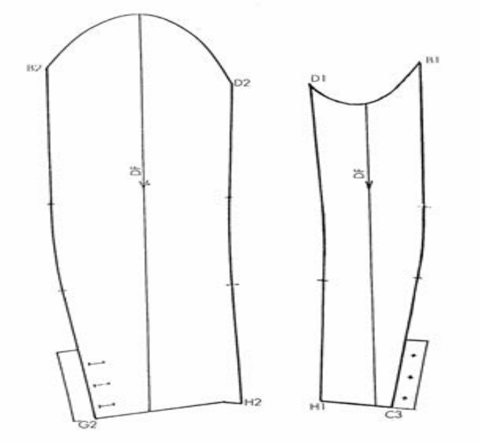
Figure 2.2 Sleeve

C. Collar
Collar is the component attached at the neck portion of the front & back panels. Pattern used to cut the collar panel is called collar pattern. The length of the collar is equal to the neck line measurement of front & back patterns.
There are different types of collars used in leather jackets. The pattern of the simple shirt collar is shown below.
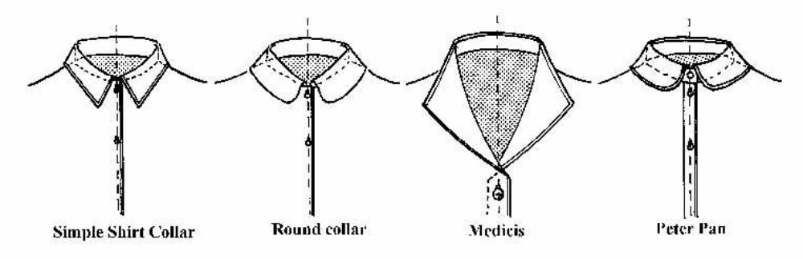
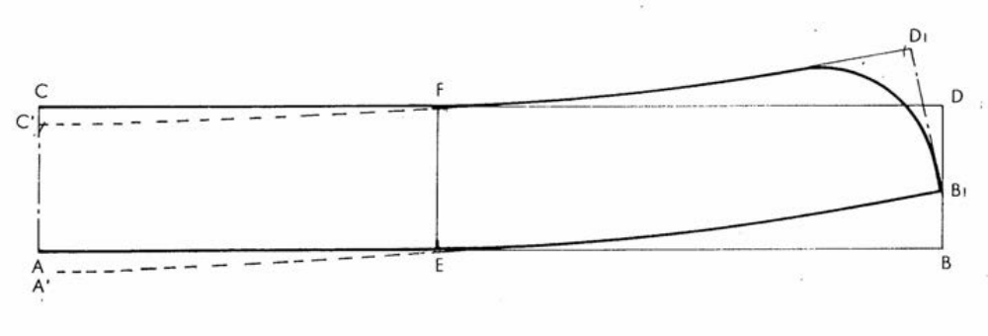Figure 2.3 Types of collar and collar pattern

- Leather cutting patterns:
This patterns help for the productions. The components pattern included all over allowances such as Folding allowances, Underlay allowances and Stitching allowances. In the leather cutting section the Labor or staffs has to maintain the quality of the leather/ material – grain, color, size, and quantity according to the requirements of the client. They have to maintain proper norms for cutting the leather and wastage has to be minimized.
The safety norms have to be maintained according to the industry act. To make less number of products, cardboard patterns are used for cutting components. To make more number of products, aluminum or galvanized metal patterns are used for cutting components. To manufacture in bulk, the cardboard patterns of the product are converted into clicking dies and the components are cut in the hydraulic clicking press. The Leather Cutting Pattern has to be marked by the red pen/ colour.

- Lining cutting patterns:
The components pattern included all over allowances such as Underlay allowances and Stitching allowances. But it should be shorter in size from the exact pattern. In the lining cutting section the Labor or staffs has to maintain the quality of the lining material – upper part, colour, size, quantity according to the requirements of the client. The Lining Cutting Pattern has to be marked by the black pen/ color.

- Cutting the traced pattern on a cardboard
The pattern maker must give in each pattern the following details, which would help: In the process of pattern making, pattern maker is considered to be a very important person next to the designer. A good pattern maker must be aware of different types of finished leathers and their suitability in making different types of leather goods.

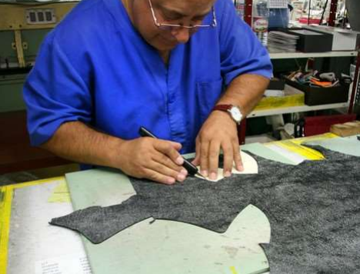
Figure 2.4cutting the traced pattern on a cardboard
He must be well versed with the techniques of fabrication and types of constructions. He must have the essential knowledge in elementary mathematics, measurements and use of geometrical instruments for drawing geometrical shapes viz. square, rectangle, circle, etc. and other odd shapes. He must be aware of different types of fittings, linings, reinforcements and other miscellaneous items, which are used in leather goods making.

The pattern maker must give in each pattern the following details, which would help the cutter in the subsequent process of cutting to cut components easily and swiftly. To make less number of products, cardboard patterns are used for cutting components. To make more number of products, aluminum or galvanized metal patterns are used for cutting components. To manufacture in bulk, the cardboard patterns of the product are converted into clicking dies and the components are cut in the hydraulic clicking press for production.

Good Craftsman/ Sample man has to keep in his mind –
- A good pattern of the right size which has been adjusted to suit your individual requirements will enable you to obtain a perfect product.
- A pattern prepared on thick paper or card board can be preserved for a long time and can be used over and over again.
- By manipulating the pattern pieces it is possible to produce patterns for Complicated and original designs.
- A paper pattern of a particular size can be used to make new patterns of proportionately larger or smaller sizes by following a systematic procedure called "grading".
- Cutting with the help of a paper pattern is quicker and easier than on the leather, fabric and other materials.
- Use of a paper pattern will enable you to cut the bag pattern with a minimum amount of material because it is possible for you to try out the placement of pattern pieces in different ways till you have found the most economical way to keep them.

- Types of Patterns
- Different Types of Patterns
Pattern making and pattern cutting are the most Important and fundamental in manufacture of leather garments. It forms the very core and the beginning.
Before making any leather garment the geometrical shapes of its parts are first cut in paper. Such patterns, which are cut in paper, are called paper patterns. The paper patterns are stuck on thick millboard or a white board, using adhesive and then cut into cardboard patterns. By using the cardboard patterns, leathers, linings, wadding and reinforcements needed for making leather garments are cut. The economy of leather garment depends upon pattern cutting, which determines the cost of production. Since patterns are cutting guide, it must be very accurate. It helps to ensure that the materials are cut accurately without any wastage.
The art of pattern cutting requires anticipation, sound judgment, and cultivated style of approach with a sense of quality control. Generally in pattern making for leather garments, as a first step basic block or master draft is made based on standard body measurement/mannequin measurements. And from that enlargement or ease is incorporated. After that individual pattern pieces are extracted.
Different types of patterns extracted are
1) Leather cutting patterns,
2) Lining cutting patterns,
3) Wadding cutting patterns and
4) Reinforcement cutting patterns.
Leather Cutting Patterns
Leather cutting patterns are used to cut the leather panels, which are used for making the outer shell and also for facing panel in the inner shell. Basic design of the garment and providing style lines appropriately decides the size of individual leather panels and also this is one of the factors influencing the cutting value. The cost of manufacturing leather garment is influenced by the leather cutting to a major extend. Hence leather-cutting patterns are very important in this process. After extracting the patterns from the enlarged pattern, different allowances such as seam allowance, folding allowance are provided and markings such as notches are provided to make it final cutting pattern
In the leather cutting section the Labor or staffs has to maintain the quality of the leather/material – grain, color, size, and quantity according to the requirements of the client. They have to maintain proper norms for cutting the leather and wastage has to be minimized. The Leather Cutting Pattern can be given a specific colour code to enable easy identification.
This patterns help for the productions. The components pattern included all over allowances such as Folding allowances, Underlay allowances and Stitching allowances. In the leather cutting section the Labor or staffs has to maintain the quality allowances.
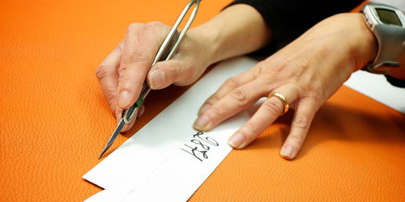
Figure 2.5Leather cutting
In the leather cutting section the Labor or staffs has to maintain the quality of the leather/ material – grain, color, size, and quantity according to the requirements of the client. They have to maintain proper norms for cutting the leather and wastage has to be minimized. The safety norms have to be maintained according to the industry act. To make less number of products, cardboard patterns are used for cutting components. To make more number of products, aluminum or galvanized metal patterns are used for cutting components. To manufacture in bulk, the cardboard patterns of the product are converted into clicking dies and the components are cut in the hydraulic clicking press. The Leather Cutting Pattern has to be marked by the red pen/ colour.
Lining Cutting Patterns
The lining cutting patterns are used to cut lining components which makes the inner shell of the garments. The lining patterns are made of single or two panels for front and back lining because of the use of textile materials for lining.
Lining patterns also should have notch marks, pocket marking etc. to enable the cutting & assembly process easier. The lining patterns are generally shorter in size compared to leather patterns but at the same time the lining patterns have to be provided with sufficient ease to accommodate and retain the shape of the garment. In the lining cutting section the Labor or staffs has to maintain the quality of the lining material – upper part, color, size, quantity according to the requirements of the client.
They have to maintain proper norms for cutting the lining and wastage has to be minimized. The safety norms have to be maintained according to the industry act. To make less number of products, cardboard patterns are used for cutting components. To make more number of products, aluminum or galvanized metal patterns are used for cutting components. A colour coding system can be given for lining patterns also.
The components pattern included all over allowances such as Underlay allowances and Stitching allowances. But it should be shorter in size from the exact pattern. In the lining cutting section the Labor or staffs has to maintain the quality of the lining material – upper part, color, size, quantity according to the requirements of the client. They have to maintain proper norms for cutting the lining and wastage has to be minimized. The safety norms have to be maintained according to the industry act. To make less number of products, cardboard patterns are used for cutting components. To make more number of products, aluminum or galvanized metal patterns are used for cutting components. To manufacture in bulk, the cardboard patterns of the product are converted into clicking dies and the components are cut in the hydraulic clicking press. The Lining Cutting Pattern has to be marked by the black pen/ color.

Wadding Cutting Patterns
Wadding is the material attached with lining for the purpose of thermal insulation as well as for giving shape to the garment. The wadding is attached with lining using a special stitching called quilting. Generally these patterns can be derived from lining patterns with extra allowance for accommodating the volume. Wadding patterns has to be marked with a colour code for easy identification.
Reinforcement cutting patterns
Reinforcement materials are used in garments to give stiffness & retain the shape of some of the garment components such as collar, cuff etc. Reinforcement materials are made of textile or cellulose martial with a wax coating. Upon heating/ Ironing the reinforcement material gets attached to leather panel hence it is also called as self-fusing material. Patterns used to cut the reinforcement material are called reinforcement cutting patterns. This pattern has no allowances of folding, stitching and underlay. And it should be shorter than the exact patterns of the components.
Normally card boards are used for making of the reinforcement cutting patterns. To make more number of products, aluminum or galvanized metal patterns are used for cutting components. Some times for bulk production the clicking dice can be used to cut the reinforcements.
This pattern has no allowances of folding, stitching and underlay allowances. And it should be shorter than the exact patterns of the components. Normally the EVA / Rubber sheet, texon / flexo board, foam, self fusing cloth, bakram for using of the reinforcement cutting patterns. For bulk production the clicking dice can be used to cut the reinforcements. . To make more number of products, aluminum or galvanized metal patterns are used for cutting components. To manufacture in bulk, the cardboard patterns of the product are converted into clicking dies and the components are cut in the hydraulic clicking press. This pattern has to be marked by the green pen/ color.

- Common Pattern Markings (References) And Specification
Specification On to the Pattern
A good pattern maker must be aware of different types of finished leathers and their suitability in making different types of leather goods. He must be well versed with the techniques of fabrication and types of constructions. He must have the essential knowledge in production process and the machinery, pattern pieces and information. He must be aware of different types of fittings, linings, reinforcements and other miscellaneous items, whichare used in leather goods making. The pattern maker must give in each pattern the following details.
Apply pattern information and specifications:
- Pattern information and specifications are applied to bag production.
- Name of the product and reference number
- Pattern pieces, information and specifications are checked for accuracy throughout bag production process.
- Name of the parts (front, back, gusset, pocket, flap, handle, etc)
- Details of the raw materials (leather, lining, foam, reinforcement, etc.)
- Number of components to be cut
- Centre points for perfect joining of the components.
- Marks or slots for fixing fittings and zips
- Stitching width and stitches per inch or length of stitch in mm.
- Use of good and defective leather components for visible and invisible parts of the product
- Bag production faults relating to pattern or pattern information and specifications are identified and reported.
- OHS practices are followed
- Action is taken according to OHS practices to prevent accidents and to eliminate risks to personal safety.
- Production documentation is completed as required.

Material Type
Materials selection refers to choosing materials for garments, including materials and accessories. After having a basic designing idea, the designers should consider the materials selection because materials explain the character and style of garment. A good pattern maker must be aware of different types of finished leathers and their suitability in making different types of leather garments.
There are many kinds of materials involved in making the leather garments, which has changed with each passing day. Materials are reflected fully by the exploitation of materials, the change of garment construction, the fashion color of new style, graphic pattern, and others.
Different materials and decoration give a different style. The suitable material plays a crucial role in the garment pattern-design. If the designer attempts to integrate the material, the style and the color, and get great originality, they have to consider the interrelationship among those factors and understand the whole production process of garments.Separate patterns are made for Leather cutting, Lining cutting, wadding cutting and reinforcement cutting. Each pattern should contain the detail of the material on which the pattern is used. Leathers used for garment include sheep nappa, goat nappa, cow nappa, goat suede etc. Lining used in leather garments is polyester, silk etc.

Material quantity
Material quantity refers to number of times the particular material is cut using the pattern. For example in a leather cutting pattern (say front yoke) the quantity is mentioned as “cut 2”. This means the pattern has to be used for cutting two pieces of leather, one by placing the pattern normally and the other by turning back the pattern. This is done to keep the balance of right andMaterial quantity refers to number of times the particular material is cut using the pattern. For example in a leather cutting pattern (say front yoke) the quantity is mentioned as “cut 2”. This means the pattern has to be used for cutting two pieces of leather, one by placing the pattern normally and the other by turning back the pattern. This is done to keep the balance of right and left in any garment.
The material quantity mentioned in the pattern should be strictly followed to maintain the correct cut pieces in each bundle. This also eliminates the delay in the production process for want of any single piece. In lining cutting sometimes the cutting happens with many layers of material. In such cases it is advisable to make markers or lay marking to maintain the exact quantity required. In lining cutting and fusing cutting lay marking is possible because the material comes is a regular shape but in case of leather it is difficult to place the patterns because of the non-uniform shape as well as presence of defects.

Notches
Notches are marks placed on the edges of patterns so as to enable easy assembly of cut pieces. The notches are also used to identify different pattern pieces from other similar patterns. Different types of notches such as slit notch, V notch, T notch etc. are used in garment pattern making.

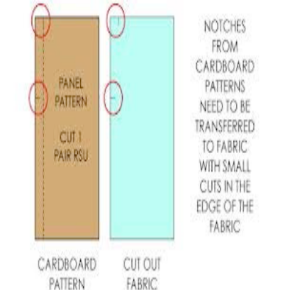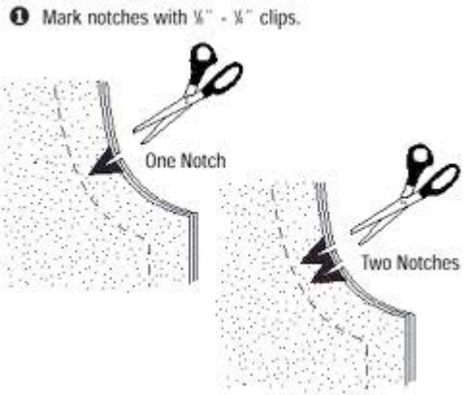
Figure 2 Notches

Button markings
Button markings are made in patterns where ever the buttons has to be provided. The size of the button marking depends on the size and type of the buttons used.
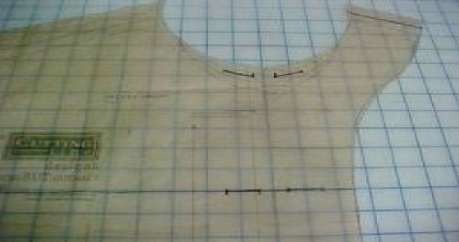
Figure 3.7 Button markings

Pocket marks
According to the type of pockets the markings are made on the patterns. For Patch pocket the outline of the pocket is drawn on the pattern or marked using drill holes. For inside pocket the mouth of the pocket is marked with drill holes and inside portion is shown in dotted lines.

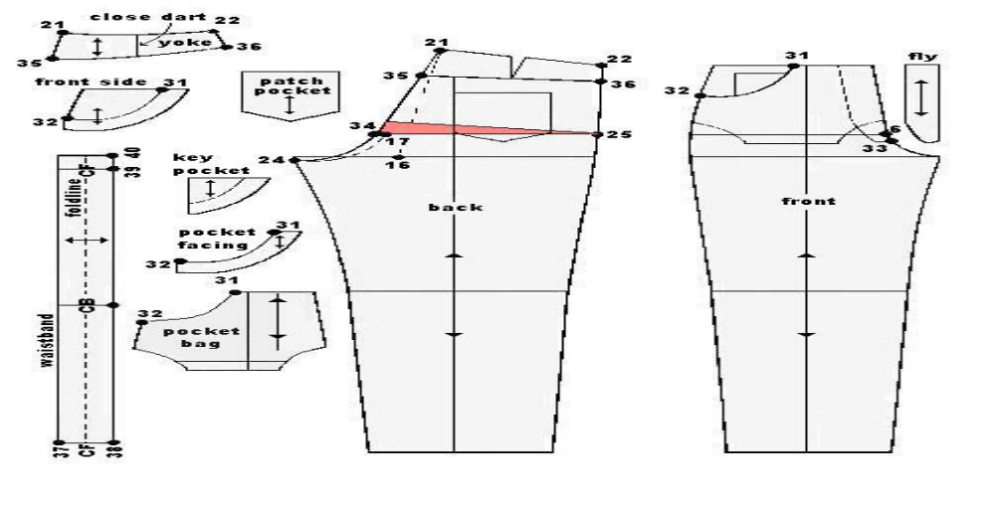
Figure 2.8 pocket component of trouser

- Leather Goods And Garment Style
- Identifying leather garment style feature
- Garment type
Different types of leather garment include jackets, coats, skirts, pants etc.
Pattern designing for each garment needs to be done according to the customer requirement. Initially for pattern making a working sketch or drawing is very important. The working sketches of garments are given below.
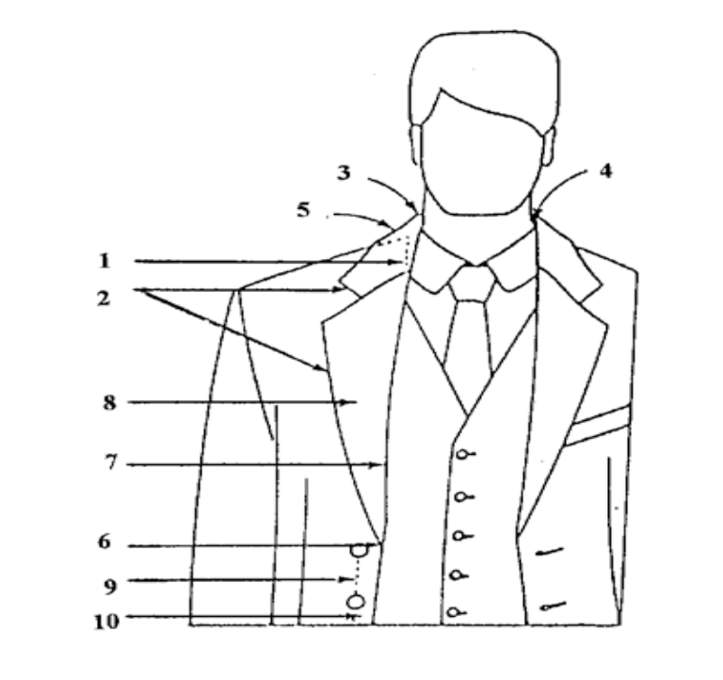
Figure 2.9 Collar sketch of jacket

Terms used for collar construction
1) Neck Line
2) Style line
3) Roll line
4) Stand
5) Fall
6) Break point
7) Break line
8) Revert
9) Centre front line
10) Button stand

Collar
Different type of collars used in leather garments are given below
Figure 2.10 Types of collar

Sleeves
Garments are designed with a wide variety of sleeves, which differ greatly in look and in method of construction. Sleeves must be accurately cut, set and fitted for comfortable wear. They should be cut in such a way that arm can move quite easily. There are five types of sleeves used in leather garments.

They are simple shirt sleeve, tailored sleeve, dropped shoulder sleeve, raglan sleeve and kimono sleeve. Simple shirt sleeves are the most widely used type. The simple shirt sleeve is cut separately from the garment and inserted into the armhole. The length and width of the sleeve can differ but the method of insertion is the same. Raglan sleeve is attached to the back and front of the garment with a long diagonal seam running underneath the arm. Kimono sleeves are usually cut in one piece with the body of the garment.

To achieve perfection in making sleeve patterns it is necessary to observe the
Following principles:
1) Check garment and sleeve fit and alter the pattern accordingly,
2) Transfer all sleeve and armhole markings to the garment,
3) Use proper pressing techniques during construction and
4) Finish the lower edge of the sleeve before attaching it to the garment.

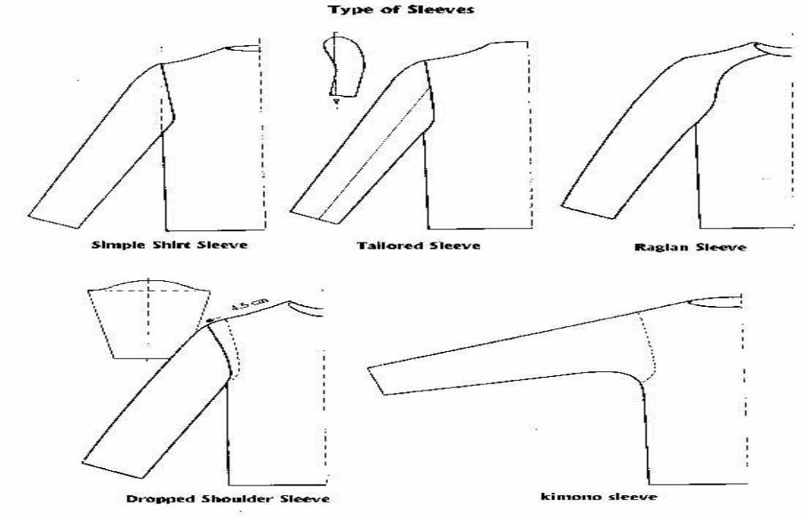
Figure 2.11 Types of sleeve

Yoke
Yoke is a shaped pattern piece which forms part of a garment, usually fitting around the neck and shoulders, or around the hips to provide support for looser parts of the garment, such as a gathered skirt or the body of a shirt. Yoke construction was first seen in the 19th century. What is a yoke? If a shirt, blouse or dress has a separate pattern piece for the shoulder area that attaches to the front or back of the garment; this piece is Calles a yoke. A yoke can be in the front or back shoulder area only.

Sides and panels
An apparatus for the secure stowing of a magazine, the apparatus comprising a pocket defined by a first pair of opposing side panels and a second pair of opposing side panels, the first pair of opposing side panels being in substantially perpendicular plane to the second pair of opposing side panels and the first pair of opposing side panels being shorter in height than the second pair of opposing side panels, a bottom panel, and a top opening; biasing means whereby at least one pair of opposing side panels are biased toward one another; and means of attachment whereby the pocket may be attached to a person or object.
Openings
There are many types of openings designed for the fronts of shirts, jackets and coats. However, all designs should follow the basic principle that the centre front on a pattern is a stable position and cannot be moved or the fit of the jacket will alter. Therefore care must be taken when button stands and straps are added to patterns. If the neckline requires lowering or altering in any way, it must be completed before working the instructions for front openings.
Neckline buttons
Standard Front
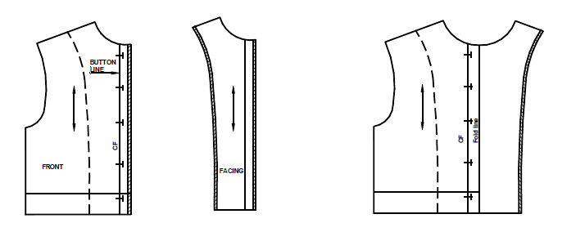
Figure 2.12front buttons

Mark buttonholes on center front line (buttonholes overlap the line by 0.2 cm).
Add button stand, approximately 2.5 cm (varies with size of button). Draw in facing line with a dotted line. Trace round front edge of pattern and trace through facing line to construct facing pattern. Add seam allowances to front edge of body section and vertical edges of facing pattern.

- Double Breasted Front
The example shows neckline lowered before front is constructed. Draw in two button lines at equal distances each side of center front. Mark buttonholes, button placing and add button stand. Construct facing as for a standard front.
Add seam allowance to front edge of body section. Add seam allowance to both outer edges of strap.
- Single Strap Front
Decide width of strap. Add button stand to center front, half width of strap. Draw strap line in from center front, half width of strap. Trace off strap pattern, mark center front line; Mark buttonholes. Add seam allowance to front edge of body section and to both outer edges of strap.
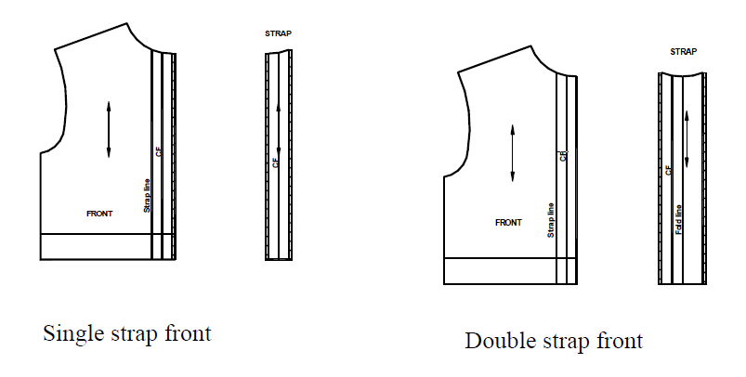
Figure 2.13 Single and double strap

- Double Strap Front
Decide width of strap. Add button stand to center front half width of strap.
Draw strap lines in from center front, half width of strap. Trace off step pattern, make it double the finished width, repeating a light curve at neck edge. Mark center front line, buttonholes, folds line. Add seam allowance to both outer edges.Measure width of zipper will be shown on front of jacket.
Mark in from center front half this distance and mark this line ‘front edge line’. Rub out center front line. Draw in facing line with a dotted line. Trace round front edge of pattern and facing line to construct facing pattern. Add seam allowance to front edge of body section and to vertical edges of facing pattern.
Draw in facing line with a dotted line, trace round center front edge of pattern and trace facing line to construct facing pattern. Add a seam allowance of 2 cm to center front edge of body section and to front edge of facing. Add seam allowance to inside edge of facing.
- Seams
Seams are the result of a sewing operation which forms a number of stitches, in a material using a continuous thread. The successive linear formation of such stitches is called a SEAM. The purpose of Seam is to Joining, Reinforcing and Decorating of the material.
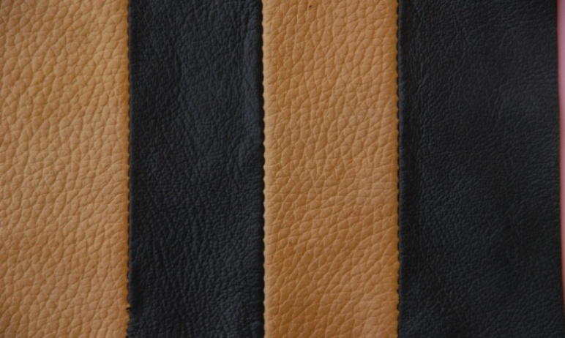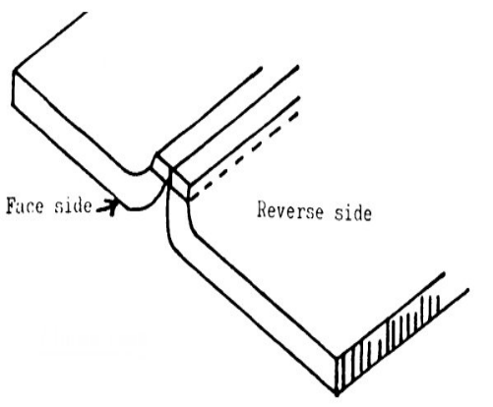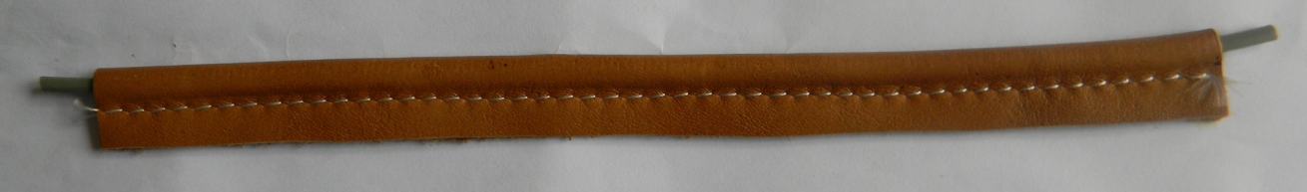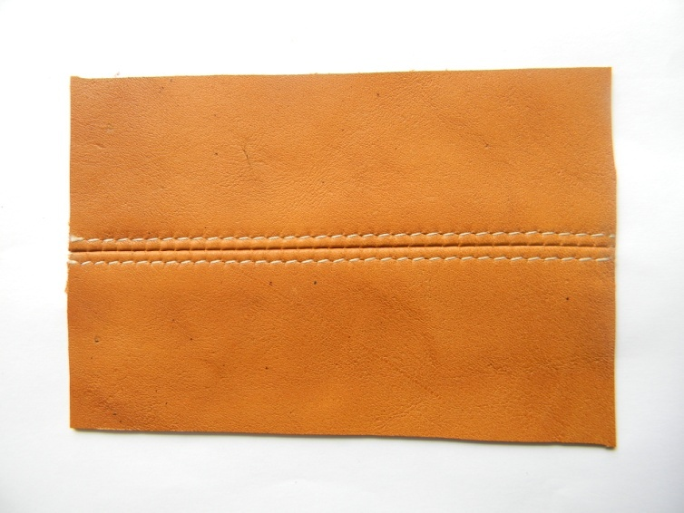
Figure 2.14Different types of seam

Different types of edge finishing
- Raw edge
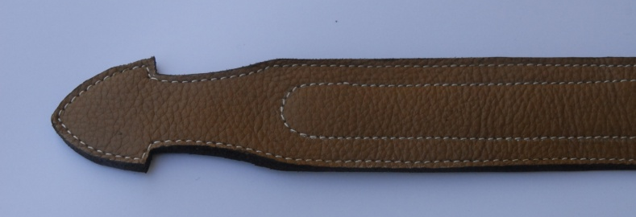
Figure 2.15raw edge finishing
The leather has to choose minimum substance and not looseness. According to the thickness of the leather should be split into measurements, suppose the handle or strap the thickness should be 2 or 2.2mm. So the upper part should be 1.4 or 1.2mm and the lower part be .8mm both has to be joined to make a strap. After that the Strap cutting machine is required to cut the leather according right measurements for the straps.
In the lower part of the strap put the reinforcement – Eva (rubber), cotton cloth, canvas cloth with the glue and pasted the top part also. After joining the both side then the final trimming needed. For smoothening the edge of the strap use the Emery paper (00 numbers).With the help of brush or Edge coloring machine put the color with binder on the edge of strap. After drying the edge again smoothen the surface with emery paper and again color it. For finishing the edge should be needed waxing and polishing it. Before stitching every function should be finish.For good finishing belt needed little bit skiving and proper reinforcement and good decorative stitching?
- Folded edge
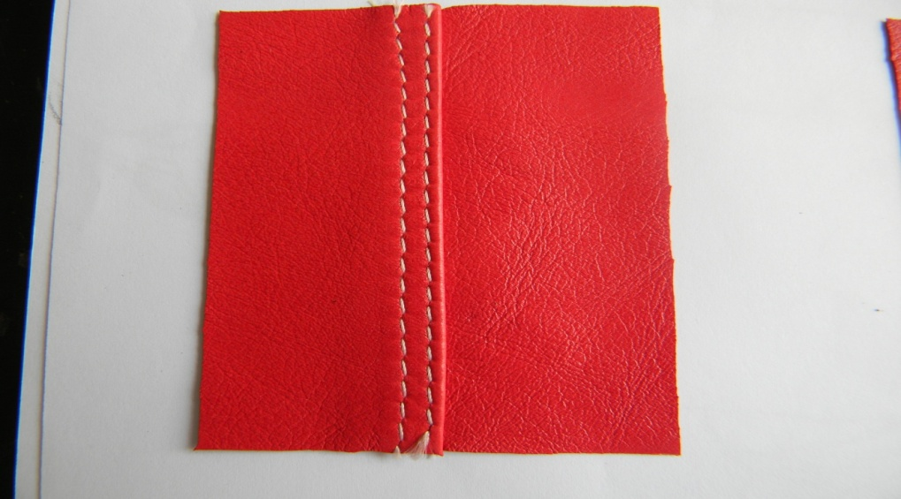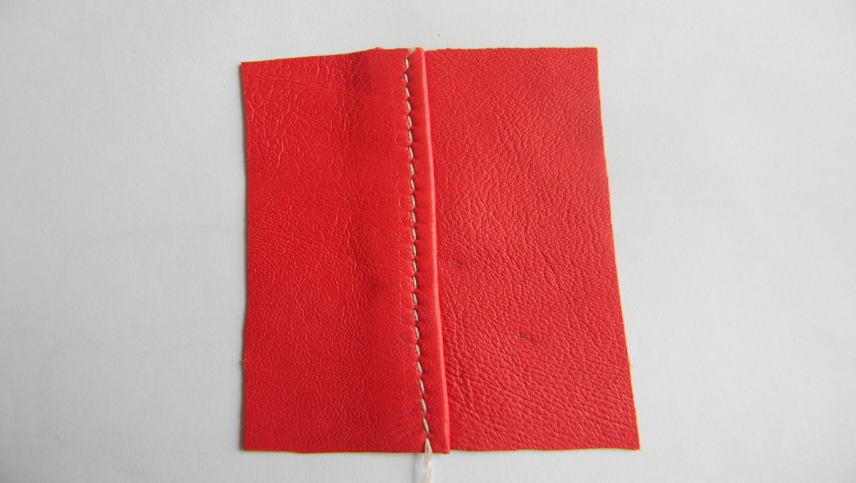
Figure 2.16Folded edge

The edge of the components or the straps has to be skive according the measurements of the folding. If the fold measurement is 1cm, then the skive portion should be 1.1cm. Put the reinforcement with glue and fold it. Folding could be done by hand or by Thermo Folding Machine. .
- Zips
Zippers otherwise called as fasteners provide closings and opening on a variety of fashion features in garments. Basically zippers are of three types namely conventional, separating and invisible. Conventional zippers are most often used. They are closed at one end and sewn into a seam. Separating zippers are open at both ends and are sewed into a seam that will open completely. The invisible zipper is constructed to disappear into a seam. Like conventional zipper, it has one closed end. All zippers have chain of metal (Aluminum, Brass, and Zinc Oxidized) or plastic teeth joined to fabric tapes.
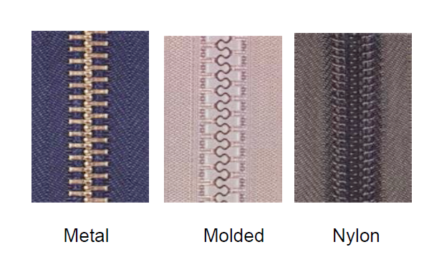
Figure 2.17 Zippers
- Gathers
Gathers change the look of the basic garment, but do not affect the fit.

Types of gathers:
- Gathers at shoulder
- Gathers at centre front
- Gathers at waist
- Gathers at neckline
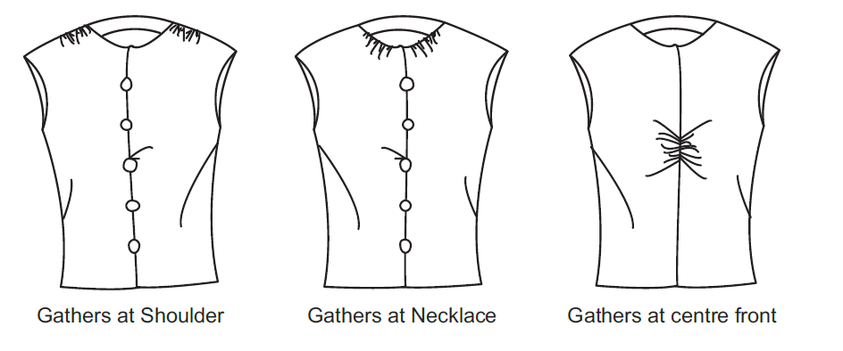
Figure 2.18Different gathers Garment

- Pleats
A pleat is an unstitched, folded dart held securely along the joining seamline. It is a fold in the fabric that releases fullness. Pleats are used to increase stride room, or can also be used as a design. Pleats are found on skirts, bodices, sleeves, dresses, jackets etc. they are formed in a variety of ways. They may be folded and left un-pressed or pressed, stitched or left unstitched. They may be grouped together with even or uneven spacing. Pleat depth may be single, doubled or tripled.

Types of pleats:
- Knife pleats: Pleats are grouped and face in one direction.
- Box pleats: Pleats are folded away from each other on right side of the garment.
- Inverted pleats: Pleats are folded to meet each other on the right side of the garment.
- Accordion pleats: Pleats have folds resembling the bellows of an accordion. The pleats are close together and depth is equal from waist to hemline.
- Sunburst pleats: Pleats fan out and graduate from the waist. They are generally used on circular skirts.
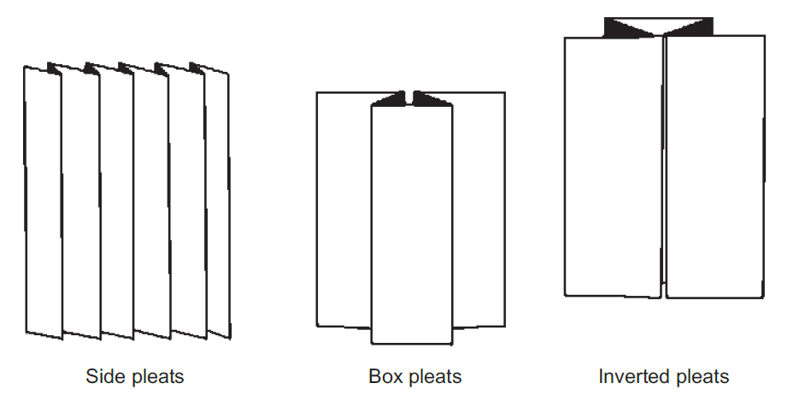
Figure 2.19 Different t types Pleats

- Panels and Tucks
A tuck is a stitched fold on the right side of the fabric resembling a pleat. Tucks are used as design details and can be placed on any garment (top, skirt, dress, sleeve, pants etc.). Tucks can be placed in any direction (vertical, horizontal and diagonal) and may be of any width. They can be spaced close or far apart for varying effects.
Types of tucks:
- Pin tucks
- Shell tucks
- Release tucks
- Cross tucks
- Space tucks

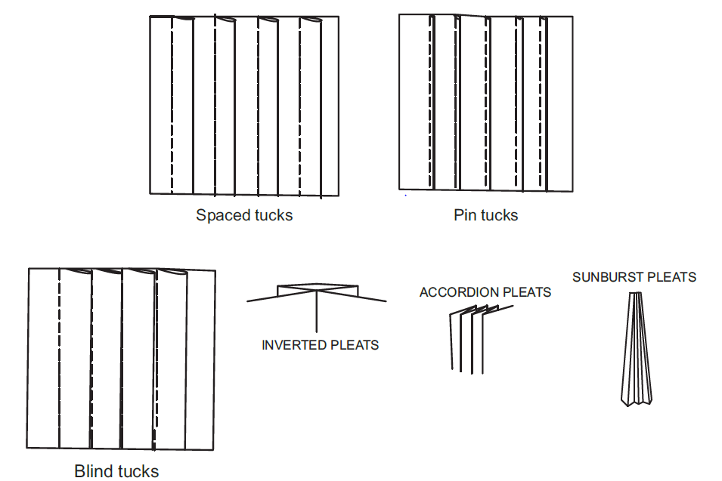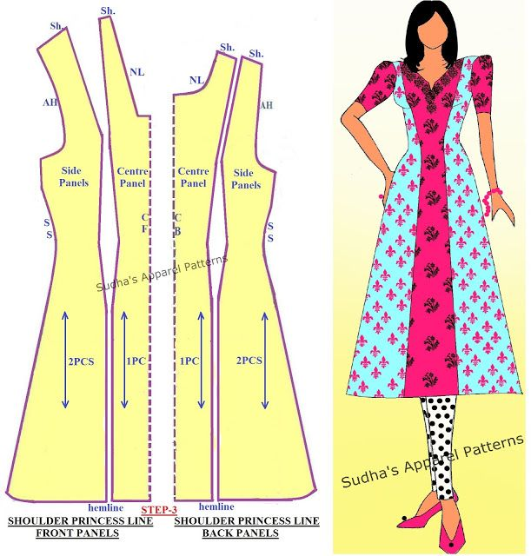
Figure2.20 Tucks and panels

- Buttons
Purse buttons of different sizes (3/2, 3/3, 4/3 and 7/7) are extensively used in leather goods. The button-fitting tool is used for buttoning. When fixing the buttons, care is taken to hammer the buttons gently as heavy hammering may damage the buttons.
Since hand operation is a slow process, treadle operated or hand operated buttoning machine is used which ensures speedy operation and perfect setting of buttons. Automatic buttoning machine is used in big industries. A set of purse buttons consists of cap, spring, rivet and stud.The leather components are first punched with suitable holes. The machine is then fitted with a set of male and female dies for fixing cap and spring.
The cap of the button is pushed through the hole and placed over the bottom male die. The cap spring of the button is fitted to the spring Stem.The handle or treadle is pressed gently. The cap and the spring get fixed in the first component. The dies are removed and another set of male and female dies are fitted to the machine.
The rivet of the button is pushed through the hole and placed over the bottom male die.
The handle or treadle is pressed gently. The rivet and stud get fixed in the second component. Both the components are pressed and the button gets fixed with a click sound. If no click is heard, the button is improperly fixed. So care must be taken to fix the buttons accurately. The process of fixing buttons is carried out as described above. After fixing buttons, the quality of the buttoning is checked. For maximum using of a purse and ladies bags magnet snapper, it also have sizes – big and small.
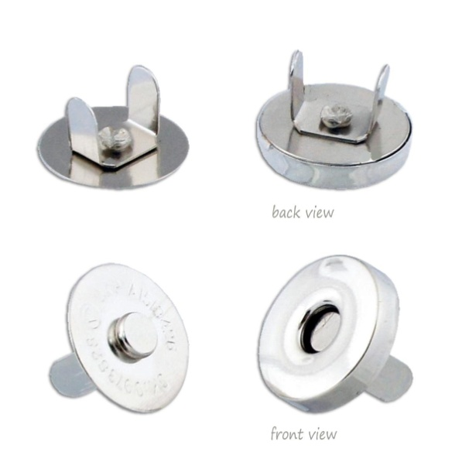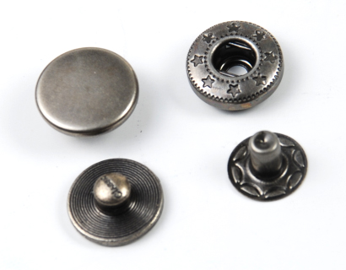
Magnet snapper snap button
Figure 2.21 Different button
- Leather patches
The leather patches, leather badges, leather emblems, hang Tags, patches, packaging and labels, are used in the luggage bags, hand bags and the designer’s bag. Some of the leather tags are also printed. Including custom printed single and manifold tags,
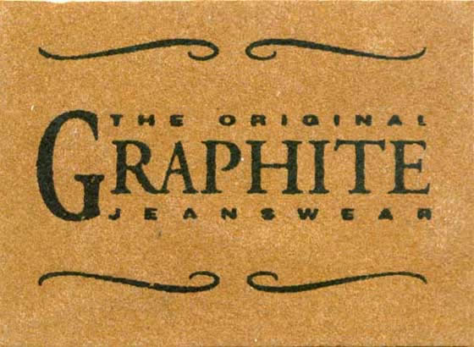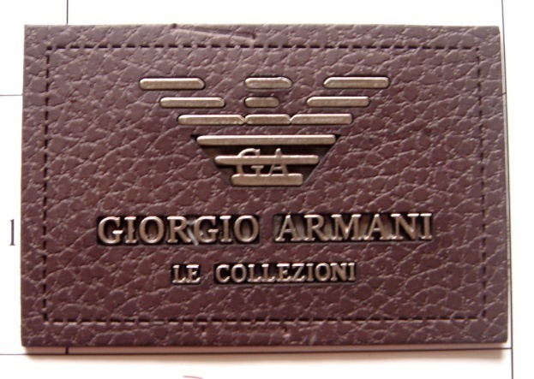
Figure 2.22 Lather patches
pressure sensitive labels, blank and thermally imprinted tags and labels, hangtags, emblems, badges, packaging, bar-code labels, rubber labels, and much more for industrial used in leather goods and leather garments

- Interpretation of essential element

- Draft/Construction Pattern: All the design methods of the drawing or photograph has to implemented in this pattern and has to be designed for the final shape ,size and proportion.
- Traced Pattern: These patterns are traced from base pattern and have no allowances of Stitching or Underlay. Exactly the same as base pattern but traced individually.
- Final Pattern: After tracing form the base pattern stitching allowances and Underlay allowances are added and the now they are called final patterns.
- Production Pattern: This patterns help for the productions. These patterns are made in card boards or thick boards. The components pattern included all over allowances such as Folding allowances, Underlay allowances and Stitching allowances and also markings such as notches, drill holes etc.

A good pattern of the right size, which has been adjusted to suit your individual requirements, will enable you to obtain a perfect product. A pattern prepared on thick paper or cardboard can be preserved for a long time and can be used over and over again. By manipulating the basic pattern pieces it is possible to produce patterns for complicated and original designs. A paper pattern of a particular size can be used to make new patterns of proportionately larger or smaller sizes by following a systematic procedure called "grading". Cutting with the help of a cardboard pattern is quicker and easier on the leather but on fabric paper patterns are preferred.

- Master pattern: All the design methods of the drawing or photograph has to implemented in this pattern and has to be designed for the final shape ,size and proportion.
- Exact / working pattern: From the Master Pattern, the components parts of the product are cut to the correct measurements and shapes .But stitching allowances and Underlay allowances has to be included in this pattern. These patterns are called Exact /Working /making patterns and are largely used for making product.
- Raw edge /cut edge: This pattern has no allowances of folding but it has to be included Stitching and Underlay allowances. Exactly the same as Exact Pattern /working pattern
- Cutting pattern: This patterns help for the productions. The components pattern included all over allowances such as Folding allowances, Underlay allowances and Stitching allowances.
To make less number of products, cardboard patterns are used for cuttingcomponents. To make more number of products, aluminum or galvanized metal patterns are used for cutting components. To manufacture in bulk, the cardboard patterns of the product are converted into clicking dies and the components are cut in the hydraulic clicking press for production.

Figure 2.23 Cut leathers
A good pattern of the right size which has been adjusted to suit your individual requirements will enable you to obtain a perfect product. A pattern prepared on thick paper or card board can be preserved for a long time and can be used over and over again. By manipulating the basic pattern pieces it is possible to produce patterns for complicated and original designs. A paper pattern of a particular size can be used to make new patterns of proportionately larger or smaller sizes by following a systematic procedure called "grading". Cutting with the help of a paper pattern is quicker and easier than on the leather, fabric and other materials. Use of a paper pattern will enable you to cut the bag pattern with a minimum amount of material because it is possible for you to try out the placement of pattern pieces in different ways till you have found the most economical way to keep them.

Self check-2

Directions: Answer all the questions listed below. Examples may be necessary to aid some explanations/answers. Point for each
- List a points consider good craftsman sample maker consider?
- List a type of collar used in leather jackets
- Briefly explain reinforcement?
- Explain lining cutting pattern?
- What is Wadding Cutting Patterns?
- Explain material quantity and material type?
- What are notches and their use of?
- Explain buttons markings?
- What is the purpose of seam?
- Define briefly what is sleeve and Types of sleeve?
Choose the correct answer
- Is done usually in small leather goods industries using either cardboard patterns or metal.
- Hand cutting
- Machine cutting
- A and B
- All
- One of the following is not key points to be remembered during cutting:
- Make sure of correct patterns and markings.
- Examine for defects size and shape of the skin.
- Selective cutting must be practiced.
- Good cutting not begins with a sharp knife.
- cutting pattern components include
- Folding allowances,
- Underlay allowances and
- Stitching allowances.
- All

- The cut components should be inspect for which defects:
- Loose or fibrous material
- Brand marks operation scars and open flaws.
- Closed flaws wire marks and scratches
- Growth marks or fat wrinkles
- All
- -----nesting of pattern of a particular style on leather
- Layout
- pattern
- cutter
- All

Note: Satisfactory rating –above 60% Unsatisfactory - below 60%
You can ask you teacher for the copy of the correct answers

Unit Three: Duplicate cutting patterns
This learning guide is developed to provide you the necessary information regarding the following content coverage and topics:
- Tracing Template
- Cut Traced Pattern
- Reference And Specification
- Pattern Pieces, Information And Specification
- Garment and Goods Pattern Faults.
- Appropriate Corrective Action

This guide will also assist you to attain the learning outcomes stated in the cover page. Specifically, upon completion of this learning guide, you will be able to:
- Trace template on a given card board
- Cut traced pattern from a cardboard
- Apply reference and specification on the pattern
- Check pattern pieces, information and specification
- Identify and report garment and goods pattern faults.
- Take appropriate corrective action

- Tracing Template
- Template tracing on a given card board
- Tracing Wheel
Tracing wheels are usually a blunt or serrated edge wheel on a wooden or plastic handle. The blunt ones can be used for tracing with carbon paper to mark off one pattern onto another paper or piece of cardboard. Tracing wheels are the most commonly used which pierce a line of small holes through from one layer of paper or cardboard onto the layer underneath.
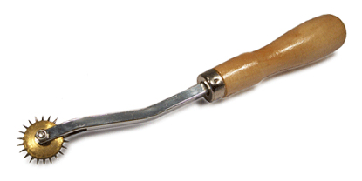
Figure 3.1Tracing wheel
- Cuff pattern
A cuff is an extra layer of fabric at the lower edge of the sleeve of a garment covering the arms also at the end of the leg of a pair of trousers. Turning back the material may make cuffs, or a separate band of material may be sewn on or worn separately attached by buttons or studs.
- Sleeve pattern
Sleeve is that part of a garment which covers the arm, or through which the arm passes or slips. The pattern of the sleeve is one of the characteristics of fashion in dress, varying in every country and period.
- Collar pattern
In clothing, a collar is the part of a shirt, dress, coat or blouse that fastens around the neck. Among clothing construction professionals, a collar is differentiated from other necklines such as reveres and lapels, by being made from a separate piece of fabric, rather than a folded or cut part of the same piece of fabric used for the main body of the garment’s collar may be permanently attached to the main body of the garment (e.g. by stitching) or detachable.
- Pocket pattern
A pocket is a bag- or envelope-like receptacle either fastened to or inserted in an article of clothing to hold small items. Pockets may also be attached to luggage, backpacks, and similar items. In older usage, a pocket was a separate small bag or pouch.
- Complete set of skirt pattern
A leather skirt is a skirt made of leather. Although durable material, the particular combination of style and material makes for a certain fashion statement. Leather skirts appear in a variety of lengths and styles.
- Complete set of jacket pattern
A leather jacket is a type of clothing a jacket-length coat. Usually worn on top of other apparel, and made from the tanned hide of various animals. The leather material is typically dyed black, or various shades of brown, but a wide range of colors is possible. Leather jackets can be designed for many purposes, like motorcyclists, militaryaviators, police, and music subcultures, which have worn the garment for protective or fashionable reasons, and occasionally to create a potentially intimidating appearance.
- Complete set of trouser pattern
Trousers are an item of clothing worn from the waist to the ankles, covering both legs separately rather than with cloth stretching across both as in skirts and dresses.

- Cut traced pattern
- Cutting traced pattern from a cardboard
The pattern maker must give in each pattern the following details, which would help: InA good pattern maker must be aware of different types of finished leathers and their suitability in making different types of leather garment. He must be well versed with the techniques of fabrication and types of constructions. He must have the essential knowledge in elementary mathematics, measurements andUse of geometrical instruments for drawing geometrical shapes viz. square, rectangle, circle, etc. and other odd shapes.

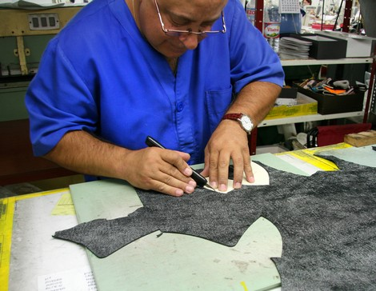
Figure 3.2Traced cutting pattern on cardboard
He must be aware of different types of fittings, linings, reinforcements and other miscellaneous items, which are used in leather garment making. The pattern maker must give in each pattern the following details, which would help the cutter in the subsequent process of cutting to cut components easily and swiftly.
To make less number of products, cardboard patterns are used for cuttingcomponents. To make more number of products, aluminum or galvanized metal patterns are used for cutting components.
- Reference And Specification
- Applying reference and specification on the pattern in garment
Prior to leather garment pattern designing, observe the style (sketch/sample) carefully. Note down all the details; this should help you to know where to start. Practice ‘Style reading’ from magazine clippings of various types of garments. If possible draw a working sketch indicating details. Also note down the important points for construction.
Observing the model is a very important step before beginning the construction. Observe the model carefully and make a detailed description of volume, type of collar, pleats, sleeves, details, topstitching, etc.
For Construction of pattern outline necessary basic block. Make necessary enlargements according to desired volume. Mark button placements, determine cross-over value. Outline lines corresponding to model: seams, yokes, pockets, pleats, etc. Assemble front and back with darts closed. Place pattern on the dummy. This will help to indicate if volumes are correct. Make changes if necessary. Place pattern on cutting table; construct collar, sleeve, pleats, lining, etc.
Notches are necessary when the model is being assembled. Their position varies according to the model. Some important places where notches are present
- Front, back & sleeve arm hole
- Collar: centre back , shoulder line &centre front
- Waistband: centre back, side &centre front
- Pleats: on the edge of pleat lines & on the interior pleat lines
- Beginning of darts
- Cross-over edges
- Hem width
- The middle of a seam if it is very long
- Pocket position
- Along assembly lines of two identical curves (one or several notches)
- Folding lines
Basic Blocks
The first step in pattern designing/development is the preparation of basic block, which is used for all pattern adaptations. The basic block is the representation of three-dimensional solid measurements of a mannequin (dummy) in a two dimensional (flat) form. Thus the basic block is the foundation pattern constructed to fit a specific figure. In the garment industry the blocks are constructed to a set of standard measurements for a particular size. It is used as a basis for interpreting a design and producing a finished pattern. The design shape may change dramatically but the basic fit of the pattern will conform to the size of the basic blocks. The basic block will vary from company to company depending on various factors.
Draft/Construction (Working Pattern)this is developed from the basic block. The various styling details such as dart manipulation, types of seams, yokes, gathers, pleats, pockets etc. are planned in the draft. The construction is kept intact until the sample garment is finished.
Final (Sample) Patternthis is the pattern developed from the working sketch. Here each section (panel) is traced and adapted to achieve the desired effect on shape and fit.Seam allowances are added, marked and labeled with all the necessary information (Refer instructions). During sample preparation if any alteration is required, it is done for this pattern also. These patterns are usually cut in soft white paper or brown sheet.
Production Pattern
This is the copy of the final pattern. This must be 100% accurate with all necessary information indicated on it. This production pattern is then sent for grading together with the sample to be graded in the required sizes.
Graded pattern
The graded pattern consists of copies of the production pattern in the required sizes (i.e. 50, 52, 54 etc.). Some firms prefer to have different color codes for different sizes.The following are common pattern information’s written on each patter for production purpose:
- Style/ Item e.g. Blouse
- The name of each pattern piece e.g. Front panel
- The number of pieces to be cut e.g. cut 2X
- Style no. e.g. BL 001-2004
- Size e.g. 36
- Fold line e.g.
- Grain line e.g. or
- Notch e.g. V- or U- mark on the edge of the pattern to show like seam and hem allowance, dart legs, for fitting of long seam etc.
- Drill mark/punch hole e.g. to show pocket position, dart endings, button hole position, etc
- CB or CF

The name of the style/product number
- Pattern size
- The name of each piece
- Center back/center front
- Fold lines
- Balance marks (matching points marked by notch)
- Grain lines (marked by arrow lines)
- Construction marks
These includes
- Darts
- Button holes
- Pocket placing
- Pleats

- Seam allowances
- Number of pieces to be cut (x1, x2, x4)

Apply pattern information and specifications of goods
In the manufacture of leather goods, pattern making and pattern cutting are the most
Important and fundamental in fabricating leather goods.
It forms the very core and the beginning. Before making any leather goods, the sizes and geometrical shapes of its parts are first cut in paper.
Such patterns, which are cut in paper, are called paper patterns. The paper patterns are stuck on thick millboard or a white board, using adhesive and then cut into cardboard patterns.
By using the cardboard patterns, leathers, linings, foam and reinforcements needed for making leather goods are cut.

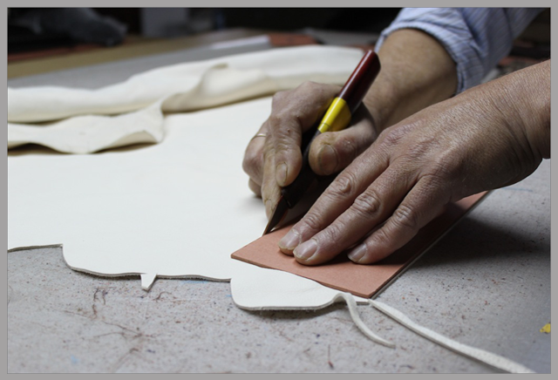
Figure 3.3 Cut reinforcement by using cardboard bored
The economy of leather goods depends upon pattern cutting, which determines the cost of production. Since patterns are cutting guide, it must be very accurate. It helps to ensure that the materials are cut accurately without any wastage. The art of pattern cutting requires anticipation, sound judgment, and cultivated style of approach with a sense of quality control. In leather goods making, two kinds of patterns are used. They are making patterns and cutting patterns.
master pattern: All the design methods of the drawing or photograph has to implemented in this pattern and has to be designed for the final shape ,size and proportion.
Exact / working pattern: From the Master Pattern, the components parts of the product are cut to the correct measurements and shapes .But stitching allowances and Underlay allowances has to be included in this pattern. These patterns are called Exact /Working /making patterns and are largely used for making product.
Raw edge /cut edge: This pattern has no allowances of folding but it has to be included Stitching and Underlay allowances. Row age exactly the same as exact /working pattern.
Cutting pattern: This patterns help for the productions. The components pattern included all over allowances such as Folding allowances, Underlay allowances and Stitching allowances.

To make less number of products, cardboard patterns are used for cuttingcomponents. To make more number of products, aluminum or galvanized metal patterns are used for cutting components. To manufacture in bulk, the cardboard patterns of the product are converted into clicking dies and the components are cut in the hydraulic clicking press for production.
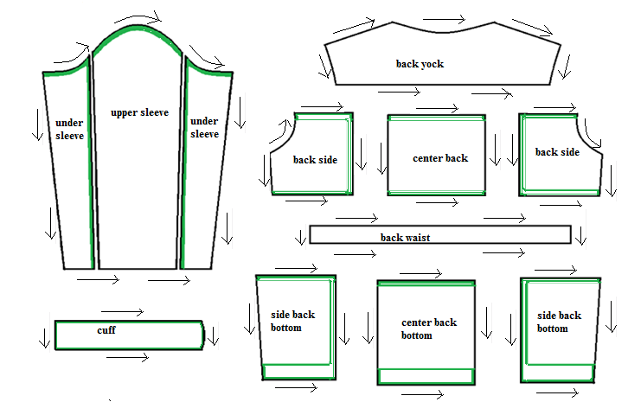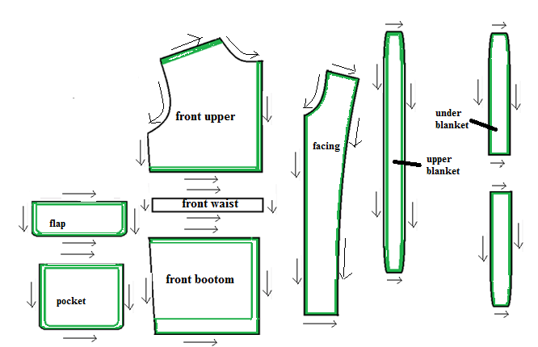

Figure 3.4 Component of trouser, Directions on how to cut men’s jacketwith cutting direction

- Pattern Pieces, Information And Specification
- Checking pattern pieces, information and specification to eliminate duplicating process
In the process of pattern making, pattern maker is considered to be a very important person next to the designer. A good pattern maker must be aware of different types of finished leathers and their suitability in making different types of leather garments. He must be well versed with the techniques of fabrication and types of constructions. He must have the essential knowledge in elementary mathematics, measurements and use of geometrical instruments for drawing geometrical shapes viz. square, rectangle, circle, etc. and other odd shapes. He must be aware of different types of fittings, linings, reinforcements and other miscellaneous items, which are used in leather garments making.
The pattern maker must give in each pattern the following details, which would help the cutter in the subsequent process of cutting to cut components easily and swiftly.
- The name of the style/product number
- Pattern size
- The name of each piece
- Centre back/centre front
- Fold lines
- Balance marks (Matching points marked by notch)
- Marks or slots for fixing fittings and zips
- Grain lines (usually marked by arrow lines)
- Construction marks (these include darts, button holes, pocket placing pleats or punch holes
- Seam allowances
- Number of pieces to be cut (Mention if it is a single piece, a mirrored piece or a paired piece)
- Details of the raw materials (leather, lining, foam, reinforcement, etc.)

The details of different lines marked on front and back pattern is given below
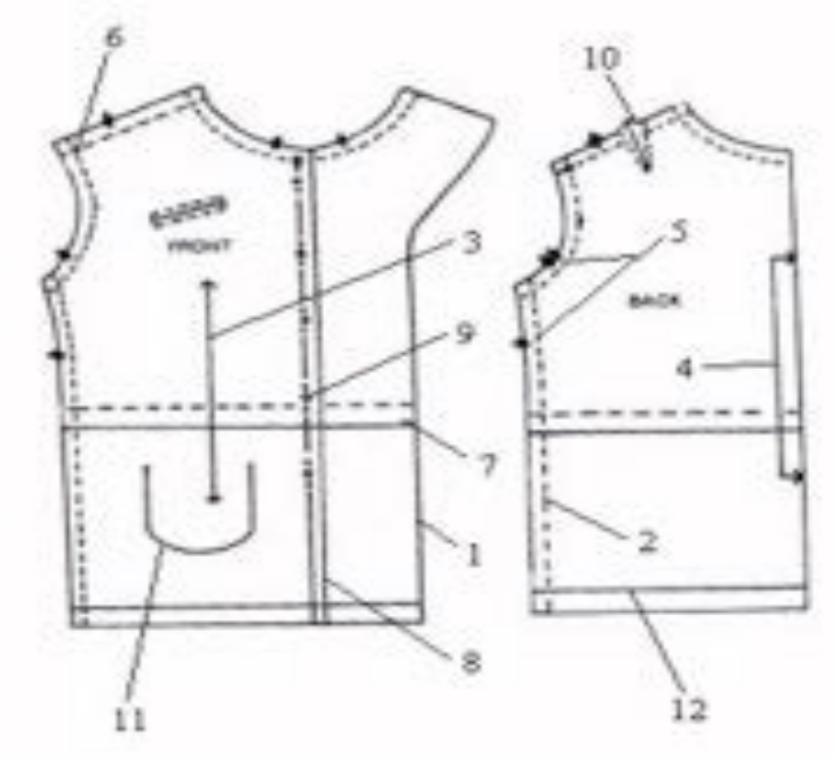
Figure 3.5 Front and back pattern
1: Cutting line
2: Stitching line
3: Grain arrow
4: Place on fold line
5:Notches,
6: Circles and squares
7: Lengthen and shorten line
8: Fold line
9: Button and buttonhole placements
10: Dart placement
11: Pocket placement
12: Hemline.
During pattern making process the pattern master has to check and control the following points:
- All the pattern pieces required for a particular design should be there.
- All the pattern pieces should be according to the size specifications.
- The entire pattern must be aligned with fabric grain.
- Grain line should be parallel to the selvedge.
- Pattern pieces of different sizes should be correctly labeled in marker.
- Darts, notches, drill marks should be at correct location and distinct.
- While doing grading the increase or decrease in size should be proportionate according to the given size range.
- In the marker there should be enough space for knife movement for proper cutting.
- Patterns for checks and stripes should match properly.
- Patterns should not move from its position while marking the marker.
- Pattern lines should be defined properly (e.g. chalk too thick may lead to inaccurate cutting)
Accuracy of pattern pieces
The pattern maker must give in each pattern the following details, which would help the cutter in the subsequent process of cutting to cut components easily and swiftly.
- Name of the product and reference number.
- Name of the parts (front, back, gusset, pocket, flap, handle, etc.)
- Details of the raw materials (leather, lining, foam, reinforcement, etc.)
- Number of components to be cut.
- Centre points for perfect joining of the components.
- Marks or slots for fixing fittings and zips.
- Stitching width and stitches per inch or length of stitch in mm.
- Use of good and defective leather components for visible and invisible parts of the product
- Good component
- Defective component

- Garment And Goods Pattern Faults
We describe the observations of development, testing, system operation and maintenance problems in terms of incidents, faults and changes. Whenever a problem is observed, we want to record its key elements, so that we can then investigate causes and cures.
In particular, we want to know the following:
- Location: Where did the problem occur?
- Timing: When did it occur?
- Mode: What was observed?
- Effect: Which consequences resulted?
- Mechanism: How did it occur?
- Cause: Why did it occur?
- Severity: How much was the user affected?
- Cost: How much did it cost?
The eight attributes of a problem have been chosen to be (as far as possible) mutually independent, so that proposed measurement of one does not affect measurement of another; this characteristic of the attributes is called orthogonality.
Orthogonalitycan also refer to a classification scheme within a particular category. For example, cost can be recorded as one of several pre-defined categories, such as low (under $100,000), medium (between $100,000 and $500,000) and high (over $500,000). However, in practice, attempts to over-simplify the set of attributes sometimes result in non-orthogonal classifications. When this happens, the integrity of the data collection and metrics program can be undermined, because the observer does not know in which category to record a given piece of information.
IncidentAn incident report focuses on the external problems of the system: the installation, the chain of events leading up to the incident, the effect on the user or other systems, and the cost to the user as well as the developer. Thus, a typical incident report addresses each of the eight attributes in the following way.
Incident Report
Location: such as installation where incident observed - usually a code (for example, hardware model and serial number, or site and hardware platform) that uniquely identifies the installation and platform on which the incident was observed.
Timing: CPU time, clock time or some temporal measure. Timing has two, equally important aspects: real time of occurrence (measured on an interval scale), and execution time up to occurrence of incident (measured on a ratio scale).
Mode: type of error message or indication of incident (see below)
Effect description of incident, such as "operating system crash," "services degraded," "loss of data," "wrong output," "no output". Effect refers to the consequence of the incident. Generally, "effect" requires a (nominal scale) classification that depends on the type of system and application.
Mechanism chain of events, including keyboard commands and state data, leading to incident. This application-dependent classification details the causal sequence leading from the activation of the source to the symptoms eventually observed. Unraveling the chain of events is part of diagnosis, so often this category is not completed at the time the incident is observed.
Cause: reference to possible fault(s) leading to incident. Cause is part of the diagnosis (and as such is more important for the fault form associated with the incident). Cause involves two aspects: the type of trigger and the type of source (that is, the fault that caused the problem). The trigger can be one of several things, such as physical hardware failure; operating conditions; malicious action; user error; erroneous report while the actual source can be faults such as these: physical hardware fault; unintentional design fault; intentional design fault; usability problem.
Severity: how serious the incident’s effect was for the service required from the system. Reference well defined scale such as "critical" "major" "minor". Severity may also be measured in terms of cost to the user.
Cost: Cost to fix plus cost of lost potential business. This information may be part of diagnosis and therefore supplied after the incident occur
FaultsAn incident reflects the user’s view of the system, but a fault is seen only by the developer. Thus, a fault report is organized much like an incident report but has very different answers to the same questions. It focuses on the internals of the system, looking at the particular module where the fault occurred and the cost to locate and fix it. A typical fault report interprets the eight attributes in the following way:
Fault Report
Location: within-system identifier, such as module or document name. The IEEE Standard Classification for Software Anomalies, [IEEE 1992], provides a high-level classification that can be used to report on location.
Timing: phases of development during which fault created, detected and corrected. Clearly, this part of the fault report will need revision as a causal analysis is performed. It is also useful to record the time taken to detect and correct the fault, so that product maintainability can be assessed.
Mode: type of error message reported, or activity which revealed fault (such as review). The Mode classifies what is observed during diagnosis or inspection. The IEEE standard on software anomalies, [IEEE 1992], provides a useful and extensive classification that we can use for reporting the mode.
Effect: failure caused by the fault. If separate failure or incident reports are maintained, then this entry should contain a cross-reference to the appropriate failure or incident reports.
Mechanism: how source was created, detected, corrected. Creation explains the type of activity that was being carried out when the fault was created (for example, specification, coding, design, and maintenance). Detection classifies the means by which the fault was found (for example, inspection, unit testing, system testing, integration testing), and correction refers to the steps taken to remove the fault or prevent the fault from causing failures.
Cause: type of human error that led to fault. Although difficult to determine in practice, the cause may be described using a classification suggested by Collofello and Balcom: [Collofello and Balcom 1985]: a) communication: imperfect transfer of information; b) conceptual: misunderstanding; or c) clerical: typographical or editing errors.
Severity: refer to severity of resulting or potential failure. That is, severity examines whether the fault can actually be evidenced as a failure, and the degree to which that failure would affect the user.
Cost: time or effort to locate and correct; can include analysis of cost had fault been identified during an earlier activity.
ChangesOnce a failure is experienced and its cause determined, the problem is fixed through one or more changes. These changes may include modifications to any or all of the development products, including the specification, design, code, test plans, test data and documentation. Change reports are used to record the changes and track the products most affected by them. For this reason, change reports are very useful for evaluating the most fault-prone modules, as well as other development products with unusual numbers of defects. A typical change report may look like this:
Change Report
Location: identifier of document or module affected by a given change.
Timing: when change was made
Mode: type of change
Effect: success of change, as evidenced by regression or other testing
Mechanism: how and by whom change was performed
Cause: corrective, adaptive, preventive or perfective
Severity: impact on rest of system, sometimes as indicated by an ordinal scale
Cost: time and effort for change implementation and test
The following are faults related to pattern/ pattern information and specifications.
- Finished garment NOT to size- using wrong pattern
- Missed parts
- Wastage of fabric
- Mismatched pattern pieces e.g. side seam of the front panel NOT fit with side seam of the back panel
- Wrong marking e.g. drills/ pin hole is wrongly placed on the pattern
- Wrong grain line placed on the pattern.

- Appropriate Corrective Action
In the manufacturing of leather garments the mistakes or faults made in the pattern making will seriously affect the production. Hence it is important to make the patterns accurately so that the production problems are eliminated at the root. The following section explains the possible production problems and how to correct the problems in the patterns.
Balance Stance: (Forward & backward)
If the jacket fits well but the jacket rises at front or back because of the body stance (posture), make the following adaptations.
Forward Stance: Draw a line A-B at back pitch point; cut across this line, open a wedge at A. (Make sure neck point stays on vertical back line) Trace round new outline as shown.
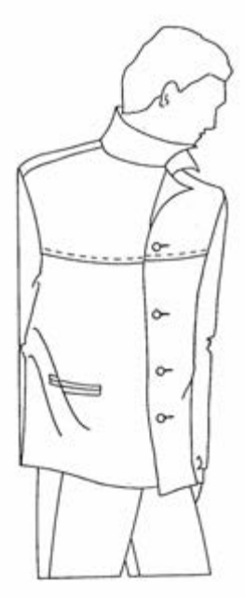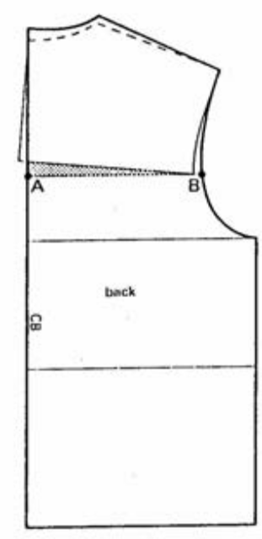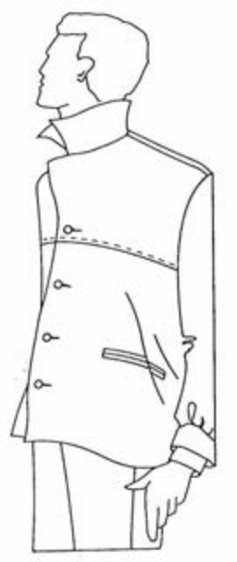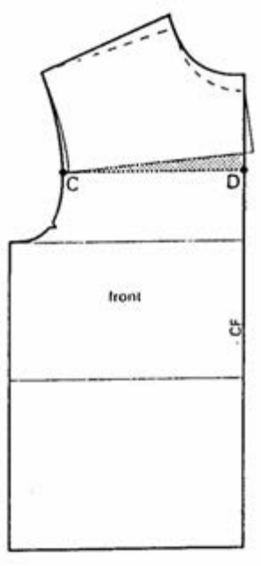
Figure 3.6Forward stance backward stance
Backward Stance: Repeat as above by drawing line C-D at front.
Note: If the body is much stooped and the back requires being raised more than 1.5 cm, cut across the whole block on waistline, raise the already adapted block a further amount at back waistline. Trace round new outline as shown.
Short Back: Extra fullness appears across centre back. Draw a line A-B at cross back, mark C at shoulder, cut across line, overlap required amount. The sleeve head will have to be re-drafted to fit the length between B and C
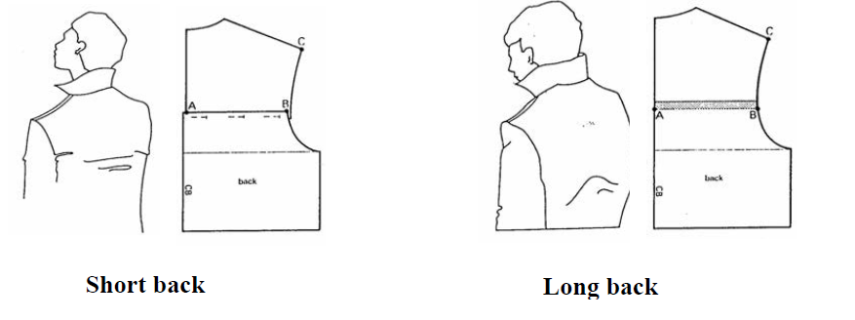
Figure 3.7short back and long back
Long Back: Jacket rises up because of an obvious rounded back. Draw a line A-B at cross back, cut across line and open the required amount. The sleeve head will have to be re-drafted to fit the length between B and C
Long Chest & Short Chest: The same adaptations can be made 6 cm above front pitch point. The sleeve head will have to be re-drafted to fit the length between B and C
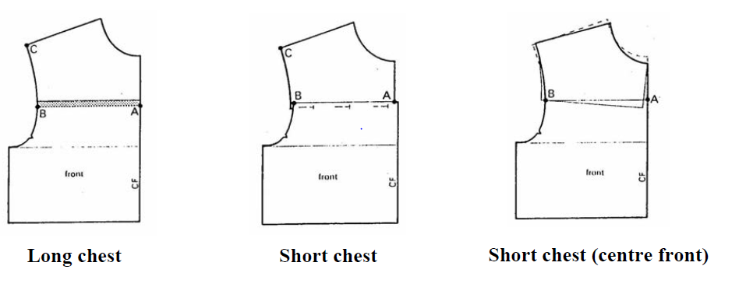
Figure 3.8 Long Chest & Short Chest
Short Chest (at centre front only): Cut across the line A-B, overlap top section at A (make sure neck point touches centre front vertical line). Trace round new outline.
Wide or Narrow Shoulders:
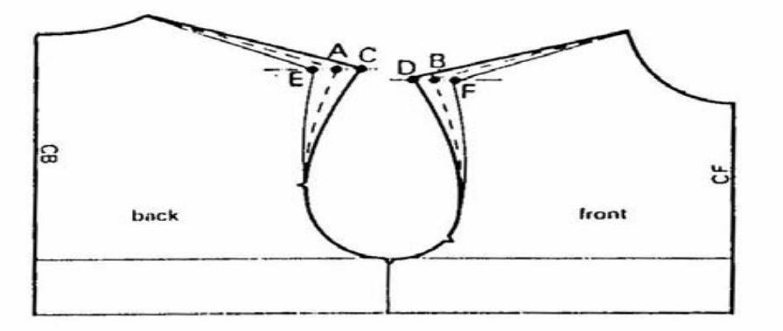
Figure 3.9 Wide or Narrow Shoulders

If the shoulder measurement differs from the standard measurement for chest size, work out the difference. Mark A and B at shoulder points
Draw horizontal lines through points A and B.
Wide shoulders: A - C and B - D = Shoulder difference; join C and D to neck points and armhole.
Narrow shoulders: A - E and B - F = shoulder difference; join E and F to neck points and armhole.
Square Shoulders: Horizontal strain lines appear below back neck. Cut across back shoulder from A-B. Open a wedge at B the required amount. Raise armhole at C so that armhole measurement remains the same. Repeat this operation on front shoulder.
Note: Many figures with square shoulders have well developed arms, in this case do not raise armhole but re-draft sleeve head to fit larger armhole.
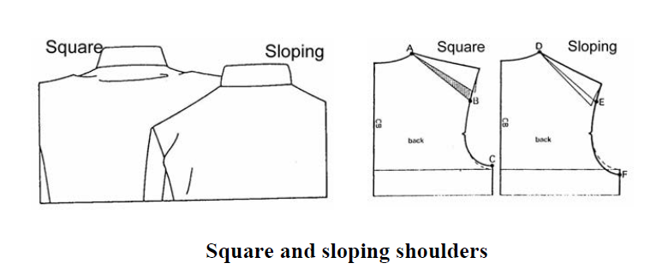
Figure 3.10 square and sloping shoulders
Sloping Shoulders: Diagonal lines drape at armhole. Cut across back shoulder from D-E overlap sections the required amount. Lower armhole at F so that armhole measurement remains the same. Repeat the operation on front shoulder.
Sleeve Pitch: The sleeve drags to left or to right. Remove sleeve from the garment and pin at the shoulder point so that the sleeve hangs correctly.
Remark balance points on sleeve this means that underarm seams of sleeve and body section will move out of line.

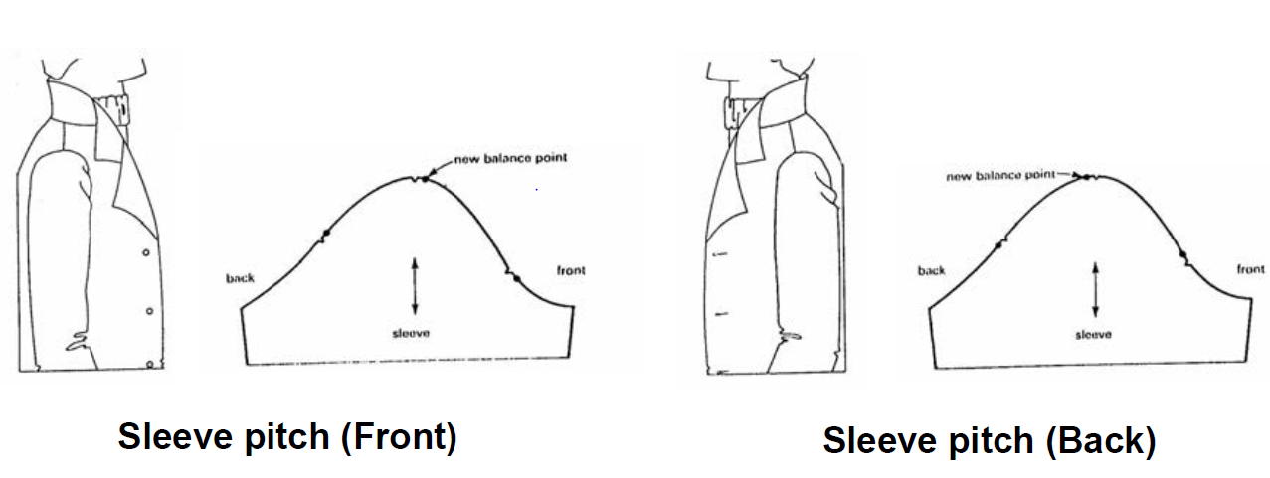
Figure 3.11 sleeve pitch front and back

Self check-3
Directions: Answer all the questions listed below. Examples may be necessary to aid some explanations/answers. 10 point for each
- Define what is tracing wheel?
- What is the use of tracing wheel?
- To make less number of products, ---------------------are used for cuttingcomponents.
- to make more number of products, --------------------------patterns are used for cutting components
- Where notch is applied on garment and goods pattern?
- List common pattern information written on each production pattern?
- In the pattern making process a pattern master has to cheek and control---------------------?
- Write faults related to pattern information and specification?
- Discuses briefly about faults report and change report?
- Discuses possible production problems and how to correct the problems in the patterns
True or False:
- Without notches are used to line up two or more pieces of the leather/ materials that you will be joining together.
- Bags foreside and backside are the major parts.
- Construction markings, on the other hand, are very helpful during the sewing process.
- Cutting pattern has allowances of folding but it has to be included Stitching and Underlay allowances.
- Reinforcement pattern has allowances of folding, stitching and underlay allowances.
- The Lining Cutting Pattern has to be marked by the BLACK PEN/ COLOUR.
- Cutting pattern has allowances of folding but it has to be included Stitching and Underlay allowances

Note: Satisfactory rating –above 60% Unsatisfactory - below 60%
You can ask you teacher for the copy of the correct answers

Operation sheet-3

Operation Sheet 3.1 Procedures to trace patterns on a given card board
How to trace patterns on a given card board
Step 1:Put the construction paper on card board then put the weight above on it.
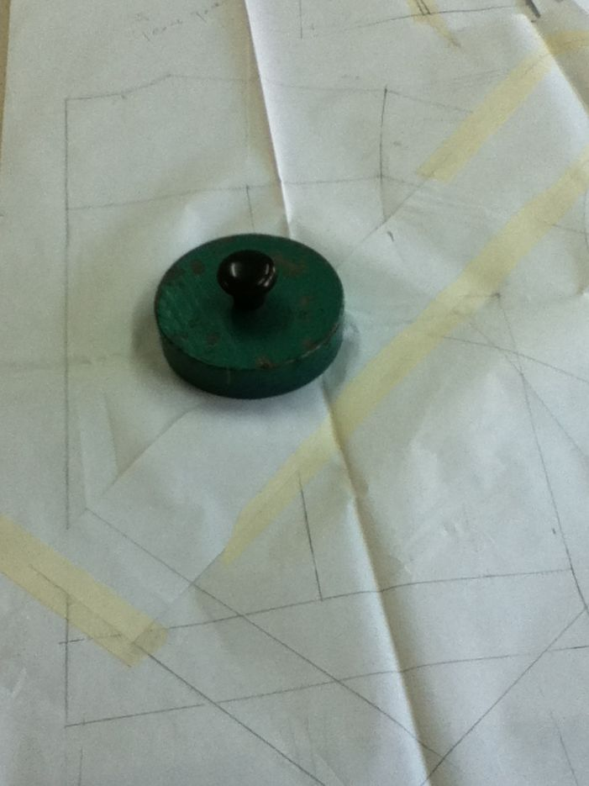
Figure 3.12 weight
Step 2:Byusing tracing wheel trace those patterns on to card board
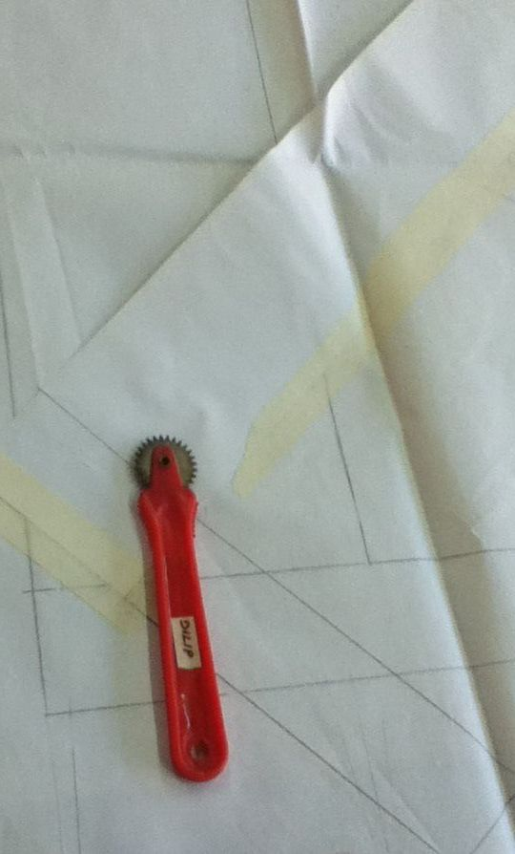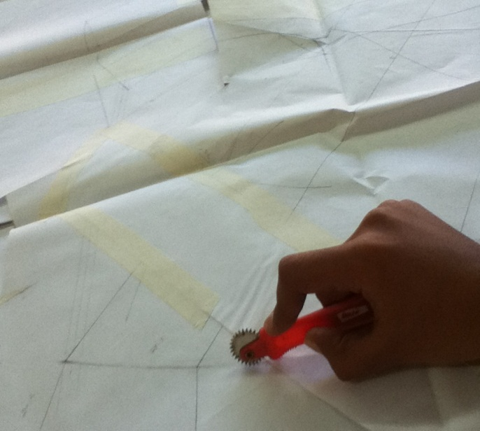
Figure 3.13 tracing wheel tracepatterns

Step 3:Draw those lines on card board by using ruler and French curve.
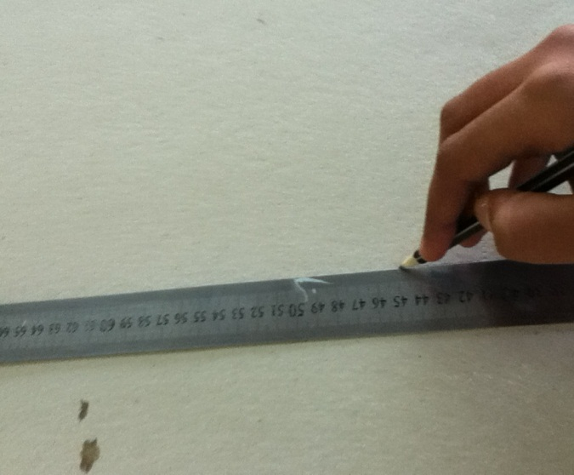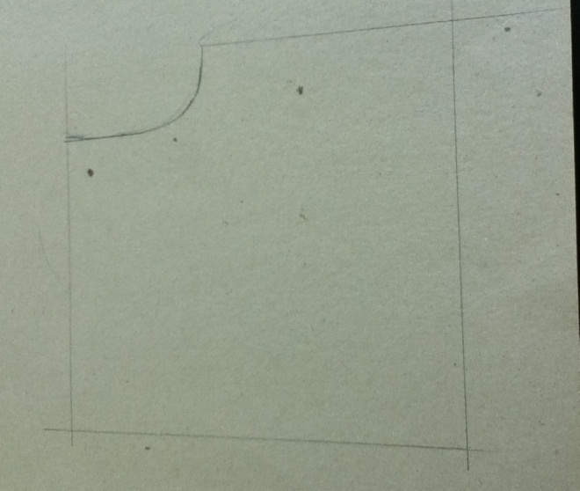
Figure 3.14 drawlines using ruler and French curve
Step 4:Give 1cm allowance around and cut all components by using cutting knife.
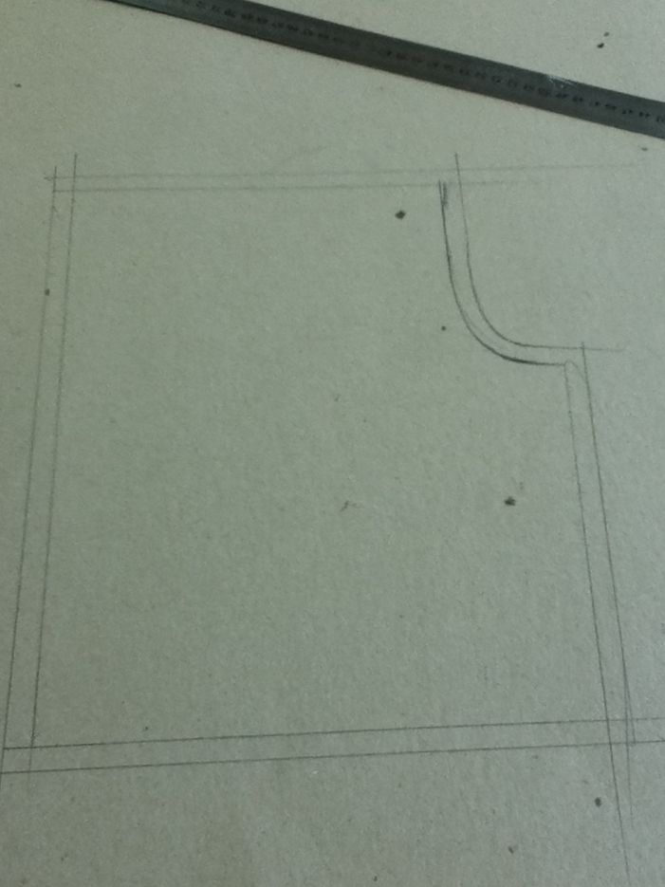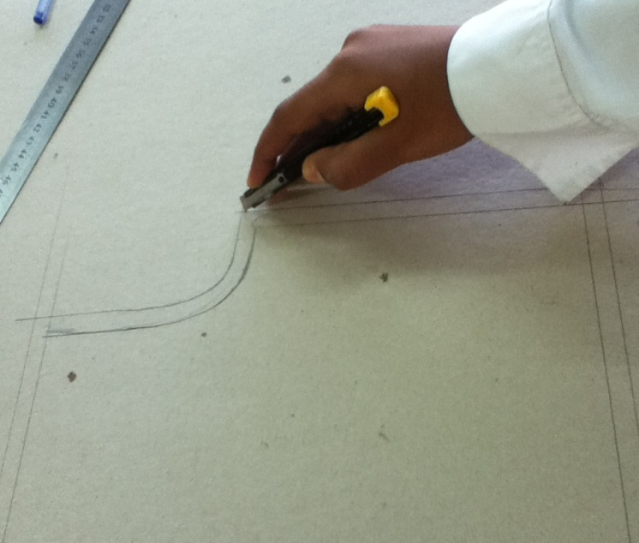
Figure 3.15 using cutting knife
- Trace Cuff pattern
- Trace Sleeve pattern
- Trace Collar pattern
- Trace Pocket pattern
- Trace Complete set of skirt pattern

Operation Sheet 3.2 Procedures on how to cut patterns on a given card board
Cut the jacket components on leather as below
- Sharpen the knife
- Press the pattern with left hand fingers
- Start cutting from left hand side to right hand side direction
- Pattern cutting direction is shown in the fig
- The left hand fingers should move along the knife direction
- Notches are to be cut properly
- No. of pieces to be cut
- After cutting the pattern write those specifications (mentioned on work sheet) on it.

Lap Test-3
Instructions: Based on the demonstration that you have seen
Task 1:Trace ladies jacket patterns on a given card board?
Task 2:Cut ladies jacket patterns on a given card board

Unit Four: Sort and assess leather
This learning guide is developed to provide you the necessary information regarding the following content coverage and topics:
  - Bundle Of Leather And Match Shades
  - Sort And Assess Of Leather
  - Lay And Assess Of Leather Defects
  - Identify And Mark Defects
  - Report The Records

This guide will also assist you to attain the learning outcomes stated in the cover page. Specifically, upon completion of this learning guide, you will be able to:
  - Lay a given bundle of leather to match shades
  - Sort and assess of leather according to color and grain structure
  - Lay of leather on cutting table and assessing for defects
  - Identify and mark of defects
  - Report the records

  - Bundle Of Leather And Match Shades
Introduction
Leather is a durable and flexible material created by tanning animal rawhide and skins. The most common raw material is cattle hide. These are full grain, top grain, genuine, split grain, and bonded leather, and much detail about each will be shared. Leather is used to make a variety of articles, including footwear, automobile seats, clothing, bags, book bindings, fashion accessories, and furniture. It is produced in a wide variety of types and styles and decorated by a wide range of techniques.

Laying out given leather on the horse to match shades
Leathers are assorted on the horse shape table under bright lights and carefully examined for color/shade, texture, stretch, grain pattern, etc. Leathers are selected which are most alike in feel, thickness.
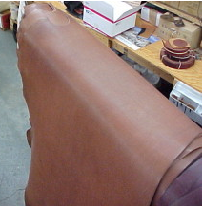
Figure 4.1 Leathers on the horse shaped table

This is done by the Human Eye and hand; it is one of the most difficult areas to train as it relies on individual skills and concepts. There are no exact standards or methods for grading leather, since is done by the grain characteristics, sight and feel developed through experience and training.

A skin is divided into five quality regions; the best part is “Butt”. This has the tightest fiber structure. The fiber structure can vary considerably depending on the age of the animal and the living conditions. The neck and the belly have the loosest fiber structure.

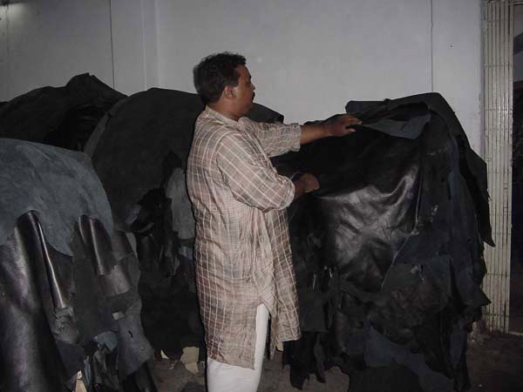
Figure 4.2 Leather quality inspections

Leather quality inspection
In the cutting operation the cutting man has to select the right quality leather, because when one deals in leather he/she will find that no two skins /hides are the same, either in texture, quality or thickness. Therefore , one has to have the necessary skill to determine what parts of the hide/skin is most suitable for each component part and to be able to position cutting patterns in the correct position to minimize waste and still assuring the correct orientation of each component as to its stretch properties.

- Making bovine and sheep skin assortments
- Next, various assortments of bovine and sheep skin (with or without fur) are presented for garments, and their main characteristics.
- Sets of bovine leather with slightly polished face and finished with a coating film, smooth and pressed color. The leather assortments are obtained by tanning cattle hide with basic chromium salts and processing by means of wet finishing operations (neutralization, retaining, and dyeing, fat liquoring), mechanical and dry finishing operations by coating with smooth, pressed film (Figure 4.1).
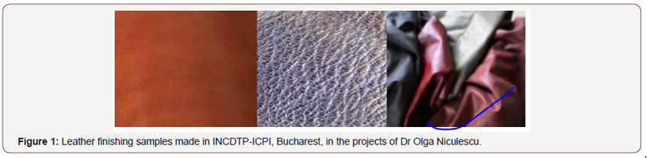
Figure 4.3 leather finishing samples

Assortments of bovine leather finished with coating film, reptile pattern embossing, two-color leathers, used to make footwear and leather goods. The vegetable-tanned leather assortments are obtained by tanning cattle hide, with basic chromium salts or with vegetable tannins, and processing by means of wet finishing operations, mechanical operations and dry finishing by coating with finishing film, and reptile pattern embossing

Assortments of bovine leather finished with a coating film, smooth, with aesthetic stains, used to make leather goods and office supplies. The leather assortments are obtained by tanning cattle hide, with basic chromium salts and processing by means of wet finishing operations (neutralization, retaining, and dyeing, fat liquoring), mechanical operations and dry finishing by coating with finishing film, with aesthetic staining using machines with spray guns

Assortments of sheepskin finished with a coating film, perfumed, used to make garments. The fur sheepskin assortments are obtained by tanning the sheepskin with basic chromium salts, or with synthetic agents based on phenol sulfuric acids and aromatic oxisulfones and processing by means of wet finishing operations, mechanical operations and finishing with scented Napa finishing film.
There are many different methods for testing and evaluating leather properties. For a layman, only rough and basic testing options are available when purchasing a good and beautiful leather item. Some of the criteria can be checked directly as an end customer, but when certain criteria cannot be tested, don't be afraid to ask the vendor the right questions.
Below we list some basic checks that can be carried out.
- Look of the leather: Beautiful top quality leather looks very natural and does not contain markings on the surface.
- Leather grain texture: The grain texture should look good and be as natural as possible. An embossed grain pattern is very uniform, which does not correspond to the natural grain of a skin and embossed leather often feels less natural.
- Softness of the leather: Generally, leather should be soft to the touch and have a natural feel. But leather shoes or leather belts require certain strength.
- Haptic evaluation of leather surfaces: Leather should feel good, whether it's soft, blunt or smooth. The more beautiful leather feels, the better its quality.
- The leather finish: To protect the leather, it is often useful to apply a binder-based finish to the surface. The more layers of leather paint are applied, the more unnatural it feels. If the grain texture is sanded before the finish, the leather feels even more unnatural. So too does film-coated leather, usually considered to be inferior to natural leather and therefore relatively inexpensive. On the other hand, the effect is an accepted feature of patent leather.
- Breathability of leather: An advantage of leather over alternative materials is its breathability. But the more leather is coated with leather colour or a film, the lower the breathability.
- Tear strength and stability of the leather: Good leather is stable and resistant to tearing, whereas suede, nubuck or extremely soft lambskin will not have the same stability as, for example, a belt leather. But within the types of leather very different qualities exist. So, inferior quality leather within the same type of leather will always tear more easily than that of a higher quality. Also sanded leather is usually less stable than full-grain leather.

  - Sort And Assess Of Leather
Introduction
The leather then undergoes a quality check and is sorted according to the quality. Hides which do not have any blemishes or marks are best quality and can be processed to aniline leather. The ones which have marks may be processed into corrected grain.
Sorting leather before cutting will depend on the producer requirement according to the required product quality and the type of leather needed for the design of the material.
Sorting of leather
It becomes necessary to sort the leathers for the average usable area and its ratio to the whole area determines the assorted grade and thus the market price. The area of leathers is measured by either pin wheel measuring machine or electronic measuring machine. The unit of measure for finished leathers is square decimetre (dm²) or square feet (sq.ft); 1 sq.ft = 9.29 sq.dm.
General sorting of leathers based on the cutting value is as given below:
- Grade A = minimum useful area 80%
- Grade B = minimum useful area 65%
- Grade C = minimum useful area 50%
- Grade D = minimum useful area 25%
- Rejects = minimum useful area <25%

Sorting of area measured leathers: in area measured leather the usable area related to whole area determines the assorted and thus the market price.
General classification of area measured leather:
- Size I = minimum used area 80%
- Size II = minimum used area 65%
- Size III = minimum used area 50%
- Size IV = minimum used area 25%
- Size V = Rejects

Properties of garment leathers: the essential properties, which one looks for in garment leathers, are:
- Drape
- Softness
- Nap in the case of suedes
- Light weight
- Surface smoothness in the case of grain garment leathers.
- Fastness to light
- Fatness to wet and dry rubbing
- Fastness to washing
- Fastness to dry cleaning in the case of suedes
- Fastness to perspiration
- Uniform level ageing
- Dye penetration in the case of suedes
- Shower proofness in the case of suedes
- Strength properties such as stitch tear and slit tear.

Mostly the sorting of leather can be as follows
- Sorting by Color – Which will help to group the same color shading from a bundle of leather and to have the same color shade in one model at the time of cutting for a product.
- Sorting by size or area of leather – This type of sorting will assist the proper utilization of material to use bigger sizes for bigger patterns.
- Sorting by thickness – The thickness of the material can be split the sorting of leather by thickness will assist to use the thicker material for the required part. This is mostly important for leather garment.
- Sorting by texture / grain – Leather having similar texture will be sorted for the process needed.

Colour matching
In aniline dye batch, the leather should have to be matched for shade and the components of the article have to be cut from the matched grain of same shade.
In case of pigment finished leather the defects would have been covered due to a thick color coating. In this case, especially the backbone area is measured and any mark is visible, it is not advisable to use these portions in the front panel of the article.
Grain matching
Leather grain refers to the composition and appearance of the hide. It is similar to wood grain, which refers to the texture and appearance of wood fibers. Most of the time the panel of leather garments is sectioned. In this case the grain of each component should be matched; otherwise the articles will appear odd and doesn’t have good appearance.
Matching grain is an important factor, particularly for the high grade articles proper consideration of grain matching is necessary. Of course for minimization of wastage and cost reduction some items grain matching has been difficult, but in all articles the front panel of article is usually have well matched grain pattern.
The area of best quality of leather generally corresponds to those areas of best substance. However, other factors must be taken in to consideration when considering the quality of the leather.
- The proportion of prime material compared with the size of the skin.
- The regularity of the substance.
- The shape of the skin like, good square shape or narrow etc.
- The defect with the skin like, natural, mechanical and disease disfiguration which have occurred during the animal life.

The substance and quality of different parts of leather are determined by the anatomy of the animal –
- Butt – Is the strongest leather as this covers the delicate organs along the back, this is also most even in quality and texture and is the first quality.
- Shoulder – Is the lighter substance which is the second-best quality.
- Neck – It is thick in substance and heavily lined with growth marks. This portion is the third best quality.
- Belly – Is the poorest in quality, lot of elasticity and stretchable.
- Shank – Is light of potion it is stretchy with wrinkles; it may or not be used based on its quality.
Characteristics of leathers
Each type of leather is suited to a range of uses, according to its unique characteristics choosing the right one for the job is easy, once you know what to look for. Leather is tanned and finished on the grain side to have a smooth rich surface. Leather, which is tanned and finished on the flesh side, is called suede. Various types of finished leathers, which are used for making leather products, are described below:
Buff hides: are hides from buffalo it is thick, strong and durable. Buff uppers are finished in a few shades. They are used for making heavy and luggage leather goods.
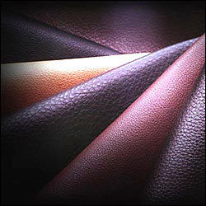

Figure 4.4 Buff hides
Cowhides: cowhides are thick, strong and durable. They have smooth grain surface. Cowhides are finished in different colors with different techniques and are used for making a wide range of leather goods. Most commonly used finished cow hides are;

Cow dry-milled uppers: are tanned with characteristic grains, developed naturally. Technique of embossing using hydraulic embossing press is also applied to get characteristic grains. They are used for making heavy, medium and small leather goods.
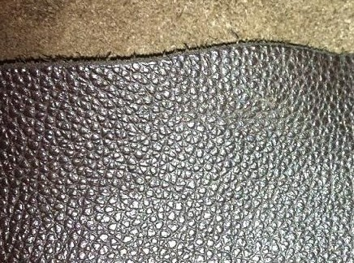
Figure 4.5Cow dry-milled uppers

Cow Napa leathers: are soft and have larger area with increased cutting value and smoothness of grain. Cow Napa leathers are used for making softy types of leather goods.
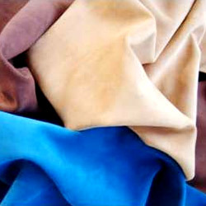
Figure 4.6 Cow Napa leathers

Upholstery leathers: are finished in attractive colors with design printing. Upholstery leathers are largely used in furniture and automobile industries.
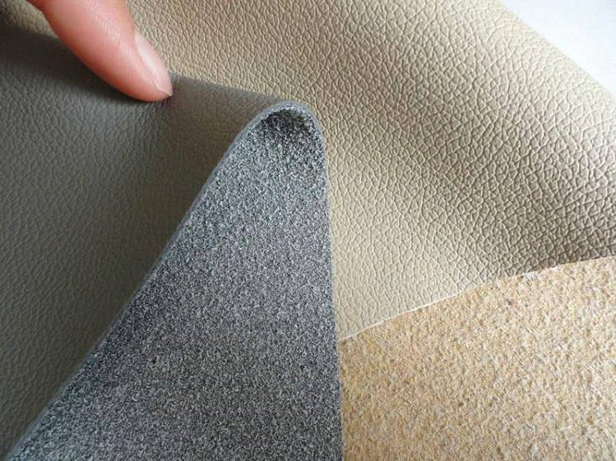
Figure 4.7 Upholstery leathers

Split leathers: are under layers of buff and cow hides (flesh side). Split leathers are up-graded by special finishing techniques in attractive colors. They are either plainly finished or printed.

Patent leather: is a type of japanned leather (tanned with a heavy black lacquer) that has been given a high gloss, shiny finish Characterized by a glass-like finish that catches the light, patent leather is typically solid black. Patent leather may also come in several colors such as neutral tan, white, black or even neon colors such as neon-green and hot-pink. In addition to the mirror-like finish, patent leather is also virtually waterproof, while still retaining a very flexible texture. The visual aspects of patent leather have made it a sought-after material for formal accessories.


Figure 4.8 Patent leather

N.B: a hide is the upper most natural covering of big animal having an average size of 6 ft² and above while a skin is the upper most natural covering of small animals having an average size of 4-6ft²
Skins/ leather
Buffalo/cow calf skinsCalf skin is the term generally used to describe an animal in suckling stage. Dyed calfskins are very rich in appearance and have a soft smooth satin-like finish (weave that typically has a glossy surface). These skins are used for making small and sophisticated leather goods.
Goat skinsThese are strong, durable soft skins. Their fibers are short and compact. Naturally finished goat skins are used for making leather goods with carving, tooling and embossing works. Most commonly used finished goat skins are;
Goat uppers: are tanned with smooth and bright glossy finish. Glaze kids are generally used for making novelty goods.
Morocco leathers: are fine and lovely finished goat skins. They are thin by longwearing and come in a limited number of colors and are especially known for its rich red hue.
Goat suedeGoat suede is subcategory of suede leather. Goat refers to the type of animal skin used, while suede refers to a specific treatment used to achieve a soft nap on the leather. Whereas full-grain leather is made from the outer side of an animal skin, that which the fur was attached to, suede leather uses the inner side. The inner side is more supple to begin with but is further softened and made flexible by buffing its surface to create the slightly fuzzy texture of suede. Some skins may also be split, the inner side of the leather from the outer side, leaving very flexible and soft suede.
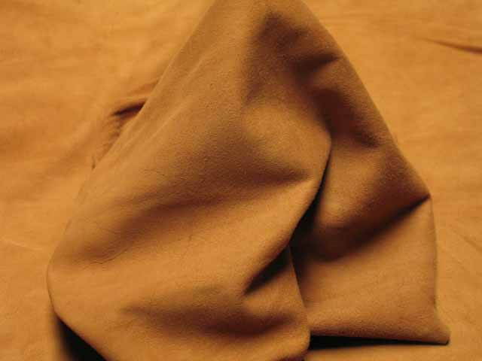
Figure 4.9 Goat Suede Leather

While softer and often considered more comfortable than full-grain leathers, suede is less durable and requires more upkeep. A stiff brush, with soft bristles, should be used regularly to loosen and brush away dirt that may be attracted to the suede’s surface. Water can badly stain suede, so a waterproofing spray should be applied directly after brushing at least once a year and more frequently if the suede item is used constantly. Note that any waterproofing spray should be tested in an inconspicuous spot for discoloration.
Nu buckNu buck is top-grain cattle leather that has been sanded or buffed on the grain side, or outside, to give a slight nap of short protein fibers, producing a velvet-like surface. It is resistant to wear, and may be white or colored.
Nu buck is similar to suede. It differs in that suede is created from the inner side of a hide, whereas nubuck is created from the outer side of a hide, giving it more strength and thickness along with a fine grain. It is generally more expensive than suede, and must be colored or dyed heavily to cover up the sanding and stamping process.
Some of the identifying characteristics are very soft to the touch, it will scratch very easily, and water drops will darken the leather temporarily (it will return to its original color upon drying).The word nubuck probably comes from “new + buck (skin)”


Figure 4.10 Nu buck Leather
Sheep skins: have a smooth grain and its strength properties are less as compared to goatskins. Sheepskins are good starting materials for making softy types of leather goods, particularly, ladies’ handbags, wallets, etc. they can be made as Napa or suede.

SheepNapa
Napa leather is made of full grain sheepskin soft, full grain gloving or clothing leather made from un-split sheep, lamb, and goat or kid skins. It is usually tanned with alum and chromium salts and dyed throughout its substance.
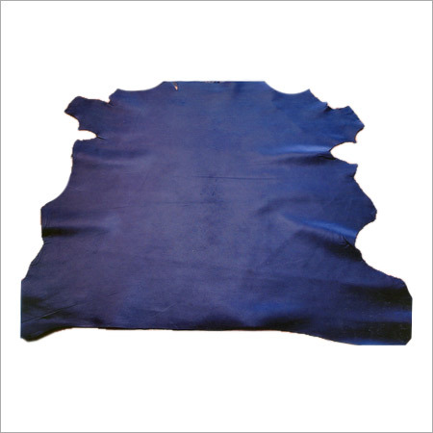
Figure 4.11 Sheep Napa leather
Suede leather: is made from the underside of the skin, primarily lamb, although goat, pig, and calf are commonly used. Because suede does not include the tough exterior skin layer, suede is less durable but softer than standard ("full-grain") leather. Its softness, thinness, and pliability make it suitable for clothing and delicate uses; suede was originally used for women's gloves. Suede leather is also popular in upholstery, shoes, bags, and other accessories, and as a lining for other leather products. Due to its textured nature and open pores, suede may become dirty and absorb liquids quickly.
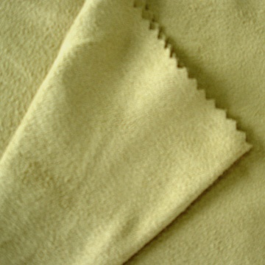
Figure 4.12Suede leather

Exotic skinsExotic skins are skis which are rare, and very costly leathers. They are skins of reptiles such as crocodiles, alligators, lizards, cobras, pythons etc
Leather assessment: Based on
- Substance/thickness
The thickness of the leather is measured comparing with the reference sample leather and with the help of thickness gauge.
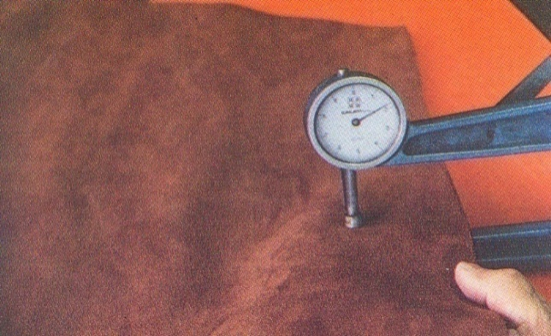
Figure 4.13 leather substance/ thickness

- Finish appearance
The finish appearance of the leather is checked by comparing with the reference sample leather or shoe.
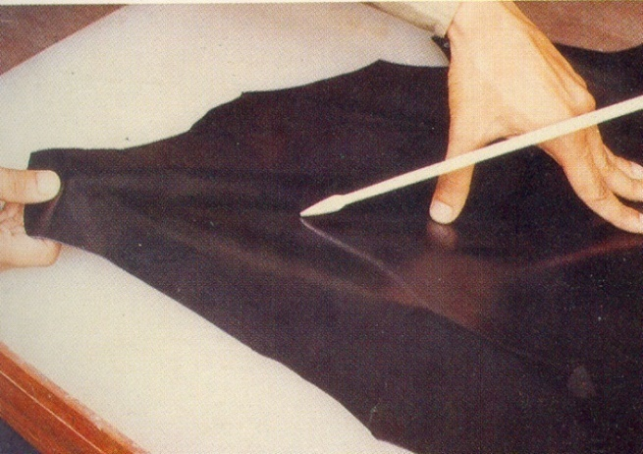
Figure 4.14 Finish appearance

- Feel/softness and stretch
Feel/softness of the leather is checked by filling up with palm with it at different places and comparing with the reference sample leather.
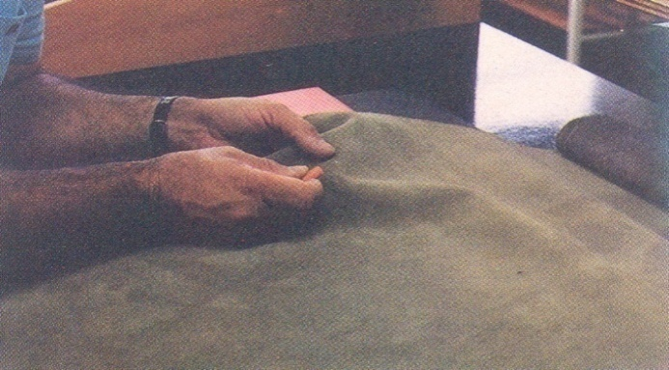
Figure 4.15 Feel/softness and stretch
- Color
Color of the leather is checked by comparing with the reference sample leather or shoe.
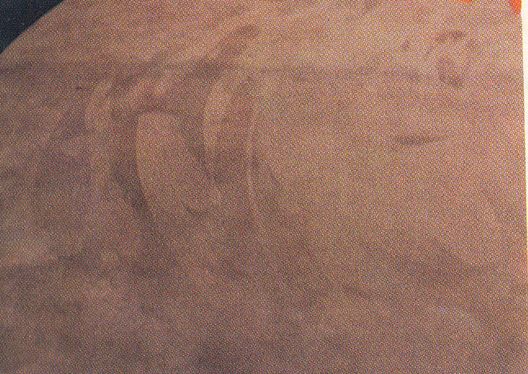
Figure 4.16 Color variation

  - Lay And Assess Of Leather Defects
Introduction
Leather is a natural animal. There are various defects, which may finally appear on finished leather. Some of the common leather defects are listed below: Every skin of an incoming shipment of upper leather is examined for possible defects.
In quality control, defects of the hides have to be identified and marked into zones. Because the range of defects is wide and various, automated defect detectors are still inefficient in identifying and evaluating the whole range of defects. Experienced workers can evaluate the defects best and assign them to five different quality categories of A, B, C, D and holesHowever; defects cannot be eliminated entirely by the current manufacturing technologies. 3 Deeper defected and damaged areas are required to be restored to similar characteristics of grain leathers; this is important from the profitability point of view. Alternatively, coating these superficial and structural defects with flock treatment, as was the case for synthetic leather surface modifications, has been considered as a novel approach for making use of inferior quality leathers with coated fibrous surface appearances, thereby making them alluring products.
When the leathers are assessing on the table before processing for production some variable characters of leather defects are identified. Assorting is a vital process carried out by highly skilled technicians before cutting.
In selecting leather, one should have to know
- What will be made
- What techniques will be used
- What are the dimensions
- What thickness is required
- Will the leather be dyed or natural
- How are parts to be joined by glue, sewing, lacing…etc.
- Is the necessary equipment available and so on

  - Identify And Mark Defects
Defects in hides and skins:
Leather is a natural animal. There are various defects, which may finally appear on finished leather. Some of the common leather defects are listed below: Every skin of an incoming shipment of upper leather is examined for possible defects. We often found a number of defects in hides and skins. These defects occur during the lifetime of the animal as well as after the death of animal.
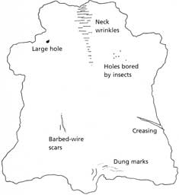
Figure 4.17 Defects in hides and skins
Ant-mortem defects:
These are defects occurring during the life time of the animal we can find two categories i.e. defects/damages carried by parasite, fungal and viral diseases and defects/damages caused by mechanical means.
- Defects/damages occurred by parasite, fungal and viral diseases
- Baldness: is a defect seen in the regions where the bacteria are in or molds (fungi) affected the skin.
- Anthrax: an infectious disease of animals that will cause a defect on the skin/hide.
- Tick: a parasite which suck blood from animals. It is usually found on the inner parts of the thigh and elbow capable of making small holes in the hides by biting.
- Leaches: are usually found on the surface of water. They attack the animals around the rumps and down the bellies and near the fore legs, when the animals are immersing in water pool/pond.
- Pox: Viral diseases that usually appear on the skin as a red spot and turn out in to small blisters and latter grow in to a bigger size.
- Warble HOLES: are fully like insects which attack the cattle and cause damages to the hides forming holes.
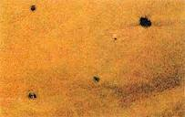
Figure4.18 Holes in leather

- Damages/defects caused by mechanical means
- Brand marks: are generally made for the identification of the animals.
- Yoke marks: are the patches of hardened skin on the shoulder of the animal caused by the pressure and rubbing of the yoke against the hide during plaguing and pulling carts.
- Scratches: are very common type of damages caused by thorns, bar bed wires and horns.
- Bruises: found on the hip and shoulder areas due to crowding, bumping and rushing of animals sometimes caused by caning or whipping the animals.

In addition to the above defects many hides are very poor in substances because of nutrition’s and old age of the animal. A large number of cattle are allowed to linger on till they die of sheer old age. The hides of such animals are loose and lack in proper substance.
Post- mortem defectsAre defects or damages occurring after the death of the animal such as:-
Abrasion: are caused to the hide or skin by dragging the animal or the carcass over the rough ground.
Fly cuts: occur due to careless flying or using improper tool for flaying.
Autolysis: when the hide or skin is removed from the animal an enzymatic degradation (self-digestion) will take place which is called autolysis. To avoid this, curing is to be done immediately after removing the hide or skin from the animal and it only slows the rate of autolysis.
Hair slips: caused by degeneration of either by autolysis or bacterial action before cutting or during storage.
Grain crankiness: in the flaying operation sometimes blunt edged hammers are used to pound the hides to remove easily from the carcass which causes the grain creakiness.
Goad Mark: While plugging the field the cattle in our country often beat by their owner with a stick which is shucked by a sharp nail on the edge. This makes permanent holes on the butt portion of the animal. This defect hampers the quality badly.
Vulture mark: when the fallen animals are left lying in the field for a long time vulture prey up on carcass puncturing the hide with sharp calves. By these punctures, the hides get damaged and reduce their value.
Thorn marks: A long and deep scratches caused by the thorny shrubs of the fences of fields or of the jungles where the cattle stray out to graze.

Faults & surface defects of suede leather
- Flay cuts or butcher marks-These cuts are on the flesh side of the skin & usually trimmed off.
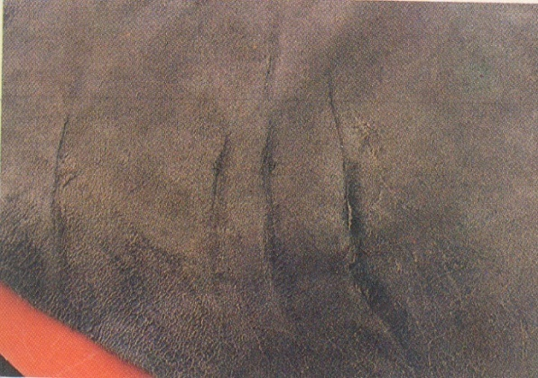

Figure 4.19 Flay cuts or butcher marks
- Patchy coloring- It’s due to the size of the nap.
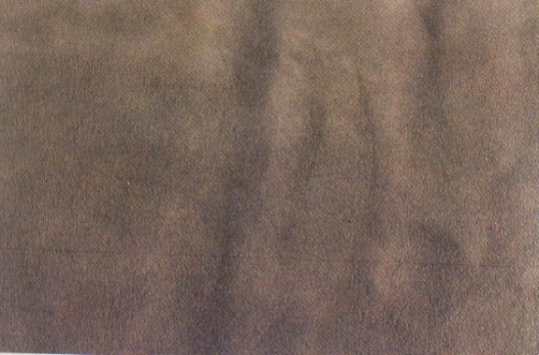
Figure 4.20 Patchy coloring
- Strength- Full strength of suede split.
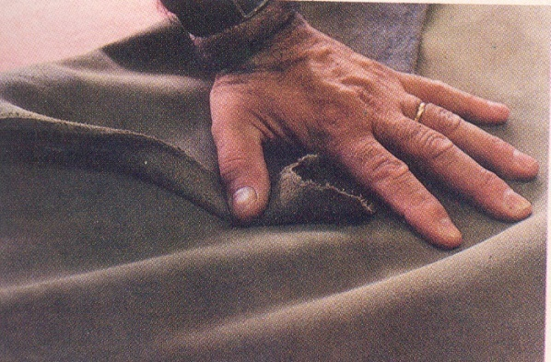
Figure 4.214Strength- Full strength of suede split

Scratches or Blemishes in the Grain: - one of the most common damages of hide and skins is the grain scratches and tears. The main causes are barbed wire, nails, thorns, horns, etc. which encounter the animals during their grazing time, fighting each other or rubbing of the animal to get relief from insect bites, sores, etc.
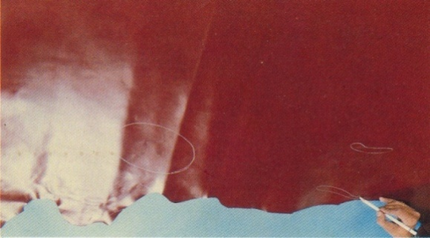
Figure 4.22 Scratches or Blemishes in the Grain
Brand Marks in Butts: - is burning of the hide/skin protein with a red hot iron. The animals are normally burned so deep that the scar tissue forms through the skin and the brands are visible on the flash side. Brands are made.
- As a sign of ownership.
- As a cure from disease.
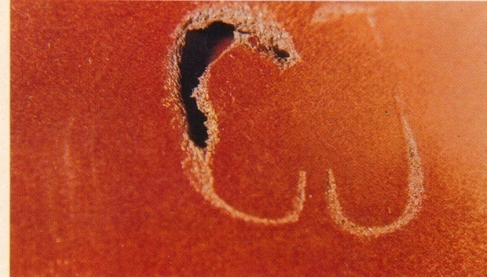
Figure 4.23 Brand Marks in Butts

Growth Marks in the Neck
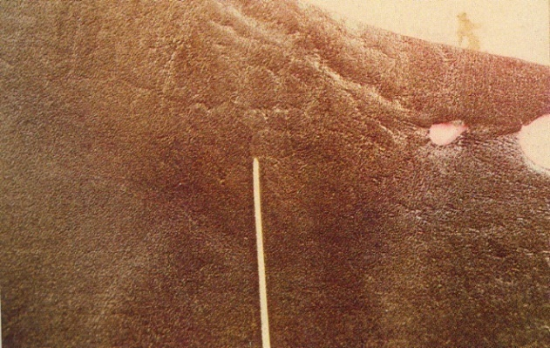
Figure 4.24 Growth Marks in the Neck
Loose Flanks
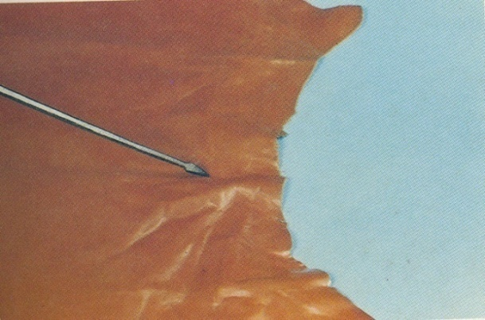
Figure 4.25 Loose Flanks
Vain Marks
Vainness is in which branching lines of blood vessels can be seen on the flesh side. (If, because of poor curing or old age, for example, the structure around them becomes loose, the skin is said to be vein and the branching pattern of the veins usually shows through on the grain side.
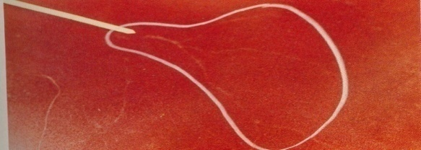
Figure 4.26 Vain Marks

Flay Cuts: - these flaying defects reduce considerably the value of a hide (skin). The damages can all be avoided since they are caused by carelessness or flaying by inexperienced person or by using improper tool.
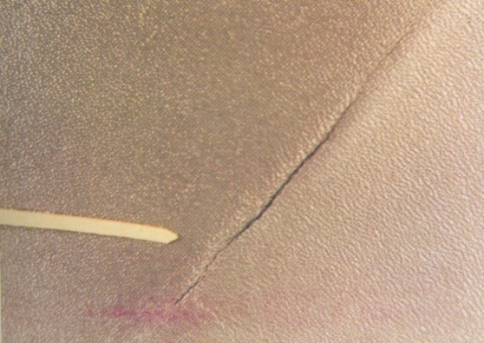
Figure 4.27 Flay Cuts

Stain Marks on Reverse Side, if used for Unlined Shoes
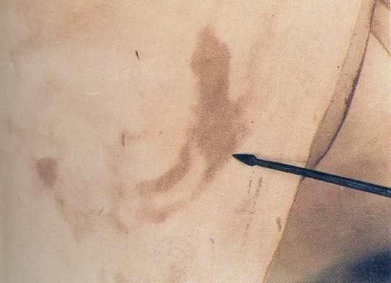
Figure 4.28 Stain Marks on Reverse Side, if used for Unlined Shoes

Coarse finish
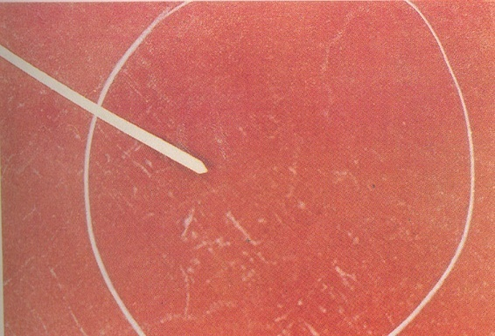
Figure 4.29 Coarse finish
Heavy Break
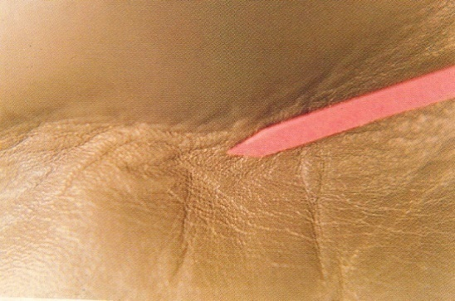
Figure 4.30 Heavy Break

Tick Marks: - leave scars or pits on the hide (skin) or on the finished or semi-finished leather. Rubbing to get relief from the itching leads to grain scratching or tearing and secondary infection .Ticks usually attack the tender part of the skin/hide (bellies). Grain correction cannot remove all damages.

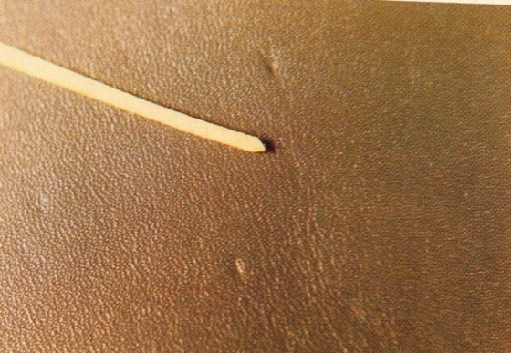
Figure 4.31 Tick Marks
Warble Holes: - The larvae of the warble fly known as grab live in the flesh and lower depths of the corium makes holes through the hide for breathing and later on for escaping from the animal. Warble flies are found in hot countries.
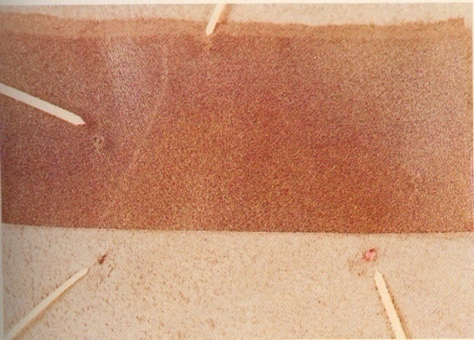
Figure 4.32 Warble Holes

Loose Fibers
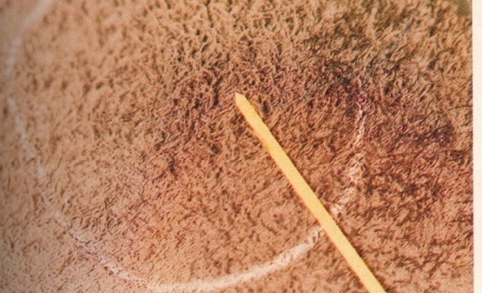
Figure 4.33Loose Fibers

  - Report The Records
Introduction
A report is a document that presents information in an organized format for a specific audience and purpose. Although summaries of reports may be delivered orally, complete reports are almost always in the form of written documents.
Leather assessment is one of the most important before starting cutting leather Garment and Goods. If these are not assessed and sorted there will be high rejection rate. Based on the assessment the assessment and assortment the following result have to be reported. Final inspection is very important in catching quality problems. This is the last check before the cut components are sent to the next operation. Skilled auditors are required to perform this job because many of the defects at this point require the attention of a skillful eye

The Cutting Report displays information about the panels, parts and off cuts contained in the whole cutting layout. To reach this section select "Cutting Report" tab in the main window. Panels - displays information about the panels in the cutting layout as a result of the optimization process.
This technical report includes the observations, findings and recommendations of the expert on further action to be taken. It describes also the method used during the seminar for experts who will follow up with an evaluation of the results obtained.
Cutting section plays an important role in manufacturing Footwear, Garments, Leather goods etc. as 70% of the cost of product is influenced by Cutting Department in the form of material. To run this department successfully, following goals must be achieved:
Included information defect report
What is included in defect report?
Defect reports contain details of actions in the software application that don't get the expected result. Defect reports provide vital information for application development management and staff to fix areas of the application that don't work properly.
- ID.
- Description.
- Product.
- Steps to Replicate.
- Release Version.
- Actual Result.
- Component Feature.
- Expected Results.
- Defect Reports Should Clearly State the Problem
How do you write a defect report?
- Step 1: Define the defect. The first step is to define the defect by writing a summary in the defect title and providing a general description of the problem. ...
- Step 2: Research the root cause. ...
- Step 3: Add supporting documentation. ...
- Step 4: Format your report for high readability

Self check-4
Directions: Answer all the questions listed below. Examples may be necessary to aid some explanations/answers.
- What is the name of the table used for leather matching?
- What are the different methods for testing and evaluating leather properties?
- Explain different types of leather sorting?
- Explain the mining and use of buff hide?
- ------------ Leathers are largely used in furniture and automobile industries.
- What is an ant-mortem defect and post-mortem defect?

Multiple Choices

1. _________________ is defined as an area, in an office, outfitted with equipment and furnishings for one or more workers

A. Factory

B. School

C. Work station

D. College

2. ______________should starts from butt to belly (i.e. from left to right side and from bottom to top).

A. Stitching

B. Assembling

C. Cutting

D. Selecting

3. ________________is a material made from steel and used to hold the material (leather) against the cutting table so that the leather will not move while the cutting process is held.

A. Weight/Load

B. Cutter

C. Awl

D. Knife

4. When bundling the leather, start from the_____________ and roll it over until you rich the neck on the grain side so that it would be easy to store .

A. Belly

B. Butt

C. Neck

D. Shoulder

5. ______________ leather is soft and have larger area with increased cutting value and smoothness of grain. It is used for making softy types of leather goods.

A. Cow Napa

B. Cow Milled

C. Upholstery Leathers

D. Split

6. _____________ is the poorest in quality, on the sides of the skin/hide lot of elasticity and stretchable.

A. Belly

B. Shank

C. Butt

D. Neck

7. Once the model (the particular product) to be cut with all its specification has arrived to the ______________ department.

A. Design

B. Cutting

C. Stitching

D. Selling

8. The cutting person should prepare all the necessary materials i.e. Leather, lining, reinforcements and all other materials accordingly including the ______________ and _______

A. Quality & Quantity

B. Color& Texture

C. Color& Thickness

D. All

9. The type of sorting will assist the proper utilization of material to use bigger patterns.

A. Sorting By Texture

B. Sorting By Color

C. Sorting By Size/Area of Leather

D. None

10. The best part of the leather is used for cutting the greater proportion of_____________ parts (patterns).

A. Large B. Small

C. Medium D. All

Note: Satisfactory rating –above 60% Unsatisfactory - below 60%
You can ask you teacher for the copy of the correct answers

Operation sheet-4

Operation Sheet 4.1 Sorting and assessment of leather according to color and grain
Purpose: to sort and assess color shades
Materials and tools:
- Color sheet
- Leather
- Florescent
- Procedures:
Step 1: Selecting Leathers by consider like feel, thickness, color/shade, texture, stretch, grain pattern, etc.
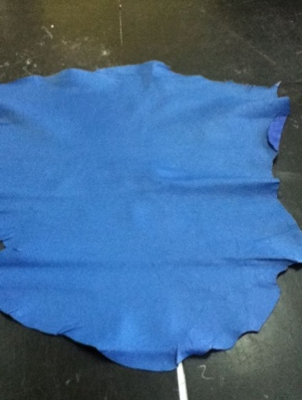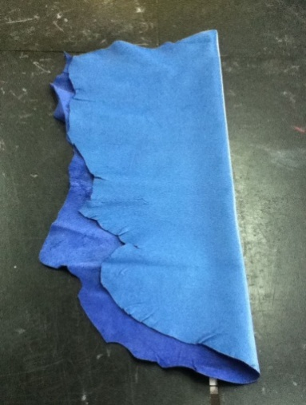
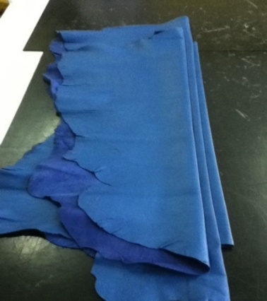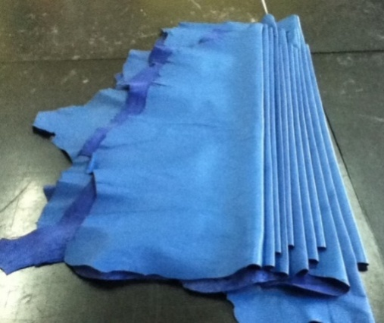

Step 2: Sorting leathers
Step 3: After selecting leathers, they are sent with patterns having fabricating details to the next process of cutting.

Operation Sheet 4.2 Separating different types of leather on cutting table
Purpose: assess and sort different types of leather
Materials and equipment: cutting board, leather, florescent light
Procedure: identify by sorting and assessing defects of different leather types
Step 1: Color matching
Step 2: Grain matching
Step 3: Separating different types and size of leathers

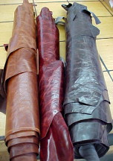

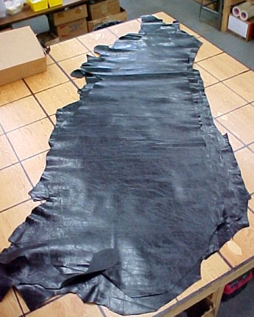
Figure 4.34 Separating different types and size of leathers

Operation Sheet 4.3 Identification and marking of defects
Purpose: To identify and mark defects
Step 1: Assess and sort leather for defects
Step2: Noticeable defects are marked with a silver marking pencil, which can be easily erased by a piece of soft cloth.
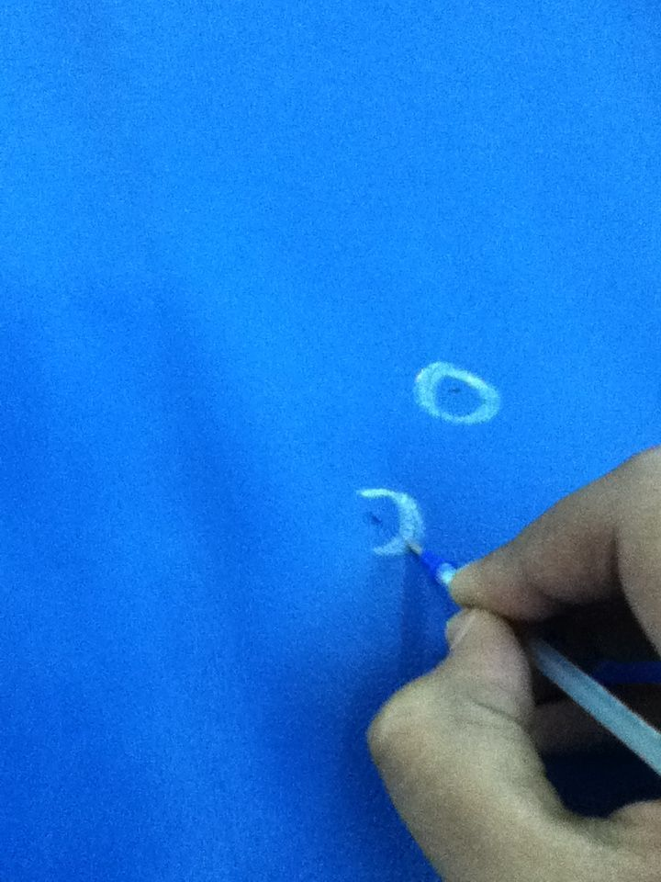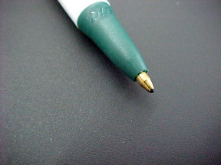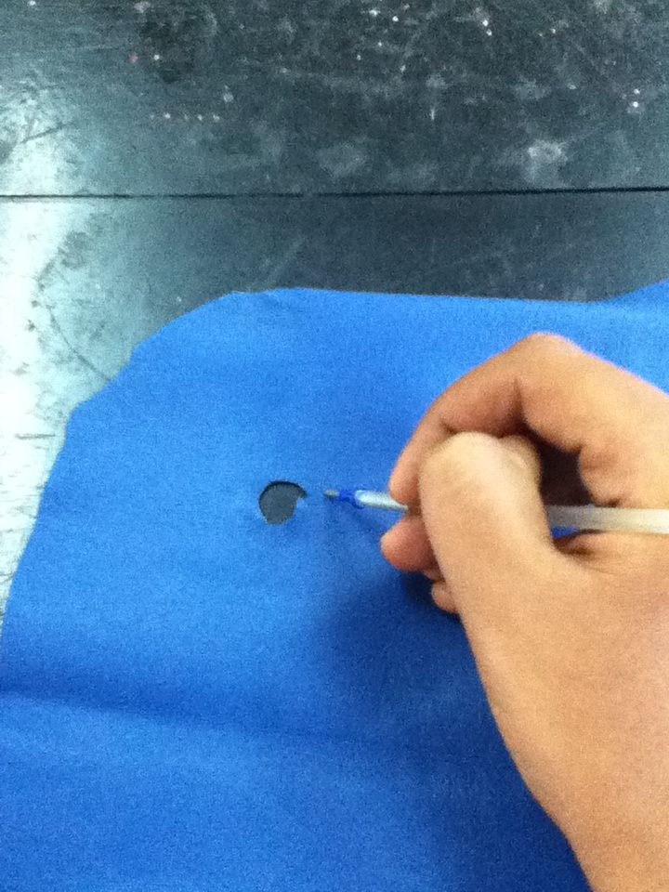
Figure 4.35 Identification and marking of defects

Lap Test-4
Instructions: Given necessary templates, tools and materials you are required to perform the following tasks. The project is expected from each student to do it.
Task 1Sort and assess color shades
Task 2Assess and sort different types of leather
Task 3Identify and mark defects

Unit five: Cut leather by hand
This learning guide is developed to provide you the necessary information regarding the following content coverage and topics:
  - Identify defects and faults
  - Positioning patterns
  - Match patterns shape, type, size and leather quality
  - Cut components
  - Check the actual consumption of cut components.
  - Identify and repair faults with patterns, knives and cutting boards.
  - Carry out works
This guide will also assist you to attain the learning outcomes stated in the cover page. Specifically, upon completion of this learning guide, you will be able to:
  - Identify defects and faults
  - Position patterns for economical cutting
  - Match patterns shape, type, size and leather quality using cutting norms
  - Cut components Precisely matching size and color
  - Check the actual consumption of cut components.
  - Identify and repair faults with patterns, knives and cutting boards.
  - Carry out works according to OHS practices

  - Identify defects and faults
Defect and faults identification
The correct pattern layout will help ensure that your leather is cut out on-grain. Pinning and cutting your leather carefully will avoid wasting leather.
Leather can be folded in a variety of ways before pattern pieces are positioned for cutting.
Use the following guidelines when laying out your pattern pieces on your fabric.
- Circle the correct layout diagram on your pattern instruction sheet. Choose the correct diagram according to the pattern view, size, and fabric width.
- Make any desired fit or design alterations to your pattern before laying it out. “Pattern Adjustments,” for more information on alterations.)
- Lay all pattern pieces on the fabric before pinning any of them in place. This will allow you to make sure that all pieces will fit on the fabric
- Follow the shading key shown on your instruction sheet. Solidly-shaded areas denote fabric. Unshaped areas denote pattern pieces to be placed with the printed side up. Lines denote pattern pieces to be placed with the printed side down.
- Sometimes a layout diagram will show a pattern piece that is placed halfway off the fabric. This piece will usually be accompanied with an asterisk (*). Find the symbol on your instruction sheet and follow the directions given. This symbol generally means there is not enough room to place the pattern piece on the folded fabric. The instructions will tell you to cut out all other pattern pieces. Then you should open the fabric to accommodate the piece that was placed partially off the fabric.
- Sometimes a layout diagram will show two pattern pieces with the same number. This indicates that the pattern piece will have to be cut out twice, such as when you need four cuff pieces. The pattern will only include one pattern piece. Therefore, simply relocate the pattern piece and cut it out a second time.
- Avoid placing pattern pieces on the selvage edges of the fabric. Selvages do not give and can cause seams to pucker. If you must place a piece on the selvage, clip the selvage about every ½ inch to create more give.
- When you are cutting two layers of fabric, the pattern pieces do not have to be placed printed side up. If you are cutting one layer, however, the pattern pieces must be placed printed side up. They must also be placed on the right side of the fabric. Otherwise, you may find that pattern pieces fit the wrong side of your body
- Be sure to use the “with nap” layout when working with napped leather. “The Pattern Envelope,” for more information on napped fabrics.) Also use this layout when working with knits, as most knits tend to have shading in one direction. If this layout is not followed, differences in color may appear on the finished garment.
Leathers
Leather can be made from the skin of any animal, bird, fish or reptile although only that from cattle and a few other farm animals, such as sheep, are of major commercial importance. The skin of most animals consists of three main layers: the grain, the corium and the flesh. The grain is outer most on the animal; the corium is the main or central layer with thicker fibers and provides most of the strength of the leather; and the flesh is a thin layer between the corium and actual flesh of the animal.
The latter is of little value in the finished leather and may be partly or wholly removed. Leather is usually sold as whole skins or as sides. A side is one half of a whole Skin cut along the backbone. Most skins are split down in thickness and, therefore, do not contain all three lasers. The best leathers have the grain laver intact with varying amounts of corium. Flawed leathers have the grain bulled or corrected before finishing. Most suede's are made from splits without the grain.
A split may also be coated to simulate a grain surface. The skin is converted to leather by a process known as tanning. The two main methods are chrome tanning and vegetable tanning. Most shoe leather is chrome tanned although mixed vegetable/chrome treatments are also popular. Chrome tanned leather has good resistance to heat, moisture and perspiration.
Suitability of leather for upper materials
- Elasticity and plasticity
- Strength and stretch
- Permeability
- Surface characteristics
- Ease of working and maintenance
Collecting, sorting and lay out materials in preparation of cutting
Material collection: It means the amount of the material issued to the clicker from the store for a particular order or plan. A work ticket is issued to the clicker. In this work ticket order no., color of the leather, sizes of the pairs, sizes of the skins, no. of the pairs to be cut etc. is mentioned. On the basis of this work ticket leather is issued to the clicker. Clicker collects the leather from the store.
Cutter’s ticket
NAME OF THE ORGANIZATION
CUTTERS’ JOB TICKET.
CUTTER’S NAME:-________________________
DATE:-____________________
MATERIAL:-_______________________
COLOR:-__________
GRADE:-____________ LAST NO:-_______
STYLE MODEL:-_____________________
MATERIAL ISSUED:-_____________________
MATERIAL RETURN/EXTRA:-________________
SAVED/WASTE MATERIAL:-_________________

DEPARTMENT’S SINGNATURE:-

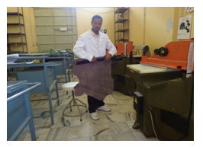

Figure 5.1 leather product work shop cutting section
Sorting of Leather
Leather may be sorted for standard size, grain and shade. This increases his productivity. The sorting is done as follows:
Leather

Big Size Skins Medium Small

Dark Shade Light Shade

Before starting cutting the cutter must check
- Tin patterns
- Work tickets
- Production samples and production guide
The perfect state of tin pattern has the important task at clicking out. At the check the clicker concentrate on
- Cutting edge quality
- Dimension (time to time the patterns are checked with the master pattern in production)
- Design
- Faults
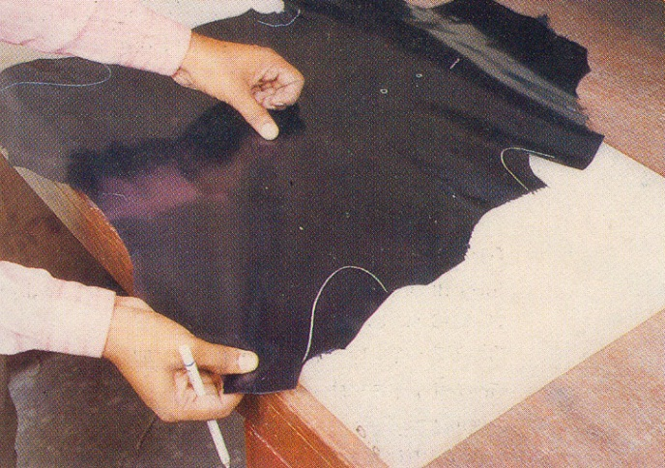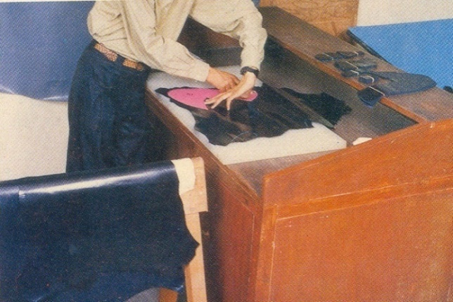
Figure 5.2 layout leather on table and cut

The material is put on the leather horse according to the following rules
  - At first he can put thinner leather and thicker ones are put up.
  - Color shades are put from the darkest to the lightest ones step by step (for an easier pairing).
Whole leather is over loaded at the longitudinal axis by grain up and shifted out slightly.
Textile
This term describes any-woven or knitted material. Yarns used for weaving and knitting are of natural origin, such as cotton, wool or linen, or a host of synthetic yarns, such as viscose, nylon, etc. Some fabrics are made of a blend of natural and synthetic fibers. All textiles used in shoe production must be backed with another material, usually cotton sheeting or drill, or double-woven in such a way to provide the necessary weight or thickness required of shoe uppers and linings.

  - Positioning patterns
Positioning patterns for economical cutting
- Laying out the patterns
- Separate the patterns individually
- Nest the patterns by laying it adjacent or by a 180 degree flip
- Ensure minimum amount of interlocking waste
- Repeat until original outline is surrounded by patterns
- Mark the vertices of a parallelogram formed by the nested patterns
- The parallelogram contains two pieces of the nested pattern plus the interlock waste (also called the First Wastage)
- Find the area of the parallelogram
Consistent with these principles the aim of the cutter is to use his leather as economically as possible by avoiding waste involved in uncut able remains. He does this by arranging the patterns or knives so that they interlock closely.

The aim of the cutter is to reduce the waste as much as he canExperience enables him to see exactly where and how each pattern would be placed. Some guiding rules are.
- cut larger sizes from the larger skins
- Fit a straight line to a straight line: a curve to a like curve.
- Never cut a section without planning the next.
- cut sections square across the leather, avoiding awkward angles

After preparation of any pattern like jacket, coat, skirt etc. on card board place those patterns on leather and lining by analysing pattern placing for economical cutting.

Requirements
- Tools
- Furniture
- Materials

Pattern positioning
- Use the pattern as a knife-guide. Keep the blade edge against the pattern at all times
- Your cutting movement with the knife should be as continuous as possible. Shorter cuts and several stops will give you irregular edges as the stop points
- Arrange your straight edge patterns in the way that straight lines fit against straight lines to have a minimum amount of waste.
- To minimize waste of curved edge patterns, use the possibilities similar curved patterns
- Keep patterns ‘square’ to back bone line. Do not turn patterns to avoid defects as this will create more waste
- Always keep a note of how many pieces are cut to make complete sets. Do not leave one pattern to last as good quality leather may be used for an unimportant piece.
- Work out small and large patterns together. Mix pattern shapes to get the best combination/utilization
Always remember that you should reach the maximum quantity of parts at a consistent quality.
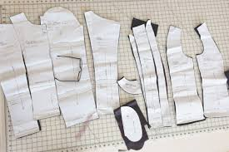
Figure 5.3Garment patterns

Grain, color & shade matching:
- When cutting in the pairs cut pair matching grain, color & shade.
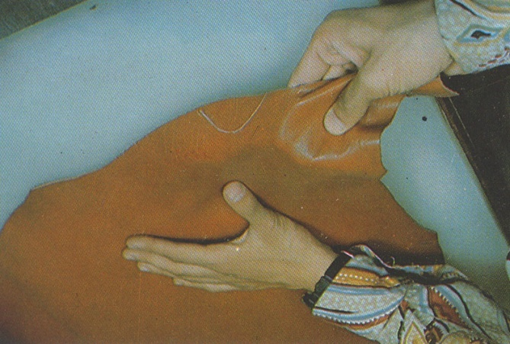
Figure 5.4
- Check tightness
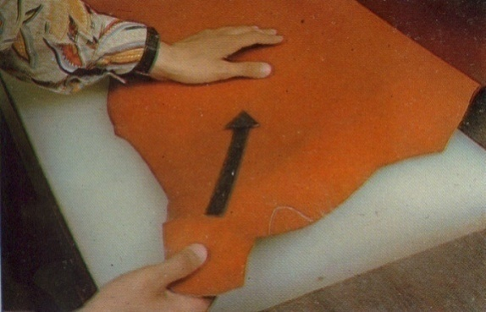
Figure 5.5
- Check the components to make sure that all the patterns are there, if you are missing a pattern you may find it impossible to grain match later.
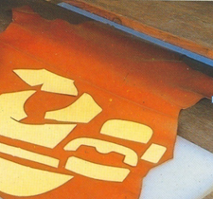
Figure 5.6
- From your cutting sheet always when possible start cutting with the largest size pattern & the larger skins. This will give you better material usage.
- Buff calf leather has a matching grain that is the same on both side of the backbone.
  - Cut components
Manual cutting
Leather is a tough and durable substance, and it can be very difficult to cut. The various ways to cut leather include a straight edge, a utility knife, a leather shears, a rotary knife, a mallet cutting die, a clicker die, or a laser cutting system. A pattern is the first step in precisely cutting leather. To make a customized pattern, draw a design on paper with a pencil or use a computer drawing program.
Lay the paper pattern on the leather piece. Start out cutting with either a straight edge utility knife or a rotary cutter. A rotary cutter is effortless to use and if used the right way, it results in a clean edge. Safety warning: This tool has an exceedingly sharp blade and should be used with care. Keep the rotary cutter, and all sharp cutting tools away from small children. Cut your leather using the rotary cutter, using a self-healing cutting mat beneath the leather. These mats keep your table or counter surface from being damaged by the cutter.
A Leather shears is a industrial scissors that usually has serrated blades, and it is able to cut soft or even heavy strap leather. A good quality leather shears will cut through most leathers with simplicity. The razor utility, swivel knife or hobby knife pertains generally to cutting tools and more specifically to cutting tools that are engaged in leather craft. Conventional hand cutting tools that are generally utilized by hobbyists and others occupied in the art of decorative leather tooling typically consist knife-like blades fixedly and permanently mounted within a holder that is accommodated for manual operation by the user.
Strap cutter is a changeable wooden cutting tool that cuts parallel strips of leather from part of a hide. It works equally well with heavy strap leather or soft garment leather. It is able to cut 16 oz. leather in to 4" straps or soft suede into strips. A clicker press is a machine that cuts shapes out of rolls of soft material, such as rubber, cardboard, or leather, using a sharp metal piece called a die. A metal tool and die shop will take a pattern, and bend, weld and form pre-sharpened steel into a die. A cutting die is commonly a steel cutting tool to be used with a clicker press. Cutting dies are appropriate for cutting paper, leather, rubber, plastic and more including envelope cutting dies, label cutting dies, clicker dies, window dies, punch dies, gasket cutting dies, washer dies, trimming dies, high dies, threaded punch dies, rotary panel cutters, corner blades, strap dies and more.
Leather is increasingly cut by laser. Laser leather cutting is a highly skilled job. The operator will program the design to be cut by the laser cutting machine. Cutting leather in this method may be a time consuming exercise. The leather cut by laser is extremely accurate, and true to your pattern. There are many different methods for cutting leather, which is a tough, durable, and difficult to cut material. For the small manufacturer a clicker or mallet cutting die would increase production. The larger manufacturer usually uses clicker dies or laser cutting system for its leather cutting. For the home craftsman, the best ways to cut leather would include the leather shears, the utility knife and straight edge
For individual products or small amounts, the blanks can be cut using a template. A stencil is placed on the leather and marked. Then the leather is cut out by hand with a pair of scissors or a knife. Important! Markers with permanent inks can cause color migration. There are various pens for marking leather, which do not cause such problems.

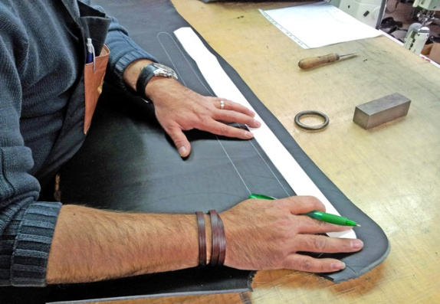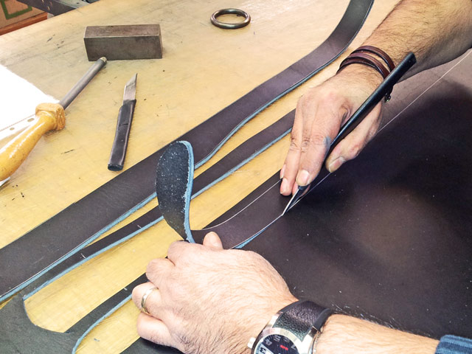
Figure 5.7 Hand cutting operation
Cutting tools and equipment used in cutting leathers Leather is a tough and durable substance, and it can be very hard to cut. The diverse ways to cut leather include the following tools and equipment. Cutter –use to cut leather Scissor –use to cut leather Cutting board –a surface to where the leather is cut off Upholstery knives French curve –use to trace curve line leather cutting shearSticks Ruler Leather knife tapered round handle leather knife Cutting pattern tracing pencil –use to mark cutting line

Machine cut
There are various machines for cutting leather and, with the aid of lasers; it is possible to detect the external contours of the leather skins. For this purpose, leather damagesare marked. Computer programs then calculate the optimal cutting. The skin is then aligned on the cutting table. The outer contour of the previously scanned skin is marked on the table by light, so that the skin is correctly positioned. Then the skin is sucked onto the table by vacuum and the cutting is automatically performed by a knife or water jet. Small knives, costing less than €10, can cut up to 15 kilometers.
Soft or wavy leathers are cut by placing a plastic film around outer edges of the skin. The vacuum ensures the edges stay flat on the table allowing them to be cut either by a machine or a knife.

Cutting Technique
Your material and technique
- The best part of the leather is used for cutting the greater proportion of large parts (patterns).
- Start to cut smaller parts after large parts are completed.
- Place several patterns on to the leather at the same time to get the best combination (reduce waste)
- Always plan two or three cuts ahead. Never cut without knowing where the next pattern will be placed.
- Always start cutting at the butt part of the leather and proceed along the backbone to the outward direction as much as the quality and substance of leather is suitable
- If you are cutting skin leather, start also at the butt and continue towards each side from the backbone to the shank until you reach the neck.
- If you find defects near the backbone, start cutting as close as possible to the defected portion and proceed towards the direction from the backbone to shank.

Key points to be remembered during cutting:
- Make sure of correct patterns and markings.
- Examine for defects size and shape of the skin.
- Selective cutting must be practiced. The best part of the article demands the
- Best part of the skin.
- Visible part must have good grain surface and section covered could contain grain defects.
- Good cutting begins with a sharp knife. Less sharpened knife or blunt knife
- Cuts the leather with ragged edges.
- The angle between the edge of the knife and the cutting board depends of the
- Hardness of the material being cut. A small angle for very soft materials like fabric and a greater angle for hard materials like leather and reinforcements.
Leather
Leather is the most suitable Material for uppers, linings, insoles, outsoles, heals toe puffs and stiffeners. Leathers for foot wear are commonly produced from calf, cow buffalo, kid, goat and sheep. Most high quality shoes sold today are still made of leather just as they have been for centuries. Leather is still the material of choice for its durability and flexibility. Some leathers are more desirable than others and in this article we will go over some of the qualities of different leathers and how they are used.
Full grain side leather: - which is used to make the uppers for shoes is one of the most versatile of all leathers as well as being the most common. This type of leather is very durable and malleable while possessing the other desired characteristics of leather such as breathability.
Corrected grain leather: - as the name indicates has the surface grain either partially or completely removed due to the fact that the tannery has deemed that the hide has too many natural hallmarks on the surface. This of course would reduce the cutting efficiency of the hide so the tannery will buff the surface and then apply a simulated grain to the surface after the pigmented finish is applied. This improves the durability of the surface. When produced by a tannery experienced in the manufacture of leather, corrected grain leathers can be expected to give excellent service.

Nubuck leather is a type of leather with a soft, velvety surface and is some of the most expensive leather to purchase. Unlike the less expensive suede, Nubuck leather is far more durable and is excellent for use in shoe because it will last much longer than suede.
Suede is produced from the under layer of the hide that has been split. The split side is aniline dyed and buffed to create the typical velvety effect.Suede splits are used in shoes, garment and handbag industries.
Sorting of the suede leather
For doing this nesting exercise following points is to be considered
- Suede split –The skins are usually too thick & heavy for footwear upper.
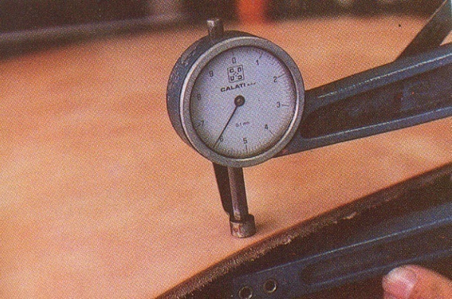
Figure 5.8Suede split
- They are usually split.
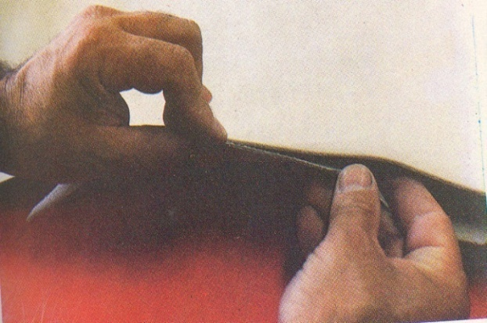
Figure 5.9

- The flesh side is made in to suede.
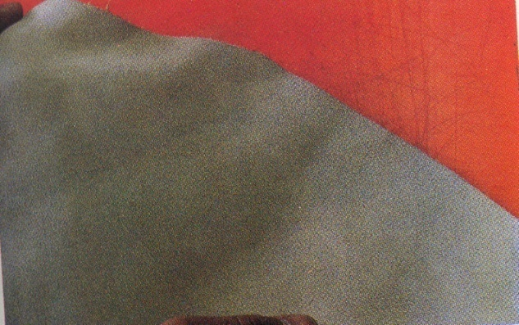
Figure 5.10
- Flesh split make inferior suede leather( splitting cuts the fiber structure)
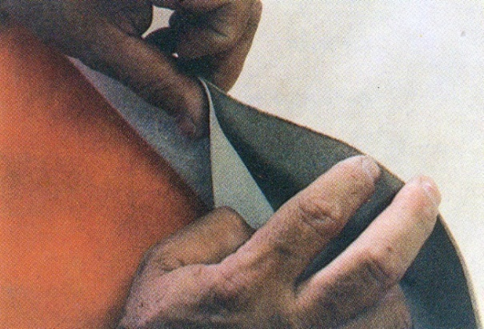
Figure 5.11
- The skins vary in colors.
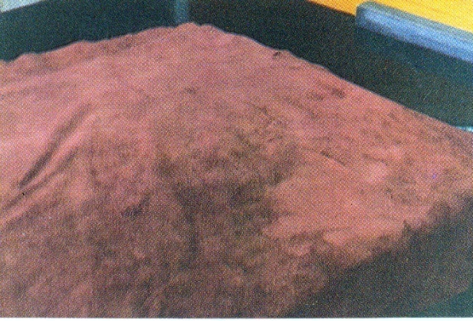
Figure 5.12
- The nap varies all over the skins (the nap refers to the fineness or coarseness of the split texture.
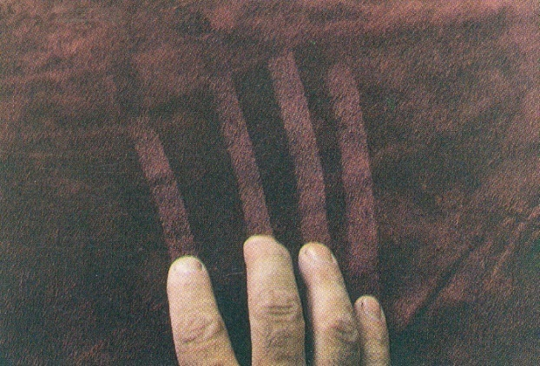
Figure 5.13
- The size of the suede usually varies from 50-150 sdm.
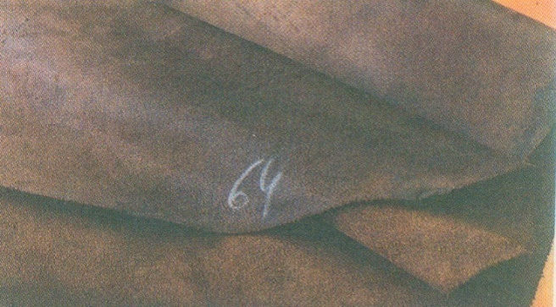
Figure 5.14
- Sealed break: The reverse side (back) of suede is sealed on the flesh side of the skin.
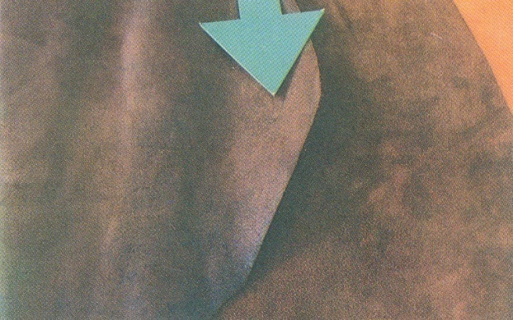
Figure 5.15
- Sealed back: Sealing back also waterproofs the material & improves the comfort in an unlined shoe.
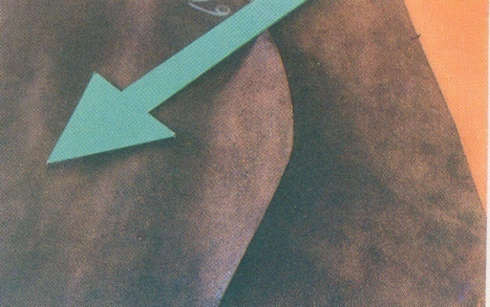
Figure 5.16
- The thickness of the suede varies from 1.2-2.5mm.
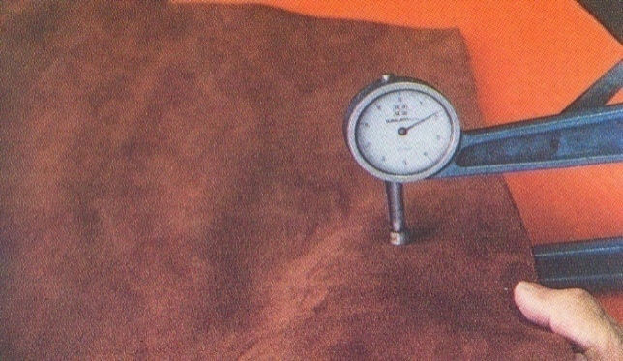
Figure 5.17
- The skins are usually trimmed severely.
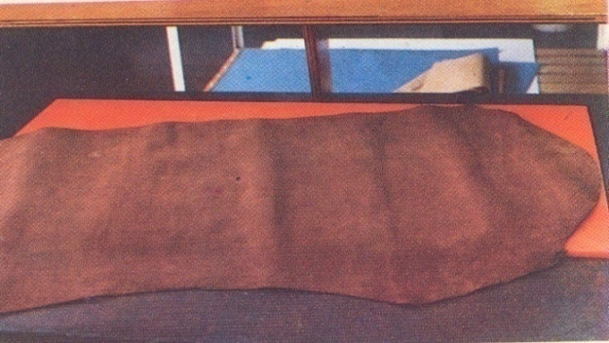
Figure 5.18
- They are almost trimmed in square.
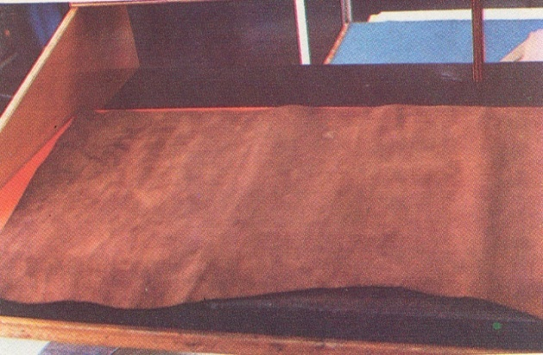
Figure 5.19
- Suede split have a weak fiber structure.
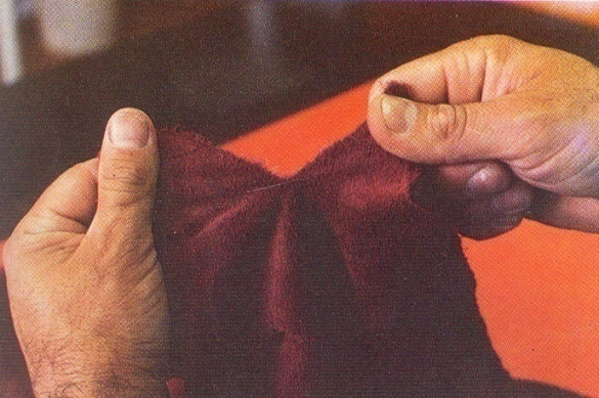
Figure 5.20
- Full grain suede-When the grain surface of otherwise good quality skins is damaged. The flesh side is snuffed to make the suede. This leave grain layer as backer to the flesh side & thereby making strong leather.

Figure 5.21

- The color of the suede may vary due to the nap. The nap varies greatly especially in the belly & flank area.
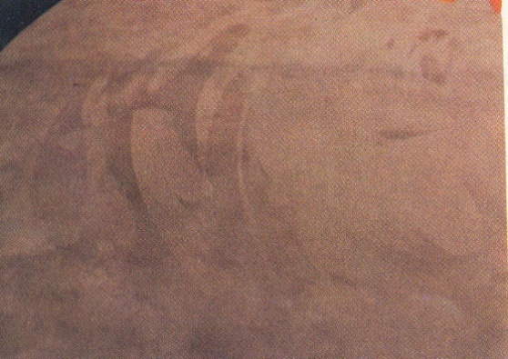
Figure 5.22
Sheep Napa leather is a full-grain leather, typically dyed, made from sheep-skin by tanning with salts of chromium or aluminum sulfate, and noted for softness and durability. It is often used in high-quality leather products.
Sorting of goat leather
- A goatskin is very similar to a kidskin, only larger in size. The grain of the leather will be coarse with areas around the flank showing slightly more offal, although this will vary from skin to skin.
- Substance will also vary over the skin.
- Due to the size of the skin approxpairsPlus will be normal. If the skin cuts 2.5 pairs then the same rules for grain matching apply as kid.
- Variation in the color can be found in the goat. This must be taken in to consideration when grain matching.
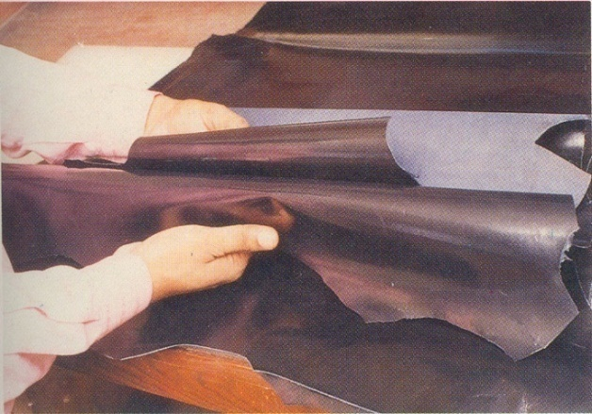
Figure 5.23
The same rule applies with the back bone as in the kid. It should not be used in the center of the vamp as the grain will be open up.
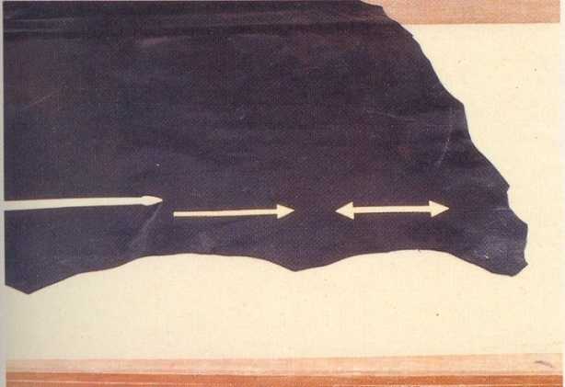
Figure 5.24
- In goat leather the clicker must test his leather for stretch, to ensure that the cut parts are correct.
- They should always grain & color matches his skins prior to the cutting.
- These will be graded in to three grades, fine grains, medium grain & coarse grin.
- The smaller skin is used for small sizes, the larger skins for the larger size.
- After grading & selection of the cutter should place the leather on hoarse.
- Ensure that your patterns are smooth & the knife is sharp.
Area of skin
Leather from different parts of the animal varies in its characteristics, and this has to be taken into account when using leather in products. The hide thickness varies all over the animal, and to get it to the right thickness it is usually split on a special cutting machine or buffed to an even thickness. The main parts of the hide are shown in the diagram below
- The butt is composed of the stoutest leather as this covers the delicate organs along the back. This is also most even in quality and texture.
- The shoulder is of lighter substance but the quality remains good.
- The neck varies considerably. Cattle, especially bull calf, and sheep, tend to be quite stout in substance but heavily lined with growth Marks. This does not apply as much to goats.
- The shanks are light but the quality is often quite sound.
- The belly this part of the hide is quite thin and has a much looser fiber structure than the back, and often stretches under stress.
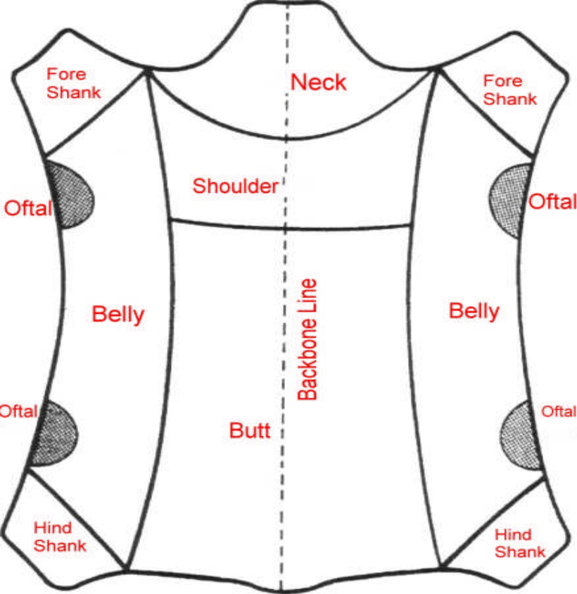

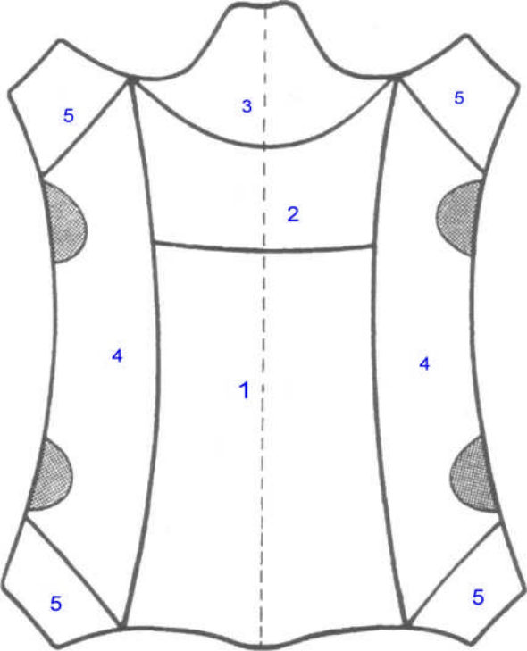
Figure 5.25Quality area of leather
  - Check the actual consumption of cut components.
The most common and widely used data sets in the field of food consumption statistics are obtained through food balance sheets. They provide estimates of quantities available for human consumption in a country during a specified period.
Estimation of Quantity of Materials
Material cost is the cost of direct and indirect materials (including all waste) in the production of a product(s). As a general rule each material has a defined percentage waste. Estimating material requirement means that estimating the gross usage of materials which includes the defined waste percentage of the respective materials. So, to estimate gross material usage (material requirement), one can use the net pattern area measuring techniques (to be discussed next) and then measure the area of each component cutting patterns and add up the area measurements together. Finally, incorporating the defined waste percentages discussed above, it can be concluded that the gross material usage (material requirement) is calculated.
Net Pattern Area Measuring Techniques
Some of the methods of measuring the net pattern area are the following:
a. Using Square or Graph Paper (see operation sheet 2)
b. Using Measuring Grid – Transparent (plastic) grids of area 1 sqft, 0.5sqft and 0.25sqft with squares divided into 1/100 sqft squares should first be prepared.
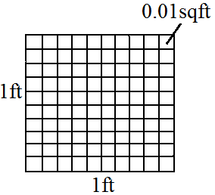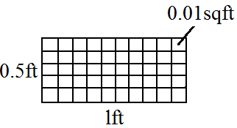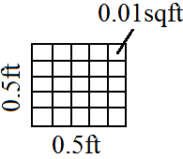
Figure 5.26 Plastic grids of 1 sqft, 0.5 sqft, and 0.25 sqft respectively.
Measuring is done using any of the three grids depending on the size of the component cutting pattern.
c. Use of Balance - cut a one sqft of the material which the pattern is made of. Weigh this 1sqft pattern material and record the result (it is a good idea to write the weight on the 1 sqftmaterials itself). Weigh the pattern and record its weight. Calculate the net pattern area by relating the weight of the 1sqft material and the weight of the material.
Net pattern area = Weight of the pattern
Weight of the 1sqft pattern

d. Use of Computer – net pattern area can be measured using computer with digitizer.
Hence, using one of the net pattern area measuring techniques, one can estimate the leather, lining and reinforcement materials required (gross material requirement) to manufacture one goods product.
In calculating the lining consumption we divided the total area of the lining components by the width of fabric (mostly 120cm) to get the total lining consumption in running meter.
To find the gross lining consumption of the Kelly bag we have to add a waste percent of 15% of the net which is the standard waste percent for leather on the net leather consumption.
Therefore, Gross lining consumption of Kelly bag = 0.21m + 15% of 0.21m
= 0.21m + (0.15 x 0.21m)
= 0.2415m = 0.24m
Reinforcement: calculating the consumption of reinforcement material depends on the unit of measurement of the material.
Some sell reinforcement materials in ft², cm² or m² and others sell in sheet or pc^{s}. If the reinforcement material is bought in pc^{s} or sheet, we have to calculate how many components can be cut out of a piece or sheet of the reinforcement material and then we can easily arrive at the net consumption. If bought in m², cm² or ft², then the net consumption can be calculated similar to leather or lining consumption.
N.B: consumption calculations should be done using cutting patterns.
Accessories: consumption of accessories depends on the design or style of the end product
How garment consumption is calculated (lining)
- Fabric Consumption by Single Formula Method: (Body length + Sleeve L. + Allowance) × (Half Chest + Allowance) × 2 × 12 × 160. ...
- Fabric Consumption by Individual formula Method: Body part consumption; (Body length + Allowance) × (Half Chest + Allowance) × 2 × 12 × 160 × 1.10. ...
- Fabric Consumption by marker planning formula:
  - Identify and repair faults with patterns, knives and cutting boards.
    - Pattern defects/faults
- Some parts of pattern are missing, probably because the marker did not include the correct number of parts.
- Mixed parts—probably because the marker is not correctly labeled, resulting in a marriage of wrong sized parts.
- Patterns not aligned with respect to the leather grain.
- .poor line definition
- .skimpy marking-caused by either the marker did not use the outside edge of the pattern.
The following are some leather problems and faults with knives and cutting board;
- When your blade is not perpendicular to the leather. Your cuts will appear to be straight but you will find out that they’re not completely straight once you get to the process of burnishing.
- When cutting knives is not sharp there is not create clean, smooth cuts and other much fewer mistakes.
- When you do not use a coin or washer as a guide during cutting smooth curves in your leather, Line your coin up into the corner of your leather, following along the edge with your knife.
- When you guide the blade with your wrist instead of with your body, you may have a natural tendency to guide the blade with your wrist, but your wrist has a limited range of motion. Instead, keep your elbow in close to your body and pull the cutting motion with your shoulder. This will keep you on track and ensure that the blade remains straight.
- Using a hobby knife to cut thin leather of 1 mm or less can pull and crease the leather and make it harder to get a straight line since it’s so fragile and more prone to moving. It’s best to cut thin leather of a thickness of 1mm or less with a rotary cutter. For the best results, keep the rotary cutter as close to the edge of the ruler as you can get.
- When you don’t slowly and gently drag the hobby knife along the cut line the edge of pattern become jagged. For thicker material, all you need is a sharp hobby knife to get a clean, straight cut, in addition to a sturdy ruler.
- As with knives, cutting surfaces need to be flat, smooth and somewhat soft so your blade doesn't get dulled or broken too easily.
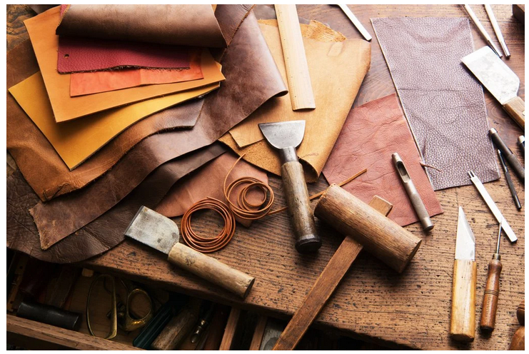
Figure5.27Cutting tools

    - Check patterns with master patterns.
Before start cutting the operator must check the all patterns, this is simply improve by assemble the patterns and check which pattern is missed and he must have the sketch or the sample of the model. This is used to cut quality leather for seen part of the shoe and he is simply understood the stretch and tightness or generally the grain line. Before starting the cutting the cutter should consider the following things:-
- Cutter’s ticket: - With the help of this cutter can know the article no., no of pairs to be cut, leather color, leather type, size assortment of the pairs etc.

Table 5.1Cutter’s ticket
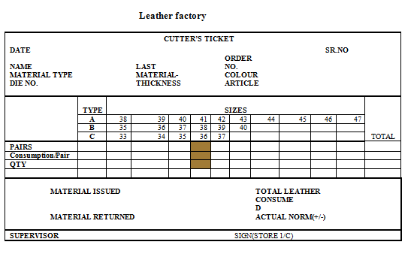
- Cutting patterns: - Should be checked properly
- Cutting handle: - Blade of the cutting handle should be sharpened properly and curve of the blade should be according to the material to be cut.

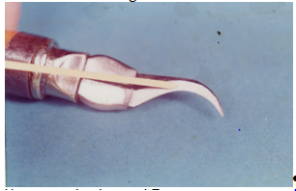
Figure5.28Cutting handle
- Tin sheet: - Should be properly cleaned.
    - Checking Handling and Maintenance of Patterns
- Check patterns for nicks or rough spots. The smallest nick on a pattern could cause a knife to blunt quickly.
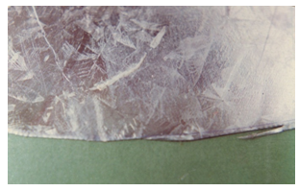
Figure 5.29
- Patterns should be checked by running the back of the knife over the edge of the pattern if you use your fingers,
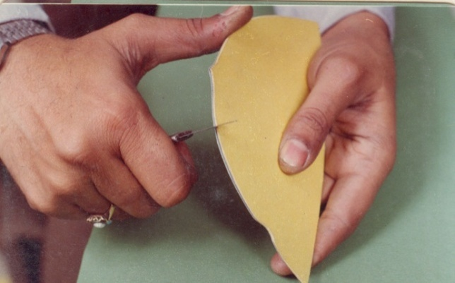
Figure 5.30
Remember: A good sharp edge on a pattern could cut you.
Keep your patterns in good condition smooth off any rough sports with a fine piece of emery.
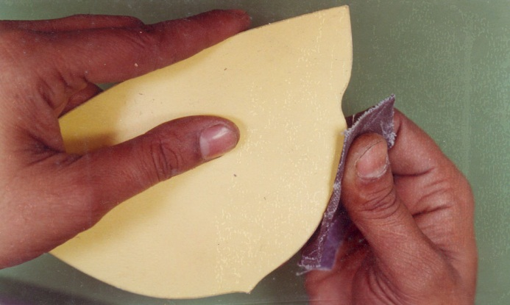
Figure 5.31
Lift your patterns off the material. Sliding a pattern off can result in scratching the leather.
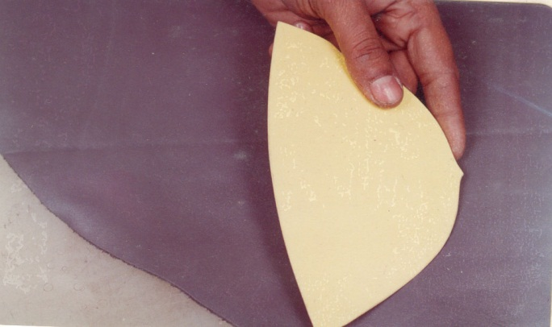
Figure 5.32

    - Check sizes with cutting plan.
The understanding of the following things written on the pattern is required:
- The name of the each pattern
- The number to be cut
- It is left/right or not
- The grain line
- The notch marks
- The size of the pattern.

  - Carry out works
    - Work place safety
The purpose of the Health and Safety policies and procedures is to guide and direct all employees to work safely and prevent injury, to themselves and others. All employees are encouraged to participate in developing, implementing, and enforcing Health and Safety policies and procedures.
Workplace safety is about preventing injury and illness to employees and volunteers in the workplace. Therefore, it's about protecting the nonprofit's most valuable asset: its workers. By protecting the employees' and volunteers' well-being, the nonprofit reduces the amount of money paid out in health insurance benefits, workers' compensation benefits and the cost of wages for temporary help. Also factor in saving the cost of lost-work hours (days away from work or restricted hours or job transfer), time spent in orienting temporary help, and the programs and services that may suffer due to fewer service providers, stress on those providers who are picking up the absent workers' share or, worse case, having to suspend or shut down a program due to lack or providers.
    - Occupational safety and health (OSH)
Occupational safety and health Is a cross-disciplinary area concerned with protecting the safety, health and welfare of people engaged in work or employment. The goals of occupational safety and health programs include fostering a safe and healthy work environment.OSH may also protect co-workers, family members, employers, customers, and many others who might be affected by the workplace environment.
Occupational safety and health can be important for moral, legal, and financial reasons. All organizations have a duty of care to ensure that employees and any other person who may be affected by the companies undertaking remain safe at all times. Moral obligations would involve the protection of employee's lives and health. Legal reasons for OSH practices relate to the preventative, punitive and compensatory effects of laws that protect worker's safety and health. OSH can also reduce employee injury and illness related costs, including medical care, sick leave and disability benefit costs.
"Occupational health should aim at: the promotion and maintenance of the highest degree of physical, mental and social well-being of workers in all occupations; the prevention amongst workers of departures from health caused by their working conditions; the protection of workers in their employment from risks resulting from factors adverse to health; the placing and maintenance of the worker in an occupational environment adapted to his physiological and psychological capabilities; and, to summarize, the adaptation of work to man and of each man to his job.
"The main focus in occupational health is on three different objectives:
The maintenance and promotion of workers’ health and working capacity;
- the improvement of working environment and work to become conducive to safety and health and
- Development of work organizations and working cultures in a direction which supports health and safety at work and in doing so also promotes a positive social climate and smooth operation and may enhance productivity of the undertakings.
The concept of working culture is intended in this context to mean a reflection of the essential value systems adopted by the undertaking concerned. Such a culture is reflected in practice in the managerial systems, personnel policy, principles for participation, training policies and quality management of the undertaking.Hazard identification and control, risk assessment and implementation of risk reduction
    - Workplace hazards
Physical and mechanical hazards
Physical hazards are a common source of injuries in many industries. They are perhaps unavoidable in many industries such as construction and mining, but over time people have developed safety methods and procedures to manage the risks of physical danger in the workplace.
Falls are a common cause of occupational injuries and fatalities, especially in construction, extraction, transportation, healthcare, and building cleaning and maintenance.

Machines are commonplace in many industries, including manufacturing, mining, construction and agriculture, and can be dangerous to workers. Many machines involve moving parts, sharp edges, hot surfaces and other hazards with the potential to crush, burn, cut, shear, stab or otherwise strike or wound workers if used unsafely. Various safety measures exist to minimize these hazards, including lockout-tag out procedures for machine maintenance and roll over protection systems for vehicles.
According to the States Bureau, machine-related injuries were responsible for 64,170 cases that required days away from work in 2008. More than a quarter of these cases required more than 31 days spent away from work. That same year, machines were the primary or secondary source of over 600 work-related fatalities. Machines are also often involved indirectly in worker deaths and injuries, such as in cases in which a worker slips and falls, possibly upon a sharp or pointed object.
Confined spaces also present a work hazard. The National Institute of Occupational Safety and Health defines "confined space" as having limited openings for entry and exit and unfavorable natural ventilation, and which is not intended for continuous employee occupancy. These kind of spaces can include storage tanks, ship compartments, sewers, and pipelines. Confined spaces can pose a hazard not just to workers, but also to people who try to rescue them.
Noise also presents a fairly common workplace hazard: occupational hearing loss is the most common work-related injury in the United States, with 22 million workers exposed to hazardous noise levels at work and an estimated $242 million spent annually on worker's compensation for hearing loss disability. Noise is not the only source of occupational hearing loss; exposure to chemicals such as aromatic solvents and metals including lead, arsenic, and mercury can also cause hearing loss.
Temperature extremes can also pose a danger to workers. Heat stress can cause heat stroke, exhaustion, cramps, and rashes. Heat can also fog up safety glasses or cause sweaty palms or dizziness, all of which increase the risk of other injuries. Workers near hot surfaces or steam also are at risk for burns.Dehydration may also result from overexposure to heat. Cold stress also poses a danger to many workers. Overexposure to cold conditions or extreme cold can lead to hypothermia, frostbite, trench foot, or chilblains.
Electricity poses a danger to many workers. Electrical injuries can be divided into four types: fatal electrocution, electric shock, burns, and falls caused by contact with electric energy.

Vibrating machinery, lighting, and air pressure can also cause work-related illness and injury. Asphyxiation is another potential work hazard in certain situations. Musculoskeletal disordersare avoided by the employment of good ergonomic design and the reduction of repeated strenuous movements or lifts.

    - Manual handling techniques
Manual handling refers to any activity that requires the use of force to lift, lower, push, pull, carry or move a person, animal or object. By observing simple, safe manual handling methods, you can avoid manual handling injuries.
The efficient handling and storing of materials are vital to industry. In addition to raw materials, these operations provide a continuous flow of parts and assemblies through the workplace and ensure that materials are available when needed. Unfortunately, the improper handling and storing of materials often result in costly injuries.
    - Manual handling injuries
In addition to training and education, applying general safety principles—such as proper work practices, equipment, and controls can help reduce workplace accidents involving the moving, handling, and storing of materials. Whether moving materials manually or mechanically, you should know and understand the potential hazards associated with the task at hand and how to control their workplaces to minimize the danger. Because numerous injuries can result from improperly handling and storing materials, workers should also be aware of accidents that may result from the unsafe or improper handling of equipment as well as from improper work practices. In addition, workers should be able to recognize the methods for eliminating—or at least minimizing—the occurrence of such accidents. You should examine the workplaces to detect any unsafe or unhealthful conditions, practices, or equipment and take corrective action.
    - Potential hazards
Workers frequently cite the weight and bulkiness of objects that they lift as major contributing factors to their injuries. In 1999, for example, more than 420,000 workplace accidents resulted in back injuries. Bending, followed by twisting and turning, were the more commonly cited movements that caused back injuries.

Other hazards include falling objects, improperly stacked materials, and various types of equipment. You should make your employees aware of potential injuries that can occur when manually moving materials, including the following:
- Strains and sprains from lifting loads improperly or from carrying loads that are either too large or too heavy,
- Fractures and bruises caused by being struck by materials or by being caught in pinch points, and
- Cuts and bruises caused by falling materials that have been improperly stored or by incorrectly cutting dies or other securing devices.

    - Personal protective equipment
When moving materials manually, workers should attach handles or holders to loads. In addition, workers should always wear appropriate personal protective equipment and use proper lifting techniques. To prevent injury from oversize loads, workers should seek help in the following:
- When a load is so bulky that employees cannot properly grasp or lift it,
- When employees cannot see around or over a load, or
- When employees cannot safely handle a load.
- Using the following personal protective equipment prevents needless injuries when manually moving materials:
- Hand and forearm protection, such as gloves, for loads with sharp or rough edges.
- Eye protection.
- Steel-toed safety shoes or boots.
- Metal, fiber, or plastic metatarsal guards to protect the instep area from impact or compression.
Personal protective equipment (PPE) refers to protective clothing, helmets, goggles, or other garment or equipment designed to protect the wearer's body from injury.
The purpose of personal protective equipment is to reduce employee exposure to hazards when engineering and administrative controls are not feasible or effective to reduce these risks to acceptable levels.

    - Safe materials handling
Safe materials handling can reduce injuries resulting from handling and storing materials by using some basic safety procedures such as adopting sound ergonomics practices, taking general fire safety precautions, and keeping aisles and passageways clear.
    - Fire Safety
Flammable and combustible materials must be stored according to their fire characteristics. Flammable liquids, for example, must be separated from other material by a fire wall. Also, other combustibles must be stored in an area where smoking and using an open flame or a spark-producing device is prohibited. Dissimilar materials that are dangerous when they come into contact with each other must be stored apart.
    - Aisles and Passage ways
When using aisles and passageways to move materials mechanically, workers must allow sufficient clearance for aisles at loading docks, through doorways, wherever turns must be made, and in other parts of the workplace. Providing sufficient clearance for mechanically-moved materials will prevent workers from being pinned between the equipment and fixtures in the workplace, such as walls, racks, posts, or other machines. Sufficient clearance also will prevent the load from striking an obstruction and falling on an employee.
Employers must ensure that all passageways that workers use remain clear of obstructions and tripping hazards. Workers should not store materials in excess of supplies needed for immediate operations in aisles or passageways, and employers must mark permanent aisles and passageways appropriately.
    - Ergonomic arrangement of workplaces
Ergonomics is defined as the study of work and is based on the principle that the job should be adapted to fit the person rather than forcing the person to fit the job. Ergonomics focuses on the work environment, such as its design and function, as well as items such as the design and function of work stations, controls, displays, safety devices, tools, and lighting to fit the employees' physical requirements and to ensure their health and wellbeing.

Ergonomics includes restructuring or changing workplace conditions, to make the job easier, and reducing stress that cause musculoskeletal disorders. In the area of materials handling and storing, ergonomic principles may require controls such as reducing the size or weight of the objects lifted, installing a mechanical lifting aid, or changing the height of a pallet or shelf.
Although no approach completely eliminates back injuries resulting from lifting materials, you can prevent a substantial number of lifting injuries by implementing an effective ergonomics program and by training your employees in appropriate lifting techniques.
    - Safe storage of equipment
Stored materials must not create a hazard. You should make workers aware of such factors as the materials' height and weight, how accessible the stored materials are to the user, and the condition of the containers where the materials are being stored when stacking and piling materials. To prevent creating hazards when storing materials, must do the following:
- Keep storage areas free from accumulated materials that cause tripping, fires, or explosions, or that may contribute to the harboring of rats and other pests;
- Place stored materials inside buildings that are under construction and at least 6 feet from hoist ways, or inside floor openings and at least 10 feet away from exterior walls;
- Separate non compatible material

In addition, you should consider placing bound material on racks, and secure it by stacking, blocking, or interlocking to prevent it from sliding, falling, or collapsing.It is very important to store tools, equipment, materials and products safely because it prevents them from getting lost, damaged or stolen, It can prevent accidents, if the tools were placed in an incorrect area, there is a possibility that someone could slip or trip over it. E.g. the best place to store a knife is in a knife block or rack. If a knife must be stored in a drawer, keep it separate from other utensils and always keep the handles and blades pointed in the same direction.

    - Reporting accidents and incidents
Responsibility for health and safety within a workplace is to report and keep records of:
- work-related deaths;
- serious injuries;
- cases of diagnosed industrial disease; andcertain 'dangerous occurrences' (near miss accidents)

Self check-5
Directions: Answer all the questions listed below. Examples may be necessary to aid some explanations/answers.
- Which tools are used for pattern cutting? (10pts)
- How to cut materials economically?(5pts)
- What are the key points to remember during cutting? (10pts)
- What are the faults occurred patterns? (10pts)
- What is consumption?(5pts)
- What should you know before moving, handling, and storing materials? (10pts)

Choose the correct answer

- Which one of the following are not the quality parameters of products?
- Raw material A
- Durability
- Serviceability
- Features
- Which one is not marking tools?
- Stainless-steel rulers
- Marking tools
- Awl
- Tracing wheels
- Which one of the following is cutting tool?
- Steel ruler
- Clicking knife
- Measuring tape
- Awl

- ______________should start from butt to belly (i.e. from left to right side and from bottom to top).
- Stitching
- Assembling
- Cutting
- Selecting
- .When bundling the leather, start from the_____________ and roll it over until you rich the neck on the grain side so that it would be easy to store.
- Belly
- Butt
- Neck
- Shoulder

Note: Satisfactory rating –above 60% Unsatisfactory - below 60%
You can ask you teacher for the copy of the correct answers

Operation sheet-5

Operation sheet 5.1 layout or position and techniques of using cutting tools
  - Purpose: layout or position and cut leather for proper cut
  - Material and tools:
- Leather
- Cutting table
- Cutting tools
- Pattern pieces
  - Pre-Operation Procedures
Step 1: Work Place Layout
- Always keep your work in front of you in an orderly manner. This will also help in minimizing the possibility of over cutting an order.
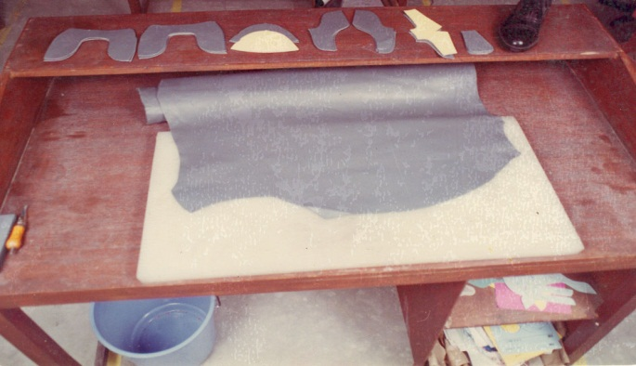
- Keep your tools and equipment within easy reach.
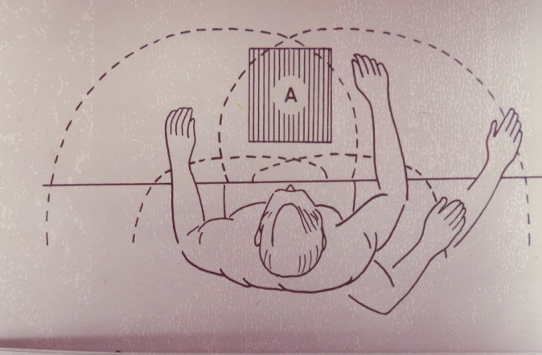
- Work at height that is comfortable. Either raises you by standing on a platform. (Old cutting boards can also be used.)
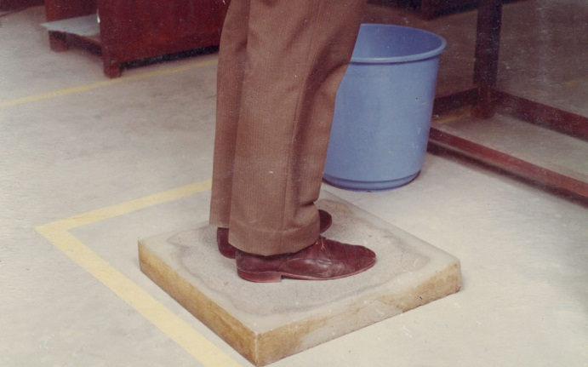
- Or raise your cutting board.
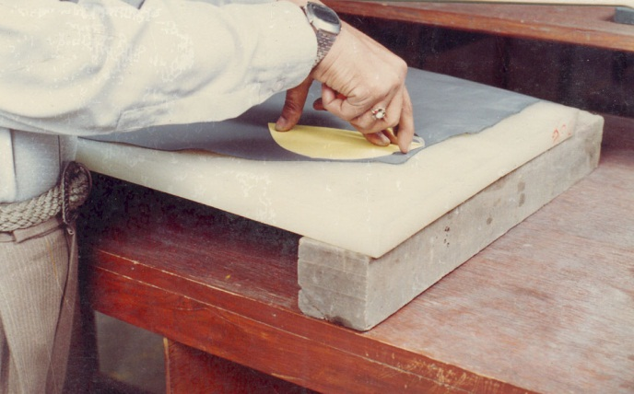
Remember: That the strain on your back/today could affect you in later life.
- Keep your tools equipment in a fixed place.
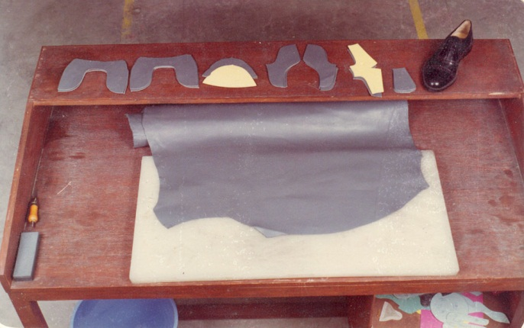

Step 2: Safety points for hand cutting:
- Hold your knife correctly for cutting.
(Right handed cutter)
Hold the handle with your 2nd, 3rd and 4th fingers.
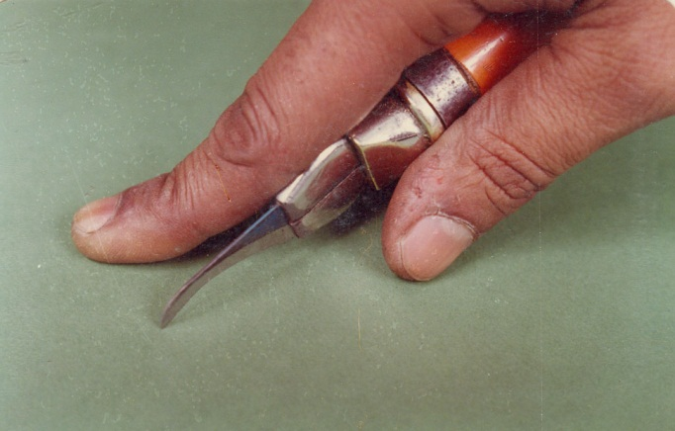
- Place your 1st finger across the clamping jaws so that it will just touch the material being cut.
This finger helps guide you.
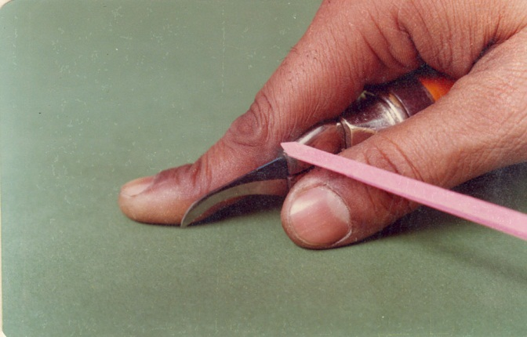
- Place the thumb on the side of the clamping jaws.
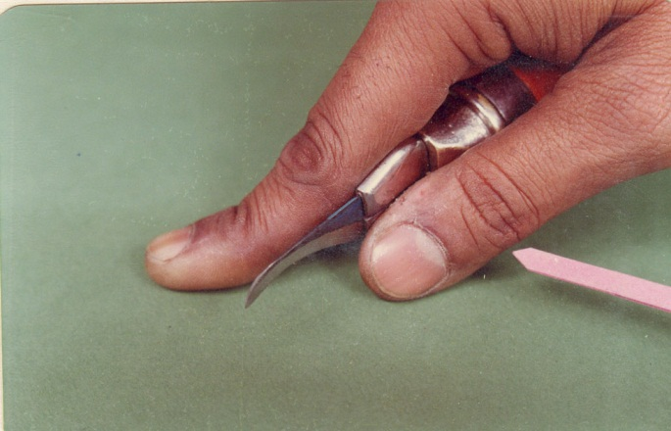
- A left handed person does the same with the left hand.

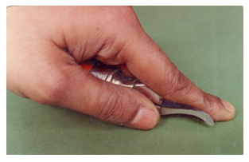

Operation sheet: 5.2Cutting leather by hand
- Purpose: To able to cut leather by hands
- Materials for the activity:
- Cutting knives
- Pencil
- Cutting pattern
- Ruler
- French curve Scissor
- Cutting board
- Leather materials
- Procedure:
- Inform your trainer that you are ready for this activity.
- Your trainer will now provide you with cutting equipment and materials as well as the cutting pattern.
- Study the pattern and perform cutting of leather according to job requirement.
- Identify and report problems with patterns, knives and cutting boards in order to achieve quality standard
- Check the cut products for compliance with job specification and quality standard.
- Identify and replace rejects
- Record the results.
- Clean workplace and equipment as per workplace standard
- Dispose waste properly

Lap Test-5
Instructions: Given necessary templates, tools and materials you are required to perform the following tasks. The project is expected from each student to do it.

Task 1:- layout or position and cut leather for proper cut
Task 2:- Cut leather by hands

Unit6: Cut lining and reinforcement materials by hand
This learning guide is developed to provide you the necessary information regarding the following content coverage and topics:
  - Position of patterns for economical cutting
  - Match patterns shape, type, size and leather quality
  - Cut of components Precisely
  - Clean cutting boards
  - The actual consumption of cut components.
  - Faults with patterns, scissor cutting knives, cutting boards and referring

This guide will also assist you to attain the learning outcomes stated in the cover page. Specifically, upon completion of this learning guide, you will be able to:
  - Position patterns for economical cutting
  - Match patterns shape, type, size and leather quality using cutting norms
  - Cut of components Precisely Using cutting techniques
  - Clean cutting boards
  - Check the actual consumption of cut components.
  - Identify faults with patterns, scissor cutting knives, cutting boards and referring to repair

  - Position of patterns for economical cutting
    - Introduction
Leather Lining Cutting lining leather is different from cutting upper leather: The best leather must be placed in the rear of the shoe because this is where it has to be the most wear resistant. When cutting lining quarters, their rear should always point towards the butt. Vamp linings should not be cut from the butt.
    - Folding the Fabric
Fabric can be folded in a variety of ways before pattern pieces are positioned for cutting. The type of fold used depends on
- the number of pattern pieces that must be placed on a folded edge
- the fold that results in the most economic use of the fabric
- the width of the fabric
- the pattern sizes
    - Sequence of cutting of synthetic materials
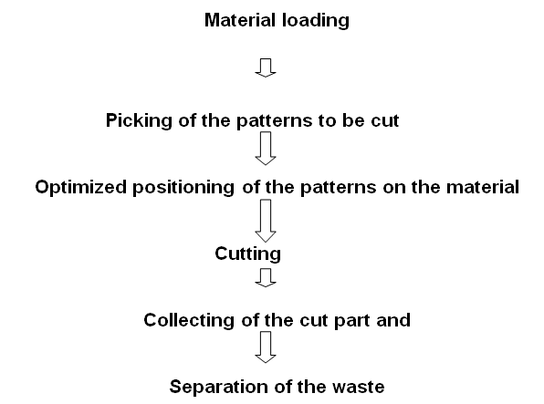
Figure 6.1 Sequence of cutting

Requirements
- Tools
- Furniture
- Materials
    - Pattern positioning
- Use the pattern as a knife-guide. Keep the blade edge against the pattern at all times
- Your cutting movement with the knife should be as continuous as possible. Shorter cuts and several stops will give you irregular edges as the stop points
- Arrange you’re straight edge patterns in the way that straight lines fit against straight lines to have a minimum amount of waste.
- To minimize waste of curved edge patterns use the possibilities similar curved patterns
- Always keep a note of how many pieces are cut to make complete sets.
- Work out small and large patterns together. Mix pattern shapes to get the best combination/utilization
- Always remember that you should reach the maximum quantity of parts at a consistent quality.

  - Match patterns shape, type, size and leather quality
    - Cutting the pattern pieces
Cut pattern pieces on folded lining if the number of cutting is one and then make the necessary marks on the lining with chalk or pencil.
Transfer notch marks from your pattern to the lining by cutting snips into seam allowances. When joining garment pieces, place corresponding notch marks in the two pieces together.
Always plan two or three cuts ahead never cut without knowing where the next pattern will be placed.
Cut lining along with garment patterns without space for facings (but remember to add seam allowances) and hem seam allowances. Do not cut lining for collars.

    - Interfacing
Cut and iron interfacing to under collars, facings, waist bands, slit facings, blouse and shirt button extensions and sleeve cuffs. Using interfacing at jacket's hem seam allowance makes get a neat hem.
If you sew a patch pocket, attach interfacing to it also.
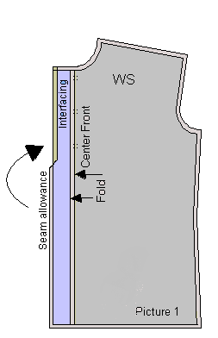
Always trim interfacing to eliminate the seam allowances 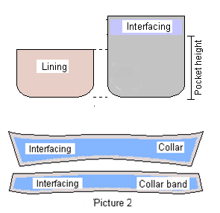
Figure 6.2 Lining and interfacing

  - Cut of components Precisely

The material cutting job is very precise work for the productions. The components pattern included all over allowances such as allowances. In the cutting section the Labor or staffs has to maintain the quality of the material – size, and quantity according to the requirements of the requirement. They have to maintain proper norms for cutting the material and wastage has to be minimized. The safety norms have to be maintained according to the industry act. To make less number of products, cardboard patterns are used for cutting components

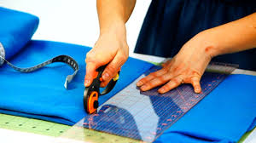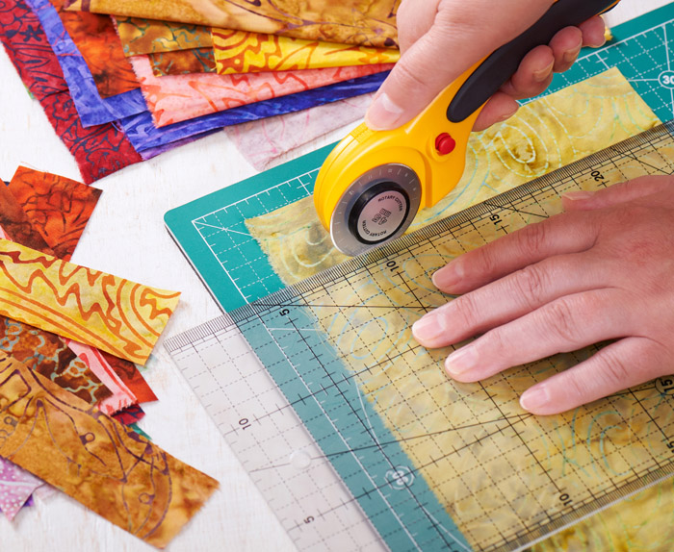
Figure 6.3Cut lining and interfacing
Refer this LO#6 information sheet#2 for further information on cutting techniques

  - Clean cutting boards
    - Leather Cutting Mat
Cutting Boards the prevalent plastic material for cutting boards is polyamide (PA) blended with other thermoplastics. The crucial properties of cutting boards are:
- Hardness (expressed in Shore / °Sh)
- Thickness
- Size
The most important property of a cutting board is its hardness. Depending on the supplier, there are different approaches to choose the appropriate cutting board for each specific cutting press and each specific material to be cut
Self-healing leather cutting mats are specialty-plastic mats comprised a several layers of material that serve as a cutting surface underneath sharp blades. To help ensure the longevity and sharpness of knife blades, it's important to use softer surfaces underneath them when cutting.

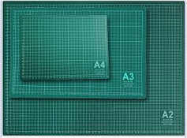
Figure 6.4 cutting matt
    - Usage of cutting mat/board
A cutting mat protects your work surface so that it does not receive any marks from the rotary cutter's blade. It also prolongs the life of the blade by keeping it from becoming dull. Many cutting mats also have grid lines or rulers, which helps you to measure as you cut.
Luckily, cleaning a wood cutting board by hand is easy enough. All you need is hot water (turn the faucet up all the way!), dish soap, and a brush or sponge. Rinse the board off with hot water and apply soap. You can use regular dish soap or antibacterial dish soap, if you want
    - How to sanitize wood cutting board?
Soak a clean, white cloth with either pure white vinegar or three percent hydrogen peroxide. Wipe down the board thoroughly and let sit for a few minutes. If there are stains or odors, sprinkle kosher salt or baking soda on to the board, and rub with the cut side of a lemon to clean and deodorize.
Knife Blade: Cleaning the cutting mat
- Keep the mat flat supported by a firm surface, and place in the sink.
- Run lukewarm water over the mat. Use a plastic, hard-bristled brush to gently scrub in a circular motion until the entire surface of the mat had been cleaned.
- Pat dry with a paper towel.
- Let mat air dry completely for stickiness to return

  - The actual consumption of cut components.
Average fabric consumption also depends on nature of the fabric/ leather, like tubular or open width fabric. Whether the fabric is solid colored, check or stripe or any specific design repeat required. In the following, one example has been shown with a formula for better clarification about the calculation.

Basic formula:
To estimate fabric consumption for a knitted top use following formula
Consumption in grams= {(L*C) + (B*SL)}*2*GSM/10000 grams (when length units are in centimeter) Where,
- C= Chest +allowance
- L= length of the body measure + allowance
- SL= Sleeve length +Allowance
- B=Biceps +allowance
- GSM = fabric weight in grams per square meter
Example: Product - knitted top. Garments components are front, back, and sleeves.
Measurements without allowances | Measurement with allowances
Chest (C) = 23.25”  Body Length (L) = 30.5”  Sleeve Length (SL) = 26”  Bicep (B) = 9.2”  Fabric GSM =200 | +1.75” = 25”  +2.50” = 33”  +1.50” = 27.5”  +0.80” = 10”
As per above formula consumption of fabric for this style is = {(L*C) + (B*SL)}*2*GSM/10000 grams= [{(33*25) + (10*2*27.5)}*2*(2.54*2.54)*200]/10000 grams (Note: 2.54 is inch to cm conversion factor) = [{825+550}*400*6.45]/10000 grams= 354.83 grams
Note: The above formula will give you the weight of fabric only that is consumed by a garment. In the above formula, I have not included fabric loss due to fabric width, marker loss and fabric wastage (such as end loss, end bits, defects). When you purchase fabric you have to consider all of these parameters in fabric consumption calculation.
  - Faults with patterns, scissor cutting knives, cutting boards and referring
Pattern defects/faults
- Some parts of pattern are missing, probably because the marker did not include the correct number of parts.
- Mixed parts—probably because the marker is not correctly labelled, resulting in a marriage of wrong sized parts.
- Patterns not aligned with respect to the leather lining.
- Poor line definition
- Skimpy marking-caused by eitherthe marker did not use the outside edge of the pattern.
- Undefined points and missing of specification.
The following are some leather problems and faults with knives and cutting board;
- When your blade is not perpendicular to the lining. Your cuts will appear to be straight but you will find out that they’re not completely straight.
- When cutting knives is not sharp there is not create clean, smooth cuts and other much fewer mistakes.
- When you do not use a ruler as a guide during cutting lining you cannot cut straight.
- When you guide the blade with your wrist instead of with your body, you may have a natural tendency to guide the blade with your wrist, but your wrist has a limited range of motion. Instead, keep your elbow in close to your body and pull the cutting motion with your shoulder. This will keep you on track and ensure that the blade remains straight.
- When you don’t slowly and gently drag the hobby knife along the cut line the edge of pattern become jagged. For thicker material, all you need is a sharp hobby knife to get a clean, straight cut, in addition to a sturdy ruler.
As with knives, cutting surfaces need to be flat, smooth and somewhat soft so your blade doesn't get dulled or broken too easily.

Self check-6
Directions: Answer all the questions listed below. Examples may be necessary to aid some explanations/answers.
  - How to cut synthetic materials?
  - How to cut pattern pieces?
  - In the cutting section the Labor or staffs has to maintain the quality of the ---------according to the requirements of the requirement
  - Write the formula in grams
  - List and explains leather problems and faults with knives and cutting board
  - What is cutting mat?
A fills blank space
- _____________________is an important process and a bridge of transforming the graphic designs to the products.
- The finished product is often different from designer’ idea in ____________
- To make more number of products ------------------ or -----------------metal patterns are used for cutting components
- Cutting with the help of a -------------------- is quicker and ---------------- than on the leather, fabric and other materials.
- The ------------------------- is usually according to an order that make the major parts first, which can result to the shape and the size of the bag.
- All the design methods of the drawing or photograph has to implemented in ------------------------
- Bag is good for designers to ----------------------- the ------------------- between the craft and bag model.
- Flatten the same paper and take a scale and make the -------------------------.
- The straps and Handles are very much depended according------------, --------------and Feelings.
- The Front pattern depending according to the------------------------,Appropriate Sizing ------------ and Costing of the articles
- The belt needed little bit--------------and proper ------------------ and good decorative stitching.
- Gussets are determined by its nature of the design of leather goods--------------.
- ____________________: Quality must not be confused with excellence.
- ___________________ requires not only good quality control but also tangible evidence to show its effectiveness and to convince a potential customer that product quality is under control

Note: Satisfactory rating –above 60% Unsatisfactory - below 60%
You can ask you teacher for the copy of the correct answers

Unit 7: Cut leather and reinforcement by machine
This learning guide is developed to provide you the necessary information regarding the following content coverage and topics:
  - Select and prepare cutting dies
  - Set up cutting machine
  - Position material accurately on cutting machine
  - Defects and positioning dies
  - Cut material
  - Consumption of cut components
  - Operate cutting machine
  - Monitor performance of machine
  - Perform minor maintenances
  - Report major problems

This guide will also assist you to attain the learning outcomes stated in the cover page. Specifically, upon completion of this learning guide, you will be able to:
  - Select and prepare cutting dies
  - Set up cutting machine
  - Position material accurately on the cutting machine
  - Identify defects and positioning dies properly
  - Cut material
  - Check consumption of cut components
  - Operate cutting machine in accordance with OHS requirements
  - monitor performance of machine through regular checking
  - Perform minor maintenances of cutting machines.
  - Report major problems.

  - Select and prepare cutting dies
    - Selecting and preparing cutting dies
In this information sheet, participants should be able to understand about Selecting and preparing cutting equipment such as cutting dies, layer cutting motorized knife and patterns according to work specifications and customer’s instructions. Selection of dies for cutting depends on the type of materials such leather, fabric, Lining, Foam, Elastics, Inter-lining and Re-enforcements. All concerns activities help to participants to produce quality with productivity.
      - Selection of dies
Selection of Dies for cutting leather, fabric, Lining, Foam, Elastics, Inter-lining and Re-enforcements etc vary as per the material characteristics and the cutting process. The different types of dies with their specific uses are given below:
      - Types of Dies and their Uses:
Dies is of various types. Some of them are listed below
- Dies as per Height – 19 mm, 32 mm and 50 mm height Dies are available for various purposes. Normally19 mm die is used for leather upper and lining cutting. 32 mm and 50 mm dies are normally used for synthetic cutting, layer cutting, insole and shank board cutting, interlining and reinforcement cutting.
- Dies as per Edge – Single edge and double edge Dies are made for cutting. Using double edge die we can cut right and left component from the same die, which reduces the die cost. The single edge die is generally used for layer cutting.
- Straight Edge and Decorative Edge Dies – Die edges can be straight or gimped as per the design requirements.
- Perforated Dies – Dies can be perforated. It can be perforated for punched designs e.g. Brogue, Moccasin etc.

    - Types of Dies as per Edge for Machine cutting
- Single edge clicking die
- Double edge clicking die
A die is a specialized tool used in manufacturing industries to cut or shape materials mostly using a press. Like moulds, Dies are generally customized to the item they are used to create.
Mass production of leather garment and goods requires cutting every type of goods material. Leather, fabric, foam, and reinforcing materials must be cut into the product patterngoods. While there are many new technologies for cutting leather garment and goods materials such as a laser, water jet, and CNC drag knife; the steel rule-cutting die is still the most common for production. Used to cut out leather goods parts these steel cutting dies look just like cookie cutters.
Each die is made of sharpened rule steel then coated with rust proof paint and marked with the goods size and model number. Making goods requires hundreds of dies. One dies for each part, for every size of a product. For high volume goods production, the factory may need many sets of cutting dies.
The cutting die maker starts with the cut paper pattern templates of the garment or goods pattern. The worker will then bend the rule steel into shape using the paper pattern as a guide.
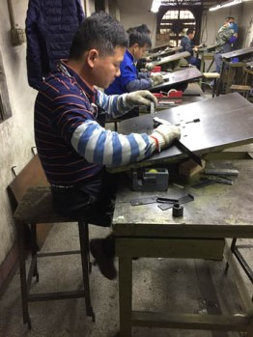
Pins for perforations are also added to the cutting dies. Once the die is fully assembled a worker will test it to make sure the cutting surface is aligned flat and level.
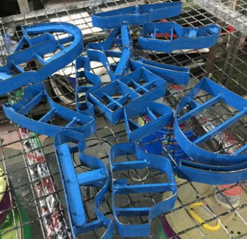

Figure 7.1Cutting dies getting a coat of paint

The final operations to make the garment or goods cutting dies include coating it with rust proof paint and a final check to make sure the cutting edge is very sharp.
While there are many operations required to make shoe cuttings dies the production is fast, the materials and labor are relatively inexpensive. For small orders, a cutting die fee may be charged by the factory, but usually, the cost of the cutting dies are accounted for the LOP (labor, overhead and profit) charges.
  - Set up cutting machine
    - Setting up cutting machine
Leather garment and goods manufacturers have a number of options for cutting synthetic materials, textile, toe puff and counter stiffener with varying mixture of technology and human skills.
The synthetic materials are cut in multiple layers and require more knives that are substantial. For leather and lining materials, these are usually single-edged heavy-duty strip steel knives 32 mm deep. For bottom stock, they are usually forged steel knives up to 100 mm deep.
Checklist: The checklist should be made ready before the cutting actually performed.
- Materials to be cut.
- Tooling- Die templates etc.
- Proper layering of the material (even no. of layers).
- Design and material specifications.
- Job order quantity.
- Bundling and packing specifications.
Quality Parameters:
- Cut tight to toe whenever possible.
- Use sharp knives and keep cutting boards in good condition.
- The knives are suitably stored in racks to avoid damage of edges.
- Determine direction and ease of laddering by picking at the cut edges of a scrap piece of the fabric cut component such that the laddering direction is from the feather line upwards to the top line.
- The no. of layers to be cut should be fixed for different materials.
- No two layers are kept in opposite weaving direction.
- Reinforcement and foam materials should be cut at the end of the plan.
- Proper lighting of the work area should be given

    - Work station setup:
Before starting the cutting process, the machine is adjusted as per the die height, type of material and number of layers to be cut. During cutting, the most important factor is interlocking pattern of dies, both widthwise and lengthwise. Smaller patterns used at the edges can save materials.
Further it is always advisable to cut pair wise for the same fold to provide uniformity in the lot. Proper checking, stamping and bundling of all the cut-components is required before packing and transfer.
Cutting system
Cutting is the process in which goods or garment material are cut and converted in to the shape of the patterns of the component of the goods or garment.
- There are two types of cutting system
      - Hand cutting
      - Machine cutting
Machine cutting
There are different types of machineries used for Cutting Operation.
  - Hydraulic clicking press machine
  - Splitting Machine
  - Skiving Machine
  - Strap Cutting Machine
  - Hydraulic Embossing machine
  - Edge Staining machine
  - Hand shearing machine
  - Fabric Spearing machine
  - Fabric CNC Cutting Machine
  - Fabric Straight and Circular Knife
  - Leather Dieless Cutting Machine
Advantages over hand cutting
- Speed of operation.
- Accuracy and uniformity
- Productivity increase
- Negotiation of intricate patterns and least wastage

Swing arm hydraulic cutting machines: - it is a hydraulic machine used to cut materials in single layer using clicking dies.
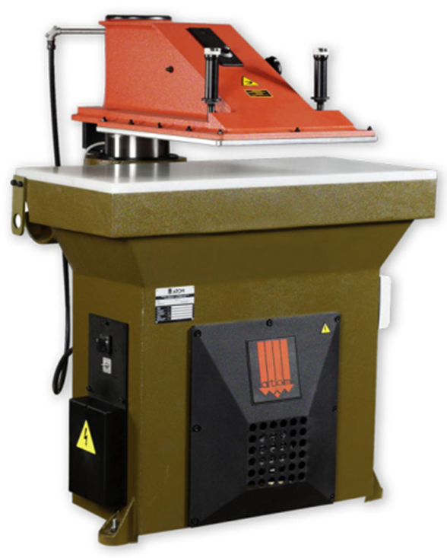
Figure 7.2 Cutting machine
The clicking machine most commonly used for cutting leather and components for leather goods. This machine has been equipped with a cutting plate made from Teflon sheet allowing the cutting die to cut approx, 1 mm down into the surface, as it must always be possible to cut the skin/hide properly. This means that the plate is subject to uneven wear and consequently it has to be resurfaced at regular intervals to allow unproblematic cutting. The movable machine beam head, punches by means of a hydraulic system with 10 -18 tons pressure on the cutting die, depending on the type of machine applied.
The pressure surface of the swing beam has been provided with an aluminium sheet making it possible to cut with double- sided cutting dies without damaging the cutting edge.
Travel head cutting and hydraulic plain cutting press machines: - it is a hydraulic machine used to cut materials with several layers.
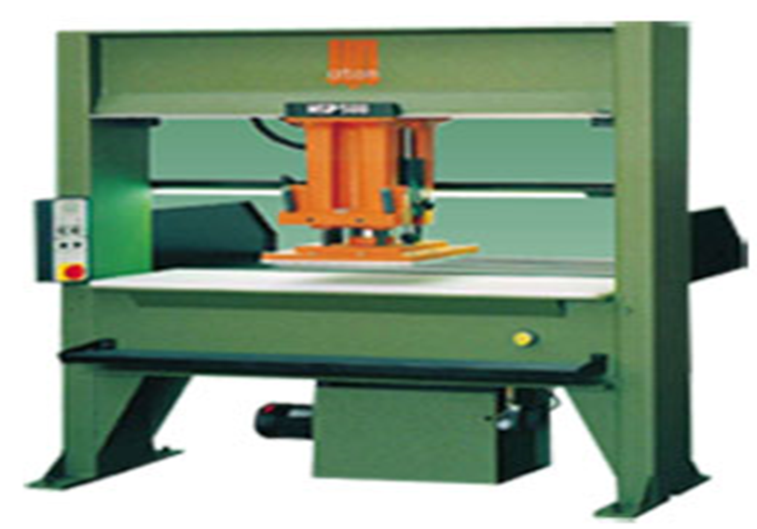
Figure 7.3Travel head cutting press machine

Strap cutting machine:-is a machine used to cut strap components with accuracy
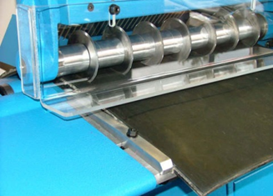
Figure7.4 Strap cutting machine

Edge staining machineEdge staining machine is used for staining the raw edges of the cut-edged construction.
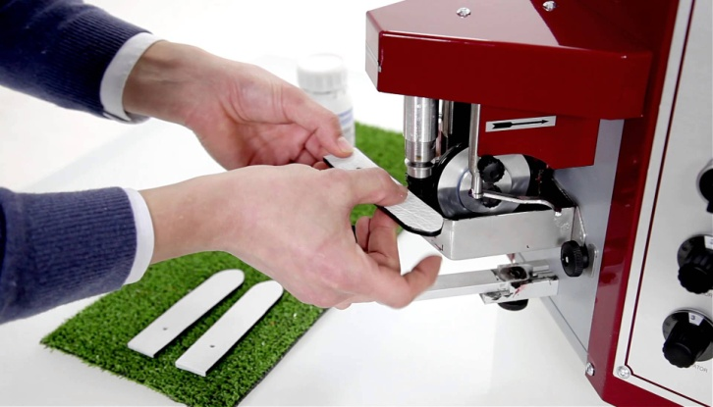

Figure 7.5 Edge staining machine
Hand shearing machine
- Hand shearing machine is used to cut reinforcement materials such as paperboards, straw boards, etc., in the manufacture of leather goods.
- It is very useful for cutting drawing sheets and paperboards in the pattern cutting process. It can also be used to cut leathers for making straps.
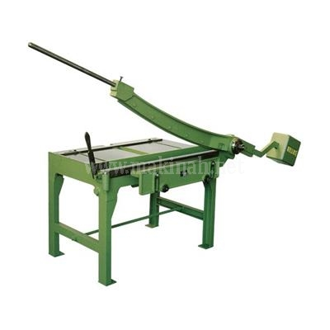

Figure 7.6 Hand shearing machine
Fabric cutting machine / straight-knife / hand-held
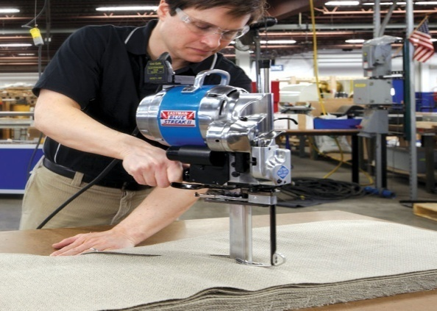
Straight Knife Cutting Machine is one of the most popular and versatile machines used in the cutting sections of garment industries around the globe. The machine is significant to bulk cutting.

Figure 7.7 Straight-knife
  - Position material accurately on cutting machine
    - Positioning material accurately in to cutting machine
Positioning is the placement of leather patterns in lather in effective way it is a best practice in the leather goods manufacturing unit. If the cutting process is manage then the minimum wastage will be recover. In the leather, there are many defects, marks; patches but the positioning of patterns is an experience job for a cutter.
Take an example of a bag – From the butt portion the best part of a bag i.e. Front part and the Flap part will place the pattern to cut. The back part will positioned for the rest place of the butt top portion or can be neck portion. Flap inside part will cut from the neck portion. From the belly portion –Gusset, Base and Handles pattern will place it and cut the leather. The inside Zipper part, Loops and other patterns will come out from the rest pieces of the leather portion. This is the way for economical cutting the leathers into a bag-manufacturing unit or factory.
Tools used in machine cutting
- Clicking dies: - there are different types of dies, this will be discussed further in other learning guide
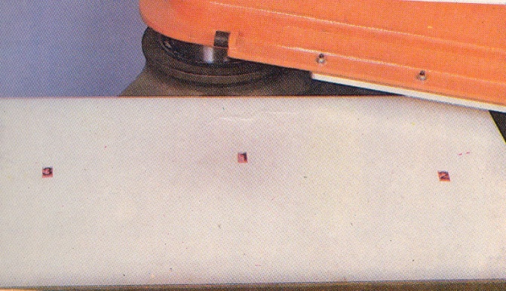
- Cutting board/nylon board

Figure 7.8 Cutting board/nylon board
Board cutting:
Reinforcement boards are cut in the hand-shearing machine for use in making leather goods. After cutting process is over, only leather components are sent for splitting and skiving. The other components viz. lining, foam and reinforcements are kept safely in plastic trays.

Straw boards:
Yellow straw boards are used as reinforcement material in making molded type of articles viz. desk pad, pen and pencil tray, penholder, pin cushion, photo frame, etc.
Ply woods:
Ply-wood/deal-wood is very lightwood and hence they are suitable for making for box type goods viz. attaché cases, suitcases, jewel boxes, etc.
Iron frames:
The iron frames are used in the Handles and frames to make Doctors bag and the ladies bags also. Iron frames are used as reinforcement material in heavy/luggage goods. They not only help to provide sufficient strength to the fittings but also prevent deformity of the products due to impact. M.S. hoop iron frames are used in document cases, medical representative bags, sports kit bags, suitcases, etc.
Foam / rubber sheets:
The foam and rubber are the best backup of the body of the bag. According the designs and the purpose this reinforcements are used. Such as soft look and feel the foam are used as thickness. Normally 2mm to 3mm thick foam is the best to put in the front, back and sometime flap also. In the base part the rubber has to use for weight carrying. In the laptop bag, thick foam and rubber are used for safety purpose.
Polyurethane foam rubber sheets are used in a variety of leather goods where cushioning of the products is necessary. 2m x 1m x 3mm and 2m x 1m x 6mm foam rubber sheets are normally used in leather goods making.
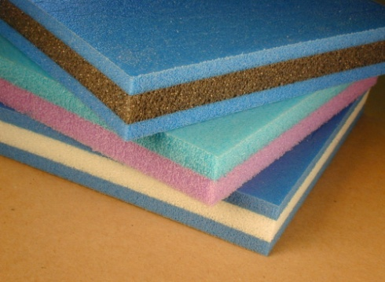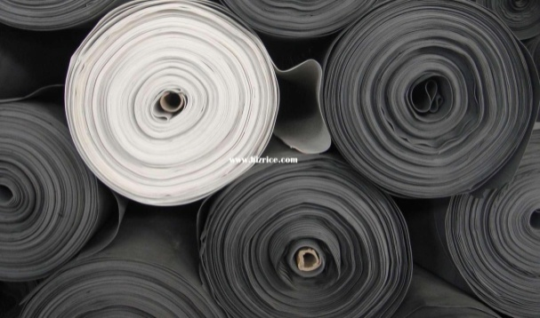
Figure 7.9Rubber sheet and Rubber sheet rolls
BOARD CUTTING:
Reinforcement boards are cut in the hand-shearing machine for use in making leather goods. After cutting process is over, only leather components are sent for splitting and skiving. The other components viz. lining, foam and reinforcements are kept safely in plastic trays.
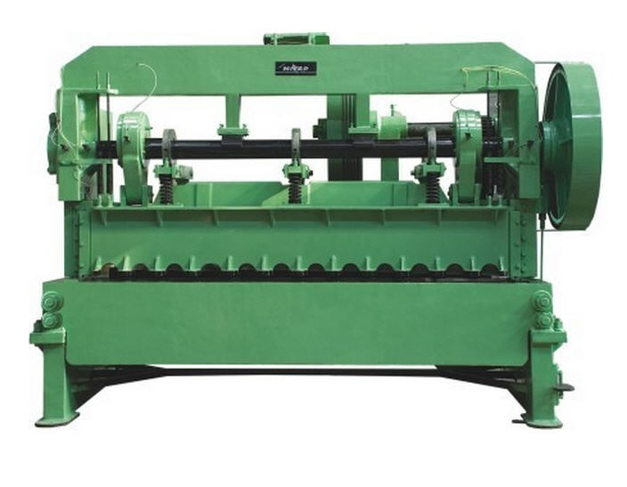
Figure 7.10Hand Shearing Machine
- Measuring ruler
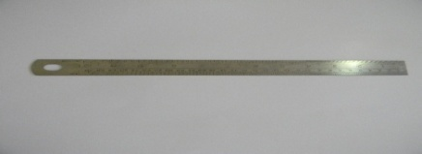
Figure 7.11 Ruler

- Silver pen
- Hammer
- Scissors
    - Machines used for cutting leather goods materials
Swing arm hydraulic cutting machines: - it is a hydraulic machine used to cut materials in single layer using clicking dies.
Figure 7.12 Cutting machine
Travel head cutting and hydraulic plain cutting press machines: - it is a hydraulic machine used to cut materials with several layers.
Figure 7.13 Travel head cutting press machine

Strap cutting machine:-is a machine used to cut strap components with accuracy
Figure 7.14 Strap cutting machine

  - Defects and positioning dies
    - Identifying leather defect
Leather defects are Imperfections in the grain surface or structure of a hide or skin resulting in unsightly appearance and/ or weakness of the resultant leather. Such defects may have arisen during the life of the animal, or may have developed in the flaying and/or preparation of the stock.
In general, leather defects are classified as
- Anti-mortem defects and
- Post mortem defects

- Antimortem defects:
Anti-mortem defects are defects that occur during the life of the animal. There are different causes of this defect this are:-
- Pock mark
- Tick mark
- Warble holes
- Brand marks
- Goad mark
- Sore mark
- Thorn marks
- Yoke mark

- Pock mark: A small round depression on the grain side of the hide. Pock marks diorites the value of the hides. This depression can be controlled by mass vaccination of cattle.
- Tick mark: A small depressions similar to pock mark caused by cattle ticks zoologically known as spider, scorpions and mites. These ticks get their nourishment by sucking blood from the cattle .This mark makes the quality of the leather inferior. One can minimize this defect by spraying tick-killing solution to the body of the cattle.
- Warble holes: These holes are caused by flying insects known as warble fly. It generally attacks on both sides of the spinal cord.
Three types of warble fly
a) Hypiderma Cineatum
b) Hypodermic Bovis
c) Hypodermic Erossi
- Brand marks: To make branding on animal, red-hot iron is used to mark figure on the animal as per owner’s choice.
- Goad mark: While ploughing the field the cattle in our country often beat by their owner with a stick, which is shucked by a sharp nail on the edge. This makes permanent holes on the butt portion of the animal. This defect hampers the quality badly
- Sore mark: Cattle are often get soared. It is not timely attended and because of that, it spreads. Ultimately, the sores heal up but the marks are left behind making the affected parts useless.

- Thorn marks: A long and deep scratches caused by the thorny shrubs of the fences of fields or of the jungles where the cattle stray out to graze.
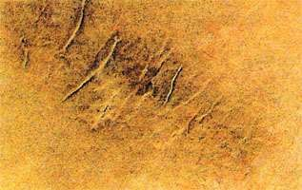
Figure7.15 Thorn marks
- Yoke mark: A patch of hardened skin is often found on the shoulder of the animal. This is due to the constant friction and pressure of the yoke to the shoulder.
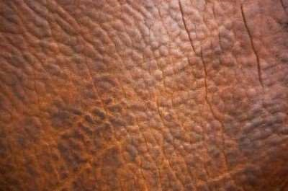
Figure 7.16 Yoke mark
In addition to the above defects, many hides are very poor in substances because of nutrition’s and old age of the animal. A large number of cattle are allowed to linger on until they die of sheer old age. The hides of such animals are loose and lack in proper substance.
- Post – mortem defects:
These defects occur after the animals are flayed. There are different causes of post mortem defects these are
- flay cut/butcher cut
- vulture mark
- burns
- purification

- Flay cut/butcher cut: At the time of flaying the skin from slaughtered or dead animal the flay cut occurs due to butcher’s negligence. It diorites the quality of the skin
- Vulture mark: In remote village, the fallen dead cattle are often left lying on the field away from the civil area. The vultures lie on the carcass puncturing the hide with their sharp claws. In similar jackal and dogs, also damage the hides. This defect lowers the value of the hide.
- Burns: Hides or skins of wet region are dried for preservation over wood fire. These hides often show the damage due to burning.
- Purification: After flaying if the hides and skins are not preserved immediately the purification may start and even can damage the whole lot of hides/skins. If the curing of the hides and skins is not sufficient, it causes local damage. Sun blister may form and the interior portion of the hide may partially putrefy during transit or store.
The common problems or faults occur in leather products are:-
- Looseness of leather
- Signs of excessive growth
- Uneven dying
- Cracking leather
- 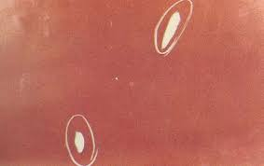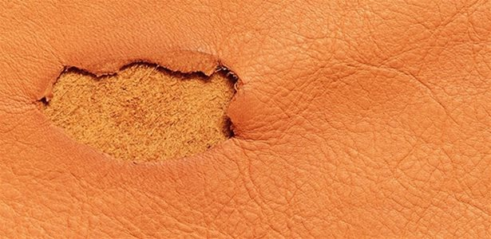
- Color variation
- Grain damage
- Poor yield
- Weak leather
- Finish failure
- Smell
- Color migration
- Breakage
- Peeling of the leather finish

Figure7.17Faults occur in leather products
White pencils and chalks are used to mark the defect in the leather hides or leather cut components.

Figure 7.18pencils
  - Cut material
    - Cutting material according to dies specification
Specification in leather bags:
A typical bag Specifications for general purpose may include some of the basic information as listed below:
1. The picture of the bag
2. Details of upper material – leather
3. Details of lining material – leather or fabric
4. Construction type
5. Details of Metal accessories and their placement in the bag
6. Size specification with given measurement.
7. Quality check needs to be taken into consideration while manufacturing.
    - Cutting or clicking of material
In this stage, clicking or cutting is carried out to cut different components of leather goods, which are further checked as per the approved design or size.
General rules that a cutter should be aware on while cutting the leather
- Closely affect the leather for any defects, these include surface marks, flay cuts, loose offal and mark these areas for ease of identification.
- Check the flesh side of the skin for warble hole and fly cuts.
- Check for the correct line of tightness, as this will vary slightly from skin to skin.
- Check the components to be cut make sure that all patterns are there.
- Ensure that your working bench is clean.
- From your cutting sheet select the largest size patterns
- Variations in color
- Grain matching
- The cutter must test his leather for stretch, to ensure that the cut parts are correct.
- After grading and selection the cutter should select for cutting leathers from the horse
- Ensure that your patterns are smooth and your knife is sharp
- After cutting, the leather must check the quality of his product, and place it on the bench in front of him.
Locating cutting patterns and studying specifications once the patterns are ready:-
- Cutting should start from butt to belly (i.e. from left to right side and from bottom to top).
- Make sure that it is the correct pattern of the article you desire to cut
- Examine for defects, size and shape of hide/skin.
- Selective cutting must be practiced; the best part of the article demands the best part of the hide/skin.
- Visible area should have good grain surface and section covered could contain grain defect.
- Good cutting begins with a sharp knife less sharpens or blunt knife cuts the leather with rugged edge.
- Over cutting and under cutting must be avoided.
- Pattern must be placed in such a way to insure quality, economy and minimum wastage.
- Straight-line cutting must be done first with steel scale/ruler curved line cutting or regular shape must be cut with templates.
- Cutting must be done on a smooth surface of soft wood, play wood, galvanized iron plate or zinc plate for accurate cutting.
- Start cutting from left top corner of the pattern and end at the right bottom corner
- Cut through the leather in one stroke.
Apart from leather, lining material is also clicked in this section. Clicking can be carried out mechanically using clicking press and manually using clicking knives. The former method is recommended, when the production is carried out at a large quantity only.

  - Consumption of cut components
    - Checking consumption of cut components against standard
In the process of pattern making, pattern maker is considered a very important Person next to the designer. A good pattern maker must be aware of different types of finished leathers and their suitability in making different types of leather goods. He must be well versed with the techniques of fabrication and types of constructions. He must have the essential knowledge in elementary mathematics, measurements and use of geometrical instruments for drawing geometrical shapes viz. square, rectangle, circle, etc. and other odd shapes. He must be aware of different types of fittings, linings, reinforcements and other miscellaneous items, which are used in leather goods making.
The pattern maker must give in each pattern the following details, which would help the cutter in the subsequent process of cutting to cut components easily and swiftly.
Figure 7.19Cut components

Good Craftsman/ Sample man has to keep in his mind -
1. A good pattern of the right size, which has been adjusted to suit your individual requirements, will enable you to obtain a perfect product.
2. A pattern prepared on thick paper or cardboard can be preserved for a long time and can be used repeatedly.
3. By manipulating the basic pattern pieces it is possible to produce patterns for complicated and original designs.
4. A paper pattern of a particular size can be used to make new patterns of proportionately larger or smaller sizes by following a systematic procedure called "grading".
5. Cutting with the help of a paper pattern is quicker and easier than on the leather, fabric and other materials.
6. Use of a paper pattern will enable you to cut the bag pattern with a minimum amount of material because it is possible for you to try out the placement of pattern pieces in different ways till you have found the most economical way to keep them.
7.6.2 LEATHER COMPONENTS
This patterns help for the productions. The components pattern included all over allowances such as Folding allowances, Underlay allowances and Stitching allowances. In the leather, cutting section the Labor or staffs has to maintain the quality of the leather/ material – grain, color, size, and quantity according to the requirements of the client. They have to maintain proper norms for cutting the leather and wastage has to be minimized.
The safety norm has to be maintained according to the industry act.
- To make less number of products, cardboard patterns are used for cuttingcomponents. To make more number of products, aluminum or galvanized metal patterns are used for cutting components.

- To manufacture in bulk, the cardboard patterns of the product are converted into clicking dies and the components are cut in the hydraulic clicking press. The Leather Cutting Pattern has to be marked by the RED PEN/ COLOUR.
We all know that leather is a natural product, which is derived from the rawhide and skin of the animals. Hide is the outer covering of animal of large skins e.g. cow, buff etc. whereas, skin is the outer covering of animals of small species e.g. goat, sheep etc. A hide is normally divided into two parts through the backbone for convenience in handling. Each part is called a side.
A large proportion of the hide or skin coming to the tannery are full of defects and they are either unusable or it is very costly for shoe manufacturers to use them. The tanner therefore, endeavors to improve the quality by eliminating or rendering these defects by a procedure called “Correcting the grain side”.
Before proceeding for nesting exercise following points is to be considered
- The proper skin is to be regarded as perfect that is there is no defect anywhere.
- The person must be clear about the lines of tightness of all the components to make a bag, their quality division & the allowances.
- The cutter must be able to divide the paper skin correctly in various parts i.e. butt, belly, shoulder and should have a clear understanding of lines of tightness in different parts of the skin/side.
- The aim of the cutter should be to use his/her leather as economical as possible by avoiding wastage due to bad pattern interlocking.
- Before starting nesting on paper skin directly they must take interlocking trial one or more times with every pattern as for every pattern there is more than one method of pattern interlocking.
- There are guidelines given for achieving better pattern interlocking one may consider these while interlocking.

  - Operate cutting machine
    - Operating cutting machine in accordance with OHS requirements
Carrying our works according to OHS practices
Hand tools are extensions of our hands. When we misuse our hands, we experience pain. When we misuse hand tools, the possibility of injury to ourselves or people working around us increases considerably. Furthermore using a tool incorrectly can damage the tool or even cause the tool to fail. Here are some guidelines for hand tool safety. Using the correct tool for the job is the first step in safe hand tool use.
Tools are designed for specific needs. That is why you will find screwdrivers with various lengths and tip styles and pliers with different head shapes. Using any tool inappropriately is a step in the wrong direction. To avoid personal injury and tool damage, select the proper tool to do the job well and safely. Quality professional hand tools will last many years if they are taken care of and treated with respect. Manufacturers design tools for specific applications. If you use your screwdriver as a chisel or a pry bar, you cannot expect it to be in good shape when you actually need to drive a screw. Use tools only for their intended purpose.
Machinery can injure people by:
- crushing
- cutting
- shearing
- puncturing abrading
- burning
- tearing
- Stretching
Common injuries include:
- amputation
- crushing
- electric shock
- hearing loss
- Ill health from hazardous chemicals or lack of oxygen

Controlling machinery hazards
Employers and principals are responsible for making sure the hazards associated with machinery are controlled in the workplace so they do not harm workers and operators.
The hierarchy consists of three steps: eliminate, isolate or minimize the hazard. If employers cannot eliminate or isolate the hazard (because it is not practicable to do so) they must minimize it.
- Eliminate hazards
With elimination, the hazard or hazardous work practice is removed from the workplace. With machinery, this may involve employers changing processes and machinery so workers are not exposed to significant hazards. Hazards can be eliminated at the design stage too (see section 6 of this guideline).
- Isolate hazards
If elimination is not practicable, the significant hazard must be isolated. This involves isolating or separating the hazard or hazardous work practice from those who may be harmed by it. These usually protect everyone around the machine (which is known as a group control). They can be fixed guards, interlocked guards or safe by position.
- Minimize hazards
If it is not practicable to eliminate or isolate the hazard, then the likelihood of it causing harm must be minimized. Minimization provides a framework of expected behaviors, such as rotation of staff to reduce exposure to a hazard, personal protective equipment or a documented safe system of work – such as ‘lock-out – tag-out’. These types of controls rely on extensive instruction, information, training and supervision.
Minimizing a hazard can stop injuries, but it is the least effective option because it relies more on human behavior, maintenance programmers and supervision. In the long term, minimization can also be more expensive, because it needs time and ongoing oversight by managers and employers, and additional costs of personal protection (eg hearing protection).

When a hazard can only be minimized, section 10 of the HSE Act requires employers to monitor employees’ exposure to the hazard and monitor their health. Employers can only monitor employee’s health with their informed consent.
Because minimization relies on human behavior, hazard management needs to consider the actions of the people who:
- Install or dismantle machines
- operate machines and equipment
- maintain or repair machines
- Clean machines.
POTENTIAL HEALTH & SAFETY HAZARDS

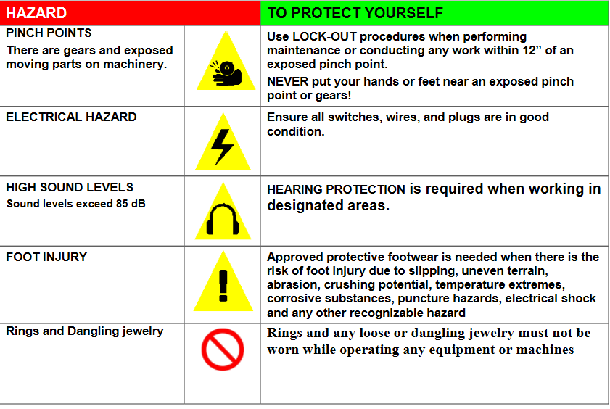
Figure 7.20 health and safety hazards

  - Monitor performance of machine
Checking performance of machine
Cutting machine/clicking machine
In using a Cutting machine/clicking machine, the following performance rules must be followed
- Do not operate the machine without prior approval
- Do not work without written job order card
- Only one person is allowed to work on the machine at one time
- Before the start of the cutting, check the die for the Article, Size, and Upper/lining/interlining.
- Before starting cutting, set the pressure and adjust the aluminum plate 10mm above the die
- Check the die for deformation of shape before proceeding for cutting
- Do not keep the Dies on top of the other
- Switch off the machine when not in use
- Use only one die on the Nylon board while cutting material

Checking Clicking dies/Knives:
- Use the right knife for the task.
- Keep knives sharp
- Always cut on a stable surface, like a cutting board.
- Always cut away from your body.
- Store knives safely in a rack or knife block.
- Don’t leave knives in washing –up water.
- Always carry knives with the blade pointing downwards.

Checking Grinder
In using a grinder especially for blade making, the following safety points must be followed.
- Hair must be tied back
- Wear tight clothes
- Shoe must be protective
- Do not operate the machine without prior approval.
- Do not work without safety glass.
- Only one person is allowed to work on the machine at one time.
- Switch off the machine when not in use.
- Do not spill the water on the machine.
- Break the hack saw blade on the vice.
- Do not wear loose cloth while sharpening the blade,
- Clean your work place after completing your work.
- Do not walk around carrying the knife with the cutting blade exposed. It can cause injury.
- Do not try and catch a falling knife instead when it is not in use put your knife in a secure place

Checking Strap cutting machine
  - Do not operate the machine without prior approval
  - Switch off the machine when not in use
  - Only one person is allowed to work on the machine at one time
  - Do not work without written job order card

Checking Stamping machine
- Do not operate the machine without prior approval.
- Only one person is allowed to work on the machine at one time.
- Switch off the machine when not in use.
- do not spill the water on the machine
- do not wear loose cloth while working,
- place the component on machine platform carefully
- keep the hands away from the heated number plate/die
- Clean your work place after completing your work.
- Empty the leather waste in to waste bin only.

  - Perform minor maintenances
    - Maintenance of equipment’s and machinery
What is maintenance?
The process of preventing a condition or situation or the state of being prevented, the technical meaning of maintenance involves functional checks, servicing, repairing of necessary devices, equipment, machinery, to the machinery or equipment perform its required functions
Different types of maintenance
- Productive maintenance
- Preventive maintenance
- Predictive maintenance
- Breakdown maintenance
- Corrective maintenance

- Productive maintenance
The goal of the pm is program is markedly increase production while, at the same times increasing employee morale and job satisfaction
- Preventive maintenance
It is daily maintenance (cleaning, inspection, oiling and re-tightening), design to keep the healthy conditions of equipment and prevent failures through the prevention of deterioration, periodic inspection or equipment condition diagnosis, to measure deterioration,
Just as human life is extended by preventive medicine, the equipment service life can be prolonged by doing preventive maintenance
- Predictive maintenance
The service life of important part is predicted based on inspection, In order to use the parts to the limit of their service life in this method. Compared to periodic maintenance, predictive maintenance is condition-based maintenance. It manages trend values, by measuring and analyzing data about deterioration and employs a surveillance system, designed to monitor conditions through an on- line system.
- Corrective maintenance
It improves equipment and its components so that preventive maintenances can carried out reliability. Equipment with design weakness must be redesigned to improve reliability or improving maintainability.
- Breakdown maintenance
It means that people waits until equipment fails and repair it. Such a thing could be used when the equipment failures does not significantly affect the operation or production or generate any significant loss other than repair cost.
The maintenance function is performed mainly in two ways
- By prevention of break down successful preventive maintenance can be achieved through two ways routine servicing and scheduled works and periodic scheduled repair
- By the repair of break down
    - Maintenance of Hand tool
- Screwdrivers
Screwdriver is a tool, manual or powered, for screwing (installing) and un screwed (removing) screws. A typical simple screwdriver has a handle and shaft, ending in tip the user puts in to the screw head before turning the handle handles are typically wood, metal, or plastic and usually hexagonal, square, or oval in cross-section to improve grip and prevent the tool from rolling when set down.
A typical screwdriver comprises an approximately cylindrical handle of a size and shape to be held by a human hand; an axial shaft embedded in, and protruding from, the handle; and a tip found at the end of the shaft, opposite the handle.
The handle and shaft allow the screwdriver to be positioned and supported and, by rotating the handle, torque is applied to the tip via the screwdriver's shaft.
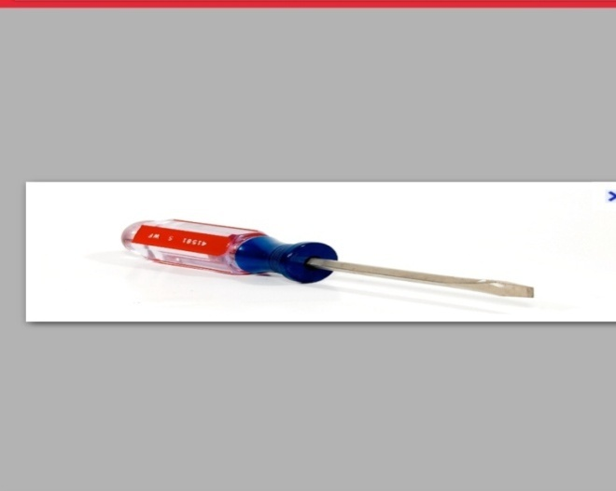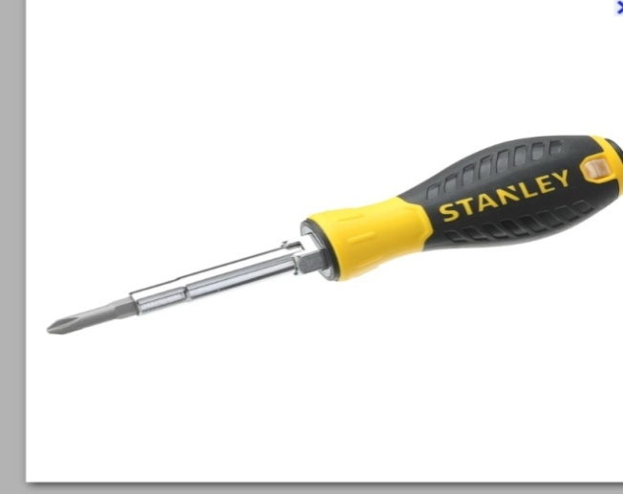
Figure 7.21Screwdriver
- Cleaning Brush
A cleaning brush is a tool with bristles wire or other filaments, used for cleaning surface finishing and for many other purposes. It is one of the most basic and versatile tools known to making It generally consists of a handle or block to which filaments are affixed either parallel- or perpendicular wise, depending on the way the brush is to be gripped during use. The material of both the block and bristles or filaments is chosen to withstand hazards of its application, such as corrosive chemicals, heat or abrasion.
Many sewing machine problems are often the result of thread and lint build-up in the area between the faceplate and the bobbin. A flat artist's paintbrush in 1/2-inch size is useful, and a soft blush or makeup brush with a short, stubby handle is effective. The long, soft bristles of the makeup brush clean without damage and hold lint well.
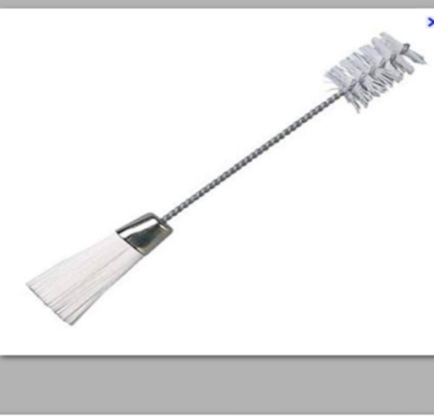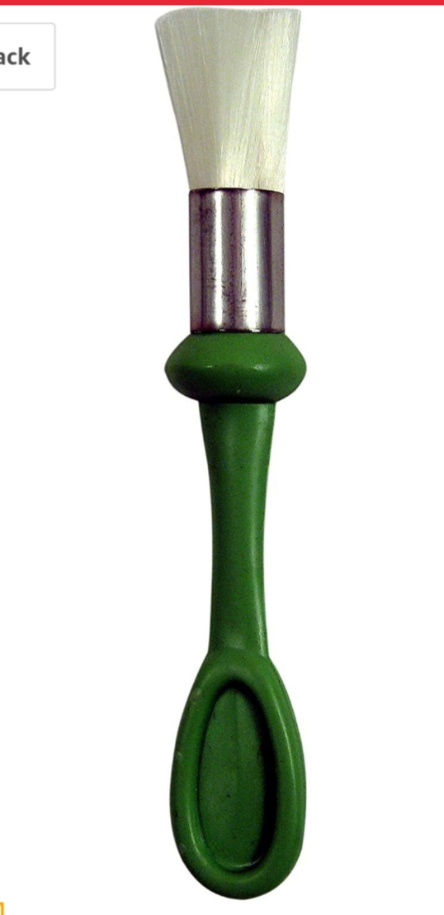
Figure 7.22 A cleaning brush
How to clean the machine
- Take a machine apart First, up plug the machine, take out the bobbin casing, lower the race cover and remove the hook. Take of the presser foot and throat plate.
- Grab a brush
Brush out any lint that built up in the bobbin casing and throat plate .most machines come with a small plastic brush, through any anti-static brush or pipe cleaner will work
- Oil the machine
A little oil goes a long way and yes, it is totally possible to over oil your machine. If that is happened, run some muslin pr scrap fabric through the machine unit it comes out clean and without oil stains
Reassemble the machine
Place the hook, bobbin casing and throat plate back in their respective places. Change your needle and reattach the presser foot. Replace the bobbin, thread your machine
- Blower An air blower is a machine used for generating flow of air at substantial pressure and defined as, a blower is a device designed to blow cool or hot air over wet or damp surface, in order to accelerate the evaporation of water particles and dry the surface.
Air blow can be categorized in the following types based on principle of airflow generation
- Centrifugal blower –air enters axially and leaves the blade radial direction
- Axial fans – air enters axially and also leaves the fan blades in axial direction
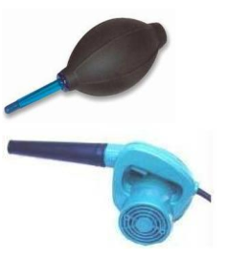
Figure 7.23 Air blow
- Tweezers are small tools used for picking up objects too small to be easily handled with the human hands. They are probably derived from tongs pincers or scissor like pliers used to grab or hold objects. In a scientific or medical context they are normally referred to as forceps.
Tweezers makes use of two third class levers connected at one fixed end with the pincers at the others
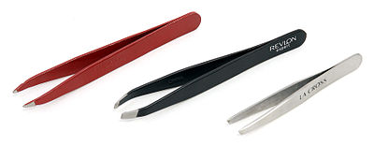
Figure 7.25 Tweezers

- Oiling can
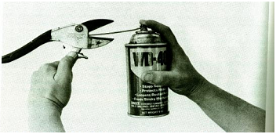
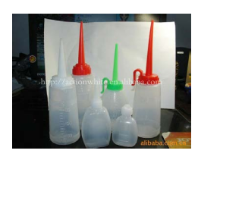
A can that stores oil to be used in a sewing machine for various purposes Oilcan is used to lubricate various leather goods tools, equipment and machines with suitable machine oils.

Figure 7.26Oilcan
- Cleaning cloth
Different types of cloth are available for cleaning parts of a sewing machine.
Anything, which is dry, is used for cleaning sewing machine and its parts.
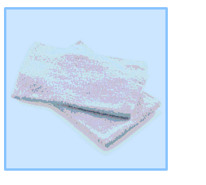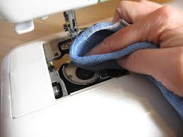
Figure 7.27cleaning cloth
- Pliers:
Three types of pliers’ viz. nose pliers, diagonal cutting pliers and lineman’s pliers are very useful in a leather products manufacturing workshop for cutting and bending, pulling small fittings and holding metal fittings that are to be filed or hammered. Nose pliers are used for cutting and bending thin wires and small fittings.
Diagonal cutting pliers are sometimes called as wire cutters. It has scooped jaws, which make them ideal for extracting small nails, or damaged fittings. Lineman’s pliers are sometimes called engineer’s pliers. They are very useful for bending, gripping and manipulating sheet, metal and wire. Their wide, heavy, checked jaws and long handles provide leverage and nonslip hold necessary to turn thzwe head of a bolt, the nut or stubborn screw whose slot is too chewed up to be removed with a screwdriver. These pliers are used in fabricating leather goods, repair works and maintenance of machinery.

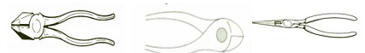
Figure 7.28 Linesman’s pliers Diagonal cutting pliers Nose pliers
- Pincer:
Pincer pulls out nails that a claw hammer cannot (for example a wire nail without head). It is used for short pulls. The fine claw at the end of pincer handles slips well into the well-driven nails or rivets.
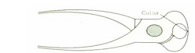
Figure 7.29 Pincer
- Bench grinder
Bench grinder has two grinding wheels. One is coarse and the other is fine. The grinding wheels are provided with guards and tool rest. The tool rest must be 3mm away from the wheel at the required angle. This prevents the tool from being dragged into the wheel. A bowl of cold water is kept by the side of the machine so that cooling of the work can be done periodically. Bench grinder is used to sharpen clicking and skiving knives. While sharpening the knife, the following steps are to be followed:
- Adjust the angle of the knife to be ground,
- Use the hand to hold the knife steady while moving it across the grinding wheel from side to side and
- Keep the surface being ground as cool as possible by dipping the knife in water bath. When the bevel has been removed, the knife is reading for whetting.
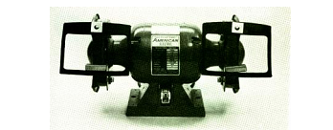
Figure 7.30Bench grinder
Needle Theaters and Small Flashlights
In order to repair a sewing machine, you will need to thread the needle and check the stitching. Save time by keeping a few needle traders on hand, along with some miniature flashlights. The electric sewing machines often have to be unplugged to work on internal parts for safety, so the lighting provided by the machine is not available. Have easy lighting available, even if it is a key chain flashlight.
Other Useful Tools
Long-handled tweezers are handy for working on a sewing machine, and the ones with the angled pinchers are best. A flat magnet is good for holding or retrieving tiny pieces and parts when working on the sewing machine. Scissors are helpful for the sewing machines that do not have a built-in thread cutter (or if you don't know where it is). The instruction book for the model you are working on is an essential tool, and some of these are available online.
Personal Protective Equipment (PPE)
- PPE is defined in the Personal Protective Equipment at Work Regulations as:
‘All equipment (including clothing affording protection against the weather) which is intended to be worn or held by a person at work which protects them against one or more risks to their health and safety’.
- PPE includes equipment such as safety footwear, hard hats, high visibility waistcoats, goggles, life jackets, respirators and safety harnesses.
- Waterproof, weatherproof, or insulated clothing is subject to the Regulations only if its use is necessary to protect employees against adverse climatic conditions that could otherwise affect their health and safety.
Grease gun
A grease gun is a common workshop and garage tool used for lubrication. The purpose of the grease gun is to apply lubricant through an aperture to a specific point, usually on a grease fitting. The channels behind the grease nipple lead to where the lubrication is needed. The aperture may be of a type that fits closely with a receiving aperture on any number of mechanical devices. The close fitting of the apertures ensures that lubricant is applied only where needed.
There are three types of grease gun:
- Hand-powered, where the grease is forced from the aperture by back-pressure built up by hand cranking the trigger mechanism of the gun, which applies pressure to a spring mechanism behind the lubricant, thus forcing grease through the aperture.

Figure 7.31Hand-powered grease gun
- Hand-powered, where there is no trigger mechanism, and the grease is forced through the aperture by the backpressure built up by pushing on the butt of the grease gun, which slides a piston through the body of the tool, pumping grease out of the aperture.
- Air-powered (pneumatic), where compressed air is directed to the gun by hoses, the air pressure serving to force the grease through the aperture. Russell Gray, inventor of the air-powered grease gun, founded Graco based on this invention.
The grease gun is charged or loaded with any of the various types of lubricants, but usually a thicker heavier type of grease is used.

  - Report major problems
    - Reporting major problems
Check sheets / quality sheets:
Check sheets are a simple device on which data is collected by putting a mark against predetermined items of measurement. The purpose for which the data is collected should always be clear. These check sheet needs to be monitored on day-to-day basis to keep check the area of faults and its reporting for the rectifications.
This is also helpful in finding out that in which division are creating maximum number of faults and report to the concern supervisor for the same.
For example, check sheets can be used to track events by factors such as timeliness (in time, one day late, two days late, etc.), reasons for failure during inspection (defects like blow holes, cracks, etc.) or number of customer complaints per day.
SAMPLE CHECK SHEET FOR INSPECTION OF METAL ACCESSORIES:
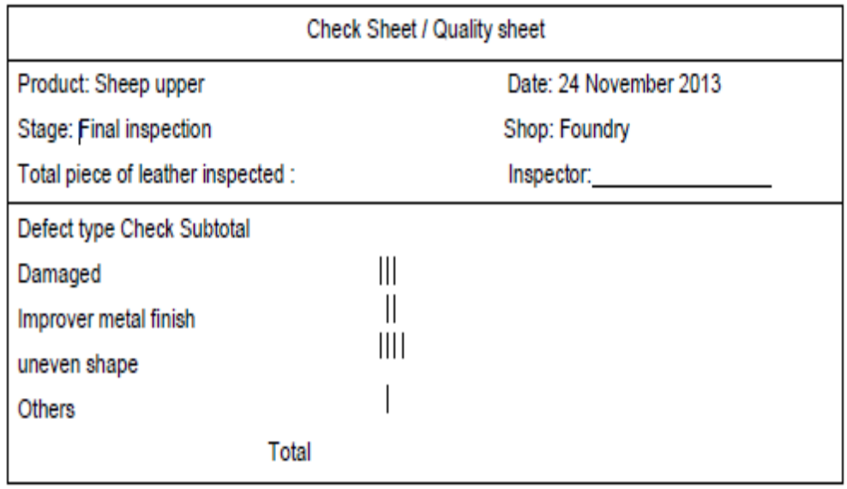
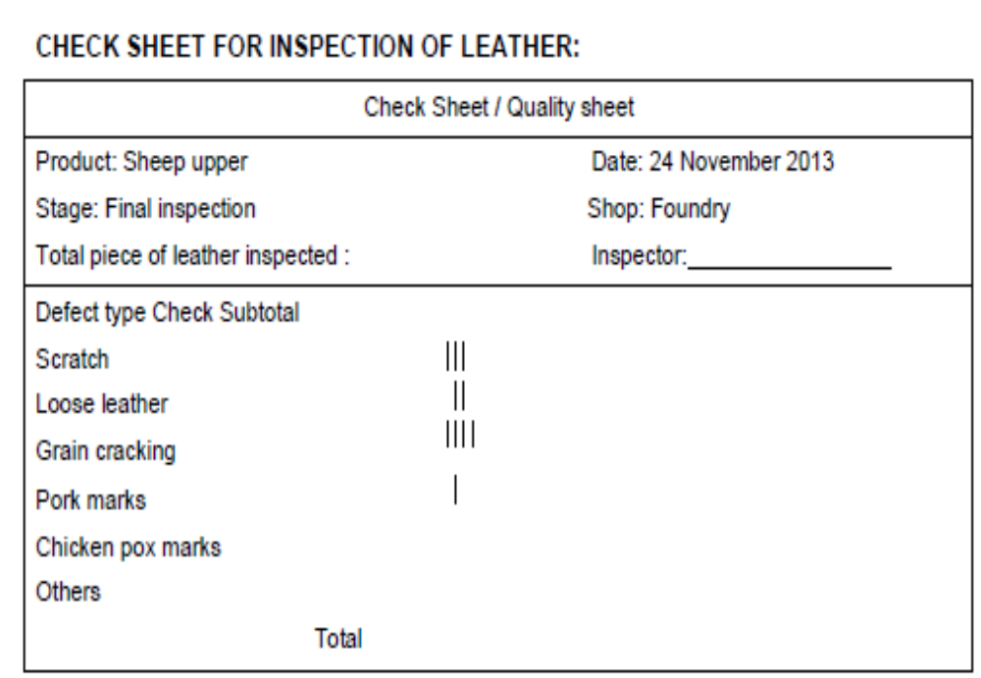
CHECK SHEETS OF FINAL INSPECTIONS – MAJOR / MINOR DEFECTS.
Check sheets, are a simple device on which data is collected by putting a mark against predetermined items of measurement. The purpose for which the data is collected should always be clear.
For example, check sheets can be used to track events by factors such as timeliness (in time, one day late, two days late, etc.), reasons for failure during inspection (defects like blow holes, cracks, etc.) or number of customer complaints per day.
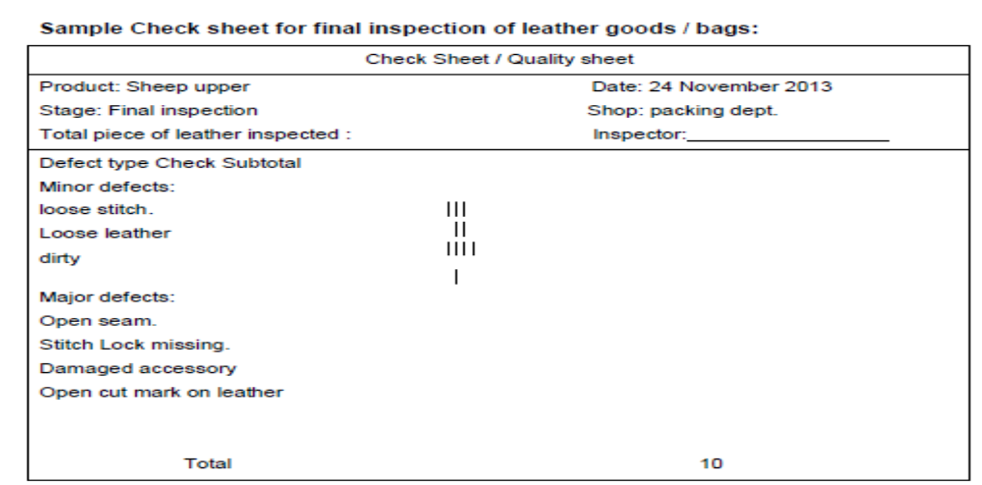

Self-check-7
Directions: Answer all the questions listed below.
- Selection of dies for cutting depends on the type of materials such.
- Write the types of Dies as per Edge for Machine cutting.
- A------------------------------Is a specialized tool used in manufacturing industries to cut or shape materials mostly using a press?
- For leather and lining materials, these are usually single-edged heavy-duty strip steel knives -------------------mm deep. For bottom stock, they are usually forged steel knives up to ------------------------ mm deep.
- Writ the first 3 of Quality Parameters?
- There are two types of cutting system write there--------?
- ------------------------ is the placement of leather patterns in lather in effective way it is a best practice in the leather goods manufacturing unit?
- ------------------------------is a hydraulic machine used to cut materials with several layers?
- What is Looseness in leather?
- What is grain damage
- What are the common problems or faults in leather?
- A typical bag Specifications for general purpose may include some of the basic information write at list 3.
- Write general rules that a cutter should be aware on while cutting the leather?
- A good pattern maker must be aware of different types of finished -------------------and -----------------------in making different types of leather goods.
- The pattern maker must give in each pattern the following details, which would help the cutter in the subsequent process of cutting to cut -------------------------and------------------?
- Common injuries should be including.
- The hierarchy consists of three steps.
- In using a Cutting machine/clicking machine, the following performance rules must be followed------------------------------.
- What is the use grease gun?
- List down the tools required to perform maintenance.
- What are tweezers?
- What is the use of oilcan?
- Check sheets are a simple device on which data is collected by putting a mark against predetermined items of measurement.
- The purpose for which the data is collected should always be clear.

Note: Satisfactory rating –above 60% Unsatisfactory - below 60%
You can ask you teacher for the copy of the correct answers

Operation sheet-7
Practical Demonstration
Consider the following steps while checking the components
- Name of the product and reference number
- Name of the parts (front, back, gusset, pocket, flap, handle, etc)
- Details of the raw materials (leather, lining, foam, reinforcement, etc)
- Number of components to be cut
- Centre points for perfect joining of the components.
- Marks or slots for fixing fittings and zips
- Stitching width and stitches per inch or length of stitch in mm.
- Use of good and defective leather components for visible and invisible parts of the product
- Good component
- Defective component
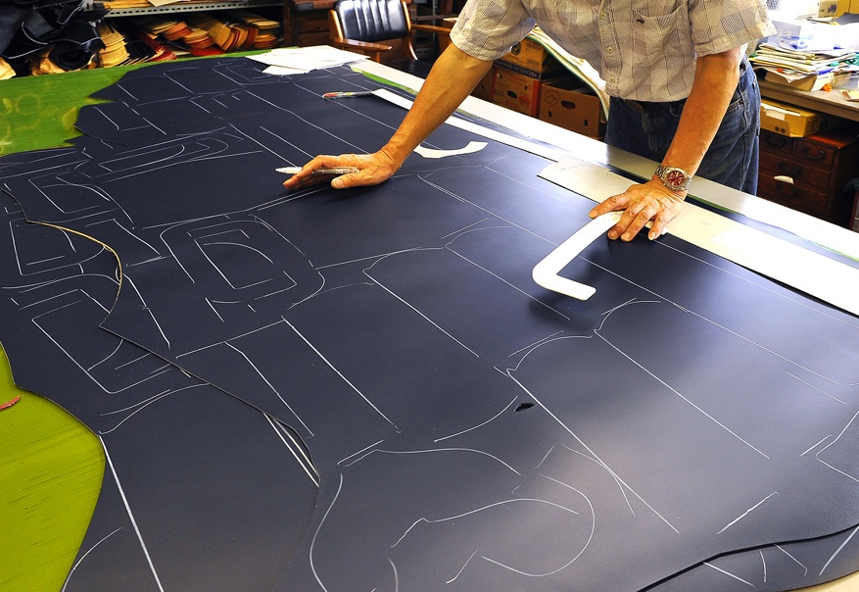

Figure 7.32 checking the components

The following steps represents how to much and interlock patterns
- Curve to curve interlocking.
- Straight edge to straight edge.
- Cutters are not required to nest components in pairs in the case of corrected grain cutting exercise. Rather on completion of the work, they should end up with approx. components.
- Cutting usually commences from the butt, continue along the backbone, working outwards as far as the substance (thickness) and quality permits, utilizing the poor quality areas for the parts, which have little or no strain during wear.
- If because of defects the material near the backbone is unsuitable, cutting should still be in accordance with the principle of working in the direction from backbone to bank commencing as more as possible to the defects, in order to ensure the minimum waste of the best material, which invariably is to be found in the butt.
- Change the direction of the patterns for getting components wise.

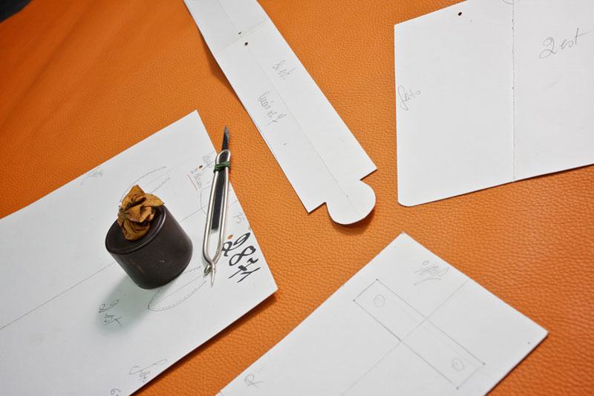
Figure 7.33 much and interlock patterns

Unit 8: Check cut components
This learning guide is developed to provide you the necessary information regarding the following content coverage and topics:
  - Check components
  - Address faults
  - take corrective action

This guide will also assist you to attain the learning outcomes stated in the cover page. Specifically, upon completion of this learning guide, you will be able to:
  - Checking components against job specification
  - Address faults
  - take appropriate corrective action

  - Check components
    - Checking components against job specification
      - Leather components
Leather garment components are each partition of construction. It’s differing from one product to another. This includes
For leather jacket
- Back yoke
- Side back
- Center back
- Front yoke
- Center front
- Side front
- Top collar
- Under collar
- Top sleeve
- Under sleeve
- Pocket
- Flap
- Piping
For leather skirt
- Front waist band
- Back waist band
- Front
- back
For leather trouser
- Front waist band
- Back waist band
- Front
- Back
- Pocket
- Fly etc
      - Lining components
Lining: covers the interior construction details of a garment. It allows the garment to slide on and off easily. It is used in coats, jackets, skirts and pants (trousers) either entirely or partially. The lining should be smooth and durable.
The lining provides a smoother and clean finish to the jacket by concealing interlining, raw edges and padding, and most importantly-it extends the life of the jacket. The lining in a leather jacket helps to perfectly shape to your body, while also preventing it from stretching. Light weight fabrics such as silk, stain, polyester cotton, nylon cotton, wool, nylon, synthetic material, etc. are used as garment lining. The weight, color and care should be compatible with the garment. In leather garment, lining is used to preserve shape, to reduce clinging and to prevent the color form crocking on to the skin and other inside garments.
Characteristics of lining
- They are usually smooth and slippery fabrics
- Linings should be colorfast, and wrinkle resistant
- Linings should be durable
- Linings and under linings made from fibers, which breath, are more comfortable to wear
- Thin lining should not be used
- Damaged, weaving defects to be avoided
- Generally, the shade of the lining should be 1 tone lighter than the leather.
Types of lining materials used in leather jackets
- Silk lining
- Rayon/viscose lining
- Cotton lining
- polyester lining
- shearing linings
- satin lining

- Silk lining
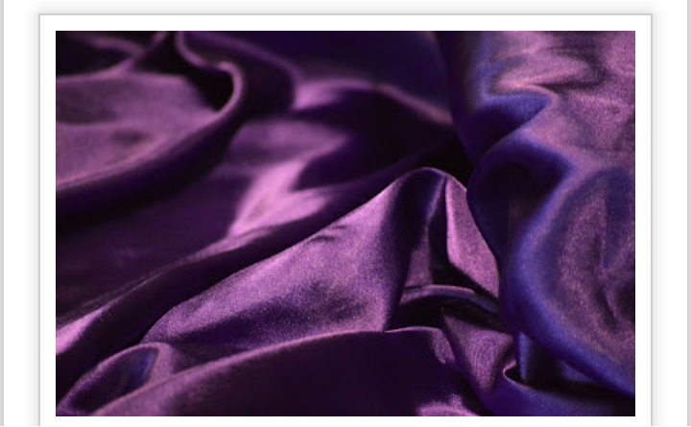
Silk might be the fantastic yet expensive choice for lining in leather jackets. It has such a smooth and lustrous feel. It is obviously made up of interlaces of natural fiber, thus it lasts long and extremely buttery features that you cannot resist from being embraced by it.

Figure 8.1 Silk lining
- Rayon/viscose lining
Rayon lining are also known as Bamberg. it is non-static, breathable and drapes well around your body. It is found in ready-made jackets. It requires tailoring expertise in laying the linings nicely against the key areas to restrain from scratchily bulges. These lining would playfully shine through the front opening of your jackets.

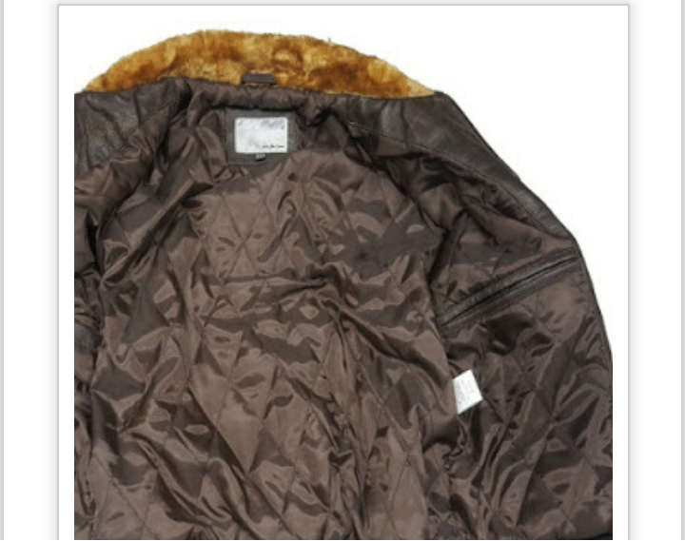
Figure 8.2 Rayon lining

- Cotton lining
Cotton is slightly heavier and extremely breathable. It is light, comfortable and inexpensive. Cotton makes an unpleasant drag to your clothes as it is sticky and wraps adherently on your bodice. However, it is economical and warmer to use in leather jackets.
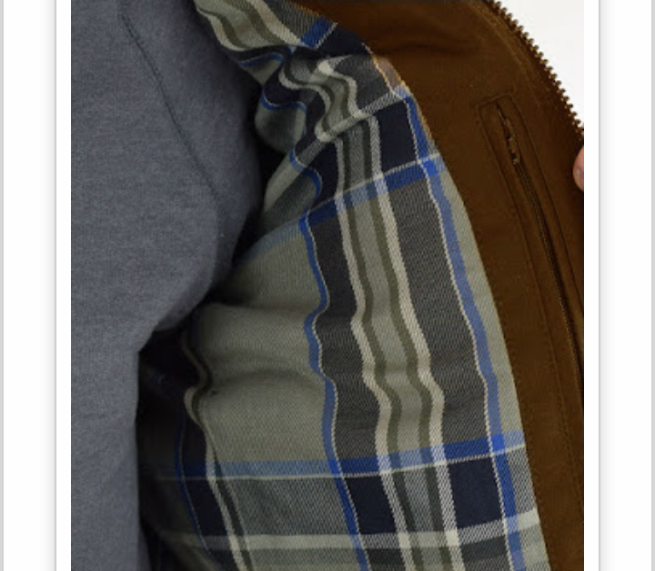
Figure 8.3 Cotton lining
- polyester lining
Polyester compared to rayon has more gloss and less resilient, yet it slides very smoothly. Polyester lining is great for winter jackets.

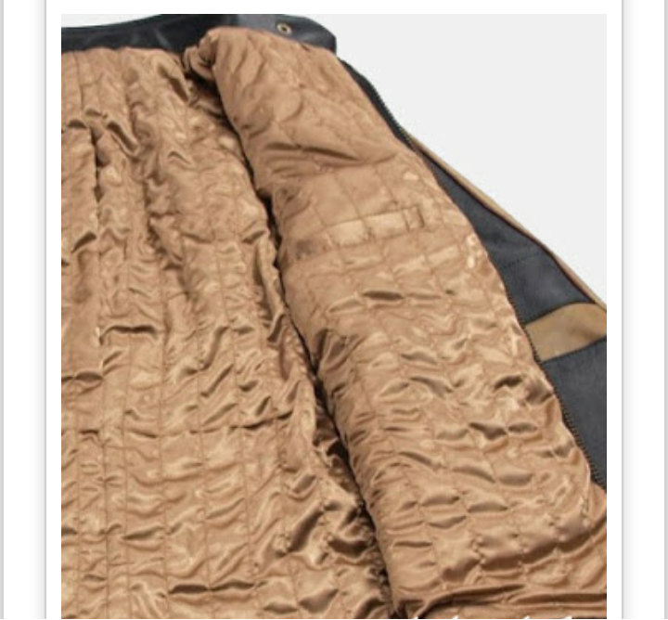
Figure 8.4Polyester lining

- shearing linings
Shear lings are made from lambskin or sheep skin; thus, a delicacy and suppleness can be taken for guaranty. This uniform fleece material feels extremely soft and comfortable and due to the high quality, it grants enough warmth to enjoy the nippy days in the polar areas. Shearling jacket are thus expensive and considered luxurious and a perfect material to use for linings in heavy jackets.
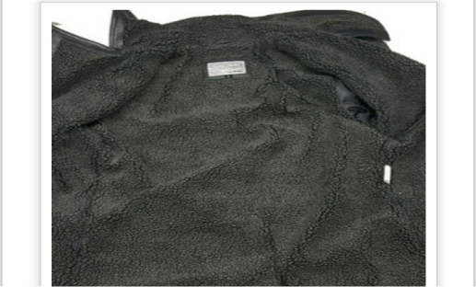
Figure8.5 Shearing lining
- satin lining
Satin linings are easy to wear and comfortable. It is a bit weighty than other lining materials but widely found in leather jackets and costumes. It is best to provide a structure, supports to your jackets from inside, and gives draped feel to your body.
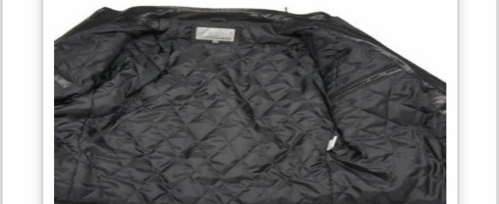
Figure 8.6 Satin lining
3. Reinforcement components
Interfacing: Interfacing is a textile used on the unseen or wrong side of fabrics to make an area of a garment more rigid. Interfacings can be used to:
- stiffen or add body to fabric, such as the interfacing used in leather jacket collars,
- Strengthen a certain area of the jacket, for instance where buttonholes will be sewn.
Cut and iron interfacing to under collars, facings, waistbands, slit facings, blouse and shirt button extensions and sleeve cuffs. Using interfacing at jacket's hem seam allowance makes get a neat hem. If you sew a patch pocket, attach interfacing to it also. Always trim interfacing to eliminate the seam allowances
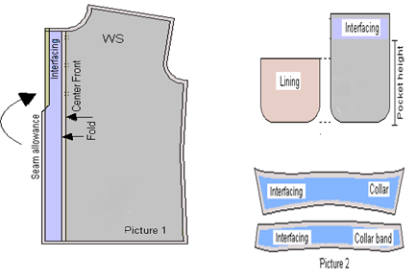
Figure 8.7Interface Area of a garment
  - Address faults
    - Addressing faults
Leather goods, including clothing, belts, as well as small goods, are not only high value Items, but are also highly variable in terms of species, types of leather, dyeing / color, Chemicals employed in finishing and microbiological activity.
CHECKING LEATHER
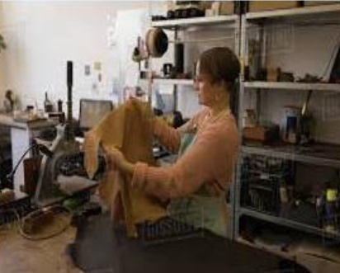

Figure 8.8 checking leather

For the following general defects:
- Loose leather
- Open grain
- tick marks and scratches
- brand marks
- shade variation
- Under/over substance
- poor nap on nubucks
- growth marks
- poor color fastness
- grain not matched
- Fat pocket in sheep
- cut marks/flay cut
- wire marks
- babble holes
- vein marks
- Wrong cutting direction
- Wrong size cut
- Extra cutting
- Overlap cut
- Die damage cut
- stretches marks/scratches
- small pock marks
- pin marks
Leather chemical testing in laboratory.
- Chromium (VI),
- Azo colorants,
- Formaldehyde and
- Pentachlorophenols are harmful substances, which may be found in leather.
Leather physical testing in factory.
- Grain matching –visual examination
- Shade matching –visual examination
- Anti-mortem and post mortem defects –visual examination
- Thickness –check with gauge machine
- Tensile strength –check with crushing.
- Durability –check with stretch.
- Water absorption capacity –check with water.
- Color fastness –dry rub and wet rub test

Metal accessories testing:
- Zippers
- Linings
- Interlinings and
- Buttons
To assess your accessory’s performance before entering the manufacturing process
1. Tests for dry cleaning fastness
2. Light and color fastness
3. Water spotting
4. Finish adhesion.
5. Veslic rubbing on finished garments and materials

CHECKING PRODUCTS

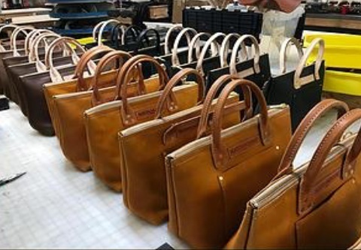

Figure 8.9 checking products

Check Handbags and Small Luggage
- The strength of strap or handle
- Buckle finishes.
- Strength of metal components
- Strength of thread
Check Belts
- Color fastness (wet and dry rub fastness) of leather
- Tarnishing of buckles
- Buckle finishes.
- Strength of metal components
- Strength of thread
    - Check Leather Garments
- Dry cleaning fastness
- Light fastness
- Finish adhesion
- Veslic rubbing can be carried out on finished garment or materials and components prior to manufacturing.
- Components such as zip, linings, interlinings and buttons should also be assessed for performance.
- In addition, a cleansing assessment overall garment may also be considered.

Check Small Goods (Purses and Wallets)
- Attachment strength of gilt corner pieces,
- Clasp attachment,
- Seam strength and abrasion resistance of linings,
- Flex resistance of outers.
- Strap/handle strength tests,
- Abrasion resistance,
- Flex resistance and seam strength tests are all important for luggage items for obvious reasons.

  - Take Corrective Action
    - Corrective action
The leather goods industry works in chain process in which like any other organization things are moving in a chain system and whatever faults are coming your way needs to be rectified immediately else it will goes to damage other products which are coming down the line. Like if any machine is not working perfectly we cannot use it until and unless it is rectified at the movement else it will deliver the products which are not acceptable on the basis of quality terms.
    - Difference between correction and corrective action
The definition of correction is action taken to eliminate a detected nonconformity. The Organization must take action to ensure that the nonconformity is corrected. The emphasis at this stage should be on the immediate action taken versus actions that will be taken. It is important to note that correction addresses an immediate action without regard to why something happened. It does not address the underlying cause of the nonconformity. Once the nonconformity has been corrected or contained, the next step in the process is to determine why the nonconformity occurred-the root cause.

The goal of effective root cause analysis is to analyze and investigate the fundamental issue that allowed the nonconformity to occur. Since corrective action is designed to eliminate the cause of nonconformity and prevent recurrence, the root cause process must be dynamic. Finally, once actions have been taken, verification must take place to validate that the actions taken were appropriate in addressing the nonconformity. Each component of the corrective action process is essential. It is important to understand the goal of each part of the process to ensure that nonconformities are dealt with appropriately. Simply put-correction eliminates a detected nonconformity while corrective action eliminates the cause of the nonconformity.
Corrective action: “Identification and elimination of the causes of a problem, thus preventing their recurrence.”
The corrective action process can be broken down into various components-
  - Identification of the requirement
  - Identification of the nonconformity
  - Correction (or containment) of the issue
  - Root Cause Analysis
  - Corrective Action Implementation
  - Verification of Effectiveness of the actions taken

Self-check-8

Directions: Answer all the questions listed below.
- ---------------- Tool is used to poking and scratching tools for creating small holes and marking leather.
- --------------Tool is used to for creating clean folds in leather.
- ------------- Tool used to set the halves of a snap together, usually two metal parts used with a mallet.
- -------------- - tool is used to easily punch different sized holes in leather without having to use a hammer and a punching surface.
- -------------- tool is a plastic slab like a cutting board that goes over your quartz slab so your tools aren't deformed or dulled during punching and stamping.
- List Leather physical testing in factory.
- List some of area to Check Handbags and Small Luggage.
- List what will be checked for belt.
- List what will be checked for leather garment.
- -----------------------is Identification and elimination of the causes of a problem, thus preventing their recurrence.
True or False:
- Without notches are used to line up two or more pieces of the leather/ materials that you will be joining together.
- Bags foreside and backside are the major parts.
- Construction markings, on the other hand, are very helpful during the sewing process.
- Cutting pattern has allowances of folding but it has to be included Stitching and Underlay allowances.
- Reinforcement pattern has allowances of folding, stitching and underlay allowances.
- The Lining Cutting Pattern has to be marked by the BLACK PEN/ COLOUR.
- Cutting pattern has allowances of folding but it has to be included Stitching and Underlay allowances
Note: Satisfactory rating –above 60% Unsatisfactory - below 60%
You can ask you teacher for the copy of the correct answers

Unit 9: Dispatch completed Work
This learning guide is developed to provide you the necessary information regarding the following content coverage and topics:
- Bundle or dispatch component
- Record faults
- Complete and maintain records
This guide will also assist you to attain the learning outcomes stated in the cover page. Specifically, upon completion of this learning guide, you will be able to:
- Bundle, number, stack, store or dispatch component.
- Record faults
- Complete and maintain records

  - Bundle or dispatch component
    - Dispatching component in accordance with workplace procedures
      - Meaning of Dispatching
Dispatching is the routine of setting productive activities in motion through the release of orders and necessary instructions according to pre-planned times and sequence of operations embodied in route sheets and loading schedules.
The decision of assigning the various jobs to different machines and equipment is called Dispatching.
      - Functions of Dispatching
- To check the availability of input materials and ensure the movement of material from store to first process and then from process to process
- To ensure the availability of all production and inspection aids
- To obtain the requisite drawings, specifications and material lists.
- To assign the work appropriate machine, workplace and men
Bundling is the process of disassembling the stacked and cut pieces and reassembling them in production lots grouped accordingly. Stored materials must not create a hazard for employees. Employers should make workers aware of such factors as the materials' height and weight, how accessible the stored materials are to the user, and the condition of the containers where the materials are being stored when stacking and piling materials.
To prevent creating hazards when storing materials, must do the following:
- Keep storage areas free from accumulated materials that cause tripping, fires, or explosions, or that may contribute to the harboring of rats and other pests;
- Place stored materials inside buildings that are under construction and at least 6 feet from hoist ways, or inside floor openings and at least 10 feet away from exterior walls;
- Separate non compatible material; and
In addition, workers should consider placing bound material on racks, and secure it by stacking, blocking, or interlocking to prevent it from sliding, falling, or collapsing.
Manufacturers use a variety of bundling methods depending upon their needs, with four basic systems being the most common among local manufacturers
- Item Bundling
All pieces that comprise the product are bundled together.
- Group Bundling
Several (10-20) components are put together in a bundle and given to a single operator or team to sew.
- Progressive Bundling
Pieces corresponding to specific sections of the product are bundled together and given to one operator. Other operators sew other parts of the garment, which are then assembled into the finished product in the final phase.
FRONT PART / UPPER PART
The front / upper part is the major or can be the balancing part of the bag. It is depending according to the Proportion, Appropriate Sizing, Consumption and Costing of the articles. On this pattern, we have to designed pocket position, the handle position, zipper position, base and different patches or decorative parts. Every paper pattern has to be crease in the middle part for symmetry or the balance of the article. Some of the front part has to be attached the seam allowances. After these designing on the pattern slash by the knife (TENSILE) to get the different components from the Front / Upper part Sometimes the Front/ Upper part can be also the Master Pattern according to the construction of the bag.
BACK PART:
The back part is same size according to the front part. The seam allowances / stitching allowances also have to implement into the back part and the designing part also. In the back part the Flap position, Back Zip position, Handle position, the Open Seam stitch for consumption and wastage has to be designed on the back part. Every patterns are included the crease line in the middle part of the pattern for symmetry / balance and the sizing.
GUSSET:
Gussets are determined by its nature of the design of leather goods styling. Gussets are inserted where spaciousness is required. Articles, with proportionate gussets assembled in right way and stitched properly, give well outlook and serve for a long time. Gussets are made in a variety of types and commonly used gussets in leather goods making are side gussets, continuous gussets and folded gussets. Gussets are also made with different types of gusset joints. According to the designs of the bag different types of gussets are required.
Some of the gussets are joined at the sides of the article e.g. ladies Kelly Bag, Boston Trunk, shopping bags, duffel bags, medical representative bags, etc.
In the U- Shape bag, the continuous gussets are joined at the sides, top and bottom of the article e.g. Messenger bags, portfolios, travel knighted bag, laptop case, shoulder bags, shopper bags, wrist pouches, shaving kit bags, women handbags, etc. Folded gussets are joined at the sides and bottom of the article e.g. document cases, filecases, portfolio bags, clutch bags, women handbags, etc.
BASE:
The Oval Base bag or Bottom Rounded Base bag determined from the bottom part. The front and the back part will depend upon the base part. The Base part pattern has to cut first and then the front/upper part has to cut by pivoting the base. The volume of the bag also depends on the styling of the bag and the purpose of utility. We can see in the European market e.g. Buguatti bag, tote bag, Drawstring bag, instrument carrier, wine carrier, shopper bag, shoulder bag etc.
POCKET PATTERN:
In the leather goods, the pockets are assembled on the upper part/ Front part of the bags. In the portfolios the bigger pockets has to use for maximum use. Normally the zip pockets are used in the back part of the bag. There are different types of pocket constructions are used in the leather bags, according to designing.
LINING COMPONENTS:
The components pattern included all over allowances such as Underlay allowances and Stitching allowances. But it should be shorter in size from the exact pattern. In the lining cutting section the Labor or staffs has to maintain the quality of the lining material – upper part, color, size, quantity according to the requirements of the client.
They have to maintain proper norms for cutting the lining and wastage has to be minimized. The safety norm has to be maintained according to the industry act. To make less number of products, cardboard patterns are used for cutting components. To make more number of products, aluminum or galvanized metal patterns are used for cutting components. To manufacture in bulk, the cardboard patterns of the product are converted into clicking dies and the components are cut in the hydraulic clicking press.
The Lining Cutting Pattern has to be marked by the BLACK PEN/ COLOUR.
There are different types of process to accommodate lining in the bags. The lining depends according to the construction and types of the bag where it should be fitted.
Linings are used as reinforcement materials in a wide variety of leather goods. The uses of linings in leather goods are:
  - to mask the rough surface of split leather components,
  - to cover the defects of flesh side of the leather components,
  - to add sufficient strength to the components,
  - to match the color of the articles and
  - To improve the elegant look of the articles. Lining is done usually with fabrics, leathers and synthetics.
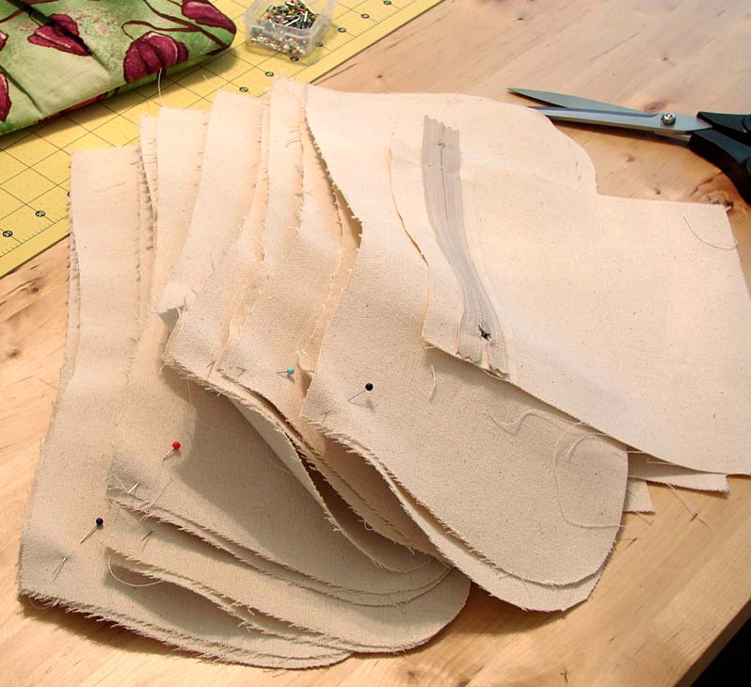
Figure 9.1 fabric linings
FABRIC LINING
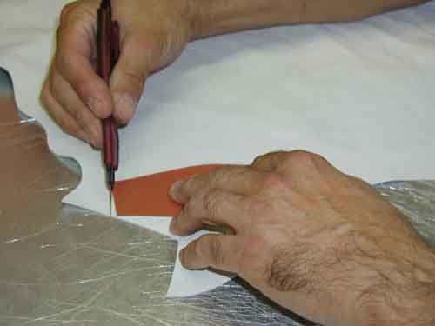
Figure 9.2 fabric lining
Cotton and silk are generally used as linings in leather goods. Drill and Polyester linings are used as linings in heavy and luggage leather goods. Taffeta, crape, satin, and moiré silk linings are used as linings in small, medium and sophisticated leather goods. Velvet linings are used in jewel boxes, camera cases and attaché cases.
LEATHER LINING
Swedes, splits and skivers are used as linings in leather goods making. These linings give more strength, durability and luxury look to the products. Suede linings are used in sophisticated leather goods like brief cases, attaché cases, jewel boxes, camera cases etc. Split linings are used in heavy and luggage goods. Skiver linings are used in small leather goods.
SYNTHETIC LINING
Plastic, Rexene, nylon and flocked fabric (imitation suede) linings are used in certain types of leather goods. Flocked fabric or imitation suede lining is used as a substitute for suede leather lining in a variety of articles. Plastic or Rexene linings are used as linings in articles where waterproofing is necessary for example shaving kit, cosmetic box, water bottle covers, etc.
    - TYPES OF LINING CONSTRUCTION (EDGE LINING)
Edge lining is done on the edges of the component, which gives softy feel to the products. Most pocket and small leather goods are done with edge lining.
STUCK LINING
Stuck lining is attached to the whole surface of the component, using adhesive. The edges of the leather component are folded and then stitched. This lining gives firmness to the components. Structured bag some of the structured leather goods are done with stuck lining.
SACK LINING / DROP IN LINING
The lining is stitched first and then attached to the product on the top by stitching. The lining is held loosely inside the article. It is also called pull out or loose lining. This type of lining is done in most of the ladies handbags and different types of bags.
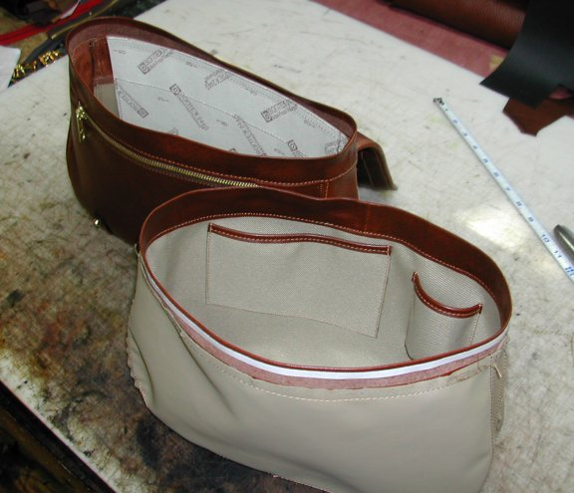
Figure 9.3sack lining / drop in lining
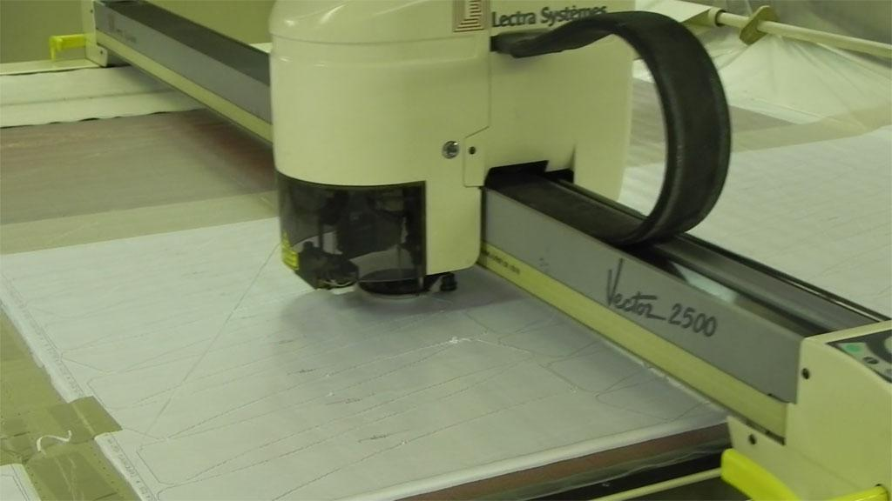
Figure 9.4 Automatic Lining Cutting Machine
    - REINFORCEMENT COMPONENTS
This pattern has no allowances of folding, stitching and underlay allowances. In addition, it should be shorter than the exact patterns of the components. Normally the EVA / RUBBER SHEET, TEXON / FLEXO BOARD, FOAM, SELF FUSING CLOTH, BAKRAM for using of the reinforcement cutting patterns. For bulk production, the clicking dice can be used to cut the reinforcements. .
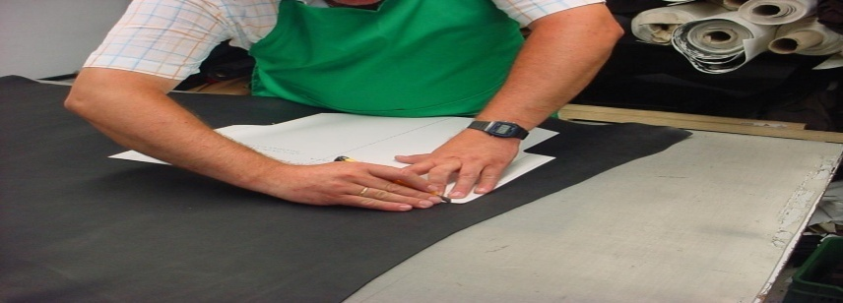
Figure 9.5 tracing reinforcement
To make more number of products, aluminum or galvanized metal patterns are used for cutting components. To manufacture in bulk, the cardboard patterns of the product are converted into clicking dies and the components are cut in the hydraulic clicking press. This pattern has to be marked by the green pen/ colour.
Reinforcements are the materials that are introduced in the articles to add substance, strength and shape. They are introduced in the articles in between the leather and lining materials. Reinforcements play a vital role in modern leather goods without which many of the designs would not be possible and most of the articles would have to be soft and shapeless. As reinforcement materials support the shape, strength, and thickness of the articles, they have to be cut accurately in the machine wherever possible... Roll directions have to be marked on boards, as this is very important to assist bending and prevent cracking of boards. In molded, built-up and box work constructions, reinforcement materials are generally used. Some of the reinforcement materials that are commonly used are cartridge/drawing papers, millboards, yellow straw boards, ply-wood/deal woods, mild steel hoop iron frames, etc.
Cartridge / drawing paper:
Cartridge papers or white drawing papers are used for pattern making process. It is also used as a lining reinforcement.
Millboards:
Millboards are used in a variety of works in leather goods making, in particular, for making patterns for the products.
Figure 9.6 millboards
It has a smooth surface on one side and coarse surface on the other side. The smooth side provides uniform smooth surface to the leather components during assembling while the coarse side provides firm grip to the Reinforcements. Mill boards are used as a reinforcement material in making molded type of articles like, jewel box, penholder tumbler, pincushion, desk pad, letter paper and envelope case, visiting card case, etc. and also in heavy leather goods like document case, briefcase, suitcase etc.

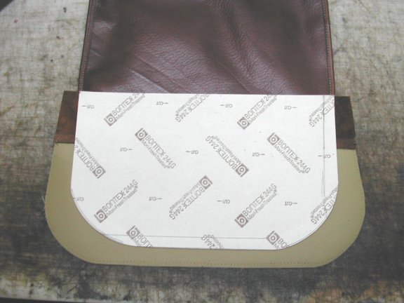

Figure 9.7 reinforcement material
    - PRECISE CUTTING OF COMPONENTS
The material cutting job is very precise work for the productions. The components pattern included all over allowances such as allowances. In the cutting section the Labor or staffs has to maintain the quality of the material – size, and quantity according to the requirements of the requirement. They have to maintain proper norms for cutting the material and wastage has to be minimized.
The safety norms have to be maintained according to the industry act. To make less number of products, cardboard patterns are used for cuttingcomponents. To make more number of products, aluminum or galvanized metal patterns are used for cutting components. To manufacture in bulk, the cardboard patterns of the product are converted into clicking dies and the components are cut in the hydraulic clicking press. The pressure surface of the swing beam has been provided with an aluminium sheet making it possible to cut with double- sided cutting dies without damaging the cutting edge.
  - Record faults
    - Recording faults as required
Fault records are one of the most important pieces of evidence that event analysts can have during system event investigations. They can provide the reasons for premature equipment failure, supply waveforms and status of equipment behavior during an event, and give necessary information to perform post-fault event analysis.
Proper use and interpretation of event records can lead to corrective action for a given system problem resulting in improved performance and reliability of any generation, transmission, and distribution system. Fault records are now captured by microprocessor relays but records are limited to sampling rate and record length. Some use digital filters that do not reflect the real captured waveform.
Fault recording has been used for decades now, and it is generally used for two main purposes:
- Recording of system events
- Monitoring of system protection performance

    - Recording Faults and Remedies
Recording faults is crucial when in an office. It is important as you could have the same people phoning up the support and describing the same problem as the last time that they phoned. The fault log will allow you to identify any problems that have happened before as it will contain information on what has happened before and how it has been solved in the past. This increases the speed of resolving the issue so that you can solve more problems within the day. You will also get people who call often with the same problem and will describe the exact same problem 99% of the time.
When taking fault logs, you will need to record what type of problem it is. All the faults that are recorded are put into a table, which is full of different kinds of errors that have happened to the company. You will be able to perform a query to search for the problem by typing in the problems that have been occurring and will be able to find a solution to the problem within minutes usually. The solutions to each problem are entered into the database with their problems to make it easier for a technician to find the solution.

  - Complete and maintain records
    - Completing and maintaining records
Complete and well-organized documentation is the key for the smooth functioning of the organization. The purpose of the documentation is providing clear guide line & procedure for the functioning of any activity in the organization. The core of the documentation process is to ensure that organization function’s work efficiently is optimum & leaves lesser scope of the confusion in terms handling of any assignment / routine activity by the staff. It is however, the term record is different from the document as records deals with capturing of the real time data under given condition. They are different from the document with respect to the utilization.
The documents are generally prepared taking in to long term horizon & objective of the organization in to account. These can be company policy, procedure, system documents, Standard Operating Procedure (SOP) etc. Whereas, the records can be daily production report, rejection report, hourly production, material consumption reports etc. Records are generally dynamic in nature. Though every organization has different purpose & objective of maintaining documents, also the degree of documentation also varies. However, generally the purpose of documentation is following:
- To provide defined procedure for carrying out routine work of the organization.
- To provide guidance for reporting & developing structure based information flow
- To helps to train new personnel on understanding and adopting new system
- To suggest likelihood course of action in case of decision making in different options
- To help & ensure organizations practices are in accordance to the statuary requirements.
- To ensure maintenance of the record & retrieval of the same
The documentation always follows a system, which is designed based on statuary, & policy based requirement of the organization. However, these can be amended on time-to-time basis.
The documents pertains to the quality department relates to procedural requirement of inspection including procedure of inspection, testing requirement & method of inspection, analysis of defects & method of reporting. The function of Quality department of any organization is to ensure that the products and services provided by the organization match the expectation of the customers. Therefore, records and documents plays an important role is ensuring that the process variables are recorded and all corrective, preventive actions have been initiated /carried out as per the policy and procedural requirement of the organization.
    - Preparation of quality standard as per product
Quality Standards: Three kinds of tolerances have to be realistic before any system of quality control can begin to operate with efficient economy.
They are as follows:
  - Tolerances for the characteristics of the final products
  - Tolerances for the parts and manufacturing processes , raw material and so on which may have an effect upon the characteristics of the final product
  - Tolerance which permits assembly and interchangeability of components (if applicable)
The engineer might have set the characteristics of the final products such as shoes, garments, goods or by the customer, himself based upon the information they get or in possession. Although it may be desired that the performance variable may be increased or decreased but it is equally difficult to understand from the customer point of view whether the customer is going to accept or will insist upon augmentation of the reliability.
For example, suppose a goods manufacturer think about altering the chemical composition of the metal accessory, which might not have any adverse effect on the performance of the good. However even though it appears to be simple to answer but from the quality point of view, it is not that simple.
Before fixing up the altered chemical composition, the quality department has to carry out various tests to establish the fact that assumption is acceptable to the standard defined or it matches the standard, which has been set. Therefore, quality department may carry out extensive tests at regular intervals during the process of manufacturing, raw material selection as well as on the final product.
Evaluation of the specification for parts, components and manufacturing process is being defined through trials and testing thereby defining quality standards for the product.
    - Fixing product specifications
A specification is the minimum requirement according to which a producer or service
Provider makes and delivers the product and service to the customer. In setting Specification limits, the following should be considered:
- The user’s and/or customer’s needs
- Requirements relating to product safety and health hazards provided for in the
- Statutory and regulatory requirements
- Requirements provided for in national and/or international standards the competitor’s product specifications, in order to gain marketing advantages
In designing the product, the capacity of processes and machines should be kept in mind. It is also necessary to maintain a balance between cost and value realization. The clearer the specification better possibility of creating and delivering quality products.
    - Monitoring of process and product quality as per company procedure
The process of manufacturing of the product is an important part as it defines the output of the organization. The performance of the product much depends upon the type of, material being selected, the standard of quality maintained during the manufacturing process and the factor of reliability taken in to account. Thus, the monitoring of the process and the product becomes paramount. Different organizations use different parameters and tools for monitoring of the manufacturing process as well as maintaining product’s quality. Some of the tools, which are extensively used, are as below:
CHECK SHEETS
Check sheets, or tally charts, are a simple device on which data is collected by putting a mark against predetermined items of measurement. The purpose for which the data is collected should always be clear. For example, check sheets can be used to track events by factors such as timeliness (in time, one day late, two days late, etc.), reasons for failure during inspection (defects like blow holes, cracks, etc.) or number of customer complaints per day.

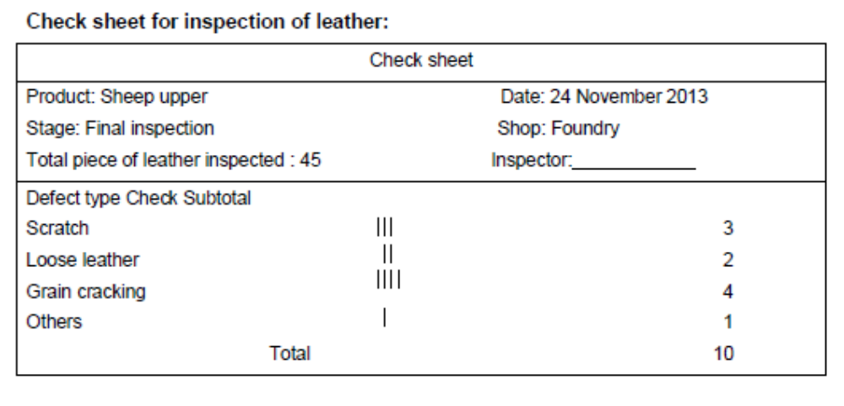
Figure 9.8 Check sheets
FLOW CHARTS
A flowchart is a schematic diagram of the sequence of steps involved in an operation or process. It provides a visual tool that is easy to use and understand. By seeing the steps involved in an operation or process, everyone develops a clear picture of how the operation works and where problems could arise.
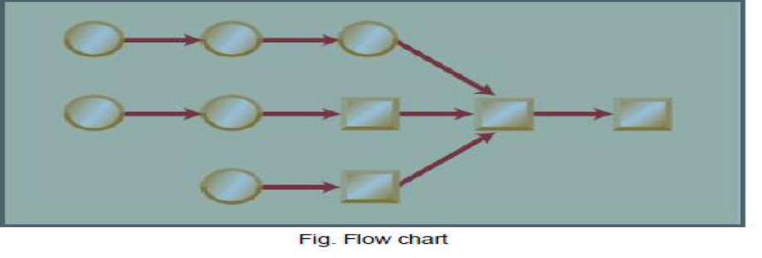
Figure 9.9 A flow chart
GRAPHICAL LAYOUTS
There are numerous types of graphs, ranging from simple plotting points to a graphic presentation of complex and interrelated data. Graphs are a good way to organize, summarize and display data for subsequent analysis. The most common examples of graphs are histograms, line graphs, and pie charts.
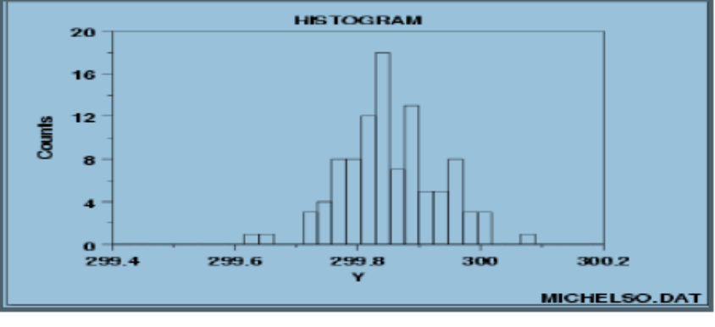
Figure 9.10graphical layouts
PARETO ANALYSIS
Pareto analysis is based on a bar graph and a line chart. The bar graph lists in descending order the problems affecting a process. The line chart accumulates the percentage of the total number of occurrences for each problem area. The other name of this tool is the 80-20 rule, indicating that 80 per cent of the problems stem from 20 per cent of the causes. It helps to identify the most important area to work to solve the problem. Joseph M. Juran, an expert on quality control has said that one should concentrate on the “vital few” rather than the “trivial many” in tackling quality problems. Let us take an example of a restaurant that is trying to analyze and prioritize the complaints received from its customers. The complaint data is shown in the table below.
The Pareto diagram of this data is shown in figure
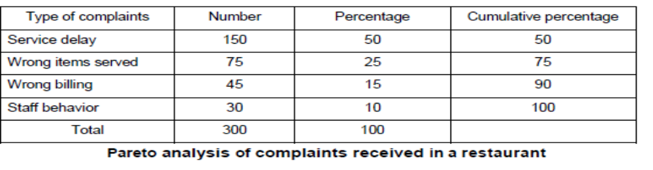
Figure 9.11 Pareto analysis
CAUSE AND EFFECT DIAGRAMS
Cause and effect diagrams represent the relationship between a problem and its potential causes. They are also known as fishbone, or Ishikawa, diagrams. These diagrams deal only with factors, not quantities.
To prepare a fishbone diagram, all the causes relating to a problem (effect) are collated through brainstorming among the people concerned. The problem is indicated on the horizontal arrow). All the causes listed from the brainstorming are classified by theme.
Each theme represents a diagonal attached to the spine of the diagram. Individual causes are listed along the diagonal.
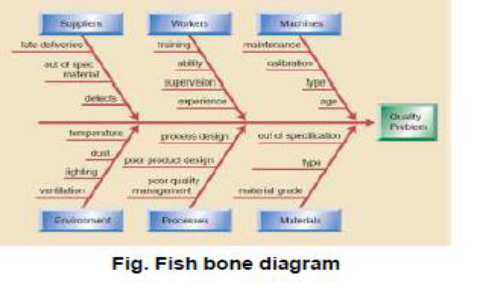
Figure 9.12 Cause and effect diagrams
Steps
- Identify the Problem
- Work out the Major Factors Involved
- Identify Possible Causes
- Analyze your diagram

SCATTER DIAGRAMS
Scatter diagrams are used to study the possible relationship between one variable and another. This can be used to test the possible cause and effect relationship. It does not prove that one variable causes the other, but it does make it clear whether a relationship exists between them and determines the strength of the relationship. Usually the horizontal axis in the diagram is the one over, which there is control.
Each data point as observed is plotted. The more closely the dots group along an axis, the stronger the correlation. The more scattered they are, the weaker the correlation.
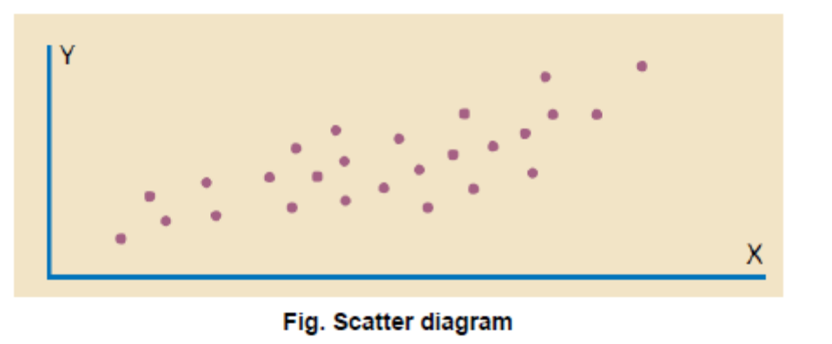
Figure 9.13 Scatter diagrams
CONTROL CHARTS:
Control charts are pictures of variations found in a process. The data of measurement or observations is plotted on graphs against time. These charts consist of two lines, called upper control limit (UCL) and lower control limit
(LCL). These are not the same as specification tolerances, rather they are the values within which a process is expected to operate and if the results of measurements exceed these limits then the cause must be investigated and action taken on the process immediately.
In order to reduce variations in the process, fundamental changes may need to be made in methods, machines and/or materials. Control charts help to monitor and control quality by acting as a set of process “traffic lights” and are valuable in all types of activity. Control charts can be plotted for variable or continuous data (such as weight of a bag, temperature of cold storage, time of baking, dimension of a rod or speed of a conveyor).
Control charts for variables consist of mean and range charts. Control charts can also be plotted for attribute or discrete data such as the number of defects found in a lot, the number of cracks in a piece, the number of missing stitches in a garment, percentage delays in shipments or percentage delays in responding to customer complaints. As regards attribute data, the two most popular charts are control charts for the number of defective items in a lot, known as an “npchart” and the proportion of defective items, known as a “p-chart.
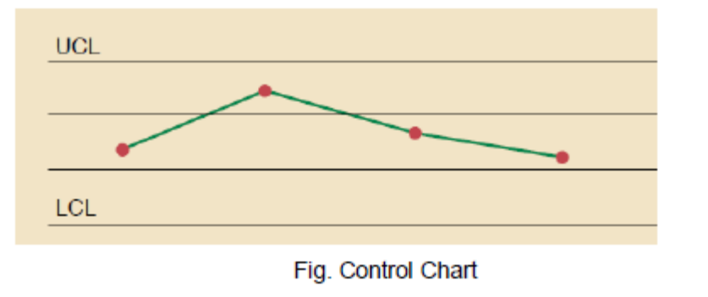
Figure 9.14 Control charts

Self check-9

Directions: Answer all the questions listed below.
- What is meant by bundling? (10pts.)
- Explain the difference between item bundling, group bundling and progressive bundling? (10pts.)
- Discuss the function of the dispatching? (10pts)
- What is the main purpose of recording a fault? (10Pts)
- Benefits of recording a fault? (10Pts)
- The documentation always does not follow a system, which is designed based on statuary, & policy based requirement of the organization. (10pts)
- Complete and well-organized documentation is the key for the smooth functioning of the organization. (10pts)
- A flowchart is a schematic diagram of the sequence of steps involved in an operation or process. (10pts)
- There are numerous types of graphs, ranging from simple plotting points to a graphic presentation of complex and interrelated data. (10pts)
- Pareto analysis is not based on a bar graph and a line chart. (10pts)

Chose the correct answer
    - ----------- is the amount of leather from the cutting line to the center of folding edge
- Folding allowance
- Seam allowance
- Stitching allowance
- All
    - If the folding allowance is 1cm, what measurement should take for skiving?
  - 1cm
  - 0.9mm
  - 1.1cm
  - Any measurement.
    - Which one is odd to introduce Reinforcements materials?
- shape
- substance
- size
- strength
    - ---are used to line up two or more pieces of the leather/ materials that you will be joining together
- Notches
- pattern
- Seam allowance
- All
    - One of the following is small V-shaped wedges of leather removed from a seam allowance.
- Pattern notch
- Pattern notch
- Center notch
- All

    - The amount of leather added to the main pattern for the purpose of either for fold allowance or seam allowance:-
- Cutting allowance
- Folding allowance:
- Seam allowance
- Underlay allowance
    - Which of the following is not classify under parts of the seam ?
- Cutting line:
- Folding line
- Cutting allowance
- Stitching line/seam line:
    - In leather goods production folding allowance is:-
- Use after skiving the leather part,
- Differs according to the products.
- Normally 1cm allowances are kept.
- All
    - The area of leather between the stitching line and the cutting line.
- Cutting allowance
- Folding allowance:
- Seam allowance
- Underlay allowance
- Every manufacturing organization will establish safe work practices at all its workplaces to
- minimize the risk of injury
- illness
- property damage
- All
- From the following which is not classified under General safety rules
  - First aid treatment
  - All work must be carried out
  - Employees must wear proper Personal Protective Equipment (PPE)
  - Tools are not to be used only for the purpose
- Housekeeping involves a wide range of routine activities including:-
  - Maintaining floors and surfaces;
  - keeping aisles and exits free of clutter
  - Handling and disposing waste.
  - All
- Powerfully built and unique leather handbags in fashion give makes a woman;-
  - Elegant
  - Brendy and seductively
  - Provocative
  - All
- From the following which stitch construction is not seen outside
  - Butt edges construction
  - Stitch and turn construction
  - piping construction
  - Raw edges construction
- -----is a temporary adhesive as it gives temporary bonding effect and so stitching is necessary after joining the components
  - Rubber adhesive
  - Specific adhesion
  - mechanical adhesion
  - All

- When the seam is rubbed down and tapped it is called a
  - Brooklyn Seam
  - Closed seam
  - French seam
  - Open seam
- which one of following important points of creasing:
  - creasing line must be close to the edge.
  - The line marked should be distinct and glossy appearance.
  - Suitable temperature must be needed for perfect creasing.
  - All
FILL THE BELCK SPACE
1 ----------------is done over the lining or reinforcement and then stitched.
2---------------is very popular and extensively used in leather goods making
3-----------is rubbed and a woven tape is attached to the reverse side with two rows of stitching one on each side of the seam.
4-------------is similar to be closed seam except that the pieces are placed grain to grain and stitched
5------------the edges of two components are placed on top of one another, both are facing upward
6-------------the process of making holes in leather components using a set of hole punching
Write True or False
    - After assembling the lining use glue and stitch the leather bag.
    - Avoid the false stitch because it is final stitch.
    - The stitch should be 2.5mm to 3mm from the edge of the bag
    - For final sewing stitch should be done preciously
    - Strap will attached only at the back component by using exact making pattern
    - The magnetic lock will attach at the front component using making pattern.
    - When sewing is done the flap will attached at the front component

Note: Satisfactory rating –above 60% Unsatisfactory - below 60%
You can ask you teacher for the copy of the correct answers

Reference

1.http://www.scoutstuff.org/leather-handbook-cover.html
2. http://www.leatherati.com
3. Learning Guide for Basic Leather Garment and Goods Production Operations level 4.http://www.scoutstuff.org/leather-handbook-cover.html
5. http://www.leatherati.com
6. Learning Guide for Basic Leather Garment and Goods Production Operations level I
7. http://www.books.google.com/books/about/Leatherworking_Handbook.html?id=rc 9_JtobVG0C
8.http://www.tandyleatherfactory.com
9. Learning Guide for Basic Leather Garment and Goods Production Operations level I

Participants of this Module (training material) preparation
No | Name | Qualification (Level) | Field of Study | Organization/ Institution | Mobile number | E-mail
1 | Siyoum Negash | B(MSC) | Leather Garment | SNNP, Dillapolytechnic college | 0913084257  0902249766 | Siyoum2006@gmail.com  nagashsiyoum@yahoo.com
2 | mohammad juhar | A(MSC) | Garment technology | Dessiew/rosiheen polytechnic college | 0913632589 | mdjuher143@gmail.com
3 | KALAB GIETIE | B(MSC) | Leather technology | Deberebrihan | 0996884181 | kalabtenaw@gmail.com

