Leather Garments and Goods Production
Level-II
Based on November, 2021, Curriculum verision 1
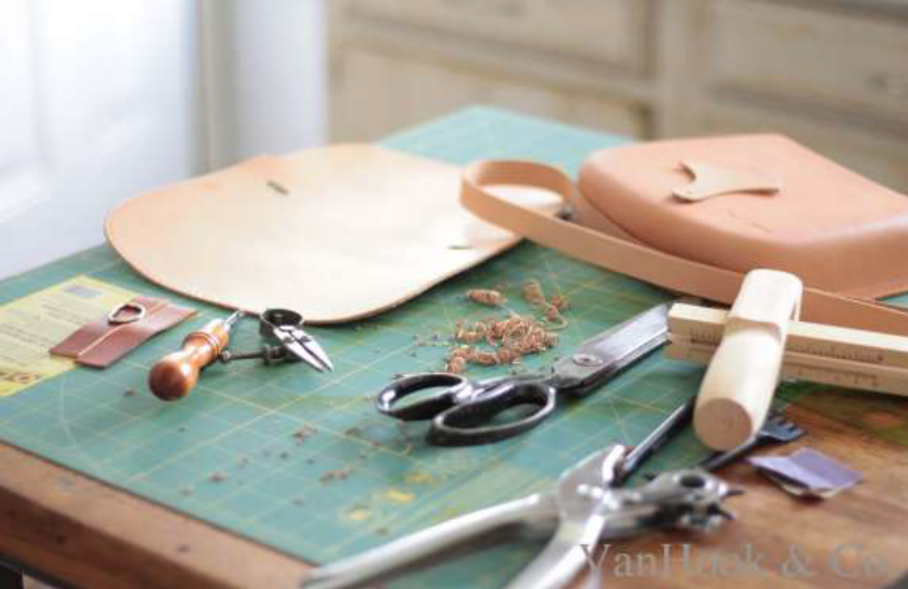
Module Title:-Apply Finishing and Packaging of leather garments and goods products
Module code: IND LGG1 MO5 1221
Nominal duration: 60Hour
Prepared by: Ministry of Labour and Skill
August, 2022
Addis Ababa, Ethiopia
Table of content
Acknowledgment 1
Acronym 2
Introduction to the Module 3
Unit one: - Prepare for work 5
1.1. Selecting appropriate finishing tools 6
1.1.1. Selecting Finishing Tools and Equipment 6
1.1.2. Measuring Tools 15
1.1.3. Adhesive for Finishing of Leather Garment and Goods 16
1.2. Setting workplaces according to OHS practices 21
1.2.1. Main causes of accidents 22
1.2.2. Safety Rules for the Leather Garment and Goods Production 25
Self-Check 1 29
Unit Two: Perform Finishing Operation 31
2.1. Removing excess materials 32
2.1.1. Cleaning Excess Materials 32
2.1.2. Thread Trimming 36
2.2. Ironing leather garment and goods 39
2.3. Polishing leather garment and goods 44
2.4. Performing finishing operation for leather garment and goods 47
2.4.1. Performing finishing operation for leather garment and goods 47
Self-Check 2 49
Unit Three: Determine requirements for repair of leather garments and goods. 50
3.1. Assessing and examining leather garment and goods for repair work 51
3.1.1. Assessing Leather Goods for Repair Work 52
3.2. Determining requirements of restoration 57
3.3. Determining the costs of repair work 58
Self-Check 3 62
Operation Sheet 1- 64
LAP test1 66
Unit Four: Perform repair work 67
4.1. Preparing Leather Garments and Goods for Repair Work 68
4.1.1. Preparing leather garments and goods for repair work 68
4.2: Obtaining materials and equipment for repair work 71
4.3. Identifying methods and approaches of repairing work 75
4.4. Undertaking repair works by using appropriate processes 76
4.5. Checking the repaired work against requirement 77
4.6. Undertaking finishing measures on repaired products 80
4.7. Checking quality of repair works and Rectifying faults 82
Self-check 4 86
Unit Five: Pack leather garment and goods 87
5.1. Folding the final product and made ready for packing 88
5.1.1. Attaching Labels According To Specification 92
5.2. Packing the leather garments and goods with packing materials 96
5.2.1. Requirements of Garment and goods packing 96
5.3. Assembling and labeling packing boxes 98
5.3.1. Assembling of packing Boxes 98
5.3.2. Labeling Packing Boxes 100
5.4. Putting dehumidifying agents in box 101
5.4.1. Dehumidifying agents 101
5.5. Bundling and marking package boxes 102
5.5.1. Bundling and Marking package boxes according to Color, Stock, Destinations 102
5.5.2. Marking Package Boxes 102
5.6. Preparing relevant documents in accordance with enterprise procedure 103
5.6.1. Prepare relevant documents 103
Self-check 5 105
References 107

Acknowledgment

Ministry of Labor and Skills wish to extend thanks and appreciation to the many representatives of TVET instructors and respective industry experts who donated their time and expertise to the development of this Teaching, Training and Learning Materials (TTLM).

Acronym

OHS: Organizational health and safety
S: Small
M: Medium
L: Large
XL: Xyel

Introduction to the Module

Applay finshing through processing is responsible for adding beauty to Garments and Goods determine requirements for repair of leather garments and goods. Prober finishing could provide better look to the products, change the feel of the fabric and brings about a change to the texture of the fabric.the major activities of finishing include thread trimming, checking and ironing. The folding, tagging and packing of products are done in the packing section of finshing departmet .
This module covers the units:
- Prepare for work
- Perform finishing operation
- Determine requirements for repair of leather garments and goods
- Perform repair work
- Pack leather garment and goods
Learning Objective of the Module
- Determine work preparation
- Perform finishing
- Determine requirements of leather garments and goods
- Pack Leather garment and goods product
- repair work
Module Instruction
For effective use this modules trainees are expected to follow the following module instruction:
Read the information written in each unit
Accomplish the Self-checks at the end of each unit
Perform Operation Sheets which were provided at the end of units
Do the “LAP test” given at the end of unit if it has
Read the identified reference book for Examples and exercise

Unit one: - Prepare for work
This unit is developed to provide you the necessary information regarding the following content coverage and topics:
Selecting finishing tools
Set-up of OHS practice
This unit will also assist you to attain the learning outcomes stated in the cover page. Specifically, upon completion of this learning guide, you will be able to:
Select Appropriate tools required to perform finishing operations
Set-up Workplace arrangements according to OHS practices

1.1. Selecting appropriate finishing tools
A tool is any physical item that can be used to achieve a goal, especially if the item is not consumed in the process. Tools that are used in particular fields or activities may have different designations such as "instrument", "utensil", "implement", "machine", or "apparatus". The set of tools needed to achieve a goal is "equipment".
In the leather goods making strand, people utilize different tools to make leather and synthetic bags, repair bags, make and repair straps and loops make and accessories / fittings etc. In the making of leather garment industries use tools and equipment to carry out ironing operations, cleaning of adhesives and marks, folding, etc.

1.1.1. Selecting Finishing Tools and Equipment
The tools and equipment used for finishing and repairing of leather garment and goods are described below:
A ) Scissors
Scissors are hand-operated cutting instruments. They consist of a pair of metal blades pivoted so that the sharpened edges slide against each other when the handles (bows) opposite to the pivot are closed. Scissors are used for cutting materials. In leather manufacturing #8 scissors used.
Scissors are used for cutting leather components, lining components, foam, Reinforcements, etc. in leather products fabrication. Big scissor is used for cutting leathers, linings, etc. while small scissor is used for trimming excess thread after stitching. Pinking scissor is used for ornamental cuttings. It is very much used in garment industries.
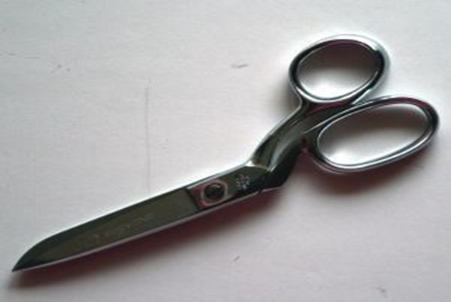
Figure1. 1: scissor

B ) Trade trimmer: is a cutting instrument used to cut out unwanted excess thread from the finished products. There are different kinds of trimmer instrument in garment manufacturing:
Attached with sewing machine, to trim when you finished stitch formation
Hand-operate (fig 2), to trim when you finished stitch formation and unwanted thread
Trimmer machine, to trim unwanted thread overall finished garment with trimmer machine
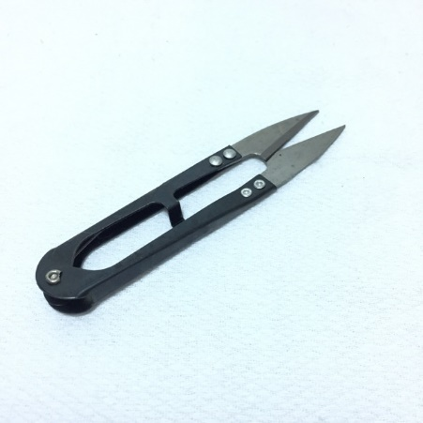
Figure1.2: Trimmer
In leather goods production, Thread trimmer is used to trim excess thread after stitching of the components or products in the sewing machine. It is also used in final finishing of the products to trim excess thread, left un-noticed. Thread trimming tool is a very important tool used to fuse excess thread after stitching. Since leather goods are stitched with synthetic threads, it is necessary to use thread burning tool to fuse the excess thread after stitching. This enhances stitch appearance on the products.
C ) Stitch Ripper (Stitch Remover)
I ) Seam ripper
A seam ripper is a small tool used for unpicking stitches. The most common form consists of a handle, shaft and head. The head is usually forked with one side of the fork flattening out and becoming a blade and the other side forming a small point.
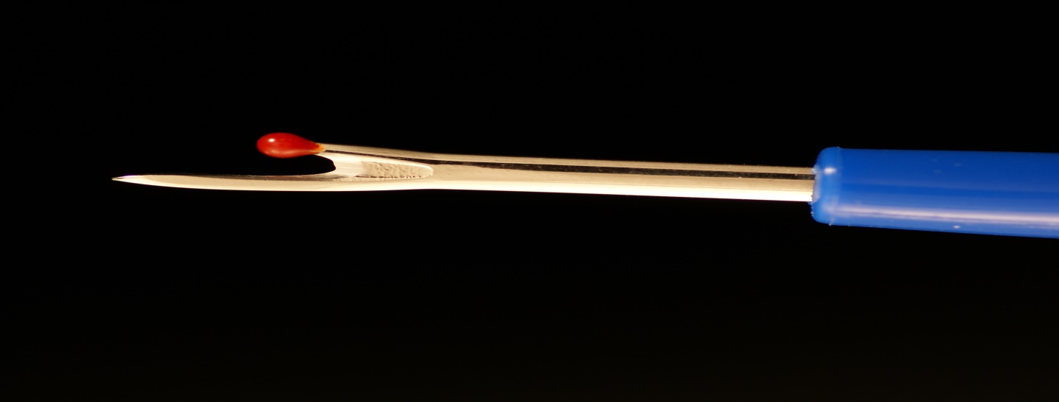
Figure1.3: Stitch Ripper
II ) Stitch Repair
Stitching repairing needle is a tempered steel needle. One end of it is flattened with a groove to pull the thread. The flattened head is made very sharp so that it can pierce into the fibrous leather components easily. It is generally known as cobbler's needle. It is used in leather goods making for stitching handles and for joining component where machine stitching is not possible.
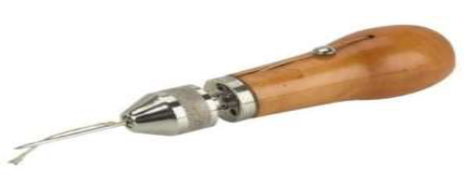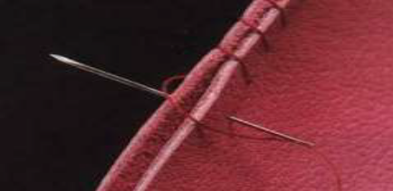
Figure 1.4: Stitch Repair
D) Leather garment Cleaning brush
Cleaning brush is used to clean unwanted materials on the surface area of finished leather garment. The cleaning brush fibers must be soft because it would not damage the area of finished leather garment.
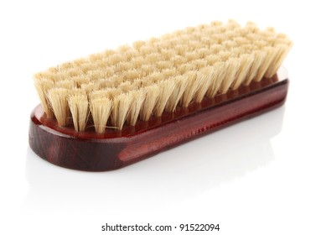
Figure1.4: Cleaning brush
E) Leather Goods Cleaning
Soft brass wire brush is used to remove dust and loose foreign substances from suede and nubuck leather. Brushed lightly in one direction to give same nap. Suede brush cleans and brushes up the nap in the suede. If the suede is shiny use a little piece of 120 grit sand paper, they bring up the nap even more. In this way we use shoe brush 100% horse hair they provides the high gloss shine in suede leather. Similarly use leather shine cloth, after polishing, it provides extra- bright high gloss shine. The bars remove shiny marks and stains. The brush brings the nap of the leather to its original appearance.
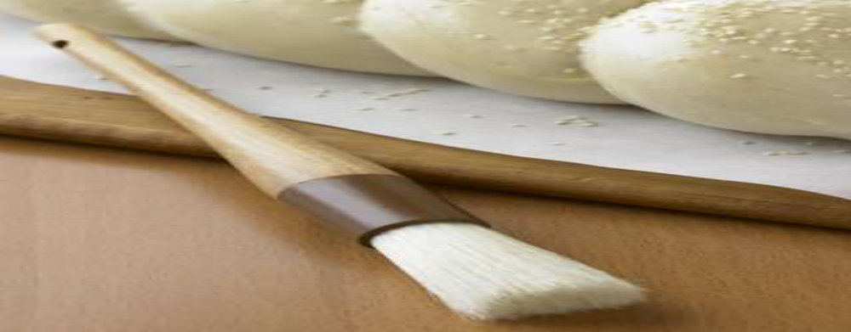
Figure 1.5: Soft brass wire brush
Suede and nubuck wire brush to raise the nap of the leather on hand bags or any other suede / nubuck items. Especially good for reaching hard- to- get places. For the cleaning of suede and nubuck product, manufacturer use the following products for their long life preservation.
I ) Suede and nubuck protector
II ) Suede and nubuck cleaner
III ) Tara go suede dye To restore color to old suede shoes and accessories.
Suede and Nubuck Protector
Suede and nubuck protector provides protection against water and stains. Keep suede and nu buck shoes, boots, coats, bags etc. looking new. Coats leather with a special polymer that creates an invisible shield to provide maximum protection against water and stains.
Suede and Nubuck Cleaners
The cleaners clean, conditions and softens suede and nu buck leather. Removes dust and dirt from bags, shoes, boots, belts, clothing and more. The cleaners built in bristle top makes application and cleaning easy and mess free.
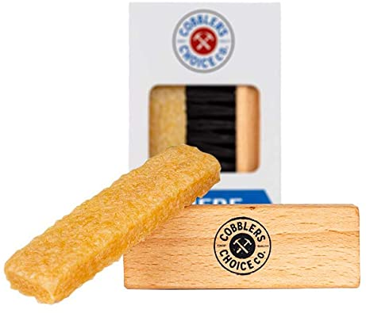
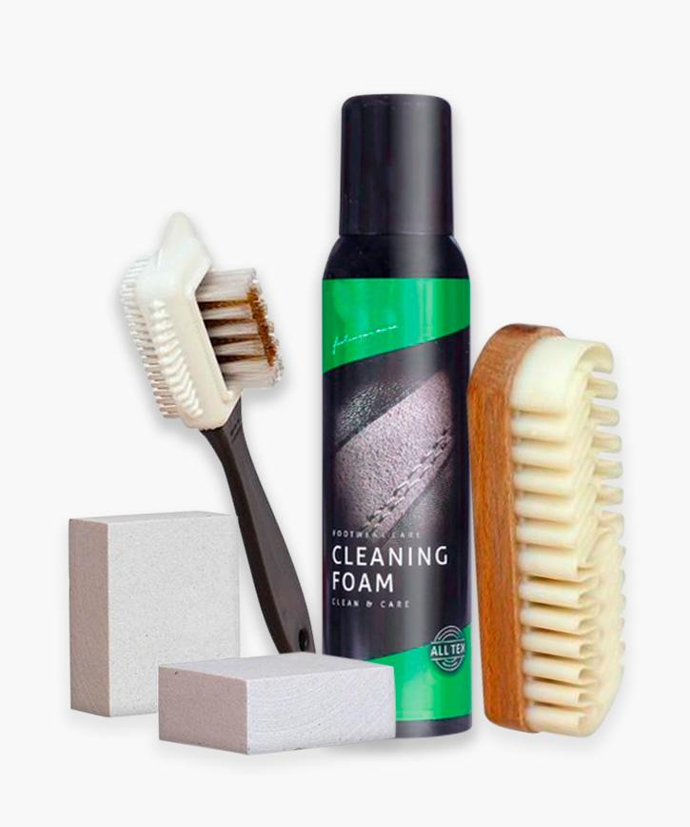
Figure 1.7: Suede and Nubuck cleaner

Tara go suede dye
A specially formulated suede and nubuck dye used to change colors from light to dark. Once dry, it will not transfer onto other articles. To restore color to old suede shoes and accessories.
iii) Leather Garment Polishing Brush
It is used to polish with appropriate wax on finished leather garment where it required.
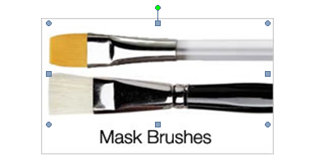
Figure1.6: Polishing brush
F). Leather Goods Polishing Cream and Brush: Leather goods polish is a waxy paste cream, or liquid used to polish to provide shine, water proof and restore the appearance of leather goods, bags etc. and extending the leather life.
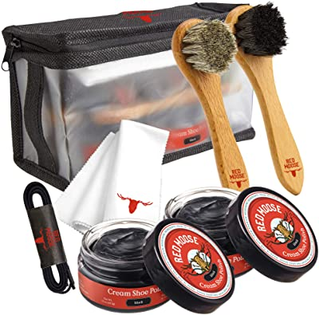
Figure1.7: Leather goods polishing kit
Various substances have been used as leather goods finish for hundreds of years, starting with natural substances such as wax and tallow. Modern polish formulas were introduced early in the 20th century and many of those original formulations are still in use today. Leather goods polish is usually made from a mix of natural and synthetic materials including Naphtha, turpentine, dyes and gum Arabic, using a chemical processes. Leather polish is usually flammable, can be toxic and if misused can stain skins. It should be used in a well-ventilated area with care taken to protect cloths, carpet and furniture.
Polishes and creams are non- film forming. Normally wax polishes are used and are widely available either neutral or pigmented to match the color. Surface waxes can impart a measure of water repellency tor leather although they cannot be regarded as water proofing agents.
Waxes and creams are also suitable for gloss enhancement or to give some special appearance (antique effect) on leather look synthetic material. Cream could be soft, medium or hard. Soft and medium creams are those that require to be polished, and are referred to as the creams to be polished. Hard creams are available as self- shining creams. They do not require polishing or brushing operation.

1.1.2. Measuring Tools
A) Measuring tape
A Tape Measure or Measuring Tape is a flexible form of ruler. Tape measures that were intended for use in tailoring or dressmaking were made from flexible cloth or plastic.
Measuring Tape is used to take measurements of the parts of the sample leather products, given for fabrication. Normally Drop length of a bag, the measuring tape is required.
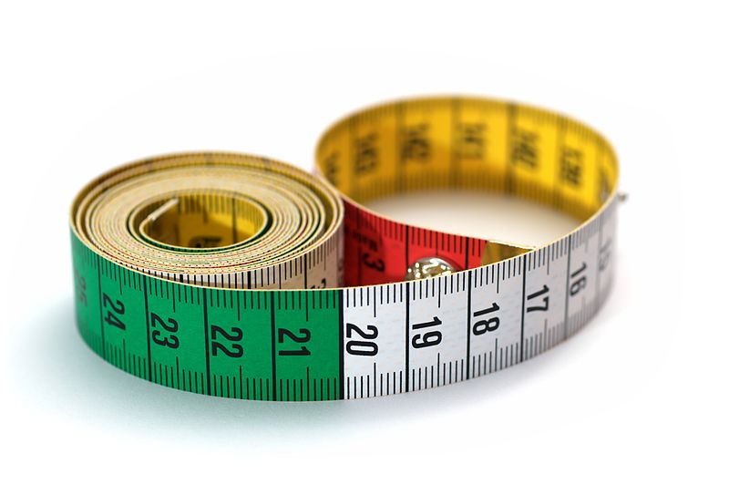
Figure 1.8: Measuring tape
B) Stainless Steel Scale
Normally it is used for straight lines or straight cutting in patterns and leathers. But for leather cutting the Cutting Scale should be used with a thick gauge. Stainless steel scale/ruler is used in pattern making process. The parts of the leather product are drawn first on a drawing paper with accurate measurements, using a ruler and then the measured parts are cut, using ruler and knife as paper patterns. It is also used as a cutting guide for cutting leather and lining components for making leather goods. 12” and 24” stainless steel scales are normally used.
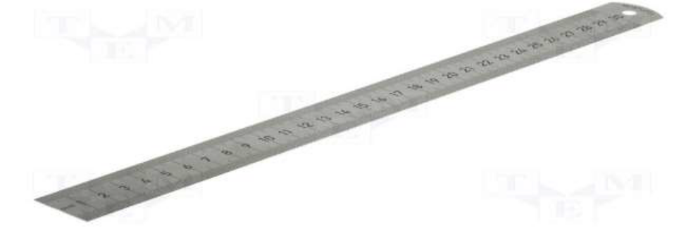
Figure 1.9: Stainless steel scale

1.1.3. Adhesive for Finishing of Leather Garment and Goods
Adhesives are used for assembling leather garments and goods before stitching, and to repair cracked leather or damaged parts. Adhesion plays a vital role in assembling components viz. leather, lining and reinforcements during fabrication of the products. Further strength of the parts can be achieved by stitching. There are two types of adhesives, which are extensively used in the fabrication of leather goods. They are (i) temporary adhesive and (ii) permanent adhesive. Rubber adhesive is a temporary adhesive as it gives temporary bonding effect and so stitching is necessary after joining the components. It is buff colored natural rubber adhesive. It is easy spreading characteristics coupled with cleanliness, flexible bondage and economy of application make it particularly suitable for general works.
An adhesive is a substance, which can hold materials together by surface attachment. The bodies held together by adhesive are known as adherents while the process of holding one adherent to another by adhesive is called ‘bonding’ and the final assembly of two adherents and the adhesive is called bond or joint.
The requirements of an adhesive are: it should wet and adhere to the surface to be bonded and the dry film should have high cohesive strength. There are two main types of adhesion- Specific and mechanical. Specific adhesive is related to molecular attraction and polarity and is usually the determining factor governing the selection of an adhesive for surfaces such as metal and glass. Mechanical adhesion is most evident in bonding of papers, textiles, leathers, etc. where the adhesive penetrates the interstices of the material and blocks itself into a fibrous structure. Commonly used adhesives in leather goods making are natural rubber adhesive and synthetic rubberadhesive.
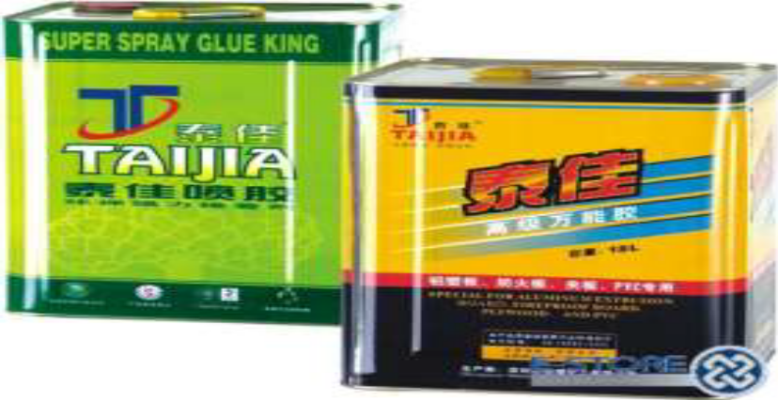
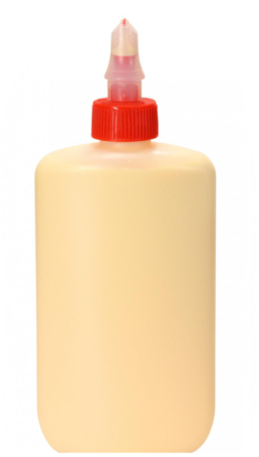
Figure 1.10 Adhesives

Selection of Adhesive
The selection of adhesives for finishing and repairing of leather garment and goods depends on the following:
Depending upon the type of materials, specific adhesive is needed to achieve good bonding effect.
Depending upon the application of adhesive either by brush or by any other means, the viscosity and solvent system must be taken into consideration.
The solvent in the adhesive must evaporate quickly for giving rapid tack development.
Tack retention must remain as long as possible for perfect bonding.
While choosing the adhesive to give high bonding strength, the performance of the adhesive and other conditions like heat, water and flexibility must be taken into consideration.
The adhesive should give trouble free performance both during application and in service.
Ironing Machine
Ironing is used to attach and remove wrinkles from leather. The piece at the bottom is called sole plate. Special electrically heated hand irons, which are thermostatically controlled, are used for removing wrinkles. Sometimes the whole leather surface is ironed to improve the finished quality.
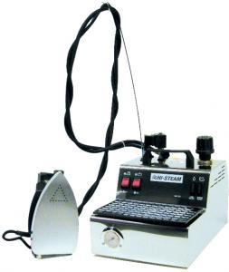
Figure 1.11 Ironing Machine

Some of the precautions to consider while ironing are: Avoid a heat build in a small-localized area, which may damage the finish of the leather, or shrink the leather upper. Have TEFLON CLOTH on the iron to prevent burning. Maximum temperature of the iron 70 – 75 degree centigrade and with the Teflon up to 96-degree centigrade. May apply water before ironing to prevent burning or anti crease wax if water cannot be used.
Patent and high gloss finishes are very easily or loose gloss in the heat. It is sometimes an advantage to apply a little Vaseline or anti creasing wax as a lubricant especially when ironing.
Discoloration of pastel shades, white and aniline finishes, all have a tendency to discolor under heat. Check the effect on scrape before attempting the bulk.
High grease content leather, the heat may bring the grease to the surface and prevent adhesion of later dressing or cause bloom to appear after boxing.
Synthetics, wrinkle chasing is relatively ineffective, and most of these materials have poor resistance to the heat.

1.2. Setting workplaces according to OHS practices
Organizational Health and Safety (OHS) is work place safety standard applied to reduce and prevent accidents. Safety and health measures play an important role in any industry. It is essential that the workers be aware of the various occupational hazards in the industry. At the same time, it is necessary that the management take the necessary steps to protect workers from potential hazardous situations .Occupational health and safety considerably benefits the company, as healthy employees are guaranteed to be more productive.
Leather garment and goods manufacturing, like other industrial processes, can be hazardous Work. It is necessary for employers and workers to be aware of the accidents associated with the production of leather products and take precautions to guard against work-related illnesses and injuries. The occupational health and safety condition of the workers belonged to the industry, is getting more critical and complicated gradually.
Basic Safety Issues:
The basic safety issues to consider are:
- Respiratory protection
- Eye protection
- Heat stress protection
- Fire protection
- Finger protection
- Proper lighting
- Ergonomic design of the work station
- Awareness
- First aid medicine
The following suggestions can be made to improve the safety and health conditions in leather garment and goods units:
- The seats of the workers and the tables should be well aligned in height so that there is no musculoskeletal strain.
- There should be proper lighting at the place of work so that eyestrain can be avoided.
- Machinery should be well maintained in order to reduce the level of noise. If necessary, certain parts of machines can be replaced.
- In case the noise level cannot be controlled, workers should be provided with earplugs so that exposure to noise can be reduced.
- Workers can be rotated within jobs so that they are not faced with continuous noise exposure for a long period.
- There should be proper ventilation at the place of work.
- In order to reduce the exposure to dust, workers should be provided with masks.
- Trained medical personnel and first aid facilities as well as safety equipment’s such as fire extinguishers and fire alarms should be available at the place of work.
- In units where there is heavy exposure to dangerous chemicals, workers should be provided with safety gloves.
- Proper dust control equipment should be set up and maintained to reduce the workers exposure to cotton dust.
- The employers for the workers should conduct medical examinations from time to time. If significant occupational health problems are observed, the management should respond appropriately.

1.2.1. Main causes of accidents
The four main causes of accidents in work place are:
Chemicals: Chemical substances applied before or during the leather production process can have an impact on safety and health of people exposed to these during the work.
Working environment and conditions: Influence workforce behavior and practices and thereby indirectly cause accidents or health risks.
Machines and equipment: Faulty design and/or poor maintenance can lead to a sequence of events, which finally may result in an accident.
People: Managers' and supervisors' performance and behavior influence those of the workers with regard to following good work practices and being able to respond properly in case of an emergency. Important factors to be taken into account are :

- Job experience and training
- Information and instructions on working practices and hazards involved
- Supervision by managers and skilled workers.
The easiest way to identify the prevalent hazards in factories is by looking at each step of the production process.

1.2.2. Safety Rules for the Leather Garment and Goods Production
Some of the safety precautions in leather garment and goods production are:
- Safety is important to everyone and it is your responsibility to maintain a safe working place. To maintain a safe environment, learn these safety rules and practice them at all times.
- When in doubt, ask the instructor
- Report any injuries or accidents immediately to the instructor
- Report a breakage to a tool or machine to the instructor. If the equipment does not operate properly, notify the instructor immediately.
- Wipe up any oil specified on the floor immediately to prevent anyone from slipping.
- Keep aisles clear at all times.
- Operate only the machines you have been trained to operate.
- Operate machines only with permission.
- Always inspect the machine before starting to work. Be sure it is clean and threaded correctly, with no loose threads on the pulley belt and all guards in place.
- Make only adjustments you have been trained to perform. Otherwise, as the instructor.
- When sewing on a power machine, wear low shoes and close-fitting clothing. Avoid loose fitting sleeves, sweaters, jewelry, ties, and ribbons when operating the machine. If your hair is long, tie it back.
- Always practice proper posture to reduce fatigue, help prevent accidents and increase efficiency. If possible, adjust the chair height that your feet rest flat on the floor.
- Do not move your chair forward or toward while operate he machine.
- Use both hands to raise and lower the machine head.
- Always keep your head above the table.
- Keep your feet off the treadle when you are setting or threading the needle.
- Turn the motor off before you are not stitching.
- Turn the motor off before cleaning, oiling or adjusting the machine.
- Turn the motor off before removing or replacing the pulley belt and run the machine out. Waft until all motion has stopped.
- Turn the motor off in case of an emergency or when in doubt.
- Turn the motor off before unplugging the machine.
- When unplugging the machine, hold onto the plug, not the cord.
- Do not use your hand to stop and start the hand wheel.
- Use your hand only to set the hand wheel.
- Before operating the machine, close the slide bed cover.
- Before operating the machine, be sure the needle is properly set and the bobbin is properly placed.
- When operating the machine, do not be careless.
- When operating the machine, do not talk with your colleagues.
- When operating the machine, keep your attention on your work and hands.
- When operating the machine, keep your hands at a safe distance from the needle.
- When operating the machine, keep your hands, scissors, and other sharp objects away from the belt.
- Keep the machine and work station clean with tools in the side drawer.
- Use the proper needle for the job.
- Do not stitch over pins or put them in your mouth.
- When the machine is not in use, lower the foot and needle.
- Three-way plugs are a safety feature on the machines. Do not cut off the ground prong.
- Unplug the machine at the end of the day.
- Know the location of the main power switch, outlets, and fuses in case of an emergency.
- Do not remove any safety devices from the machines.
- Turn off the iron at the end of the class.
- Always place the iron on the iron pad to avoid scorching the ironing board cover. Always place the industrial iron flat on the iron pad to avoid knocking it over.
- When trimming or cutting, put all trimmings in the wastebasket.
- Scissors should be handed to another person with the handles toward the person.
- Never toss or throw scissors or equipment.
- Do not eat, drink, or smoke in the work area.

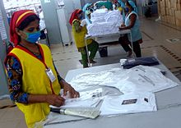
Figure 1.12: OHS practices in finishing and packaging

Self-Check 1 | Unit 1
Part- A
Fill in the blanks: (5 * 1= 5)
1. The four causes of accidents are………, ………….., …………….and …………
2- A……… is any physical item that can be used to achieve a goal, especially if the item is not consumed in the process.
3- Leather goods polish is a ………………cream , or liquid used to polish to provide……...
4- Rubber adhesive is a …………….as it gives temporary bonding effect and so ………….is necessary.
5- Electrically heated …………….which is thermostatically controlled are used for removing……………
Part-B
Directions: Answer all the questions listed below.
- What is used to attach and remove wrinkles from leather surface? (5 points)
- Describe at least 5 tools and equipment required to perform finishing in leather garment and goods production (3 points)
- Discuss the importance of finishing operation in the leather garment and goods production (3 points)
- Which tools are used to trim unwanted thread, leather and others materials. ( 3 points)
- If any other tools required for finishing operation write their names. (3 points)
- Explain the four causes for accident in leather garment and goods unit (3 points)
- What are the basic safety issues in making leather garment and goods (3 points)
- Discuss the Safety rules for the leather garment and goods production (3 points)
Part- C
Maching (5 * 1 = 5)
- A Tape Measure or Measuring Tape A). attach and remove wrinkles from leather
- Patent and Napa wire brush B). Used for making curved lines and straight lines in pattern making.
- Measuring tape C). Used to take measurements of drop length of handle.
- .divider D). flexible form of ruler
- Ironing . E). raise the nap of the leather on hand Bags

Unit Two: Perform Finishing Operation
This unit to provide you the necessary information regarding the following content coverage and topics:
- Removing excess materials
- Ironing leather garment and goods
- Polishing leather garment and goods
This guide will also assist you to attain the learning outcomes stated in the cover page. Specifically, upon completion of this learning guide, you will be able to:
- Clean excess materials from leather garment and goods product
- Iron leather garment and goods
- Polish leather garment and goods

2.1. Removing excess materials

2.1.1. Cleaning Excess Materials
Leather is a difficult material to take care of. In the manufacturing of garment and goods, we should carry out cleaning excess material after finishing the whole operation. Excess materials to be cleaned consist of adhesive, excess thread, and others.
Velcro and foams may appear after finalization of the product. During this situation, trim the excess unwanted material. cleaning excess materials includes
- Cleaning Markings
Marks can be removed by rubbing gently with a suede cleaning block, a hard rubber eraser, or by touching up the surface with a fine emery paper. Spray new/clean items with a specialist leather protectant to help retain its color and appearance. Ensure you raise the nap before spraying by using a soft brush.
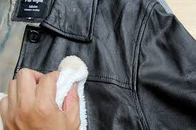
Figure1.13 Cleaning of markings
- Cleaning of Adhesive from the leather garment and goods
The requirements of an adhesive are: it should wet and adhere to the surface to be bonded and the dry film should have high cohesive strength. There are two main types of adhesion- Specific and mechanical. Specific adhesive is related to molecular attraction and polarity and is usually the determining factor governing the selection of an adhesive for surfaces such as metal and glass. Mechanical adhesion is most evident in bonding of papers, textiles, leathers, etc. where the adhesive penetrates the interstices of the material and blocks itself into a fibrous structure. Commonly used adhesives in leather goods making are natural rubber adhesive and synthetic rubber adhesive
Advantages of adhesives
Some of the advantages of adhesives in finishing and repairing are:
I. It can be applied to the surface of any materials
ii. It does not require high heat for bonding
iii. It facilitates the surface to join easily and rapidly
iv. Its application is simple and
v. It gives smoother surface
Limitations
Some of the limitations of adhesives in finishing and repairing of leather garment and goods are:
I. Most of the adhesives are organic materials and as such, they cannot be used at high temperatures.
ii. The bonding strength decreases as the temperature increases
iii. Specific adhesive is required for specific jobs and hence selection of suitable adhesive is necessary
iv. Adhesives take time for curing and setting.
v. Adhesives are generally susceptible to high humidity.
vi. Adhesives provide perfect bonding only on plain and clean surfaces.
vii. Adhesive strength is generally lower than other methods of joining like riveting.
Quality of Adhesive:
Quality of adhesive is judged by:
- Degree of Tackiness
- Rapidity of Bonding
- Strength of Bonding Effect after Drying and
- Durability.
In order to clean excess adhesive, remove any wet or dry glue from your finished leather garment and goods with help of plastic wrapper.
Crepe rubber
Crepe Rubber is used to clean the surface of the leather garment and goods wherever glue or adhesive has been be stuck. For cleaning purposes, it is a good option. It is a natural product produced by coagulation of latex from the rubber tree. Latex is formed into thin sheets, and then laminating and pressing a good number of sheets together to give a specific thickness. Chemically it is a polymer made from “Isoprene” monomer units which has sufficient strength not to need vulcanizing. The crepe which is harder and lighter in color provides better wear comfort.
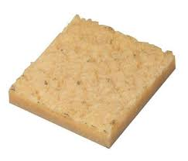
Figure 2.1፡ Crepe rubber
Advantages of Crepe Rubber
Some of the advantages of using crepe rubber are:
- It is comparatively cheap to process.
- It has good wear resistance.
- It has self-sealing ability and provides a very good resistance to flex crack but slips on dry surface.
- It is very light in weight (0.88 g / c.c.)
- Resilience is high and the strength is moderate.
Disadvantages of Crepe Rubber
Some of the disadvantages of using crepe rubber are:
- It is very sensitive to heat and become soft and sticky in worm condition. It has tendency to spread under body weight.
- It has a poor resistance to ageing. If it is exposed to heat of sunlight, it shows surface hardening and cracking.
- It is sensitive to solvents mainly petroleum and oil.
The whole product is cleaned both inside and outside with a clean piece of foam. Before the articles are sent for packing, strict quality control is observed for perfection in assembling, Stitching accuracy and smooth functioning of fittings. Start by removing any dirt or debris by wiping the bags with a foam/ cloth. Apply a small amount of cream and spread evenly in a circular motion over bags. You can use either Foam, cotton cloth or a polish application brush to apply. Polyurethane foam rubber sheets are used in a variety of leather goods where cushioning of the products is necessary. 2m x 1m x 3mm and 2m x 1m x 6mm foam rubber sheets are normally used in leather goods reinforcement making and polishing with cream.

2.1.2. Thread Trimming

2.1.2.1. Thread
To provide good sewing performance a thread must have consistent size, strength, stretch and needle heat resistance. The thread selected for sewing has to provide satisfactory appearance in the seam in both stitch formation and color match. Sewing threads are made from two types of fibers:
- Natural fibers (cotton, silk and linen)
- Synthetic fibers: (nylon, polyester, rayon etc.)
Natural fibers provide best sewing performance while synthetic fibers provide best seaming performance. Cotton thread is vulnerable to abrasion while synthetic thread provides excellent seam strength, resistance to abrasion and wears.
Special features of Polyester cotton Threads:
- Improved sewing performance because it is less harsh.
- Cotton rap acts as insulation against needle heat.
- Gives extra seam grip.
- Fills the needle hole completely and
- Prevents leathers being cut by the hard synthetic core
Special features of Nylon cotton Threads:
- High strength and durability.
- Excellent fineness/strength ratio.
- Higher abrasion resistance.
- Improved sew ability.
- Better seam performance.
- Rot-proof and immune to attack by mildew, fungus etc. and
- Minimum wear of machine parts because of superior lubrication
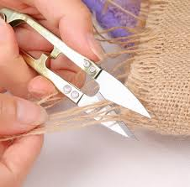
Figure 2.2 Thread trimming
In finishing process of leather goods and garment, excess threads have to be removed carefully in manufacturing units. The quality of the product is maintained by quality checkers, who are responsible for the work. Thread trimming tool is a very important tool used to fuse excess thread after stitching. Since leather goods are stitched with synthetic threads, it is necessary to use thread burning tool to fuse the excess thread after stitching. This enhances stitch appearance on the products.
In garment and goods manufacturing after finished the whole product formation it must be trim unwanted thread and leather. For this formation hand operating and machine trimmer tools are important.
Issues of Thread trimming Machine:
- Trimmer not cutting cleanly
- Tension release not working properly causing the thread to pull back out of the needle when the thread is trimmer
- Thread caught in trimmers
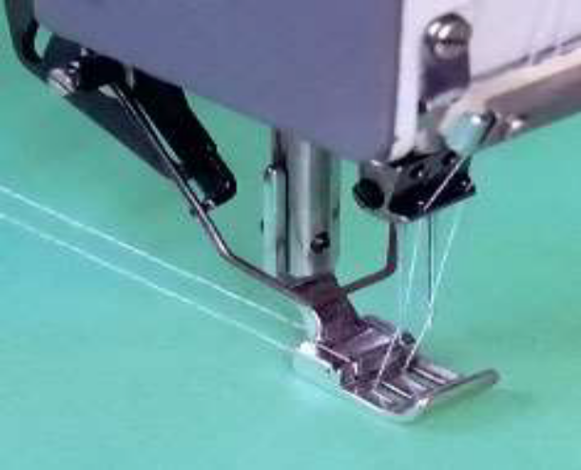
Figure 2.3፡ Thread trimmer attached with sewing machine
Make sure the Thread trimmer is operating properly
- The trimming knifes are sharp, the needle and bobbin thread are cleanly placed.
- The tension release mechanism is working properly so a needle thread tail is left allowing it to be picked up at the beginning of the next stitching cycle.

Thread Burner
A thread burner is a tool used in beadwork to cut and melt the end of gel-spun (fishing line-type) and nylon beading threads. It allows for the very precise application of heat and replaces the use of a lighter to trim and seal ends.
Push and hold the button of the Thread Burner. The element tip will begin to heat up. Touch the element tip of the Thread Burner to the end of the thread. Burn, or melt, the end of your thread until the end is no longer visible.
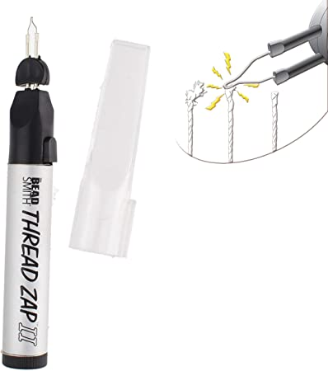
Figure 2.3፡ Thread burner

2.2. Ironing leather garment and goods
Ironing is the use of a machine, usually a heated tool (an iron), to remove wrinkles from the leather surface. Genuine leather outfits are always trendy. Leather is stylish, casual, and waterproof and does not crumple easily. However, because of improper storage, there are situations when wrinkles and crumples appear on the leather. Hence, ironing removes those wrinkles from the surface of the leather products.
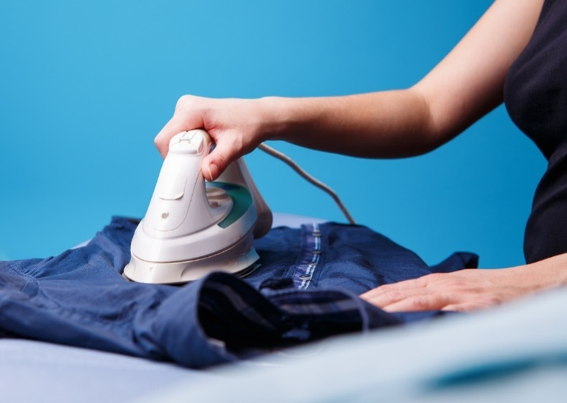
Figure 2.4፡ ironing of leather garmen

Types of Material and Features
In order to effectively smoothen the folds on the leather clothes with an iron, you need to know what type of material you are dealing with. Leather clothing can be made of the following types of material:
- Genuine leather
- Artificial leather
- Eco-leather
If you do not know what type of leather your product is made of, look at its underside. The reverse side of the natural material will be velvety and fleecy. Pleather and eco- leather, which is a kind of artificial leather, will have a woven underside. You can see the weaving of the threads on the reverse side of the product.
For all types of material, you can use the same methods of ironing, with just slight variations. A skirt or a dress made of genuine leather is better ironed from the front side through paper or cotton material. Artificial leather, which has a woven base, can be ironed from the underside without the use of fabric layer.
In case a dress or a skirt has a lining that does not allow you to see the reverse side, you need to iron the outfit from the front side through a thin fabric. You can also use other ways to straighten folds at home.
When does it become necessary to iron the leather? It can be one of the following factors:
- The presence of crumples and creases on the surface of the leather as a result of improper storage or other reasons
- The stretched areas appear on outfits made of genuine leather when wearing, for example, on elbows or backside. Outfits made of artificial material are not stretchable
- Deformation of the leather outfits occurred as a result of improper care or for other reasons
- To maintain the shape of the leather garment and goods
If the outfit has changed its shape under the influence of moisture or heat, you cannot restore it to its original form by ironing. For example, a skirt made of genuine leather was completely soaked and then crumpled. Ironing is also useless if the outfit was put on a hot radiator and it has deformed. In other cases, when the leather clothes are wrinkled or stretched, they can be ironed out.
The quality of the leather also matters. The thinner and better the material used for making clothes, the easier and faster you will be able to iron and smooth it. Thin, genuine leather is easier to iron than hard artificial leather.
To iron crumpled leather clothes, place the piece on the ironing board and straighten it out. Cover it with paper or a dry cotton cloth. Turn the iron on minimum power and gently iron the leather on the edge. It’s best to test the iron on a spare piece of the same leather your garment is made of. But if you don’t have one, you will just have to be very careful.
Iron the crumpled area, placing the iron directly onto the crease. If you do not see any effect, slightly increase the temperature. After the crumpled area is smoothed out, wait until the garment has cooled and hang it up.
Straightening out the parts that stretched out is done in much the same way. Put the skirt on the ironing board with the back part facing up, smooth it with your hands and cover with a cloth. Place the iron on the outstretched areas and hold it for a while. If you use the right temperature, the skirt should restore its original shape.
The creases on the dress or skirt can also be removed using the steam function. Hang up the leather garment; switch the iron into the steam mode. Steam the skirt at a short distance and on low power so as not to spoil the leather. Direct the steam stream onto the folds, while slightly pulling the material from the bottom.
Using water
Small creases on the garments can be removed in an easy way. Hang up the clothes in the bathroom. Sprinkle crumpled areas with water from the spray gun or wet with your hand. Water should be purified, so it does not leave stains.
Leave the leather outfit hanging for some time (several hours). During this time, it should recover its original shape.

Using steam
Hang the leather outfit up in the bathroom and smooth the surface with your hands. Open the hot water tap, and make sure that the stream does not touch the clothes. Close the door to the bathroom so the steam cannot come out.
To iron a leather outfit at home and not damage it, use the above recommendations. Choose the most effective way yourself. In order to avoid ironing in the future, store and care for leather clothes properly.
If hanging your jacket for long periods of time does not solve your wrinkle problem or is not an option follow these instructions:
- Adjust the iron to the lowest setting. Let the iron heat up and do not use steam.
- Place aluminum foil under the cloth that covers the ironing board. The aluminum foil will heat up and attack the wrinkles from the opposite side. It may not be necessary to iron both sides.
- Use a towel, brown paper bag, or thick newspaper between the jacket and iron. Gently and firmly press down on one spot at a time.

2.3. Polishing leather garment and goods

Polishing is the process of smoothing and shinning the surface of leather garment and goods by rubbing. After cleaning adhesive and thread, polishing leather in appropriate wax with smoother cloth or towel helps to enhance the look of the product and retain leathers natural characteristics. Polishes enhance the color and provide a protective layer from light rains and spills.
Polish usually contains several kinds of synthetic waxes, paraffin waxes, resin, solvents, auxiliary agent and water. As well as the requirements of the consumer, cost of the components is an important factor in the formulations. In all types of color and design the polishes are needed with every type of leather goods.
A polish conditions and helps retain leathers natural oils. It masks scuffs and marks, enhances the color and provides a protective layer from light rains and spills.

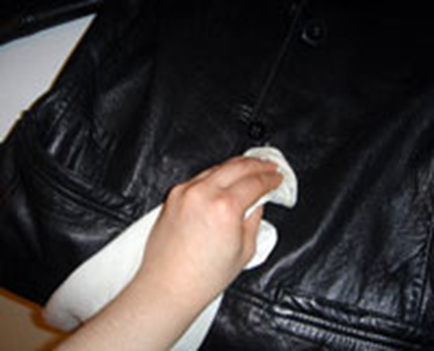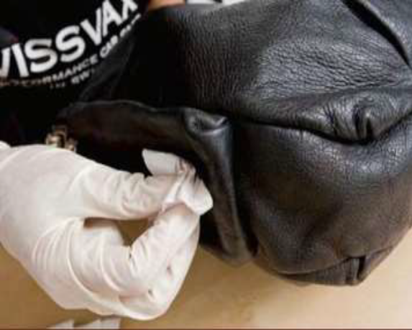
Figure 2.5: Polishing leather garment
Polishing Instruction
- Polishing should take no more than a few minutes.
- Start by removing any dirt or debris by wiping the bag with a damp cloth.
- Apply a small amount of cream and spread evenly in a circular motion over bag. You can use either cotton cloth or a polish application brush to apply.
- Take a minute to allow the cream time to dry on bags.
- Once dry, buff off with a polishing cloth or polishing pad for high shine.
Tips and Tricks
- Try to match the polish as close as you can to the color of your bags.
- If you choose the color neutral, use this on light colored bags only as it tends to leave a white film on dark colored bag over time.
- Always remove bags accessories before polishing to good clean and ensures that is not stained by the polish.
- If the bag has stains or greasy oil marks on them, use “SPOT Stain Remover” Before Polishing

2.4. Performing finishing operation for leather garment and goods

2.4.1. Performing finishing operation for leather garment and goods
Tools and equipments are
- Foam/cloth
- Fine emery paper
- Crepe rubber
- Thread trimmer
- Ironing machine
- Polishing cream

2.4.1.1. Procedures to apply the finishing
- Remove any dirt or debris by wiping the bags with a foam/cloth.
- Clean markings using suede cleaning block or hard rubber eraser or fine emery paperboy smooth rubbing.
- Clean excess adhesive using crepe rubber by gentle rubbing.
- Trim excess thread by using trimmer. The thread should be trimmed properly with our damaging the seam. You should take care of the trimmer’s sharpness at the tip.
- Set your iron to the lowest setting. Let the iron heat up and do not use steam.
- Place aluminum foil under the cloth that covers the ironing board. The aluminum foil will heat up and attack the wrinkles from the opposite side. It may not be necessary to iron both sides.
- Place towel, brown paper bag, or thick newspaper between the jacket and iron.
    - 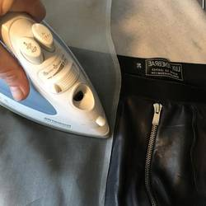
Figure 2.6: Ironing
- Viii. Gently and firmly press down on one spot at a time. However, it should not take loner.
- Hang your garment.
- Apply a small amount of cream and spread evenly in a circular motion over the garment. You can use either cotton cloth or a polish application brush to apply.
- Take a minute to allow the cream time to dry on the garment.
- Once dry, buff off with a polishing cloth or polishing pad for high shine.

Self-Check 2 | Written Test
Part A
Directions: Answer all the questions listed below. Examples may be necessary to aid some explanations/answers.
- Explain how to clean finished leather garment and goods (3 points)
- What tools do you use for cleaning? (3 points)
- What materials did you clean from leather garment and goods? (3 points)
- Explain how to clean leather goods properly (3 points)
- Discuss on the advantages and disadvantages of crepe rubber (3 points)
- Which tools is used for trimming (3 points)
- What is the purpose of Thread Trimmer? (3 points)
- What are the precautions to follow while operating in thread trimming machine? (3 points)
- Discuss the characteristics of fibers used in stitching of leather garment and goods (3 points)
- Discuss on special features of cotton fibers, nylon fibers and blends (3 points)
Part- B
Fill in the blanks: (5 * 1= 5)
1. Leather clothing can be made ………, , …………….and ………… types of material.
2- Sewing threads are made from…………………. and ……………………………….
3- Quality of adhesive is judged………… , …………… , …………… and …………...
4- …………., is the use of a machine, usually a heated tool (an iron), to remove wrinkles from the leather surface.
5-……………, is the process of smoothing and shinning the surface of leather garment and goods by rubbing.

Unit Three: Determine requirements for repair of leather garments and goods.
This learning guide is developed to provide you the necessary information regarding the following content coverage and topics:
- Assessing and examining leather garment and goods for repair work
- Determining requirements of restoration
- Determining the costs of repair work
This guide will also assist you to attain the learning outcomes stated in the cover page. Specifically, upon completion of this learning guide, you will be able to:
- Assess or examine Leather garments and goods for repair work
- Determine Requirements for restoration of leather garment and goods
- Calculate Costs to determine feasibility of restoration/repair

3.1. Assessing and examining leather garment and goods for repair work

We can repair and restore most types of damage on leather jackets including men’s and women designer jackets. Leather jackets can be made from a variety of different types of leather from cows, sheep’s, and other. Leather Jackets are usually made with very soft and delicate aniline leather. It is sometime quite difficult to repair this type of leather but generally, we can repair most of the things. To do repair work check the following:
The styles and actual materials are used in the design according to material sheet.
Measured according to measurement chart require
Style description and stitching performed according to sketch requirement
Position of main label, care label, size label, and made in according to label plan
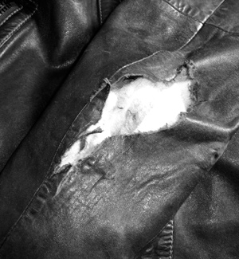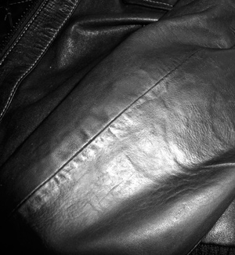
Figure 3.1: Leather Jacket Hole before and after Repair
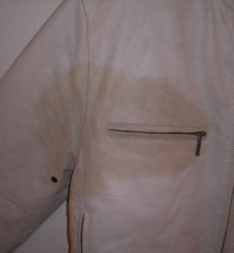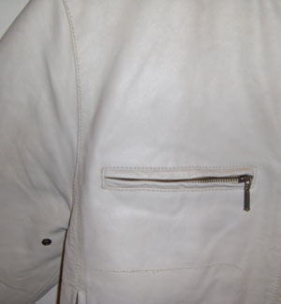
Figure 3.2: Leather Jacket Stain Before and after repair

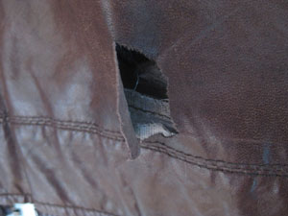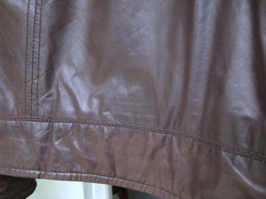
Figure 2.3: Leather Jacket Tear Before and after repair

3.1.1. Assessing Leather Goods for Repair Work
The Production Manager / Supervisor must have knowledge for those who carry out repairs on leather goods manufacturing environment. To repair leather goods product check the following
- Examine the specific item to identify what type of repair is best suited
- Establish the options, agreeing the decision with the customer and confirming the expected length of time the repair will take preparing
- Prepare the item for repair
- Carry out the repair
- Remove excess materials by hand knife or machine
- Groove by machine or by hand
- Stitch using the appropriate sewing machine.
- Finish the repair
- Polish and make ready for handover to the customer
The key areas of knowledge of repair
- The types of leather goods requiring repairs by hand or machine stitching
- What the range of options is and which are most suited to the different types of leather goods construction
- Which common factors affect repair
- What the main pieces of equipment are needed to repair the item and their capabilities
- What the characteristics are of the materials and how they differ
- What the problems may be when stitching different constructions
- The skills and techniques required for repairing
- Preparing the product requiring repairs by stitching
- Checking equipment before work starts
- Ensuring the equipment has the correct controls, attachments and how to ensure its smooth running.
- Operating the different types of stitching machine
- Carrying out simple maintenance on machines
- Operating a band scourer and edge trimmer
- Storing, using and applying adhesives
- Starting and finishing stitching
- Changing threads, needles and awls
- Adjusting the tension of the thread on the machines
- Altering stitch length
- Hand sewing using sewing thread and hand awls
- Carry complex repairs and patching
- Trimming excess materials and ensuring the original contours are maintained
- Applying finishing methods appropriate to the leather goods
- Cleaning and polishing the repaired leather goods
- Maintaining, adjusting and replacing worn parts on the machines required for different types of attachment

- Regulations, rules and guidelines for repairing:
  - The different tools, equipment and material
  - Using abrasives, hand tools and other ancillary equipment
  - Storing and using solvents and adhesives
  - Equipment used in attaching metal fastenings
  - Edge cutting and trimming
  - Storage, handling and use of coloring materials
  - Various types of polishing equipment

Workplace skills
- Communicate effectively with colleagues and customers
- Maintain good working relationship with colleagues
- How to communicate effectively to find out what the customer requires
- Comply with written instructions
- Complete forms, reports and other documentation

3.2. Determining requirements of restoration

Restoring is the processes of repairing or correcting the faults and damages made on leather garment and goods to improve its usability and functionality. Determination of requirements of restoring is one of key activities in finishing and repairing of leather products. Selection of appropriate tools and equipment required to perform finishing operations according to supervisor's instructions is the key in performing required task.
Table 3.1: the requirements for restoration of leather garment and goods
N.o | Element | Performance Criteria
1. | Determine Requirements | 1. Leather garment/goods is assessed or examined  2.Requirements for restoration, maintenance or repair of leather garment/goods are determined  3.Costs are calculated to determine feasibility of restoration/repair
2. | Prepare leather product | 1.Leather product/good is prepared in appropriate manner for restoration maintenance or repair  2.Materials and/or equipment required for the task are assembled
3. | Undertake restoration, or repair | 1.Restoration/repair is undertaken to restore product to optimum condition using appropriate equipment, tools, processes and materials, as required  2.Restored/repaired product is checked against specifications and appropriate quality standards  3. Adjustments are made as required  4. Leather product is prepared for storage, where appropriate
4. | Maintain Documentation | 1.All relevant paperwork and documentation is  prepared in accordance with enterprise procedures

Some other requirements include:
- Packing List
- Poly Bag, to Cover Finished Garment to Protect from damage Cut small hole on the Corner of Poly bag to pass air
- Antifungal Tablet, Protect from fungus
- Tissue Paper, to avoid any Impressing on Leather Surface like Close Zip, Runner, Buckle and Metal Button

3.3. Determining the costs of repair work
In repairing/restoration process of leather garment and goods the Production Manager/Supervisor must be able to identify leather hides and skins, make patterns, perform calculations, set up and use a sewing machine, use and maintain tools and equipment, and cut materials in a manner that are able to meet customers and attend to their enquiries.
In repairing of leather products people should study the feasibility of cost of repairing and restoring the product so that the manufacturer is not losing profit at the same time meet customers’ requirement. In doing so the supervisor should aware that all the repairing works comply the company’s rules, regulations, guidelines and working ethics.
The key requirements for determining costs of repairing
- Different types of leather garment and goods construction, the characteristics, and which Materials are compatible must be identified.
- The features of worn and damaged leather product
- Which repair options are available and the correct combinations of materials and components
- The factors influencing the repair options and their costs
- Which different materials are used in the construction and repair of leather goods and their availability
- Which types of solvents and adhesives are used in leather garment and goods repair
- Which adhesives are compatible with different combinations of materials
- Which different tools and machinery are used in making repairs
- What the types, sizes and uses are of different fasteners.
- The different types of polishing and buffing materials and equipment

The skills and techniques required for cost determination are
- Methods of preparing leather garment and goods for repair
- The different methods of attaching combinations of materials using solvents and adhesives.
- Common problems encountered when repairing with adhesives and methods to prevent and correct these problems
- The techniques used to achieve secure, neat and correctly positioned fastenings.
- The approved methods and techniques for removing excess materials
- How to use edge cutting and trimming equipment
- The different techniques used to produce various surface finishes on leather and repair materials
- How to use different types of finishing equipment and the safety precautions associated with them
- Methods of preparing the different materials to receive coloring
- Methods of mixing and preparing colors
- The techniques, for applying colors to different materials and surfaces
- The correct coloring materials and processes for different leather garment and goods materials
- Techniques used to obtain different surface finishes and effects

Table 3.2: Repairing Work Cost Sheet
S.No | Items | Unit Measurement | Quantity | Unit Price | Total Amount
1 | Leather
2 | Lining
3 | Fusing
4 | Padding
5 | Zip No:5
6 | Zip No:3
7 | Twill
8 | Shoulder pad
9 | Woven fuse
10 | Buttons
11 | Main label
12 | Care label
13 | Size label
14 | Thread
15 | Adhesive tape
16 | Glue
17 | Tissue paper
18 | Antifungal
Material cost
Transport cost
Overhead cost 25%
Manufacturing cost
Advertising cost
Selling price
Total cost

Self-Check 3 | Written Test
Part A
Directions: Answer all the questions listed below. Examples may be necessary to aid some explanations/answers.
- What are the checking points for repairing leather garment (3 points)
- List at least four checking points for leather goods repairing (3 points)
- List the regulations and guidelines to be followed in performing leather garment and goods repairing (5 points)
- What are the skills and techniques required in repairing leather goods and garment? (3 points)
- What are the work place skills required to effectively meet customers’ requirements while repairing faults in garment and goods? (3 points)
- Why is important assessing and examining the product before repairing?(3 points)
- What are the determining elements for restoration of leather garment and goods products (5 points)
- . Explain at least three performance criteria in determining requirements for restoration (5 points)
- . List other requirements for determining requirements for restoration (5 points)
- . Why is important to determine the cost of repairing (5 points)
- . What are the parameters to be considered while determining the cost of repairing (5 points?)
- Prepare cost sheet to determine the cost of repairing (5 points)
13. What is to be done if the cost of repairing is very high (5 points)

Part B
Fill in the blanks: (5 * 1= 5)
1- Remove excess materials by ---------------------- or ----------------------.
2- Make sure that the materials used in the repair are free of ------------------- and --------
--------- With the article’s materials
3- ------------------ effectively with colleagues and ------------------------ as required.
4- Restored/repaired product is --------------------- against specifications and appropriate
-----------------------------.
5- The different types of leather goods construction, the---------------------, and which
Materials are--------------------------.

Operation Sheet 1- Calculate cost of repair
To calculate the repair cost of leather goods follow the procedures below
Identify the features of worn and damaged leather product.
Determine which repair options are available and the correct combinations of materials and components.
Identify different materials, which are used in the construction and repair of leather goods and their availability.
Determine which types of solvents and adhesives are used in leather garment and goods repair.
Identify types, sizes and uses of different fasteners.
Determine which type of polish and buffing material is compatible.
Prepare cost sheet using table below.

S.No | Items | Unit Measurement | Qty | Unit Price | Total Amount
1 | Leather
2 | Lining
3 | Fusing
4 | Padding
5 | Zip No:5
6 | Zip No:3
7 | Twill
8 | Shoulder pad
9 | Woven fuse
10 | Buttons
11 | Main label
12 | Care label
13 | Size label
14 | Thread
15 | Adhesive tape
16 | Glue
17 | Tissue paper
18 | Antifungal
Material cost
Transport cost
Overhead cost 25%
Total cost

LAP test1- Performance test
Instructions: Given necessary information, you are required to calculate repairing cost of leather bag within one hour.
Task-1 Calculate the repairing cost of a lining of the wrist leather bag in the picture below. Assume the length and height of the bag is 9 inches and 6 inches respectively.
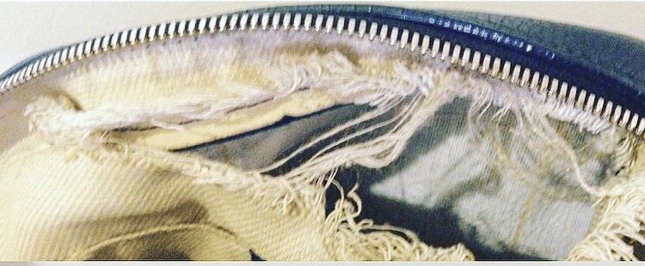

Unit Four: Perform repair work

This learning guide is developed to provide you the necessary information regarding the following content coverage and topics:
- Preparing leather garments and goods for repair work
- Obtaining materials and equipment for repair work
- Identifying methods and approaches of repairing work
- Undertaking repair works by using appropriate processes
- Checking the repaired work against requirement
- Undertaking finishing measures on repaired products
- Checking quality of repair works and
- Rectifying faults
This guide will also assist you to attain the learning outcomes stated in the cover page. Specifically, upon completion of this learning guide, you will be able to:
- Prepare Leather garment and goods in appropriate manner for restoration or repair work.
- Obtain Materials and/or equipment required for the repair work as per the job requirement.
- Identify and confirmed Relevant repairing methods and approaches according to the job requirement.
- Undertake Repair work to restore the leather garment and goods to optimum condition using appropriate equipment, tools, processes and materials
- Check Repaired leather garment and goods against requirement
- Check qualities of repairs
- Rectify faults

4.1. Preparing Leather Garments and Goods for Repair Work

4.1.1. Preparing leather garments and goods for repair work
Leather is generally quite durable and long lasting, but it still requires regular cleaning to maintain its appearance and prevent future damage ( for an inexpensive way to clean leather surfaces, use a microfiber cloth and gently dust the surface). However, for those inevitable scratches, stains, and holes, we recommend the Furtive Leather and Vinyl Repair Kit. This repair kit is one of the best all-around products on the market thanks to its affordable results and easy five-step application process.
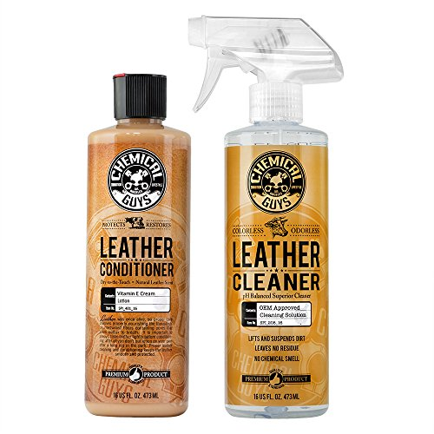
Figure 4.1: Leather repairing material
Before starting the repair work for leather garment and goods we have to consider the following points
- The type of damage occur on the product
- Availability of resources to make the repair
- Availability of materials, equipment, tools to carry out the repair according to the specification
- Check correct materials are used to construct the product
- Check each panels are assembled correctly according to specification
- Organize work station in such a way that you could comfortably operate the machines, tools and other equipment to perform the work
- Prepare materials and tools to carry out the repair work

Figure 4.2: Materials and tools to carry out the repair work
To carry out the repair work for leather garment and goods one should consider the following tips as guiding rules:
- Identify the different types of leather garment and goods construction, the characteristics, and which materials are compatible
- The features of worn and damaged product
- Identify Which repair options are available and the correct combinations of materials and components
- Study the factors influencing the repair options and their costs
- Collect different materials used in the construction and repair of leather garment and goods and their availability
- Sort out the different types of solvents and adhesives used to make the repair work
- Identify Which adhesives are compatible with different combinations of materials
- select different tools and machinery used in making repairs
- Decide what the types, sizes and uses are of different fasteners are required

4.2: Obtaining materials and equipment for repair work
In the production of leather garment and goods production different materials, equipment and tools are utilized as per the job requirement. All the required resources need to be made ready to perform the required tasks as per the specification and customer wants. In the same way to carry out the repair of leather garment and goods all the necessary equipment and materials should be obtained as per the requirements before starting the work.
Some of the material and equipment required for the repair work are:
a) Adhesive
They are two types of adhesives
- temporary adhesive and
- Permanent adhesive
Rubber adhesive is a temporary adhesive as it gives temporary bonding effect and so stitching is necessary after joining the components. It is buff colored natural rubber adhesive. Its easy spreading characteristics coupled with cleanliness, flexible bondage and economy of application make it particularly suitable for general works. It gives a firm grip while stitching and helps in making articles with stitches. Rubber adhesive is applied uniformly to the surface to be bonded. After achieving maximum tack development, the surfaces are joined. The joined surfaces are rolled down with a smooth roller to remove air bubbles. The components are then taken for stitching.
Some of the advantages of adhesives in finishing and repairing are:
- It can be applied to the surface of any materials
- It does not require high heat for bonding
- It facilitates the surface to join easily and rapidly
- Its application is simple and
- It gives smoother surface
Some of the limitations of adhesives in finishing and repairing of leather garment and goods are:
Most of the adhesives are organic materials and as such, they cannot be used at high temperatures.
- The bonding strength decreases as the temperature increases
- Specific adhesive is required for specific jobs and hence selection of suitable adhesive is necessary
- Adhesives take time for curing and setting.
- Adhesives are generally susceptible to high humidity.
- Adhesives provide perfect bonding only on plain and clean surfaces.
- Adhesive strength is generally lower than other methods of joining like riveting.
Quality of Adhesive:
Quality of adhesive is judged by:
- Degree of Tackiness
- Rapidity of Bonding
- Strength of Bonding Effect after Drying and Durability.
Selection of Adhesive
The selection of adhesives for finishing and repairing of leather garment and goods depends on the following:
- Depending upon the type of materials, specific adhesive is needed to achieve good bonding effect.
- Depending upon the application of adhesive either by brush or by any other means, the viscosity and solvent system must be taken into consideration.
- The solvent in the adhesive must evaporate quickly for giving rapid tack development.
- Tack retention must remain as long as possible for perfect bonding.
- While choosing the adhesive to give high bonding strength, the performance of the adhesive and other conditions like heat, water and flexibility must be taken into consideration.
- The adhesive should give trouble free performance both during application and in service.

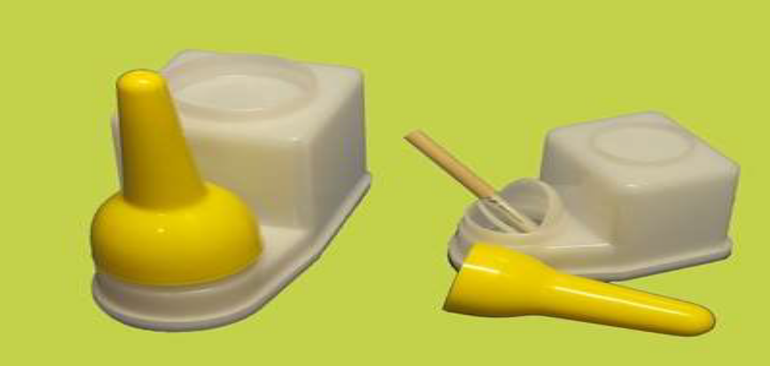
Figure 4.3: Rubber adhesive
b) Some other materials and tools include:
- Threads
- Glue
- Fusing materials
- Leather:- natural flexible material
- Foam: reinforcement materials
- Fusing material: it used for strength
- Synthetic materials
- Puncher
- Owl
- Stitching machine
- Skiving machine
- Polishing cream
- Measuring tools
- Foam
- Lining
- Others
- Velcro
- Hooks

4.3. Identifying methods and approaches of repairing work
In performing repair, works for leather garment and goods relevant repairing methods and approaches should be identified as per the job requirements. The methods selected should be cost effective related to manpower, material usage, time of repairing the defects, machinery availability, design modification and complexity, and customer’s wants.
The following approaches are very important in repairing of leather garment and goods
- Identify the product in which part repairing is required
- Ask your client about his/her requirements and make sure that it is cost effective make ready machine and equipment
- Prepare the article for repair including removing worn or damaged parts and preparing any adhesive solutions
- Make sure that the materials used in the repair are free of faults and compatible with the article’s materials
- Minimize wastage of repair materials
- Attach new components
- Complete any final repairs
- Trim any excess material(threads, lining,)
- Polish and buff the article as required
- Perform packaging of the product as per the specification
In doing repairing work, try to protect Common problems encountered while repairing with adhesives and methods to prevent and correct these problems

4.4. Undertaking repair works by using appropriate processes
In the manufacturing of leather garment and goods, appropriate production processes are used to optimize wastes and improve productivity of the machine and workers. In the same manner, the choice of appropriate processes and methods is vital in repairing of leather garment and goods. Repair work is undertaken to restore the leather garment and goods to optimum condition using appropriate equipment, tools, processes and materials.
Carry out the following steps to repair leather garment and goods:
I).Fusing
- Confirm correct fusing materials used or not
- Check evenly if fusing is required or not
- The excess outcome fusing should be cut and cleaned
- If the jacket having button hole (front, cuff), the fusing material should not show outside after cutting the hole
II).Cutting
- check each panel, grains
- compare with sketch
- left and right panels equal
- The loose grain must be used invisible place or in side panel
- Finished garment look without any defect
III).Assembling and stitching
- Check the garment component with design
- Confirm that single and double stitch
- Check the stitch length
- Check thread used
- Check any jump stitching on the garment
- check missing stitching component with the style
- check panel joint stitching
- check inner lining stitching according to requirement
IV).Finishing
- clean unnecessary thread, glue, and others from finished garment
- use polishing cream if required plane
- Iron finished garment, use ironing table and cotton cloth
- put tag and brand label
- put finishes garment in poly bag
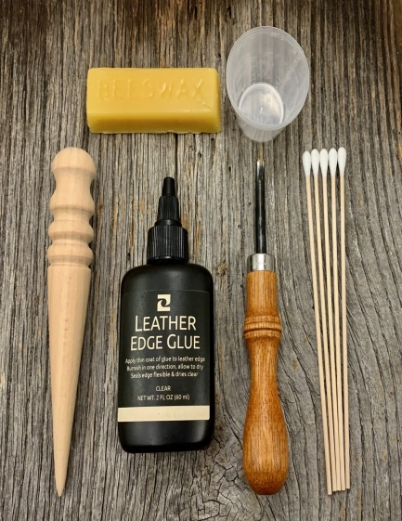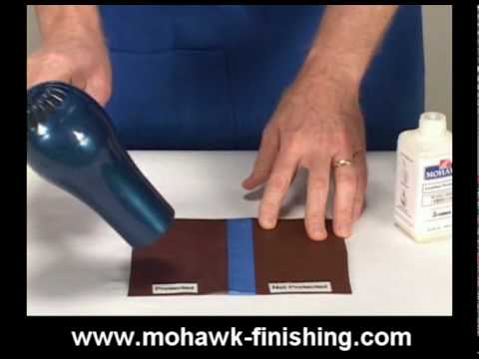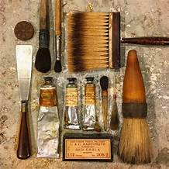
Figure 4.4: Finishing materials

4.5. Checking the repaired work against requirement
The Production Manager / supervisor of the company must have knowledge about the product and the Buyer’s repaired garments and goods against requirement.
A).Checking repaired leather garment against the requirement
- Checking Measurement According to the given specification
- Confirm back length from center back neck to bottom
- Check front length from neck(zip length)
- Check sleeve length from shoulder point (or from center back neck)
- Confirm all given measurement like pocket, collar, cuffs, neck…etc
- Label position
- Confirm correct material and size
- Confirm outer shell and inner shell balanced
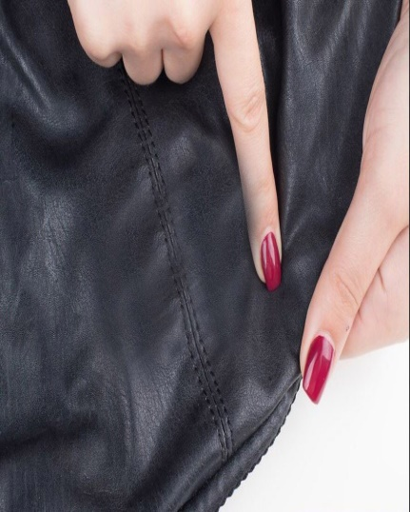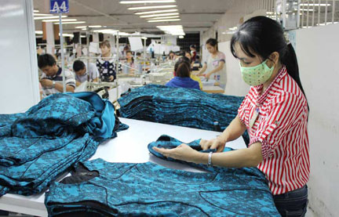
Figure 4.5: checking leather garment
B) Checking repaired leather goods against the requirement
Checking of leather goods totally depends upon the quality control in different stages.
This system is based on the following principles:
- Well defined specifications.
- Checking and testing all input materials.
- In- process quality control.
- Final quality check.
- Monitoring quality.
The main objective is to achieve a consistent quality standard for the product.
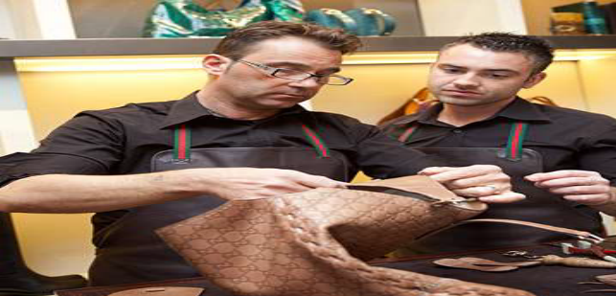
Figure 4.6: Checking of leather goods
The following points will affect the quality of repairing leather garment and goods
- Inconsistent quality: Some load is above the required standard and some below the standard and variation is too large and not acceptable by the customers.
- Lack of clear understanding of quality: Each staff member of a company has a different view on quality and there is no clear company standard for materials or clear identification of major and minor faults.
- Tendency to save money on testing: Testing is the fix parameter of the company. If the company is not doing testing, then it will cause a great loss of the company
Insufficient planning to ensure quality.
- Lack of Top management commitment to quality.
- Tendency to monitor quality at the end of the line instead of in process quality control.
- Poor Documentation.
- Tendency to take only corrective action but not preventive action.
- Lack of understanding on how to achieve quality.
- In most factories good quality is only a matter of chance.

4.6. Undertaking finishing measures on repaired products
In the manufacturing units, the main areas of quality control are :
- Material
- Cutting section
- Stitching and assembling section
- Repairing, cleaning and checking
- Dispatching.
The main responsibility of a company to produce a better quality to the manager (Production) and production supervisor of each line is to improve the quality in their product. The objective of the quality system should be to prevent a problem rather than a postmortem after the products are made. This means a shift from end of line quality checks to one that anticipates problems and corrective action taken before major damage occurs. It is possible to measure quality and managements should watch the quality index chart every month to ensure upward progress.
Continuous improvement and involvement of the workforce is essential for success. Schemes that operate in fits and start like quality week are not likely to have long-term benefits. It is possible to measure quality and managements should watch the quality index chart every month to ensure upward progress.
Why quality is important for us?
During the last few years increased competition, recession in many countries and overcapacity in footwear manufacturing worldwide have put great pressure on manufacturers to either improve quality or perish.
It is the recent survey that manufacturers lose 10- 15% of their sales due to poor quality. These quality improvements can bring about genuine cost reductions. The biggest problem in world is inconsistent quality. Variations in quality from lot to create major problems for leather goods chains to sell merchandise. Most companies lack of testing center. They look at laboratory tests as additional costs rather than a way to plug major losses. Cost of quality is rarely measured for e.g., rejections, rework, recur orders etc.
The supervisor / Production manager must know
- Follow the instructions on the work ticket accurately and check whether there are any special instructions
- Use the correct tools and equipment
- Check that equipment is safe and set up in readiness for use
- Select the correct component parts for the style being worked on
- Check that the materials to be used are free from faults
- Report faults in the materials
- Promptly correct work that does not conform to company quality standards and tell the responsible person about damaged work
- Follow company reporting procedures about defective tools and machines which affect work
- Make sure that work is correctly sorted and placed to assist the next stage of production
- Make sure that the work area is safe and secure when work is complete.
The key areas of knowledge and understanding of quality
- Which styles of bags are currently being produced
- What should be the appearance of the final product
- What the common faults are
- How to handle materials and avoid making them unusable
- Which tools, equipment and settings are needed for the operation?
The skills and techniques quality
- Processed to the correct quality standards
- Correctly sorted to assist the next stage of production
- Carefully placed to minimize the risk of damage

4.7. Checking quality of repair works and Rectifying faults
Rectification of leather garment and goods is a process of correcting; making changes, and set right the defect of garment and goods. While performing finishing works for repaired leather garment and goods, the standards and instructions should be given from the supervisor/manager.

Figure 4.7: Rectification of a cap
In the rectification process of faults in leather garment and goods products companies consider the following principles
- Follow the specifications using the tools and equipment appropriate for the work
- Check that tools and equipment for finishing are clean and fit for purpose
- Check that components are of the correct quality standard
- Carry out finishing activities in the correct sequence to meet the requirements of the specification
- Remove excess materials using the most effective method and technique
- Make sure that the original contour is maintained whilst carrying out finishing Activities
- Make sure that surface finishes meet the requirements of the style being worked on.
In leather garment making check the following:
- See the full style comparing with the sketch using hanger as well as the dummy
- In hanger, hang the style and see the inner lining where loose or tight.
- See the color matching and defects, both pockets equal position as well as in collar, cuff, joint matching in a flat table.
- Put the garment in to the dummy and look at the designs whether they are placed in proper way or not confirm (dummy size)
- Finally keep in to poly bag cover and transfer to finished store
In leather goods making check the following:
- Check the finished leather goods against the work ticket to ensure it meets the agreed quality standard
- Identify the type and nature of fault where the product is below the quality standard
- Carry out minor repair operations where the fault is recoverable and return the approved product to the next stage of production
- Isolate non-recoverable faults and mark the location of the fault
- Inform the appropriate person(s) of the faults identified and the action taken
- Pass on to the next stage of production if necessary
- Choose packaging materials to meet customers’ requirements
- Package the items and any support material
- Prepare packaged orders to meet the production requirements
- Label goods correctly
The key areas of knowledge and understanding required for rectifying faults
- The styles of leather garment and goods currently being produced
- The production schedule
- Where to find and how to identify the final specification and quality standard requirements expected by the customer
- The importance of the final specification and how to access this information and identify any changes / repairs made
- The normal quality of the final product so that defects can be identified which may have been missed previously
- The common defects associated with different specifications and materials
- The importance of reporting faults promptly
The skills and techniques required for rectifying faults are
Carrying out visual inspections of the finished leather goods with regard to the:
- Quality of the workmanship
- Overall finished appearance
- Cleanliness of the leather goods.
Regulations, rules and guidelines
- The organization’s rules, codes, guidelines and standards
- Company procedures for dealing with substandard leather goods that has been repaired and the bag that is rejected including for filling out documentation
- Equipment operating procedures
- Statutory responsibilities under the Health, Safety and Environmental legislation
Preparing All Relevant Document In Accordance With Enterprise Procedures
The Production Manager / Supervisor of the company should check and examine finished leather garment and goods as per relevant documents in accordance with the enterprise procedures.
Leather Garment Prepare documents for the following parameters
- Front and back view design
- Style description
- Types of collar
- Pocket size
- Top stitch
- Sketch of inner view in full size
- Measurement sheet
- Labelling sheet
- Material sheet
Leather Goods Prepare documents for the following parameters for rectification of faults
- Sketch the product
- Measurement of the product
- Lining material used
- Stitch type
- Upper leather type and finish
- Date of repairing
- Type of repairing work
- Corrective actions taken
- Tools and equipment utilized
- Customers’ satisfaction and complaints
- Others

Self-check 4 | Written test
Name……………………………… ID………………………… Date…………………
Directions: Answer all the questions listed below.
- Part B Least at least four points to be considered while preparing leather garment and goods for repair work (10 points)
- List at least five guiding rules to carry out repairing of leather garment and goods effectively (5 points)
- Why is it important to obtain materials and equipments before starting the repair works (5 points)
- List at least six materials and equipments required to carry out repairing of leather garment and goods (5 points)
- Why identification of best methods and approaches are very important in repairing of leather garment and goods (5 points)
- Explain the approaches for selecting appropriate methods for repairing (5 points)
- How to carry out fusing of leather garment and goods for finishing processes?(5 points )
- How to carry out Assembling and stitching? (5 points )
- List at list the points to be seen in checking repairing of leather garment against requirements (5 points)
- List at list the points to be seen in checking repairing of leather goods against requirements (5 points)
- Explain quality parameters to be considered in checking leather garment and goods(5 points)
True or False: (2 * 1 = 2
1. The bonding strength of adhesive decreases as the temperature increases
2. Rubber adhesive is a permanent adhesive.

Unit Five: Pack leather garment and goods
This learning guide is developed to provide you the necessary information regarding the following content coverage and topics:
- Folding the final product and made ready for packing
- Packing the leather garments and goods with packing materials
- Assembling and labeling packing boxes
- Putting dehumidifying agents in box
- Bundling and marking package boxes
- Preparing relevant documents in accordance with enterprise procedure
This guide will also assist you to attain the learning outcomes stated in the cover page. Specifically, upon completion of this learning guide, you will be able to:
- Fold and make Finished leather garment and goods ready according the work requirement.
- Pack Leather garment or goods with packaging materials in accordance with standard operating procedures.
- Assemble and label Packaging boxes in accordance with company requirements.
- Put dehumidifying agent in boxes according to company procedures.
- Bundle and mark Package boxes according to color, stock and destination.
- Prepare all relevant paperwork and documentation in accordance with enterprise procedures
- One of that affect the quality of repairing leather garment and goods is Inconsistent quality

5.1. Folding the final product and made ready for packing
A package is a physical container or wrapping for a specific product.
Packaging means wrapping, compressing, filling or creating of goods for the purpose of protection of goods and their convenient handling.
Packaging is an important part of the product, which has to receive a lot of attention to the people. It is concerned with designing & producing of appropriate packages for a product. Packaging also refers to the process of design, evaluation, and production of packages. Packaging can be described as a coordinated system of preparing goods for transport, warehousing, logistics, sale, and end. After final inspection & garments folding, the garments are poly-packed dozen wise, color wise, size ratio wise, bundled and packed in the carton. The carton is marked with important information in printed form, which is seen from outside the carton easily. Specially, it is needed to ensure the placement of sticker in proper place. It is an integral part of product planning and promotion
10% of the retail price is spent on developing, designing, and producing just the package
Companies sometimes change packaging to update their image and reach a new market
Functions of Packaging
Some of the functions of packaging are-
- Promoting and Selling the Product
- Defining Product Identity
- Providing Information
- Expressing Customer Needs
- Ensure Safe Use
- Protecting the Product
The various functions of packaging are divided into primary, secondary and tertiary functions. In contrast with the primary functions, which primarily concern the technical nature of the packaging, secondary functions, relate to communications. Primary, secondary and tertiary functions are divided into the following sub-functions.
Primary Functions
- Protective Function
The protective function of packaging essentially involves protecting the contents from the environment and vice versa. The inward protective function is intended to ensure full retention of the utility value of the packaged goods. The packaging is thus intended to protect the goods from loss, damage and theft. In addition, packaging must also reliably be able to withstand the many different static and dynamic forces to which it is subjected during transport, handling and storage operations. The goods frequently also require protection from climatic conditions, such as temperature, humidity, precipitation and solar radiation, which may require “inward packaging measures” in addition to any “outward packaging measures”.
- Storage Function
The packaging materials and packaging containers required for producing packages must be stored in many different locations both before packaging of the goods and once the package contents have been used. Packaging must thus also fulfill a storage function.
- Loading and Transport Function
Convenient goods handling entails designing transport packaging in such a manner that it may be held, lifted, moved, set down and stowed easily, efficiently and safely. Packaging thus has a crucial impact on the efficiency of transport, handling and storage of goods. Packaging should therefore be designed to be easily handled and to permit space-saving storage and stowage. The shape and strength of packages should be such that they may not only be stowed side by side leaving virtually no voids but may also be stowed safely one above the other.
The most efficient method of handling general cargo is to make up cargo units. Packaging should thus always facilitate the formation of cargo units; package dimensions and the masses to be accommodated should where possible be tailored to the dimensions and load-carrying capacity of standard pallets and containers.
Secondary Functions
- Sales function
The purpose of the sales function of a package is to enable or promote the sales process and to make it more efficient.
- Promotional function
Promotional material placed on the packaging is intended to attract the potential purchaser’s attention and to have a positive impact upon the purchasing decision. Promotional material on packaging plays a particularly important role on sales packaging as it is directly addressed to the consumer. This function is of subordinate significance in transport packaging. While product awareness is indeed generated along the transport chain, excessive promotion also increases the risk of theft.
- Service function
The various items of information printed on packaging provide the consumer with details about the contents and use of the particular product. Examples are the nutritional details on yogurt pots or dosage information on medicines. The package may also perform a further function once the contents have been used (e.g. storage container, toy)

- Guarantee function
By supplying an undamaged and unblemished package, the manufacturer guarantees that the details on the packaging correspond to the contents. The packaging is therefore the basis for branded goods, consumer protection and product liability. There are legislative requirements which demand that goods be clearly marked with details indicating their nature, composition, weight, and quantity and storage life.
Tertiary Functions
Additional function
The additional function in particular relates to the extent to which the packaging materials or packaging containers may be reused once the package contents have been used. The most significant example is the recycling of paper, paperboard and cardboard packaging as waste paper
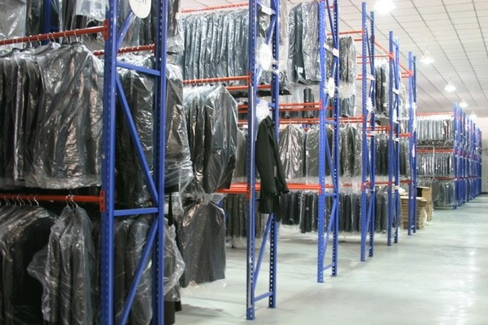
Figure .5.1: Garments ready for packaging
Each pressed garment is then folded with tissue or cardboard. Folding varies from product to product and also from buyer to buyer. Hang tags, special tag and price tag are attached with plastic Kindle or thread. Folded and tagged garments are then packed into the poly bags / desired packing.

5.1.1. Attaching Labels According To Specification
Although most labeling regulations are sector related, generally all leather garment and goods must be labeled to show the name of the product, important qualifiers such as “made by hand” on leather products, a list of all components, Name and Address of manufacturer or vendor, usage instructions, any required dates (i.e., date the product was made, “use by” date, etc.), price--including all taxes (applicable to all prepackaged goods, except those sold by mail order), brand name or trademark, and specifications that tell the consumer of any particular limitations or sales conditions for the product.
The country of origin of leather goods products must be included only in cases where provided information might be misleading regarding the real country where the product was manufactured. A so-called corrective mark of origin is required on all imported foreign products that trademarks, names, signs, or indications of any sort that might lead to the belief that the products originate in a country other than their real country of origin. Labels and/or tags are selected according to product specification and work ticket requirements.
There are four different categories of labeling requirements in garment products:
- Main label
- Country of origin label
- Care label
- Size label
Main label: it is expressed trademark and manufacturer name, the label must be attached to the inside center of the opening midway between the shoulder seams.

Figure 5.2: Main labeling
Country Of Origin Label: the place where the garment product (yarn, fabric or product) was processed or manufactured.
Care label: A care label is a permanent label or tag that contains regular care information and instructions. The label must be attached so that it will remain on the product and remain readable during the useful life of the product. The care label must state what regular care is needed for the ordinary use of the product. Regular care is defined as: "customary and routine care" of the garment, not spots care. A care label must give full care instructions about one regular care method for the garment or, if a garment cannot be cleaned without harm, the label must provide warnings. If the instructions given are followed, they must not hurt the product. Specify care/washing instructions
Size label: it expresses the size of garment. Most of the size label attached under main label Unique to your needs or use our S, M, L, XL and more
Other categories of labeling requirements in garment products:
Woven Name/Logo Label - logo or text either in color or black and white, in any size you need
Care Labels/Tags - Specify care/washing instructions
Content Labels/Tag - Include fabric content
Size Labels - Unique to your needs or use our S, M, L, XL and more.
Combination - A combination label can include ALL of the above listed, or any parts needed.
Hang Tags - Smudge-Proof, High Quality, and Slight Gloss, Professionally Printed. These can be 2-sided, in color or in black and white
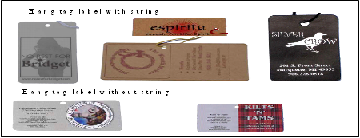
Figure 5.4: Hangtags
- Woven Label Types
Sew on - SA – Seam Allowance needed for attaching.
Iron On - These have a heat seal backing.
Self-Adhesive- These are like stickers, they do not stay on during washings.
These have the highest standard of appearance and are woven to narrow width with the necessary information. These can also have Jacquard design
- Die cut label: A die cut label is a label that is produced using a block or die because of its unique shape.
- Printed cotton labels

Table 5.1: Product specification table
ARTICLES NAME: - | STYLE / CODE NO.:-
CLIENTS NAME:- | TYPE OF MATERIAL:-
 | SIZE/DIMENSIONS ( GARMENT/BAG),
 | PRECAUTIONS ON HANDING:-
Mfg. Date: (Manufactured Date) | Name of the labeler and information contact (address or telephone number)
 | MRP.(Manufacturing Retail Price)

5.2. Packing the leather garments and goods with packing materials

5.2.1. Requirements of Garment and goods packing
Plastic bags are most commonly used for garment packing either at the completion of production or when they arrive at the finished goods stores. A carton package made of quite strong corrugated material is normally preferred while transporting the boxed or hanging garments in bulk form. The packed garment boxes are sealed by contact adhesive paper tape or bound with a plastic tape.
Flowchart of Garment and goods Packaging:
Folding with inserting backboard, tissue
Hang tagging
Received garments and goods from the finished section

Bar-coding
Applied adhesive tape on the pack
Cartooning
Poly bagging

Packing complete

Figure 5.5: Flowchart of Garment and goods Packaging.

Packaging Materials
- Plastic clip
- Paper board
- Wooden Boxes and Crates
- Butterfly
- Plastic collar
- Tag pin
- Ball head pin
- Poly bag
- Inner box
- Tissue paper
- Carton
- Scotch tape
- Quality specifications for packing materials
- The basic quality factors of packaging materials are
- Properties
- Clarity
- Thickness
- Width and length
- Weight
- Yield
- Characteristics
- Tensile strength
- Elongation
- Bursting and tearing strength
- Porosity
- Flammability
- Air/moisture permeability
- Sunlight transference
- Resistance to odors
- Dimensional stability to heat and sunlight

5.3. Assembling and labeling packing boxes

5.3.1. Assembling of packing Boxes
Assembling boxes is the process of bringing and putting together the components of a box to create one box to pack the finished products for shipping.
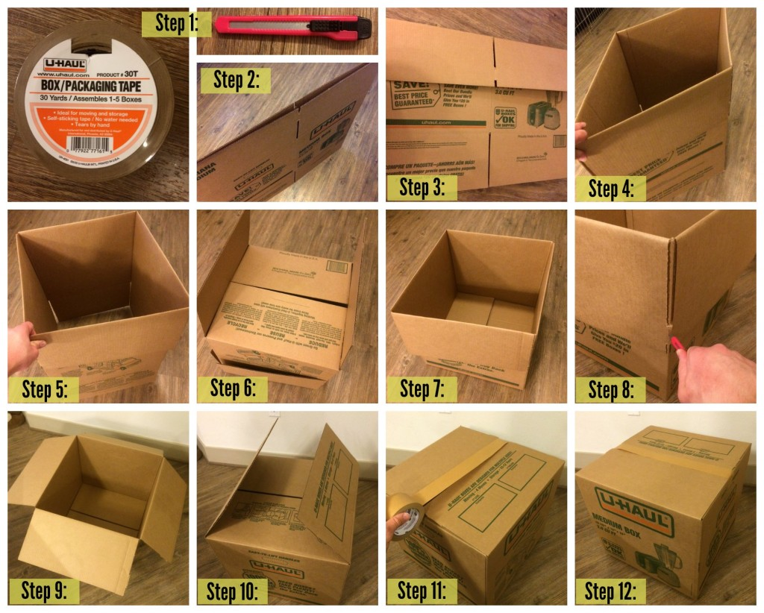
Figure 5.6፡ Assembling of carton

Types of carton packing
After the garment and goods packing the process of cartooning is carried out based on the size of the leather garment and goods and its color and style. Most used types are given belowSolid color solid size pack
- Solid color assorted size pack
- Assorted color solid size pack
- Assorted color assorted size pack

5.3.2. Labeling Packing Boxes
Labeling is a process of inserting identification on boxes or the packaging that’s done. Labeling is the process of writing important information on the packing boxes for identification and forward information regarding the care, moving, types of item, number and other related issues to the customers.
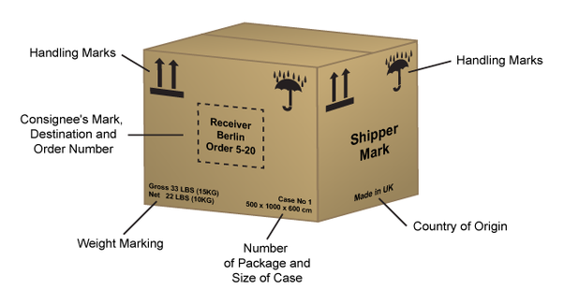
Figure 5.7፡ Labeling and Packing Boxes
Some of the information’s to be provided are:
- Carton box number
- Order number
- Style and color of the product
- Number of pieces in each color and style
- Total number of pieces
- Contact number
- Net weight
- Dimension of the carton box

5.4. Putting dehumidifying agents in box

5.4.1. Dehumidifying agents
A dehumidifier is an electrical appliance, which reduces and maintains the level of humidity in the air or eliminate musty odor and prevent the growth of mildew by extracting water from the air. Dehumidifiers remove extra water content from air inside the room and maintain ideal humidity levels and dry air in the room, which ensures the packaging material, corrugated boxes, stickers etc. are not affected by humidity thus making them fit for transportation and keeping the stacking strength of the boxes intact.
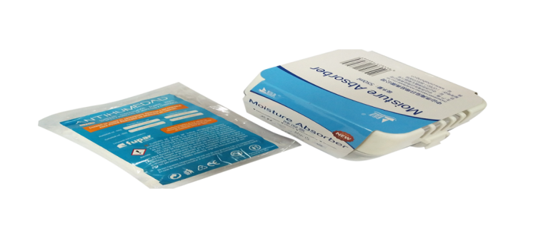Figure 5.8 Dehumidifying agents
Overall packaging and labeling form a very important process as they are transported to the end user along with the products and are responsible for ensuring the quality of products stay intact.
If packages are visibly wet or damaged then you are certainly facing high humidity problems in your packaging area. High humidity tends to affect the adhesives that are used to stick the cardboard boxes, when the adhesives won’t work, the cardboard forming the box will not stay together and are very likely to open up and fall apart causing damage to the material kept inside the boxes. Taking any chances with packaging is not advisable.
Some packaging materials are more able to withstand the effects of high humidity than others. Generally, packages that have plastic covers or are sealed in aluminum foil pouches are relatively impermeable to moisture whereas the plastic-paper pouches and uncoated textile wraps are permeable to moisture.

5.5. Bundling and marking package boxes

5.5.1. Bundling and Marking package boxes according to Color, Stock, Destinations
Bundling is the process of bringing complementary items together. Product bundling is where you package complementary products together.
Why Bundling?
- Some of the benefits of bundling are፡
- Bundling can create the opportunity to provide custom bundle sizes to retailers
- Creates the opportunity to reduce confusion of identifying products packed
- Create greater strength than existing in an individual boxes
- Create savings in transportation and card board material

5.5.2. Marking Package Boxes
Marking is the information that goes on the outside of the boxes and tells the people what is inside the box. A carton mark should have these things at minimum:-
- Your shipping label (including a receiving and return address)
- Numbered box
- Boxes in shipment (example 1 of 3)
- Weight
- Measurements

Types of bundling
- Inline bundling
- In layers side by side
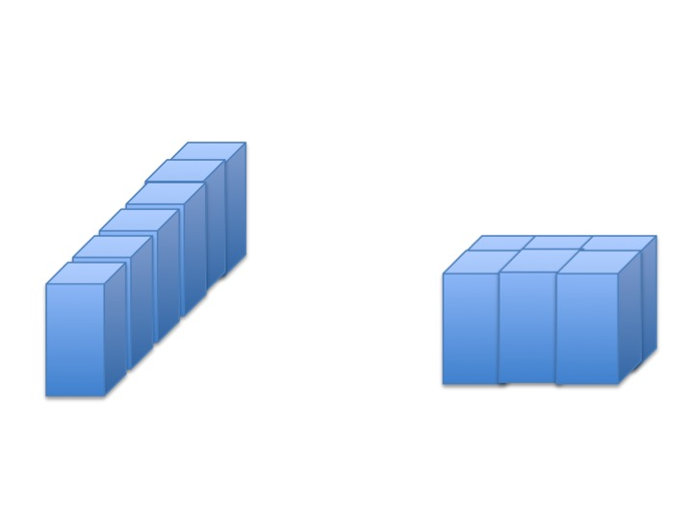
Figure 5.9፡ Inline bundling and in layer side bundling

5.6. Preparing relevant documents in accordance with enterprise procedure

5.6.1. Prepare relevant documents
After finalizing the packaging processes all relevant papered work and documentation. Documentation is prepared in accordance with enterprise procedures. A packing list is a very important document for the leather garment and goods industry. Generally, merchandisers or packing in-charge is responsible to make and delivering packing lists to related departments. The packing section does packing as per customer packing requirements that solid or asserts/ratio pack. Packing is done when a PO packing is completed, without giving packing list buyer QC never does a final quality inspection, packing list confirm buyer QC that a PO is packing is closed. The packing list is very important to export documents, without the packing list commercial department cannot submit exports document for the products shipment, that’s why the packing list consider as important documents.

- Documents to be prepared include:
- product maker, Specific style and buyer name
- Total and size-wise order quantity
- Style description and color
- Size-wise Cut vs. Order vs. pack quantity, carton quantity
- Carton wise case number
- Size-wise carton net and gross weight
- Carton measurements and Total carton
- Total over or short pack quantity

Self-check 5 | Written test
Directions: Answer all the questions listed below. Examples may be necessary to aid some explanations/answers.
Part A
- Explain packaging (5 points)
- List the functions of packaging (5 points)
- What are the primary functions of packaging(5 points)
- List categories labels( 5 points)
- List at list five types of packaging materials (5 points)
- Draw flow chart for packaging of leather garments (5 points)
- What are the criteria for choosing packaging materials? (5 points)
- What is assembling of packing boxes (5points)
- What is labeling (5 points)
- List the information’s included in labeling of boxes (5 points)
- List the types of carton packing (5 points)
- Define and explain dehumidifiers? (10 points)
- Why is important putting dehumidifiers in boxes during packaging (10 points)
- List types of dehumidifying agents used (10 points)
- What do we mean by documentation of packaging process (3 points)
- What is the use of documentation in packaging processes (3 points)
- When should we do documentation (4 points)
Part B
True or False: (2 * 1 = 2)
1. Bundling is the process of bringing complementary items together.
2. Packaging means wrapping, compressing, filling or creating of goods for the purpose of protection of goods and their convenient handling.

References

www.libertyleathergoods.com/types-of-leather
http://www.leatherique.com
http://www.yellowpages.com/hanson-ma/leather-goodrepair
http://www.bing.com/images/search
www.mahawk-finish.com
https://www.howitworksdaily.com/what-makes-velcro-stick/

Participants of this Module (training material) preparation
No | Name | Qualification (Level) | Field of Study | Organization/ Institution | Mobile number | E-mail
1 | Siyoum Negash | B(MSC) | Leather Garment | Dilla polytechnic college | 0913084257  0902249766 | Siyoum2006@gmail.com
2 | mohammad juhar | A(MSC) | Garment technology | Dessie w/ro siheen polytechnic college | 0913632589 | mdjuher143@gmail.com
3 | KALAB GIETIE | B(MSC) | Leather technology | Debere brihan | 0996884181 | kalabtenaw@gmail.com
4
5
6
7

