Surveying Technology
Level-II
Based on December 2022, Curriculum Version 2
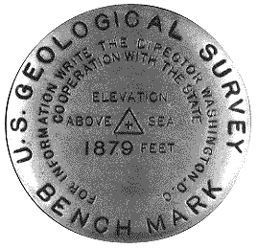
Module Title: - Control survey points
Module code: EIS SUR2 M04 06 22
Nominal duration: 250 Hours

Prepared by: Ministry of Labour and Skill

December, 2022
Addis Ababa, Ethiopia
Table of Contents Page
UNIT ONE:INTRODUCTION OF CONTROL POINT 6
1.1.Diffinition of control point 7
1.2.Surveying terminology and Control Survey 7
1.3. Materials, Tools and equipments of control point 7
Self check 1.1 15
Written test 15
UNIT TWO :TRAVERSE 16
2.1.Introduction of traverse 17
2.1.1. Traverse stations or traverse points. 17
2.2. Types of traverse 18
2.2.1 Types of close traverse 19
2.3. Horizontal and vertical angels 20
2.4. Azimuth and bearing 27
2.4.2. Back azimuth 29
2.5. Fieldwork activities 31
2.6. Computing coordinates 31
2.7. Area computation 51
2.7.1.Area Computation by coordinate method 51
2.7.2.Area Computation by meridian system 55
Exercise1 55
Self check-2 59
3.1. Introduction Triangulation 63
3.2. Triangulation stations 64
3.3. Establishing monuments 65
3.4. Measuring angle and base line 65
3.5.Computing triangulation 67
2.5.1.Adjustment of Chain of Single Triangles 67
3.4.2 Adjustment of a quadrilateral 69
3.5.3. Eccentric Stations (Reduction to centre) 73
3.5.3. Computation of lengths 76
3.5.4. Coordinate calculations 78
UNIT FOUR: INTERSECTION 82
4.1.Introduction of Intersection 83
4.2.Computing Intersection 85
UNIT FIVE: RE SECTION 90
5.1.INTRODUCTION OF RESECTION 91
5.2. Writing the description for station 92
5.3. Establishing Resection 93
5.4. computing resection 97
UNIT SIX: TRILATRATION 104
6.1. TRILATRATION SYSTEM 105
6.2. ADJUSTMENT OF MEASURED DISTANCES 106

Acknowledgment
Ministry of Labor and Skills wish to extend thanks and appreciation to the many representatives of TVET instructors and respective industry experts who donated their time and expertise to the development of this Teaching, Training and Learning Materials (TTLM).

Introduction to the Module
In Surveying filed; the Control survey points helps to know the Traversing, Triangulation. Intersection, Re section and Trilatration
This module is designed to meet the industry requirement under the surveying technology occupational standard, particularly for the unit of competency: Control survey points
This module covers the units:
- Introduction
- Traversing
- Triangulation.
- Intersection
- Re section
- Trilatration
Learning Objective of the Module
- Perform Control Survey points
- Perform Traversing.
- Compute Triangulation.
- Establish Intersection
- Establish Re section
- Describe Stations
Module Instruction
For effective use this modules trainees are expected to follow the following module instruction:
- Read the information written in each unit
- Accomplish the Self-checks at the end of each unit
- Perform Operation Sheets which were provided at the end of units
- Do the “LAP test” giver at the end of each unit and
- Demonstrate the given project
- Read the identified reference book for Examples and exercise

UNIT ONE: INTRODUCTION OF CONTROL POINT
This learning guide is developed to provide you the necessary information regarding the following content coverage and topics:
  - Definition of control point
  - Surveying terminology and Control Survey
  - Materials, Tools and equipments
  - Safety requirements
This guide will also assist you to attain the learning outcomes stated in the cover page. Specifically, upon completion of this learning guide, you will be able to:
- Definite Control Survey points
- Apply Safety requirements
- Identify materials, tools and equipment

1.1.Diffinition of control point
The determination of the precise position of a number of stations, usually spread over a large area, is referred to as control surveying. Control surveys can be horizontal or vertical.
The objective of horizontal control surveys is to establish a network of control stations whose position is specified in terms of latitude and longitude, where as the objective of vertical control survey is to provide the elevations of fixed benchmarks with respect to the mean sea level datum. These control surveys are located where other surveys can be conveniently and accurately tied in to them.
The results of the control surveys are used as a basis from which surveys of smaller extent can be originated. Boundary surveys, construction, route surveys, topographic and hydrographic surveys and other may be involved.
Horizontal control can be carried out by precise traversing, by triangulation, by trilateration, and perhaps by same combination of these methods. Intersection, resection, and satellite positioning are also the other methods in horizontal control surveys. The exact method used depends of the terrain, equipment available, information needed and economic factors.

1.2.Surveying terminology and Control Survey
- Azimuth :An angle measured from north direction up to a given line.
- Bering : is an angle measure from north or south direction up 90⁰
- Station: is a point that is the instrument is set up on.
- Bench mark: is a point that is the elevation is known
- Base line: a line that the value is measured

1.3. Materials, Tools and equipments of control point
A. Theodolite
Theodolite Survey is used to measure horizontal and vertical angles. It is also used for levelling, indirect measure of distances and prolonging a line etc. The line of sight of Theodolite can be rotated through 180º in vertical plane about its horizontal axis. Theodolite is a precision instrument for measuring angles in the horizontal and vertical planes.
Parts of Theodolite and their Functions A Theodolite consist of following parts, are as under
Telescope
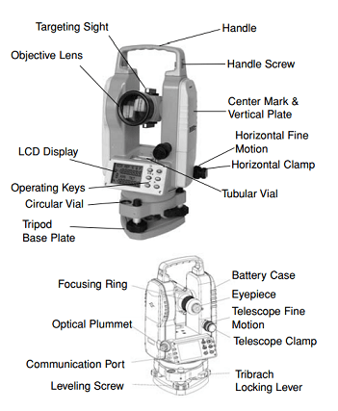
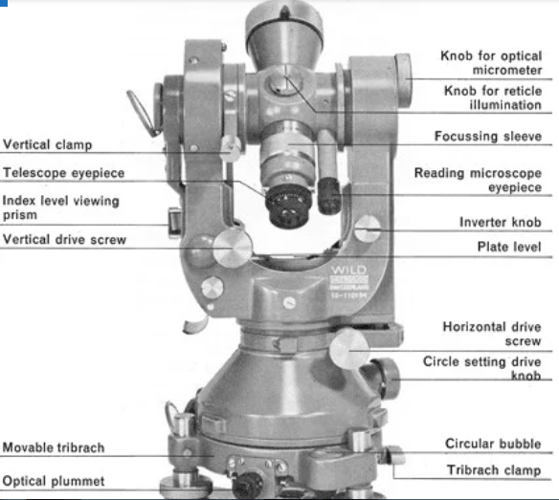
Figure 1.1 Theodolite
Uses of Theodolite in Surveying
Theodolite uses for many purposes, but mainly it is used for measuring angles, scaling points of constructional works. For example, to determine highway points, huge buildings’ escalating edges Theodolites are used. Depending on the job nature and the accuracy required, Theodolite produces more curved of readings, using paradoxical faces and swings or different positions for perfect measuring survey. Followings are the major uses of Theodolite: Measuring horizontal and vertical angles
The Theodolite helps us a good within the engineering field. This instrument plays a major role in measurement horizontal angles, vertical angles, bearing, etc. To use Theodolite, it is necessary to know about Theodolite parts, types of Theodolite and for what it is used wisely in the field.
B. Tripod: Tripod is nothing but a stand on which Theodolite is mounted. It should place in such a way that Theodolite should be in exact levelled position. The tripod has legs with steel shoes at their ends. These hold the ground strongly without any movement when placed. Tripod has an external screw which helps to attach the Theodolite by tribratch plate in fixed position.
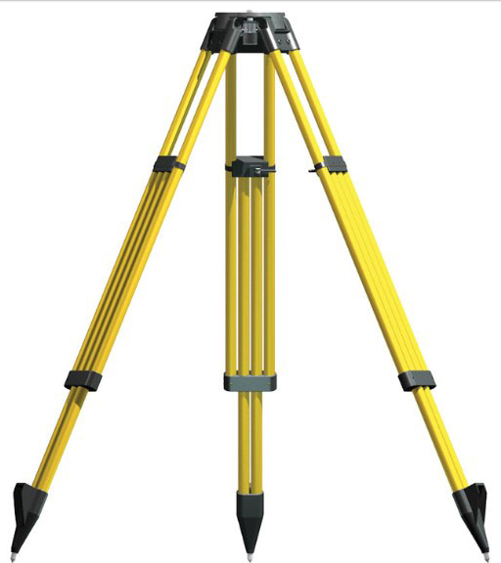
Figure 1.2 Tripod
C. Plumb Bob: Plumb bob is tool having a cone shaped weight attached to a long thread. The weight is hanged using thread from the centre of tripod stand and centering of Theodolite is done.
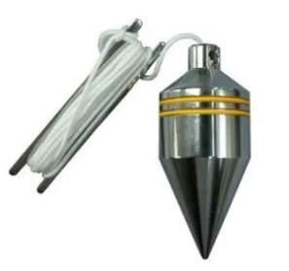
Figure 1.3 Plumb
D. Magnetic Compass: Simpler Theodolites may contain circular compass box in the centre of upper plate. When we select north as reference meridian it will be useful.
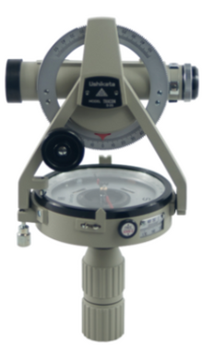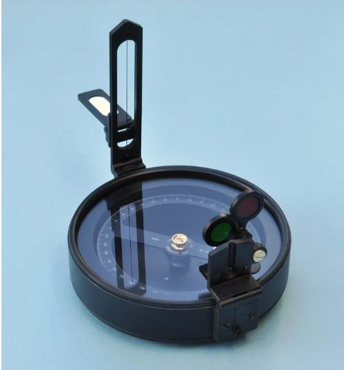

Figure 1.4 Magnetic Compass
E. Ranging Poles
Ranging poles (see Fig. 7) are used to mark areas and to set out straight lines on the field. They are also used to mark points which must be seen from a distance, in which case a flag may be attached to improve the visibility.
Ranging poles are straight round stalks, 3 to 4 cm thick and about 2 m long. They are made of wood or metal. Ranging poles can also be home made from strong straight bamboo or tree branches.
REMEMBER: Ranging poles may never be curved.
Ranging poles are usually painted with alternate red-white or black-white bands. If possible, wooden ranging poles are reinforced at the bottom end by metal points.
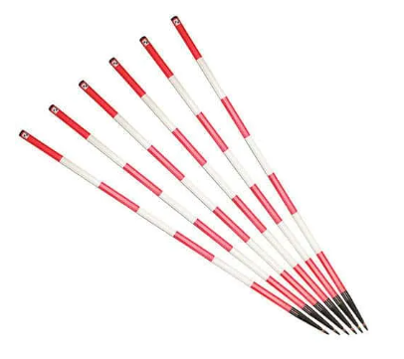
Figure 1.5 Ranging pole
F. Page; A boundary peg is a hardwood stake that is placed at each corner of your property. And it is set down by the surveyor. It is used to indicate the boundary line between your parcel of land and the ones adjacent to it.
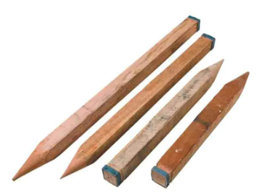
Figure 1.6 Page
G. Tapes: Is an instrument used to measure horizontal distance
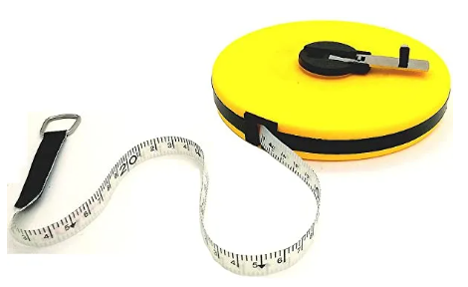
Figure 1.7 Tape
H. Paper: is a thin sheet material produced by mechanically or chemically processing cellulose fibres derived from wood, rags, grasses or other vegetable sources.

Figure 1.8 Parer
I. Pencil: A pencil is a writing or drawing implement with a solid pigment core in a protective casing that reduces the risk of core breakage, and keeps it from marking the user's hand.

Figure 1.9 Pencil
J. Calculator:
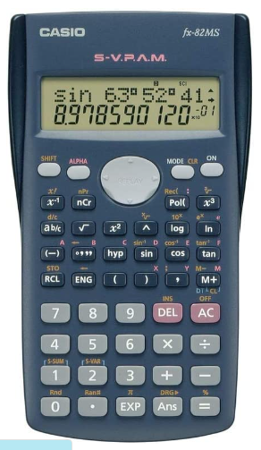
Figure 1.10.Calculatore
K. GPS: GPS, or the Global Positioning System, is a global navigation satellite system that provides location, velocity and time synchronization. GPS is everywhere. You can find GPS systems in your car, your smart phone and your watch. GPS helps you get where you are going, from point A to point B.
The use of GPS is to establish control point.
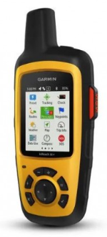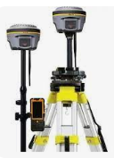
Figure 1.11.GPS
1.4. Safety requirements:
- To minimize the possibility of damage always keep the accessory port door closed
- Do not use out of the accepted rang of energy or out of the recommended rang of power which limited by the manufactured organization
- Do not aims the telescope at the sun use the solar filter to avoid casing internal damage to the instrument when observing the sun.
- Protect the instrument from heavy shocks or vibration
- Turn the power off before removing battery
- Adverse use can lead to injury, malfunction and damage.
- The person responsible for the product must ensure that it is used in accordance with the instruction
How to Use a Theodolite
- Mark the point at which the theodolite will be set up with a surveyor’s nail or a stake. This point is the basis for measuring angles and distances.
- Set up the tripod. Make sure the height of the tripod allows the instrument (the theodolite) to be eye-level. The centered hole of the mounting plate should be over the nail or stake.
- Drive the tripod legs into the ground using the brackets on the sides of each leg.
- Mount the theodolite by placing it atop the tripod, and screw it in place with the mounting knob.
- Measure the height between the ground and the instrument. This will be used a reference to other stations.
- Level the theodolite by adjusting the tripod legs and using the bulls-eye level. You can make slight tunings with the leveling knobs to get it just right.
- Adjust the small sight (the vertical plummet) found on the bottom of the theodolite. The vertical plummet allows you to do ensure the instrument remains over the nail or stake. Adjust the plummet using the knobs on the bottom.
- Aim the crosshairs in the main scope at the point to be measured. Use the locking knobs on the side of the theodolite to keep it aimed on the point. Record the horizontal and vertical angles using the viewing scope found on the theodolite’s side.
Self check 1.1 | Written test

Test-I Multiple Choose
Instruction: select the correct answer for the give choice. You have given 1 Minute for each question. Each question carries 2 Point.
1. Which instrument use to measure azimuth.
A. Rage pole B. Compass C. Page D. Tape
2. The use of tape to measure ___________________
A. Vertical distance B. Paper distance C. Horizontal distance D. Elevation distance
3.Which instrument use for collecting control point
A. Theodolite B. Computer C. Protractor D. Leveling
Test II: short Answer writing
Instruction: select the correct answer for the give choice. You have given 1 Minute for each question. Each question carries 2 Point
A B
1. GPS A. Measure angle
2.Thedolite B. To measure direction
3.Rage pole C. Alignment
4. Compass D. Measure distance
5. Tape E. To measure angle
Part III: Short answer writing
Direction: Give short answer to the following questions. Time allotted for each item is 2mniut and each question carry 4 point.
1. What is azimuth
2. What is the use of Theodolite
3.What is the difference between azimuth and Bering
Note: Satisfactory rating – above 60% Unsatisfactory - below 60%
You can ask you teacher for the copy of the correct answers

UNIT TWO :TRAVERSE
This unit to provide you the necessary information regarding the following content coverage and topics:
- Introduction of traverse
- Types of traversing
- Horizontal and vertical angels
- Azimuth and bearing
- Fieldwork activities
- Computing coordinates
- Areal computation
This guide will also assist you to attain the learning outcomes stated in the cover page. Specifically, upon completion of this learning guide, you will be able to:
- Identify types of traverse
- Measure horizontal and vertical angels.
- Apply Traverse fieldworks.
- Compute azimuth and bearing.
- calculate Area

2.1.Introduction of traverse
Traversing is a series of horizontal distances and angles are measured. This is generally cheaper due to shorter sights and convenience to carry it out under less favorable weather conditions than the other methods. Its disadvantage is that, there are fewer checks available for locating mistakes in the work and the whole system can rather easily sway or bend. To check a traverse it is necessary to form a loop returning to its starting point or to tie it in to previously established control points.

2.1.1. Traverse stations or traverse points.
Any temporary or permanent point of reference over which the theodolite is set up is called a traverse station. On most surveys the traverse station is a peg, called a hub, driven flush with the ground and having a tack driven in its top to mark the exact point of reference for measurement. On pavements, the traverse stations may be a driven nail, a cross cut in the pavement or curb, or a tack set in a hole drilled with a star drill and filled with lead wool. In land surveying the stations are often iron pipes, stones, or other more or less permanent monuments set at the corners, In mountainous country, often the station marks are cut in the natural rock.
2.1.2.Purpose of traverse:
Traversing is a convenient, rapid method for establishing horizontal control. It is particularly useful in densely built up areas and in heavily forested regions where lengths of sight are short so that neither triangulation nor trilateration is suitable. Traverses are made for numerous purposes, including:
- Property surveys to locate or establish boundaries
- Supplementary horizontal control for topographic mapping surveys
- Location and construction layout surveys for highways, railways, and other private public works.
- Ground control surveys for photogrammetric mapping.
Frequently, the traverse is employed to densify the number of coordinated control points in a triangulated or trilaterated horizontal control network.

2.2. Types of traverse
There are two types of traverse
A. Open traverse. B. Closed traverse.
A. Open traverse
Open traverse is originates at a point of known position and terminates at a point of unknown position. No computational check is possible to detect errors or blunders in distances or directions in this type of traverse. To minimize errors, distances can be measured twice, angle turned by repetition or reiteration methods, magnetic bearings observed on all lines, and astronomic observations made periodically.
In spite of these precautions, an open traverse is a risky proposition and should not be used for any of application where high accuracy is required, since the results are uncertain and will always be subject to question. Open traverse are necessary in certain types of mine surveying. Hence, there are applications of an open traverse when circumstances dictate their use.
Open traverse
V -4
V - 3
V - 2
V-1
Known Point

Figure:2.1 Open traverse
B. Closed traverse:
Closed traverses is originate at a point of known position and close on another point of known horizontal position. A point of known horizontal position is given either by geographic latitude and longitude or by X and Y coordinates on a rectangular coordinates grid system. In Fig traverse MABCDQ originates at known point M with a backside along line MN of known azimuth and closes on known point Q, with a foresight along line QR also of known azimuth. This type of traverse is preferable to all others since computational checks are possible which allow detection of systematic errors in both distance and direction.

R
Q
B
D
C
A
N
M

Figure:2.2 Clouse link traverse
A traverse that originates and terminates on a single point of known horizontal position is called a closed - loop traverse. In fig traverse 1–2 –3 -4 -5 -6 -7-1, which originates and close on point 1,is an example of a closed – loop traverse. This type of traverse permits an internal check on the angle, but there is no way to defect systematic errors in distance or errors in the orientation of the traverse. A closed loop – traverse should not be used for major projects. To minimize the chance of errors in a closed – loop traverse, all distance measuring equipment must be carefully calibrated and astronomic observation must be made periodically.
A closed – loop traverse that originates and terminates on a point of assumed horizontal position provides an internal check on angles but no check on systematic errors in distance. An additional disadvantage is that the points are not located on any datum and have no relationship with points in any other survey, although the relative positions are determined. The use of such a method of running a traverse is to be discouraged except under extenuating circumstances, where no feasible alternative is possible.

2.2.1 Types of close traverse
A. Loop traverse
Closed-loop Traverse: Closed Traverse creates a closed geometrical shape (polygon). A closed traverse is one that either begins and ends at the same point. Therefore the angles can be closed geometrically and the position closure can be determined mathematically.

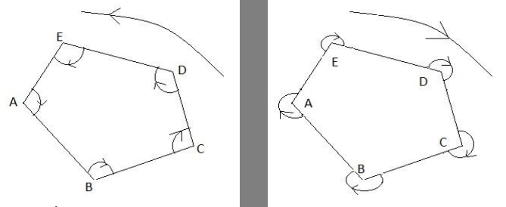

Figure:2.3. loop traverse
Closed-link Traverse:
A link traverse is connected to at least two points, at the beginning and at the end of traverses ,whose coordinates have been previously determined. Calculations can be made to check for errors.
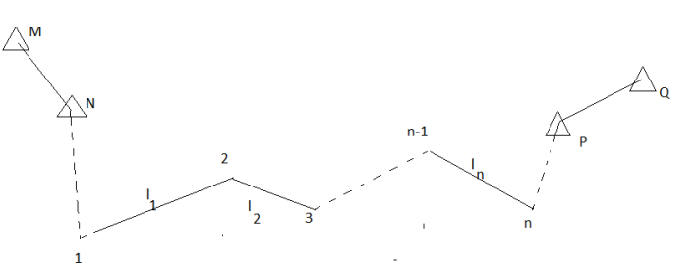
Figure:2.4. Link traverse

2.3. Horizontal and vertical angels
Horizontal angle: An angle is defined as the difference in direction between two convergent lines. A horizontal angle is formed by the directions to two objects in a horizontal plane.
method of turning angles
Each of the types of traverse discussed above can also be described according to the method of turning the angles in the traverse. Thus, there are traverses by intersection angles, deflection angles, Azimuth method, each of these methods for running traverse are shown below.

Interior angles are measured clockwise or counter-clockwise between two adjacent lines on the inside of a closed polygon figure.

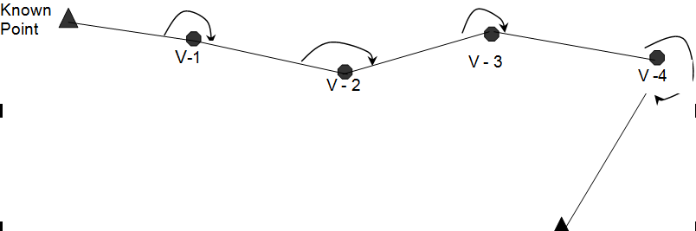
Figure:2.5. Interior angle
In a loop traverse the angles can be measured internally (interior angles) or externally (exterior angles)
7
6
5
4
3
2
1
Traversing by Interior Angles

Figure:2.6. Interior angle
Notice that at Interior angles the loop traverse is routed and numbering at anticlockwise direction;
Exterior angles are measured clockwise or counter-clockwise between two adjacent lines on the outside of a closed polygon figure.
2
3
4
5
6
7
1
Traversing by Exterior angles

Figure:2.7. Exterior angle
Notice exterior angles; the loop traverse is routed and numbering at clockwise direction
Angles to the right are turned from the back line in a clockwise or right hand direction to the ahead line.
Deflection angles
The deflection angle can be measured clockwise (right deflection angle) or anticlockwise (left deflection angle) It is measured from the prolongation of the back tangent to the fore tangent. Most of the time the surveyors prefer to measure the intersection angle and then figure out the deflection angle, since the different between them is 180⁰ so we can state that:
Right deflection angle = Intersection angle - 180⁰
Left deflection angle = 180⁰ – Intersection angle
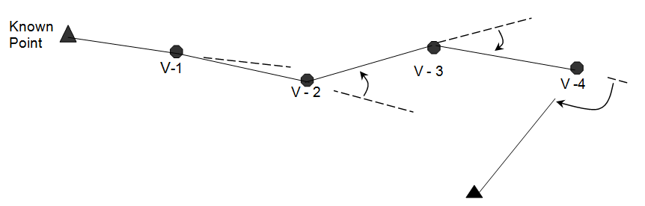
Figure:2.8. Deflection angle
Azimuth angle
Traversing by azimuth is not a suitable method since the magnetic north – south meridian are not parallel at control points due to the local magnetic declination, in addition some magnetic fields such as electric lines, iron objects near the control points and even solar magnetic storms can disturb the magnetic meridian position, consequently a high accuracy is not reachable.
MN
MN
MN
MNN

Figure:2.9. Azimuth angle
Angles to the left are turned from the back line in a counterclockwise or left hand direction to the ahead line.
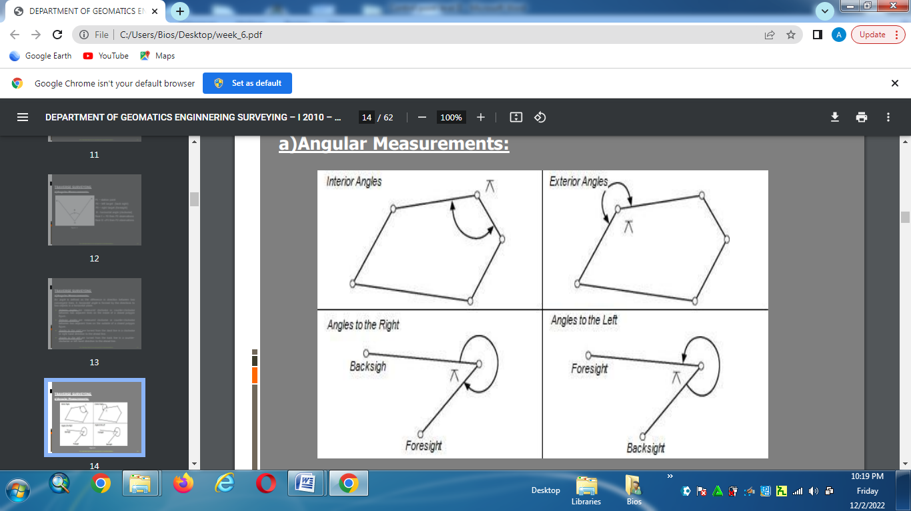
Figure:2.10. Angle to left

Angles to the right are turned from the back line in a counterclockwise or left hand direction to the ahead line.
Figure:2.11. Angle to righte
A vertical angle is formed by two intersecting lines in a vertical plane, one of these lines horizontal.
A vertical angle is an angle formed by two connected lines in the vertical plane*, that is, between a low point and two higher points. Since these angles are in the vertical plane, the lines that form them will usually be lines of sight
A vertical angle is measured in the direction of gravity
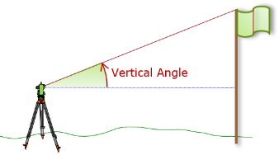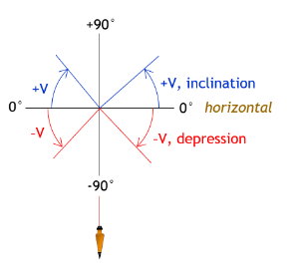
Figure:2.12. Vertical angle
Zenith angle: is the complementary angle to the vertical angle and is formed by two intersecting lines in a vertical plane, one of these lines directed toward the zenith.
A Zenith angle is measured from the upper end of the vertical line continuously all the way around, Figure F-3. It ranges from 0° directly upward (zenith) to 90° on the horizontal to 180° directly downward (nadir) to 270° on the opposite horizontal to 360° back at the zenith. This is typical of angle measurements with closed-standards optical transits and theodolites.
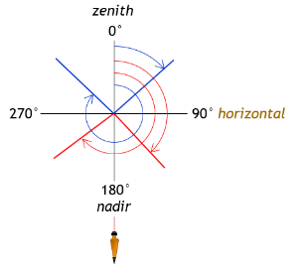
Figure:2.13.Zenith angle
Example 1
Figure .2.13. shows combined Vertical (red) and Zenith (blue) angle circles with an instrument at their center as a reference.
Convert a 56°40’ zenith angle to a vertical angle.
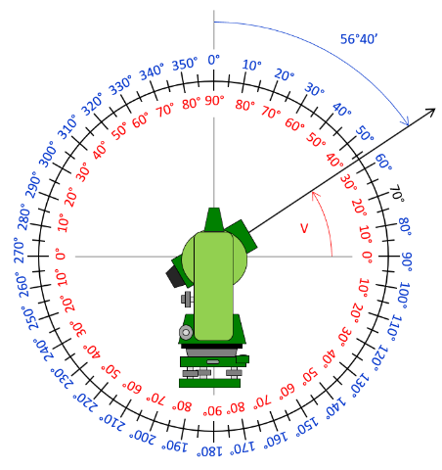
V=90⁰00'00'' -56⁰40'00''
Figure:2.14. Zenith angle
Example 2
Convert a 227°30’ zenith angle to a vertical angle.
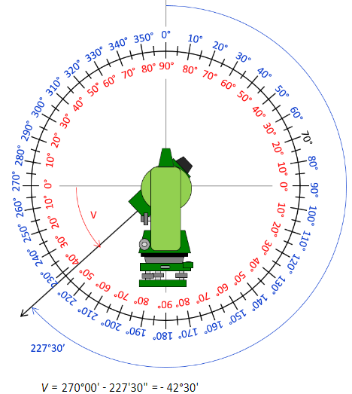
Figure:2.15. Zenith angle

Example 3
Which zenith angles are the same as a -36°10’ vertical angle?
Recall that there are two vertical angles one on each side of the zenith circle.
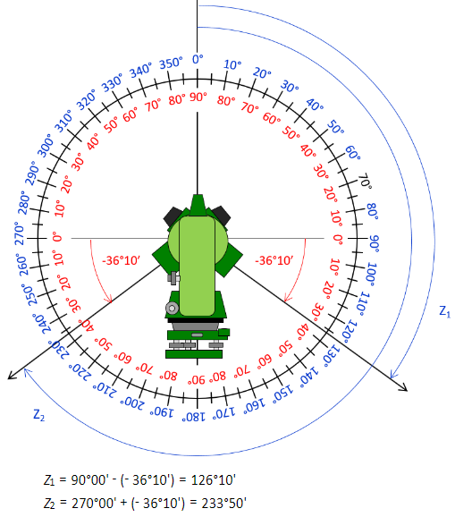
Figure:2.16.Vertical angle

2.4. Azimuth and bearing
2.4.1. Azimuth:
-It is an angle measured clockwise from a reference north.
-It is always measured clock wise and north direction
-Its range is [0,360]
- Unlike bearing the direction will not mentioned
- Azimuth sometime called Whole Circle Bearing
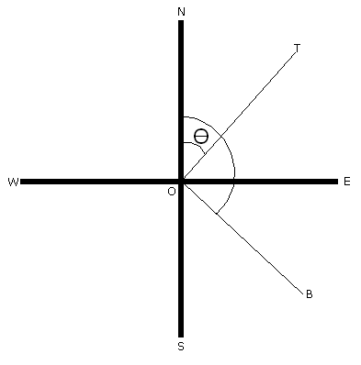
Example.1
Azimuth of line OA =θ
Azimuth of line OB =β
Range of Azimuth in different quadrants
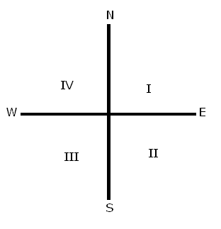
In I Quadrant
In I Azimuth between 0⁰ - 90⁰
In II Quadrant Azimuth is between 90⁰ - 180⁰
In III Quadrant Azimuth is between 180⁰ -270⁰
In IV quadrant Azimuth is between 270⁰ - 360⁰

The relationship between azimuth and bearing
The relationship b/n bearing and azimuth in different quadrants is different.
In I quadrant Angular Value of bearing = Azimuth
In II quadrant Azimuth = 180 ⁰ - angular value of bearing
In III quadrant Azimuth = 180 ⁰+ angular value of bearing
In IV Quadrant Azimuth = 360⁰-angular Value of bearing

2.4.2. Back azimuth
Similarly to bearing the back azimuth is the reverse of forward azimuth
Back azimuth of AB = Azimuth of BA
The angular difference b/n forward and backward azimuth is equal to 180⁰
Computing a back azimuth from forward azimuth
If a forward azimuth is less than 180⁰, Backward azimuth = forward Az + 180⁰
If a forward azimuth is greater than 180⁰ ,Backward azimuth = foreword azimuth +180⁰
Example
Find the backward azimuth of the following lines having foreword azimuth
Line Forward azimuth
AB 43⁰11’20’’
BC 112⁰ 20’15’’
CD 197⁰ 18’36’’
DE 320⁰ 17’40’’

Solution
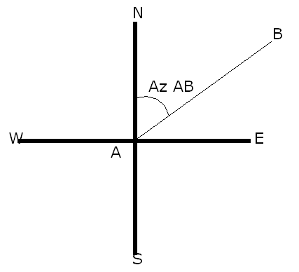

Since Az AB < 90⁰
Az BA = Azimuth of AB +180⁰
= 43⁰11’20’’ + 180⁰
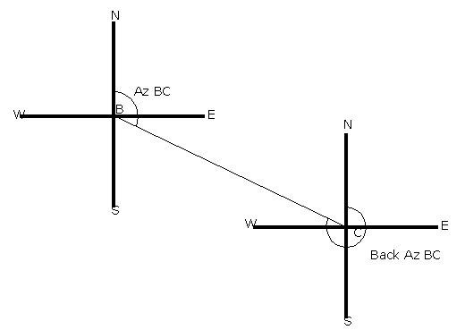 = 223⁰ 11’20’’

Since 90⁰ < Az BC< 180⁰
Back azimuth of line BC= 112⁰29’15+180⁰
= 290⁰29’15’’
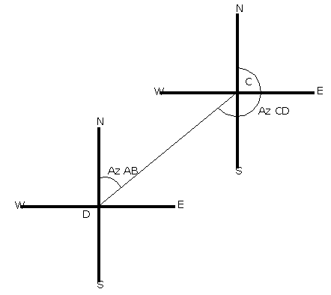

Since 180⁰ < Az CD< 270⁰
Back azimuth of CD = Az CD-180⁰
=197⁰18’36’’-180⁰
= 17⁰ 18’36’’

D. Since 270⁰ < Az DE < 360⁰
Back azimuth DE = Az DE -180⁰
= 320⁰17’40’’-180⁰
= 140⁰ 17’40’’

2.5. Fieldwork activities
Select equipment, tools and material for measuring angle distance, direction and one coordinate for calculating traverse.

2.6. Computing coordinates
General Step (for a loop traverse)
Angular Stage
I .Computing the angular closure error ec= ∑ α – 180⁰ (n – 2)
II. Determining the angular permissible error = 1’ √n or30’’√n 0r 10’’√n
III .Determining the angular correction c = ec/n
IV. Appling the angular correction to interception angles α_{(corrected)} = α ± c
(the correction is introduced into the angle with the error appositive sign)
V .Checking the angular correction: ∑α_{(corrected)} = 180⁰ (n – 2)
VI. Computing the azimuth of every line A_{BC} = A_{AB} + α_{(corrected)} ± 180⁰
VII. Determining the bearing upon the azimuth of every line.
In first quadrant Br. = Az
VIII Computing the differences in X and Y: ∆X₂ = dist₁ * sin Azimuth₁₋₂
∆Y₂ = dist₁ * cos Azimuth₁₋₂
II Determining the total error in X: X _{e} = ∑∆X total error in Y: Y_{e} = ∑∆Y ____________
III Determining the linear absolute error Ae = √ ∑∆X²+ ∑∆Y²
IV Computing the Precision or liner relative error: P = 1D/Ae
V Comparing the achieved Precision with the expected Precision or Project Precision, It must to be fulfilled that: P > PP (otherwise the field data are not acceptable)
VI Computing the correction for ∆X and ∆y: C = ∑∆X * dist
D
C = ∑∆Y *dist
D
VII Appling the correction to ∑∆X and ∑∆Y :∑∆X_{(corrected)} = ∑∆X ± C
∑∆Y_{(corrected)} = ∑∆Y ± C
VIII Checking the linear correction now it must be fulfilled That :
∑∆X = 0
∑∆Y = 0
IX Computing the final coordinate of every traverse vertex :
X_{b} = X_{a} ± ∑∆X_{(corrected)}
Y_{b} = Y_{a} ± ∑∆Y_{(corrected)}
X Filling out the calculus compendium
Example1 (loop traverse)
2.6. Areal computation
2.6.1. coordination methods
2.6.2. meridian system
110⁰ 53’ 10’’
200⁰ 54’ 14’’
79⁰ 07’ 00’’
219⁰ 57’ 02’’
55⁰ 30’ 06’’
354. 51
318.54
274.17
469. 65
246. 57
365.01
Azimuth
1 – 2
110⁰ 00’ 00’’
MS
MN
6
5
4
3
2
1
53⁰ 38’ 02’’
Known data: Pp = 1 : 10 000 X₁ = 5000.00 Y₁= 2000.00
I – Determining the angular closure error :ec= ∑ α – 180⁰ (n – 2)
ec = 719⁰ 59’ 34’’ – 180⁰ (6 – 2 ) = 719⁰ 59’ 34’’ – 720⁰ 00’ 00’’
ec = 26’’
II – Determining the angular permissible error: pe = 1’ √n
pe = 1’√6 = 1’ x 2.4494897 = 2’ 27’’ then ce<petherefore the current angular error is acceptable.
III - Determining the angular correctionc = ec
n
c = 26’’ c = 4.3’’
6
IV - Appling the angular correction to interception anglesα_{(corrected)} = α ± c
(the correction is introduced into the angle with the error appositive sign)
α_{(corrected 1 )} = 55⁰ 30’ 06’’ + 5’’ = 55⁰ 30’ 11’’
α_{(corrected 2 )} = 219⁰ 57’ 02’’ + 4’’ = 219⁰ 57’ 06’’
α_{(corrected 3 )} =79⁰ 07’ 00’’ + 4’’ = 79⁰ 07’ 04’’
α_{(corrected 4 )} = 53⁰ 38’ 02’’ + 4’’ = 53⁰ 38’ 06’’
α_{(corrected 5 )} =200⁰ 54’ 14’’ + 4’’ = 200⁰ 54’ 18’’
α_{(corrected 6 )} =110⁰ 53’ 10’’ + 5’’ = 110⁰ 53’ 15’’
Total = 26’’ Now ∑α = 180⁰ (n – 2 ) = 720⁰ 00’ 00’’
VI Computing the azimuth of every line A_{BC}= A_{AB} + α_{(corrected)} ± 180⁰

Azimuth of line 1 – 2 is known = 110⁰ 00’ 00’’
Azimuth of line 2 – 3 = Azimuth of line 1 – 2 + α₂ ± 180⁰
Azimuth of line 2 – 3 = 110⁰ 00’ 00’’ + 219⁰ 57’ 06’’ - 180⁰
Azimuth of line 2 – 3 = 329⁰ 57’ 06’’ - 180⁰ = 149⁰ 57’ 06’’

Azimuth of line 3 – 4 = Azimuth of line 2 – 3 + α₃ ± 180⁰
Azimuth of line 3 - 4 = 149⁰ 57’ 06’’+ 79⁰ 07’ 04’’ - 180⁰
Azimuth of line 3 – 4 = 229⁰ 04’ 10’’ – 180⁰ = 49⁰ 04’ 10’’

Azimuth of line 4 – 5 = Azimuth of line 3 – 4 + α₄ ± 180⁰
Azimuth of line 4 – 5 = 49⁰ 04’ 10’’ + 53⁰ 38’ 06’’ + 180⁰
Azimuth of line 4 – 5 = 102⁰ 42’ 16’’ + 180⁰ = 282⁰ 42’ 16’’

Azimuth of line 5 – 6 = Azimuth of line 4 – 5 + α₅ ± 180⁰
Azimuth of line 5 – 6 = 282⁰ 42’ 16’’ + 200⁰ 54’ 18’’ -180⁰
Azimuth of line 5 – 6 = 483⁰ 36’ 34’’ -180⁰ = 303⁰ 36’ 34’’

Azimuth of line 6 – 1 = Azimuth of line 5 – 6 + α₆ ± 180⁰
Azimuth of line 6 – 1 = 303⁰ 36’ 34’’ + 110⁰ 53’ 15’’ – 180⁰
Azimuth of line 6 – 1 = 414⁰ 29’ 49’’ -180⁰ = 234⁰ 29’ 49’’

Azimuth of line 1 – 2 = Azimuth of line 6 – 1 + α₁ ± 180⁰
Azimuth of line 1 – 2 = 234⁰ 29’ 49’’ + 55⁰ 30’ 11’’ – 180⁰
Azimuth of line 1 – 2 = 290⁰ 00’ 00’’ – 180⁰ = 110⁰ 00’ 00’’

VII Determining the bearing upon the azimuth of every line.

Azimuth 1 - 2 = 110⁰ 00’ 00’’
Bearing 1 -2 = 180⁰ – Azimuth = 180⁰ - 110⁰ 00’ 00’’ = 70⁰ 00’00’’ SE

Azimuth 2 - 3 = 149⁰ 57’ 06’’
Bearing 2 – 3 = 180⁰ – Azimuth = 180⁰ - 149⁰ 57’ 06’’ = 30⁰ 02’ 54’’ SE

Azimuth 3 - 4 = 49⁰ 04’ 10’’
Bearing 3 – 4 = Azimuth = 49⁰ 04’ 10’’ NE

Azimuth 4 - 5 = 282⁰ 42’ 16’’
Bearing 4 – 5 = 360⁰- Azimuth = 77⁰ 17’ 44’’ NW

Azimuth 5 - 6 = 303⁰ 36’ 34’’
Bearing 5 – 6 = 360⁰ – Azimuth = 56⁰ 23’ 26’’ NW

Azimuth 6 -1 = 234⁰ 29’ 49’’
Bearing 6 – 1 = Azimuth – 180⁰ = 54⁰ 29’ 49’’ SW
Linear Stage
I Computing the differences in X and Y: ∆X₁ = dist₁ * sin Azimuth₁₋₂
∆Y₁ = dist₁ * cos Azimuth₁₋₂
∆X Computing
∆X₁ = 365.01 x sin (110⁰ 00’ 00’’) = 342.997
∆X₂ = 246. 57 x sin (149⁰ 57’ 06’’) = 123.465
∆X₃ = 469. 65 x sin (49⁰ 04’ 10’’) = 354.822
∆X₄ = 274.17 x sin (282⁰ 42’ 16’’) = -267.458
∆X₅ = 318.54 x sin (303⁰ 36’ 34’’) = -265.290
∆X₆ = 354. 51 x sin (234⁰ 29’ 49’’) = -288.601
∑∆X = - 0.065
∆Y Computing
∆Y₁ = 365.01 x cos (110⁰ 00’ 00’’) = -124.841
∆Y₂ = 246. 57 x cos (149⁰ 57’ 06’’) = -213.432
∆Y₃ = 469. 65 x cos (49⁰ 04’ 10’’) = 307.688
∆Y₄ = 274.17 x cos (282⁰ 42’ 16’’) = 60.296
∆Y₅ = 318.54 x cos (303⁰ 36’ 34’’) = 176.321
∆Y₆ = 354. 51 x cos (234⁰ 29’ 49’’) = -205.880
∑∆Y = 0.152 ___________
III Determining the linear absolute error Ae = √ ∑∆X²+ ∑∆Y²
____________
Ae = √ -0.065² + 0.152² =0.165
IV Computing the Precision or liner relative error: P = 1
D
1 Ae
P = 2 028.45 = 1: 12 293 ≈ 1: 12 200
0.165
V Comparing the achieved Precision with the expected Precision or Project Precision, It must to be fulfilled that: P > PP (otherwise the field data are not acceptable)
P > PP since 1: 12 200 > 1: 10 000 therefore OK
VI Computing the correction for ∆X and ∆y: C = ∑∆X * dist
D
C = ∑∆Y *dist
D
C =∆X
C = ∑∆X * dist
D
C₁ = - 0.065__ x 365.01 = 0.012 m = 12 mm
2028.45

C₂ = - 0.065__ x 246. 57 = 0.008 m = 8 mm
2028.45

C₃ = - 0.065__ x 469. 65 = 0.015 m = 15 mm
2028.45

C₄ = - 0.065__ x 274.17 = 0.009 m = 9 mm
2028.45

C₅ = - 0.065__ x 318.54 = 0.010 m = 10 mm
2028.45

C₆ = - 0.065__ x 354. 51 = 0.011 m = 11mm
2028.45
∑CX = 0.065 m = 65 mm
C= ∆Y
C₁ = 0.152__ x 365.01 = 0.027m = 27 mm
2028.45

C₂ = 0.152__ x 246. 57 = 0.019 m = 19 mm
2028.45

C₃ = 0.152__ x 469. 65 = 0.035m = 35 mm
2028.45

C₄ = 0.152__ x 274.17 = 0.021m = 21 mm
2028.45

C₅ = 0.152__ x 318.54 = 0.024 m = 24 mm
2028.45

C₆ = 0.152__ x 354. 51 = 0.026 m = 26 mm
2028.45
∑CY = 0. 152 m = 152 mm
VII Appling the correction to ∑∆X and ∑∆Y : ∑∆X_{(corrected)} = ∆X ± C
∑∆Y_{(corrected)} = ∆Y ± C
In this case the correction is going to be applied with positive sign since the error is negative. (correction must be applied with appositive sign of error)
Correction in ∆X
∆X_{1 (corrected)} = 342.997 + 0.012 = 343. 009
∆X_{2(corrected)} = 123.465 + 0.008 = 123.473
∆X_{3(corrected)} = 354.822 + 0.015 = 354. 837
∆X_{4(corrected)} = -267.458 + 0.009 = - 267.449
∆X_{5(corrected)} = -265.290 + 0.010 = - 265.280
∆X_{6(corrected)} = -288.601 + 0.011 = - 288.590
VIII Checking the linear correction now it must be fulfilled That : ∑∆X = 0
Correction in ∆Y
In this case the correction is going to be applied with negative sign since the error is positive (correction must be applied with appositive sign of error)
∆Y_{1(corrected)} = -124.841 - 0.027 = - 124. 868

∆Y_{1(corrected)} = -213.432 - 0.019 = - 213. 451
∆Y_{1(corrected)} = 307.688 - 0.035 = 307.653
∆Y_{1(corrected)} = 60.296 - 0.021= 60.275
∆Y_{1(corrected)} = 176.321 - 0.024 = 176.297
∆Y_{1(corrected)} = -205.880 - 0.026 = - 205. 906
VIII Checking the linear correction now it must be fulfilled That : ∑∆Y = 0
IX Computing the final coordinate of every traverse vertex :
X_{b} = X_{a} ± ∑∆X_{(corrected)}
Y_{b} = Y_{a} ± ∑∆Y_{(corrected}

Computing coordinate X :
X₂ = X₁ + ∆X₁ = 5000.00 + 343. 009 = 5 343. 009
X₃ = X₂ + ∆X₂ = 5 343. 009 + 123.473 = 5 466.482
X₄ = X₃ + ∆X₃ = 5 466.482 + 354. 837 = 5 821. 319
X₅ = X₄ - ∆X₄ = 5 821. 319 - 267.449 = 5 553. 87
X₆ = X₅ - ∆X₅ = 5 553. 87 - 265.280 = 5 288.59
X₁ = X₆ - ∆X₆ = 5 288.59 - 288.590 = 5000.00 OK.
Computing coordinate Y :
Y₂ = Y₁ - ∆Y₁ = 2000.00 - 124. 868 = 1 875.132
Y₃ = Y₂ - ∆Y₂ = 1 875.132 - 213. 451 = 1 661.681
Y₄ = Y₃ - ∆Y₃ = 1 661.681 + 307.653 = 1 969.334
Y₅ = Y₄- ∆Y₄ = 1 969.334 + 60.275 = 2 029. 609
Y₆ = Y₅ - ∆Y₅ = 2 029. 609 + 176.297 = 2 205. 906
Y₁ = Y₆ - ∆Y₆ = 2 205. 906 - 205. 906 = 2000.00

Computing coordinate X :
X₂ = X₁ + ∆X₁ = 5000.00 + 343. 009 = 5 343. 009
X₃ = X₂ + ∆X₂ = 5 343. 009 + 123.473 = 5 466.482
X₄ = X₃ + ∆X₃ = 5 466.482 + 354. 837 = 5 821. 319
X₅ = X₄ - ∆X₄ = 5 821. 319 - 267.449 = 5 553. 87
X₆ = X₅ - ∆X₅ = 5 553. 87 - 265.280 = 5 288.59
X₁ = X₆ - ∆X₆ = 5 288.59 - 288.590 = 5000.00 OK.
Computing coordinate Y :
Y₂ = Y₁ - ∆Y₁ = 2000.00 - 124. 868 = 1 875.132
Y₃ = Y₂ - ∆Y₂ = 1 875.132 - 213. 451 = 1 661.681
Y₄ = Y₃ - ∆Y₃ = 1 661.681 + 307.653 = 1 969.334
Y₅ = Y₄- ∆Y₄ = 1 969.334 + 60.275 = 2 029. 609
Y₆ = Y₅ - ∆Y₅ = 2 029. 609 + 176.297 = 2 205. 906
Y₁ = Y₆ - ∆Y₆ = 2 205. 906 - 205. 906 = 2000.00

Station | sid | Adjusted  Horizontal  Angle | Azimuth | Bearing | Distan | Prelim ∆X | C | Adjusted  ∆X | Prelim  ∆Y | C | Adjusted  ∆Y | Coordinates |  | Remarks
 |  |  |  |  |  |  |  |  |  |  |  | X | Y | Remarks
1 |  | 55⁰30’11’’ |  |  |  |  |  |  |  |  |  | 5000.00 | 2000.00
 | 1 – 2 |  | 110⁰00’00’’ | 70⁰00’00’’SE | 365.01 | 342.997 | 0.012 | 343. 009 | -124.841 | -0.027 | - 124. 868
2 |  | 219⁰57’0’’ |  |  |  |  |  |  |  |  |  | 5343.009 | 1 875.132
 | 2 – 3 |  | 149⁰57’06’’ | 30⁰02’54’’SE | 246. 57 | 123.465 | 0.008 | 123.473 | -213.432 | - 0.019 | - 213. 451
3 |  | 79⁰ 07’ 04’’ |  |  |  |  |  |  |  |  |  | 5 466.482 | 1 661.681
 | 3 – 4 |  | 49⁰ 04’ 10’’ | 49⁰04’10’’NE | 469. 65 | 354.822 | 0.015 | 354. 837 | 307.688 | - 0.035 | 307.653
4 |  | 53⁰ 38’ 06’’ |  |  |  |  |  |  |  |  |  | 5 821.319 | 1 969.334
 | 4 – 5 |  | 282⁰42’16’’ | 77⁰17’44’’NW | 274.17 | -267.458 | 0.009 | - 354. 837 | 307.688 | - 0.021 | 60.275
5 |  | 200⁰54’18’’ |  |  |  |  |  |  |  |  |  | 5 553. 87 | 2 029. 609
 | 5 – 6 |  | 303⁰36’34’’ | 56⁰23’26’’NW | 318.54 | -265.290 | 0.010 | - 265.280 | 176.321 | - 0.024 | 176.297
6 |  | 110⁰53’15’’ |  |  |  |  |  |  |  |  |  | 5 288.59 | 2 205. 906
 | 6 – 1 |  | 234⁰29’49’’ | 54⁰29’49’’SW | 354. 51 | -288.601 | 0.011 | - 288.590 | -205.880 | - 0.026 | - 205. 906
1 |  |  |  |  |  | ∑∆X =  - 0.065 |  | ∑∆X = 0 | ∑∆Y = 0.152 |  | ∑∆Y = 0 | 5000.000 | 2000.000
ec = 26’’ pe = 1’√6 = 1’ x 2.4494897 = 2’ 27’’ then ce < pe therefore the current angular error is acceptable.
1___
Ae= 0.165 P = 2 028.45 = 1: 12 293 ≈ 1: 12 200 Pp = 1 : 10 000
0.165

General Step (for a Link traverse
D
C
3
2
1
B
A

Figure:2.14.Link traverse
I – Computing the azimuth of the two known line of traverse:
- Azimuth of the traverse first line (known line)
- Azimuth of the traverse last line (known line)
Bearing _{(A – B)} = tan ∆xand Bearing _{( C – D)} = tan ∆x
∆y ∆y
∆x_{(A – B)} = x_{B}– x_{A}∆y_{(C – D)} = y_{D}– y_{C}
After knowing bearing of both lines the azimuth is determine according to the bearing quadrant regarding:
+ ∆x First quadrant + ∆x Second quadrant
- ∆y - ∆y
- ∆x Third quadrant - ∆x Fourth quadrant
- ∆y + ∆y
II - First azimuth calculate
A₂₋ ₁ = A₁₋₂ + α ± 180⁰
III – Computing the angular closure error
The angular error is the difference between the last line azimuth by data (previously calculated) and the last line azimuth by calculate. Then:
ec= Azimuth of Known line _{(by data)} - Azimuth of Known line_{(by calculus)}
II Determining the angular permissible error = 1’ √n or30’’√n 0r 10’’√n ‘
III Determining the angular correction c = ec
n
IV Appling the angular correction to interception angles α_{(corrected)} = α ± c
(the correction is introduced into the angle with the error appositive sign)
V Computing the azimuth of every line A₂₋₃ = A₁₋₂ + α_{(corrected)} ± 180⁰
(Second azimuth calculate)
VI Checking angular correction: Azimuth: A _{C – D} = A _{C – D}
A_{(last line by calculate)} = A(last line by previously calculated)
VII Determining the bearing upon the azimuth of every line.
Linear Stage
I Computing the differences in X and Y: ∆X₁ = dist₁ * sin Azimuth₁₋₂
∆Y₁ = dist₁ * cos Azimuth₁₋₂
II Determining the total error in X :X _{e} = Known ∆X – Previous ∆X
Known ∆X = X of first known point – X of last known point
Known ∆X = X_{B}– X_{C} and Previous ∆X = ∑∆X
Y _{e} = Known ∆Y – Previous ∆Y
Known ∆Y = Y of first known point – Y of last known point
Known ∆Y = Y_{B}– Y_{C} and Previous ∆Y = ∑∆Y
___________
III Determining the linear absolute error Ae = √ X_{e}² + Y_{e}²
IV Computing the Precision or liner relative error: P = 1
D
Ae
V Comparing the achieved Precision with the expected Precision or Project Precision, It must to be fulfilled that: P > PP (otherwise the field data are not acceptable)
VI Computing the correction for ∆X and ∆y: C = X_{e} *dist
D
C = Y_{e} * dist
D
VII Appling the correction to ∑∆X and ∑∆Y :∑∆X_{(corrected)} = ∆X ± C
∑∆Y_{(corrected)} = ∆Y ± C
VIII Checking the linear correction now it must be fulfilled That :
∑∆X_{(corrected)} = Known ∆X
∑∆Y_{(corrected)} = Known ∆Y
IX Computing the final coordinate of every traverse vertex :
X₂ = X₁ ± ∑∆X_{(corrected)}
Y₂ = Y₁ ± ∑∆Y_{(corrected)}
X Filling out the calculus compendium
Example
Known points coordinates
Field Data unadjusted
270.86
502.74
346.21
448.62
237⁰ 08’ 45’’
176⁰ 10’ 00’’
93⁰ 46’ 15’’
116⁰ 52’ 45’’
271⁰ 38’ 00’’
3
2
1
D
C
B
A
X Y
A 4 807.53 2 640.11 B 5000.00 2 200.00
C 5 407.36 1 524. 85
D 5 651. 71 1 0 66.26

A 4 807.53 2 640.11

B 5000.00 2 200.00

C 5 407.36 1 524. 85

D 5 651. 71 1 0 66.26
Pp = 1 : 2000 (Project’s Precision)
Angular Stage
I – Computing the azimuth of the two known line of traverse:
- Azimuth of the traverse first line (known line)
- Azimuth of the traverse last line (known line)
Tan of Bearing _{(A – B)} =∆x and Tan of Bearing _{( C – D)} = tan ∆x
∆y ∆y
∆x_{(A – B)} = x_{B}– x_{A}∆y_{(C – D)} = y_{D}– y_{C}
Bearing _{(A – B)} = tan ∆x = tan 5000 - 4 807.53 = 192.47 = 0. 4373224
∆y 2 200 -2 640.11 - 440.11
Bearing _{(A} – _{B)} = 23.620836 = 23⁰ 37’ 15’’ SE
Azimuth _{(A – B )}= 180⁰ – Bearing = 180⁰ – 23⁰ 37’ 15’’ = 156⁰ 22’ 45’’
Tan of Bearing _{(C – D )}= tan ∆x = X_{D} – X _{C}= 5 651.71 - 5 407.36
∆y Y_{D -} Y_{C} 1 066.26 -1 524. 85
Tan of bearing = 244.35 = 0. 5328288 = 28.04998 = 28⁰.03’ 00’’ SE
- 458.59
Azimuth_{( C - D )} = 180⁰ – 28⁰ 03’ 00’’ = 151⁰ 57’ 00’’
The bearing of line C – D is on second quadrant since ∆x is positive and ∆y is negative. Now the angle whose tan = 0. 5328288 is found by means of calculator.
II - First azimuth calculate
A_{B- 1} = A_{A-B} + α_{B} ± 180⁰= 156⁰ 22’ 45’’ + 271⁰ 38’ 00’’ – 180⁰ = 248⁰ 00’ 45’’
A₁₋ ₂ = A_{B-1} + α₁ ± 180⁰ = 248⁰ 00’ 45’’ + 116⁰ 52’ 45’’ – 180⁰ = 184⁰ 53’ 30’’
A₂₋ ₃ = A₁₋₂ + α₂ ± 180⁰ = 184⁰ 53’ 30’’ + 93⁰ 46’ 15’’ – 180⁰ = 98⁰ 39’ 45’’
A_{3- C} = A₂₋₃ + α₃ ± 180⁰ = 98⁰ 39’ 45’’ + 176⁰ 10’ 00’ – 180⁰ = 94⁰ 49’ 45’’
A_{C- D} = A_{3-C} + α_{C} ± 180⁰ = 94⁰ 49’ 45’’ + 237⁰ 08’ 45’’ – 180⁰ = 151⁰ 58’ 30’’
The angular error is the difference between the last line azimuth by data (previously calculated) and the last line azimuth by calculate. Then:
ec= Azimuth of Known line _{(by calculus)} - Azimuth of Known line_{(by data)}
ec = 151⁰ 58’ 30’’ - 151⁰ 57’ 00’’ = 1’ 30’’
III Determining the angular correction c = ec
n
c = 1’ 30’’ = 90’’ = 18’’
5
IV Appling the angular correction to interception angles α_{(corrected)} = α ± c (the correction is introduced into the angle with the error appositive sign)
α_{(corrected B)} = α_{B} – c = 271⁰ 38’ 00’’ – 18’’ = 271⁰ 37’ 42’’
α_{(corrected 1)} = α₁ – c = 116⁰ 52’ 45’’ – 18’’= 116⁰ 52’ 27’’
α_{(corrected 2)} = α₂ – c = 93⁰ 46’ 15’’- 18’’ = 93⁰ 45’ 57’’
α_{(corrected 3)} = α₃ – c = 176⁰ 10’ 00’ – 18’’ = 176⁰ 09’ 42’’
α_{(corrected C)} = α_{C} – c = 237⁰ 08’ 45’’ – 18’’ = 237⁰ 08’ 27’’
V Computing the azimuth of every line A₂₋₃ = A₁₋₂ + α_{(corrected)} ± 180⁰ (second azimuth calculate)
A_{B- 1} = A_{A-B} + α_{B} ± 180⁰= 156⁰ 22’ 45’’ +271⁰ 37’ 42’’– 180⁰ = 248⁰ 00’ 27’’
A₁₋ ₂ = A_{B-1} + α₁ ± 180⁰ = 248⁰ 00’ 27’’ +116⁰ 52’ 27’’– 180⁰ = 184⁰ 52’ 54’’
A₂₋ ₃ = A₁₋₂ + α₂ ± 180⁰ = 184⁰ 52’ 54’’+ 93⁰ 45’ 57’’– 180⁰ = 98⁰ 38’ 51’’
A_{3- C} = A₂₋₃ + α₃ ± 180⁰ = 98⁰ 38’ 51’’ +176⁰ 09’ 42’’– 180⁰ = 94⁰ 48’ 33’’
A_{C- D} = A_{3-C} + α_{C} ± 180⁰ = 94⁰ 48’ 33’’ +237⁰ 08’ 27’’ – 180⁰ = 151⁰ 57’ 00’’
VI Checking angular correction: Azimuth: A _{C – D} = A _{C – D}
A_{(last line by calculate)} = A(last line by previously calculated)
151⁰ 57’ 00’’ = 151⁰ 57’ 00’’
VII Determining the bearing upon the azimuth of every line.
Azimuth _{(A} – _{B)} = 156⁰ 22’ 45’’
Bearing _{A – B )}= 180⁰ - 156⁰ 22’ 45’’ = 23⁰ 57’ 15’’ SE
Azimuth _{(B} – ₁₎ = 248⁰ 00’ 27’’
Bearing _{B – 1)} = 248⁰ 00’ 27’’ - 180⁰ = 68⁰ 00’ 27’’ SW
Azimuth ₍₁ – ₂₎ = 184⁰ 52’ 54’’
Bearing _{1 – 2)} = 184⁰ 52’ 54’’ - 180⁰ = 4⁰ 52’ 54’’ SW
Azimuth ₍₂ – ₃₎ = 98⁰ 38’ 51’’
Bearing _{2 – 3)} = 180⁰ - 98⁰ 38’ 51’’ = 81⁰ 21’ 09’’ SE
Azimuth ₍₃ – _{C)} = 94⁰ 48’ 33’’
Bearing _{3 – C)} = 180⁰ - 94⁰ 48’ 33’’ = 85⁰11’’ 27’’ SE
Azimuth _{(C} – _{D)} = 151⁰ 57’ 00’’
Bearing _{C – D)} = 180⁰ - 151⁰ 57’ 00’’ = 29⁰ 03’ 00’’ SE
Linear Stage
I Computing the differences in X and Y: ∆X₁ = dist₁ * sin Azimuth₁₋₂
∆Y₁ = dist₁ * cos Azimuth₁₋₂
∆X₁ = dist_{(B -1)} x sin Azimuth _{(B -1 )} = 346.21 x sin 248⁰ 00’ 27’’
∆X₁ =346.21 x -0.92723288251153584069008559247961 = -321.017
∆X₁ = -321.017
∆X₂ = dist_{(1 – 2)} x sin Azimuth ₍₁ ₋ ₂ ₎ = 448.62 x sin 184⁰ 52’ 54’’
∆X₂ = 448.62 x -0.085097995228611273565354210232506
∆X₂ = -38.177
∆X₃ = dist₍₂₋ ₃₎ x sin Azimuth ₍₂ ₋₃ ₎ = 502.74 x sin 98⁰ 38’ 51’’
∆X₃ = 502.74 x 0.98863207178419810056141302150322
∆X₂ = 497.025
∆X₄ = dist_{(3 – C)} x sin Azimuth _{(3 -C )} = 270.86 x sin 94⁰ 48’ 33’’
∆X₄ = 270.86 x 0.99647945997790129458998939279526
∆X₄ = 269.906
∑∆X = 407.737 (previous ∆X)
Known ∆X = X of first known point – X of last known point
Known ∆X = X_{C}– X_{B} and Previous ∆X = ∑∆X
Known ∆X= X_{C} – X_{B} = 5 407.36 - 5000.00 = 407.360
II Determining the total error in X :X _{e} = Previous ∆X - Known ∆X
X _{e} = 407.737 - 407.360 = + 0.377
Computing ∆Y:∆Y₁ = dist₁ * cos Azimuth₁₋₂

∆Y₁ = dist _{(B – 1)} x cos Azimuth _{B – 1} = 346.21 x cos 248⁰ 00’ 27’’
∆Y₁= 346.21 x -0.37448522212411582973520444955708
∆Y₁ = -129.650

∆Y₂ = dist_{(1 – 2)} x cos Azimuth₁ ₋ ₂ = 448.62 x cos 184⁰ 52’ 54’’
∆Y₂ = 448.62 x -0.99637258653983011563241867552944
∆Y₂ = -446.990

∆Y₃ = dist _{( 2 – 3)} x cos Azimuth _{2 – 3} = 502.74 x cos 98⁰ 38’ 51’’
∆Y₃ = 502.74 x -0.15035500204410950664114139092481
∆Y₃ = -75.589

∆Y₄ = dist _{( 3 - B )} x cos Azimuth _{3 - B} = 270.86 x cos 94⁰ 48’ 33’’
∆Y₄ = 270.86 x -0.083837258078674138296930728016803
∆Y₄ = -22.708

∑∆Y = - 674. 937 (Previous ∆Y)
Known ∆Y = Y of first known point – Y of last known point
Known ∆Y = Y_{C}– Y_{B} and Previous ∆Y = ∑∆Y
Known ∆Y= Y_{C} – Y_{B} = 1 524. 85 - 2 200.00 = - 675. 150
Y _{e} = Previous ∆Y - Known ∆Y
Y _{e} = 674. 937 – ( - 675. 150) = + 0.213
_________
Determining the linear absolute error Ae = √ X_{e}² + Y_{e}²
_______________
Ae = √ - 0.377² + + 0.213²
Ae = 0.433
IV Computing the Precision or liner relative error: P = 1
D
Ae
P = 1 :1 568.43 = 1: 3 622 ≈ 1 : 3 600
0. 433
V Comparing the achieved Precision with the expected Precision or Project Precision, It must to be fulfilled that: P > PP (otherwise the field data are not acceptable).
1 : 3 600 > 1 : 2000
OK
VI Computing the correction for ∆X and ∆y: C = X_{e} *dist
D
∆X C = Y_{e} * dist
D
C₁ =- 0.377 x 346.21 = 0. 0002403 x 346.21= + 0.083
1 568.43

C₂ =- 0.377 x 448.62 = 0. 0002403 x 448.62 = + 0.108
1 568.43

C₃ =- 0.377 x 502.74 = 0. 0002403 x 502.74 = + 0. 121
1 568.43
C₄ =- 0.377 x 270.86 = 0. 0002403 x 270.86 = + 0.065
1 568.43
∑C = + 0.377 OK
∆Y

C₁ = + 0.213 x 346.21 = 0.0001358 x 346.21 = 0.047
1 568.43

C₂ = + 0.213 x 448.62 = 0.0001358 x 448.62 = 0.061
1 568.43

C₃ = + 0.213 x 502.74 = 0.0001358 x 502.74 = 0.068
1 568.43

C₄ =+ 0.213 x 270.86 = 0.0001358 x 270.86 = 0.037
1 568.43 ∑C = 0.213 OK
VII Appling the correction to ∑∆X and ∑∆Y :∑∆X_{(corrected)} = ∆X ± C
∑∆Y_{(corrected)} = ∆Y ± C
∆X
∆X_{1 (corrected)} = ∆X_{1 (previous)} + C₁ = -321.017 - 0.083 = - 321.100
∆X_{2 (corrected)} = ∆X_{2 (previous)} + C₂ = -38.177 - 0.108 = - 38.285
∆X_{3 (corrected)} = ∆X_{3 (previous)} + C₃ = 497.025 - 0. 121 = + 496.904
∆X_{4 (corrected)} = ∆X_{4 (previous)} + C₄ = 269.906 - 0.065 = + 269.841
VIII Checking the linear correction now it must be fulfilled That :
∑∆X_{(corrected)} = Known ∆X = 407.360
∆Y_{1 (corrected)} = ∆Y_{1 (previous)} - C₁ = -129.650 - 0.047 = - 129.697
∆Y_{2 (corrected)} = ∆Y_{2 (previous)} - C₂ = - 446.990 - 0.061= - 447.051
∆Y_{3 (corrected)} = ∆Y_{3 (previous)} - C₃ = -75.589 - 0.068 = - 75.657
∆Y_{4 (corrected)} = ∆Y_{4 (previous)} - C₄ = -22.708 - 0.037 = - 22.745
VIII Checking the linear correction now it must be fulfilled That :
∑∆Y _{(corrected)} = Known ∆Y= - 675. 150
IX Computing the final coordinate of every traverse vertex :
X₂ = X₁ ± ∑∆X_{(corrected)}
Y₂ = Y₁ ± ∑∆Y_{(corrected}
X_{B} = 5000.00
X₁ = X_{B} - ∆X₁ = 5000.00 - 321.100 = 4 678.900
X₂ = X₁ - ∆X₂ = 4 678.900 - 38.285 = 4 640.615
X₃ = X₂ + ∆X₃ = 4 640.615 + 496.904 = 5 137.519
X_{C}= X₃ + ∆X₄ = 5 137.519 + 269.841= 5 407.36
Y_{B} = 2 200.00
Y₁ = Y_{B} - ∆Y₁ = 2 200.00 - 129.697 = 2 070.303
Y₂ = Y₁ - ∆Y₂ = 2 070.303 - 447.051= 1 623.252
Y₃ = Y₂ - ∆Y₃ = 1 623.252 - 75.657 = 1 547.595
Y_{C} = Y₃ - ∆Y₄ = 1 547.595 - 22.745 = 1 524. 85

Table 4.2. Field book

Station | sid | Adjusted  Horizontal  Angle | Azimuth | Bearing | Distance | Prelim ∆X | C | Adjusted  ∆X | Prelim  ∆Y | C | Adjusted  ∆Y | Coordinates |  |  | Remarks
 |  |  |  |  |  |  |  |  |  |  |  | X | y | Y | Remarks
A
 | A - B |  | 156⁰ 22’ 45’’ | 23⁰ 57’ 15 SE
B |  | 271⁰ 37’ 42’’ |  |  |  |  |  |  |  |  |  | 5000.00 |  | 2 200.00
 | B - 1 |  | 248⁰ 00’ 27’’ | 68⁰ 00’ 27’’SW | 346.21 | -321.017 | +0.083 | - 321.100 | -129.650 | 0.047 | - 129.697
1 |  | 116⁰ 52’ 27’’ |  |  |  |  |  |  |  |  |  | 4 678.900 |  | 2 070.303
 | 1 - 2 |  | 184⁰ 52’ 54’’ | 4⁰ 52’ 54’’SW | 448.62 | -38.177 | + 0.108 | - 38.285 | -446.990 | 0.061 | - 447.051
2 |  | 93⁰ 45’ 57’’ |  |  |  |  |  |  |  |  |  | 4 640.615 |  | 1 623.252
 | 2 - 3 |  | 98⁰ 38’ 51’’ | 81⁰21 09’’SE | 502.74 | 497.025 | + 0.121 | + 496.904 | -75.589 | 0.068 | - 75.657
3 |  | 176⁰ 09’ 42’’ |  |  |  |  |  |  |  |  |  | 5 137.519 |  | 1 547.595
 | 3 - C |  | 94⁰ 48’ 33’’ | 85⁰11’’ 27’’ SE | 270.86 | 269.906 | + 0.065 | + 269.841 | -22.708 | 0.037 | - 22.745
C |  | 237⁰ 08’ 27’’ |  |  |  |  |  | ∑∆X=  407.360 |  |  | ∑∆Y =  675.150 | 5 407.36 |  | 1 524. 85
 | C - D |  | 151⁰ 57’ 00’’ | 29⁰ 03’ 00’’ SE
D
ec = 151⁰ 58’ 30’’ - 151⁰ 57’ 00’’ = 1’ 30’’ Ae = √ - 0.377² + + 0.213² Ae = 0.433

P = 1 : 1,568.43 = 1: 3.622 ≈ 1 : 3 600
0. 433

2.7. Area computation

2.7.1.Area Computation by coordinate method
Sometimes it is necessary to compute the area of a tract of land, which may be regular or irregular in shape; land is ordinarily bought and sold on the basic of cost per unit area. To compute volumes of earthworks to be cut or filled in planning a highway it is necessary to compute the areas of cross sections
In IS a unit the area is measured in square meters, hectares or square kilometres.
1 ha = 10 000 m²
1km²= 1000 000m²
The relationship between acres and hectares is:
1hectares = 2.472 acre
1acre = 0.4047 hectare
Area enclosed in a traverse
One of the principal purposes of conducting a boundary survey is to acquire the data needed to determine the area of a tract of land. Usually a traverse is run along the perimeter of the tract and the traverse is balanced. Since the coordinates of the corner Points are thus already available. It is particularly convenient to use these traverse coordinates to compute the area enclosed in the traverse. In fact the area enclosed in cross-section con be compute by its coordinates as a closed traverse.
As a general rule we can say that:
The area enclosed in a traverse is equal to the product of abscissas multiplied by the difference of backward ordinate minus forward ordinate, and divided by half.
5
4
3
2
1

X

Y

Figure:2.18. Area
As a way of checking; we can say: The traverse area is the product of ordinate multiplied by the different of forward abscissa minus backward abscissa, the partial products are summed and its half in found.
Point | X | Y | Positive Product | Negative Product
1 | X₁ | Y₁
2 | X₂ | Y₂ | X₁y₂ | X₁y₂
3 | X₃ | Y₃ | X₂y₃ | X₂y₃
4 | X₄ | Y₄ | X₃y₄ | X₃y₄
5 | X₅ | Y₅ | X₄y₅ | X₄y₅
1 | X₁ | Y₁ | X₅y₁ | X₅y₁
 |  |  | Sum 1 | Sum2
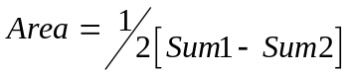
Another procedure for determine area through a loop traverse coordinates is by multiplying its abscissa and ordinates in cross way on follow:
Note: the traverse stations are listed sequentially and that the first station (station1) is listed sequentially and that the first station (station 1) is listed both at the beginning and at the end. Then by numbering the traverse stations sequentially in a clockwise direction

Adjust the quadrilateral ABCD by dragging any vertex. The area is calculated using this method as you drag. A detailed explanation follows the diagram
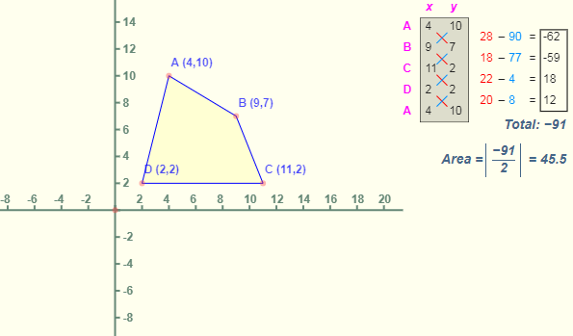
Figure:2.19.Area by coordinate
Example
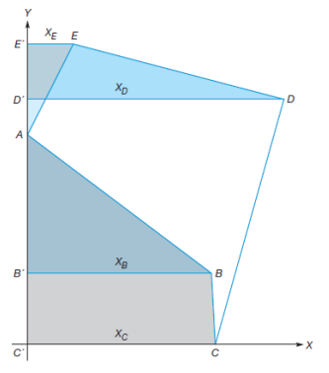
Figure:2.20. Area by coordinate

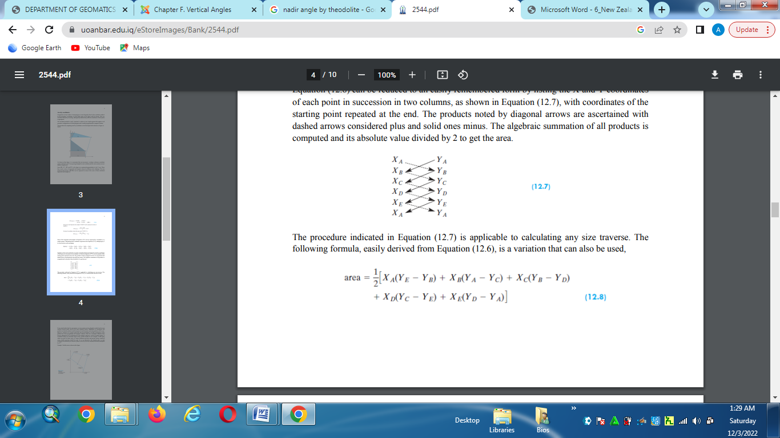
Figure:2.21. Area by coordinate
I. Distance calculation from coordinate
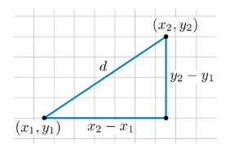
Figure:2.1. Distance from coordinate
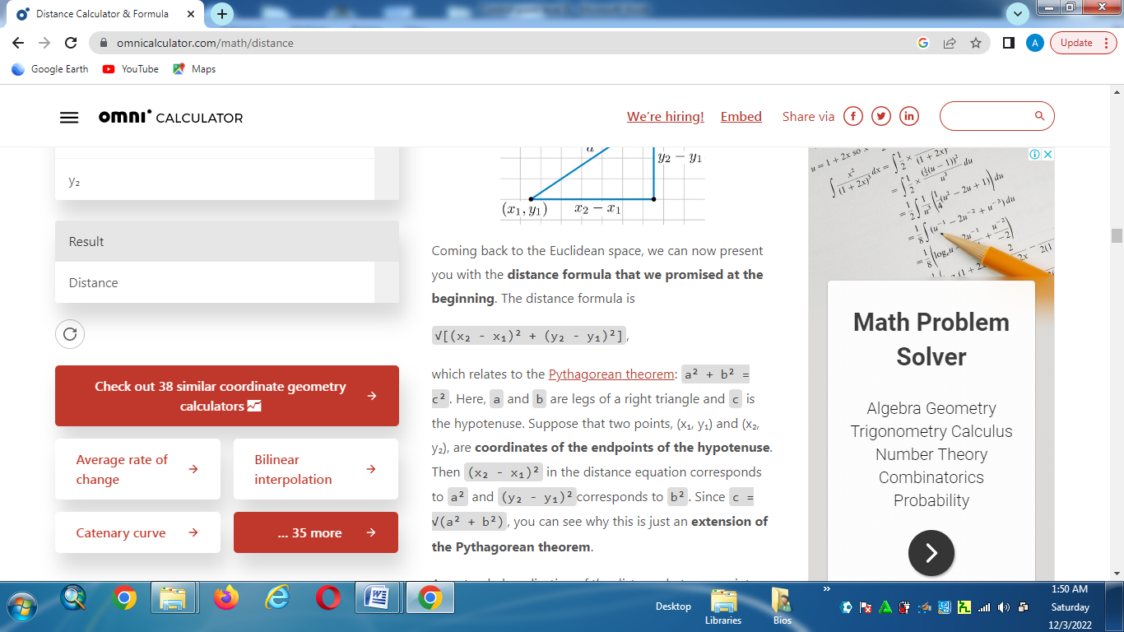

II. Azimuth calculation from coordinate

2.7.2.Area Computation by meridian system

Exercise1
Given data:
Point | Easting | Northing
46  156  257  258 | 78291.06  78862.87  79250.45  79470.58 | 803.44  129.23  88.68  191.87

measured:
from | to | Distance
257  311  312 | 311  312  156 | 108.33  132.55  154.31

Station | Target | Direction (GRAD)
257  311  312  156 | 258  311  257  312  311  156  46  312 | 0.000  250.417  0.000  183.276  0.000  190.542  0.000  141.082
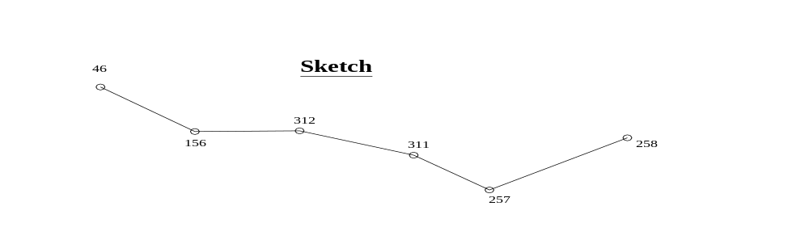
Wanted: Computation of the closed-route traverse from point 257 to point 156.
Exercise 2:
Adjust the following closed-route traverse and compute the coordinates of the traverse stations A, B, C, D and E.
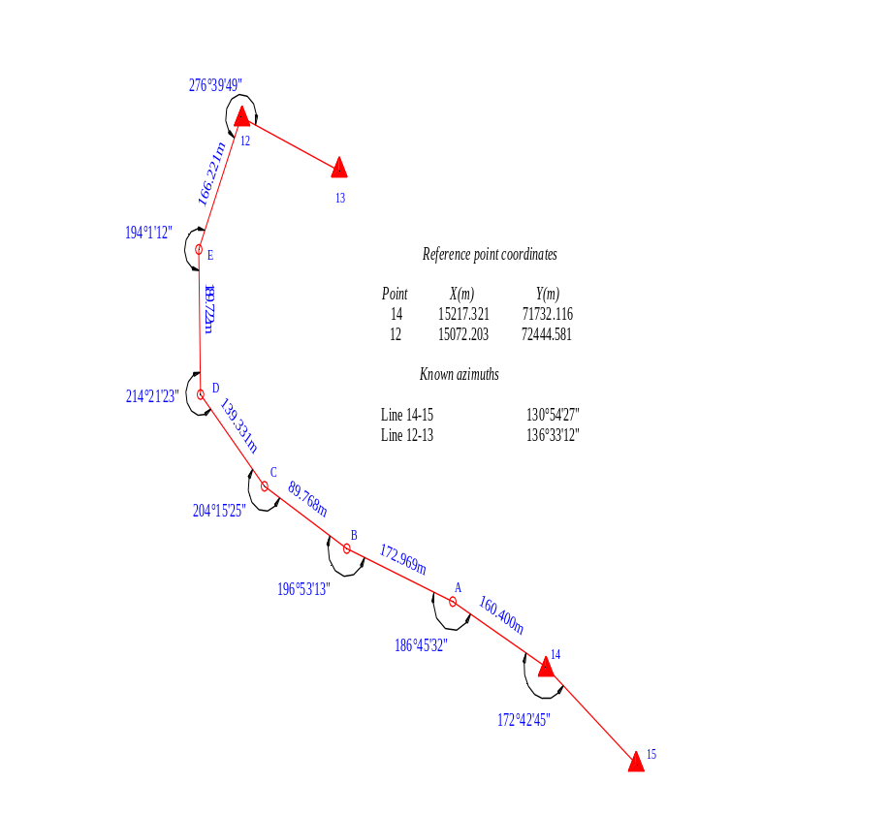

Exercise 3:
Adjust the following closed-route traverse and compute the coordinates of the traverse stations B, C, D and E.
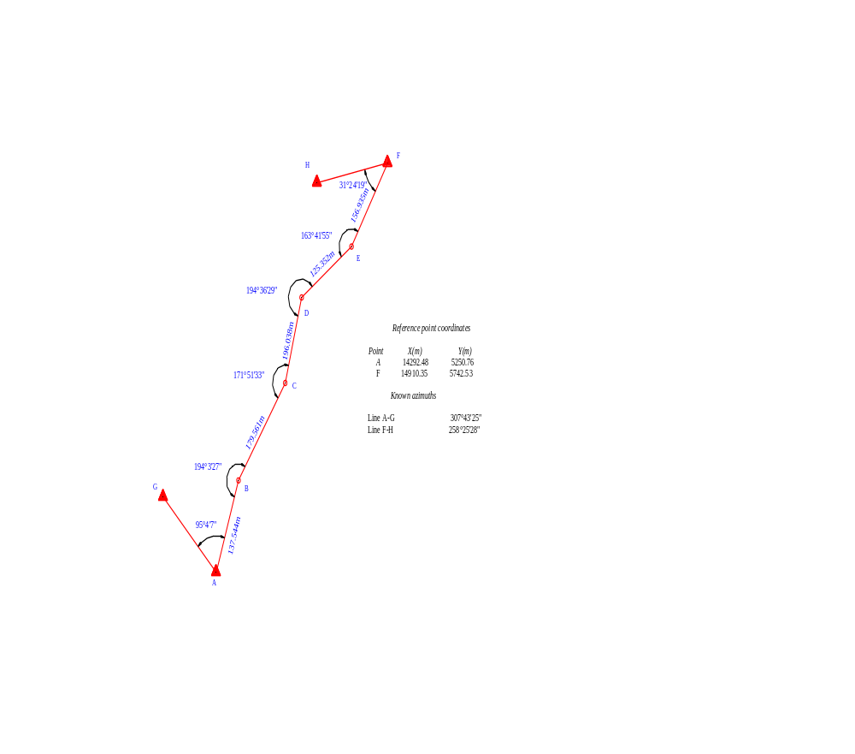Exercise 4
The sketch below shows a link traverse with its measured traverse angles and already reduced distances. Adjust the link traverse, do all necessary checks and compute the final coordinates. The entire computation has to be done in the respective computation table!

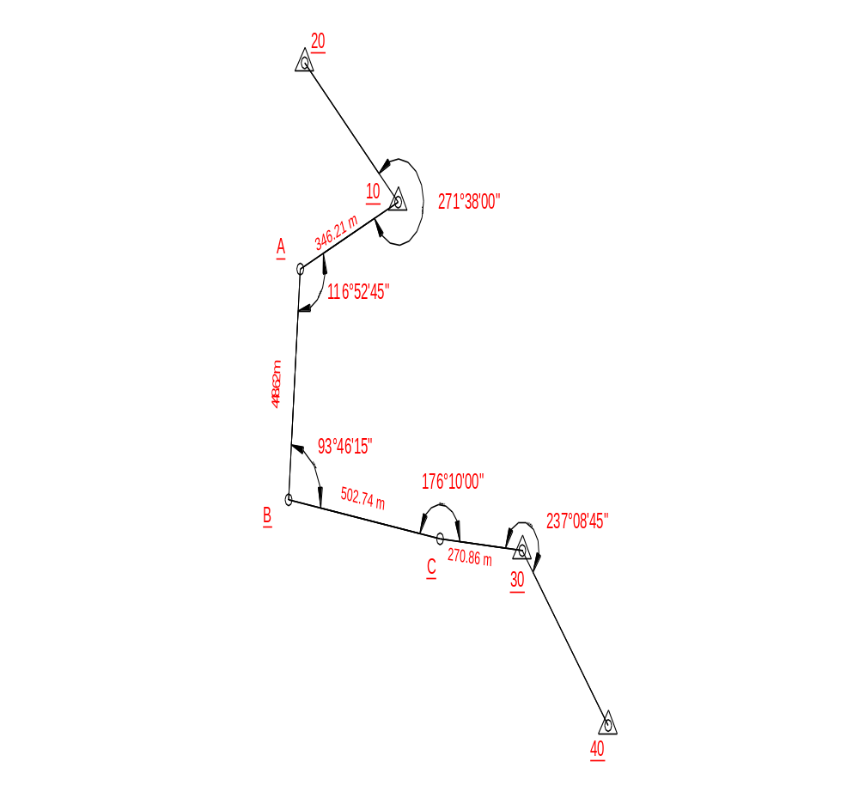

given coordinates and azimuths:
point easting[m] northing[m]
10 1000.00 1200.00
30 1407.36 524.85
Azimuths
from 20-10 156°'45"
from 30-40 151°57'00"

Self check Two | Written test

Self check-2
Test-I Matching
Instruction: select the correct answer for the give choice. You have given 1 Minute for each question. Each question carries 2 Point.
A B
1.Azimuth A. Azimuth and Bering are equal
2. Station B. The value is less than 90⁰
3.Bering C. Starting from north
4. Back azimuth D. The Theodolite is set up on
5.Quadirant one E. 180⁰
Test II: short Answer writing
Instruction: write short answer for the given question. You are provided 3 minute for each question and each point has 5Points.
1. The value of back azimuth and forward azimuth is _____________
2. The value of azimuth do to north is _______________
3. If the traverse station is starting and terminating is the same it is _________________Traverse
Part III: Short answer writing
Direction: Give short answer to the following questions. Time allotted for each item is 2mniut and each question carry 4 point.
1. What is Traverse.
2. List and describe types of traverse.
3. What is the difference between azimuth and bearing .
5. There are two types of close traverse you can describe it.
Note: Satisfactory rating – above 60% Unsatisfactory - below 60%
You can ask you teacher for the copy of the correct answers

Operation sheet one | Traverse computation
- Operation title: Traverse computation
- Purpose: To calculate coordinate
- Instruction: Using below operation sheet
- Tools and requirement:
1.Theodolite
2.Tape
3.Compass
4.Range pole
5.Page
6.Calculator
7.Paper
8.Pancel
- Steps in doing the task
1.Reconnasance the project aria .
2.Draw free hand sketch .
3.Sellect equipment, tools and material for collecting data.
4.Maesure maximum horizontal distance .
5.Maesure maximum horizontal angle.
6.Maesure minimum azimuth.
7.Maesure minimum coordinate.
8.Calculate the required coordinate
- Quality Criteria: Measure angle and distance accurately.
- Precautions: use digital Theodolite

LAP test one | Practical Exercise

Task 1. Calculate coordinate of each point.
Given
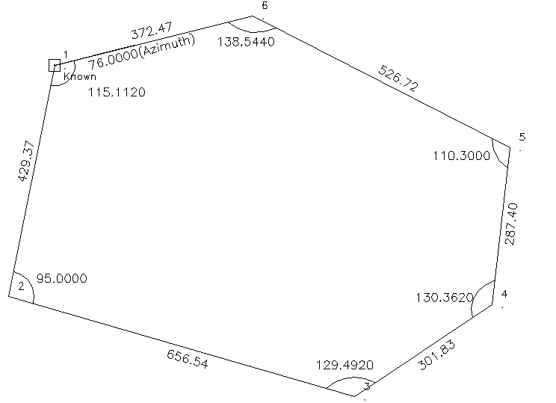
Coordinate 1. X =1000 Y= 1000
2. 1-2 =76⁰
Required Calculate azimuth
" Coordinate by traverse method

UNIT THREE: Triangulation.
This unit to provide you the necessary information regarding the following content coverage and topics:
- Introduction of Triangulation
- Triangulation satiation
- Establishing monuments
- Measuring angles and base lines
- Computing triangulation
This guide will also assist you to attain the learning outcomes stated in the cover page. Specifically, upon completion of this learning guide, you will be able to:
- Describe triangulation
- Apply placing construction monuments
- Measure angles

3.1. Introduction Triangulation
Triangulation is consists of a series of joined or overlapping triangles in which an occasional line (called the base line) is measured and all other sides of the triangles are calculated from angles measured at the vertices of the triangles. The lines of a triangulation system form a network that ties together all the triangulation stations at the vertices of the triangles. A triangulation has the following advantages:
- More redundancies or checks are available i.e more than one route can be followed to compute the length of a line.
- There is little tendency for the system to sway or bend i.e azimuths can be easily and accurately carried or established throughout system.
- Outstanding landmarks such as steeples, water tanks, etc can be located by establishing directions from different stations.
Its disadvantages are it needs long-range intervisibility, which in turn requires the erection of special towers and signals, making the system the most expensive. Moreover, a good weather is required to attain intervisibility.
Unlike triangulation, it is not easy to position transmission towers, steeples, water tanks, etc. by the EDM because to do so requires reflectors on these landmarks. These landmarks can be located if angular measurements are made to them.
In combined triangulation and trilateration systems all sides and angles in the joined or over lapping triangles are measured. This method provides the strongest control network.
Triangulation as a form of horizontal control is applied when a large area is to be surveyed and when the methods of traversing would not be expected to maintain a uniformly high accuracy over the entire area. The methods of triangulation require a maximum number of precise angle measurements and a minimum number of distance measurements. The triangles are developed in to a net of interconnected figures, and certain lines, called base lines, must be measured in order to compute the other sides in the net.
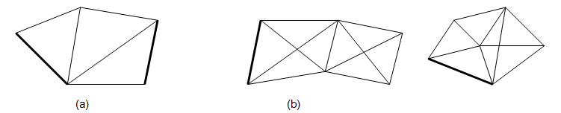
Figure:3.1 Triangulation
Triangulation is necessary to control the location of large bridge structures, state and federal highways, dams, canals, and other engineering works of a massive nature. A large project, such as boundary location, power development, water resources development, flood control, irrigation, or reclamation, requires triangulation in order to maintain the necessary accuracy throughout the system.
Once a triangulation system, whether large or small, has been developed, measured and adjusted, the points in the system then furnish control for subsequent traversing, minor triangulation, trilateration, intersection, and resection needed for day-today engineering operations.

3.2. Triangulation stations
The points forming the triangulation stations are selected on the basis of visibility as for example on the top of hills or church steeples, or radio towers, or water tanks. As a result, the points are not uniformly spaced. Some of the points are obviously inaccessible and it is necessary to establish eccentric stations from them and to determine the distance and direction s from the main stations to the eccentric stations.
Sometimes it is necessary to build special towers for making the observations. These towers contain one tower built inside another so that the towers supporting the instrument operator are independent.
For triangulation of lower accuracy, a small pole signal about 2m high guyed in place, or an object already in place might be used for sighting. As most triangulation works of higher accuracy are carried out between late afternoon or an automobile headlight may be used as signal. Signals should be free from phase.
In general, the types of signal used depend on the length of the line accuracy required whereas its form depend s on the locality and availability of materials.
Triangulation stations should be marked and referenced very carefully for use at later days. The signal used must permit centring the instrument if the station is to be occupied
(for instance, an iron pipe set vertically so that a pole can be inserted in to it for sighting and this pole can be removed when centring the instrument over the station).
When towers are required due to flat terrain, heavy timber or other factors, it is necessary to determine the minimum height of the towers required from the equation for the earth’s curvature and atmospheric refraction.
Example :
Determine the height of a tower to permit seeing the surface of the earth at a distance of 10 km.
Solution
h
d
Figure:3.2 Triangulation station
h=0.0675d² where d is the distance in km
h is the height of the tower in m.
h = 0.0675 * (10)² = 6.75m

3.3. Establishing monuments
Triangulation can be used for:
1. The establishment of accurately located control points for surveys of areas.
2. The accurate location of engineering works such as the location of large bridge structures, state and federal highways, dams, canals, tunnels, and others in order to maintain the necessary accuracy throughout the system.
3. The establishment of accurately located control points in connection with aerial surveying.

3.4. Measuring angle and base line
- Base line measurement
Since the computed sides of triangulation system can be no more accurate than the baselines, every precaution to ensure accuracy is taken in measuring these lines. The length of any baseline is determined primarily by the desirability of strong figures in the net. Ordinarily, the longer the baseline , the easier it will be found to secure strong figures. Short baselines are connected to the triangulation system through a base net.

Fig.3.3 Base net
Because of errors in angular measurements, the accuracy of the computed lengths will decrease as the distance from the baseline increases. On extensive triangulation the accuracy is maintained by measuring additional base lines.
Base lines can be measured either by tapes or by EDM equipment. For measurement of higher precision, invar tape is always used. Some of the activities required while taping are:
- Clear obstructions along the baseline;
- Setting stakes on line at distances apart equal to the length of the tape to be used;
- Fastening copper stripes to the top of these stakes for making the tape lengths;
- Providing support for the tape;
- Running levels to determine difference in elevation where required;
- Recording field temperature and pull and applying systematic corrections; etc.
Once systematic corrections have been applied to the measured lengths, the remaining step is to reduce all the triangle lengths to equivalent sea level distances in all extensive triangulation surveys.
In the figure, A and B are two points on the earth’s surface at an average elevation of h above sea level. Since the lengths of the arcs are proportional to their radii,
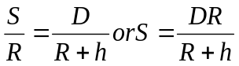
Where S= sea level length, m
Fig 3.4 Reduction to sea level D = measured length at average elevation of h above sea level
R=6,372,200m
Example
The elevation of measured base line is 540m above mean sea level. The recorded length of the base line is 1035.407m. Compute the length of the base line at sea level
Solution
S = RD / (R+h)
= (6372200* 1035.407) / (6372200+540)
= 1035.319m
- Angle measurement
The instruments to be used for measuring angles for triangulation depend on the accuracy desired in locating the positions of the triangulation stations. If first-order work is desired, directional theodolites should be used with which directions can be read directly to 0.2”. For second-order work, it is necessary to use instruments capable of being read to 1”. For third –order triangulation, engineer’s transits that can be read to 20” or 30” may be used if the angles are measured by repetition.
When the directional theodolites is used, it is set up over a particular station and pointed to each of the desired stations. For first-order triangulation the set of readings is repeated from 8 to 16 times , while for second order work they are repeated from 4 to 8 times.

3.5.Computing triangulation
Before the length computation begin, it is necessary to make triangulation adjustments.

2.5.1.Adjustment of Chain of Single Triangles
When chain of single triangles are used, it is necessary to make the following adjustments.
- Station adjustments: the sum of the angles around each point should exactly be 360⁰.
- Figure adjustments: the sum of the angles in each triangle should exactly be 180⁰.
For the angles about a point the difference between the sum of measured angles and 360⁰ is balanced equally between the numbers of angles.
In the same fashion the difference between the sum of the measured angles in each triangle and 180 is balanced equally between the angles.
Example
- For the triangles shown, the measured angles are given . Make station and figure adjustment to the angles.
A
2
1
3
5
4
B
C
8
7
6
9
10
D
Measured angles
- 41 16 10
- 53 33 20
- 265 07 45
- 91 16 10
- 268 43 30
- 35 07 00
- 78 42 30
- 246 11 00
- 60 01 05
- 249 59 15
solution
  - station adjustment
Station | angle | measured | adjusted
A | 1 | 41 16 10 | 41 16 05
A | 2 | 53 36 20 | 53 36 15
A | 3 | 265 07 45 | 265 07 40
A | ∑ | 360 00 15 | 360 00 00
B | 4 | 91 16 10 | 91 16 20
B | 5 | 268 43 30 | 268 43 40
B | ∑ | 359 59 40 | 360 00 00
C | 6 | 35 07 00 | 35 06 50
C | 7 | 78 42 30 | 78 42 20
C | 8 | 246 11 00 | 246 10 50
C | ∑ | 360 00 30 | 360 00 00
D | 9 | 60 01 05 | 60 00 55
D | 10 | 299 59 15 | 299 59 05
D | ∑ | 360 00 20 | 360 00 00
  - Figure Adjustment

Triangle | angle | Angle value after station adjustment | Angle value after figure adjustment
ABC | 2 | 53 36 15 | 53 36 27
ABC | 4 | 91 16 20 | 91 16 32
ABC | 6 | 35 06 50 | 35 07 01
ABC | ∑ | 179 59 25 | 180 00 00
ACD | 1 | 41 16 05 | 41 16 18
ACD | 7 | 78 42 20 | 78 42 34
ACD | 9 | 60 00 55 | 60 01 08
ACD | ∑ | 179 59 20 | 180 00 00

N.B. give the larger correcting factor, to large measured angle.
Check the station
A= 1 + 2 + 3 = 360⁰ 00’ 25’’
Adjust angle 3 =265⁰ 07’ 40’’ – 00⁰ 00’ 25’’ = 265⁰ 07’ 15’’

3.4.2 Adjustment of a quadrilateral
When a chain of quadrilaterals are used, there are two condition which must be satisfied.
- Geometric condition: the sum of the interior angles must equal to (n-1)*180⁰ ; where n is the sum number of sides of the figure.
- Trigonometric condition: The sine of each angle must be proportional to the opposite side of that triangle.
Consider the diagram below;
a
b
c
d
e
f
g
h
Base line
A
D
Let AD be the base line and angles a to h be measured angles.
A. Adjustment of quadrilateral by approximate method
- Geometric condition
- the sum of interior angles of a triangle should be 180⁰.
For ABC ; a + b + c + d = 180
For BCD; c + d + e + f =180
For ABD; a + b + h + g =180
For ACD ; h + g + f + e = 180
- The sum of interior angles of quadrilateral should be 360⁰.
a + b + c + d + e + f + g + h = 360
- The sum of opposite angles ( at the intersection of the diagonal) should be equal.
a + b = e + f
c+ d = g + h
- Trigonometric condition
Log { (sin a) ( sin c) ( sin e) ( sin g ) } – log{ ( sin b)( sin d)( sin f)( sin h)} = 0
Logsina+ Logsinc+ Logsine+ Logsing = Logsinb + Logsind + Logsinf + Logsinh
This geometric condition to be satisfied for quadrilateral adjustment
Steps in the adjustment of quadrilaterals
- Correct each of the eight angles so that their sum will be exactly 360.
- Adjust the vertically opposite angles so that their sum should be equal.
- Record the log sines for every alternate angles
- For each angle record the tabular logarithmic sine difference for 1” opposite each logarithm.
- Find the average required change (α ) in log sines by dividing the differences between the sums by eight.
- Find the average difference (β) for 1”.
- The ratio of (α/β) gives the number of seconds or arc to be applied as a correction . this correction is added to each of the four angles whose sum of log sines is the smaller and subtracted from each of the other four angles whose sum of log sines is the larger, and thus the correct value of angles are obtained.

Example
1.Make the necessary adjustment for the following quadrilaterals.
Measured angle
a = 38 44 06
b = 23 44 38
c = 42 19 09
d = 44 52 01
e = 69 04 21
f = 39 37 48
g = 26 25 51
h = 75 12 14
∑ = 360 00 08
b
c
d
e
f
g
h
a
A
D
B
C

Solution
Step 1. Diff. = 08” correction = 08”/8 = 1”
Step 2. b + c = 66⁰ 03’ 45’’
F + g = 66⁰ 03’ 37’’
= 08”/4 = 02” (angle f and g should be increased by 2” and angle b and c are decreased by 2” )
a + h = 113⁰ 56’ 18’’
d + e = 113⁰ 56’ 20’’
02”/4 = 0.5” ( add 0.5” to a and h and subtract from d and e
step 3. compute the log sines for every alternative angles.
Log sin a = -0.203621777 log sin b = -0.395087669
Log sin c =-0.17182419 Log sind = -0.15152906
Log sin e = -02963892 log sin f = -0.195294325
Log sin g = -0.35152145 log sin h = -0.014645342
Step 4. Compute the logarithmic sine difference for 1”
Log sin (a + 1”) - Log sin a = 2.6*10⁻⁶
Log sin (c +1”) - Log sin c = 2.3*10⁻⁶
Log sin (e + 1”) - Log sin e =0.9*10⁻⁶
Log sin (g + 1”) - Log sin g = 4.3*10⁻⁶
Log sin (b + 1”) - Log sin b = 4.8*10⁻⁶
.etc
step 5
7.2434434 – 7.2433935 = 49.9 * 10⁻⁶
therefore α = (49.9 * 10⁻⁶ ) / 8 = 6.24 * 10⁻⁶
step 6
β = 20.2 * 10⁻⁶ / 8 = 2.53 * 10⁻⁶
step 7
β = 6.24/2.53 = 2.47”
Correction: add 2.47” to all angles whose sines of log sine is smaller ( i.e for angles a, c, e and g ) & vice-versa( subtract 2.47” from b, d, f, and h )
Note : If the corrections are properly applied, the sum of the log sines of the corrected angles will agree with in 1 or 2 in the last 7th decimal place.
3.5.2. Adjustment and computation of a centre-point triangle
B 3 4 S
2 5
8
7 9

1 6
F
Figure:3.3. Adjustment centre-point
The procedure for solving the centre point triangle is as follows:
  - the angles in any triangle must sum to 180⁰ . (i.e.4+3+8=5+9+6=1+2+7=180⁰)
  - the angles at the centre station must sum to 360 without altering any previous adjustment . (i.e 8+9+7=360⁰)
  - the side condition :
Log sin 1 Log sin 3 Log sin 5=Log sin2+ Log sin4+ Log sin6

3.5.3. Eccentric Stations (Reduction to centre)
In the measurement of triangulation angles it often is not possible to centre a theodolite over a station directly below the target (church spire, lighthouse), which makes direct angle measurement equally difficult or impossible.
A field procedure that can be adopted to obtain angles at the spire or other mark is to set the theodolite at a point as near as possible to the spire. From this eccentric station, angles are observed to all points in the network as if the inaccessible point (spire) itself was being occupied.
Since the angles observed at the eccentric station will be slightly different to those, which would have been observed at the inaccessible or main station. In computing the corrections to be applied to the measured angles or directions, the simplest method is to calculate first the directions of the lines with respect to the line between the eccentric station and the true station as a meridian. Corrections are applied to the measured angles to give those applicable to the main station. This correction procedure is known as reduction to centre.
M
Y

e₂ e₁

C

E ₁

2
Figure:3.4. reduction to centre.
In figure above, stations C ,Y and M are triangulation stations, station C being inaccessible. At the eccentric station E, the directions to C,Y and M are observed and the distance EC measured. This distance should be as small as possible and measured as accurately as possible. The observed directions to Y and M are converted to their equivalents at station c by applying corrections e₁ and e₂.
In the triangle ECY,
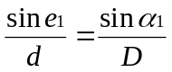
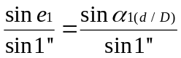
e₁’’ = 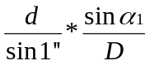
The value of L is not known but its approximate value can be taken as EY and EM which is obtained by a preliminary computation of the triangles using E as the triangulation station.
The sin of the correction is given by sin₁ and if the ratio d/D < 1/140 the formula cannot be used, but the ratio is not likely to be less than this in practice.
Therefore;
e₁ = 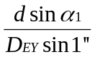 and e₂ = 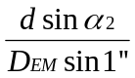
So that;
Direction CY = direction EY + e₁
Direction CM = direction EM + e₂
Angle MCY in main triangulation scheme
= direction CY – direction CM
= direction EY + e₁ – (direction EM + e₂)
Example
At inaccessible station B in a triangulation network an eccentric station E was set up nearby in order to obtain angle ABD. The following measurements were taken:
D_{AE} = 7335m AED = 95⁰16’40.52”
D_{DE} = 5556m DEB = 169⁰27’47.18’’
B

E
D
A

Solution
Converting the observed angles taken at E into clockwise directions gives, with direction EB as a reference direction:
ED = 169⁰27’47. 18’’ = ₁
EA = 169⁰27 47.18’’ + 95⁰16’40. 52’’
= 264⁰44’27. 7’’ = ₂
Reduction to centre
Station A D
Distance 7335m 5556m
264⁰44’27.7’’ 169⁰47’27.7’’
sin -0.99579 +0.18287
d/sin1’’ 1.349 *10⁶ 1.349 *10⁶
e -183.14’’ +44.40’’
angle AED = direction of BA - direction BD
= direction of EA + e₁ – [direction of ED + e₂]
= 264⁰44’27. 7’’ - 0⁰3’3.14’’ – [169⁰27’27. 7’’ + 44.40”]
= 95⁰13'12.46''

3.5.3. Computation of lengths
Two sides of each triangle are computed by using the law of sines, since one side of the triangle is always known and the three angles have been measured and adjusted. In computing the sides of the triangles in a quadrilateral, such as that in fig. below, the solutions of two triangles is sufficient to compute the positions of the forward triangulation stations. The two triangles chosen must be the strongest route through the quadrilateral.

a = 63⁰17'28.12''
b = 84⁰18'20.37''
c = 17⁰52'26.69''
d = 30⁰41'16.98''
e = 47⁰07'55.96''
f = 66⁰35'55.30''
g = 35⁰34'51.76''
h= 14⁰31'44.82''
C

D f
g e

h

Figure:3.5.Trangulation length computation
In the figure above, the side AB is the known or measured line of the quadrilateral, and the strongest route is obtained by considering triangle ABC and triangle DAC in that order. To check the accuracy of the fieldwork or the consistency of the figure adjustment, the two triangles ABC and triangle BDC can be computed in that order. This computation gives a check on the length of the side CD, which is the forward side of the quadrilateral. However, only the result for the strongest route will be used in the further computations.
If the coordinates of stations A and B are known, the length of line BA computed by:
D_{AB} = [ (E_{B} - E_{A})² + (N_{A} - N_{B})² ]^{1/2}

If E_{A}=1,442,416.25 N_{A}= 622,516.21 &
E_{B}=1,445,317.844 N_{B}=621,754.14
D_{AB}= 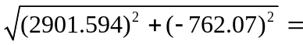3000.000m
With the side AB known, the sides AC and CB are computed by using the law of sines.
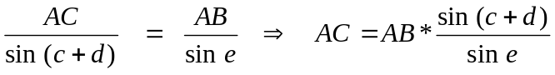
Also,
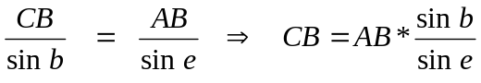
the line CA = AC is then used as the starting side of triangle DCA.
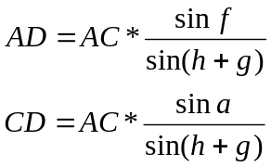
Computation of lengths in triangles
Sides Stations Angles Adjusted angles Distances
Triangle ABC
AB 3000.000
C e 47⁰07'55.96'' 0.73292548
B c+d 48⁰33'43.67'' 0.74967381
A b 84⁰18'20.37'' 0.99506538
180⁰00'00.00''
AC 3068.554
CB 4072.987
Triangle CAD
CA 3068.554
D h + g 50⁰06'36.58'' 0.76727890
C f 66⁰35'55.30'' 0.91774558
A a 63⁰17'28.12''
AD 3670.311
CD 3572.554

3.5.4. Coordinate calculations
A) Computation of Azimuths
If the coordinates of stations A and B are known, the azimuth from north of the line AB is determined by:
tan A_{AB} = 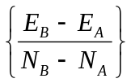
A_{AB} = tan⁻¹
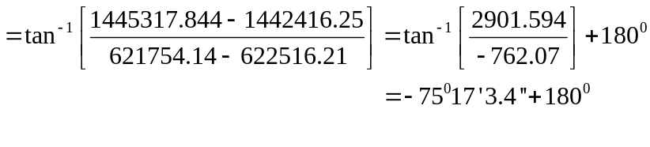
A_{AB} = 104⁰42'56.6''
Azimuth of AB = 104⁰42'56.60'' Azimuth of BA = 284⁰42'56.60''
-b = -84⁰18'20.37'' +(d + c) = + 48⁰33'43.67''
Azimuth AC = 20⁰24'36.23'' azimuth of BC = 333⁰16'40.27''
-a = -63⁰17'28.12'' azimuth of CA = 200⁰24'36.23''
Azimuth AD = 317⁰07'08.11'' + angle f = + 66⁰35'55.3''
Azimuth of CD = 267⁰00'31.53''
- azimuth CB = -153⁰16'40.2''
( f + e) = 113⁰43'51.2'' (check)
B) Position Computation
The coordinates of all the stations throughout the triangulation system are computed by using the strongest route of triangles in the network. When a station is reached whose coordinates are fixed, the positions of the intermediate stations can then be adjusted. If the triangulation system is of great extent and high precision, this adjustment should be made by application of the least-squares principle. If the system is moderate in extent, an application of the compass rule will give highly satisfactory results. In this case a traverse extending from one fixed point to another fixed point and including all the intermediate triangulation stations is selected in as direct a line as possible. This traverse is then adjusted by the compass rule.

Operation sheet two | Triangulation computation
- Operation title: Triangulation computation
- Purpose: To calculate coordinate
- Instruction: Using below operation sheet
- Tools and requirement:
1.Theodolite
2.Tape
3.Compass
4.Range pole
5.Page
6.Calculator
7.Paper
8.Pancel
- Steps in doing the task
1.Reconnasance the project aria .
2.Draw free hand sketch .
3.Sellect equipment, tools and material for collecting data.
4.Maesure minimum horizontal distance .
5.Maesure maximum horizontal angle.
6.Maesure minimum azimuth.
7.Maesure maximum coordinate.
8.Calculate the required coordinate
- Quality Criteria: Measure angle and distance accurately.
- Precautions: use digital Theodolite

LAP test two | Practical Exercise

Task 1. Calculate coordinate of "C" by triangulation method
Given
1.Angle "A" =58⁰40⁰20⁰
2. " "B" =61⁰20⁰30⁰
3. " "C" = 60⁰00⁰02⁰
Coordinate A. X =1000 Y= 1000
B. X = 1040 Y =1030
Required Calculate azimuth of "AB" from coordinate
" distance of "AB" from coordinate
" Coordinate of "C"

UNIT FOUR: INTERSECTION
This unit to provide you the necessary information regarding the following content coverage and topics:
- Introduction of intersection
- Computing intersection
This guide will also assist you to attain the learning outcomes stated in the cover page. Specifically, upon completion of this learning guide, you will be able to:
- Describe intersection
- Apply placing construction monuments
- Measure angles

4.1.Introduction of Intersection
The horizontal control of a new point can be determined by measuring angles from two points of known coordinates. The method of intersection is applicable to situation in which a point is to be established in the net work of triangulation system. but the point is not occupied (i.e it is a point of no instrument set up.)
The horizontal control of a new point can be determined by measuring angles from two points of known coordinates. This process is called intersection.
The coordinates of A and B are known, to determine the coordinates of point M by measuring the angle a ά and as follows.
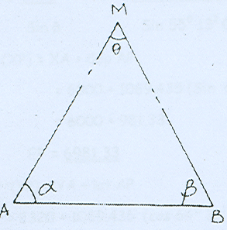
Figure:2.1

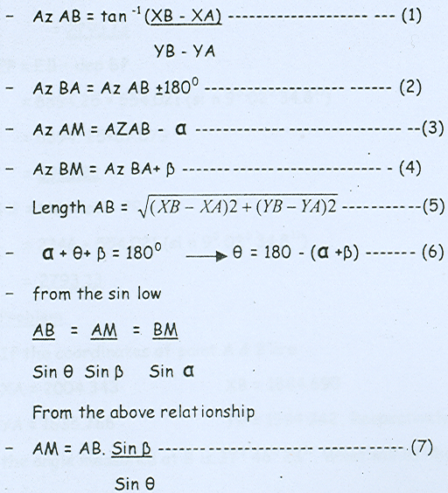
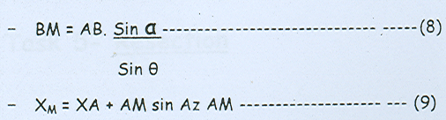
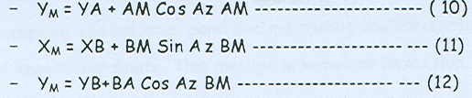

4.2.Computing Intersection
Exercise
Given that the coordinates of A are X;. 6000. Y= 2320 and of B are, X:6894 25, Y:2246. The angular measurements of a at A is 30° 28' 15" & e on B is 94° 18' 45" then compute the
Coordinates of point P
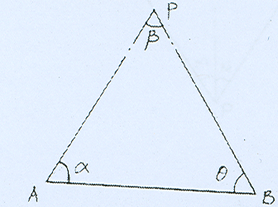
GIVEN
Point | X | Y
A | 6000.00 | 2320
B | 6894.25 | 2246

Station | Target | Direction
 | p | 0°00"00.
A | B | 30° 28'15"
 | A | 0° 00'00.
B | P | 94° 18'45.”

=94⁰18’45”
+=124⁰47’00
Azimuth AB =Tan⁻¹(XB-XA)/(YB-YA)
=Tan⁻¹(6894.25-6000)/(2246-2320)
=tan⁻¹(874.25)/(-74)=94⁰43’49.8”
Azimuth of BA=AzAB+180⁰=274⁰43’49.
Azimuth of AP=AZAB-a,94⁰43’49.8”-30⁰28’15”
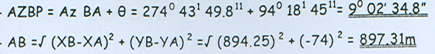
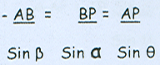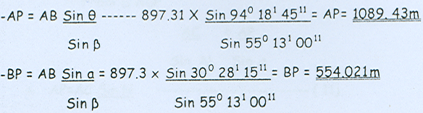

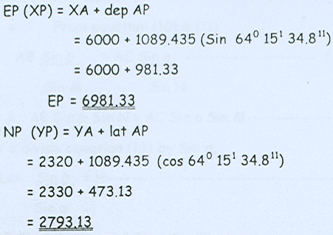

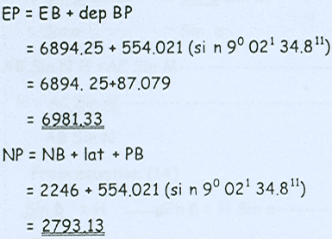

Operation sheet Four | INTERSECTION

- Operation title: Triangulation computation
- Purpose: To calculate coordinate
- Instruction: Using below operation sheet
- Tools and requirement:
1.Theodolite
2.Tape
3.Compass
4.Range pole
5.Page
6.Calculator
7.Paper
8.Pancel
- Steps in doing the task
1.Reconnasance the project aria .
2.Draw free hand sketch .
3.Sellect equipment, tools and material for collecting data.
4.Maesure minimum horizontal distance .
5.Maesure maximum horizontal angle.
6.Maesure minimum azimuth.
7.Maesure maximum coordinate.
8.Calculate the required coordinate
- Quality Criteria: Measure angle and distance accurately.
- Precautions: use digital Theodolite

UNIT FIVE: RE SECTION
This unit to provide you the necessary information regarding the following content coverage and topics:
- Introduction of resection
- Writing the description for station
- Establishing Resection
- Computing re section
This guide will also assist you to attain the learning outcomes stated in the cover page. Specifically, upon completion of this learning guide, you will be able to:
- Introduce to intersection & resection
- Establish intersection points
- Computing re section
- Identify resection references
- calculate station coordinates

5.1.INTRODUCTION OF RESECTION
Resection is a method of locating a point by taking angle observations from it to at least three known stations in a network. The situation is illustrated below:
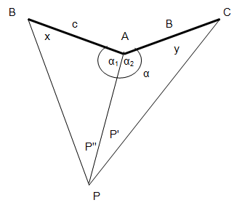
Figure:5.1 Resection diagram
Point P can be fixed by observing angles P'' and P' subtended at resection point P by control stations A, B, and C.
A summary of the method used to compute the coordinates of station P as follows:
- From the known coordinates of A, B, and C calculate lengths b and c, and angle α at station B.
- Subtract the sum of angles X, Y, and α in figure ABCP from 360⁰to obtain the sum of angles X + Y.
360⁰- (α + p' + p'') = X +Y
- Calculate angles X and Y using the following:
X+ y = 360 - (α + p' + p")
1/2 ( X + y)= 180⁰-1/2 (α + p'+ p")------------------(a)
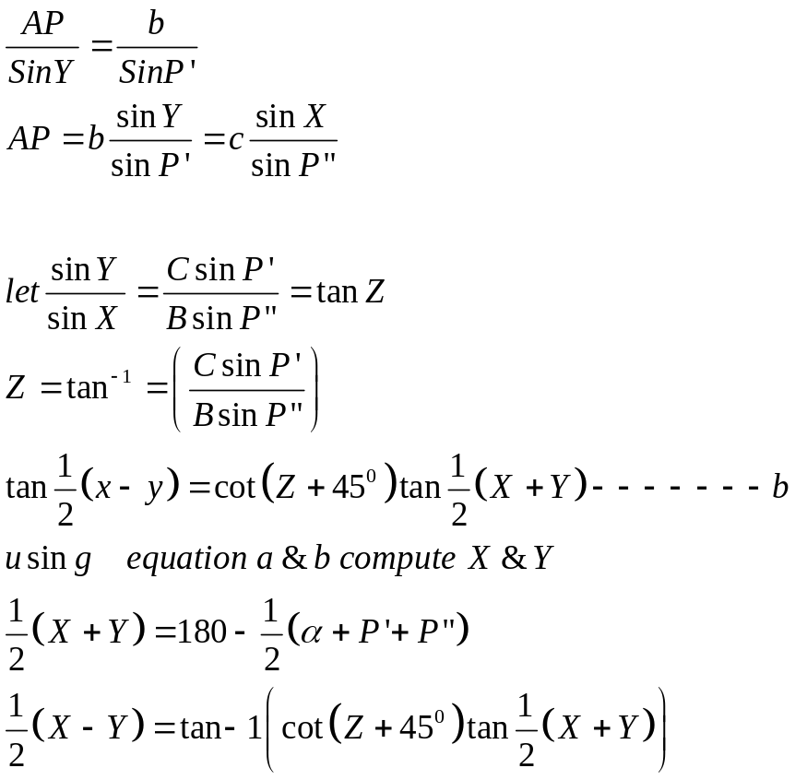
- From angles X and azimuth BA, calculate azimuth BP in triangle ABP. Then solve for length AP using the law of sines, where α₁=180⁰ - X - p''. Calculate the departure and latitude of BP followed by the coordinate of P.
- In the manner outlined in step 4, use triangle BCP to calculate the coordinates of P to obtain a check.

5.2. Writing the description for station
The task is mainly given remarks and descriptions for those control points of stations in order to have more clear information.
Writing description is making references to the X and Y values of the stations.
Some of the reasons for writing descriptions for stations are
- To find the Bench mark easily
  - To re- establish a bench mark which is destroyed during construction or maintenance.
Any reference that can be seen, well defined and exist able permanently such as concrete. or Metallic poles, concrete fences, buildi"9 corners etc can be used.
There are few points to be reminded during writing descriptions for stations.
1. The measured distance. should be horizontal.
2. The distance from station to reference points should not exceed 30 m.
3. The field book should be neat, readable and sequentially arranged, since the description for stations, reference points and others are being documented.

5.3. Establishing Resection
The method of Resection is a convenient way of determining the position of unknown point by occupying the unknown point and measuring the horizontal angles between at least.
Three points of known coordinates

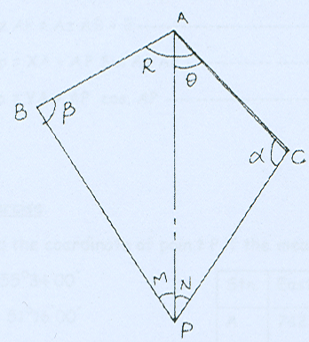
Figure:5.2 Resection diagram
The horizontal angles and coordinates of A, B & C are known, and the coordinates of a new point P are to be determined by measuring the angles M & N being the instrument is set up on point P
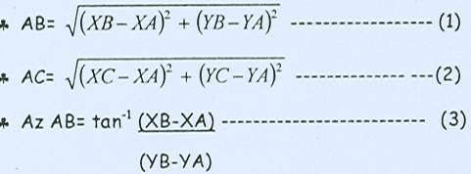

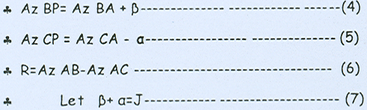
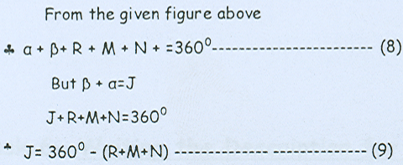
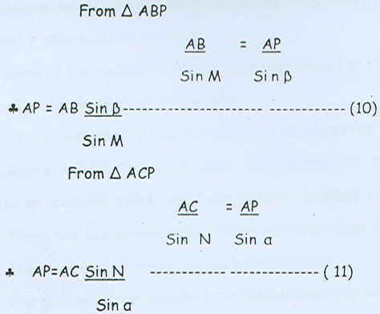

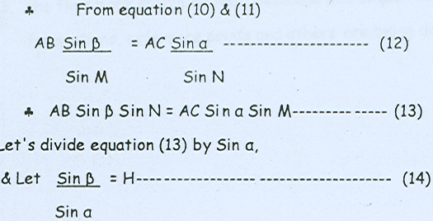
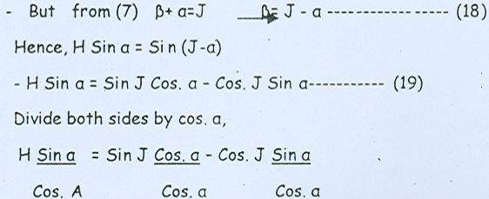
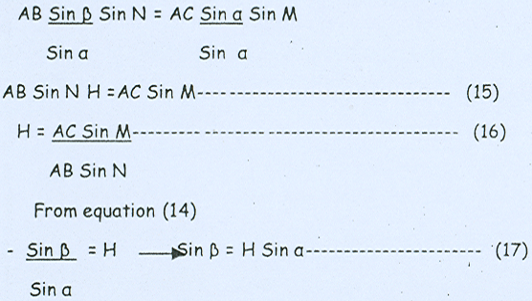

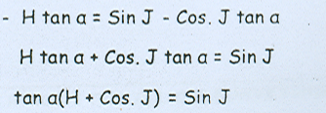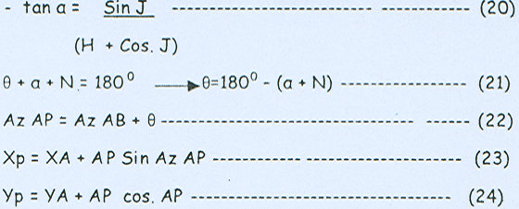
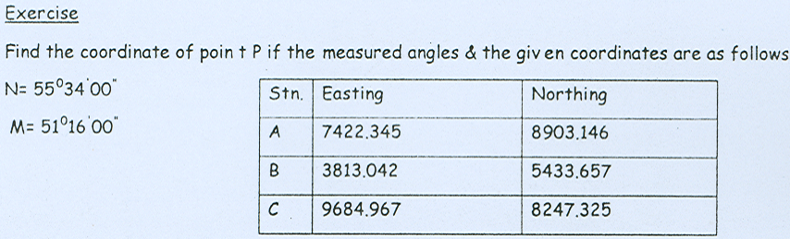

5.4. computing resection

Example
1. In the figure above, angles X and Y were measured.
P' = 30⁰42’37’’
P'' = 25⁰12’15’’
Coordinate points A, B, and C have coordinates (in metre) of:
X_{B} = 12750.000 X_{A} = 16820.540 X_{C} = 22190.788
Y_{B} = 10271.000 Y_{A} = 10105.772 Y_{C} = 11317.229
Calculate the coordinates of P.
Solution
- Compute b, c, and α
c = 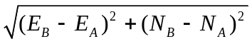
=
= 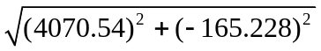
c = 4073.892
b = 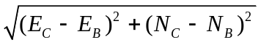
=
b = 5505.197
α = azimuth of AB – azimuth of AC
= A_{AB} - A_{AC}
A_{AB} = tan ^{–1}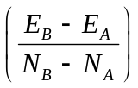
= tan ^{–1}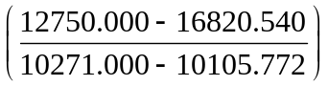 = 272⁰19’27. 9’’
A_{AC} = tan ^{–1}
= tan ^{–1}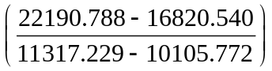 = 77⁰17’15. 43’’
α = A_{AB} - A_{AC}
= 272⁰19’27. 9’’ – 77⁰17’15. 43’’
= 195⁰02’12. 47’’
- Compute X + Y
1/2(X + Y ) = 360 – (α +p'' + p')
= 360 – (195⁰02’12. 47’’ +30⁰42’37’’ + 25⁰12’15’’)
= 109⁰02’55. 53’’
- Calculate X and Y
1/2 ( X+Y) =180⁰-1/2(α + P' + p")
=180⁰-1/2(195⁰02'12.47"+30⁰42'37"+25⁰12'15")
=54⁰31'27.76"
1/2(X-Y)=tan⁻¹[cot(Z+45⁰)tan1/2(X+Y)]
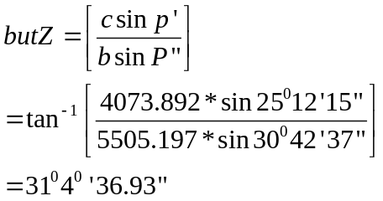
Z + 45 = 76⁰40'36.93"
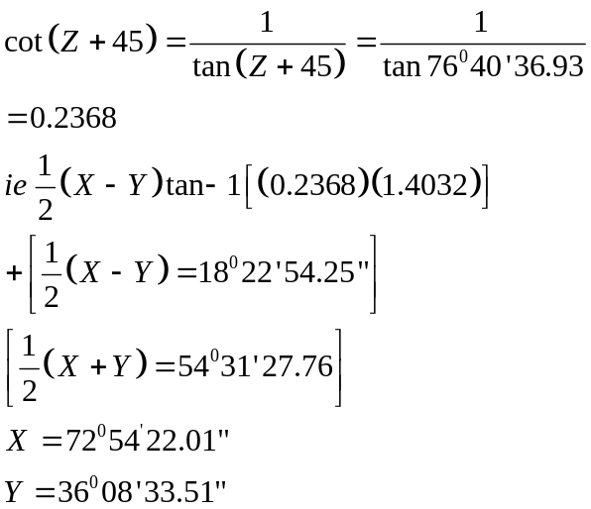
- Compute i) A_{BP,}ii) α₁ iii) BP iV) ∆X_{BP}and ∆Y_{BP} and finally iiv) X_{P} and Y_{P}
A_{BP} = A_{BA} + X
= 92⁰19'27.9'' +72⁰54'22'' = 165⁰13'49.9''
α₁ = 180 - A - P = 180 - 72⁰54'22'' - 30⁰42'37''=76⁰23'01''
BP = AB * sin76⁰23'01''/sin30⁰42'37'' = 7752.912m
∆X_{BP} = BP * sin A_{BP} = 7752.912 * sin 165⁰13'49.9'' = 1976.454m
∆Y_{BP} = BP * cos 165⁰13'49.9'' = -7496.751m
X_{P} = X_{B} + ∆X_{BP} = 12750 +1976.454 = 14726.454
Y_{P} = Y_{B} + ∆Y_{BP}= 10271-7496.751 =2774.249
- To check use triangle BCP.
Example
- The coordinates of two control points A and B are X_{A}= 602,105.32 and Y_{A}= 126,118.90m; X_{B}= 601,048.82m and Y_{B =} 125,613.48m. The clockwise angle at A from B to unknown point P is 52⁰18'46.2'';the counter clockwise angle at B from A to P is 37⁰28'16''. Compute the coordinates of P by intersection.
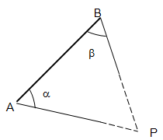
SOLUTION
α = 52⁰18'46.2'' and β = 37⁰28'16''
To compute coordinates of P , we should have to compute the azimuths of AP (A_{AP}) or azimuth of BP (A_{BP}) and length AP or BP.
Azimuth AP (A_{AP}) = azimuth of AB (A_{AB}) + A
Azimuth BP (A_{BP}) = azimuth of BA (A_{AB}) - B
A_{AB} = tan⁻¹ 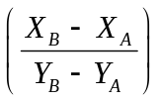 = tan ⁻¹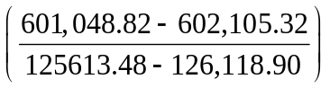 = 64⁰26'02.3'' + 180⁰
= 244⁰26'2.3''
A_{BA}= azimuth of AB +or - 180⁰ = 64⁰26'2.3''
A_{AB} = 244⁰ 26’ 2.3’’ A_{BA} = 64⁰26’2.3’’
+A = 52⁰18’46.2’’ - B = 37028’16.0’’
A_{AP} = 296⁰44’48.5’’ A_{BP} = 26057’46.3’’
Using the sine Rule
D_{BP} = D_{AB} * sinA/sinB and D_{AP} = D_{AB} * sin B/sinP
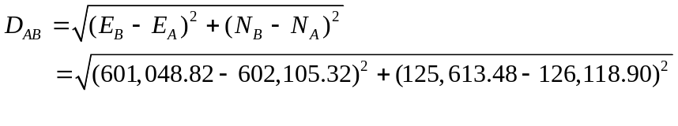
D_{AB} = 1171.171m
A + B + P =180⁰
52⁰18’46.2’’ + 37⁰28’16’’ + P =180
P = 90⁰12’57.8’’
D_{AP} = D_{AB} * sinB/sinP
= 1171.171 * sin 37⁰28’16’’/sin 90⁰12’57.8’’
= 712.500m
D_{BP} = D_{AB} * sin A/sinP
= 1171.171 * sin 52⁰18’46.2’’/sin 90⁰12’57.8’’
= 926.825m
The coordinates of P along AP can be computed as
E_{P} = E_{A}+D_{AP}*sin (A_{AP})
= 602,105.32+712.500*sin296⁰ 44’ 48.5’’
= 601,469.055
N_{P} = N_{A}+D_{AP}cos (A_{AP})
=126,118.90+712.500*cos296⁰ 44’ 48.5’’
=126,439.560
To check, compute along BP
E_{P} = E_{B} + D_{BP}*sinA_{BP}
= 601,048.82 + 926.825*sin26⁰ 57’ 46.3’’
= 601,469.054
N_{P} =N_{B}+D_{BP}cosA_{BP}
=125,613.48+926.825*cos26⁰ 57’ 46.3’’
=126,439.560
2) The coordinates in feet of three control points are as follows
Point Y X
A 98,202.66 38,762.50
B 110,002.65 61,252.84
C 89,102.32 78,565.12
- From an unknown point P₁ lying southerly from A, the clock wise angle from A to B is measured as 22⁰ 30’ 14.6’’ and that from B to C as 29⁰ 48’ 50.6’’
Compute the coordinates of P₁.
Answer
X_{p1} = 89781.053
Y_{p1} = 55772.609

Operation sheet two | computing resection

- Operation title: computing resection computation
- Purpose: To calculate coordinate
- Instruction: Using below operation sheet
- Tools and requirement:
1.Theodolite
2.Tape
3.Compass
4.Range pole
5.Page
6.Calculator
7.Paper
8.Pancel
- Steps in doing the task
1.Reconnasance the project aria .
2.Draw free hand sketch .
3.Sellect equipment, tools and material for collecting data.
4.Maesure minimum horizontal distance .
5.Maesure maximum horizontal angle.
6.Maesure minimum azimuth.
7.Maesure maximum coordinate.
8.Calculate the required coordinate

UNIT SIX: TRILATRATION
This unit to provide you the necessary information regarding the following content coverage and topics:
- Trilatration system
- Adjustment of measured distances
This guide will also assist you to attain the learning outcomes stated in the cover page. Specifically, upon completion of this learning guide, you will be able to:
- Identify trilatration
- Compute trilatration

6.1. TRILATRATION SYSTEM
A trilateration net work, like triangulation, may consist of a series of single triangles, braced quadrilaterals and centre point polygons or combinations of these but, unlike triangulation, the observed quantities are the distances not the angles.
The methods used in trilateration computations are very similar to those used in triangulation and proceed as follows.
- Using the measured or calculated baseline length and all the measured lengths, the angles in the network are calculated using the cosine rule. This is carried out by breaking down all the figures into their constituent triangles and proceeding as follows.
In triangle ABC of figure below, the angles are given by:
Cos α = 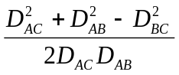

Cos β = 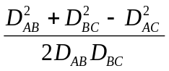

Cos γ =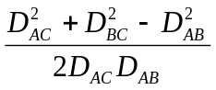
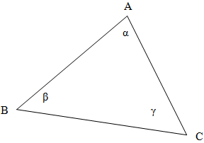

Figure:6.1 Trilatration diagram
- These computed angles are adjusted by the method discussed in adjusting triangulation systems.
- The strength of the figure of the system is evaluated.
- Starting at the baseline, all the lengths of the sides in the network are computed using the adjusted angles. In addition the bearings of all the triangle sides throughout the network are computed, again using the adjusted angles.
- The computed bearings and distances obtained in (4) are used to calculate coordinates throughout the network.
A disadvantage of trilateration is that, compared to triangulation, the number of geometric conditions for adjustment is less than that for equivalent figures.

6.2. ADJUSTMENT OF MEASURED DISTANCES
Before the lengths of the lines in the trilateration net can be used in any subsequent computations, their slope lengths determined by the instrument and corrected for atmospheric conditions must be reduced to the corresponding sea-level distance.
a) Reduction Of Slope Distance By Vertical Angles
The positive angle α and the negative vertical angle β are measured from stations A and B , respectively. The angle α is the refraction angle of the line of sight, assumed to be the same at both stations.

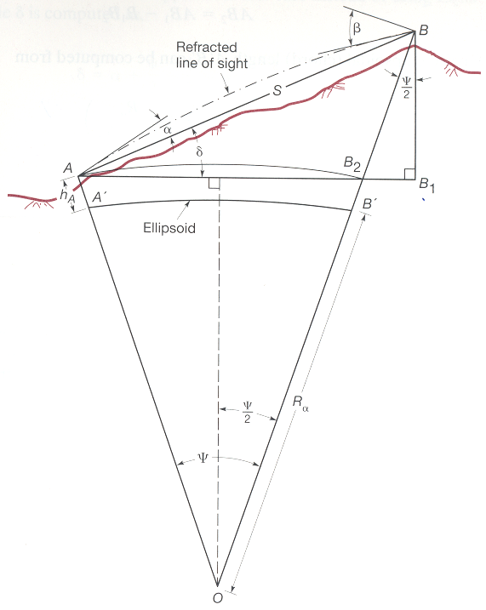

Figure:6.2 Slop distance
In the triangle AVB:
(β + α ) + (90 – ϕ) + [(90⁰- θ ) + α ] =180⁰
2 α = ϕ + θ – β
α = ϕ/2 – β/2 + θ/2
In the triangle ABB₁
Angle BAB₁ = θ – α + ϕ /2 = θ – (θ /2 – β/2 + ϕ/2) +ϕ/2
δ = BAB’= 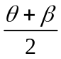
where θ is vertical angle at A and
β is vertical angle at B
AB₁= S cos δ
BB₁= S sin δ
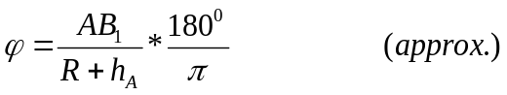
or the refraction angle α is 1/7 of the curvature;
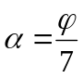
δ = θ - α + ϕ/2 = θ -ϕ/7 + ϕ/2
= θ + 5ϕ / 7
B₁B₂ = BB₁ tan (/2)
Finally, sea level (chord) length A'B' can be computed from
A'B' = AB₂ (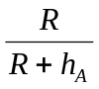) where h_{A} is the elevation of station at A.
Arc A'B' = Rϕ where ϕ is in radian
b) Reduction of Distance Observations Using Elevations
A procedure for reducing long slope distances to their ellipsoid lengths is discussed below:
Fig.

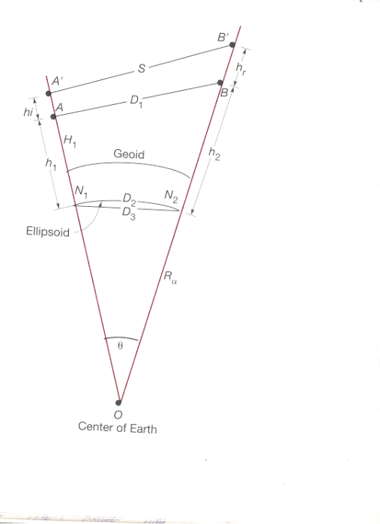
Figure:6.3.Slop distance in vertical

Operation sheet two | Practical Exercise
- Operation title: Triangulation computation
- Purpose: To calculate coordinate
- Instruction: Using below operation sheet
- Tools and requirement:
1.Tape
2.Compass
4.Range pole
5.Page
6.Calculator
7.Paper
8.Pancel
- Steps in doing the task
1.Reconnasance the project aria .
2.Draw free hand sketch .
3.Sellect equipment, tools and material for collecting data.
4.Maesure minimum horizontal distance .
5.Maesure minimum azimuth.
6.Maesure minimum coordinate.
7. Calculate all distance
8.Calculate the required coordinate
- Quality Criteria: Measure angle and distance accurately.
- Precautions: use digital Theodolite

LAP test | Practical Exercise
Task 1. Calculate all distance and coordinate by trilatration method
Given
Distance
A-B=25m
B-C=30m
C-A=28M
4. Azimuth AB is 110⁰
5. Coordinate A= X=1254 Y= 1428
Required Calculate all angle
" Azimuth of BC, CA
" Coordinate of B, C

Reference
1.Dr AM Chandra .Plane surve
2.S.K.Roy (2010) Fandamental of surveying. (second edition).
3.A.M.Chandra (2007) Plane surveying
4.Charles D. Ghilani and paul R.WOLF.Introduction to geomatics 12 Edition.
5. Dr AM Chandra. Problem solving with theory and objective type question.
6. Dr AM Chandra. Higher Survey.
7. John wiley and sons . Elementary survey
8. S.K.ROY. Fundamental survey
9. CHARLES D. GHILANI. Elementary Surveying. Thirteenth Edition.

Participants of this Module (training material) preparation

No | Name | Qualific  ation | Field of study | Organization/  Institution | Mobile number | E-mail
1 | Egigayehu Gizachew | A | CTOM | Hossana poly technique college | 0912141058
2 | Addis shimellis | A | Geoinformatics | Athlete. kenenisa poly technique college | 0920165853 | Addisshimellisabebe@gmail. com
3 | Getachew Nigussie | B | Surveying technology | Yirgalem industrial and constriction technique college | 0913249671 | Getalen14@gmail.com
4 | Tigabu | B | Surveying technology | Man buk TVETE technique college | 0918216048 | Abatetigabu76@gmail.com

