SURVEYING TECHNOLOGY
Level-II
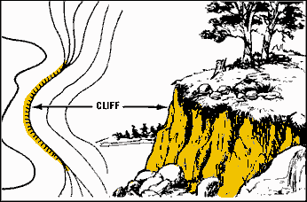
Based on November 2022, Curriculum Version 2
Module Title: - Topographical Survey plan
Module code: EIS SUR2 M07 11 22
Nominal duration: 250 Hours

Prepared by: Ministry of Labour and Skill

November, 2022
Addis Ababa, Ethiopia
Table of Contents Page
Acknowledgment 4
Introduction to the Module 5
UNIT ONE:INTRODUCTION OF TOPOGRAPHIC SURVEYING 6
1.1.INTRODUCTION 7
1.2. Topographical Survey plan and survey terminology 8
1.2.1. Survey terminology 8
1.2.2. Uses of Topographic Map 9
1.2.3. Some methods to perform topographic surveying 9
1.3. Symbols and specifications 10
1.4. Materials, Tools and equipments 15
UNIT TWO : 24
PERFORM SURVEYING USING TOPOGRAPHIC MAP 24
2.1. Figure measurement and value determination 25
2.1.1. Measurement 25
2.1.2. Measuring distance from Map 25
2.1.3. Distance measurement : 26
2.1.4. Methods for measurements: 27
2.1.5. Measuring bearing from the map 28
2.1.6. Measuring areas 29
2.1.7. Indirect methods for area measurements of irregular shapes: 30
2.1.8. Determining the position of a place 32
2.1.9 Position by the use of Geographical Grid 33
2.1.10. Position by National Grid Reference 35
2.1.11 Four digits Grid Reference System 35
2.2. Interpretation of Topographic map 38
2. 2.1. Reading Topo map 38
UNIT THREE: PREPARATION OF TOPOGRAPHIC MAP 42
3.1. Method of topographic surveying data collection. 43
3.1.1. Stadia method of preparing Topographic map 43
Mapping elements 69
Describing spatial data 69
Choosing feature code 70
UNIT FOUR:PREPARATION OF MAP BY APPROPRIATE SOFT WARE 84
4.1. Topographic data collection by total station 85
4.1.1.What is Total station? 85
Reference 120

Acknowledgment
Ministry of Labor and Skills wish to extend thanks and appreciation to the many representatives of TVET instructors and respective industry experts who donated their time and expertise to the development of this Teaching, Training and Learning Materials (TTLM).

Introduction to the Module
In Surveying filed; the Topographic map helps to know the Topographic Surveying terminology; to identify Symbols and specifications; to list Materials, to use Tools and equipments ; to apply Safety requirements; to measurement Figure and value determination ; to Interpret Topographic map; Data collection and calculations; Method of topographic surveying data collection; Reconnaissance and Preliminary survey; Detail survey ; Application of software; Base map preparations and plotting; Feature coding and True features determinations
This module is designed to meet the industry requirement under the surveying technology occupational standard, particularly for the unit of competency: Topographical survey plan
This module covers the units :
- Introduction of topographic surveying
- Perform Surveying using topographic maps
- Preparations of topographic map
- Unit four: Preparation of map by Appropriate soft ware
Learning Objective of the Module
- Perform Surveying using topographic maps
- Prepare topographical survey.
- Perform topographical Survey.
- Develop and present a topographical plan.
- Operate topographic soft ware
Module Instruction
For effective use this modules trainees are expected to follow the following module instruction:
- Read the information written in each unit
- Accomplish the Self-checks at the end of each unit
- Perform Operation Sheets which were provided at the end of units
- Do the “LAP test” giver at the end of each unit and
- Demonstrate the given project
- Read the identified reference book for Examples and exercise

UNIT ONE:INTRODUCTION OF TOPOGRAPHIC SURVEYING
This learning guide is developed to provide you the necessary information regarding the following content coverage and topics:
- Introduction
- Topographical Survey plan and survey terminology
- Symbols and specifications
- Materials, Tools and equipments
- Safety requirements.
This guide will also assist you to attain the learning outcomes stated in the cover page. Specifically, upon completion of this learning guide, you will be able to:
- Define topographical Survey plan and survey terminology
- Identify Symbols and specifications
- differentiate Materials, Tools and equipments
- Apply Safety requirements.

1.1.INTRODUCTION
Topography is generally known as the study of earth’s surface, and its features. It also gives the description of the features (such as surface, shapes, vegetation cover & elevations), depicted in maps. Topographic surveying is the process of determining the positions on the earth's surface, of the natural and artificial features of a given locality, and of determining the configuration of the terrain. In essence, it is mainly concerned with local details such as vegetative and man-made features including local history and culture. More specifically, topographic surveying involves the gathering information on terrain, three dimensional details of the surface including recognizing the specific landforms and determining the relative locations of points (places) on the earth's surface by measuring horizontal distances, differences in elevation and directions. This type of survey also shows the “contours” of the land which are representing ups and downs, plain and hills of the site.
The outcome or the purpose of topographic surveying is the graphic representation of a given land features on a map using several techniques. In order to make the topographic maps easier to interpret, symbols and colors are used to represent various natural and man-made features.
A topographic map is simply a drawing that shows the natural and artificial features of an area. It shows the spatial configuration of the earth's surface, which includes natural features as hills and valleys, streams, oceans, seas etc and man-made features such as buildings, roads, canals, cultivation, etc. In addition, topographic map provides you with features such as natural drainage patterns, locations of hills, rock outcrops, valleys and other man-made features. The topographic map also shows information which is important for planning and design of large civil engineering projects.
Topographic maps that show natural and cultural features only in plan view are called planimetric maps.
Planimetric Maps
- Show only the horizontal position of geographic and cultural features
- Do not show topographic features
- Show accurate horizontal distances

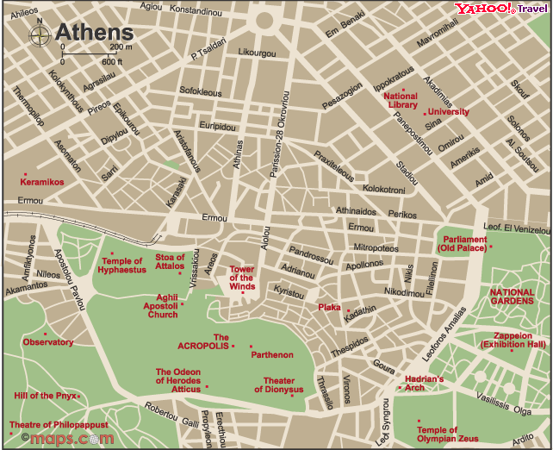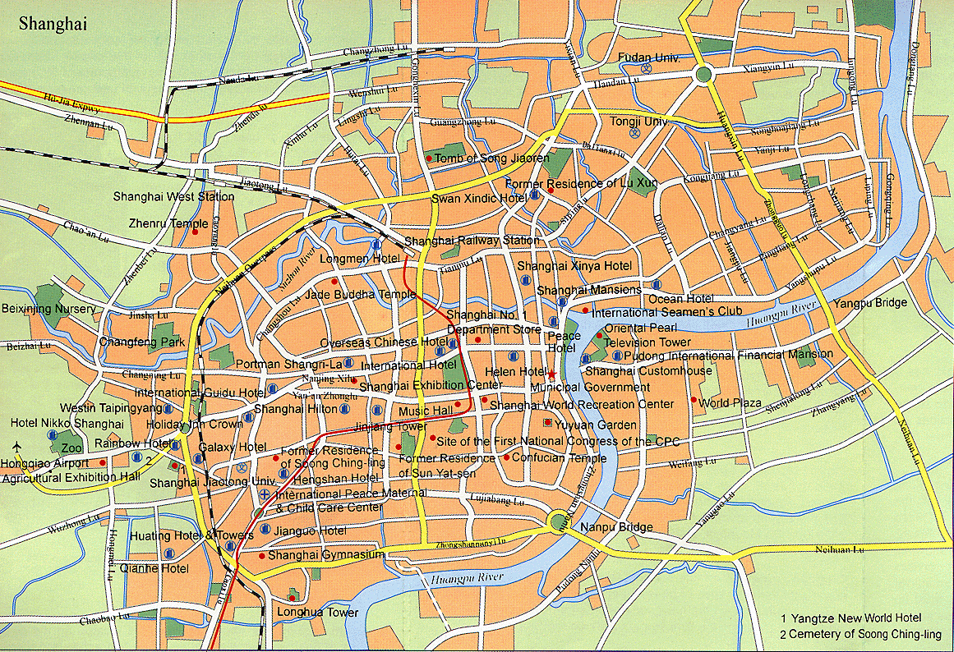
Figure 1.1. Plan view

1.2. Topographical Survey plan and survey terminology

1.2.1. Survey terminology
Relief: The physical configuration of the earth's surface, depicted on a topographic map.
Surveying: The operation of taking measurements to determine geographic location.
Topo.- Topos (Greek word.): place
Graphic: Earth’s surface features representing by geometric relationship
Topography: Features both natural and manmade, collectively depicted on earth’s surface.
Stadia (Greek word.): Unit distance
Tachometer - A Theodolite designed for rapid measurements
Tachometry: Greek word Tacheo, and metro, meaning ' measure'. Rapid measurements using Theodolite
Map: Graphical representation of the earth’s surface.
Topographic map: Map showing both natural and manmade features
Base map: Map that depicts the fundamental map elements, such as streets, buildings etc.
Map compilation: Editorial and preparatory work includes collecting, systematizing, and scientifically using cartographic source material.
Horizontal datum: the positional reference for the geographic location of features.
Mean sea level: the average height of the surface of the sea for all stages of tide, used as a reference surface from which elevations are measured.
Vertical datum: the reference or basis for elevations (usually mean sea level).

True north: direction of the northern rotational axis of the earth from North Pole.
Magnetic north: direction to which a compass needle points.
Bearing: the horizontal angle at a given point, measured clockwise or anticlockwise from magnetic north or true north to a second point.
Spot elevation (Spot height): a point on a map where height above mean sea level is noted, usually by a dot and elevation value.

1.2.2. Uses of Topographic Map
A Topography map is used for wide variety of applications such as military planning, geological exploration, civil engineering, construction and public works. Depending on the type of application the objectives of using topographic information may vary. For example, detail information terrain is and surface features are important for the planning, designing and implementation of a large civil engineering or irrigation or public works project.
The most common use of topographic maps is in the planning stages of projects to help design the layout and location of buildings, roads, dams, pipelines, landscapes, fire control routes, trails, etc The purpose of Topographic surveying is to gather data necessary for the construction of the topographic map that displays both the planimeter and topographic features.: -
- Industrial Plants
- Rail ways & high ways
- Irrigation & drainage scheme
- Hydroelectric power station
- a building complex
- Bridges, tunnels and dams
Topographic surveying and the preparation of a topographic map of the terrain is therefore generally the first step in the planning and designing of a major civil engineering project. A topographic survey is normally used to plan and design some type of project.

1.2.3. Some methods to perform topographic surveying
Ground method: Theodolite (stadia) method
: Total station method
: GPS method

: Plane table (preparing map at field) method
Photogrammetric method : Interpreting aerial photo to map
: Interpreting satellite image to map (remote sensing)

1.3. Symbols and specifications
- Map users interpret both manmade and natural features on the map through a system of symbols.
- Symbols in a map represent the actual features found on the earth’s surface.
- Types of symbols
- Point
- Line
- Area
- Abbreviation
- Height
- Some features represented on the map by symbols.
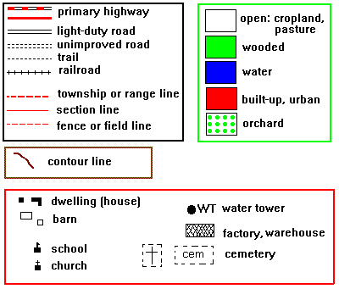

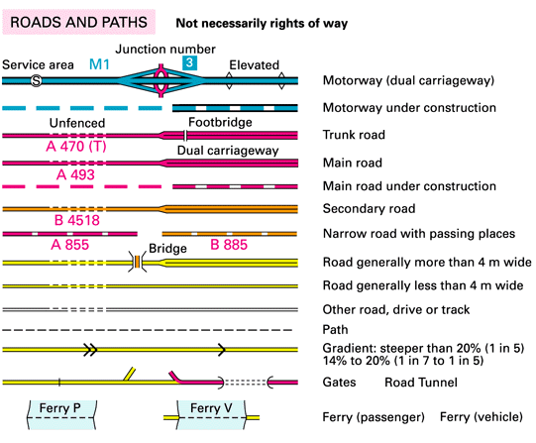
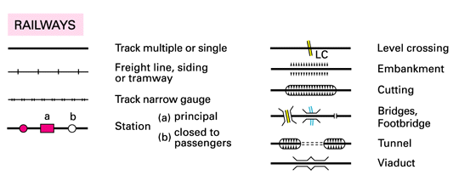
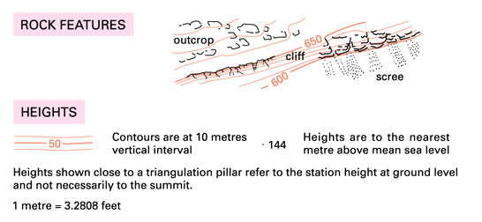
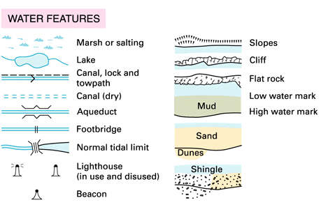
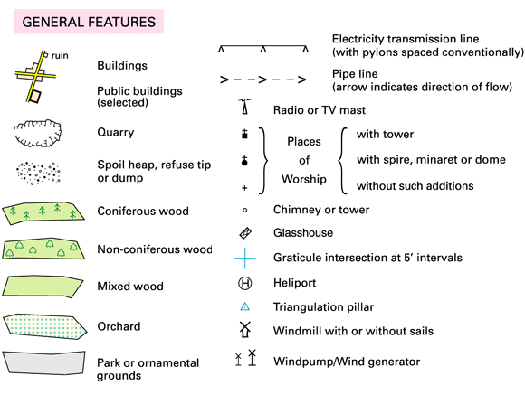
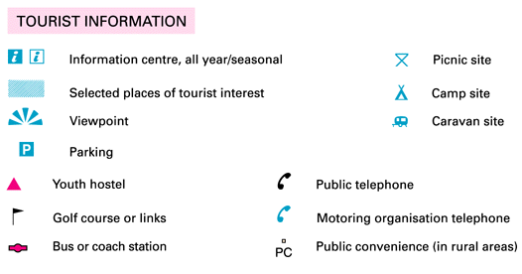
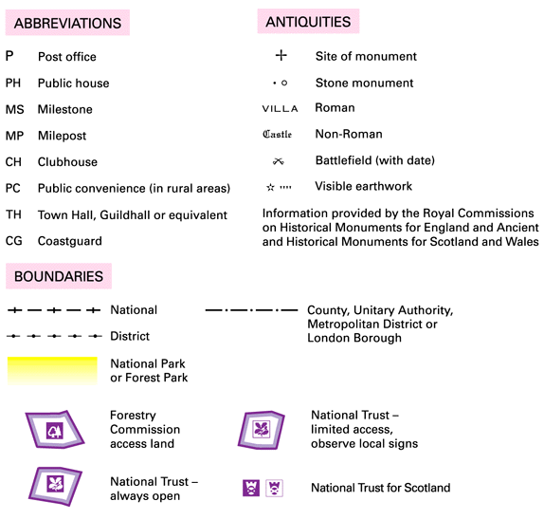
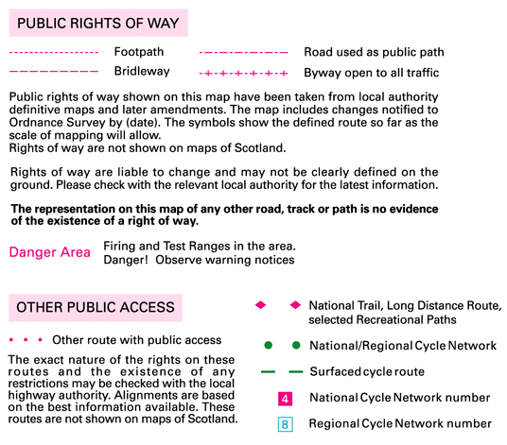
Figure 1. 2 Smbol and apasification

1.4. Materials, Tools and equipments
selecting survey methods and equipments with requirements
Methods are applied to gather the necessary data for the preparation of a topographic map:
1.Ground method: is done by means of total station or Theodolite (stadia Tachometery), as well as with levels, tapes. This method is economic and suitable for relative small areas.
Equipment used for Stadia Tachometry method
- Theodolite-with cross hairs to measure Upper, Middle, lower hair, Horizontal angle and Vertical(Zenith) angle,
- Staff- set at the target point to measure the upper, middle, and lower reading with Theodolite.
- Tripod–
- Tape- to measure the height of the instrument as well as to measure distance between two points when the points invisible for the instrument.
Equipment used for Total Station Method
- Total station- to measure all the necessary data(Co-ordinate) of points and also measure distances using EDM.
- Tripod
- Prism(or Sheet)
- Prism pole
- GPS
2.Photogrammetric method: Aerial photographs are used to gather the necessary ground data. It is an economic method for larger areas and projects. The ground work is only limited to establishing horizontal and vertical ground control points. The aerial photographs are measured stereoscopically (three-dimensionally) by means of a special instrument called stereo-plotter. With the help of such stereo-plotters the contour lines and positions of all topographic features can be determined.
Equipment used for Photogrammetric method
- Aerial Photograph-
- Stereoscope (Pocket/Mirror) etc
3) Data from satellite :It is done by capturing land information data from satellite.
Equipment used for Remote sensing method
- Satellite image
Computer with appropriate software (s.a Erdas, Arc info, Arc GIS etc
1.5. Safety requirements.
Safety Gear & Devices is
  - Warning Signs, Safety Cones, Flags, First Aid Kit, Fire Extinguisher, Water, Insect repellant, sun screen, poison plant prevention cream & wash?
Heat Stress Awareness
The heat of the sun: Risk of heat illness when the heat index is 100 °F or more.
Heat index- Accurate measure of how hot it really feels.
- Relative humidity plus actual air temperature.
  - Values for shady, light wind conditions.
  - Full sunshine increases heat index values up to 15 degrees.

Protect Yourself from
- Heat stress Heat exhaustion Heat stroke.
Heat Stress Awareness
Factors Leading to Heat Illness
- High temperature & humidity, Direct sun or heat, Limited air movement , Physical exertion, weak physical condition, Some medications, Inadequate tolerance for hot workplaces (lack of conditioning).
Preventing Heat Related Illnesses-
  - Block direct sun or other heat sources, Use cooling fans/air-conditioning, Take rest breaks regularly, Drink lots of water- about 1 cup every 15 minutes, Wear lightweight, light colored, loose-fitting clothes Avoid alcohol, caffeinated drinks, or heavy meals.
Preventing Heat Stress –Water Intake
In a day's work in the heat-
  - water intake during the workday must be about equal to the amount of sweat produced.
  - Most workers exposed to hot conditions drink less fluid due to insufficient thirst drive.
  - Do not depend on thirst to signal when and how much to drink.
Heat Stress Awareness
- Move the worker to a cool, shaded area, Loosen or remove heavy clothing, Provide cool drinking water. Don’t force it, Fan and mist the person with water.
If No Immediate Improvement, call or local emergency number at once.
Sun exposure
UV Exposure and Skin Cancer
Sunlight contains ultraviolet (UV) radiation.
Sunlight causes-
  - Premature aging of the skin & wrinkles
  - Cataracts & skin cancer
Damage from UV exposure depends on:
  - the strength of the light,
  - the length of exposure.
  - whether the skin is protected.
No safe UV rays or safe suntans.

UV Exposure and Skin Cancer
Sun exposure at any age can cause skin cancer. Important- examine your body monthly. Skin cancers detected early can almost always be cured. Most important warning sign- a spot on the skin that changes in size, shape, or color during a period of 1 month to 1 or 2 years. If you find unusual skin changes, see a health care professional immediately.
Skin Cancer
- According to the Center for Disease Control (CDC)-
  - 1 in 5 persons will develop skin cancer in their lifetime.
  - The CDC estimates that skin cancer claims the lives of 9,500 people per year.
Protecting Yourself
Protect yourself-
  - Wear a broad brimmed safety hat.
  - Wear long sleeves with tightly woven fabric.
  - Protect your eyes with UV reducing/absorbing sunglasses.
PROTECT YOUR EYES-
  - 5 – 10% of Skin Cancer Is On the Eyelids
  - 90% of Premature Aging Around Eyes is From UV Damage
  - Eyes Are the Only Internal Tissue Directly Exposed to UV
  - Protect your eyes with UV reducing/absorbing sunglasses.
Personal protective equipment (ppe)
High-Visibility Safety
- Day and Night time safety vest, shirt, and/or trousers is phasing out
- approved color: fluorescent orange-red with yellow retro-reflective material
- Visible at a minimum distance of 1,000 feet
- Colors that contrast with the flagger’s background
Safety clause Safety glasses
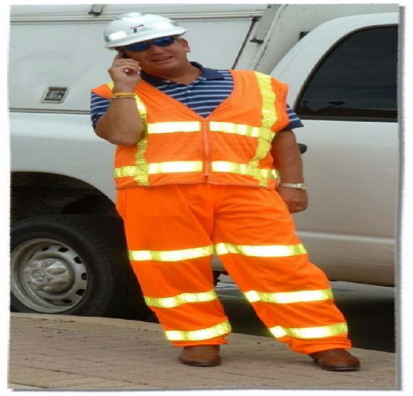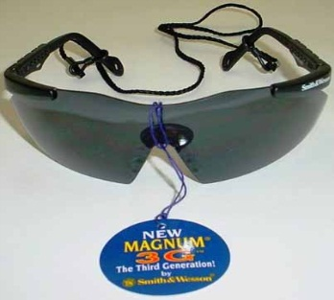
Safety footwear Gloves
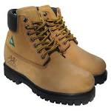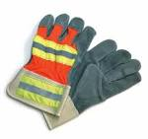

Snake Boots- non conforming type
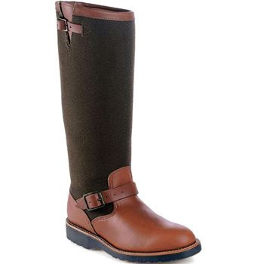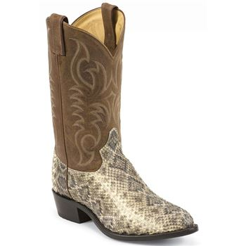

Figure 1. 3 sefty material
Snakes and snake bites
Awareness
* Look out for snakes all around you, places!

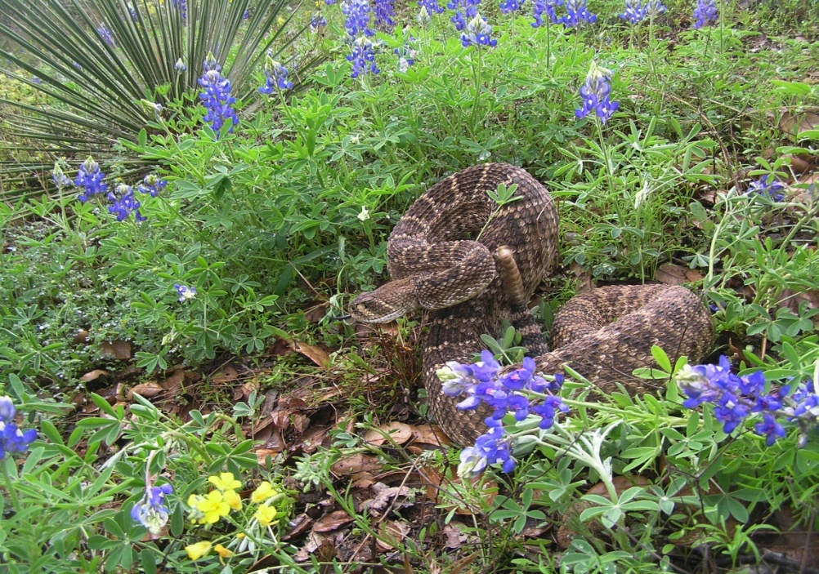
Figure 1.4 snake bite

Snakes & Snake Bites
most poisonous snake bites include bites by:
- Rattlesnake
- Copperhead
- Cottonmouth (water moccasin)
- Coral Snake
Causes
- All snakes will bite when threatened or surprised.
- Treat all snakes and bites seriously.


Figure 1.5 Types of snake
Prevention
- Avoid picking up or playing with.
- Many serious snake bites occur when someone deliberately provokes a snake.
- In an area known to have snakes, wear long pants, boots and snake leggings if possible.
- Avoid areas where snakes may be hiding- under rocks, logs, brush piles.
- Consider keeping a snake bite kit (available from hiking supply stores).
- Do not use older snakebite kits containing razor blades and suction bulbs.
Snakes & Snake Bites
General Symptoms (depends on the type of snake):
- Bleeding from wound, Blur red vision, Burning of the skin, Convulsions, Diarrhea, Dizziness, Excessive sweating, Fainting, Fang marks in the skin, Fever, Increased thirst
- Labored breathing, Loss of muscle coordination, Nausea and vomiting, Numbness and tingling, Rapid pulse, Tissue death, Severe pain, Skin discoloration, Swelling at the site of the bite, Weakness
First Aid
- Try to see and remember the color and shape of the snake. This can help with treatment of the snake bite.
- Seek medical attention as soon as possible.
- Call 911 or call local Emergency Medical Services (EMS).
- If transporting the victim, call ahead to the emergency room to get anti-venom.
- Keep the victim calm and still.
- Lay or sit the person down with the bite below the heart.
- Cover the bite with a clean, dry dressing.
- Remove rings from fingers due to swelling potential.
- Call the National Poison Control Center for any reason, 24 hours a day, 7 days a week.
First Aid Don’ts
- DO NOT allow the person to over-exert. Carry the person to safety if necessary.
- DO NOT apply a tourniquet, ice, cold compresses or water.
- DO NOT cut into a snake bite.
- DO NOT try to suction the venom.
- DO NOT give the person stimulants or pain medications unless instructed to do so by a doctor.
- DO NOT drink alcohol or caffeinated beverages.
- DO NOT raise the site of the bite above the level of theperson’s heart.
- DO NOT pick up the snake or try to trap it.

Self check-1 | Written test
Test-I Matching
Instruction: select the correct answer for the give choice. You have given 1 Minute for each question. Each question carries 2 Point.
A B
1. Symptoms of snake A. Rattlesnake
2.Types of snake B. Burning of the skin
3.Pilanimety C. The physical configuration of the earth's surface
4. Relief D. Graphical representation of the earth’s surface.
5. Map E. Two dimension
Test II: short Answer writing
Instruction: write short answer for the given question. You are provided 3 minute for each question and each point has 5Points.
1.On the symbol and specification water body describe by _______________color.
2. On the symbol and specification water Vegetation describe by _______________color.
Part III: Short answer writing
Direction: Give short answer to the following questions. Time allotted for each item is 2mniut and each question carry 5 point.
1. What is the difference between Topographic map and Planimetric maps .
2.List and discus survey terminology.
3.What is the use of topography.
4.Discus method of preparing topographic map.
5. List equipment used for Stadia Tachometry and right the purpose .
6.When one person attack by snake what to do.
7. Wright Symptoms of snake and snake bite.
Note: Satisfactory rating – above 60% Unsatisfactory - below 60%
You can ask you teacher for the copy of the correct answers

UNIT TWO :

PERFORM SURVEYING USING TOPOGRAPHIC MAP
This unit to provide you the necessary information regarding the following content coverage and topics:
- Figure measurement and value determination
- Interpretation of Topographic map
This guide will also assist you to attain the learning outcomes stated in the cover page. Specifically, upon completion of this learning guide, you will be able to:
- Interpret topographic maps.
- Determine value of figure measurements.
- Analyze Spatial data collection and calculations

2.1. Figure measurement and value determination

2.1.1. Measurement
Two kinds of measurements used in plane surveying.
Linear Measurements
- Horizontal distance
- Vertical Distance
Angular Measurements
- Horizontal angle
- Vertical angle
A variety of information about the earth, and about the features distributed on its surface, is
obtained by direct measurements from maps.

2.1.2. Measuring distance from Map
Map distance measurements assume that one of the two conditions is met so that the measurements taken are valid.
1) First condition is that the distances are short so that the earth's curvature is not an important factor in the measurement.
2) The second is that the map is on equidistant projection and the measurements are taken along appropriate alignments.
- Before starting any measurements on map it is advisable (necessary). to consider the following three points.
- If you asked to measure a distance between two points A and B, it is the real distance (ground distance) that is wanted not distance on map.
- Distance on map is measured in centimetres but distance on field is given in kilometres
- All distance obtained through measurements on maps called map distance don't consider the ups and downs on the field. In the real world the routes between locations almost always involves ups and downs. The actual surface distance between two objects, therefore is longer than the map distance, except in exceptional case where ground surface is perfectly flat. Assuming that there is relatively uniform slope between two points, the

- calculation of the distance correction for elevation involves simple application of the Pythagorean Theorem.
Suppose two pints A and B have map distance of 30 cm and elevation of A is 100 m and that of B is 200 m. The scale of the map is 1:50,000.
Then Map distance = 30 cm
Scale 1 cm equivalent to 0.5 km
Ground distance = 30 x 0.5 km = 15 km.
B 200m
Surface Distance
A 100m
Ground Distance
Height

Figure 2.1. Distance measurement
Now Height difference between A and B is 200m - 100m = 100m
Then field or surface distance = √(1500)² + (100)²
In distance measurement exercise you will be asked to find three types of distances.
a) Map distance
b) Ground distance and
c) Surface or field distance

2.1.3. Distance measurement :
Distance between two points on a map may be straight or zig-zag.
It is easy to measure accurately the lengths of a straight routes but not if they are zig-zag.
- Distance along a straight line: This is the map distance between two points which can be obtained directly using ruler or scale and also by using a pair of dividers followed by conversion to ground distance using scale of the map

30 cm
B
A
Scale = 1:50,000 i.e
1 cm is 0.5 km then
30 cm is 15 km

Figure 2.2: Distance along striate line
- Distance along a curved or zig–zag route:
B
A

Figure
Figure 62.3: Distance along zig- zag line

2.1.4. Methods for measurements:
      - Using edge of plain paper or sheet. Edge of plain paper is overlaid on curved line and two points are marked over it. The same distance is measured using scale to get the map distance. Using scale of the map it is converted to ground distance.

A
B
Paper
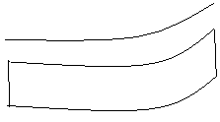
Paper
B
A

Figure 2.4: Distance measurement using paper

  - Divide the curved lines into small straight lines
  - Measure the length of each straight lines with a pair of dividers
  - Sum the length of all sections
  - Convert it into ground distance.

Figure 2.5: Distance measurement using paper
ii. Using string
  - Mark an end of a piece of string with ink or knob.
  - Overlay the string on the starting point of the zig- zag line
  - Measure the length of the string by using a plain scale
  - This method is time consuming and also less accurate for distance measurements.
iii. Using an Spiro meter
It is an instrument having route measuring wheel. The wheel is allowed to move along the route whose distance is required. The length traversed by the wheel is indicated on the dial of the instrument. The total length recorded by the instrument is converted into ground distance..

2.1.5. Measuring bearing from the map
True or Geographic North - True north is the northerly direction along a line on Longitude (Meridian Direction).
Magnetic North- A north arrow of magnetic compass points towards the north magnetic pole – a direction called magnetic north.
Grid North- The direction of north trending lines of grids of the map is called Grid north.
Azimuth- An azimuth is an angle usually measured clockwise in degree, minute and second from north to the target.
Bearing- Bearing is an angle measured from north-south base line, whichever is nearer to the target.
Directions are usually designated as Azimuth or Bearing based on True, Magnetic and Grid North.

2.1.6. Measuring areas
The areal scale of a map in contrast is defined in areal units. The areal scale of a map is sometimes used to describe the relationship between the area of a feature plotted on a map and area of same feature on the earth's surface. The ratio between area of a region on a map and the area of the same region on the earth is the square of map’s linear scale
Areal scale = (linear scale)²
e.g. if scale is 1:50,000
i.e. linear scale is 1 cm to 0.5 km
Areal scale = (0.5 km)² = 0.25 km²
A. Areas of Regular shapes
Regular shapes include square, rectangle, triangle etc, from geometry areas of regular shapes can be calculated by knowing the necessary parameters like base, height, length, radius etc. These parameters are obtained through measurements on map. Using scale of the map, the map area is converted to ground area.
B. Areas of Irregular shapes
Most areas to be measured from maps are irregular in shape. The following methods are used to calculate the area of irregular shapes on maps and then using the scale of the map, it is converted into ground area.
Direct methods of measurements:
- Polar Plannimeter : is an instrument that measures areas on a map in terms of square inches or square centimeters . These measurements are then arithmetically converted to earth measurements.
- Digital Plannimeter : is an instrument to calculate the area on map with high accuracy.
steps:
  - The Plannimeter dial is set to zero
  - Scale of the map is entered into plannimeter
  - A starting point is marked on the area to be measured
  - Tracing point is placed over the starting point. Then carefully moved over the perimeter of the area in clockwise direction and returning to the starting point
  - Note the reading on dial. At least 3 readings should be taken for an area
A final area is recorded after taking average of the 3 readings.

2.1.7. Indirect methods for area measurements of irregular shapes:
- Grid squares: a grid is an array of horizontal and vertical lines intersecting each other at right angles. Each square is called grid cell.
Grid

Figure 2.6: Grid square
Steps
- A grid of known area (generally 1 cm²) is drawn on tracing or transparent sheet.
- These grids are overlaid on area of interest.
- Count the full square that completely within the area
- Count the half or partial cell.
Area = Full Cells +(Partial Cells)/2] x Cell value
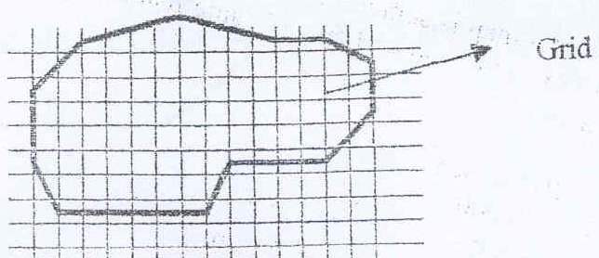

Figure 2.7: Area calculation by Grid square
ii. Dot measurement: With the dot – planimeter method of areal measurement which is a variant of the grid square method, a regularly spaced pattern of dots is placed over the map. This method is similar to the grid square method. Only difference is that instead of using grids, dots are used. Dots of known widths (generally 1 cm²) are overlaid on the shapes. No of dots within the shape and no of dots at the boundaries are counted.
Area = [dots within + (dots at boundary)/2] x dot width
In contrast to grid square method and strip methods, which are exhaustive counting methods the dot planimeter method is sampling procedure
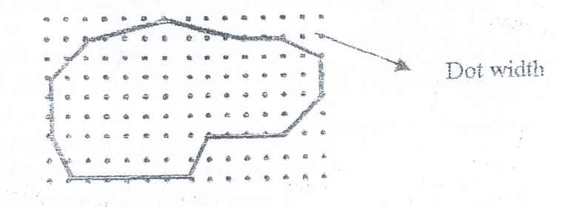

Figure 2.8: Area calculation by dot
iii) Strip method:
- In strip method a series of parallel line of known width (generally 1 cm ²) is drawn over the area.
- The end of each strip is formed by drawing vertical lines at the edge of area being measured.
- Length of each strip is measured
- Sum the individual strip length and multiply the total length with strip width to get the area.
Area = [Total strip length (cm)] x strip width (cm)
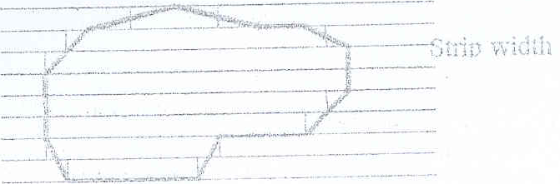

Figure 2.9: Area calculation by strip
iv) Polygon method: It is based on methods of measurement for regular shapes.
- Divide the area into number of regular shapes
- Measure the required parameters for each regular shape.
- Calculate the area for each shape
Sum the area to get the area of irregular shape
B
C
A
D
Area = area (A + B + C + D)

Figure 2.10: Area calculation by strip

2.1.8. Determining the position of a place
Showing position or location of a certain point is one of the earliest and still one of the most important uses of maps.
There are four conventional methods to give the position of a place. These are: -
- Position by the use of Place Names
- Position by the use of Bearing and Distance
- Position by the use of Geographical Grid
- Position by the use of National Grid Reference
i. Position by the use of Place Names
The place is marked with a dot on the map in its accurate position and its name is attached to it.
- It is commonly used and simplest way for positioning
- If you are interested to find any place on the map, look over map until you find the place.
- Place name used on a map must be suited to the scale of the map used.
- The place name should be meaningful to the person who uses the map to find them.
- Place names used on map should not be ambiguous.
- Place names do change from time to time.
ii. Position by the use of Bearing and Distance
Bearing is an angle measured from north-south base line, whichever is nearer to the target.
- Bearing angle never exceeds the value 90⁰.
- A bearing is designated as e.g. North 45⁰ East or N 45⁰E. The base direction is stated first, then number of degrees and finally the direction of bearing in east or west with reference direction.
- Therefore bearings are given according to the four quadrants. North-East, North-West, South-East and South-West.

TN
A
E
W
Bearing- S65⁰W
O
S
NE
SE
SW
NW
65⁰
TN
A
E
W
Bearing- N45⁰E
O
S
NE
SE
SW
NW
45⁰

Figure 2.11: Position by Bearing and distance
Shortcoming of the two methods discussed above:
- Both methods do not give a definite specific location of a certain place
In 1st method – the map-reader will suffer in finding a place among thousands of place names.
In 2nd method – the reader must know the location of major places given for reference.
e.g. Addis Ababa, Harar, Dessie etc.
- If you want to refer certain spot in the field and if spot does not have name on your map, you cannot refer to it at least by first method.

2.1.9 Position by the use of Geographical Grid
- In this method, the position is given accurately with the help of a grid composed of a network of lines known as Parallels and meridians.
- One set of lines run from North Pole to the South Pole. These imaginary lines are called meridians and join all the points with the same longitude.
- The other set of lines run around the globe parallel to the equator and called parallels. These lines join all the points with the same Latitudes.
- Latitude is angular measurements from the center of the earth northwards and southwards. Longitude is angular measurements from the center of the earth in eastwards and westwards.
- The parallels give the position in degree (⁰), minutes (‘) and seconds (“) north or south of the equator. This is the Latitude of the place. The meridians also give position of point in degree, minutes and seconds, east or west of the zero degree (prime meridian). This is longitude of the point.
1 ⁰ = 60’ and1’ = 60’’.
- Consider the following figure for positioning of points A, B and C
8⁰ N
35⁰ E

8⁰ 15’ N

8⁰ 30’N

8⁰ 45’N

9⁰ N
35⁰ 15’E
35⁰ 30’E
35⁰ 45’E
36⁰ E
A
B
C
x
y
m
n

Figure 2.12: Position of point by greed
Position of A is 8⁰ 45’ N and 35⁰ 45’ E
Position of B is 8⁰ 30’ N and 35⁰ 15’ E
Position of C is determined as follows:
- Measure the distance x, y, m and n on the map in cms.
- Say e.g. x = 5 cm, y = 15 cm, m = 20 cm and n = 8 cm.
- Now for 15 cm, Longitude difference = 35⁰ 45’ E - 35⁰ 30’ E = 15’ E
Therefore for 5 cm, Longitude difference = (15’ x 5)/ 15 = 5’ E
Therefore Longitude of C is 35⁰ 30’ E + 5’ = 35⁰ 35’ E
- Now for 20 cm, Latitude difference = 8⁰ 30’ N - 35⁰ 15’ N = 15’ N
Therefore for 8 cm, Latitude difference = (15’ x 8)/ 20 = 6’ N
Therefore Latitude of C is 8⁰ 15’ N + 6’ = 8⁰ 21’ N
Thus, position of C is 8⁰ 21’ N and 35⁰ 35’ E.
Shortcomings of this method:
  - The shape of gridlines on globes is curved lines while the shape of grid lines on most maps are almost straight line.
  - No simple relationship between degrees and the actual distance we use (not convenient for calculation) and the length of degree also vary from latitude to latitude and from longitude to longitude.
Longitude at equator = 111.1 km
Longitude at the poles is almost 0 km

2.1.10. Position by National Grid Reference
The cress cross-reference lines on a map is called grid. The vertical and horizontal lines of the grid cross at points called co-ordinates.
The lines that run horizontally are called Northing’s. The lines that run vertically are called Easting’s. There are two types of grid references.
- The four figure grid reference.
- The six figure grid reference
When reading Grid references Easting’s are given first and then the Northing’s..

2.1.11 Four digits Grid Reference System
- On a map drawn on a small scale, the 10 km sides of the square are marked with numbers that increases towards east and north.
- One digit is printed bigger than the other digit. E.g. 3¹⁰, 4⁷ like that.
- This digit gives the tens of kms from the origin
- The northing and easting are numbered at every 10 km interval.
- Each side of square is divided into 10 units (1 unit represents 1 km)

3⁵
2³
3⁶

3⁷

3⁸

3⁹
2⁴
2⁵
2⁶
2⁷
A
B
C
Divided into 10 units
Divided into 10 units

Figure 2.13: Greed reference
Table 2.1: Greed reference
 | Steps for positioning A | Easting | Northing
1 | Locate the vertical grid line left to the point A and read the large number | 6
2 | Measure the tenth of the side of the square from this grid line to the point. | 0
3. | Loacte the horizontal gridline below the point A and read the larger number |  | 8
4 | Measure the tenth of the side of the square from the gridline to the point |  | 0
Therefore the position of A is 6080

 | Steps for positioning B | Easting | Northing
1 | Locate the vertical grid line left to the point A and read the large number | 4
2 | Measure the tenth of the side of the square from this grid line to the point. | 0
3. | Loacte the horizontal gridline below the point A and read the larger number |  | 7
4 | Measure the tenth of the side of the square from the gridline to the point |  | 0
Table 2.2: Greed reference
Therefore the position of B is 4070
Table 2.3: Greed reference
 | Steps for positioning C | Easting | Northing
1 | Locate the vertical grid line left to the point A and read the large number | 5
2 | Measure the tenth of the side of the square from this grid line to the point. | 4
3. | Loacte the horizontal gridline below the point A and read the larger number |  | 6
4 | Measure the tenth of the side of the square from the gridline to the point |  | 6
Therefore the position of C is 5466

2.2. Interpretation of Topographic map

2. 2.1. Reading Topo map
Maps gives detailed information of an area through symbols and colors. every map contains are:
- Title: All maps should contain a suitable title. Titles identify the map and convey meaning and purpose for creation of the map E.g. Base map of Ethiopia
- The date of compilation: Things change with time, so the map reader must know the date of the map under review.
- Legend: each map or each series of maps have their own symbols or colors for different objects.
- Scale: The scale of the map is the ratio between the distance of any two points on the map and the distance representing the same two points on the ground. The scale can be expressed in either of the three ways: These are
- Word Statement
- Representative Fraction
- Graphical Scale
i) Word statement:scale may be expressed in a phrase such as ’’Ten centimetres to one kilometre which means that 10 cm on particular map is equivalent to 1 km on the ground. It is more appropriate to use a word statement that indicates that the map is at a scale of ten centimetres to one kilometre
i-e. Map scale – 10 cm to 1 km
ii) Scale Ratio (Representative fraction)
The scale of a map also may be expressed as the ratio between two distances
Eg. Distance between two points on the map is 10cm and the distance between equivalent points on the earth is 1km (100,000cm) then the ratio is 10: 100,000, which is reduced to 1:10000 for listing on map.
- Scale ratios are not expressed in any specific units of measurements. This means both sides of the ratio must be specified in the same units.
e.g. 1: 10,000 means 1cm on map represents 10000 cm on ground.
- Frequently the scale ratio is written as a fraction called representative fraction. e.g.
1: 10,000 can be written as 1/10,000

iii) Graphical Scale
  - Map scales also are represented in graphic form. Dividing the line into units, each of which represents, at map scale, the actual distance between two points on the earth.
  - These units generally are chosen to be easily usable, rounded numbers, such as tens or hundreds of kilometres, miles, meters or feet.
  - Often, part of the scale is subdivided into fractional units to aid in measuring distance more precisely.
Km 10 8 6 4 2 0 10 20 30 40 KM

Figure 2.14: Graphical scale
5.Map Index Number: Topographical map given a unique identification number shown in the lower left or upper right part of the map. This number is used to find out the adjoining sheets if required
- Coordinate System: every map is part of particular portion of the earth so it contains intersection of latitudes and longitudes – the values of latitude & longitudes are shown in fore corners of the map at intersection points of latitude & longitude.
- North Arrow: Every map should have a north arrow pointing towards the North.
So having above marginal information on maps it looks something like below:-

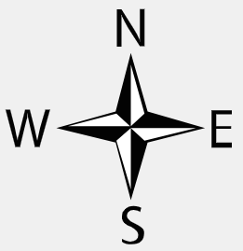
Figure 2.15: North arrow
Figure 2.16: Map information
Legend
35⁰15’
8⁰ 00’
35⁰15’
8⁰ 15’
Title
35⁰
8⁰15’
35⁰
8⁰00’
1:50000
0
1
2
3
4
5
6
7
8
9

10Km
Index No
A B C
D E F G H I

Self check 2 | Written test
Test-I Matching
Instruction: select the correct answer for the give choice. You have given 1 Minute for each question. Each question carries 2 Point.
"A" "B"
1. Title A. Show the direction map
2.Scale B. Identify the map and convey meaning
3. Legend C. Ratio between the distance of any two points on the map
4. Coordinate System D. latitudes and longitudes
5. North Arrow E. Have their own symbols or colors
Test II: short Answer writing
Instruction: write short answer for the given question. You are provided 3 minute for each question and each point has 5Points.
1.Righite kinds of measurement
2. List and describe method of measure distance from a map.
3. List and discus method of measure area from map.
Part III: Short answer writing
Direction: Give short answer to the following questions. Time allotted for each item is 2mniut and each question carry 5 point.
1.Title
2.Legend
3.Scale
Note: Satisfactory rating – above 60% Unsatisfactory - below 60%
You can ask you teacher for the copy of the correct answers

UNIT THREE: PREPARATION OF TOPOGRAPHIC MAP
This unit to provide you the necessary information regarding the following content coverage and topics:
- Method of topographic surveying data collection.
- Base map preparations and plotting
- Feature coding and True features determinations
This guide will also assist you to attain the learning outcomes stated in the cover page. Specifically, upon completion of this learning guide, you will be able to:
- Collect topographic surveying data.
- Identify Reconnaissance, Preliminary and Detail survey
- Prepare base map and plotting.
- Identify feature coding and True features.

3.1. Method of topographic surveying data collection.

3.1.1. Stadia method of preparing Topographic map
Stadia tachometry is procedure of measuring angles (Horizontal and Vertical) and cross hairs to determine horizontal distance between points and reduced level of points.
General procedures of preparing Topographic map using Stadia method:
A. Reconnaissance survey
B. Establishing control station
C. Preparing grid of map
D. Traverse Plotting
E. Stadia tachometric surveying
F. Relief representation
G. Map compilation
A. Reconnaissance survey
The term reconnaissance means the first inspection of the target area in terms of existing features, control points, possible sites for new observation stations, as well as the permanent marking of those stations, detection of possible obstacles and possible solutions to overcome them etc. With other words, after the first inspection, one has got some idea (mental map) about the terrain and the features of the ground.
A reconnaissance survey is defined as “an examination of all or part of an area accomplished in sufficient detail to make generalizations about the types and distributions of features” within a given project area. Reconnaissance surveys represent a type of field survey that is often used to gather initial information. The results of a reconnaissance survey should inform the user types of resources that are likely to be found within a project area and the need for additional survey.
Reconnaissance survey is absolutely indispensable due to sketch map is showing man made features and natural features clearly. Interesting ups and lows are also showing on sketch map.
In reconnaissance survey the major activities done are:
- Site observation
- Roughly sketch features
- Roughly sketch control station
- Estimate duration of time
- Having sketch map and mental map
- Apply generalization
Selection: Selection and retention of more important area & eliminating less important area eg. Tree
Simplification: Simplify the Shape of feature retain on maps with changes in scale eg, forest area
At a minimum, reconnaissance surveys should document the following:
- The boundaries of the area surveyed;
- The method of survey,
- The kinds of features present in the surveyed area;
Guidelines for Reconnaissance Survey Reports
  - Project Title
  - Dates of Survey
  - Brief Statement of Project Goals
  - Observer/Surveyor name
  - Project Location
  - Project boundaries
  - Work steps
  - Specific techniques used to survey
  - Sketch Map showing manmade and natural features
  - Cartographic illustrations
B.Establishing control stations

The establishing of horizontal and vertical control points is the most essential part and is the first step in the field work process of topographic surveying, since the three-dimensional coordinates (X, Y, Z) of each point to be surveyed can only be determined with respect to well established reference points. In stadia method most commonly traversing with theodolite is applied for establishing reference points. With a level, the elevations of the traverse stations are determined. The controls are used for the basis of the topographic survey measurements. The fieldwork in a topographic survey consists principally of (1)
the establishment of a basic frame-work of horizontally and vertically located control points (called instrument points or stations) and (2) the determination of the horizontal and vertical locations of details in the vicinity of each instrument point. The controls selected are invisible to each others and mark with staking materials such as pegs.
Types of controls: Horizontal and Vertical
- Horizontal control
-Is provided by two or more points on the ground and precisely fixed in position by distance and direction.
- Is the basis for map scale and locating topographic features
-For small areas, horizontal control for topographic work is usually established by a traverse, but sometimes a single straight line may be used.
- Vertical control
-Is provided by bench marks in or near the tract to be surveyed.
- Is the foundation for correctly portraying relief and elevation on a map.
-Vertical controls are usually established by lines of levels starting and closing on bench marks.
C. Preparation of grid of map
Base map is a term which varies in different applications, but, in general, refers to a map that depicts the fundamental map elements, such as streets, buildings, streams, etc., which are used frequently for locational reference. The base map includes administrative boundaries, cities, water features, physiographic features, parks, landmarks, highways, roads, railways, airports, and buildings overlaid on land cover and shaded relief imagery for added context.
In Preparation of base map:
- Arrange the paper shape in portrait or landscape
- Determine map area and marginal area
- Drawing cardinal direction
- Determine scale
- Grids drawing and labelling

Landscape
Map area
Marginal area

Portrait

Figure 3.1: Paper position
Scale Determination
Selecting the appropriate scale depends on the size of the sheet of paper and
the accurate placement of features.
- Use of known features
Reference features as Football ground, tennis court, Baseball diamond
- Use of Map Comparison
Another map from same area, having similar features can be helpful
to determine scale.
D. Traverse Plotting
The most accurate method of plotting a traverse is to determine the latitude (north – south displacement) and departure (east – west displacement) of each station of the traverse. The displacement of each station is calculated from the horizontal distance and the bearing of the course connecting the station from the previous station. Normally, the Point of Commencement (P o C) is given a defined “x, y” (departure, latitude) coordinate and the subsequent courses are added to produce a coordinate for each station. For latitudes (y coordinate), courses toward the north are positive; toward the south is negative. For departure (x coordinate), east is positive and west

negative. Traverses in azimuths (direction stated as an angle between 0º and 360º) are very easy to calculate, because the direction sign is provided by the calculator.
Traverses in “Bearings” state the angle of the course to the east or west of the North or South direction (e.g. N32W or S46E). Calculations using bearings can be more labor intensive, especially in assigning the positive or negative value of the course. A traverse table (next page) is often useful in assigning latitudes and departures. This table provides values for 0º to 45º reading from the top down, and for 45º to 90º reading from the bottom up.
E. Stadia tachometric surveying
Stadia Tacheometry is a system of rapid surveying, by which the positions, both horizontal and vertical, of points on the earth's surface relatively to one another are determined without using a chain or tape or a separate leveling instrument. Stadia readings can be taken with theodolites, transits, and levels. a surveying method for determination of distances and differences of elevation by means of a telescopic instrument having two horizontal lines through which the marks on a graduated rod are observed; also : the instrument or rod

TELESCOPE HORIZONTAL
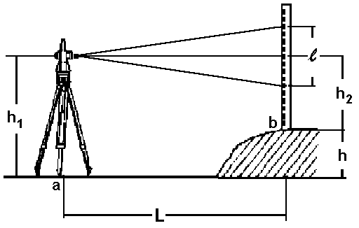
Figure 3.2: Stadia tachometric
The horizontal distance between a and b:
L = 100 x l
The height difference between a and b:
h = h1 - h2

TELESCOPE NOT HORIZONTAL

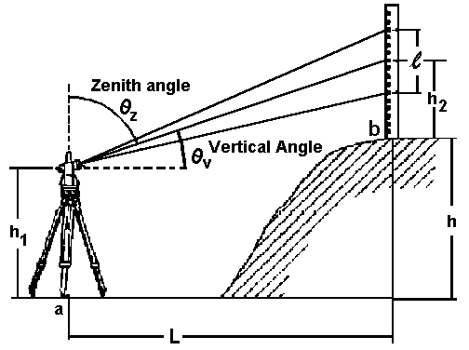
Figure 3.3: Stadia tachometric
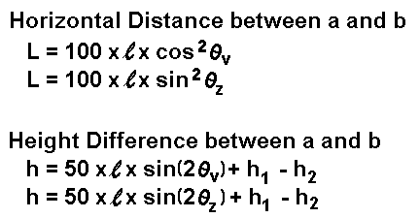
Stadia Tacheometry is used for:
- preparation of topographic map where both horizontal and vertical distances are required to be measured;
- Reconnaissance survey for highways and railways etc;
- Establishment of secondary control points.
In case of stadia techeometry the following data are measured and booked:
- Point number of point to be surveyed
- Instrument height (can be determined with a tape )
- Horizontal angle
- Vertical angle ( most commonly the zenith angle)
- Upper, middle and lower staff reading
- Gathering Stadia data
Preparation of a field book where all measured features, such as roads, buildings, trees, ditches, fences, manholes, spot heights etc. are entered. In the case of stadia tacheometry all relevant readings, such as horizontal angles, vertical angles, the three stadia readings, and the instrument height are booked in a special form. The distances and elevations are calculated in the office and subsequently the three-dimensional coordinates (X, Y, Z) of each surveyed point can be determined if necessary.
The heights of prominent points of some elevated features such as mountain summits or hill tops and the bottom of depressions are called spot heights. An ordinary transit theodolite fitted with stadia hair is known as Tacheometer. This method completely eliminated the use of tape or chain and is very rapid and convenient.
Table 3.1: Field book for Stadia method of topographic surveying
Type of Instrument:________ Observer:_______________ Date:_____________
Additive Constant C =_0__ Multiplying Factor K=100
Instrument station:_________ Station height (BM) =____________ Instrument height --------
s = upper - lower = Staff intercept HD = ( Ks +C) cos²ν with: ν = vertical angle
Δh=( Ks + C) sin ν cos ν = HD(tanν) or HD = ( Ks +C) cos²ν with: ν = Zenit angle HD = Horizontal Distance H = BM + hi ± Δh – middle hair reading H = height of the new point
Inst  Stn. | Target | Horizontal angle |  |  | Vertical  Angle (ν) |  |  | Stadia readings  upper mid lower |  |  | S | HD | Δh | H | Remarks
1 |  | 2 |  |  | 3 |  |  | 4 |  |  | 5 | 6 | 7 | 8 | 9

- Plotting of the Stadia features
Plotting refers to the transfer of survey data to the map. The plotting of all topographic features, including spot heights, can be done most easily with the use of a protractor and an engineer scale. The centre of the protractor is held with a hand exactly over the observation station.
Then, either the zero degree mark or the known azimuth is lined up with the respective traverse side in order to orient the protractor properly. The desired angle or azimuth of the points is then taken from the field notes and noted along the edge of the protractor, and fine points are marked at these positions (to avoid mixing up of points, the point numbers are written next to the points).
With engineer scale, the distances, also taken from the field notes, are then set from the traverse station and going through the respective required points. The end points are marked with a sharp
pencil (just a point with a small circle around), and labelled with their point numbers and elevations. When all points of one station have been plotted, the protractor is moved to the next position, and the process continues. The points are then connected as illustrated in the field book.
Plotting and drawing for surveying purposes has nothing to do with architectural drawing, and therefore an artistic portrayal of the topography should be avoided.
However, a map title with the map scale, a north arrow and a legend (explanation of the used symbols) are indispensable items of each topographic map.
F. Relief representation
How to show the ups and down (relief) on a plane sheet of paper is one of the many problems that have been facing the mapmakers throughout the history of map making. It is therefore, very important that the map should inform us as accurately as possible about the relief of an area.
The topographic features and contour lines, plotted in a certain scale, form the topographic map(plan). This map shows the horizontal distances between the features, their location and elevations above a given datum.
Ways of showing relief
Physiographic diagrams : (three dimensional pictures as seen by the Observer standing on the ground)
- It is a mixture of vertical and side view.
- Many details of the hill will be hidden from the view behind the backs.
- No accurate information about the actual height of different point.
- Lack of accuracy
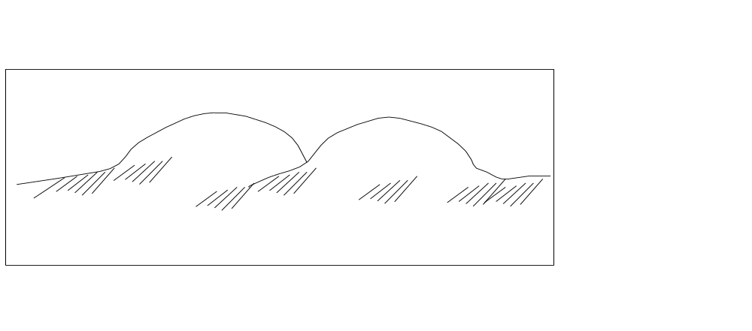
Figure 3.4: Physiographic diagrams
Hill shading: today used together with contours.
- In this method, parts of the hill having different elevations have been shaded different colours.
- Places with the same level have the same colour
- 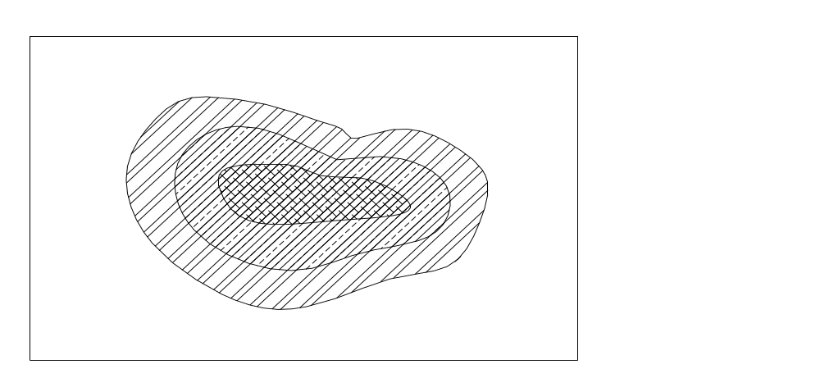fig 3.5. hill shading

By hachure's : These are short lines drawn in the direction of the ground slope. It is applied in the case of a road cutting and embankment, ditches etc.
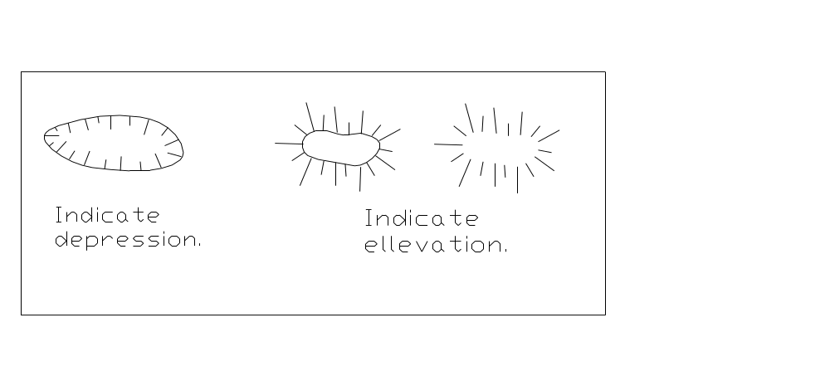 fig 3.6. Hachure
Dis advantages hachure's
- The hills all look flat topped
- The top and bottom of the hill cannot be found no measurements of the actual length
- lack of accuracy
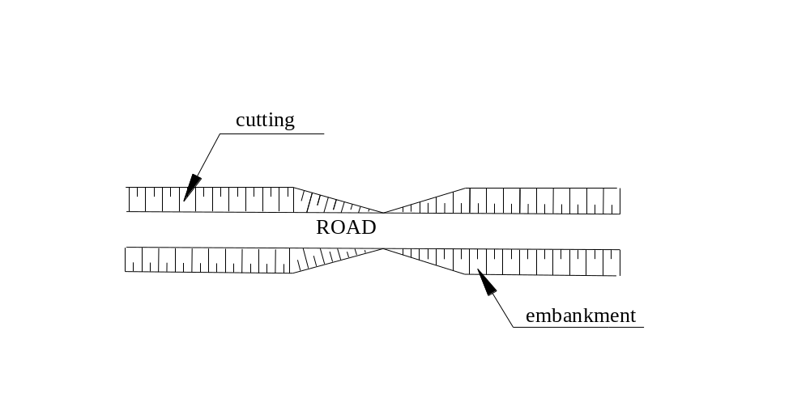
fig 3.7. hill shading

By spot heights : These are accurate altitudes for individual points along roads, mountain tops etc.
- There is no artificial physical evidence in the field of the presence of such a spot height.
- They are marked on the map, usually with a dot followed by a number giving the accurate altitudes in meters (see figure 16):
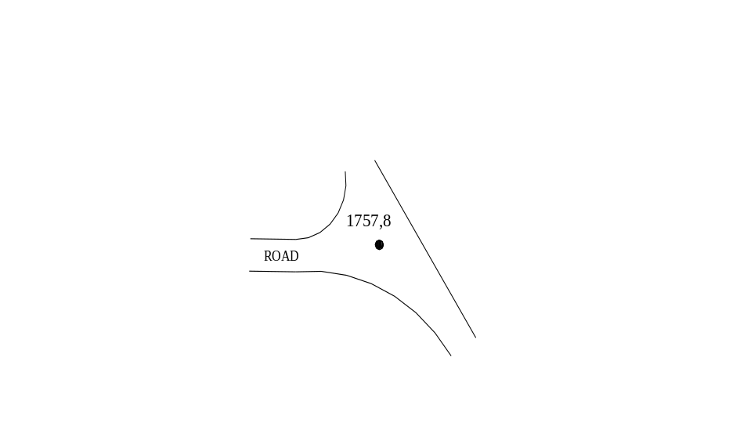
figure 3.8 :Spot height
A contour line: is an imaginary line that connects points of equal level on the surface of the earth. the most accurate method of representing relief. The constant vertical distance (height difference) between two consecutive contour lines is called the contour interval. The proper choice of the contour interval depends on the slopes of the terrain to be represented, the scale of the map and the purpose of the survey. If, for example, the terrain is very hilly and the contour interval is too small in relation to the scale, the contour lines become to crowded. In addition, the smaller the contour interval the more points have to be measured in the field and the more time consuming is the plotting. As a result of that the topographic map would become more expensive.
The uses of contour map:
1. It furnishes information regarding the characteristics/topography of the area.
2. select the most economical and suitable site for an engineering work such as a reservoir , dam wear, railways, highways etc.
3. Quantities of earth work can be calculated.
4. From a contour map, a section may be drawn along any line.
5. Contour map can be used for the determination of the capacity of a reservoir and the area of the drainage basins.
6. Gradient can be traced on contour map.
- The constant vertical distance (height difference) between two consecutive contour lines is called the contour interval.
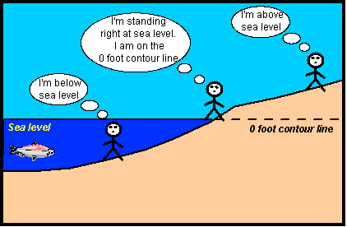
- The proper choice of the contour interval depends on the slopes of the terrain. example, the terrain is very hilly and the contour interval is too small in relation to the scale, the contour lines become to crowded.
figure 3.9; Location map
The contour line represented by the shoreline separates areas that have elevations above sea level from those that have elevations below sea level.
We refer to contour lines in terms of their elevation above or below sea level. In this example the shoreline would be the zero contour line. (relief) is most commonly done with contour lines.
Contour interval(CI): it is the constant vertical distance (height difference) between two consecutive contour lines.
- The proper choice of the contour interval depends on the slopes of the terrain to be represented, the scale of the map, the purpose of the survey/map, time & expense of the project.
- If, the terrain is very hilly and the contour interval is too small in relation to the scale, the contour lines become too crowded.
Table 3. 2. contour interval should be selected for the different map scales and terrain types:
Scale of the map | Type of terrain | Contour interval
Large  1:1000 or larger | Flat  rolling  hilly | 0,2-0,5 m  0,5-1,0 m  1,5-2,0 m
Intermediate  1:1000-1:10000 | Flat  rolling  hilly | 0,5-1,5 m  1,0-2,0 m  2,0-3,0 m
Small  1:10000 or smaller | Flat  rolling  hilly  mountainous | 1,0-3,0 m  2,0-5,0 m  5,0-10,0 m  10, 25 or 50 m
A rolling terrain has got gently raising and falling slopes.
Table 3.3 shows common contour intervals for different purposes:
Purpose of survey | Map scale | Contour interval
building sites | 1:1000 or larger | 0,2-0,5 m
town planning and reservoir planning | 1:5000-1:10000 | 0,5-2,0 m
survey of extensive area, earth work, etc. | 1:5000-1:20000 | 2,0-3,0 m

characteristics contours
Contours have the following characteristics:
- Contour lines are closed lines. However, they may close either on the map itself or outside the map, depending upon the topography.
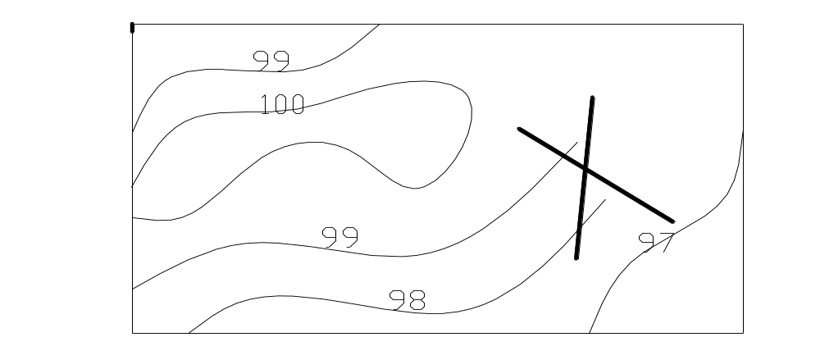
fig 3.10: Contour lines are closed
- Contour line are always perpendicular to the direction of the steepest slope. Therefore, surface water always runs downhill at right angle to the contour lines. These contour lines form U's, pointing downhill (see also figure ) .
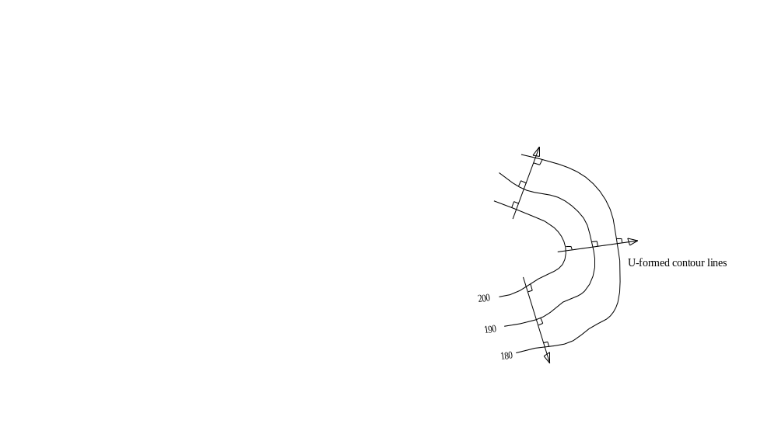 fig 3.11: U formed contour lines
- In case of a valley lines or streams, the contours run roughly parallel to the valley line or stream and form pointing uphill where they cross the valley line or stream.
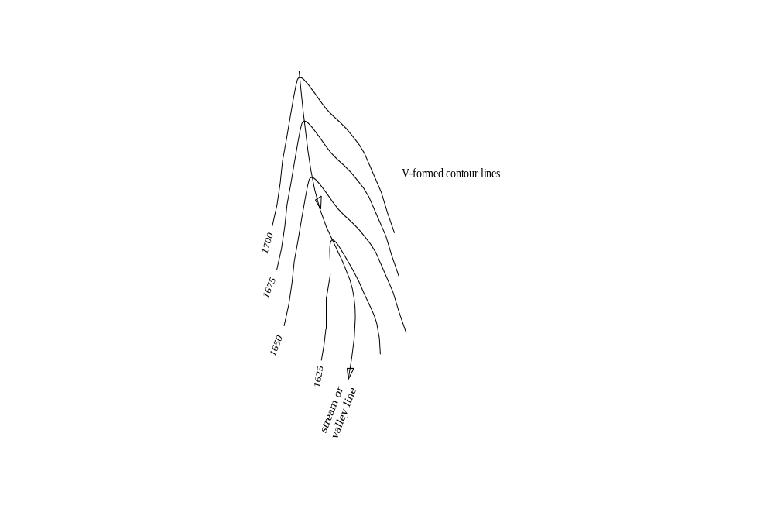
fig 3.12:V formed contour line
- If the spacing between the contour lines is small the slope is steep, but for gentle slopes the spacing is large. i.e. space=1/slope.
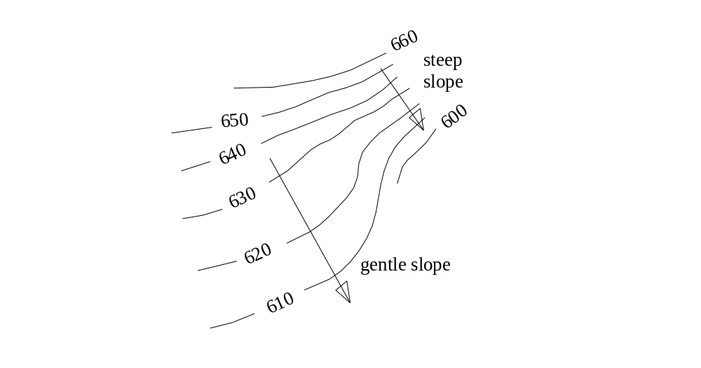
figure 3.13:PPosition of contour
- 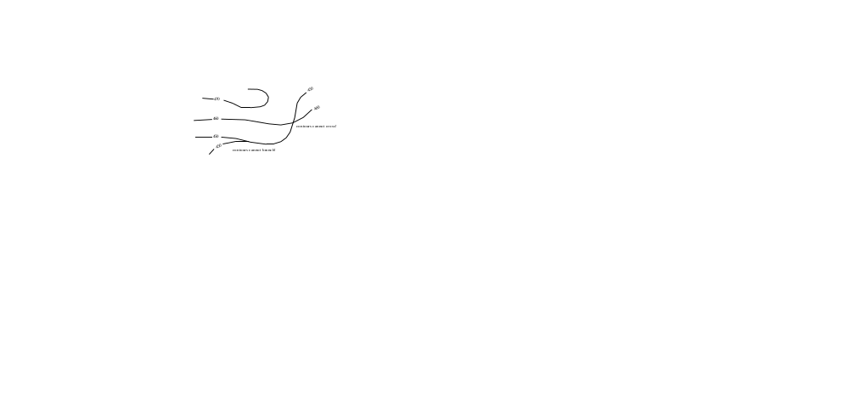contour lines, cannot have branch or cross one another on the map except in the case of vertical surfaces (e.g. a retaining wall) or overhanging ground (e.g. a cave). because a point on the ground cannot have two elevations.

fig 3.14:Contourcan not branch

- Depression contours form closed loop contours around the lowest point. The elevations of the contours decrease from outside to inside.
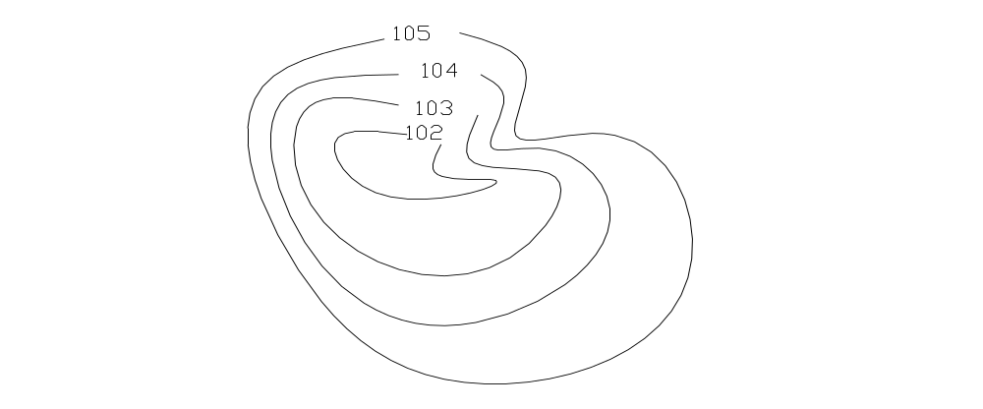 fig 3.15:Clouse contour

- A closed contour lines on the map indicate a hill if the higher values are inside Summit contours form closed loop contours around the highest point. The elevations of the contours increase from outside to inside
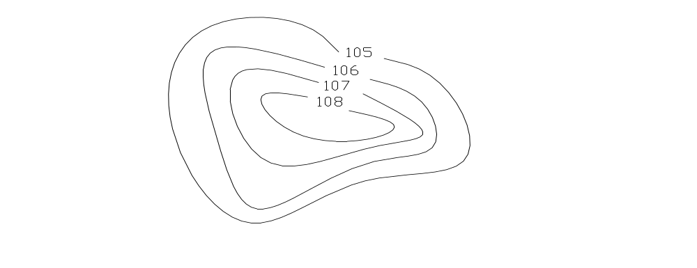
fig 3.16:Clouse contour
- Contours do not have sharp turnings.
- Horizontal Distance between contours is inversely proportional to the ground slope. Hence, on a steep slope, contour lines run close to each other.

- When a contour line crosses a gully /stream/ravine or other drainage structures, it forms a modified V pointing upstream. For ridges, the V points downstream Stream.

606
604
602
600
fig 3.17:Contour cross stream make "V" shape
- Contours are not shown going through buildings.

Building

100

102

104
fig 3.18:Contour ca not cross building
12.Horizontal Distance between contours is inversely proportional to the ground slope. Hence, on a steep slope, contour lines run close to each other.
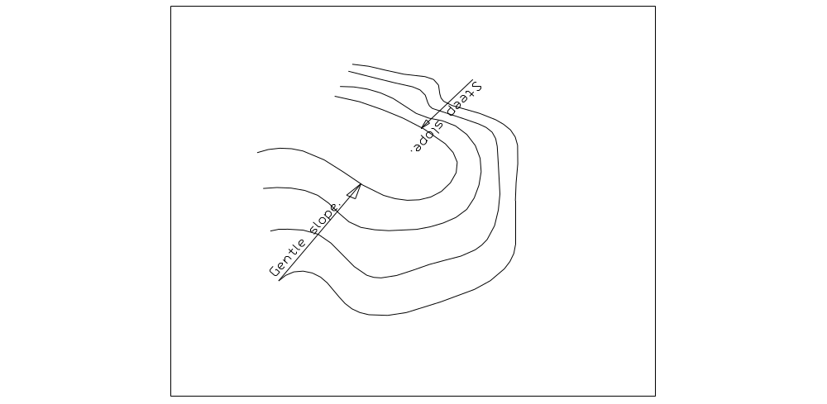
fig 3.20:Contour spacing
13.On uniform slopes the contour lines are spaced uniformly.
14.Along plane surfaces such as embankments, the contour lines are straight and parallel.
Horizontal equivalent: it is the horizontal distance between two consequetive contour lines & it can be vary from point to point depending on the steepness.
- If the contour line are equally spaced, they represent a uniform slope
If the space between contour line is irregular, they represent uneven ground
Types of contour lines
Index contour line: - it is the main contour line that helps the map users for quick height interpretation. Its drawn with thicker continuous line
Most commonly every fifth line is an index contour.
Intermediate contour line:- drawn by continuous but thinner than index contour line.
Supplementary contour line:- contour line that are drawn with dashed line of same width as intermediate contour lines.

Contouring
- Data collection for contouring.
- If not enough points are taken the contours cannot be interpolated correctly.
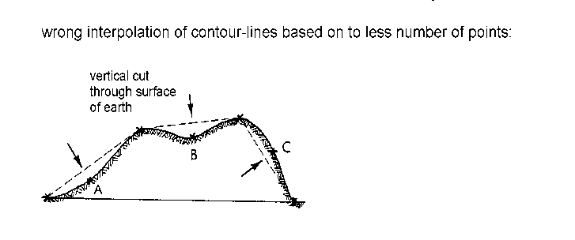
figure 3.21:Contour Interposion
- Contour can be obtained in to two ways: direct and indirect contouring.
- Direct contouring: the position of contour lines are located in the field using levelling or total station.
- A level is setup on a convenient location in the contoured area & BS staff reading is taken on nearest BM. This gives us HI that line of sight founds above datum.
- Then, maximum No of predetermined staff readings are set out & marked on the ground.
- After setting out all contour lines similarly depending on nearest control stations, the marked points are read by stadia method from main control stations to determine their horizontal positions.
- Eg. RL of BM=9553.366m & BS on BM=1.022m, compute HI & set out staff readings to locate 9352m,9353m &9354m contour lines on the ground.
- Solution- HI=RL of BM+ BS=9553.366+1.022=9354.388
- The staff readings of contour lines are can be determined as follows (HI-RL of Contour line).
-for 9352m contour= 9354.388m-9352m=2.388m
-for 9353m contour= 9354.388m-9353m=1.388m
-for 9354m contour= 9354.388m-9354m=0.388m
* the instrument man guides the staff man till he obtain the required staff readings.
* Now a days, direct setting out of contour line is easily can be done by using total station from control stations.
- Indirect contouring: is conducted by levelling points.
- Making the grids regular simplifies plotting & interpolation process.
- Then the ground levels are taken on the intersection point of the grids. If the grids are not regular stadia reading is taken to determine horizontal positions of the intersection points.
- After the required maximum number of contour data are gathered the points are plotted on the map for the next interpolation work.
Contours interpolation
Interpolation refers to the process of determining intermediate values between two observed data points. The assumption is made that the ground slope between two adjacent points is constant (in a straight line). The interpolation is therefore linear.
Interpolation is necessary because the series of points observed in the field do not necessarily lie exactly on the contour lines shown on the map; it is not practical to locate and measure every point on a “round” or whole-number contour.
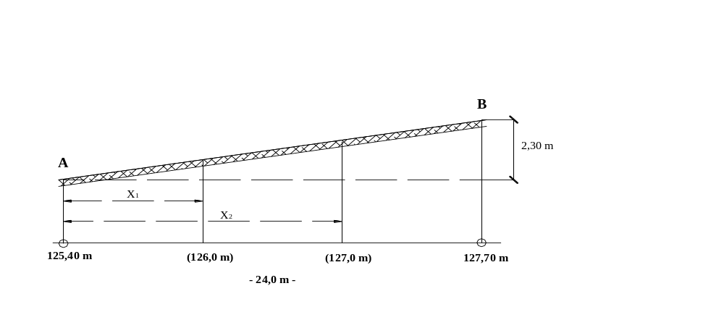The mathematical interpolation is a very accurate method and shall be applied in cases where a high accuracy is demanded. The beginning student may find it time consuming and tedious, but with some practice the speed increases.
Figure 3.22: Contours interpolation
Figure 3.1: Illustrates a vertical section through the ground. Point A and B are observed ground points with its elevations 125,40 m and 127,70 m respectively. The horizontal distance between the two points is 24,0 m. Wanted is the position of the “round-number” contour lines 126,0 m and 127,0 m along the line AB:
X1: (126,0-125,4) = 24,0:2,30 X2: (127,0-125,4) = 24,0:2,30
X1 = 6,26 m X2 = 16,70 m
Therefore, the contour line 126,0 m passes at a distance of 6,26 m from Point A towards point B, or 17.74m from point B and the contour line 127,0 m passes at a distance of 16,70 m from the same point A or 7.3m from B.
In the topographic map the two distances (X1 and X2) are set out with a scale along the straight line AB, marked with a point and labeled with its elevations.
The same calculation, carried out in the reverse direction (from point B to point A) serves as a check.
Graphical method: is done very quickly and also quite accurate.
The distance between two parallel lines on the tracing paper must be chosen and the lines are labels.
This method is useful for points that their elevation difference is shorter than the distance between them. The following figure illustrates the method:
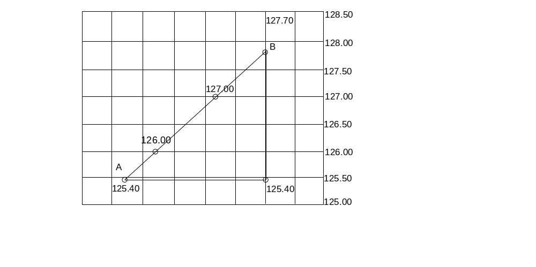
Figure 3.23: Contours interpolation Graphical method
Suppose points A and B are two points with the elevations 125.40 m and 127.70 m respectively, and it is desired to interpolate the 126m and 127m contour lines between the two points. The tracing paper is shifted in such a way, that point A takes up a value of 125.40 m between the lines 125.0 and 125.5 on the tracing paper (this is done by estimation). The point A is then fixed by means of a needle or pin to the tracing paper. Now, the tracing paper is rotated around point A until point B takes up a value of 127.70 m between the lines 127.5 and 128.0 on the tracing paper (this is done again by estimation).
In this position, the contour lines 126.0 and 127.0 are found at the intersection of the 126.0 and 127.0 lines on the tracing paper with the plotted line AB. These points are fixed by pricking with a needle trough the tracing paper into the drawing and the indexes to the contour is also transformed to the base of the map.
Limitations of interpolation
- may loses some accuracy,
- It is difficult & time consuming.
- It is practical only for small area mapping.
Note: Now a day, more accurate & suitable contour generation methods are available, such as stereo plotter can generate contour lines from aerial photographs.
Sketching of contour lines:
After locating the points of various contour lines as described previously, the contours can be sketched. To see clearly the course of each contour, the points of same elevation are joined with straight lines. Then, the points of same elevation are connected with a smooth curve. This is best accomplished by using French curves. It is positioned on the paper to pass through as many points as possible and a portion of the curve is drawn. The French curve is then repositioned for drawing another portion of the contour.
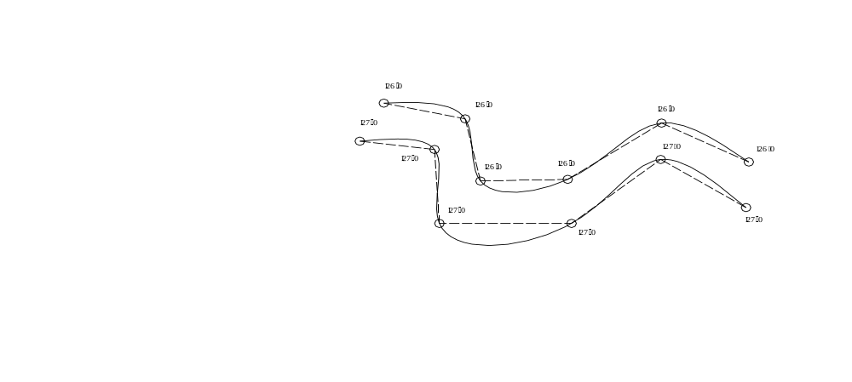
Figure 3.23: Sketching Contours
Labelling of contour lines:
Intermediate contour lines are drawn with continuous lines. The intermediate contour lines depend upon the character of the terrain. In hilly or mountainous areas, the contours, divisible by 10, 20, 25, 50 or 100 m are considered as main contour lines. However, in flat terrain a main contour line can be divisible by 1, 2 or 5 m. An index contour line is a main contour line that helps the map user to quickly interpret the height situation portrayed on the map. It is drawn with a continuous line of thicker width. When the contour interval is 10 m, the index contours have elevations that are multiples of 50 m.
- All other contour lines are drawn with a dashed line of the same width as the intermediate contour lines. They are called supplementary contour lines. In flat terrain the 0.5 or 0.25 m contour lines are drawn in that manner.
- A small gap is left for writing the elevation.
- The elevation of a contour should be so written that the foot of the text shows towards the lowest point.
The amount and the location of elevation labels should be so selected, that the map will have a neat appearance
G. Map compilation
Construction of the map frame and legend is done at the stage of map compilation.
Map editing and map layout also applied at this stage. Features are depicted on the map using various combinations of points, lines and standard symbols.
Putting marginal information- they are several components that fulfil the map other than main map body. Some of them are:-
Title:- it is used to tell map users what the map is about & mostly it is based on the mapped area. Its location on the map is varies in relation to other map elements.
Scale:- it is put on map most commonly by RF & graphical methods.
North arrow:- mostly magnetic north is used.
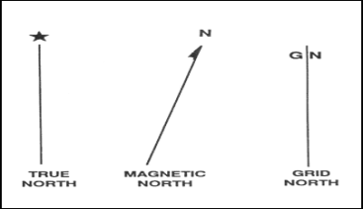
Figure 3.24: North arrow
Legend/key:- it is used to identify and interpret the signs and symbols used on that map.
Date of mapping:- it is needed because natural & cultural features are changed through time.
Margin –This is used to make a boundary for the area shown on the map.
Lettering:- during map making the title should be bigger size than others.
- For point features the name is written at upper right preferably then the other positions.
- For line & area features the letter can be written as follows:-
a) Map frame Construction
Map area

Marginal area

Figure 3.25: Map frame
b) Legend Construction
Topographic mapping is effectively done by Standard symbols of color coded and these Standard symbols on the map are interpreted in legend. For instance usually water features are blue, vegetations are green and for relief brown.
c) Map layout
Most maps are typically depicted many different types of detail effectively by the following elements.

- Clarity-ability of map readable to the user.
- Contrast-use of different line weight.
- Order-logically designing order of elements of map.
- Balance- weight of elements: size, color, font, position.
- Harmony-interrelation between elements of map.
d) Map editing
After the map manuscript is compiled, several steps remain before a map is completed. Working over a light table, the scriber then uses engraving instruments to the map's lines and symbols. This is done by removing the soft coating from the hard plastic guide sheet. A map is edited several times before final scribed sheets are completed. Type for the words on the map is selected according to standards that will ensure consistency of type sizes and styles from map to map. Type placement is important for map legibility, careful editing takes place for content, legibility, accuracy and spelling.
Some Mistakes and errors in mapping are:
Failure in equipment
Errors in instrument reading
Errors in recording values
Too few control stations etc.
Instrument index errors
Failure in adjustment
Controls not checked etc
e) Tracing map
After map layout and editing of map is finished the final draft of map is traced on the tracing paper from the original map. In the process neatness, clarity, and accuracy should be applied.
The following steps were taken when maps were compiled from existing soil maps and legends
- Generalized small-scale maps were compiled using the most recently available, larger- scaled, soil survey source maps and their reports.
- Using the source map scale, the size of the area that reduced to 1 x 1 cm (100 km2) at a scale of 1:1 million was established. This was selected as the smallest mappable area; most areas were larger. There were, however, a few exceptions where generalized map polygons at 1:1 million scale were smaller than 1 cm2 (e.g., narrow, elongated features and drainage patterns, strongly contrasting soil landscapes, and small islands). Map symbols were attached to these smaller polygons by use of a leader (a straight line), assuming the polygon density adjacent to these areas had room for the extra symbol and leader.
- Translucent material with a matte surface (Chronoflex) was overlaid and registered on the soil survey source map.
- The major drainage pattern, major physiographic features, and large, uniform, soil landscape areas were delineated on the source map.
- The source map symbols and legend information were translated to the generalized small-scale map symbol format and assigned unique polygon numbers. A change in any one differentiating property class limit on the source map resulted in a separate generalized polygon.
- Where necessary, smaller source map polygons (similar or dissimilar) were grouped to form a composite dominant portion of the generalized polygon. Its map symbol was composed and assigned a unique polygon number.
- The above procedures were continued until most areas of the source map were generalized. Any remaining small areas were reviewed and a decision was made as to which generalized polygons they should most sensibly be combined with, based on similarity of the major attributes.
- Polygon boundaries and map symbol attributes along adjacent source maps and along provincial boundaries were correlated.
- The mosaic was carefully edited to ensure that all boundaries and map symbols were correlated between adjoining maps.

Mapping elements

Describing spatial data
The spatial data in topographic map should contain:
- Water features: - Seas, Lakes, Rivers, Water bodies, Reservoirs, Canals etc.
- Relief features:-contours, Hatchers, spot height etc.
- Vegetations:-Forest, wood land, bushes, plantations etc.
- Communication network:- railway, roads, trail, power line, telephone line ,etc
- Settlement:- cities, towns, developed areas etc
- Miscellaneous :- Administrative boundaries – International, State, district etc
  - Building like church, mosque, school, post office etc. Enterprise like mills, quarries, mines etc.

Choosing feature code
Feature codes are codes to describe the natural and artificial features.
Some codes used in topographic surveying:
BM Bench Marks
BC Building Corners
SH Spot Height
MH Manhole
TR Tree
PL Power Line etc
Map generalization
- Map generalization is the process of deciding of the level of detail of a map considering the scale and purpose of the map due to map can’t show each & every detail of the earth.
- Smaller scale maps have more map generalization than larger ones.
- The following are some methods of map generalization:-
Selection:-retention of more important features & elimination of less important ones.
E.g. if a series of lakes is shown, some of the smaller lakes in the group can eliminated as the scale reduces.
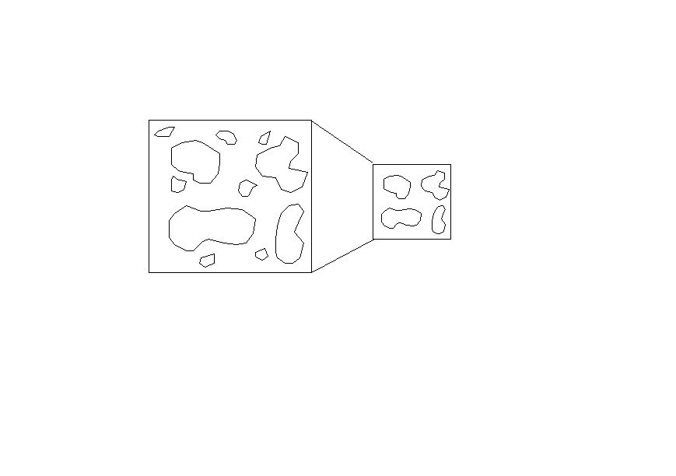
Large Scale
Small Scale

Figure 3.26: Map selection

Simplification:- simplifying the shapes of features
Eg. District boundary shown in more detailed in large scale map as compared to small scale map.
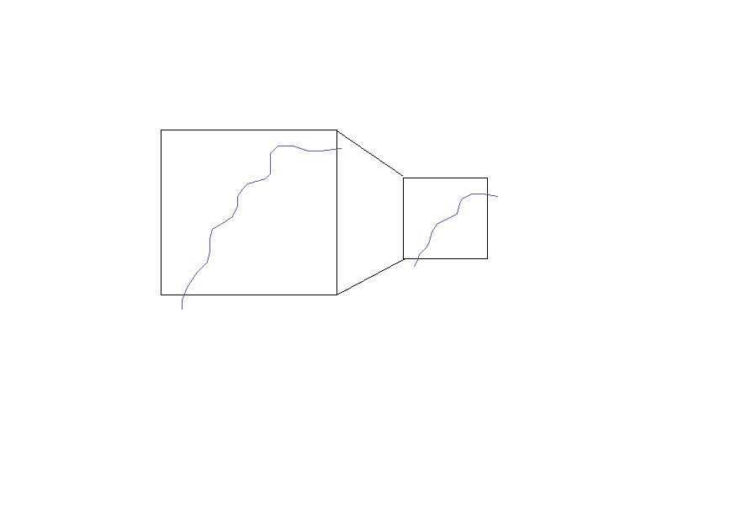
Large Scale
Small Scale

Figure 3.27: Map simplification
Combination:- merging two or more features.
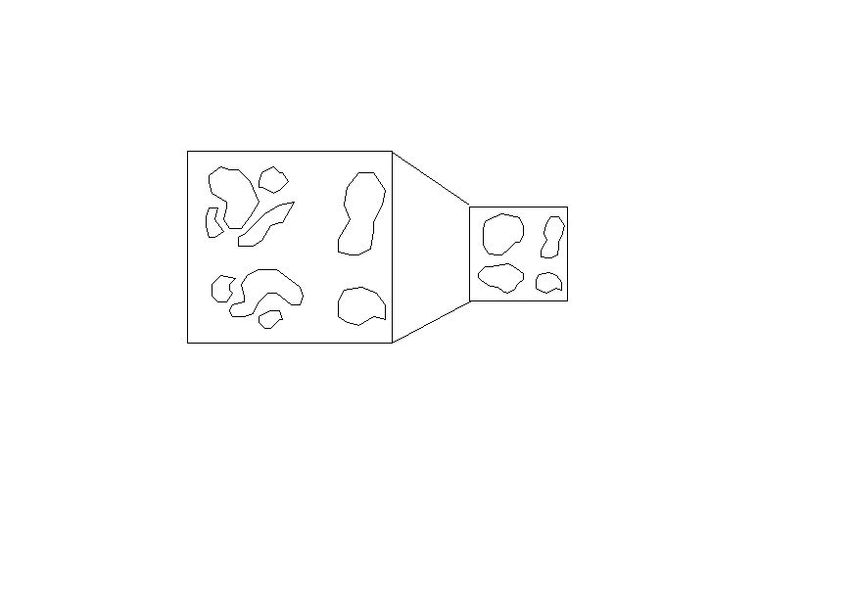two or more similar features into a single symbol. E.g. if there are two many small wodded areas in a region, two or more of small areas of them can be grouped to single wooded area.
Large Scale
Small Scale

Figure 3.28: Sketching Contours
Location shift & size exaggeration:-to show very important features their sizes should be enlarged than the reality & their locations may be shifted.
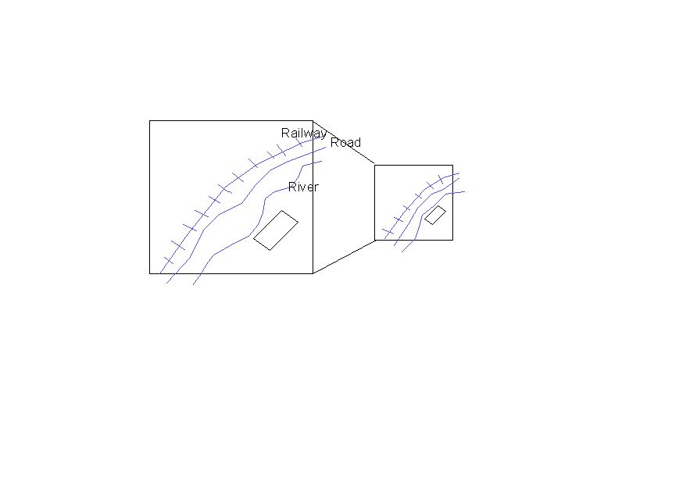 shift of location of a particular feature to highlight them.
Large Scale
Small Scale

Figure 3.29: Sketching Contours

Representation of Relief by contours:
Some relief features like concave slope, convex slope, valley, spur, ridge, escarpment etc occur frequently on surface of the earth. Therefore contours are means to represent these relief features on map and by interpreting the contour patterns the whole landscape can be understood easily.
- Uniform slope: when the horizontal distance is same at every part of the slope it is called uniform slope. Such slopes are represented by contours, which are spaced at equal distance.
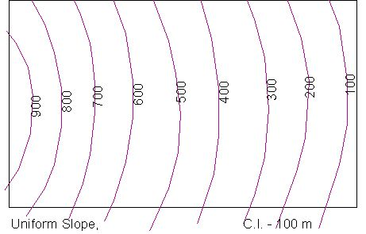

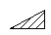

Figure 3.30: Uniform slop
- Concave slope: a slope, which curves inward, is called a concave slope. It lower part rises gently but upper part abruptly. Therefore, the lower part of concave slope is represented by widely spaced contours but its upper part by closely spaced contours.
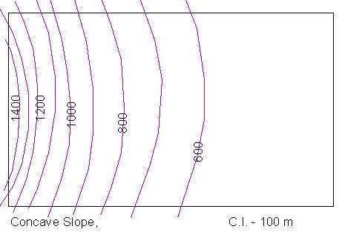
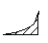

Figure 3.31: Concave slope
- Convex slope: a slope which curves outward is called convex slope. It is steep at bottom but gentle at the top. Therefore contours are close together at foot and wide apart near the top of the convex slope.
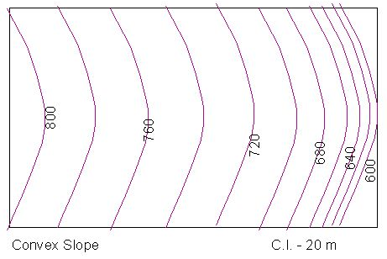
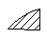
Figure 3.32: Convex slope
- Terraced slope: a terraced slope rises first gently, then steeply, then gently again and so on. The gently rising section of the slope represented by widely spaced contours and the steeply rising section is represented by closely spaced contours.

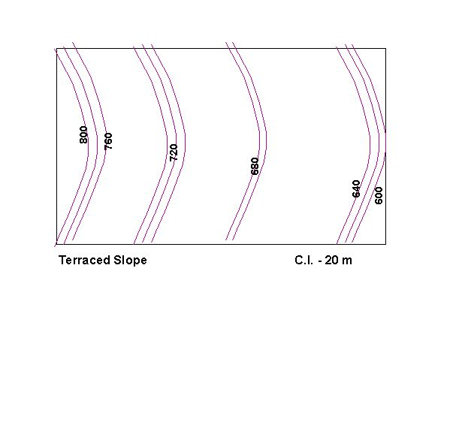

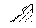

Figure 3.33: Terraced slope
- Undulating slope: when some part of the slope is convex, then concave and again convex and so on it is called undulating slope. It generally gives wave appearance. Therefore contours become wide at some place and close together at other.

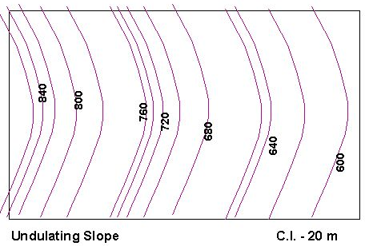
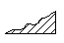

Figure 3.34: Undulating slope
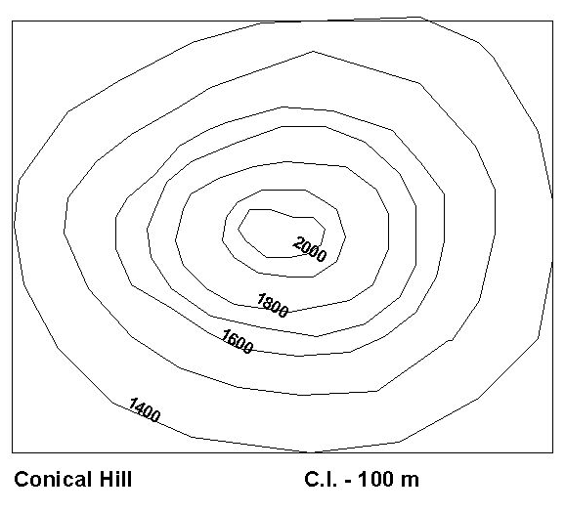
- Conical hills: a hill, which rises like a cone is called conical hill. It is represented by contours, which are nearly circular. The outer most contour represents minimum height and the inner most contour represents maximum height.
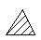

Figure 3.35: Conical hills
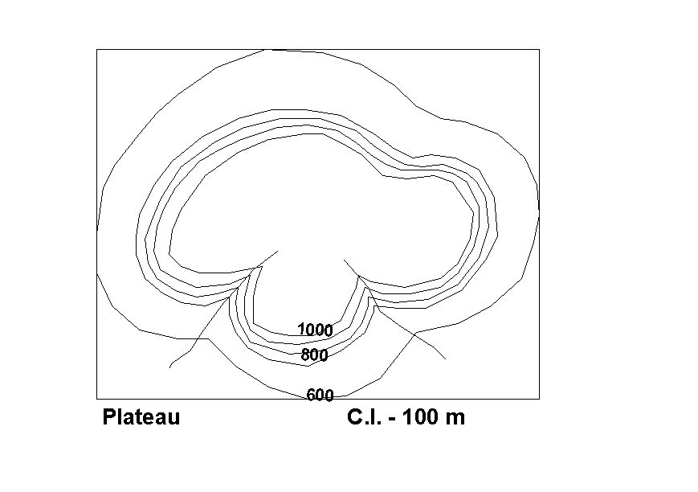
- Plateau: the surface of the plateau being more or less level is represented by widely spaced contours. The slopes surrounding the plateau being steep and hence represented by closely spaced contours.

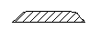

Figure 3.36: Plateau
V- Shaped valley: it is shown by V-shaped contours; the outermost contour represents the maximum height and the innermost contour the minimum height.
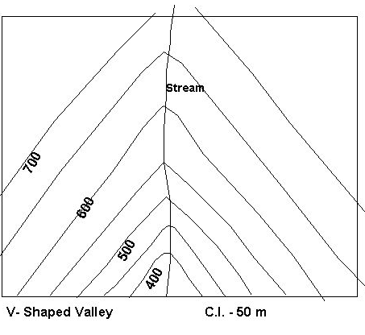
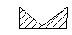

Figure 3.37: V- Shaped valley
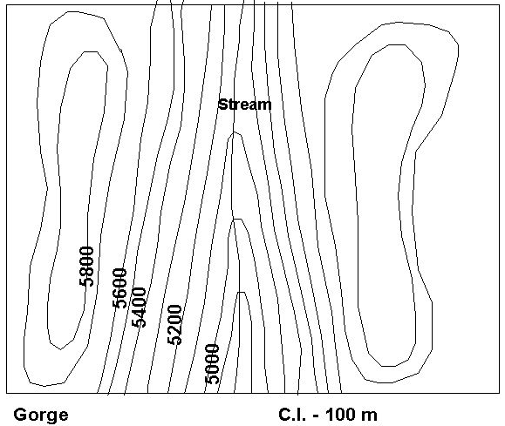
- Gorge: it is a deep narrow valley with precipitous sides. The sides of gorge are represented by closely spaced contours.
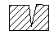

Figure 3.38: Gorge
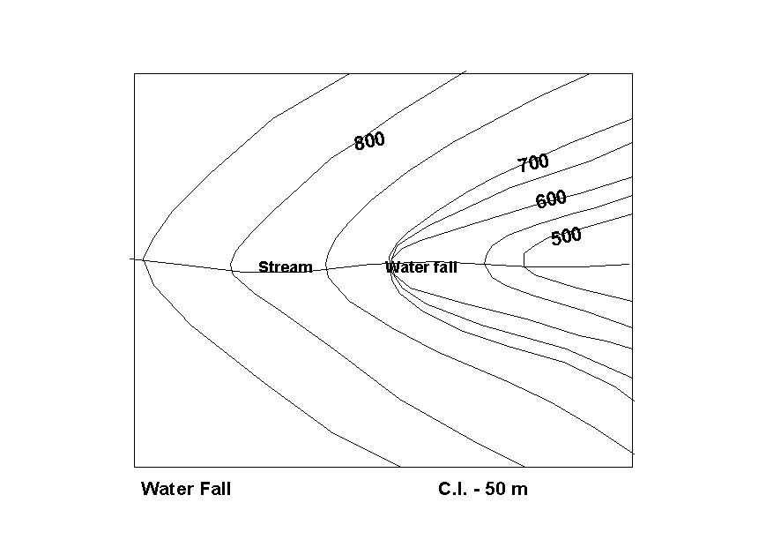
- Waterfall: in the mountainous areas, a section of a valley becomes very steep almost vertical. A stream flowing over a vertical slope makes a waterfall. As waterfall is vertical it is represented by contour, which merges into each other.
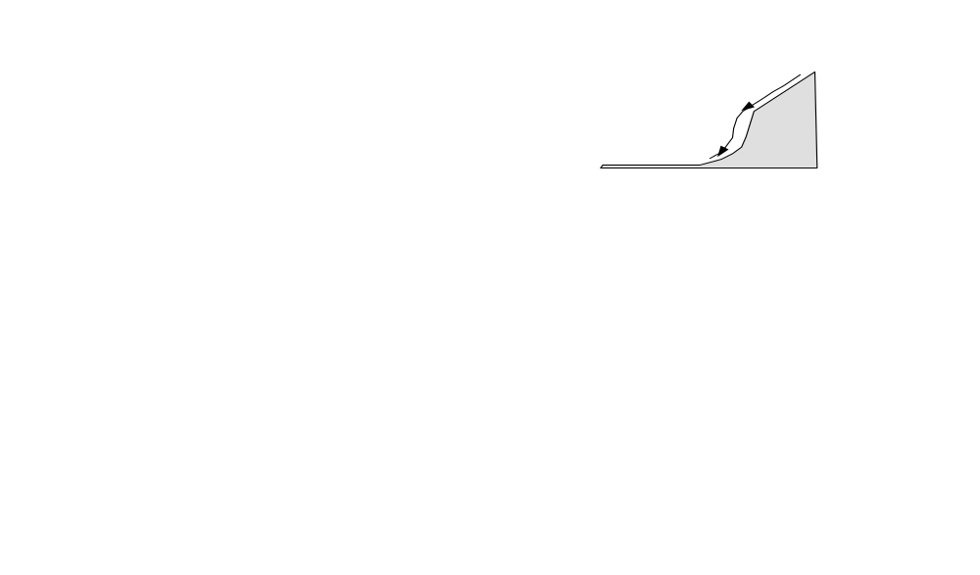

Figure 3.39: Waterfall
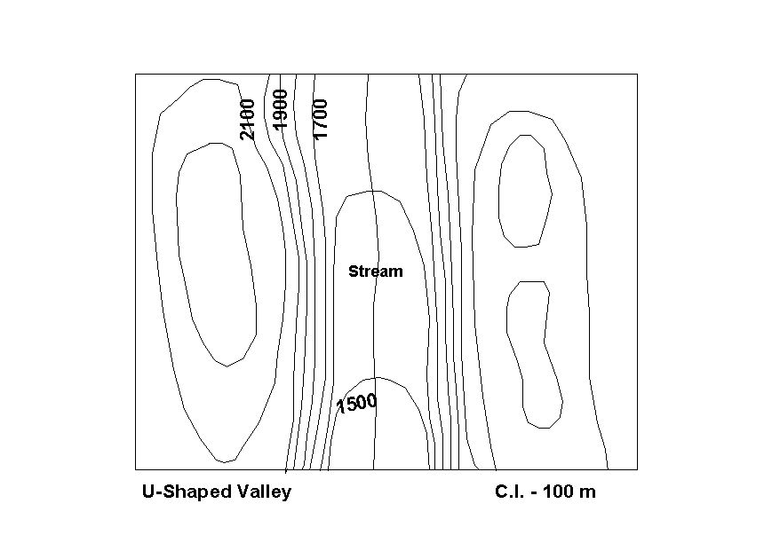
- 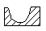U-shaped valley: the side of U-shaped valley is very steep and bottom is flat. Therefore each sides of U-shaped valley are represented by closely spaced contours and its floor by widely spaced contours.

Figure 3.40: U-shaped valley
Hanging valley: it is a tributary valley at much higher elevation than the main valley. The stream draining a hanging valley flows over a precipitous slope before joining the river of main valley. But because of quite cut, the slope of hanging valley are represented by closely spaced contours. The slope becomes very steep where it opens into the main valley
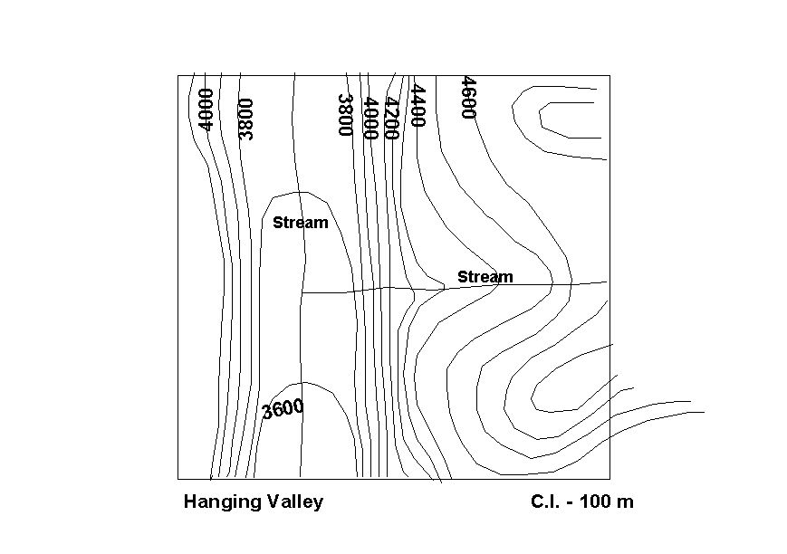
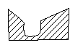
HV

Figure 3.41: Hanging valley

- Ridge: it is narrow but long high land, sloping steeply downward on its sides. Its length is much greater than its width. It generally connects two hills and represented by narrow closed
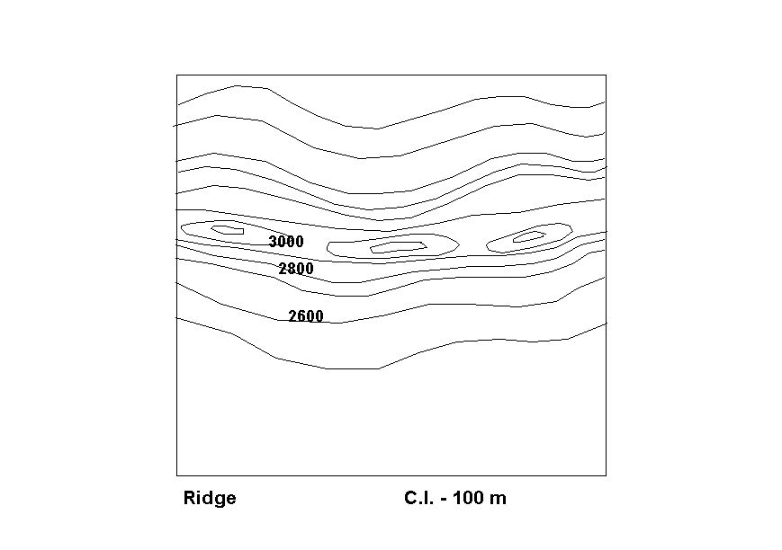
- contours.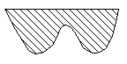

Figure 3.42: Ridge
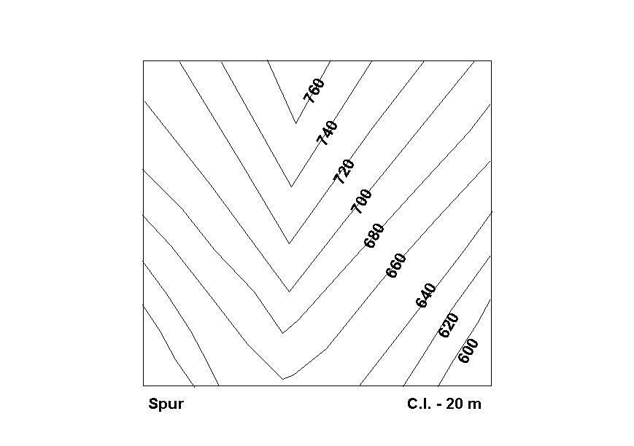
- Spur: a ridge projecting from the main body of mountain towards low ground is called spur. It is represented by v-shaped contours. The outermost contour shows the minimum height but the innermost contour the maximum height.

Figure 3.43: Spur
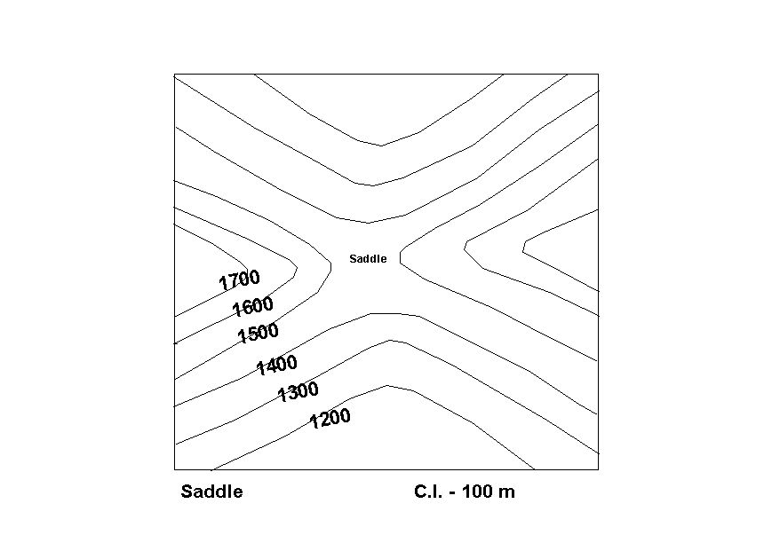
- Saddle: it is lower part connecting two hills and separating two low lands. It is used as pass. It is shown by space between contours representing hills.
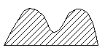
Saddle

Figure 3.44: Saddle
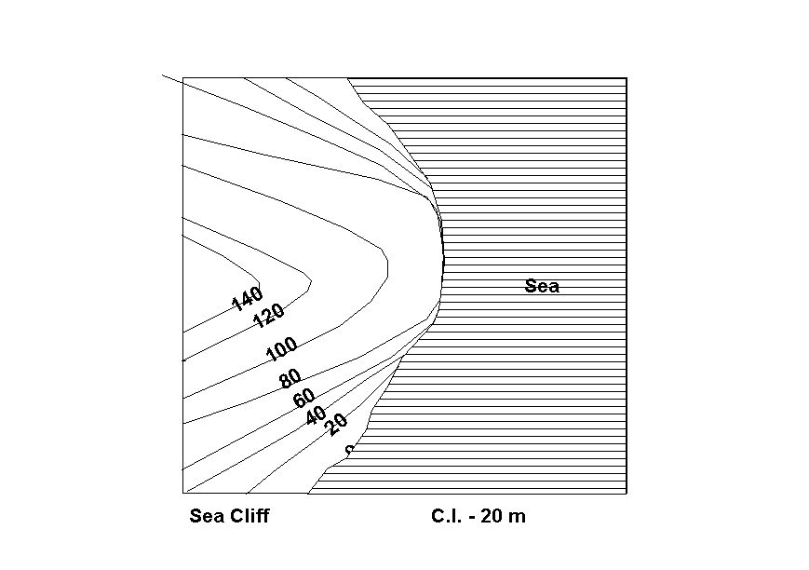
- 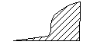Cliff: a higher and precipitous slope is called cliff. It is shown by contours, which often coincides.

Figure 3.45: Cliff
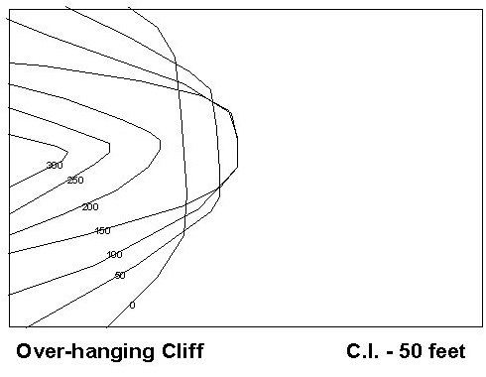
- Over hanging cliff: it is a cliff the upper part of which overhangs its lower part. The contour representing the upper overhanging part crosses those representing lower part.
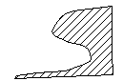
Figure 3.446: Over hanging cliff
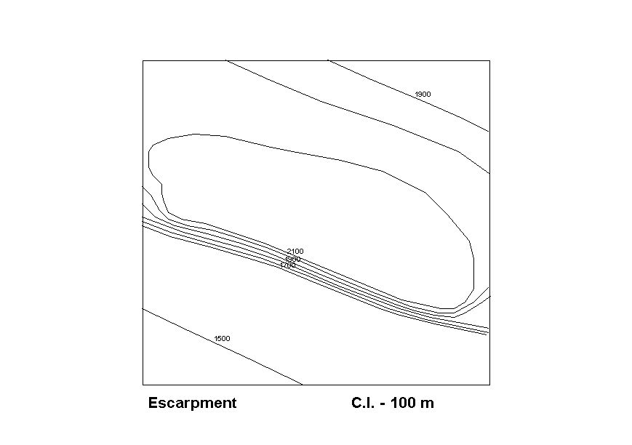
- 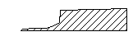Escarpment: it is high but very steep face of hills or plateau of considerable length. The upper part of which is represented by widely spaced long contours and its faces are represented by closely spaced contours.

Figure 3.47: Escarpment
- Dissected plateau: when plateau cut by deep valley and gorge it is called dissected plateau.
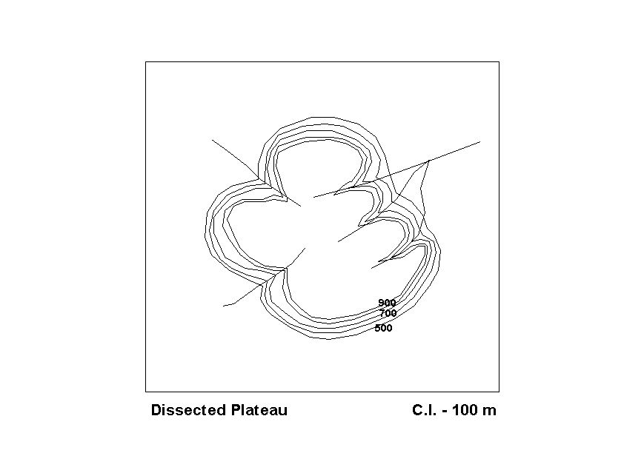
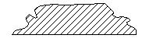

Figure 3.48: plateau
- Cirque: it is large hollow shape formed as result of glacial erosion on the
- side of the mountain and it appears like an arm chair. It has generally a lake, which is drained, by stream through a gap. The slope forming its back and sides rises steeply but the slope forming the side through which stream flows falls steeply. The contour representing the back and sides except the one through which the stream flows are closely spaced. Its bottom is nearly level and represented by widely spaced contours.
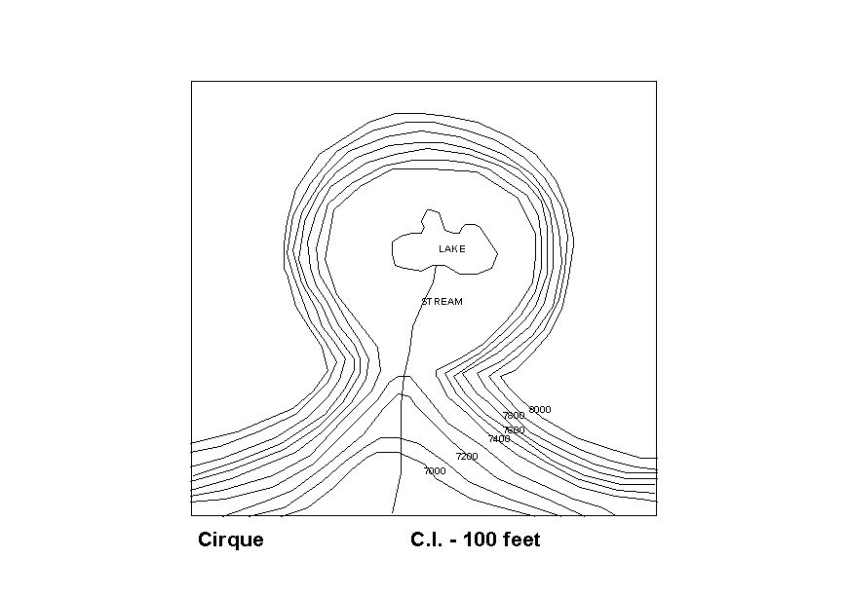

Figure 3.49: side of the mountain

Resizing Map
Enlargement and reduction of maps
The number of times you can increase the original scale is of course decided by the size of the paper that is at your disposal. Suppose you are enlarging two times. Draw a frame of your new map in such a way that the sides are double to the sides of original map.
Cover the original map with a grid of 0.5 x 0.5 cm squares (grid), drawn with a soft pencil so that it can be removed later. Cover your map under construction with a 1 cm x 1 cm squares. Using grid as guide, trace the major features that you want to show on your enlarged map carefully with the pencil. Finalize you map using, ink, color etc for the different features that you wanted to show. Give other marginal information of the map. Check your work carefully. Remove your gridlines from the map.
This method of enlargement or reduction of scale can be used for any kind of drawing and the result is relatively accurate if your measurement and tracing are carefully done.
Example: Given original Scale 1:50,000
Then Increased Twice – 2/50,000 = 1:25,000 will be scale of new map
Increased four times – 4/50,000 = 1:12,500 will be scale of new map
Decreased Twice – 1/2x50, 000 = 1:100,000 will be scale of new map
Decreased four times – 1/4x 50,000 = 1:200,000 will be scale of new map
And so on.

Self check 2 | Written test
Test-I Matching
Instruction: select the correct answer for the give choice. You have given 1 Minute for each question. Each question carries 2 Point.
1.Contour line A. The first inspection of the target.
2.Horizontal distance B. Short line drawn in the direction of slop
3. Reconnaissance C. Same elevation have shaded different colour
4. Spot height D. Upper -Lower x100
5.Hachuurs E. An imaginary line connect equal elevation
6. Hill shading F. Accurate attitude for individual point
Test II: short Answer writing
Instruction: write short answer for the given question. You are provided 3 minute for each question and each point has 5Points.
1.Righte kinds of measurement
2. Right recommence survey activity
3.Right content of map
4.list and describe contour character.
Part III: Short answer writing
Direction: Give short answer to the following questions. Time allotted for each item is 2mniut and each question carry 5 point.
1.Relif represented by _____________ ________________ _____________
2.If contour elevation is reduce from inside to outside is ___________________
3.If the contour interval is close each other it _________________________
Note: Satisfactory rating – above 60% Unsatisfactory - below 60%
You can ask you teacher for the copy of the correct answers
Operation sheet 2 | Stadia tachometry
- Operation title: Topographic map by Stadia tachometry
- Purpose: Prepare Topographic map
- Instruction: Using the Equipment, Tools and material requirement below and do topographic map by Stadia tachometry . You have given one hour the task and you are expected to write the answer on the given line.
- Equipment, Tools and material requirement:
1.Theolight
2.Rage pole
3.Tape
4.Paper,
5. Calculator
6. Pencil.
Steps in doing the task
(1) Set up the instrument over the station
(2) Hold the staff on the benchmark and take the bearing, read the vertical angle and the top, bottom, and axial hair readings, (the line of sight may be horizontal or inclined).
(3) All the representative points under the command of the instrument station are located by taking the bearings, the vertical angles and the staff readings (to the top, bottom and the axial hairs).
(4) After all the representative points are located from the first station, take a foresight at the second station and note down the bearings. Vertical angle and the staff readings corresponding to the top, bottom and the axial hairs.
(5) Shift the instrument to the second station. Set up, center and level the instrument and measure the staff reading.
(6) Take a back sight to the first station. Also observe the bearings, vertical angle, and the staff reading to the top, bottom and axial hairs.
(7) As each station is sighted twice two Values for the distances and elevations of the stations are obtained which should be within the permissible limits; otherwise, the work should be repeated.
(10) Calculate distance from staff reading.
(11) Plot by using protractor and ruler.
- Quality Criteria: the collected angle date is measured with 00⁰00⁰02⁰ accuracy
Type of Instrument:________ Observer:_______________ Date:_____________
Additive Constant C =_0__ Multiplying Factor K=100
Instrument station:_________ Station height (BM) =____________ Instrument height --------
s = upper - lower = Staff intercept HD = ( Ks +C) cos²ν with: ν = vertical angle
Δh=( Ks + C) sin ν cos ν = HD(tanν) or HD = ( Ks +C) cos²ν with: ν = Zenit angle HD = Horizontal Distance H = BM + hi ± Δh – middle hair reading H = height of the new point
Inst  Stn. | Target | Horizontal angle |  |  | Vertical  Angle (ν) |  |  | Stadia readings  upper mid lower |  |  | S | HD | Δh | H | Remarks
1 |  | 2 |  |  | 3 |  |  | 4 |  |  | 5 | 6 | 7 | 8 | 9

UNIT FOUR:PREPARATION OF MAP BY APPROPRIATE SOFT WARE
This unit to provide you the necessary information regarding the following content coverage and topics:
- Topographic data collection by total station
- Map preparation by appropriate soft ware
This guide will also assist you to attain the learning outcomes stated in the cover page. Specifically, upon completion of this learning guide, you will be able to:
- Apply Topographic data collection by total station
- Apply Map preparation by appropriate soft ware

4.1. Topographic data collection by total station

4.1.1.What is Total station?
A Total Station is a modern surveying instrument that integrates an electronic theodolite with an electronic distance meter.
A theodolite uses a movable telescope to measure angles in both the horizontal and vertical planes. Traditionally they are manual instruments that come in two types – transit, which rotates in a full circle in the vertical plane, and non-transit, rotating in a half-circle.
Total Stations use electronic transit theodolites in conjunction with a distance meter to read any slope distance from the instrument to any particular spot. They are hence two essential surveying instruments in one and when used with other technology such as mapping software are able to deliver the ‘total’ surveying package, from measuring to mapping.

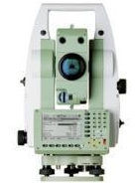
Figure 4.1. Total station instrument

Operation sheet 4 | Data collect by Total station
- Operation title: Topographic data collection
- Purpose: Prepare Topographic map
- Instruction: Use the given below operation sheet the collect topographic data by total station. For this operation you have given 3Hour and you are expected to provide the answer on the given table.
- Tools and requirement:
- Total station
- Reflector
- Computer
- Paper
- Gps
- Precautions: Check " BM" With zero precision
- Procedures in doing the task

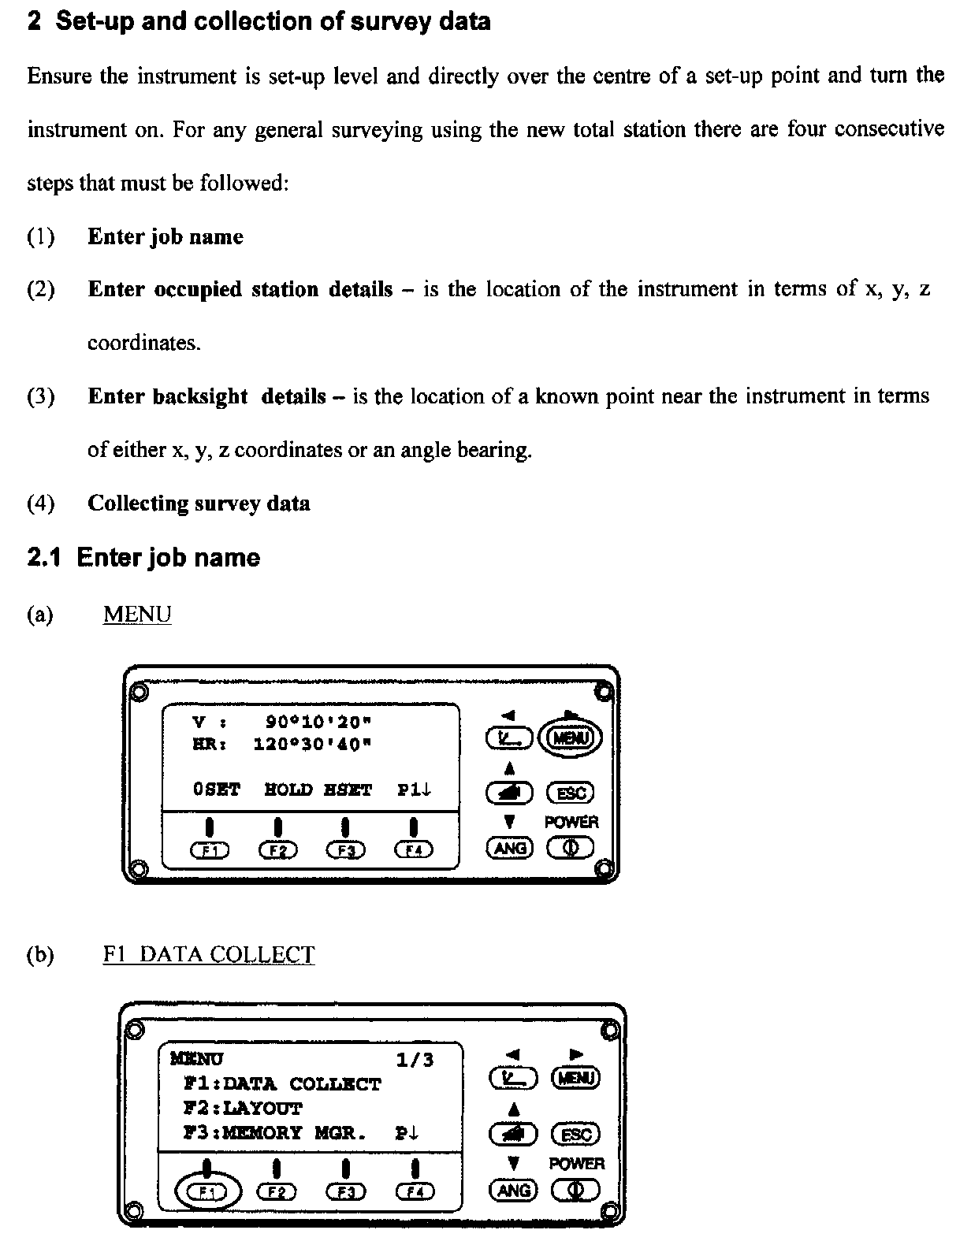

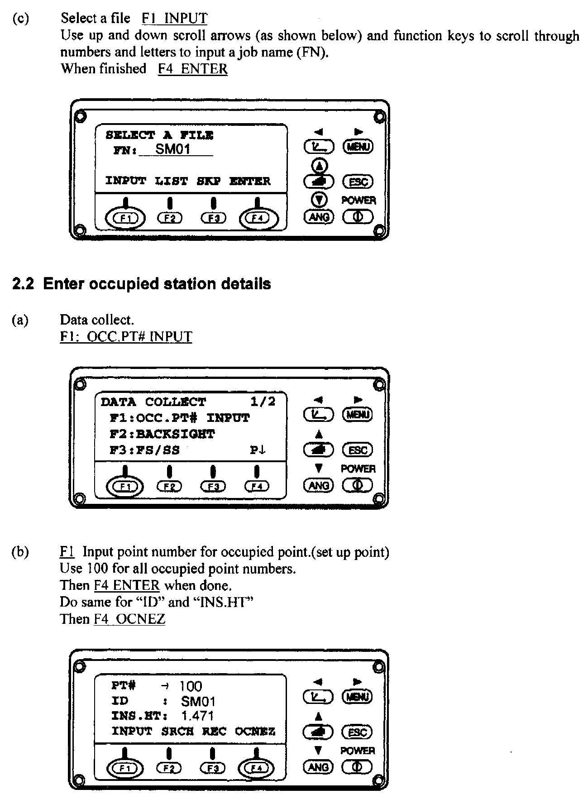

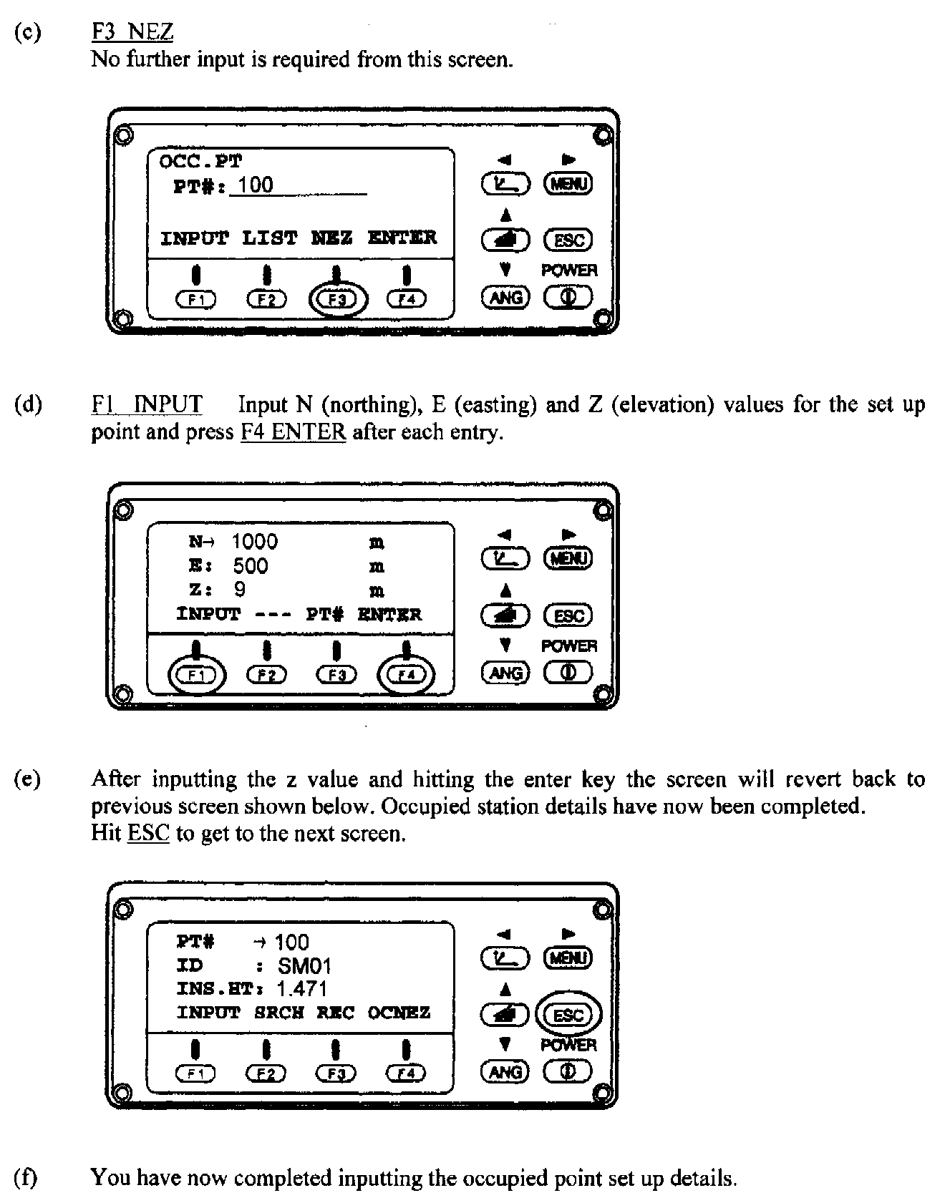

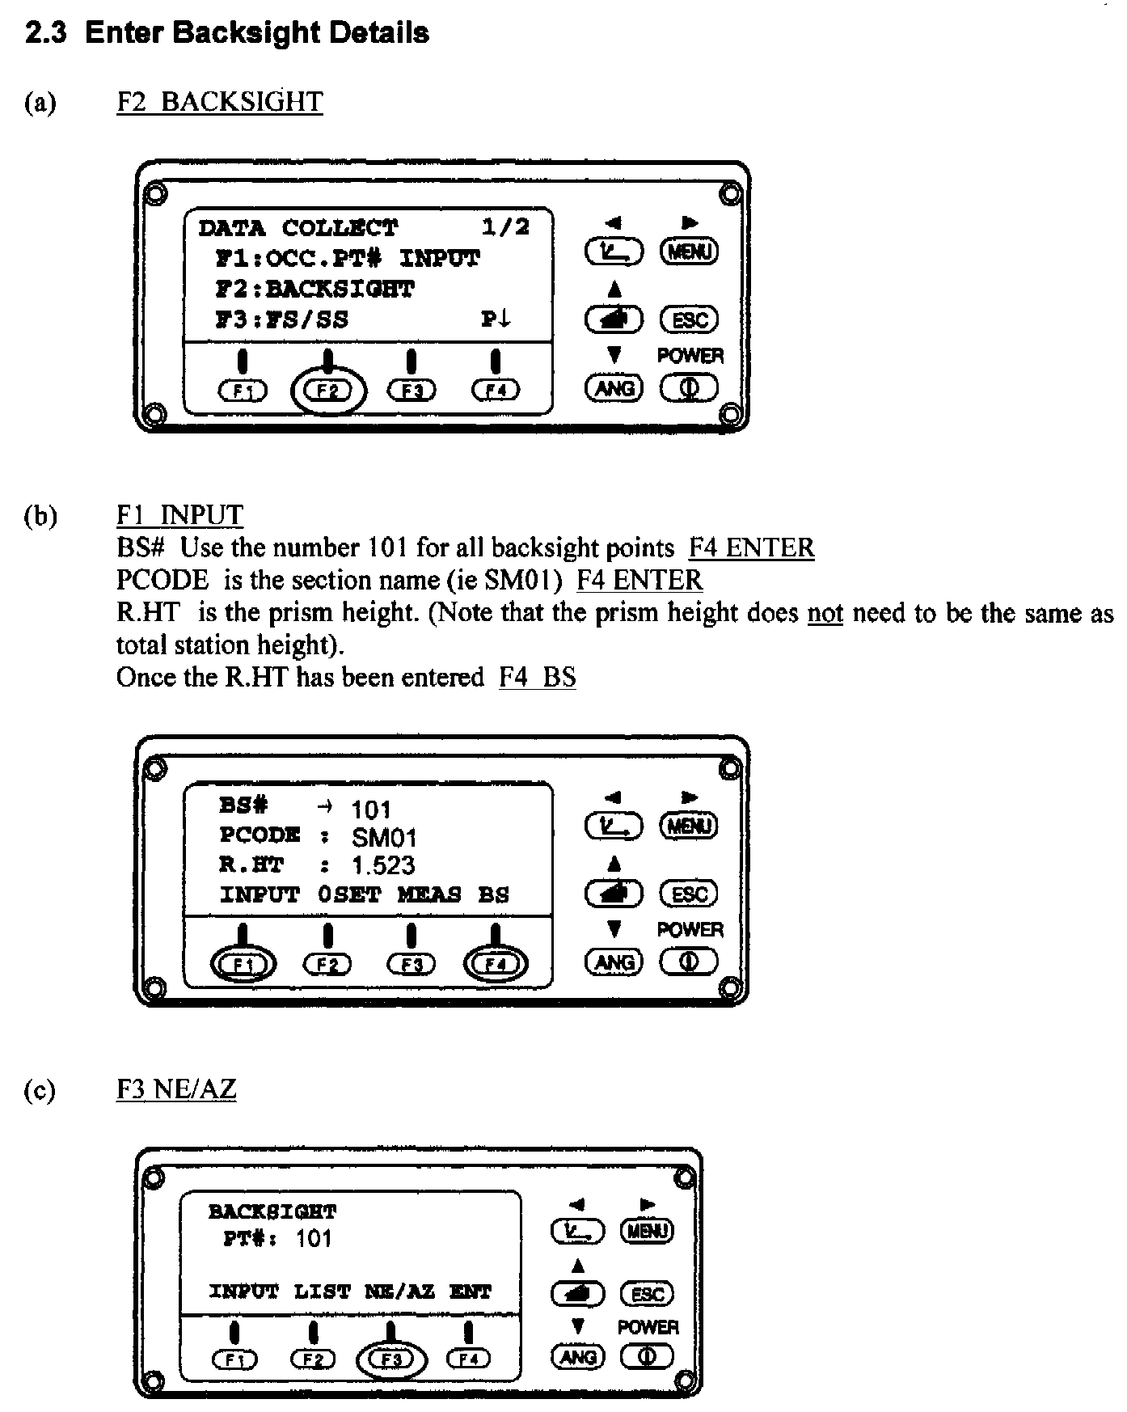

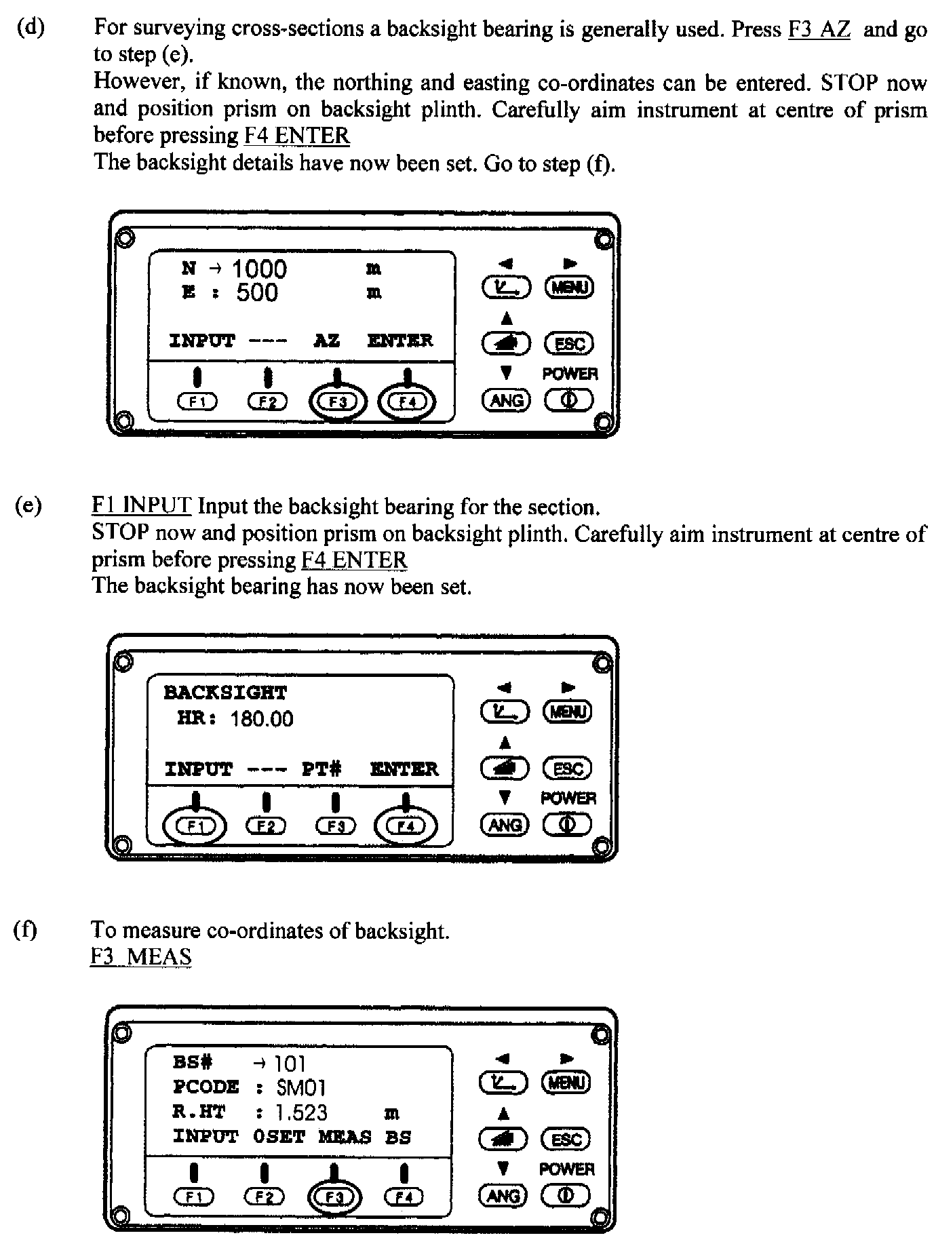

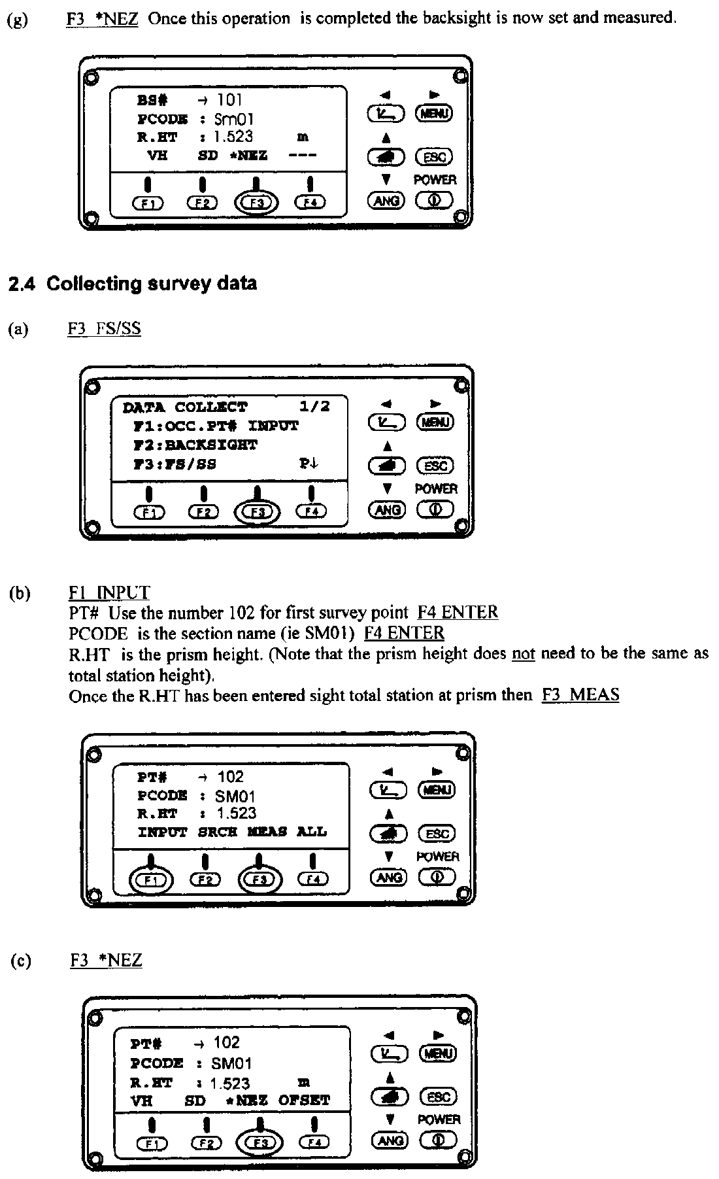

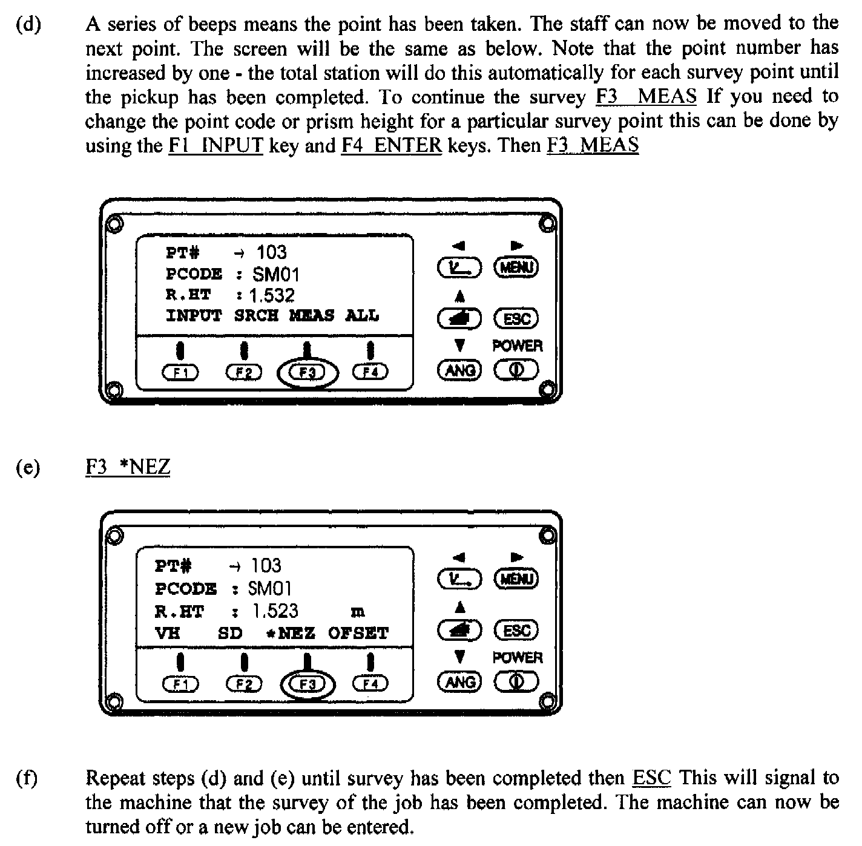

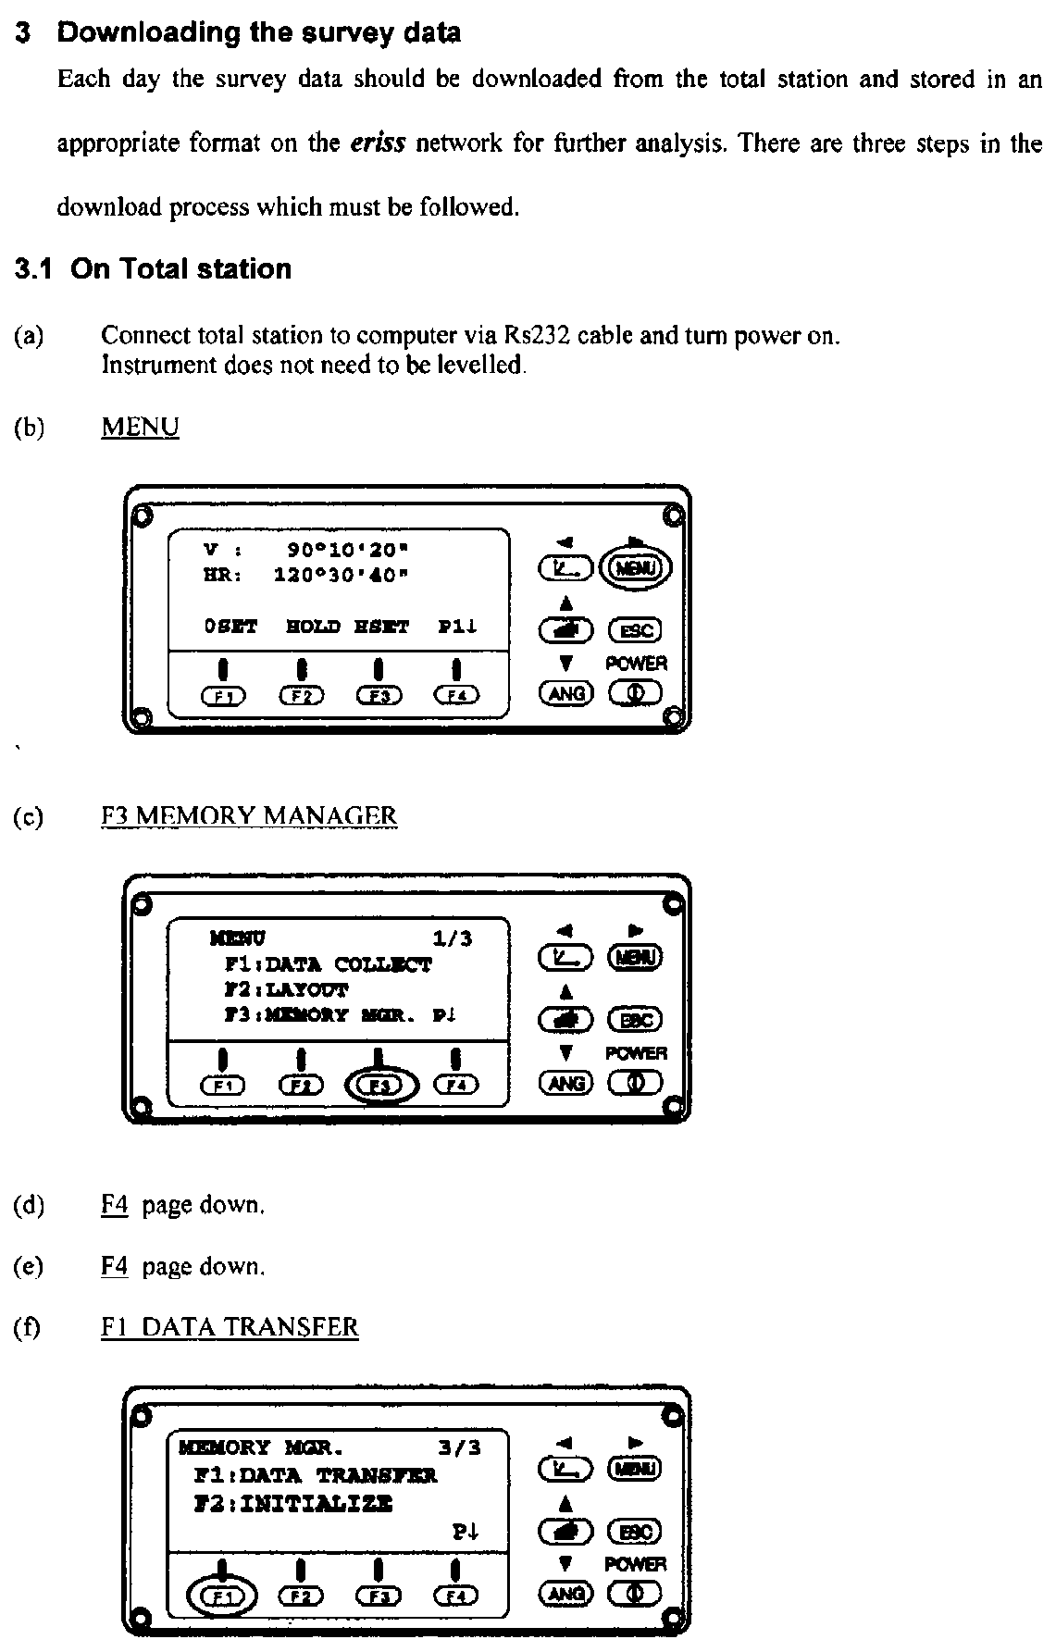

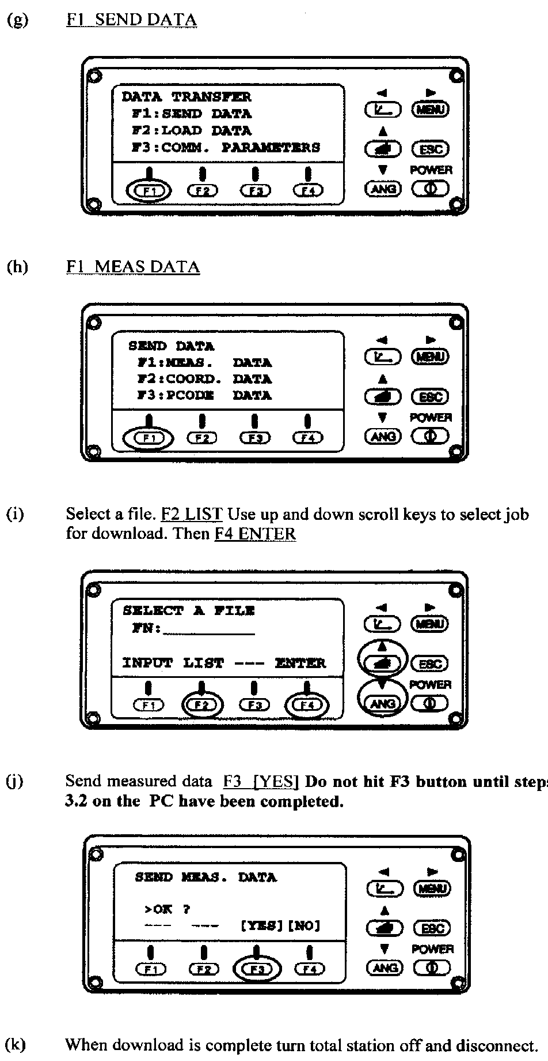

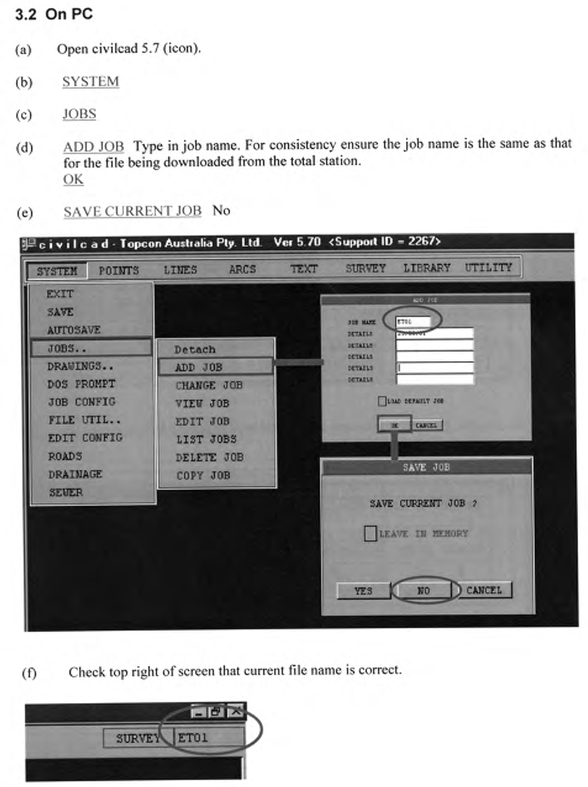

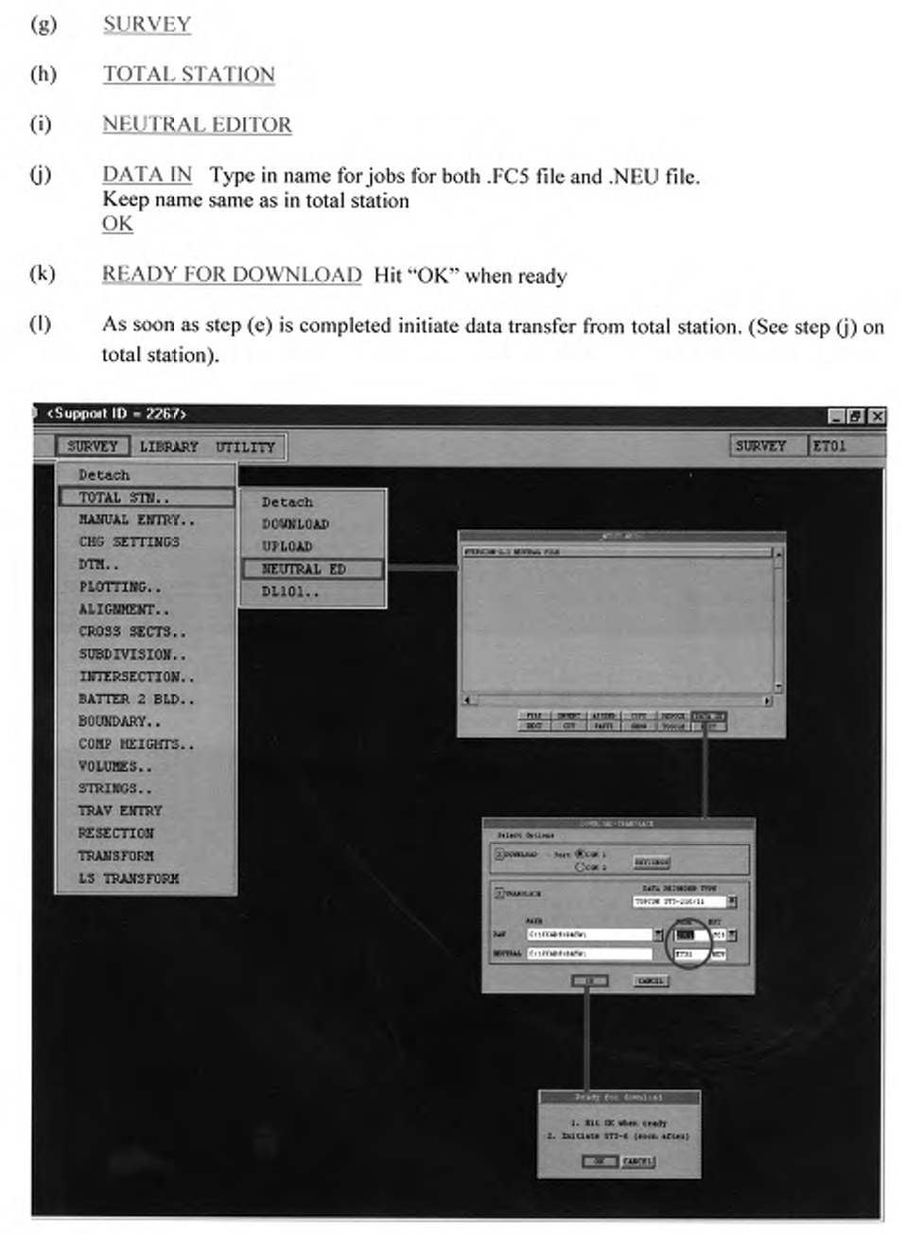

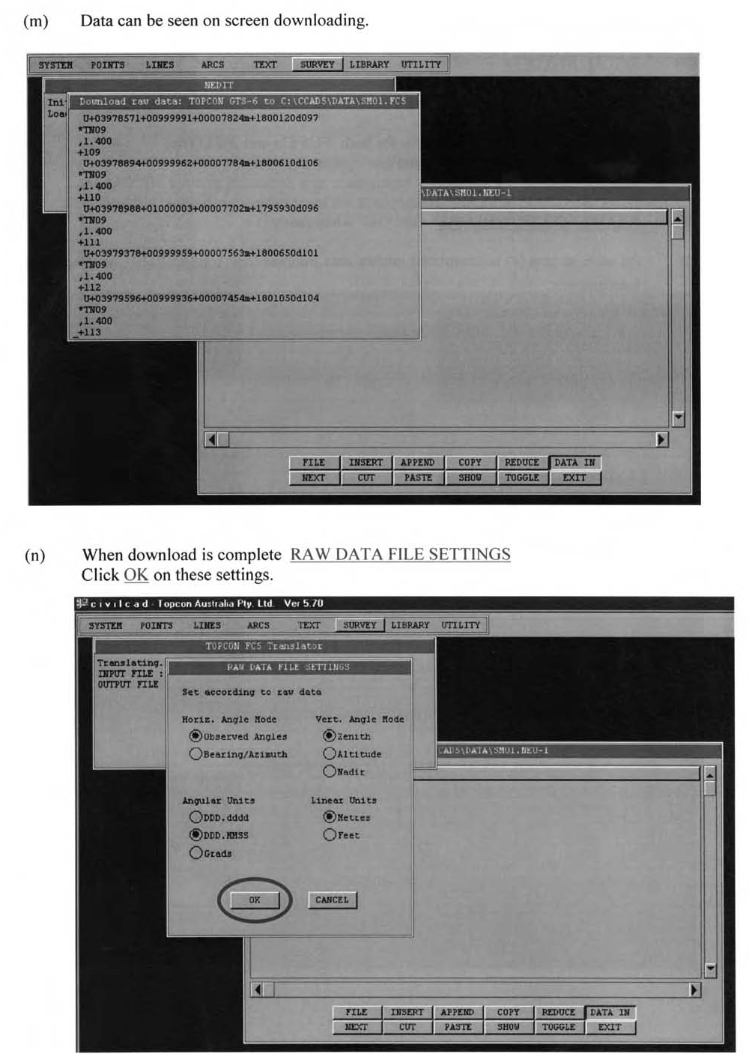

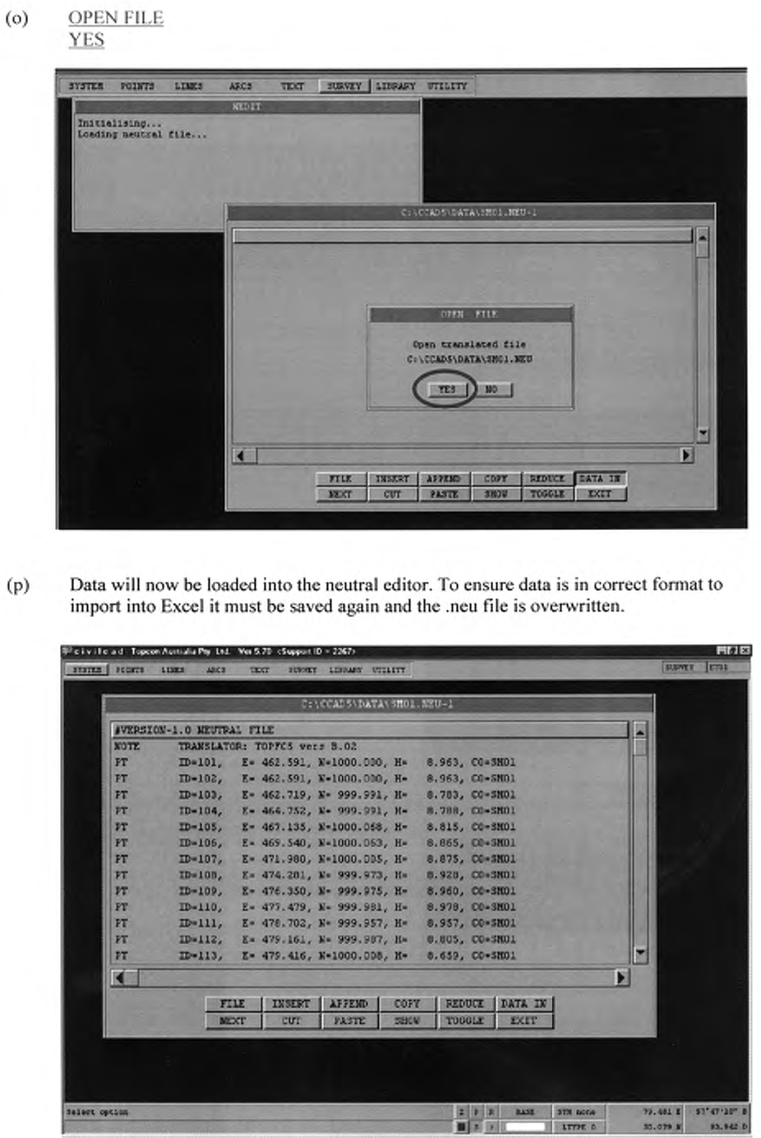

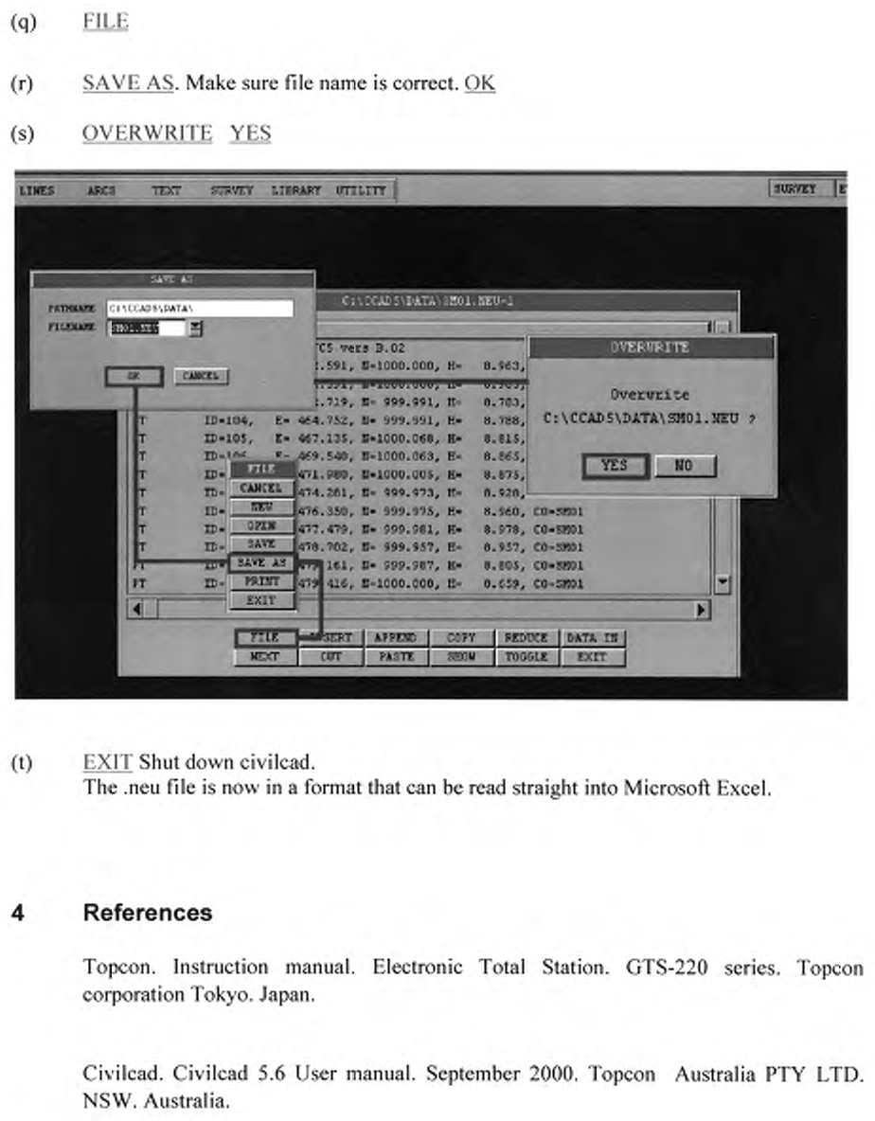

Operation sheet 4.2 | Preparation of Top map by eagle point

4.1 Creating and Starting Eagle Point Project

1. Start Eagle Point software by double clicking on the Eagle Point software found on your desktop or Eagle Point program group.
The Eagle Point menu (Figure) displays and the open dialogue box displays.
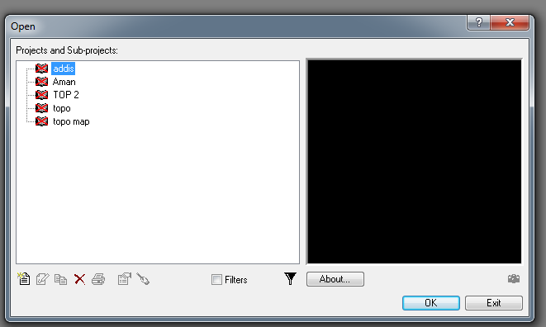
2. Click on crate new project icon
3.Click next
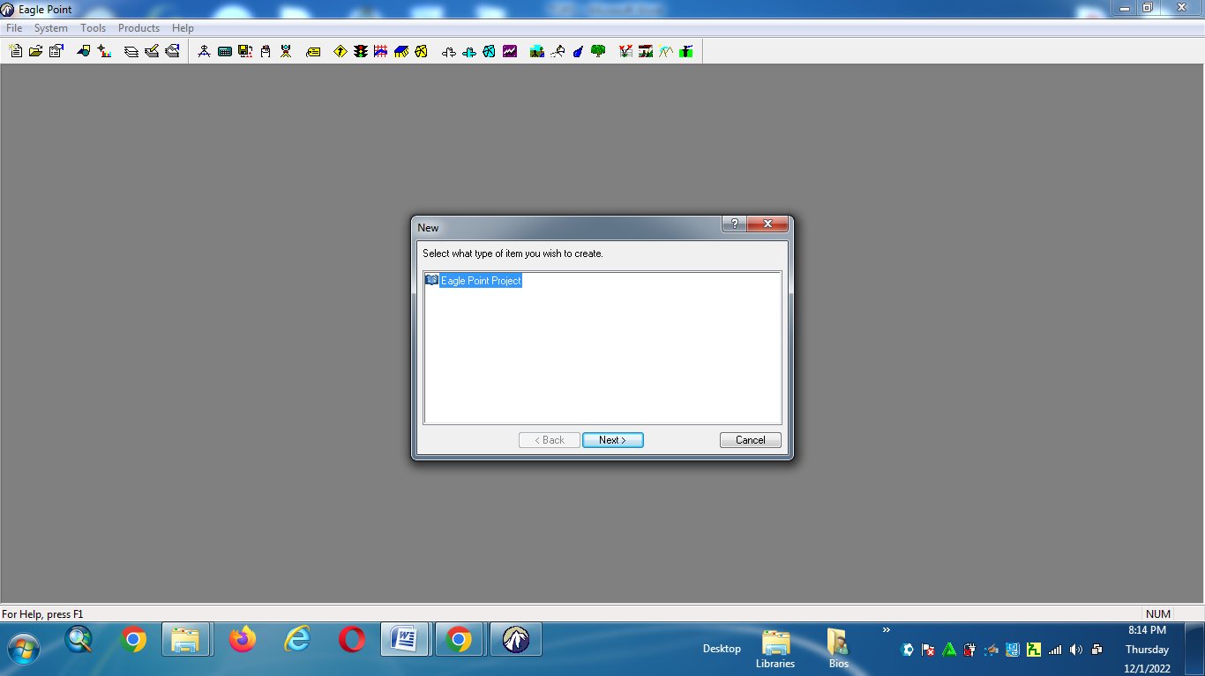
4.Finish
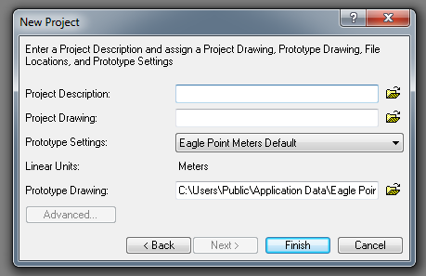

5. Ok

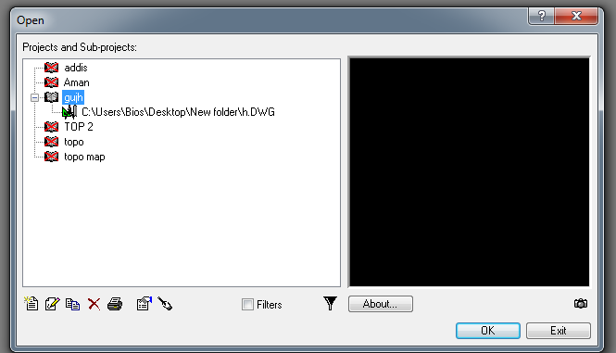
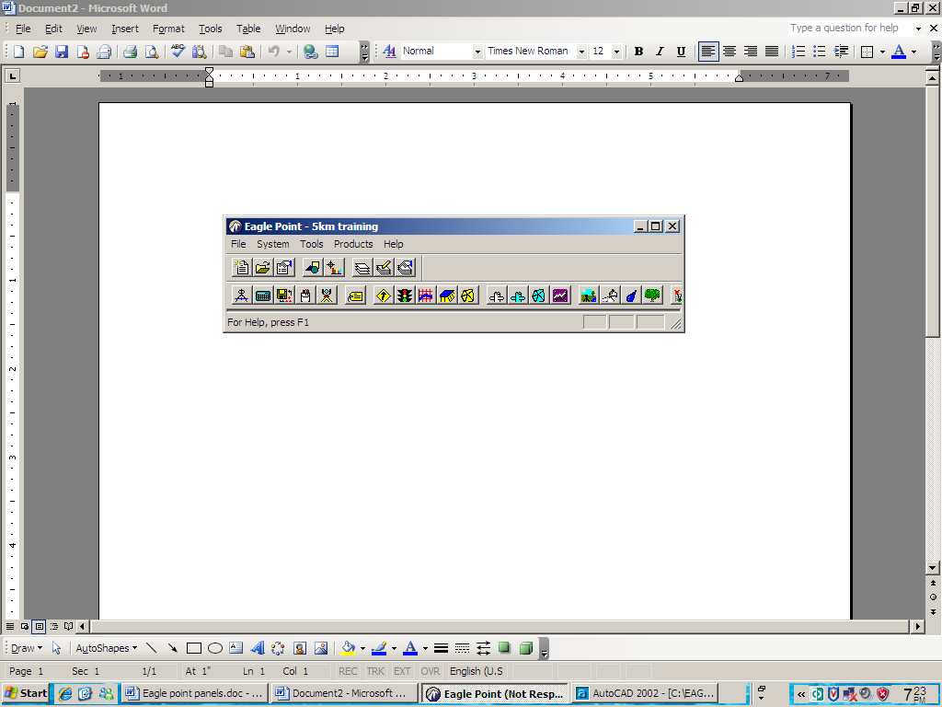
- Click on the Create New Project Icon
Sub-project icon on the open dialogue box displays the new dialog box.
3. From the new dialogue box select eagle point project from the list of available items and click on the next bottom.
Which displays the new project dialogue box.
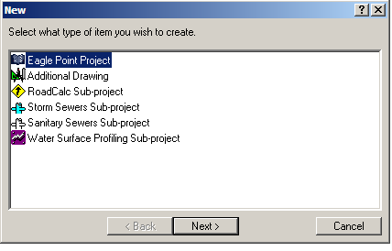

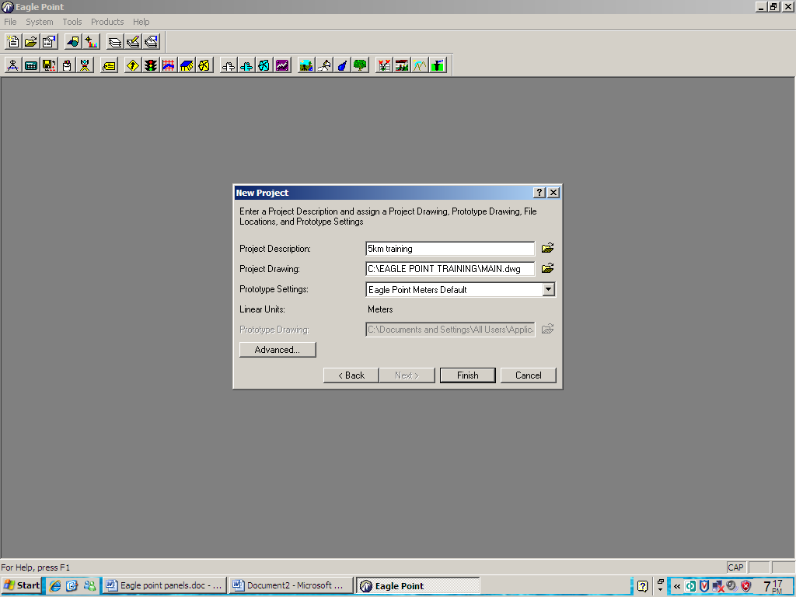
4.1.1 Units
Select units form the system pull down menu to display the unit’s dialogue box.

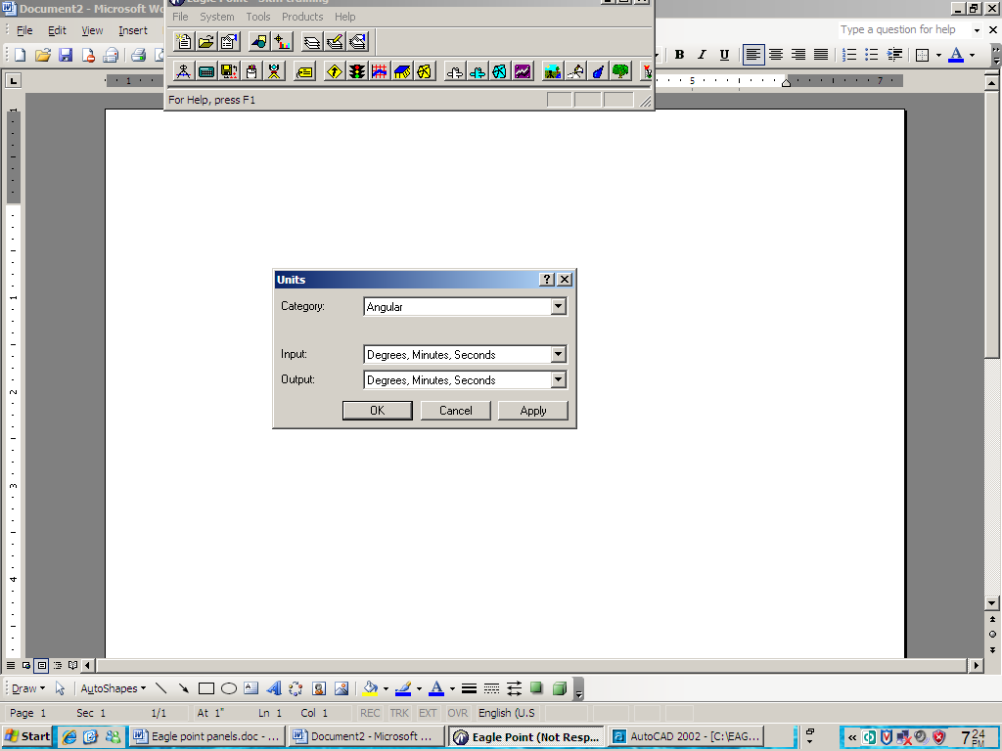
ANGULAR
Select Angular from the category drop list.
1. For both input and output make sure that Degree, Minutes, Seconds are selected.
2. Click apply to save the changes made in the dialog box.
DEGREE OF CURVATURE
1. Select Degree of Curvature form the category dropdown list.
2. Select Arc definition from the input /output drop list.
3. Type 20 in the length edit field.
4. Clicks apply to save the changes.
LINEAR
1. Select linear from the category drop list in the units dialogue box.
This allows you to review the type of linear units associated with this project since you have already specified Eagle Point Meters Default as the project's prototype

settings value when you created the project.

PLAN METRIC AREA

1. Select plan metric Area form the category drop list.
2. For both input/output, make sure square meters are selected from their respective drop list.
3. Click OK to save the changes.
4.1.2 Formats
Select formats from the system menu to display the formats dialog box.
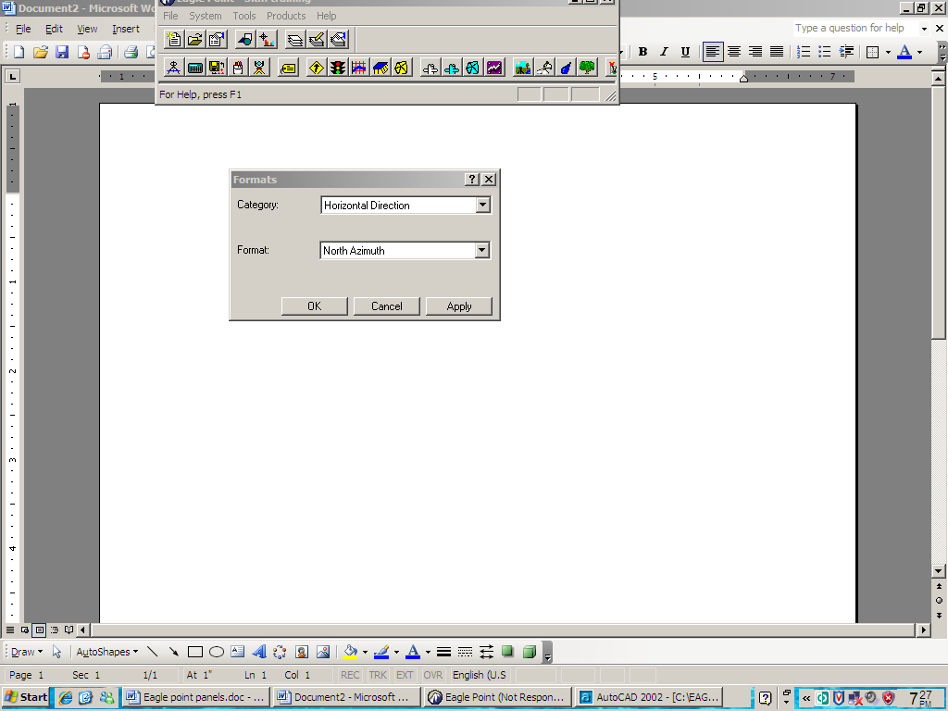

HORIZONTAL DIRECTION
1. Select Horizontal Direction from the category drop list in the formats dialog box.
2. Select North Azimuth from the formats drop list.
3. Click on apply to save the changes.
NODES
4. Select nodes form the category drop list in the formats dialog box.
- Select Numeric from the Id format drop list.
- Make sure point protection* is toggled on.
- Click apply to save the changes
- * Checks the Node number of a Node that is being place against the node number that has already been specified.
STATIONING
9. Select stationing from the category drop list tin the formats dialog box.

10. Select 0+000 from the format drop list.
11. Click OK to save the changes.
4.1.3 Precision
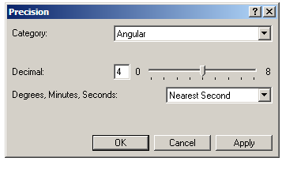
Select precision from the system menu to display the precision dialog box

ANGULAR
1. Select Angular form the category drop list.
2. Set the decimal slider to 4.
3. Select nearest second from Degrees, Minutes, and Seconds drop list.
4. Click apply.
LINEAR
5. Select linear from the category drop list.
6. Clicks apply to accept the default value of 3 decimal places.
7. Select also plan metric area. Dry volume, Wet Volume, station off set consequently and apply the default value of 3 decimal places precision respectively.
4.1.4 Scales
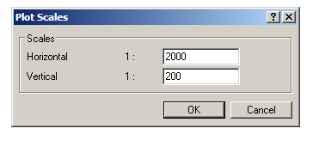
1. Form the Eagle Point menu bar, select Tools Plot scales

2. Type 2000 in the horizontal scale edit field.
3. Type 200 in the vertical scale edit field.
4. Click OK to commit your settings.
4.1.5 CAD Settings
Eagle Point provides a tool whereby you can set default CAD parameters for the majority of CAD objects that are constructed by Eagle Point.
DEFAULT CAD SETTINGS
1. Select system Default Cad Settings
2. Set a consistent text size for any incoming annotation that can be place.
3. Highlight the annotate alignment entry.
4. In the next grouping make sure plotted menu is selected.
5. Type 10 in the plotted size edit field.
6. Click on ok when you have finished to dismiss the default CAD setting dialog box
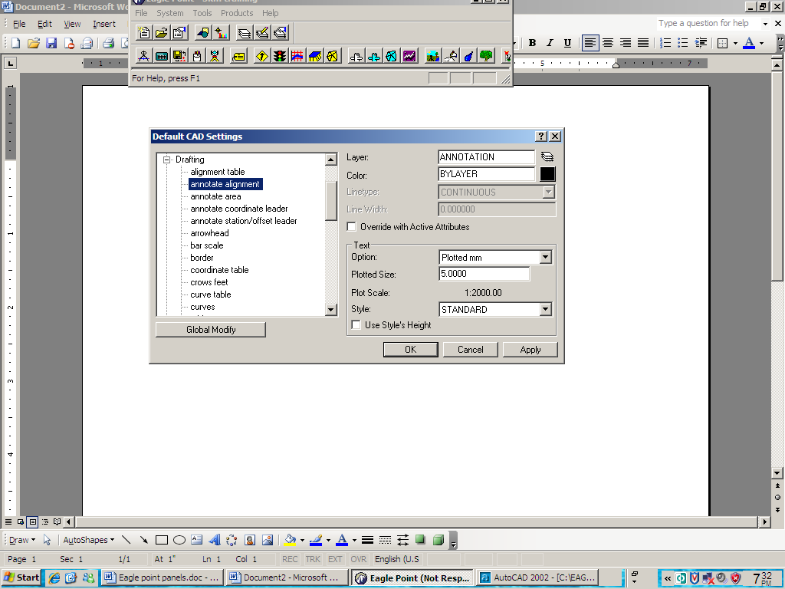
4.1.6 Prototype Settings
1. Select system prototype settings
This command allows you to create a Proto type of the system settings for use in new projects, thereby allowing you to customize the software to your requirements

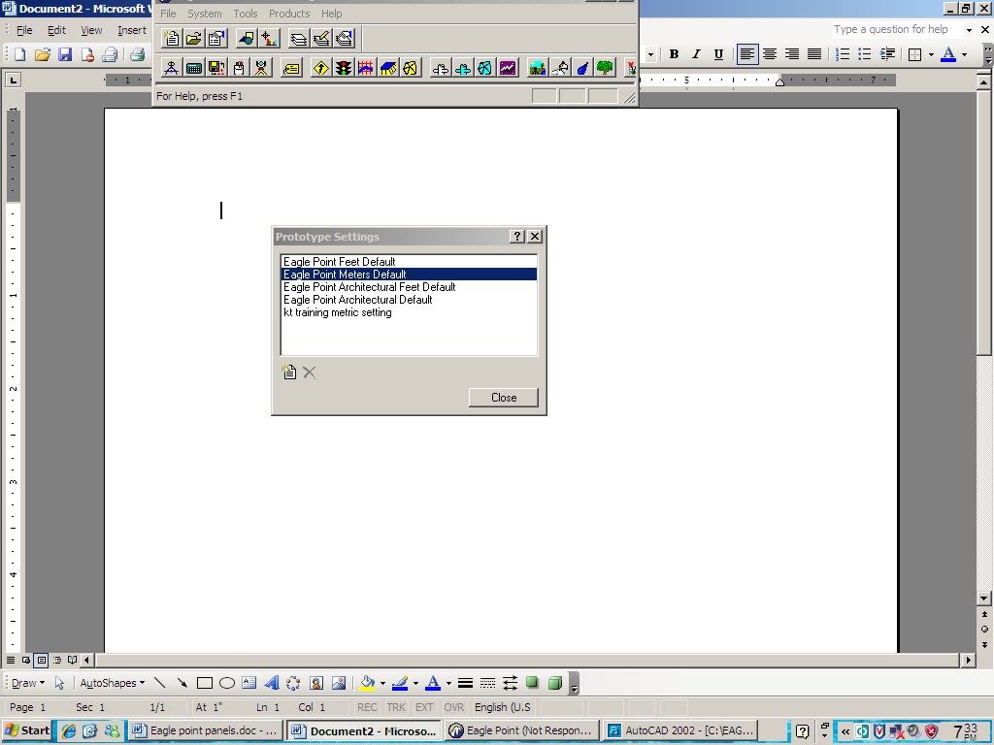

2. Click on the create new proto type icon to create a new group of settings and show the new plot type dialogue box.
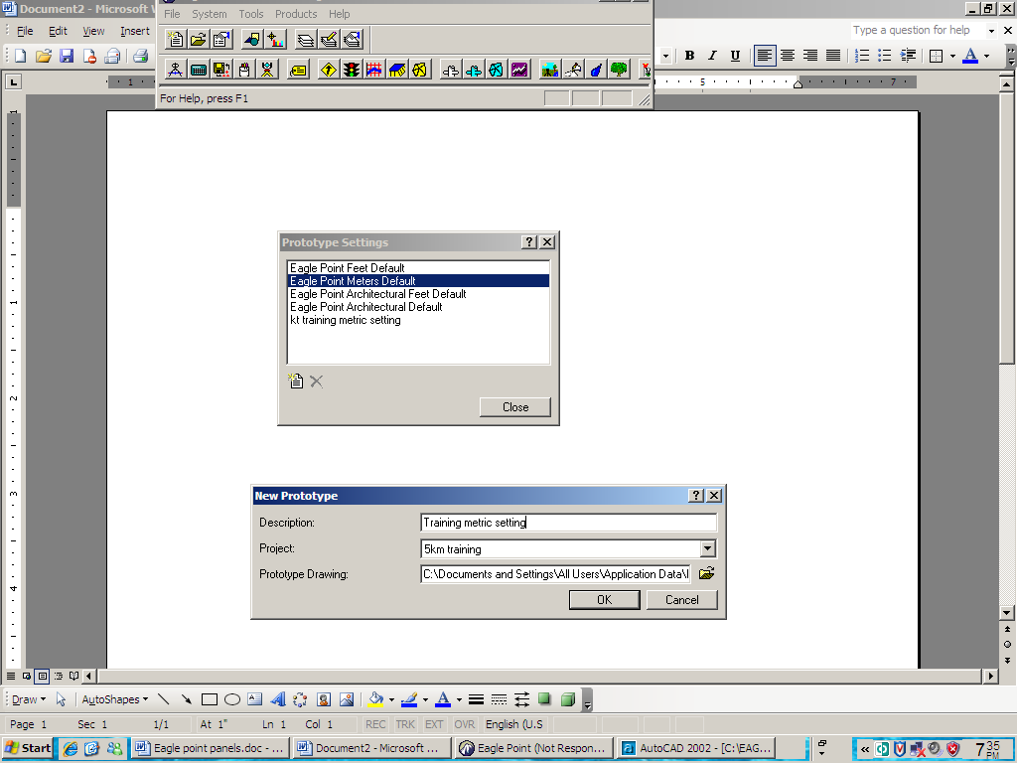

3. Supply a meaningful description of this named setting.
TYPE: Training Metric Settings in the description field.
4. Select your project from the project drop down list.
5. Indicate the name of the desired proto type CAD graphic to use when this named collection of settings is used.
6. Click OK.
7. Click close on proto type settings
4.2 Setting up a surface Model
To create and define a new surface model, complete the following steps.
1. In Eagle Point, select products Surface Modeling
2. In surface Modeling, select prepare Manage Surface Models

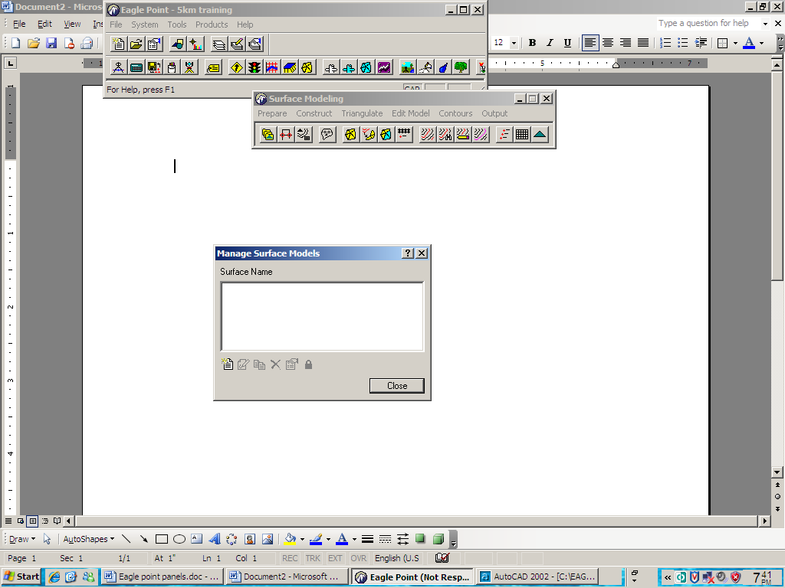
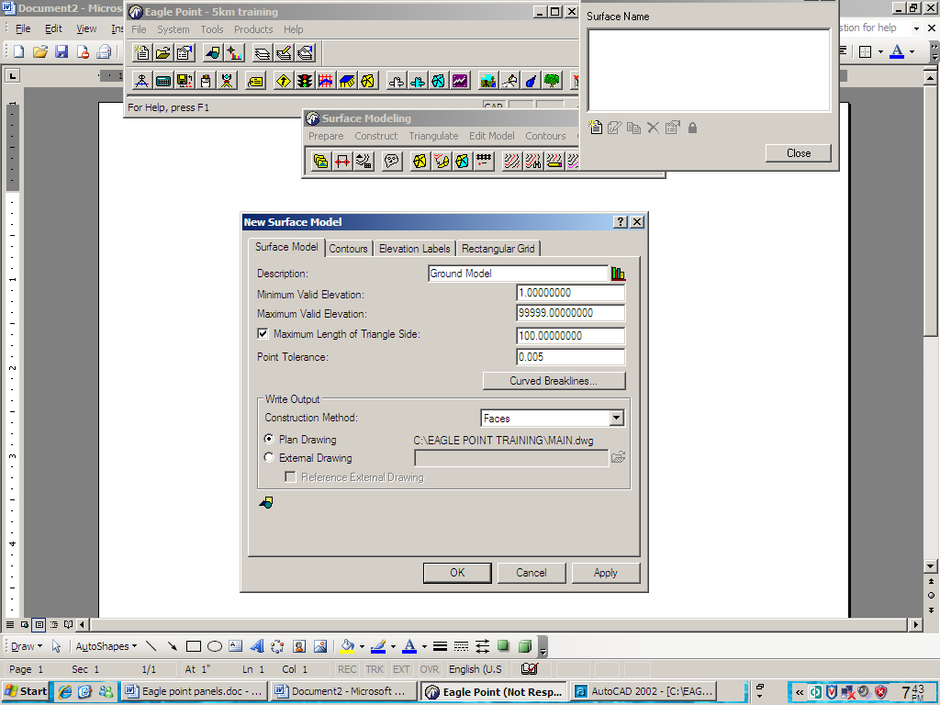
3. Click on the new surface Model icon then the new surface model dialog box displays

4. Type ground model in the description edit field
5. Type the information in to the appropriate fields in the surface model dialog box.
6. Click on the CAD settings icon. The CAD settings dialog box displays
7. Set the values of the settings to those specified in the following table click on OK in the CAD settings dialog box when complete.
CAD Settings
Layer OGL – TIN
Colour by layer
8. Click Apply

9. Click on the contours tab of the new surface Model dialog box
10. Set the values of the contours into the appropriate fields as follows
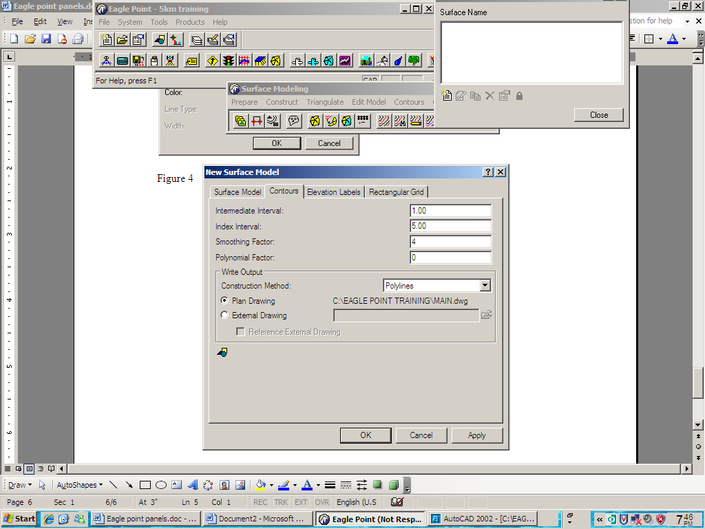

11. Click CAD settings Icon
12. set the values of the settings as follows:
Index Contour
Layer IDX - Contours
Colour 2
Line type By layer
Width 0
Intermediate contours
Layer Contours
Colour 1
Line type By layer
Width 0
- Click on apply in the new surface model dialog box

- Click on the elevation labels tab of the new surface model dialog box

- Type the information into appropriate fields in the elevation labels tab as follows

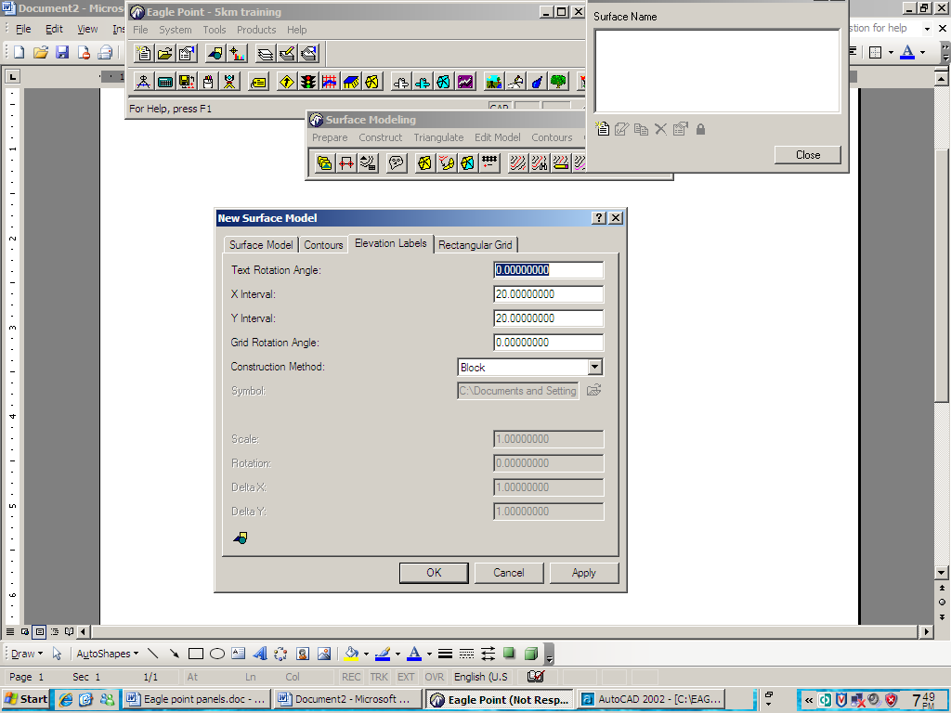

16. Click apply
17. Click on rectangular grid tab of the new surface model dialog box
18. Type the information into the appropriate fields in the rectangular grid tab
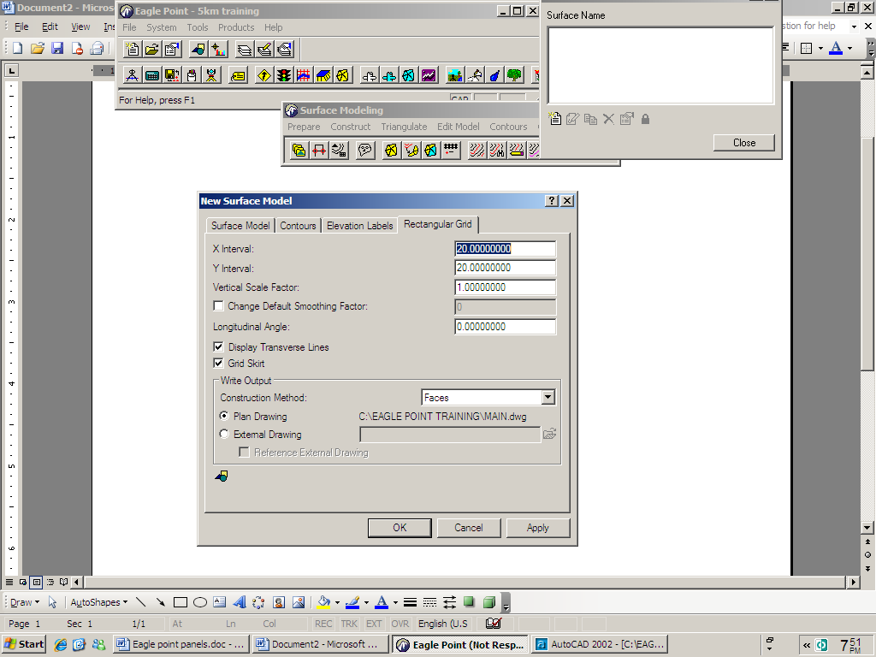

19. Click on CAD settings icon
20. Set the values of the settings to those specified in the following table. Click on OK in the CAD settings dialog box when complete
Layer Grid

Colour 3
21. Click apply
22. Click close
4.3 Importing Survey Data
- Open Excel and view your coordinate data down loaded from a total Station. The survey consists of four dimensional points with Information point, Northing, Easting and Description
 | A | B | C | D | E
1 | 1 | 972760.5 | 680959.8 | 1868.048 | topo
2 | 2 | 973367.4 | 682259.5 | 1836.196 | topo
3 | 3 | 973347.9 | 682277.2 | 1842.786 | topo
4 | 4 | 973339.8 | 682283.2 | 1845.658 | topo
5 | 5 | 973324.3 | 682281 | 1848.797 | topo
6 | 6 | 973380.3 | 682249.6 | 1832.179 | topo
7 | 7 | 973403.3 | 682233.6 | 1827.848 | topo
8 | 8 | 973411.1 | 682229.8 | 1826.3 | topo
9 | 9 | 973354.7 | 682242.9 | 1839.003 | topo
10 | 10 | 973344.3 | 682249.1 | 1842.498 | topo
11 | 11 | 973327.7 | 682258.9 | 1847.835 | topo

IN Excel File Save as CSV (comma delimited)
2. Close your raw data (survey data)
3. In Eagle Point, surface modeling, Select prepare Import ASCII
Points
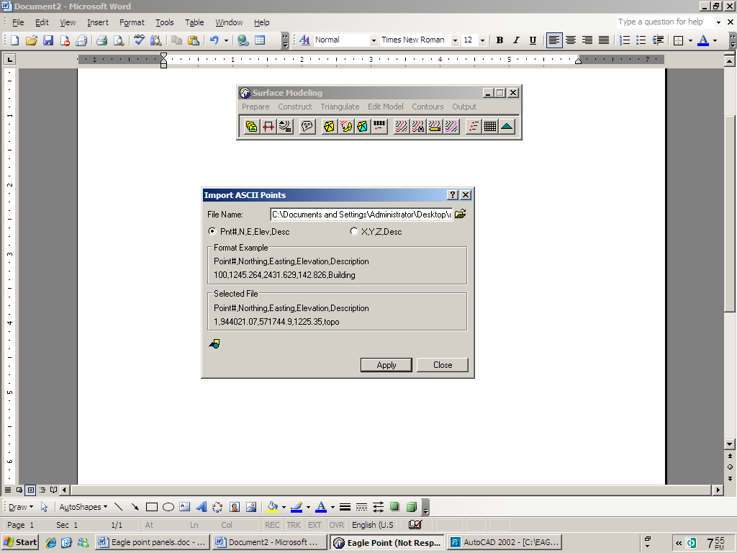

4. Browse the survey file to the location you have stored.
5. Click on the open bottom
6. Turn the radio button point, N, E, Elev, Description (point code)
7. Click on the CAD setting icon
8. Set the values of the settings as follows:
Layer Survey Points
Colour 6
Line type By layer
Width 0
9. Click on apply in the import ASCII points dialog box to import the survey data into the CAD graphic
10. Click on close
N.B! Importing data through surface modeling is one of several methods that can be used to place data into your CAD graphic. Survey data / information can also be place into the CAD graphic VIA
Data collection
Data transfer and
Logo
11. Type Z in the command line then to view all the imported data or zoom window to view partially.
4.4 Creating Model Boundary
When you want to make a surface model, you can place a boundary around the data within the boundary. This is useful when the site is not regularly shaped and you don not want triangles created in the area due to Jack of information.
The boundary (when place must be a close 2-D or 3-D poly line. You draw a boundary around the data and then predefine it for use in your surface model. To create a predefined boundary for the surface model, complete the following steps.
- In AutoCAD, create a layer called OGM boundry and make it current
- Select the poly line command

- Draw the boundary around the data
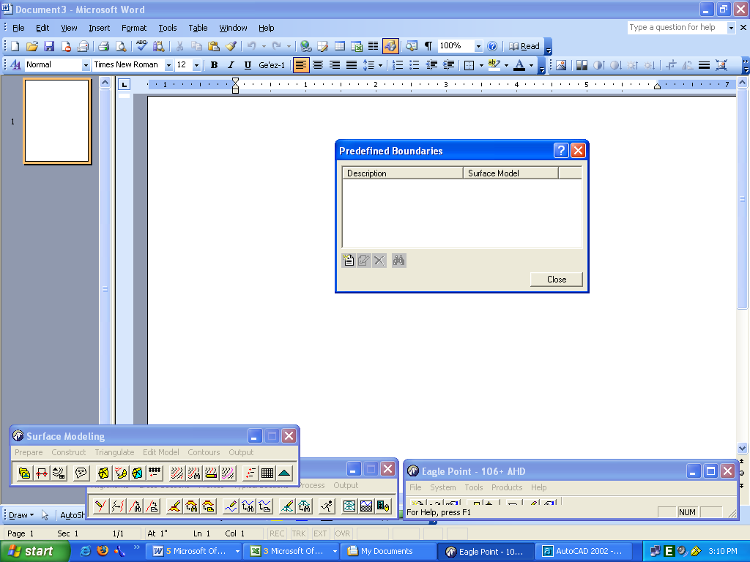
- IN surface modeling, select prepare Predefined boundaries command

- Click on the new predefined Dialog Box
- Pick the boundary object you drew earlier
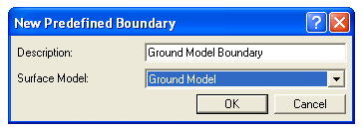

- Type Ground Model Boundary in the description edit field
- Select Ground Model from the surface model drop list
- Click OK
- Click close in the predefined dialog box
4.5 Triangulate a Surface Model
The triangulation process creates a network of triangles that made up the surface model.
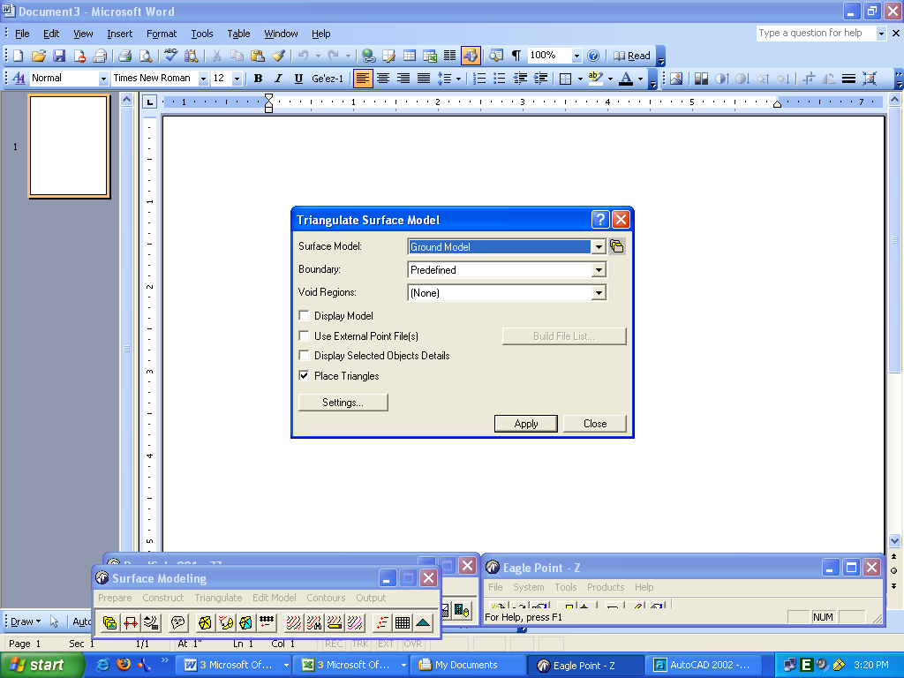
1. In surface modeling, select Triangulate Surface Model

2. Select Ground model from the Surface Model drop list
3. Select predefined from the boundary drop list
4. Since you do not have voids regions in your surface model; make sure (none) is selected from the void regions drop list.
5. Make sure the display model, use external point files(s) and display selected objects details and place triangles toggles are all toggled off.
6. Click on apply in the triangulate surface model dialog box to initiate the triangulate process then close
2.6 Reviewing Surface Model Information
1. In surface modeling select, Manage Surface Model Surface Model
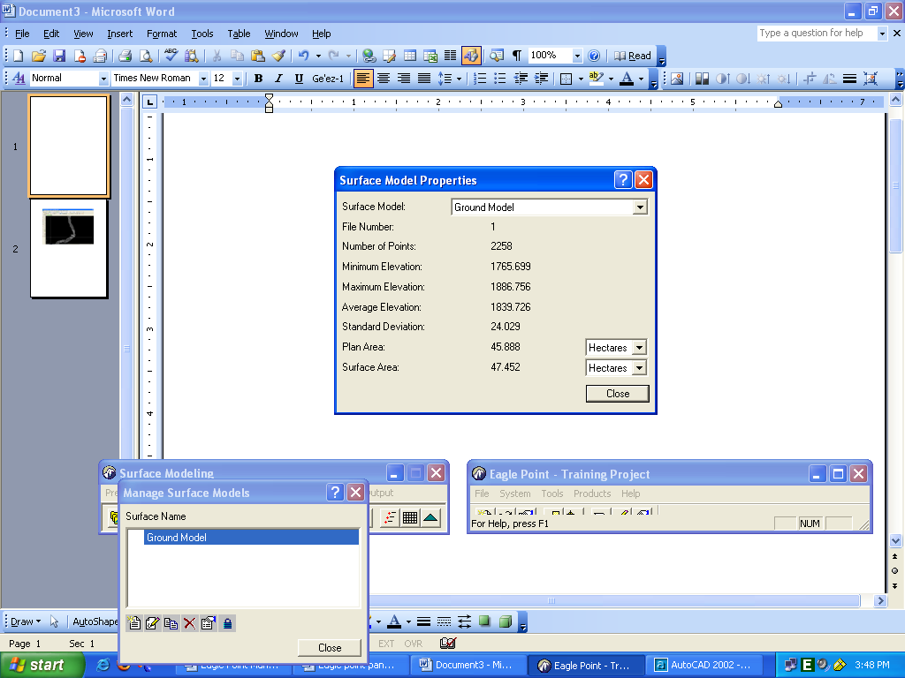

- Make sure that ground model is selected and click on the properties for surface model icon. The surface model properties dialog displays this displays a variety of information for the model
- Click on Close
2.7 Creating Contours
There are several methods you can employ to display contours and make intermediate and index contours. The preview command displays a viewer that lets you see the contours without actually committing them to the CAD graphic. The make intermediate and index command places contour objects in to the CAD graphic.
1. In Surface Modeling, select contours Preview. The preview contour dialog box displays,
2. Make sure the ground mode are displayed which allows you to look at the contours before actually placing them into the CAD graphic
3. Click on apply. Know you have preformed a cursory review of the contours, your next commit them to you CAD graphic
4. Click on Close. The preview contour dialog box closes
5. IN surface Modeling select contours Make intermediate and index

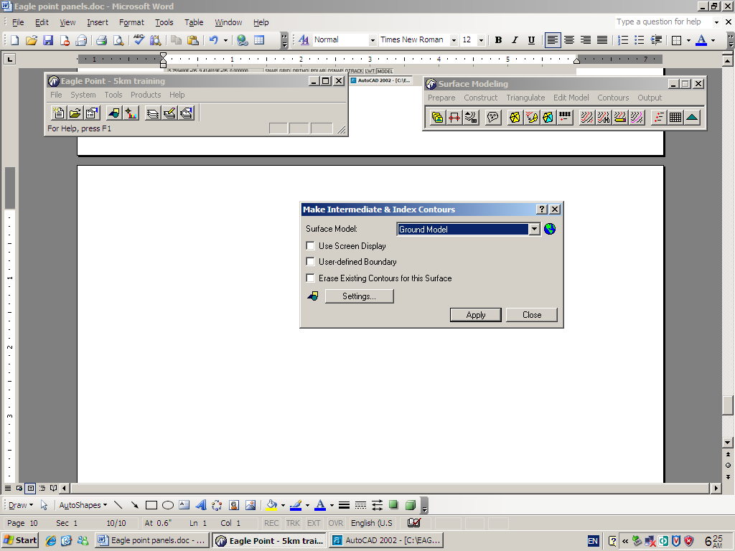

6. Make sure the Ground model is highlighted from the surface model drop list
7. Leave the use screen display, uses defined boundary, and Erase existing contours for this surface toggles toggled off
8. Click on the settings button. Since you have already preformed the settings you don’t need to change anything here. Click Cancel.
9. Click on Apply on the make intermediate and index contours in the CAD graphic
10. Click on Close
4.8 Annotating Contours
1. In surface modeling, select contours annotate
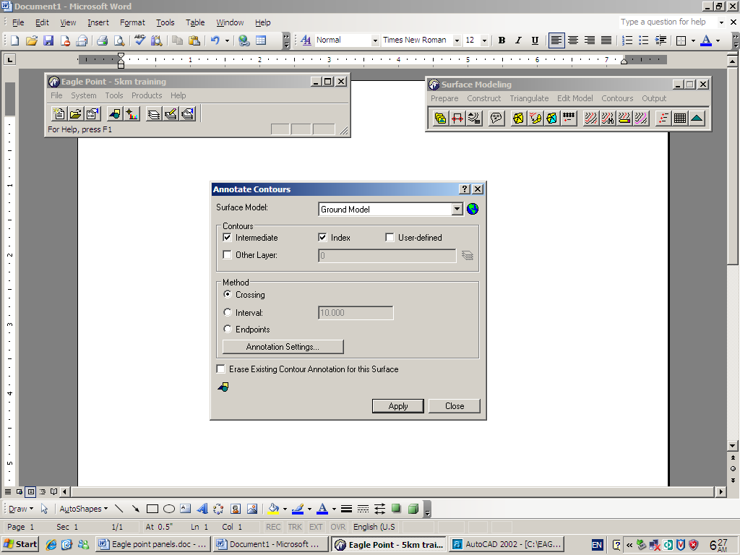

2. Make sure the original ground model is selected from the surface model drop list
3. Make sure the index toggle is on and set the other options in the contours section toggled off.
4. Select the crossing option in the method sections
5. Click on the Annotation settings button

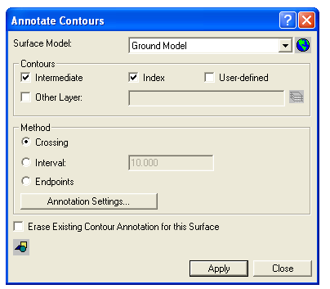

6. Make sure middle is selected from the annotation drop list
7. Make sure to toggle on break contour around annotation option.
Toggle off the other options. Toggle off the other option.
8. Click on OK to commit these settings.
9. Click on apply in the annotate contours dialog box
10. For each point, select a locate on within the contoured area of the CAD graphic.
11. Make sure the line you crate crosses some index contours.
12. Zoom into the area that was annotated
13. Click on close
4.9 Placing Spot Elevations
When you want to annotate the elevation of a specific point on the site, the process involves identifying the model from which the elevation should be extracted and the location where the label should be placed.
1. In surface Modeling, select output place spot elevation labels.
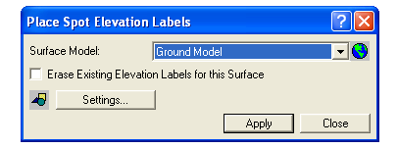

2. Make sure the ground model is selected from the surface model drop list
3. Make sure the Erase existing elevation labels for this surface toggle is off.
4. Click on the CAD setting icon
5. Set the values of the settings to those specified in the following table. Click on OK in the CAD settings dialog box when complete.
Setting Values
Layer OG-SPT
Colour 3
Height 1.0
6. Click on apply in the place spot elevation labels dialog box to initiate the placement of spot elevations, right - click to stop the picking process click on close to end the command.
7. To examine the spot elevations, zoom in around the spot elevations you placed

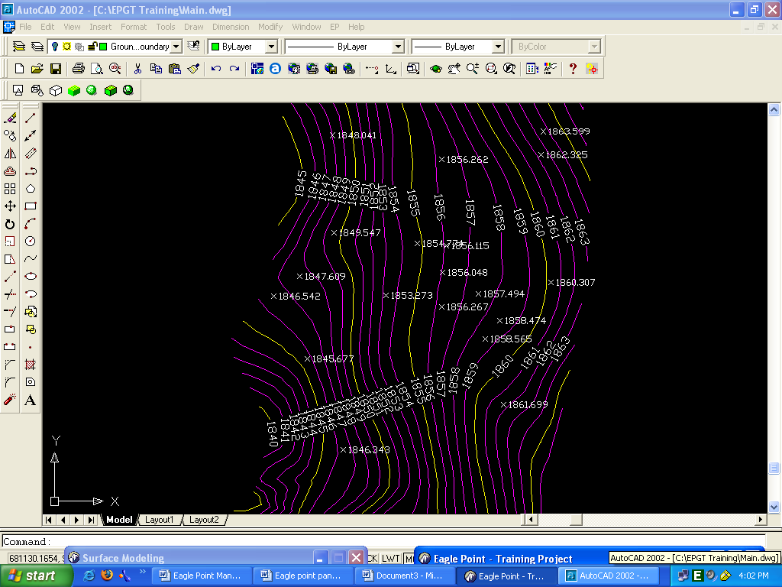

Fig. 2.18 Spot Elevations Lebels

8. Click on Close

4.10 Placing a Grid
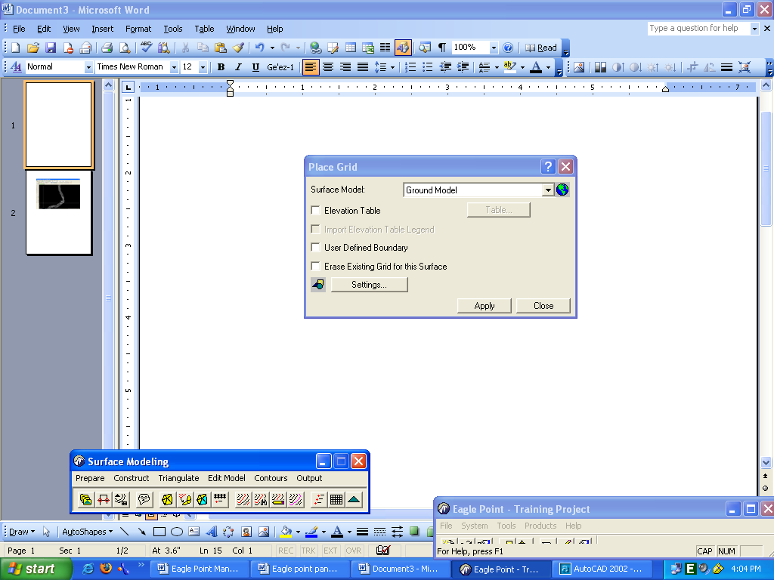
1. In surface modeling, select output place grid the place grid dialog box displays.

2. Make sure the original ground model is highlighted from the surface model drop list
3. Make sure each of the toggles on the place grid dialog box is toggled off
4. Click on the settings bottom
The gird elevation settings dialog box displays.
5. Since you are not changing these settings, click on cancel.
6. Click on apply in the pace grid dialog box
7. Click on close
4.11 Manipulating CAD Graphic
With this option you can mange to manipulate the visibility of some of the objects in the CAD graphic, change your view perspective, and render gird mesh.

4.11.1 Removing Unwanted Object
1. In surface modeling, select output erases existing objects.
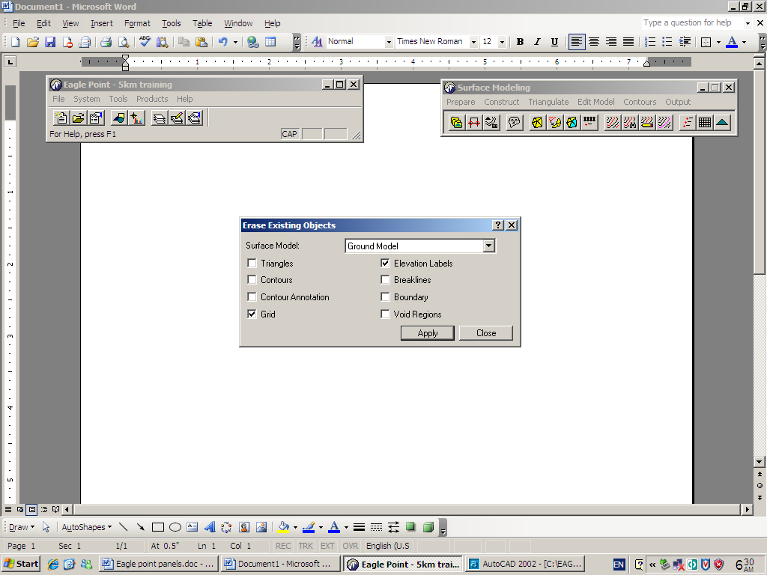

- In the Erase Existing dialog box make sure the ground model is selected form the surface model drop list.
- Toggled on the grid option on and also the contours option
- Click on to commit these settings
- Click on close
- Close the surface modeling menu bar
- Product Drafting Insert Scale North arrow coordinate greed etc

LAP test 1 | Data collect by Total station
Task 1.Prepare topographic map by stadia tachometry.
Task 2.Collect topographic data by total station from 2500 m square and your data contain Building, Tree, Road, Spot height .
Task 3.Download collected topographic data to computer and prepare topographic map by appropriate soft ware.
Task 4. Collect levelling data and generate contour (contouring).

Reference
1.Dr AM Chandra .Plane surve
2.S.K.Roy (2010) Fandamental of surveying. (second edition).
3.A.M.Chandra (2007) Plane surveying
4.Charles D. Ghilani and paul R.WOLF.Introduction to geomatics 12 Edition.

Participants of this Module (training material) preparation
No | Name | Qualific  ation | Field of study | Organization/  Institution | Mobile number | E-mail
1 | Egigayehu Gizachew | A | CTOM | Hossana poly technique college | 0912141058
2 | Addis shimellis | A | Geoinformatics | Athlete. kenenisa poly technique college | 0920165853 | Addisshimellisabebe@gmail. com
3 | Getachew Nigussie | B | Surveying technology | Yirgalem industrial and constriction technique college | 0913249671 | Getalen14@gmail.com
4 | Tigabu | B | Surveying technology | Man buk TVETE technique college | 0918216048 | Abatetigabu76@gmail.com

