WOOD WORK TECHNOLOGY
Level-III
BASED ON OCTOBER 2021, CURRICULUM
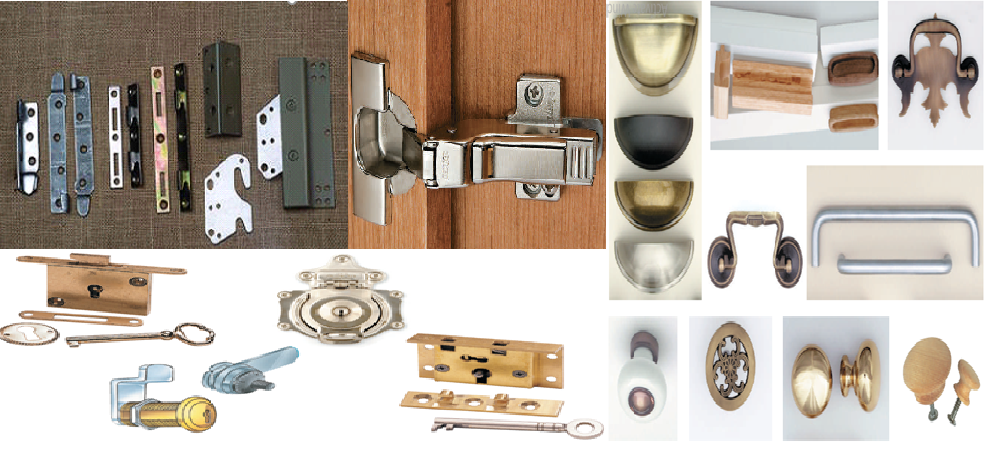

Module Title: Applying Hardware /Fixtures and Accessories
Module code: IND WWT3 M05 1023
Nominal duration: 70 Hours

Prepared by: Addis Ababa City Administration Technical and Vocational Training Bureau

October 2023
Addis Ababa, Ethiopia
Table of Contents
Introduction to the Module----------------------------------------------------------------------------------4
Unit One: Prepare for work-------------------------------------------------------------------------------------5
1.1 Safety and environmental requirements ------------------------------------------------------------6
1.2 Identifying work instruction requirement-----------------------------------------------------------8
1.3 Types of hardware and fixtures-----------------------------------------------------------------------9
1.4 Identify tools and equipment types, characteristics, uses and safe work methods------------26
1.5 Calculating Material quantity requirements based on plans and specifications---------------38
1.6. work effectively with others---------------------------------------------------------------------------41
Self-Check 1--------------------------------------------------------------------------------------------------45
self-check 2---------------------------------------------------------------------------------------------------47
Operation Sheet 1 (Cut hinge recess)----------------------------------------------------------------------48
Unit Two: Apply hardware/ fixtures--------------------------------------------------------------------------49
2.1 Laying out and installing hardware/fixtures and accessories------------------------------------50
2.2 Machine used to fix Hardware/fixtures and accessories-----------------------------------------51
2.3 Joining/ installing process of Hardware/fixtures and accessorie--------------------------------53
2.4 Applying Adhesives-----------------------------------------------------------------------------------58
2.5 Check quality of work based on specification ----------------------------------------------------63
Self-check 1--------------------------------------------------------------------------------------------------64
Oeration Sheet 1 (Round hinge)---------------------------------------------------------------------------65
Lap test 1------------------------------------------------------------------------------------------------------66
Lap test 2------------------------------------------------------------------------------------------------------67
Lap test 3------------------------------------------------------------------------------------------------------68
Unit Three: Complete work-------------------------------------------------------------------------------------69
3.1 Cleaning, maintaining and storing power tools and equipment---------------------------------70
3.2 Collecting and storing unused hardware for reuse or disposal----------------------------------70
3.3 Cleaning work area-----------------------------------------------------------------------------------70
Self-check----------------------------------------------------------------------------------------------------72
Operation Sheet 1(complete work)-----------------------------------------------------------------------73
Reference----------------------------------------------------------------------------------------------------74

Acknowledgment
Addis Ababa City Administration Technical and Vocational Training Bureau wish to extend thanks and appreciation to the many representatives of TVET instructors and respective industry experts who donated their time and expertise to the development of this Teaching, Training and Learning Materials (TTLM).

Introduction to the Module

The hardware used on a cabinet or a piece of furniture is a very important consideration when planning the piece to be built. Poorly selected or poorly installed hardware can detract from the overall appearance and function of the piece. Hardware should enhance the attractiveness of the project, and is should operate smoothly. Hardware that is properly chosen and installed is not particularly noticeable, but hardware poorly done is obvious, and it detracts from the quality of the piece. Hardware used in cabinet and furniture construction includes hinges of different types, knobs, pulls, and handles, latches and catches, drawer slides, and shelf hardware. There are various types of specialty hardware as well.

This module is designed to meet the industry requirement under the woodwork technology occupational standard, particularly for the unit of competency: Applying Hardware /Fixtures and Accessories.
This module covers the units:
- Prepare for work
- Apply hardware/ fixtures
- Complete work
Learning Objective of the Module
- Identify hardware for install
- Lay out hardware/ fixtures
- Select tools and equipments to complete work
Module Instruction
For effective use this modules trainees are expected to follow the following module instruction:
- Read the information written in each unit
- Accomplish the Self-checks at the end of each unit
- Perform Operation Sheets which were provided at the end of units
- Do the “LAP test” giver at the end of each unit and
- Read the identified reference book for Examples and exercise

Unit One: Prepare for work
This unit is developed to provide you the necessary information regarding the following content coverage and topics:
- Safety and environmental requirements
- Identifying work instruction requirement
- Types of hardware and fixtures.
- Identify tools and equipment types, characteristics, uses and safe work methods
- Calculating Material quantity requirements based on plans and specifications
- Work effectively with others
This unit will also assist you to attain the learning outcomes stated in the cover page. Specifically, upon completion of this learning guide, you will be able to:
- Understand safety and environmental requirements
- Apply work instruction requirement
- Understand types of hardware and fixtures.
- Identify tools and equipment types, characteristics, uses and safe work methods
- Calculate material quantity requirements based on plans and specifications
- Apply work effectively with others

  - Safety and environmental requirements
Safety is a special concern for any individual spending time in a woodshop. The tools we work with have the potential to do us serious harm. However, by being aware of special safety concerns connected with woodworking, and by exercising good common sense, we can all come to the end of our careers still able to count to ten on our fingers. And of course, the first hazard most of us think of is a gruesome accident resulting in the loss of a finger, or worse. But other, less visible hazards face us in the shop as well.
We must guard ourselves not only against being cut, but also against such dangers as wood dust, noise, hazardous fumes, lifting injuries, and fire. These dangers may sound intimidating, but good habits and a good safety attitude will serve you well. What do you think your most important piece of safety equipment is? Asked that question, you might say safety glasses, dust masks, perhaps hearing protection, or good guards on the equipment you use. These are all essential items, but the most important tools you can bring to woodworking are located right between your ears: They are the awareness, the attitude, and the knowledge that you bring to every aspect of your time in the shop. Safety is a habit that you develop, and like all habits, it will become instinctive over time.
- OSHA
OSHA is the acronym for the Occupational Safety and Health Administration, a federal agency that was created by Congress and signed into law by President Nixon in 1970 to ensure safe and healthy working conditions for all workers. It is part of the Department of Labor. OSHA’s mandate is to set and enforce standards that ensure safe working environments and prevent injuries. OSHA inspectors are highly trained compliance officers who can and do make unannounced site visits to make sure employers are following OSHA’s safety regulations. Noncompliance with OSHA regulations can result in heavy fines. Since OSHA inspectors cannot be everywhere, it is up to employers and employees to keep themselves safe by following some of the basic rules.
The number one safety rule is to stay alert! You must keep your attention on what you are doing. If you are unable to do that, you have no business operating dangerous tools. It is an interesting fact that many woodworkers who are badly injured in the shop have been working in the trade for some time. They allowed their attention to wander, or took a shortcut that they should not have taken, and the result was a careless mistake that caused an unnecessary injury.
So what are the greatest dangers we face? Again, you may think of physical things cuts, wood dust, and so forth. But again, the importance of awareness, knowledge, and attitude must be emphasized. With that in mind, these are the greatest hazards in a woodshop:
- Ignorance of how tools function or correct procedures for using the tools
- Overconfidence that leads to carelessness
- Rushing or hurrying
- Disregarding the basic rules of safety
- Basic Safety Rules
There are several basic safety rules that apply no matter what tool is being used. These principles form the foundation for creating a safe working environment for yourself and others.
First, be sure you are familiar with the tools you use, and use them to do what they were designed to do. For example, do not use a chisel as a screwdriver or a pry bar; take the time to go get the screwdriver. That is a simple example, but it should bring to your awareness that it is not only those tools that make noise that can hurt you. We often do not give our hand tools the respect they deserve, and we must, because an improperly used or improperly tuned hand tool can do serious damage.
Second, use tool guards whenever possible. Tool guards are safety devices designed for use with specific tools; they keep the operator’s hands from getting dangerously close to spinning blades, bits, and cutters. Many of the guards that come with machines are poorly designed, and there is a tendency in the woodworking community to operate tools without their guards. This is not a good idea. There are good aftermarket guards available, or you can fashion your own, but do use them whenever possible. Tool guards must be removed to perform certain operations.
Third, use auxiliary jigs and safety devices when needed. A jig is a purchased or shop-made device that makes a job safer and easier. If you are using the drill press, for example, to bore a hole in a small piece, find a way to hold it so that your fingers stay out of the danger zone, such as holding it in a clamp. Use push sticks to rip narrow pieces on the table saw. A push stick is a shaped wood or plastic device that allows the operator to move material past the blade without putting his fingers into the danger zone.
Fourth, maintain your equipment. As we cover the various tools in the next few chapters, we will talk about how to maintain them. Taking the time to take care of your equipment is important, both for safety reasons and for reliable results in your woodworking endeavors. Developing a routine to take care of your tools pays great dividends. Most important of all: Pay attention and be alert. Your tools cannot think or reason. They cannot differentiate between your flesh and a piece of wood. Most tools have sharp cutting edges, and are moving at very high speeds. Maintain a healthy respect for your tools. A little bit of fear, or at least an awareness of possible problems, is a good thing. Be careful. Your safety is your responsibility.
  - Identifying work instruction requirement
The aim of the competence work is to develop the trainees’ ability to put their knowledge of theory into practice using forms of construction and concepts outlined in the content.
As part of their study of the competency, trainees are required to carry out the following two main types of workshop:
- Experiments, which are assigned and closely supervised by the teacher
- Projects in which the trainees are given a degree of freedom in carrying out their tasks.
The following factors will be taken into consideration when projects and course work are being assessed.
- Manipulative skills
- Selection, care and maintenance of equipment;
- The ability to design an appropriate plan of procedure;
- The ability to plan or carry out simple experiments to test and/or compare building materials and assembly details;
- The ability to draw conclusions from practical experience and from information produced by practical work;
- The ability to present project and course work.
- Instructions to candidates
- The coursework you submit for assessment must be your own individual work.
- To enable the teacher to validate your competence, your competence must be executed in school under the supervision of your class teacher. You must submit separate, distinct coursework. This is to ensure inter-candidate equity and to assist in the processing of appeals.
- In the case of repeat candidates, new coursework must be undertaken and presented for assessment.
- You must agree the coursework with your class trainer. The coursework must meet the requirements for coursework as specified in the content for hardware Studies.
Students are completely free to decide on what type of project to select. The Instructions to candidates stipulate that the students’ coursework must be agreed with the class trainer. The timing of the project start and finish date can be decided according to the trainers and schools subject plans and organization.
Number of factors can determine the trainees’ choice of project:
- The trainees own interests and ideas
- The trainees experience, skill set and ability
- The trainees’ aims and objectives
- The factor of difficulty
- The time constraints
- Storage and space constraints
  - Types of hardware and fixtures
- Hinges
A hinge is a jointed or flexible device that allows the turning or pivoting of a part on a stationary frame. Hinges support doors and allow them to open. Hinges are also used so chest lids can be raised, slant-front desks opened, and drop leaves raised on tables. We will look first at door hinges. The type of door hinge selected depends first on the type of door being hung. The door will be one of three types: flush, overlay, or inlay, which is also called inset or lipped. A flush door sits flush with the face frame, or it may be flush with the cabinet itself, as in the case of a cabinet without a face frame. An overlay door sits in front of the face frame or cabinet. If it exposes part of the cabinet in the frameless style, it is called an overlay door with a reveal. If it hides the edge of the cabinet completely, it is called a flush overlay door. An inlay door sits partly inside the cabinet or face frame. Fig 1.1. shows illustrations of each of these situations. The types of hinges available are butt, formed, pivot, invisible, European style, and surface. Fig. shows examples of each type and lists the door styles with which each type will work.
Butt hinges are used on flush doors; they have two leaves connected by a pin, which may or may not be removable. Some butt hinges have to be mortised into place, which requires a door with a solid wood edge; this type of hinge is very strong. Mortises, called gains, are cut into the door and the cabinet frame, each deep enough for one leaf of the hinge. Gains may be routed or chiseled out, and butt hinges of this kind have leaves that are either straight or swaged (see Fig 1.2). Swaged leaves are shaped for a closer fit. Only the knuckle of a butt hinge is visible when the door is closed.
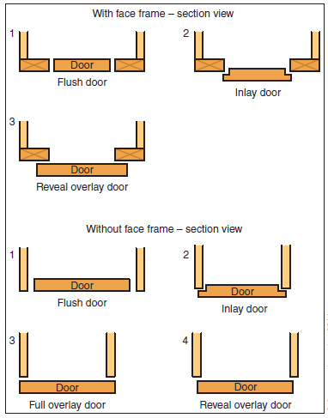
Fig1.1. Flush, overlay, and inlay doors on cabinets with and without face frames.
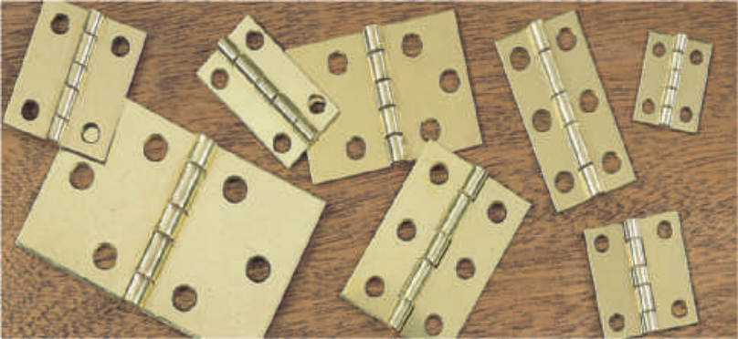
Hinge type: Butt
Application: Flush doors (face frame)
Fig 1.2. Types of hinges and their applications
- Hinges
- Any device that includes a pivot action can be called a hinge, and there are many different variations.
- Some are designed to be concealed within the framework of a cabinet, or the carcass, while others are intended as decorative features in their own right.
- It is important to choose hinges of the correct size and robustness when hanging a door so that it is well supported when it swings open.
- If a hinge or hinge pin is strained in any way, the door will not fit in the frame and may become detached, causing injury.
- Fitting Hinges
- Attaching small hinges to cabinet doors requires patience.
- The style of door will determine the type of hinge required.
- Doors which overlap the front of the cabinet can be fitted with butt hinges screwed to the front of the frame, or concealed hinges which are invisible when the door is closed.
- Flush doors, which fit inside the cabinet frame, are normally fitted with butt hinges.
- They need to be recessed into the wood. Mark around the leaf of the hinge with a craft knife or sharp pencil, and form a recess with a chisel.
- Flush hinges have very thin leaves, which avoid the need to cut a recess.
- They are small enough to fit into the small clearance gap surrounding the door.
- Concealed Hinge
- Originally designed for use in self-assembly base units, this hinge is concealed from view when the door is closed.
- It clips on to the base plate, allowing the door to be removed easily, and is adjustable in all three directions.
- A mounting hole is required, using a boring bit to suit the hinge boss.
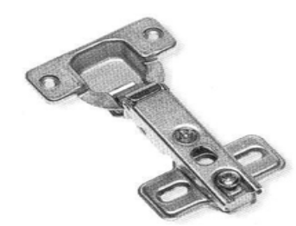Fig. Concealed hinges
- Cylinder Hinge
- Even more discreet, the barrel of the cylinder hinge is concealed in the edges of the door and frame, and is almost invisible when the door is opened.
- This is only suitable for light duty use.
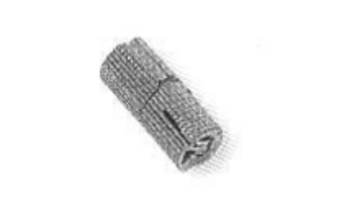
Fig. Cylinder hinge
- Counter Hinges
- These are decorative brass hinges, suitable for bar flaps, counter tops and table leaves.
- Double hinge pins allow the hinge to fold back on itself without binding.
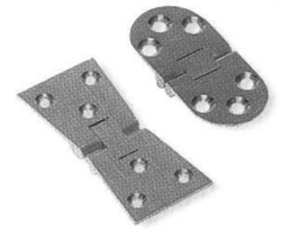
Fig. Counter hinges
- Lay on Hinge
- This is also a concealed hinge, but it requires no mounting holes.
- It is laid on the surface of the door and frame, and simply screwed in place.
- The linked pivot arms allow 180 degree opening and are spring loaded for a positive closing action.
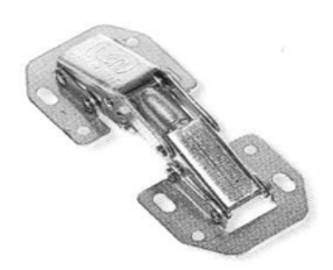
Fig. Lay on hinges
- Pivot Hinge
- A very discreet and neat hinge, suitable for small cabinet doors.
- One half screws directly into the frame; the matching half screws into the edge of the door and slips over the brass pin of the former, allowing the door to be lifted on and off.
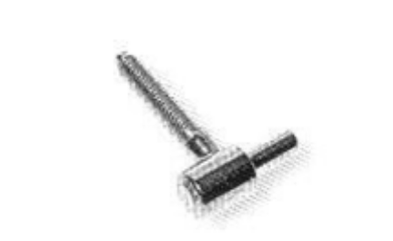
Fig. Pivot hinges
- Lift Off Hinge
A decorative hinge in polished brass with finials at the ends, which can be separated, allowing the door to be lifted on and off at will.
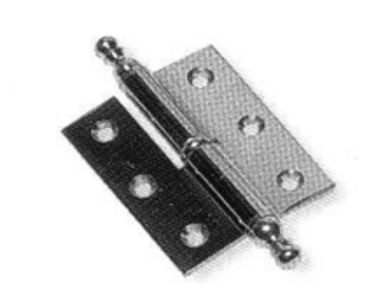
Fig. Lay off hinges
- Brass Shelf Support
Small brass clips that fit into a slotted bookcase strip, allowing shelves to be positioned at will.
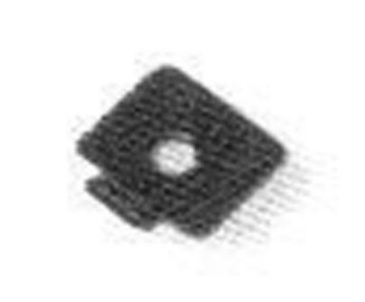
Fig. Brass shelf support
- Magnetic Touch Latch
- This latch is spring loaded so that a light touch on the closed door will release it and throw it open.
- To close the door, gently push it until the keeper plate and latch connect, and it clicks shut.
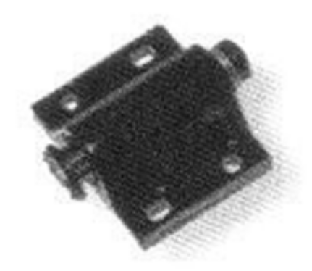
Fig. Magnetic touch latch
- mwork. We have all heard the phrase “two heads are better than one.” Of course, with more minds set on a specific goal, you have access more ideas. Looking at things from the perspective of others can increase the likelihood of quality innovation. Teams create an environment of support and people toward implementation. A team environment can increase the confidence of individuals, allowing them to do their best work.
- Good teams make the most of individual talents. Where one member may be Weak, another might be strong and working together they provide the perfect Resource for an organization. The more people work together, the more they Learn and step away to become better workers in their own jobs. Teams can Create better communication and respectful relationships among employees.
- Creating a "team" working environment
Team decision making: Managers who invite participation believe that People directly affected by a decision should be involved in making that Decision. The effort is toward joint, cooperative decision making. The aim is to give employees a chance to have a say about things that affect them. This means giving them more control over their own work and giving up some of your own power and control.
The Effects of Participation: As a supervisor you'd like your people to work hard. You'd like to have the information you need to operate well and to get ideas on how to solve problems you face. It would be great to have high quality decisions carried out well and willingly.
Building a Good Work Climate: An employee who feels that work is a good place to be is more productive. Work is more enjoyable when the area is pleasant, the people easy to get along with, and where there is team work. In such settings tardiness (the habit of not adhering to a correct time) and absences go down, while productivity goes up. A good work environment can improve morale and encourage employees to cooperate to get the job done. It helps them become a team, rather than just a group of people waiting for a paycheck who don't care about their work, their fellow employees, the organization, or themselves.
- How to work well within a team environment
- Whether you're working in a job that requires teamwork or you have a family, with children, it's important to know how to work well in teams. It's not always easy to work in teams but the rewards can be worth (value) it.
- The key to working well in teams is to have great communication among everyone involved.
- As a team member, communication is critically important. If you have a problem with other team members, talk to them directly. If you can't talk and listen to other team members you might as well be working individually.
- Learning how to work well in teams is so important, not only in business, but also in families. Children need to learn how to cooperate for the greater good Instead of being concerned only with their own good.
- If you teach trainees about teamwork when they are young, chances are good that they will be better team players when they grow up. Practice these teamwork tips, and soon you will find better team cooperation and more successful team projects both in the workplace and at home.
- Communicating effectively can also make your team, as a whole, work better and accomplish your given tasks quicker Here are some other ideas to help you work well with team members:
- First focus on the work assigned to you. If you finish with your task before other team members, ask other members if they need your help.
- Meet your deadlines. If you must miss a deadline, apologize for not Meeting it, tell your team when they will have your part, and then make sure you meets that deadline. The rest of the team will respect you more for owning up to your problem rather than blaming someone else.
- be supportive of your team members. When discussing ideas for the Project you're working on, be sure to consider other team members’ Suggestions, even if you don't think they'll work. Considering other ideas shows you're interested in someone else's opinion.
- Realize the project is a collaborative effort. It doesn't belong to any one person. It's important that each team member can claim owner ship of some part of the project. By having ownership they're more likely to put forward the effort to make the project success.
- If you're leading the team, let the team members know what's expected of them. Establish clear objectives and how each person will contribute. Be open to making changes if someone else can do a certain aspect of the job better than the person you assigned to do it.
- Motivate the team. Work on establishing and maintaining each team member's morale and their motivation to succeed as a team. Give them a reason to want the team to succeed rather than riding off into the project.
- Work together on the plan. The team will feel more ownership of the Project if everyone works together to set goals and establish deadlines for
- The various aspects of the job:
- Meet together periodically to check on progress.
- Switch jobs among team members if necessary.
- Be sure the job is done correctly and on time.

Self-check 1
Instruction: The following questions should serve only as primer. Choose the best.
- Which of the following hinges is intended for light duty only?
- Butt hinges
- Cylinder hinges
- Concealed hinges
- Lay-on hinges
2. It is a hinge that is ideal for long lids of boxes.
- Cylinder hinge
- Pivot hinges
- Piano hinges
- Flush hinges
3. Which of the following hinges is the thinnest?
- Pivot hinges
- Flush hinges
- Butt hinges
- Concealed hinges
4. Which of the following screws can be only turned in one direction?
- Surface screws
- Wood screw
- Security screw
- Pozidriv screw
5. Which of the following screws has a cross head for easy grip and the thread goes up to the portion near the head?
- Brass screws
- Pozidriv head screws
- Recessed cup screws
- Surface screws

6. Which of the following screws are equipped with plastic caps to cover its head?
- Brass screw
- Security screw
- Surface screw
- Rounded head screw
7. Which of the following screws does not have a rounded head?
- Raised and countersunk wood screw
- Rounded screw
- Black japanned round head screws
- Security screws
8. Which of the follow forms of hammers is used for pulling out nails?
- Pin hammer
- Cross peen hammer
- AGYSZALANCZY, taunton’s complete illustrated guide to jigs & fixtures.

Participants of this Module (training material) preparation
No | Name | Qualification (Level) | Field of Study | Organization/ Institution | Mobile number | E-mail
1 | Ashagre Addo | A(MSc) | Wood Technology and  management | Entoto Polytechnic college | 0973839202 | ashagreaddo8@gmail.com
2 | Agmuas Bassie | B(Bsc) | Wood technology | Lidetamanufacturingcollege | 0921667172 | Agmuasbassie9@gmail.com
3 | Minuyelet Abeje | B(Bsc) | Wood technology | Lideta manufacturing college | 0911593863 | Amuab12@gmail.com
4 | Nebiyu Ibrahim | A(MSc) | Wood Technology and  management | General Winget polytechnic college | 0911433875 | Nebex123@gmail.com
5 | Regasa Geshu | B (B.sc) | Wood processing &Engineering | Kirkos Manufacturing College | 0915931822 | rgeshu@gmail.com

